Supplementary Information
Table S1 Sequences of primers for q-PCR.
Table S2 Down regulated genes in male gonadal cells transfected with MIER3-Pex2.
Table S3 Up regulated genes in male gonadal cells transfected with MIER3-Pex2.
Table S4 Differentially expressed genes after transcriptome sequencing (see Excel file).
Table S5 The list of GO terms significantly enriched with differentially expressed genes (see Excel file).
Table S6 The list of KEGG pathways significantly enriched with differentially expressed genes (see Excel file).
Fig. S1 Some specific sequences in the protein sequence of chicken MIER3 gene are different. ① is Fig. a, ② is Fig. b, and ③ is Fig. c
Fig. S2 Evolutionary tree of MIER3 gene at amino acid sequence in different species.
Fig. S3 Relative mRNA expression of chicken MIER3-W, MIER3-Z and MIER3-C in different embryonic tissues in E6 (n=5) and E12 (n=5). The mRNA expression levels were shown as values relative to that of female gonad. SPSS 16.0 (SPSS China, Shanghai, China) was used to perform the Student’s t-test for statistical significance of differences between male and female tissues. There was significant difference among different alphabetic columns (P<0.05), * and * * represented P < 0.05 and P < 0.01, and the data were mean ± standard deviation.
Fig. S4 The relative expression of MIER3-Z in the left gonad of chicken embryo was detected by q-PCR. The mRNA expression levels were shown as values relative to that of female gonad. SPSS 16.0 (SPSS China, Shanghai, China) was used to perform the Student’s t-test for statistical significance of differences between male and female tissues. * and * * represented P < 0.05 and P < 0.01.
Fig. S5 Volcano map for differentially expressed genes. Note: The abscissa is log2(Fold Change), the ordinate is -log10 (p-value), and the blue dotted line indicates the threshold line of screening criteria for differentially expressed genes. The red and green dots indicate the genes with upregulated and downregulated expression in Chicken embryo male gonad cells transfected with MIER3 overexpression vector vs. empty vector, respectively.
Fig. S6 The histogram showing the results from GO enrichment analysis. Note; The coordination shows GO term on the abscissa and the significance of enrichment on the ordinate. The significance of enrichment is indicated by -log10 (padj). Padj denotes adjusted p value. Different colors represent different categories of GO term, including biological process (BP), cellular component (CC) and molecular function (MF).
Fig. S7 E2.5 Sex determination of E12 chicken embryo after injecting MIER3 gene into chicken embryo in vivo. Note: The female allele (ZW) has two bands at 506 bp and 351 bp, while the male allele (ZZ) has only one band at 506 bp. Results of gender identification. The individuals in the figure are numbered as follows; Female: 1,2,4,6,7,9,12,14,16,17,20,21,23; Male: 3,5,8,10,11,13,15,18,19,22.
Table S1 Primer sequences for quantitative PCR analysis
Gene | GenBank Number |  | Primer Sequence (5'-3') | Product Size
CCL4 | NM_204720.3 | F:CCTGCAGACTAGAAAGGCCC |  | 135
CCL4 | NM_204720.3 | R:AAATGCGCTCCCTACCACTC |  | 135
CDKN2A | NM_204434.1 | F:GCGGAAGAAGACACCGCA |  | 235
CDKN2A | NM_204434.1 | R:GAATACGGCGAGCATCGGA |  | 235
CDKN2B | NM_204433.2 | F:GCGGGGATTAGAGGGATGTG |  | 181
CDKN2B | NM_204433.2 | R:TCGGACCGAGGCTTATCAGA |  | 181
CHAC1 | NM_001199656.2 | F:TCCGGTGCAATACAAAGTGA |  | 190
CHAC1 | NM_001199656.2 | R:ACCAATGCGAAGGTGAGC |  | 190
CPLX1 | XM_046905843.1 | F:GAGCCATCGCCATGGATTTT |  | 106
CPLX1 | XM_046905843.1 | R:TTGGCAGCATCAGGGTCTTT |  | 106
EGR1 | NM_204136.3 | F:AACACGGCTACCGCCAATTA |  | 217
EGR1 | NM_204136.3 | R:CGGACTGTTCTCACTGGCTT |  | 217
FREM1 | XM_004949102.5 | F:TTATCATAGGCAGCCCGAAAG |  | 174
FREM1 | XM_004949102.5 | M:GGCGACAGTGGGAAAGACG |  | 174
HMBS | XM_025143289.3 | F:GCTTTAGCGGTGGAGGTTCG |  | 144
HMBS | XM_025143289.3 | R:TGCAACAGGGACACTACAGC |  | 144
MIER3-W | XM_015300440.3 | F:AGGTAGACAGTGGTAATACATCCG |  | 244
MIER3-W | XM_015300440.3 | R:TGTAGTCCTTCAGGAATTCTGCC |  | 244
MIER3-Z | XM_004937251.5 | F:TCTCAAAGGGAGTACCGTGTG |  | 100
MIER3-Z | XM_004937251.5 | R:ATGCAACGATAGCGACCTCC |  | 100
MIER3-ZW |  | F:AGGAAACATGCCGTTGGAAGA |  | 117
MIER3-ZW |  | R:TCTGGAAGTTCATCTGCAAGT |  | 117
PTGS2 | NM_001167718.2 | F:GACTCCGAAGTCAGTGCAGC |  | 145
PTGS2 | NM_001167718.2 | R:CGAGTTCCACTTGCACGAGA |  | 145
RGS1 | XM_422203.8 | F:GGAAAGGAGGACTGCAAGCT |  | 233
RGS1 | XM_422203.8 | R:AGGAACTCCCGAAAGACACC |  | 233
TNFRSF13B | NM_001097537.1 | F:CACCAGGACAGGCAGACAAA |  | 190
TNFRSF13B | NM_001097537.1 | R:CCGATGGAGGAACTGGGAT |  | 190
αGSU | NM_001278021.1 | F:ATGCAGGGTTGTCCAGAGTG |  | 169
αGSU | NM_001278021.1 | R:AGCACGTTGCTTCCGATGTA |  | 169
β-Actin | NM_205518.2 | F:TATGTGCAAGGCCGGTTTC |  | 110
β-Actin | NM_205518.2 | R:TGTCTTTCTGGCCCATACCAA |  | 110
Table S2 Down regulated genes in gonadal cells transfected with MIER3-Pex2
Name | Description | p-Value | Fold Change
PTGDS | prostaglandin D2 synthase 21kDa | 0.0032 | 0.29
TGM6 | transglutaminase 6 | 0.0032 | 0.32
NSUN7 | NOP2/Sun RNA methyltransferase family member 7 | 0.0061 | 0.48
USHBP1 | USH1 protein network component harmonin binding protein 1 | 0.0084 | 0.09
EGR1 | early growth response 1 | 0.0111 | 0.32
HAL | histidine ammonia-lyase | 0.0138 | 0.46
FREM1 | FRAS1 related extracellular matrix 1 | 0.0145 | 0.39
MSMP | microseminoprotein, prostate associated | 0.0165 | 0.14
TNFRSF13B | TNF receptor superfamily member 13B | 0.0249 | 0.34
TNFRSF18 | TNF receptor superfamily member 18 | 0.0428 | 0.47
CAMK2A | calcium/calmodulin dependent protein kinase II alpha | 0.0474 | 0.35
ACOT12 | acyl-CoA thioesterase 12 | 0.0495 | 0.49

Table S3 Up regulated genes in gonadal cells transfected with MIER3-Pex2
Name | Description | p-Value | Fold Change
CPLX1 | complexin 1 | ＜0.001 | 1.68
CCL4 | C-C motif chemokine ligand 4 | ＜0.001 | 2.7
PTGS2 | prostaglandin-endoperoxide synthase 2 | ＜0.001 | 1.99
CDKN2A | cyclin-dependent kinase inhibitor 2A (melanoma, p16, inhibits CDK4) | ＜0.001 | 1.91
CDKN2B | cyclin dependent kinase inhibitor 2B | ＜0.001 | 1.85
PCASP2 | paracaspase 2 | 0.0011 | 11.51
CSF3 | colony stimulating factor 3 | 0.0105 | 2.04
NFASC | neurofascin | 0.0145 | 2.26
DCAF11 | DDB1 and CUL4 associated factor 11 | 0.0197 | 5.18
CDH5 | cadherin 5 | 0.0232 | 2.07
EN2 | engrailed homeobox 2 | 0.0374 | 9.11
HSPB3 | heat shock protein family B (small) member 3 | 0.0464 | 2.33

Fig. S1
a
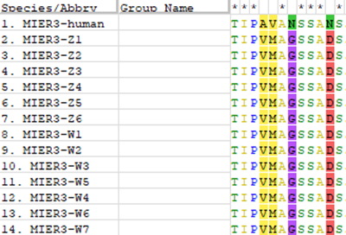
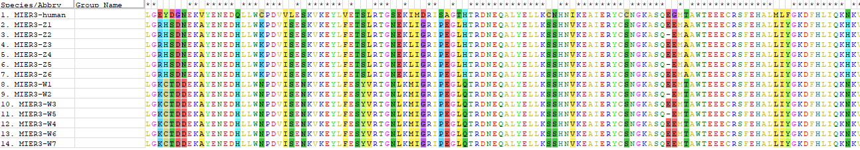
b
c
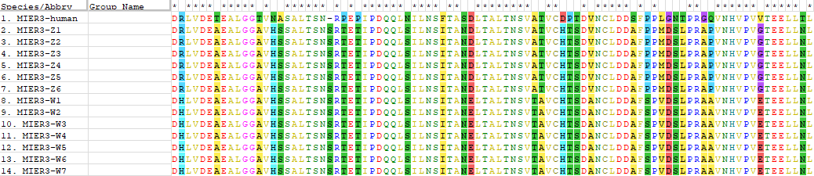
Fig. S2
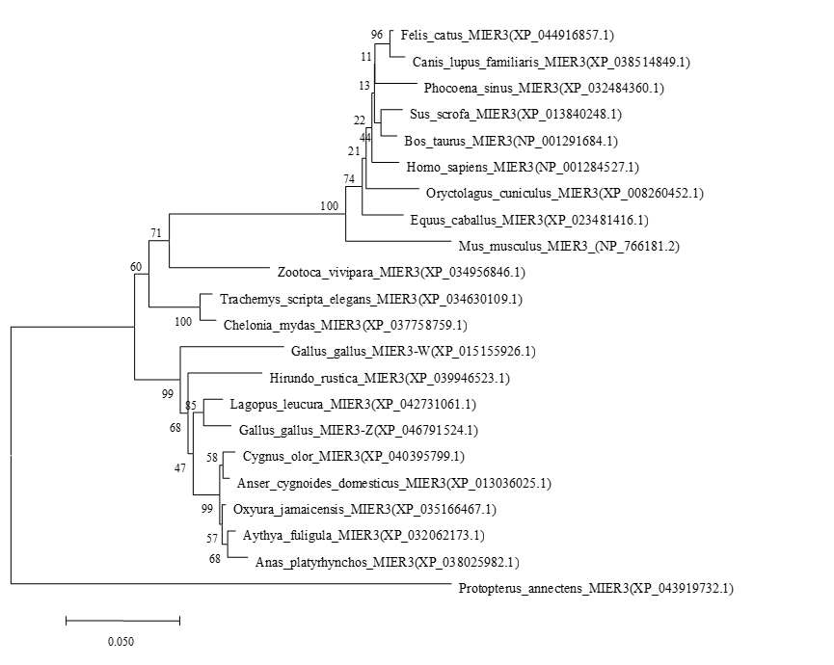

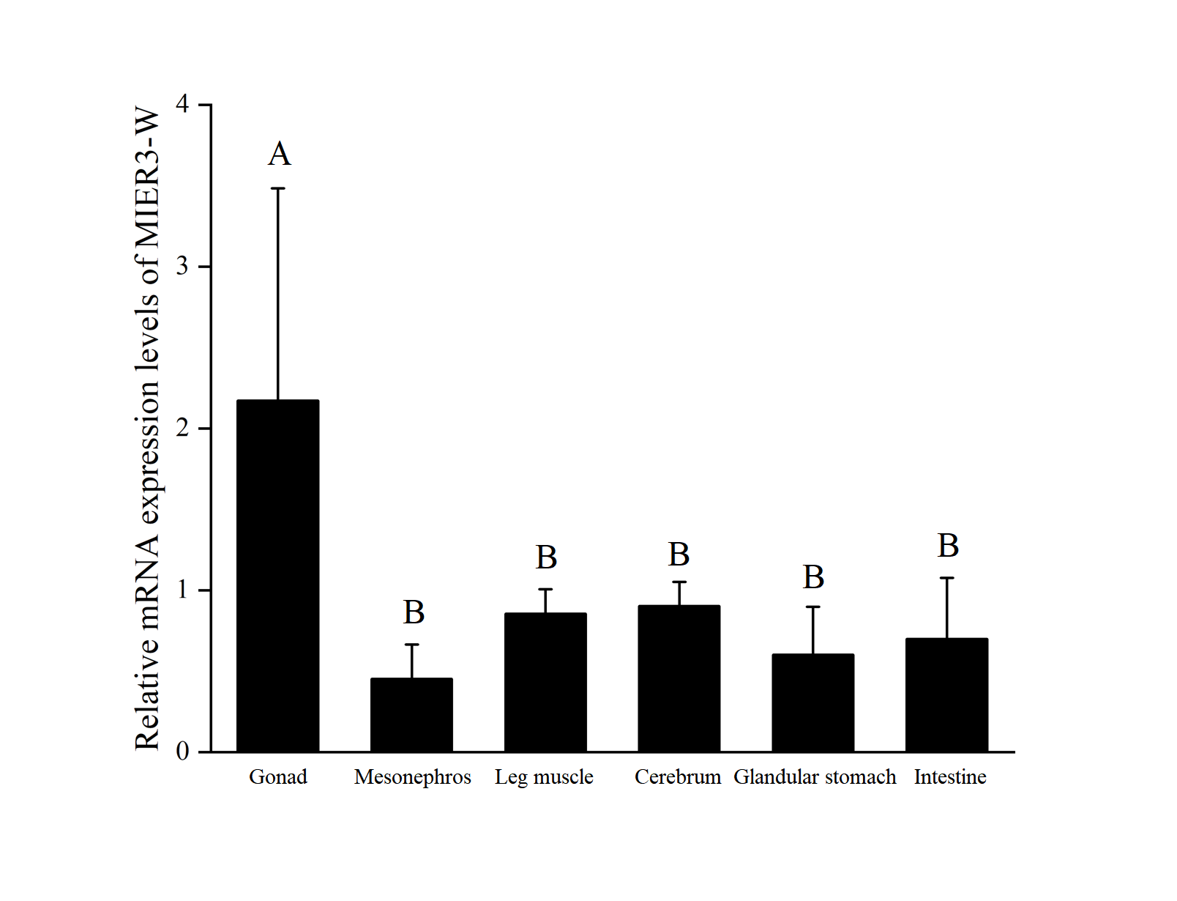
Fig. S3
a

MIER3-W

b
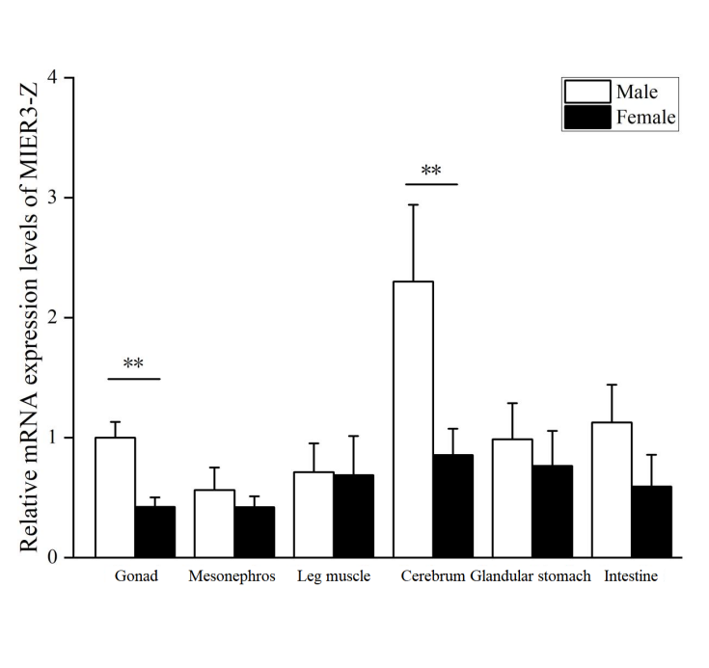
MIER3-Z

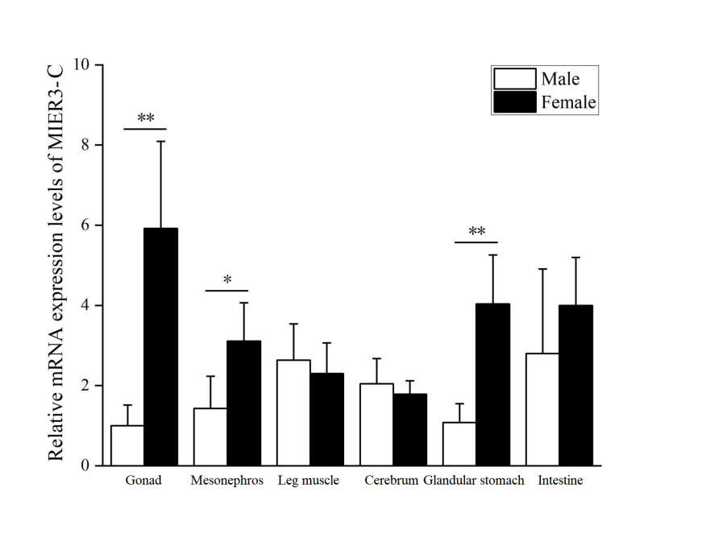
MIER3-C
c
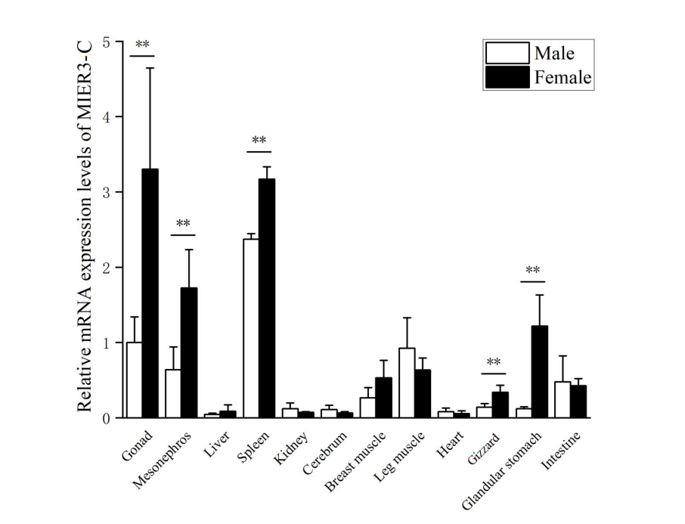
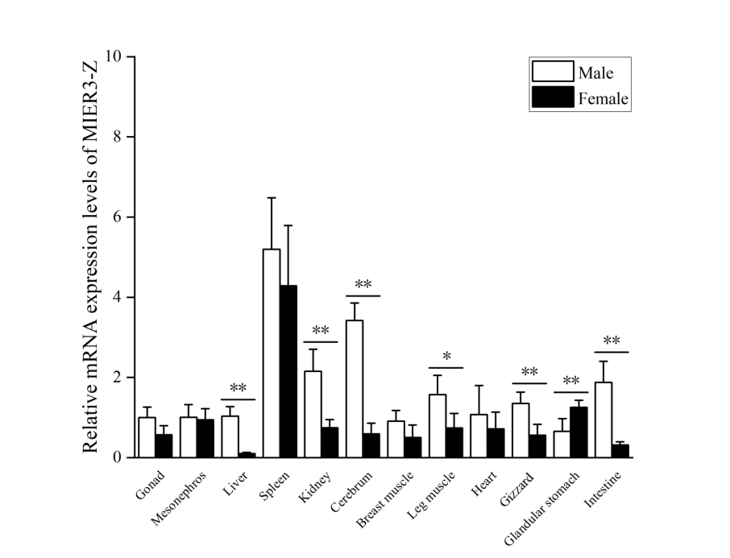
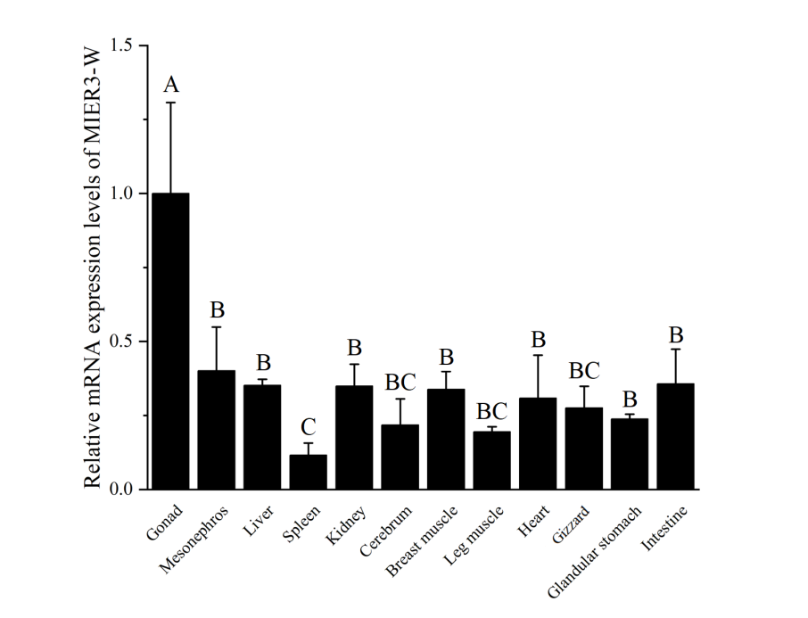
MIER3-C
MIER3-W
MIER3-Z
f
e
d
Fig. S4
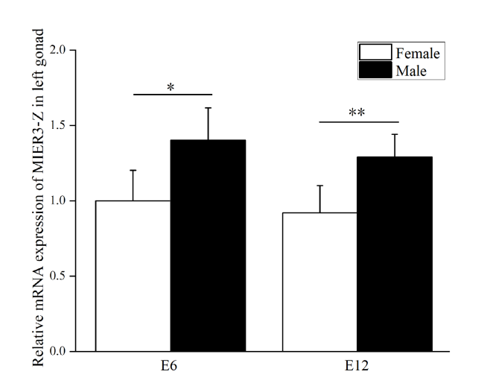
MIER3-Z
Fig. S5
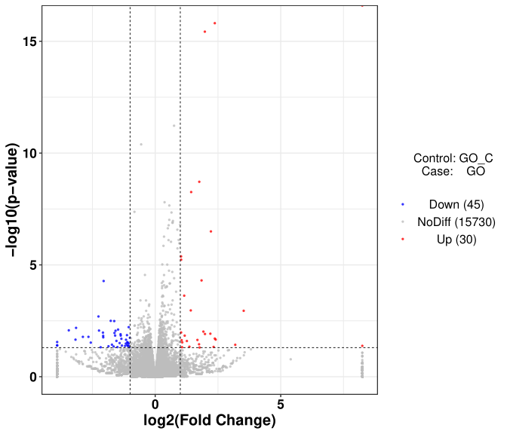
.

Note: The abscissa is log2(Fold Change), the ordinate is -log10(p-value), and the blue dotted line indicates the threshold line of screening criteria for differentially expressed genes. The red and green dots indicate the genes with upregulated and downregulated expression in Chicken embryo male gonad cells transfected with MIER3 overexpression vector vs. empty vector, respectively.

Fig. S6

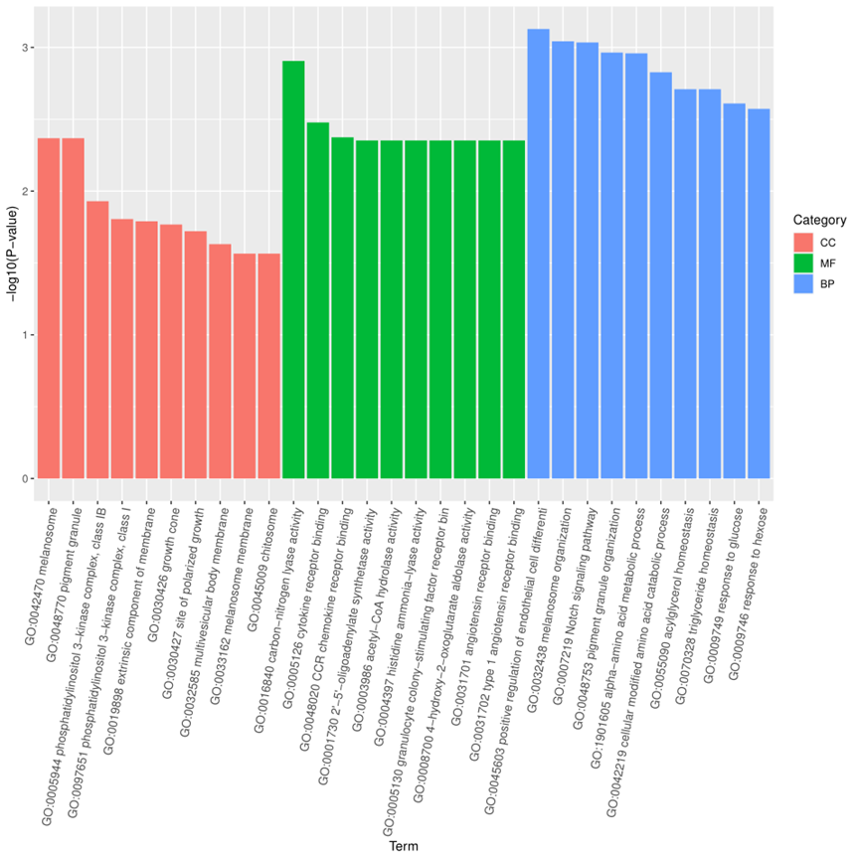

Note: The coordination shows GO term on the abscissa and the significance of enrichment on the ordinate. The significance of enrichment is indicated by -log10 (padj). Padj denotes adjusted p value. Different colors represent different categories of GO term, including biological process (BP), cellular component (CC) and molecular function (MF).

Fig. S7
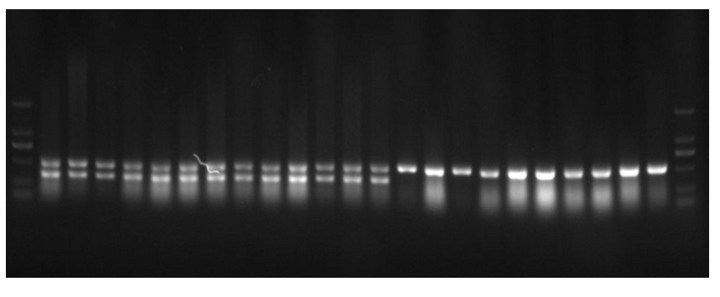
Female
Male
M 1 2 4 6 7 9 12 14 16 17 20 21 23 3 5 8 10 11 13 15 18 19 22 M
2000bp

1000bp
750bp
500bp

250bp
100bp

Note: The female allele (ZW) has two bands at 506 bp and 351 bp, while the male allele (ZZ) has only one band at 506 bp. Results of gender identification; Female: 1,2,4,6,7,9,12,14,16,17,20,21,23; Male: 3,5,8,10,11,13,15,18,19,22.

