An Artificial Neural Network-based Radiomics model for Predicting Radiotherapy response of Advanced Esophageal Squamous Cell Carcinoma patients: A multi-center Study

Yuchen Xie¹; Qiang Liu²; Chao Ji¹; Yuchen Sun¹; Shuliang Zhang¹; Mingyu Hua¹; Xueting Liu¹; Shupei Pan³; and Xiaozhi Zhang¹
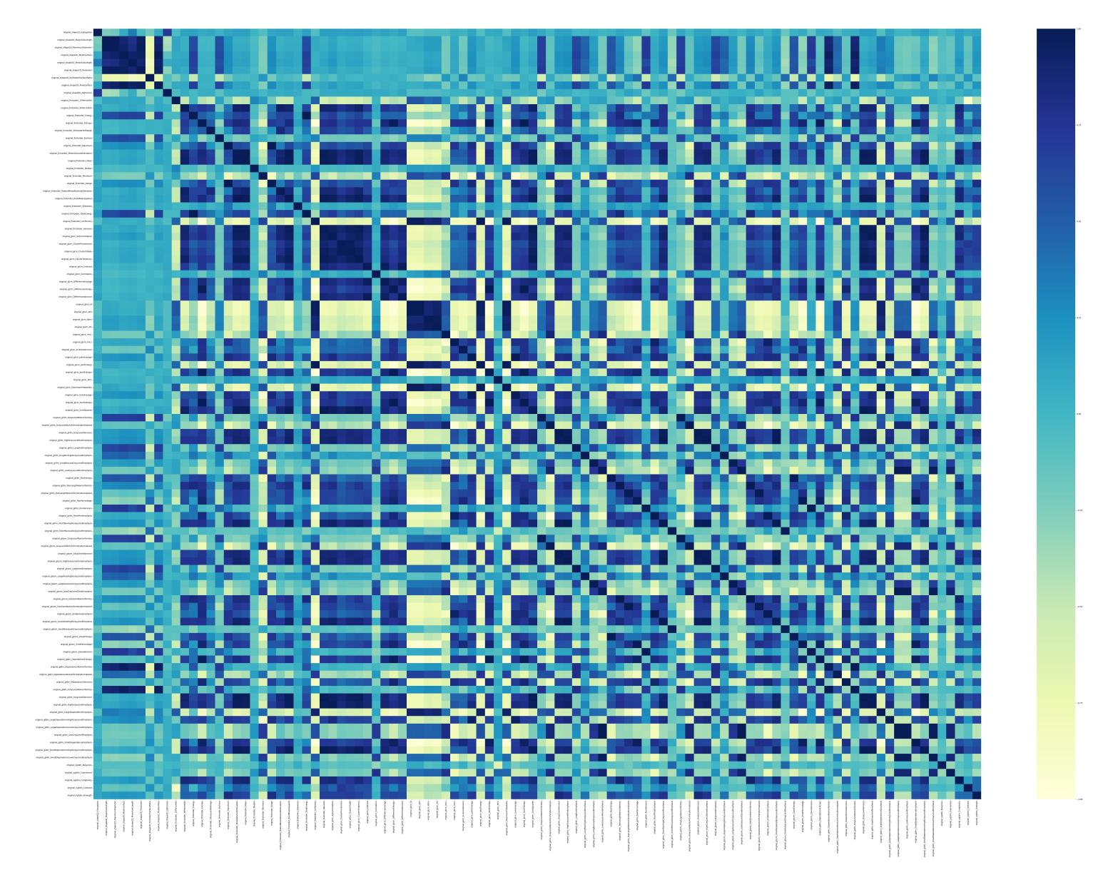

Supplementary Figure S1, Heat-map of the correlation coefficient between each pair of features.
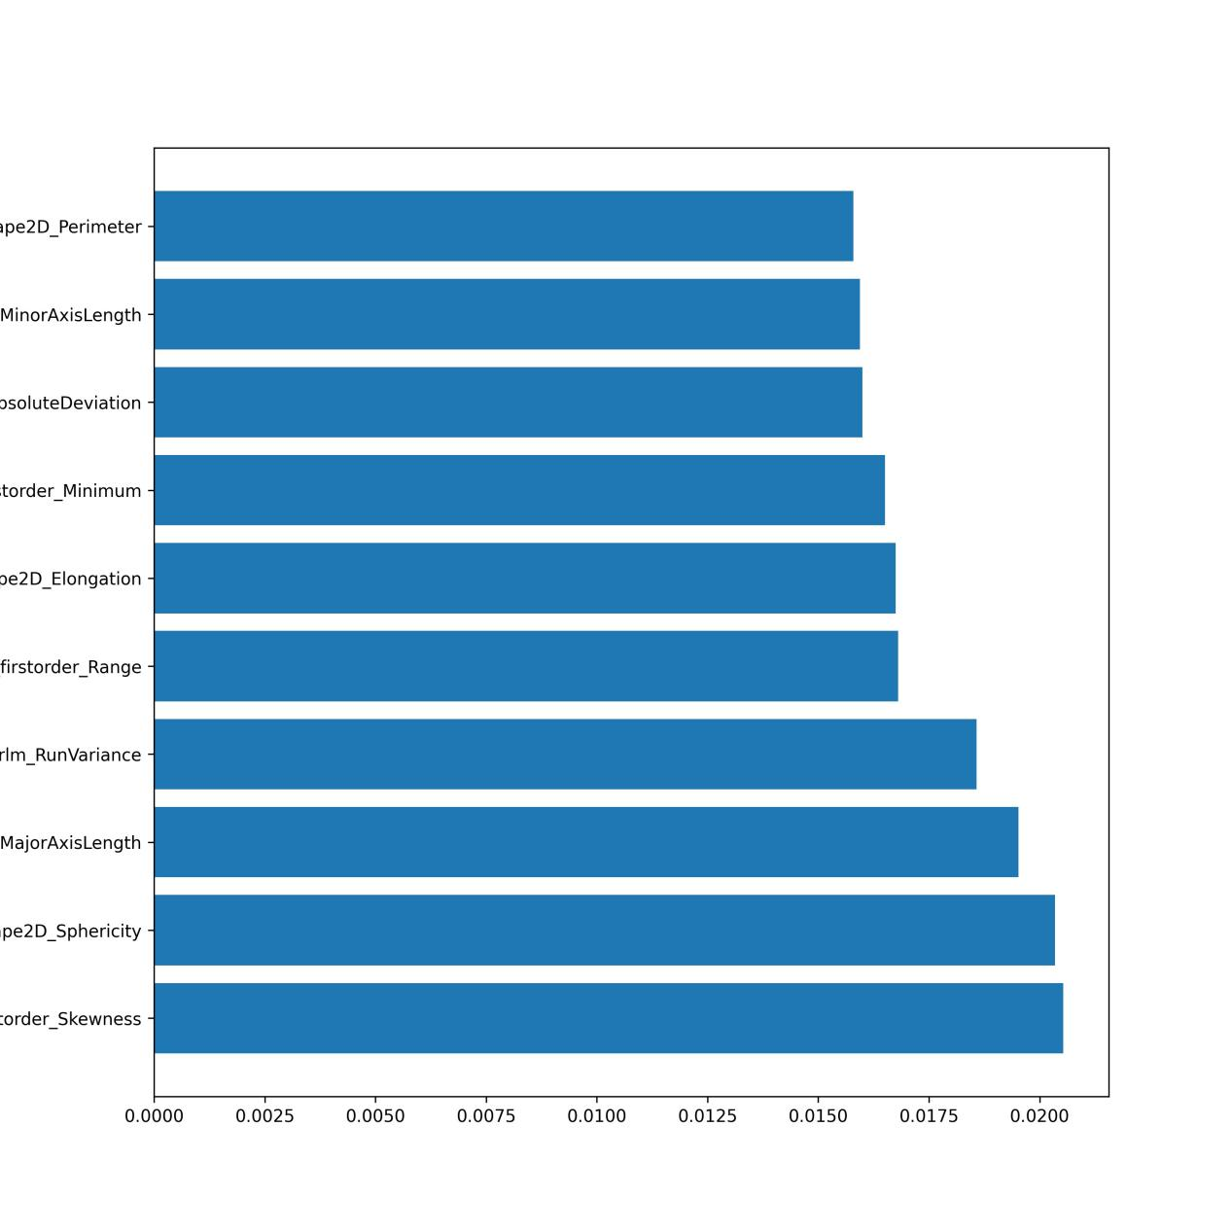
Supplementary Figure S2, Histogram of features that do not belong to the same correlation group among all features and have the best predictive power

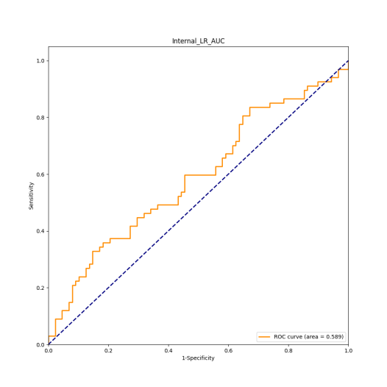
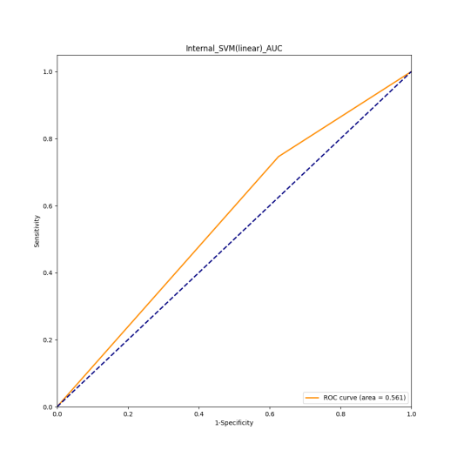
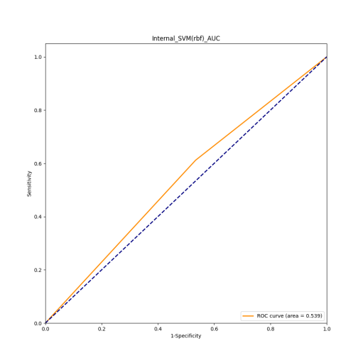
A B C
Supplementary Figure S3, A AUC curve of SVM model with rbf kernel in internal validation cohort; B AUC curve of SVM model with linear kernel in internal validation cohort; C AUC curve of Linear Regression model in internal validation cohort.

Supplementary Table S1, The univariate analysis of the association with clinical characteristics and radiotherapy reponse.
Univariate analysis
 | P Value
Sex | 1.000
Age | 0.997
Tumor length before radiotheraphy | 0.999
General types | 1.000
Tumor location | 1.000
T | 1.000
N | 1.000
M | 1.000
Clinical stage | 1.000
Alchohol | 0.998
Cigareete | 0.998

