Supplementary Materials for

Acute isolation increases reward responsiveness in human adolescents
Livia Tomova^{1,2}, Emily Towner¹, Kirsten Thomas^{1,3} and Sarah-Jayne Blakemore^{1,3}

Correspondence to: lt503@cam.ac.uk

¹ Department of Psychology, University of Cambridge
² Hughes Hall, University of Cambridge
³ Institute of Cognitive Neuroscience, University College London

This document includes:

Supplementary Materials
Figures S1 to S2
Tables S1 to S10

Supplementary Materials
Analyses for final rating at the end of isolation (T4; 3h 30min to 4h of isolation, varying between participants)
At the end of social isolation (T4), participants reported significantly increased loneliness compared with at the start of the session, in both isolation sessions (iso total: t(38)=5.88, P< 0.001, Cohen’s d=0.99; iso media: t(39) =4.92, P<0.001, Cohen’s d=0.71) and decreased positive mood (iso total: t(38)=−6.18, P<0.001, Cohen’s d=0.79; iso media: (t(39)=−6.31, P<0.001, Cohen’s d=0.76). Figure S2 shows plots including T4 measures.
We analysed changes in social craving over the duration of isolation (for iso total and iso media) but found no increase in social craving either at T4 or T3 compared to baseline in either session (all ps > 0.25).

Effects of session on state anxiety
To assess whether state anxiety was affected by isolation, we added session (baseline, iso total, iso media) and trait anxiety as predictors of self-reported state anxiety levels. We found no main effect of session or interaction of session and trait anxiety predicting state anxiety (p-values > 0.18).

Pairwise comparisons EBDM task
To further interrogate the 4-way interaction for RTs from the mixed effects model (reported in main text), we calculated pairwise comparisons between each level for the 3 factors in the EBDM task: reward (high/low) effort (high/low) and context (social/non-social) resulting in 8 tests (Bonferroni corrected p<0.0063 (0.05/8)). Table S3 shows the results for each paired t-test.

Sensitivity analyses Reward Seeking: Effects of gender, session order and days between sessions
To assess whether gender, session order or days between sessions interacted with the effects of isolation on reward seeking in the EBDM task (using RTs from high effort + high reward trials as the dependent variable), we ran a sensitivity analysis in which we added session (baseline, iso total, iso media), context (social, non-social), calibration (i.e., the maximum number of button presses performed in 10s), gender (male, female), session order (iso total first, iso media first) and days between sessions (i.e., the number of days between the iso total / iso media session and the previous session; baseline coded as zero) as predictors in our linear mixed model. The command for this model was:
fitlme(Data,’Response ~ (session * context) + Calibration + gender + session_order + days_between_sessions + (session * context|subjectID)’).
We did not find any effects of gender, session order, or days between sessions, while the main effect of session for the total isolation session remained significant (Table S4).

Sensitivity analyses Reward Learning: Effects of gender, session order and days between sessions
To assess whether gender, session order and days between sessions interacted with the effects of session on reward learning in the RL task, we ran sensitivity analyses in which we added session (baseline, iso total, iso media), condition (social, non-social), gender (male, female), session order (iso total first, iso media first) and days between sessions (i.e., the number of days between the iso total session / iso media session and the previous session; baseline coded as zero) as predictors in our linear mixed model. We ran this model for each parameter from the reward learning task (learning_pos, learning_neg and beta).
The command for this model was:
fitlme(Data,'Response ~ (session * condition) + gender + session_order + days_between_sessions + (session * condition | subjectID)').

Learning_pos. We did not find any main effect or interaction with any of the control variables. As in the main analysis, we found a significant interaction of session and condition on learning_pos rates (Table S8) showing increase learning rates in the iso total session (compared to baseline), particularly for learning from social feedback and decreased learning rates in the iso media session (compared to baseline) for learning from social feedback.
Learning_neg. We found an effect of gender in that males showed a lower learning rate from negative prediction errors than did females. As in the main analysis, we found a main effect of social feedback, indicating that participants showed a higher learning rate from negative social feedback compared to negative non-social feedback in each session (Table S9).
Beta. We found an effect of gender with lower beta values (indicating higher exploration) for males. In addition, we found an effect of session order in that overall beta values were higher (indicating lower exploration) when iso total was the first isolation session (rather than iso media). We also found a negative effect of number of days between sessions, meaning that when the session followed shortly after a previous session beta rates were higher, indicating lower exploration (Table S10). Furthermore, in contrast to the main analysis, we found a significant positive effect of both isolation sessions (iso total and iso media) on beta compared to baseline (indicating lower exploration following isolation).

Exploratory analyses: Effects of chronic loneliness, depression, trait anxiety and boredom on isolation effects
We explored whether trait differences in chronic loneliness (UCLA loneliness scale), depression (CESD scale), trait anxiety (STAI scale) or self-reported current boredom levels during each session interacted with the effects of isolation. We ran separate models for each of these variables (4 analyses for each task) to explore main effects and interactions with session and condition by adding them as a predictor in a linear mixed model for the EBDM task (RTs on high effort and high reward trials as dependent variable; other predictors: session (baseline, iso total, iso media) and context (social, non-social) and for the RL task (learning_pos rates as dependent variable; other predictors: session (baseline, iso total, iso media) and condition (social, non-social)). We report results as significant at p < 0.0125 (0.05 / 4).
We found no effects of any exploratory variable on learning_pos rates in the RL task (all p-values > 0.10). We found that chronic loneliness interacted with RTs in the EBDM task in that participants who reported higher loneliness showed faster responses in the social context trials in the iso total session (b=-0.07, t=-2.58, CI=-0.12,-0.02, P=0.011). A similar trend effect in the iso media session did not survive correction for multiple comparisons (b=-0.06, t=-2.32, CI=-0.12,-0.01, P=0.021). We found no effects of any other exploratory variable on RTs in the EBDM task (all p-values > 0.08).

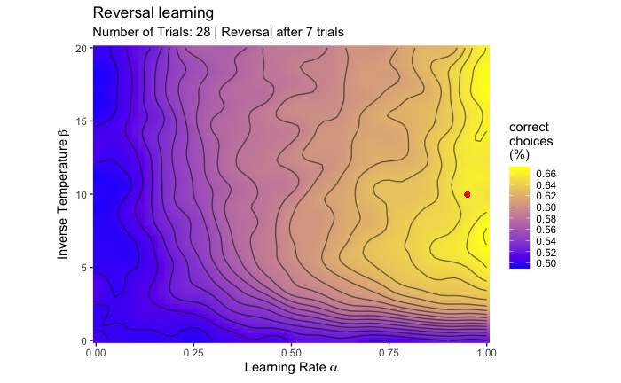
FIG. S1. Simulations of optimal parameters for reward learning task.
The figure shows the optimal combination of learning rate and inverse temperature predicting highest choice accuracy for the task setup used in this study. The values are obtained from data simulations based on the assigned reward probabilities, task length and frequency of reversals. Bright yellow colouring depicts high choice accuracy while purple colouring indicates low choice accuracy (50% equals chance performance). The red dot indicates the optimal combination of learning rate and inverse temperature predicting the highest choice accuracy for the present task setup.

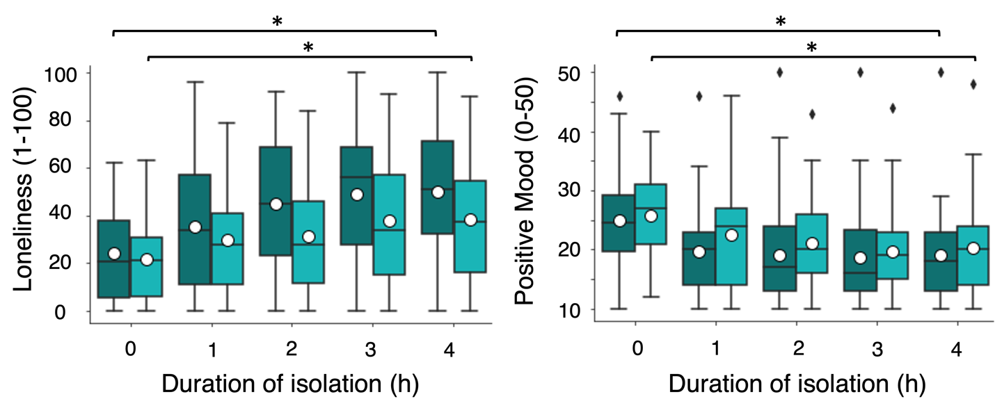
FIG. S2. Effects of isolation on loneliness and mood including T4.
Changes in self-reported loneliness (left) and positive mood (right) over time during isolation. Dark green = iso total session; turquoise = iso media session. The boxplots indicate the median (black centre line), mean (white circle), the interquartile range (IQR; box) and the 1.5 x IQR minima and maxima (whiskers). The black rhombi indicate outliers (values outside of 1.5 x IQR). The asterisk indicates significance at p < 0.001.

Predictors | Estimates | t | p
Session: Iso Total | -1.236 | -1.2 | 0.216
Session: Iso Media | -1.897 | -1.4 | 0.171
Context: Nature | -0.048 | -0.5 | 0.637
Reward: Low | -2.810 | -7.6 | 6.49e-14
Effort: Low | 0.310 | 1.9 | 0.053
Interaction: Effort (Low) – Reward (Low) | 1.429 | 4.0 | 8.12e-05
Interaction: Session (Iso total) – Context (Nature) | 0.587 | 0.8 | 0.448
Interaction: Session (Iso media)– Context (Nature) | -0.471 | -0.8 | 0.406
Interaction: Session (Iso total) – Reward (Low) | -0.075 | -0.2 | 0.857
Interaction: Session (Iso media) – Reward (Low) | 0.231 | 0.4 | 0.682
Interaction: Session (Iso total) – Effort (Low) | 1.303 | 1.1 | 0.280
Interaction: Session (Iso media) – Effort (Low) | 2.003 | 1.3 | 0.205
Interaction: Session (Iso total) – Context (Nature) – Reward (Low) – Effort (Low) | 0.967 | 1.2 | 0.232
Interaction: Session (Iso media) – Context (Nature) – Reward (Low) –Effort (Low) | -1.114 | -0.8 | 0.452

Table S1.
Full output linear mixed effects model for EBDM task - choice data.

Predictors | Estimates | t | p
Session: Iso Total | -0.616 | -3.8 | 0.0001
Session: Iso Media | -0.413 | -2.6 | 0.010
Context: Nature | -0.111 | -0.9 | 0.382
Reward: Low | 0.445 | 2.2 | 0.025
Effort: Low | -0.246 | -1.9 | 0.063
Interaction: Effort (Low) – Reward (Low) | -0.041 | -0.2 | 0.813
Interaction: Session (Iso total) – Context (Nature) | 0.125 | 0.9 | 0.375
Interaction: Session (Iso media)– Context (Nature) | 0.200 | 1.3 | 0.192
Interaction: Session (Iso total) – Reward (Low) | 0.305 | 1.0 | 0.313
Interaction: Session (Iso media) – Reward (Low) | 0.643 | 3.2 | 0.002
Interaction: Session (Iso total) – Effort (Low) | 0.113 | 0.8 | 0.422
Interaction: Session (Iso media) – Effort (Low) | 0.112 | 0.7 | 0.519
Interaction: Session (Iso total) – Context (Nature) – Reward (Low) – Effort (Low) | 0.836 | 2.5 | 0.015
Interaction: Session (Iso media) – Context (Nature) – Reward (Low) –Effort (Low) | 0.904 | 1.9 | 0.054

Table S2.
Full output linear mixed effects model for EBDM task - response time data.
Variable | df | t | p | Cohen’s d
Baseline vs Iso total – Social Context
High Reward + High Effort | 38 | 3.3 | 0.002* | 0.64
High Reward + Low Effort | 39 | 3.0 | 0.005* | 0.67
Low Reward + High Effort | 18 | 1.2 | 0.232 | 0.34
Low Reward + Low Effort | 28 | 3.5 | 0.002* | 0.71
Baseline vs Iso total – Nonsocial Context
High Reward + High Effort | 37 | 3.2 | 0.003* | 0.60
High Reward + Low Effort | 39 | 3.8 | 0.0005* | 0.82
Low Reward + High Effort | 17 | 2.5 | 0.022 | 0.66
Low Reward + Low Effort | 31 | 2.0 | 0.051 | 0.47
Baseline vs Iso media – Social Context
High Reward + High Effort | 36 | 2.1 | 0.044 | 0.34
High Reward + Low Effort | 38 | 1.7 | 0.108 | 0.38
Low Reward + High Effort | 18 | 1.2 | 0.861 | 0.05
Low Reward + Low Effort | 28 | 2.7 | 0.012 | 0.61
Baseline vs Iso media – Nonsocial Context
High Reward + High Effort | 36 | 1.9 | 0.063 | 0.40
High Reward + Low Effort | 39 | 2.8 | 0.008 | 0.53
Low Reward + High Effort | 19 | 0.8 | 0.461 | 0.20
Low Reward + Low Effort | 28 | 0.3 | 0.745 | 0.08

Table S3.
Pairwise comparisons EBDM task. Asterisks indicate significance at the Bonferroni corrected p<0.0063 (0.05/8) level.

Predictors | Estimates | t | p
Session: Iso Total | -0.450 | -3.1 | 0.002
Session: Iso Media | -0.223 | -1.0 | 0.317
Context: Social | 0.119 | 0.8 | 0.428
Gender (Male) | 0.063 | 0.4 | 0.728
Session order (Iso total first) | -0.170 | -1.0 | 0.331
Calibration | 0.001 | 0.2 | 0.873
Days between sessions | 0.002 | 0.6 | 0.542
Interaction: Session (Iso total) – Condition (Social) | -0.167 | -1.0 | 0.321
Interaction: Session (Iso media) – Condition (Social) | -0.151 | -0.8 | 0.340

Table S4.
Sensitivity Analysis EBDM task. Output linear mixed effects model for effects of session (baseline, iso total, iso media) and context (social, non-social) on response time data (on high effort / high reward trials) from the EBDM task including control variables gender (male, female), calibration (number of pumps managed in 10 s during initial calibration at the start of each session), session order (iso total first, iso media first) and days between sessions.

Predictors | Estimates | t | p
Session: Iso Total | 0.025 | 5.2 | 3.78e-07
Session: Iso Media | -0.004 | -0.9 | 0.389
Condition: Social | -0.062 | -11.6 | 7.87e-25
Interaction: Session (Iso total) - Condition (Social) | 0.195 | 31.9 | 2.30e-88
Interaction: Session (Iso media) - Condition (Social) | -0.043 | -7.1 | 1.23e-11

Table S5.
Full output linear mixed effects model for RL task - learning_pos rate parameter.

Predictors | Estimates | t | p
Session: Iso Total | 0.038 | 1.4 | 0.168
Session: Iso Media | 0.054 | 1.8 | 0.070
Condition: Social | 0.061 | 2.3 | 0.025
Interaction: Session (Iso total) - Condition (Social) | 0.045 | 1.3 | 0.197
Interaction: Session (Iso media) - Condition (Social) | 0.012 | 0.3 | 0.751

Table S6.
Full output linear mixed effects model for RL task - learning_neg rate parameter.

Predictors | Estimates | t | p
Session: Iso Total | 0.150 | 1.9 | 0.061
Session: Iso Media | 0.264 | 2.6 | 0.009
Condition: Social | -0.065 | -0.6 | 0.584
Interaction: Session (Iso total) - Condition (Social) | -0.072 | -0.5 | 0.179
Interaction: Session (Iso media) - Condition (Social) | 0.194 | 1.4 | 0.612

Table S7.
Full output linear mixed effects model for RL task – beta parameter.

Predictors | Estimates | t | p
Session: Iso Total | 0.026 | 5.2 | 3.50e-7
Session: Iso Media | -0.003 | -0.6 | 0.550
Condition: Social | -0.063 | -11.4 | 2.39e-24
Gender (male) | -0.004 | -1.9 | 0.063
Session order (iso total first) | 0.002 | 0.8 | 0.446
Days between sessions | -6.06e-5 | -1.4 | 0.179
Interaction: session (iso total) – condition (social) | 0.195 | 31.5 | 3.13e-86
Interaction: session (iso media) – condition (social) | -0.043 | -6.9 | 4.19e-11

Table S8.
Sensitivity Analysis RL task – learning_pos. Output linear mixed effects model for effects of session (baseline, iso total, iso media) and condition (social, non-social) on learning_pos rates including control variables gender (male,female), session order (iso total first, iso media first) and days between sessions.

Predictors | Estimates | t | p
Session: Iso Total | 0.032 | 1.0 | 0.307
Session: Iso Media | 0.049 | 1.6 | 0.146
Condition: Social | 0.060 | 2.2 | 0.031
Gender (male) | -0.081 | -2.0 | 0.047
Session order (iso total first) | -0.007 | -0.2 | 0.873
Days between sessions | 0.0002 | 0.4 | 0.728
Interaction: session (iso total) – condition (social) | 0.045 | 1.3 | 0.196
Interaction: session (iso media) – condition (social) | 0.012 | 0.3 | 0.735

Table S9.
Sensitivity Analysis RL task – learning_neg. Output linear mixed effects model for effects of session (baseline, iso total, iso media) and condition (social, non-social) on learning_neg rates including control variables gender (male, female), session order (iso total first, iso media first) and days between sessions.

Predictors | Estimates | t | p
Session: Iso Total | 0.257 | 2.8 | 0.005
Session: Iso Media | 0.368 | 3.4 | 0.0008
Condition: Social | -0.065 | -0.5 | 0.589
Gender (male) | -0.286 | -3.2 | 0.002
Session order (iso total first) | 0.176 | 2.0 | 0.047
Days between sessions | -0.003 | -2.6 | 0.009
Interaction: session (iso total) – condition (social) | -0.073 | -0.5 | 0.610
Interaction: session (iso media) – condition (social) | 0.195 | 1.3 | 0.185

Table S10.
Sensitivity Analysis RL task – beta. Output linear mixed effects model for effects of session (baseline, iso total, iso media) and condition (social, non-social) on beta rates including control variables gender (male, female), session order (iso total first, iso media first) and days between sessions.

