Table 1: Comparison of histomorphometric parameters of TCM between the groups in each time and three different times in each group (Mean ± Se).
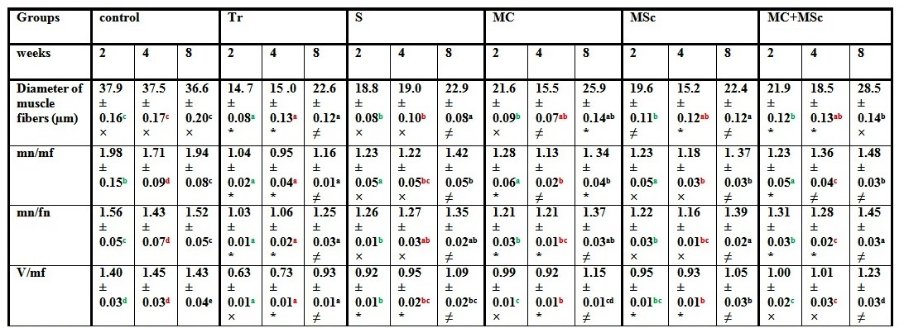
The letters are for comparison between groups in each time, and the symbols (×, *, ≠) are for comparison between three different times in each group. The presence of different letters or symbols indicates significant difference at level of P<0.05.

Table 2: Comparison of histopathologic parameters of TCM between the groups in each time and three different times in each group (Mean ± Se).
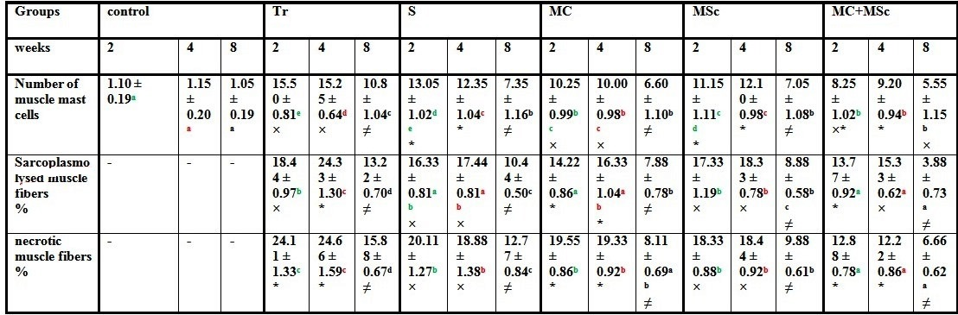
The letters are for comparison between groups in each time, and the symbols (×, *, ≠) are for comparison between three different times in each group. The presence of different letters or symbols indicates significant difference at level of P<0.05.

Table 3: Comparison of histomorphometric parameters of the sciatic nerve (proximal sections, transection site) between the groups in each time and three different times for each group (Mean ± Se).
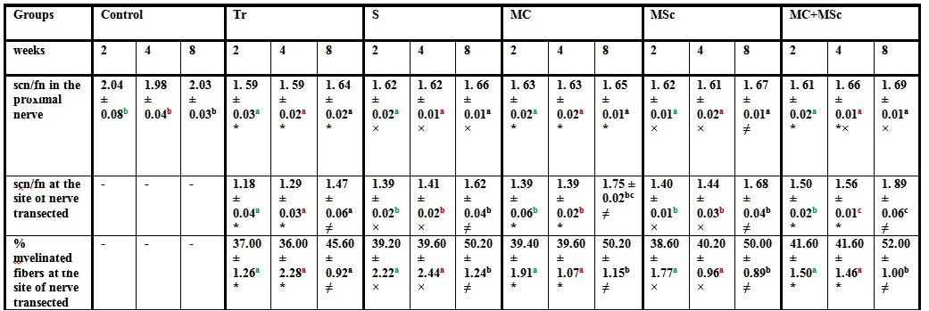
The letters are for comparison between groups in each time, and the symbols (×, *, ≠) are for comparison between three different times in each group. The presence of different letters or symbols indicates significant difference at level of P<0.05.

Table 4: Comparison of histomorphometric parameters of the sciatic nerve in distal part of transection site between the groups in each time and three different times in each group (Mean ± Se).
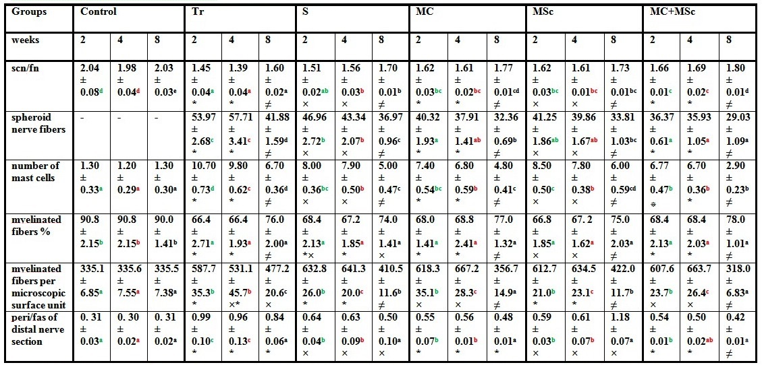
The letters are for comparison between groups in each time, and the symbols (×, *, ≠) are for comparison between three different times in each group. The presence of different letters or symbols indicates significant difference at level of P<0.05.

