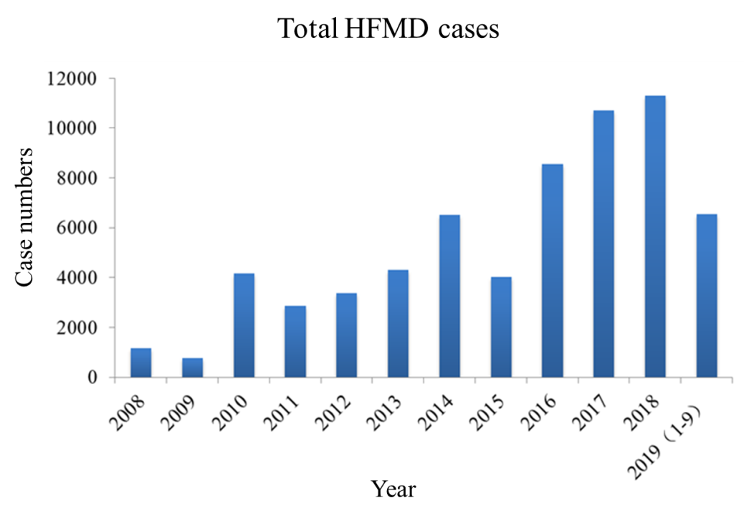
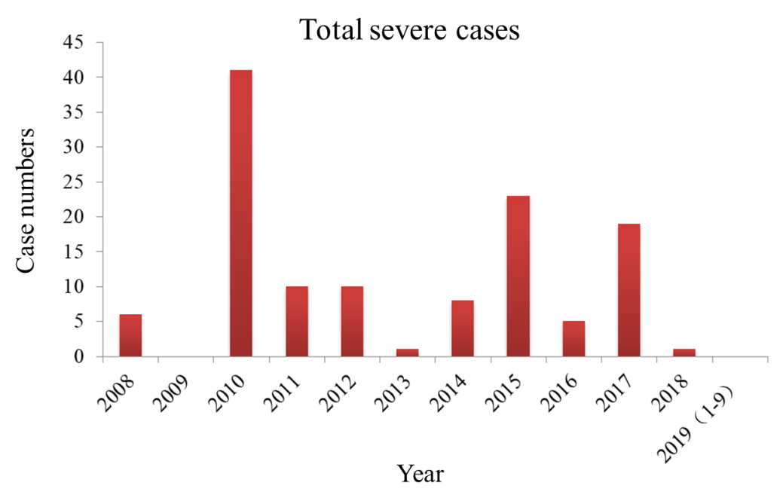
Figure S1. Total HFMD cases and severe HFMD cases in Xiamen from January 2009 to September 2019.

Table S1. Primers used for amplifying partial VP1 sequences of Non-C4 EV-A71 strains.
Primer |  | Region | Sequence (5’→3’) | Position*
Outer primer
Forward | EV1F | VP1 | CTAGTGAYGAGAGYATGATTG | 2661-2631
Reverse | nEV71R2 | VP1 | TTVACAAAAACTGAGGGRTT | 2983-2964
Inner primer
Forward | nVP1F2 | VP1 | GTTCTTAAYTCRCAYAGYA | 2643-2661
Reverse | EV1R | VP1 | CAAARCGCATRTARGTGAA | 2832-2814
Outer primer
Forward | EV71-VP1-F1 | VP1 | TGTGATCGAGAGCTCTATAGG | 2456-2376
Reverse | EV71-VP1-R1 | VP1 | TTAATGGAGTTACCGGCGTA | 3292-3273
Inner primer
Forward | EV71-VP1-F2 | VP1 | GAGAGTATGATTGAGACACGATG | 2619-2641
Reverse | EV71-VP1-R2 | VP1 | CTCTGACATGCTTCATTCTCA | 3216-3196
Outer primer
Forward | C45F1 | VP1 | AGAGCATGATTGAGACACG | 2620-2638
Reverse | C45R1a | VP1 | ATCTTTCTCCTGTTTGTGTTC | 3095-3075
Reverse | C45R1b | VP1 | GTCTTTCTCTTGCTTGTGTTC | 3095-3075
Inner primer
Forward | C45F2a | VP1 | CRGGATTAGTTGGAGAGATAG | 2698-2718
Reverse | C45F2b | VP1 | CRGGGTTAGTTGGAGAGATAG | 2698-2718
Reverse | C45R2 | VP1 | CGCAGGTGACATGAATGG | 3032-3015
Outer primer
 | 59F | 5’ UTR | CYTTGTGCGCCTGTTTT | 70-86
 | 588R | 5’ UTR | ATTGTCACCATAAGCAGCC | 602-584
Inner primer
 | 153Fa | 5’ UTR | CAAGCACTTCTGTTTCCC | 167-184
 | 153Fb | 5’ UTR | CAAGYACTTCTGTMWCCCC | 167-185
 | 541R | 5’ UTR | CCCAAAGTAGTCGGTTCC | 555-538

