Supporting Information
Fabrication of graphene: CdSe quantum dots/CdS nanorod heterojunction photodetector and role of graphene to enhance the photoresponsive characteristics

Chandrasekar Perumal Veeramalai*¹, Pratap Kollu², Guochen Lin¹, Xiaoming Zhang¹ Chuanbo Li*^{1,3}
¹School of Sciences, Minzu University, Beijing 100081, P.R.China
²CASEST, School of Physics, University of Hyderabad, Prof.C.R.rao Road, Gachibowli, Hyderabad-500046, India
³Optoelectronics Research Center, Minzu University of China, Beijing 100081, China
Figure.S1 The photographic image of Colloidal CdSe QDs and graphene:CdSe QDs nanocomposite under UV illumination at 365 nm.

Figure.S2 (a) I_{D}/I_{G} ratio of pristine graphene, QDs deposited on graphene 5 min and QDs deposited 15 min (b) I_{2D}/I_{G} ratio of pristine graphene, QDs deposited on graphene 5 min and QDs deposited 15 min.

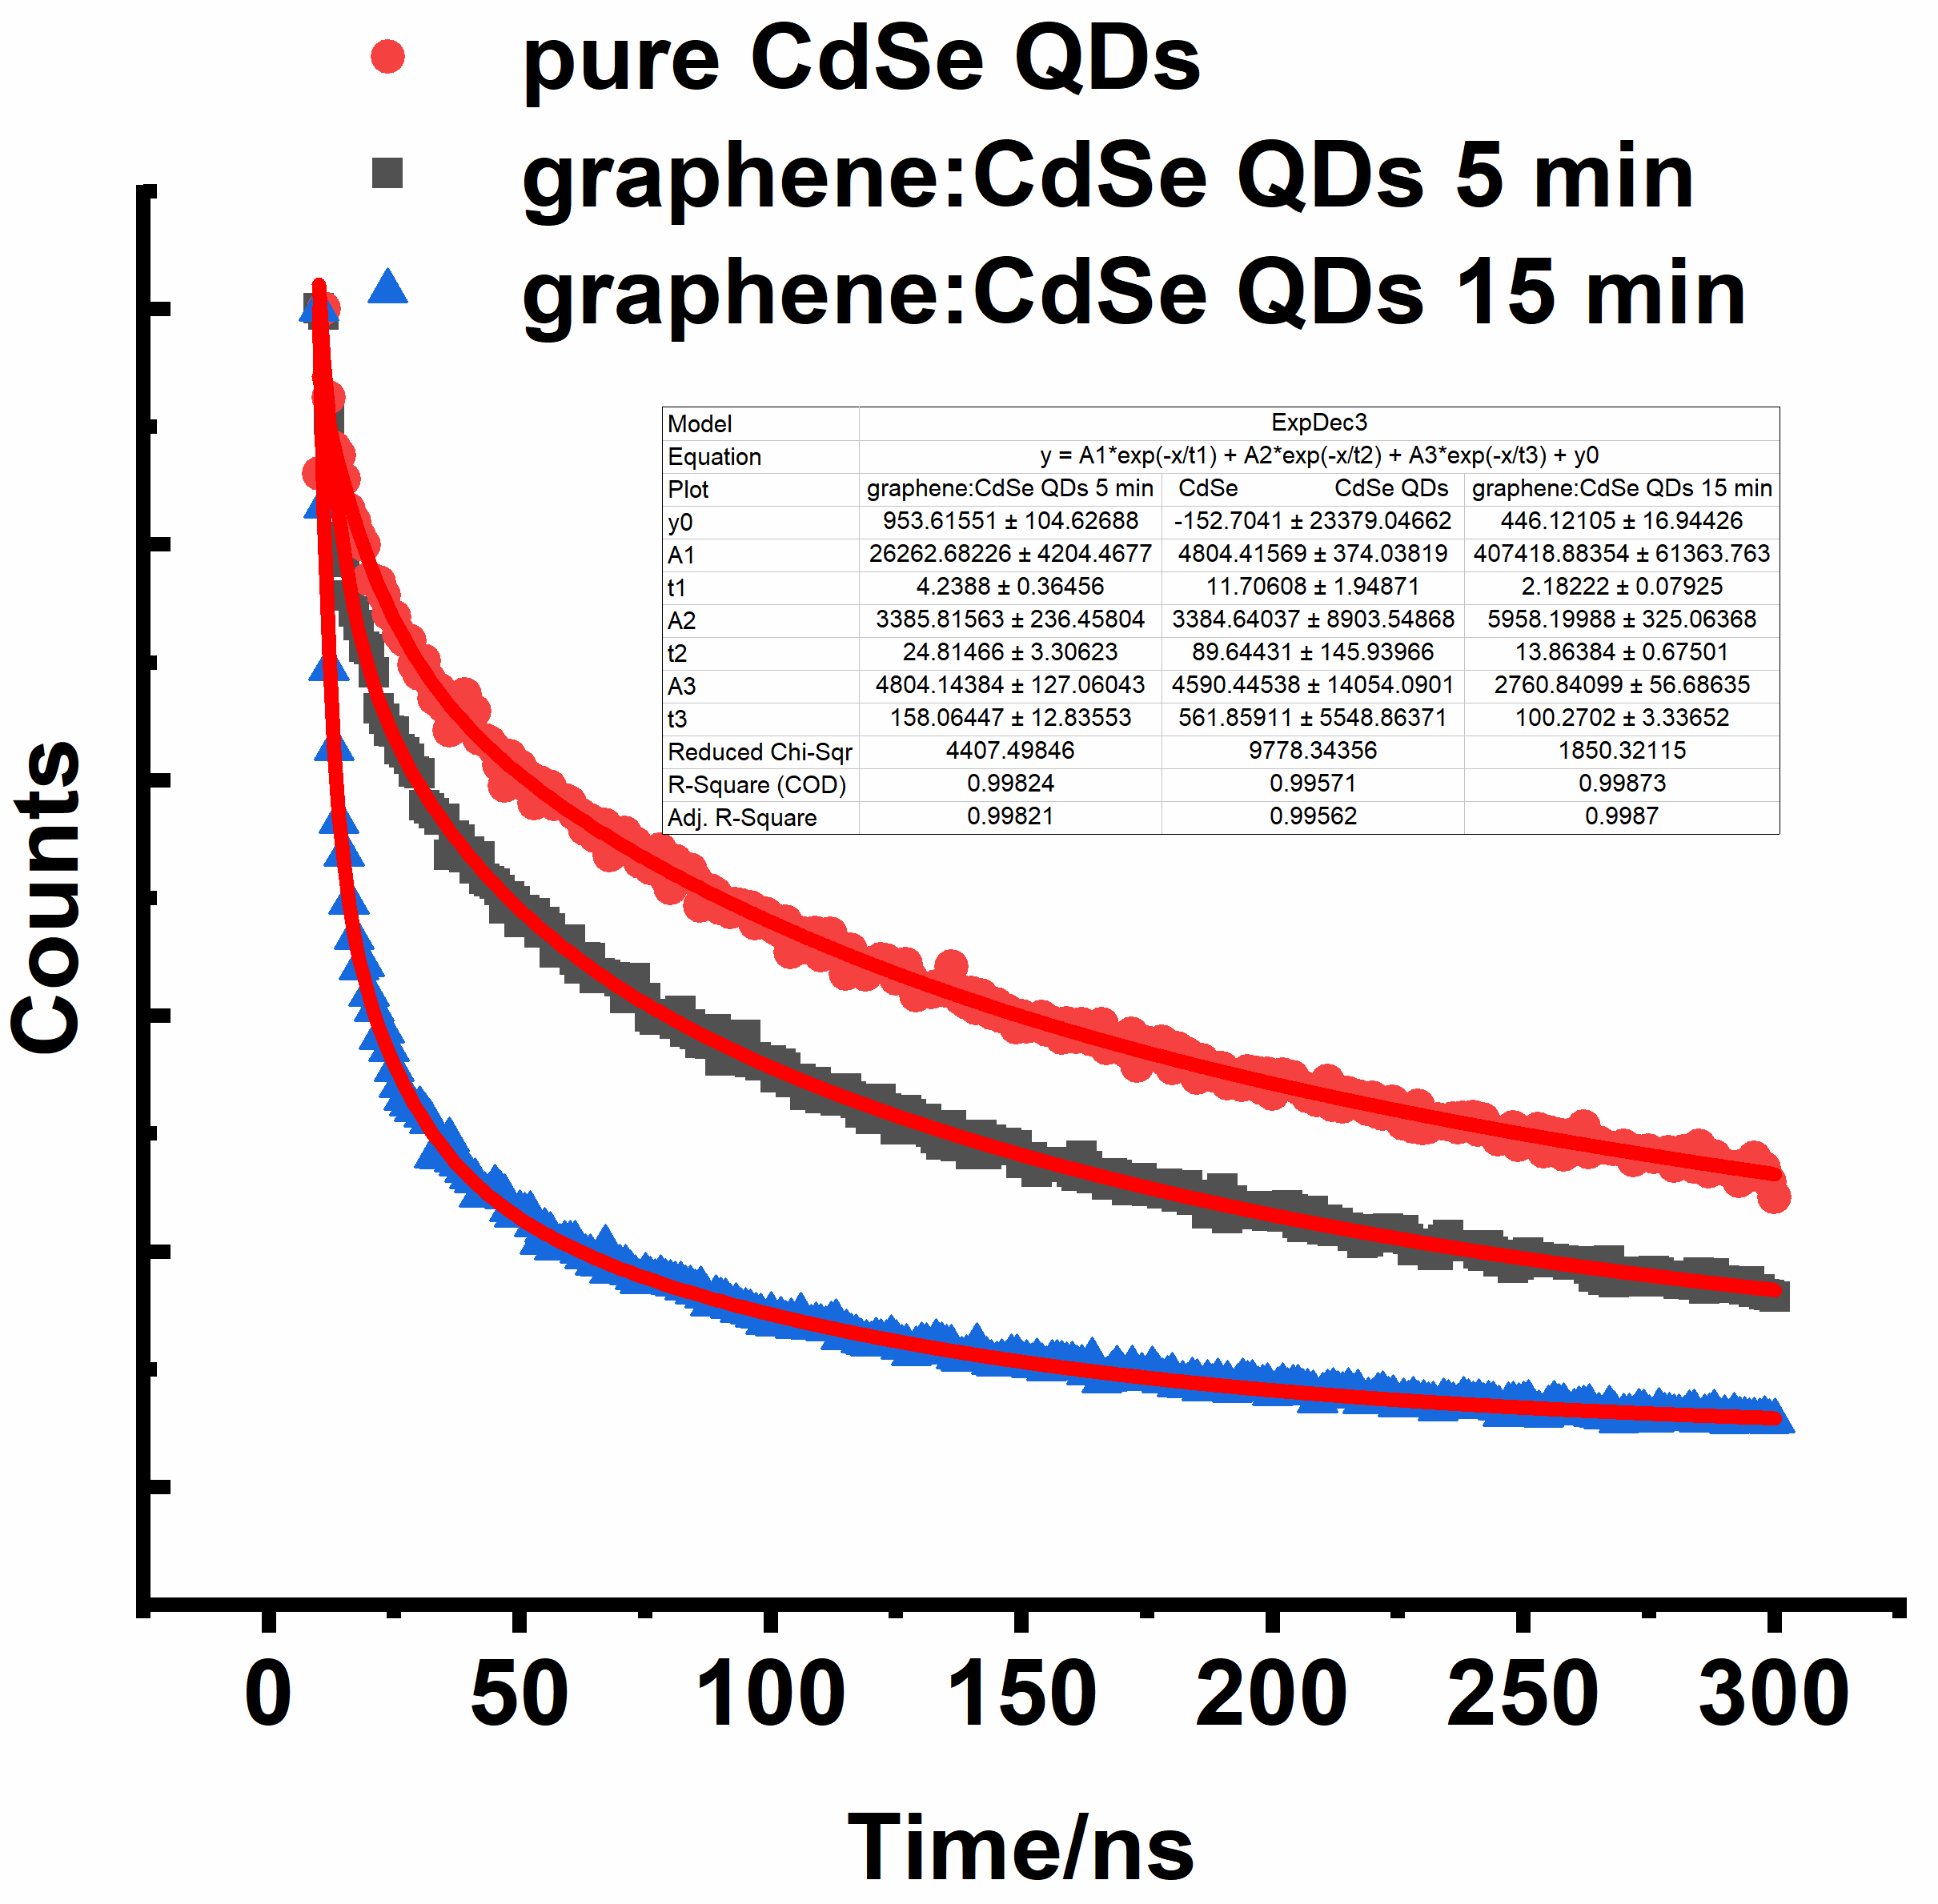

Figure.S3 Comparison of time-resolved photoluminescence (TRPL) kinetics spectrograms of pure CdSe QDs, graphene: CdSe QDs synthesized for 5 min and graphene: CdSe QDs synthesized for 15 min.

Table S1 Summary of the key kinetic parameters obtained from exponential fittings to the measured PL decay curve.
samples | τ₁ | τ ₂ | τ ₃ | < τ>
CdSe QDs | 11.70608 ± 1.94871 | 89.64431 ± 145.93966 | 561.85911 ± 5548.86371 | 557.9
Graphene: CdSe QDs  5 min | 4.2388 ± 0.36456 | 24.81466 ± 3.30623 | 158.06447 ± 12.83553 | 128.34
Graphene: CdSe QDs  15 min | 2.18222 ± 0.07925 | 13.86384 ± 0.67501 | 100.2702 ± 3.33652 | 82.77

The obtained decay curves were fitted by a tri-exponential decay model;
$I\left(t\right)=A_{1}e^{{-t}/{τ_{1}}}+A_{2} e^{{-t}/{τ_{2}}}+A_{3 } e^{{-t}/{τ_{3}}}$, where I(t) is the time-dependent fluorescence intensity, A is the amplitude, and τ is the lifetime. The excitation wavelength is 585 nm. Intensity weighted average lifetime, ‹τ_{ave}› is defined as $‹τ_{ave}› ={\sum_{i}{A_{i }τ_{i}^{2}}}/{\sum_{i}{A_{i}}}τ_{i}$.

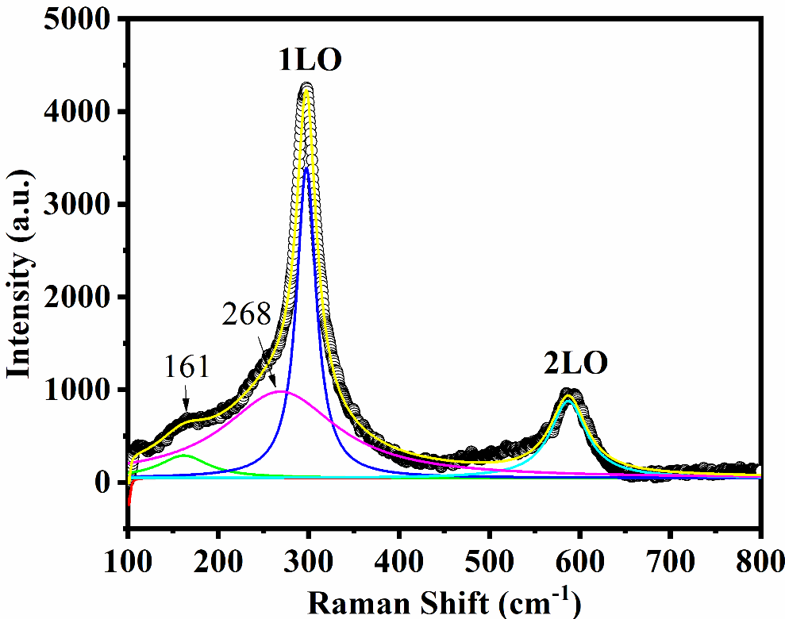
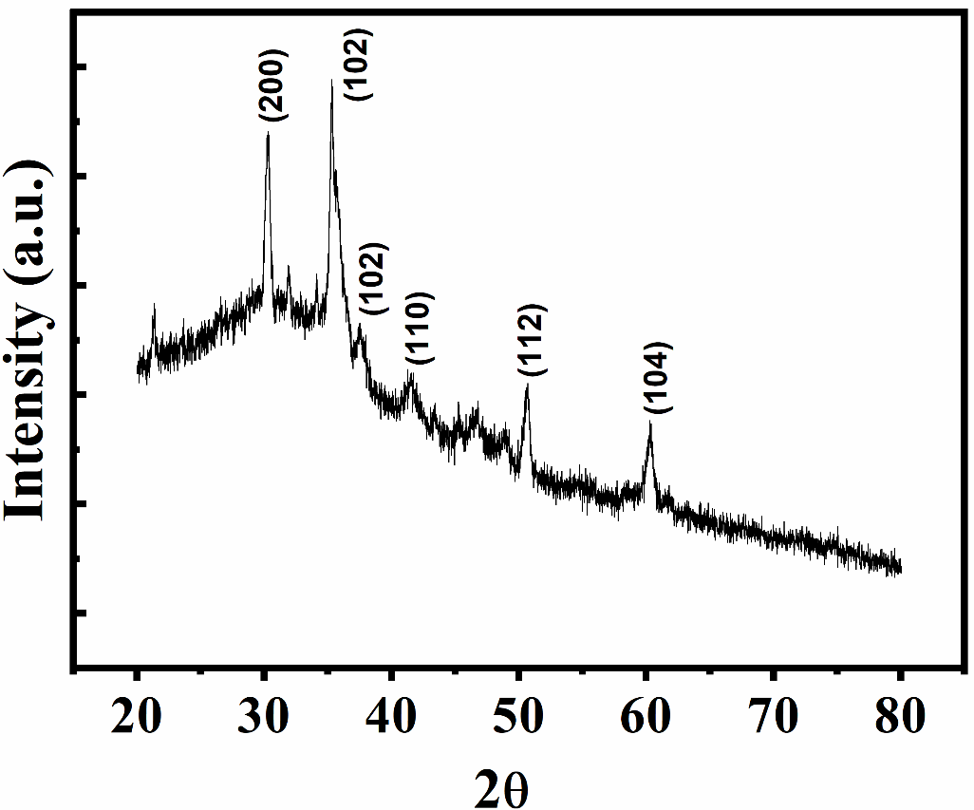
Figure.S5 Raman Spectra of CdS nanorods. In order to interpret the data,the spectrum was fitted with gaussian peak profile. It is shown that 1LO and 2LO phonon modes are observed at 298 cm⁻¹ and 587 cm⁻¹ respectively. In addition to the LO phonons and its replicas, so other peaks are also found at 101 cm⁻¹ ,162 cm⁻¹ , 268 cm⁻¹, suggesting that the nanorods have better crystal quality.
Figure.S4 XRD pattern of CdS nanorods. The XRD pattern exhibits prominent, broad peaks at 2θ values of 31.5, 35.2°, 41.6°, 50.7°, 60.4° which could be indexed to scattering from 200, 102, 102,110,112 and 104 planes respectively.

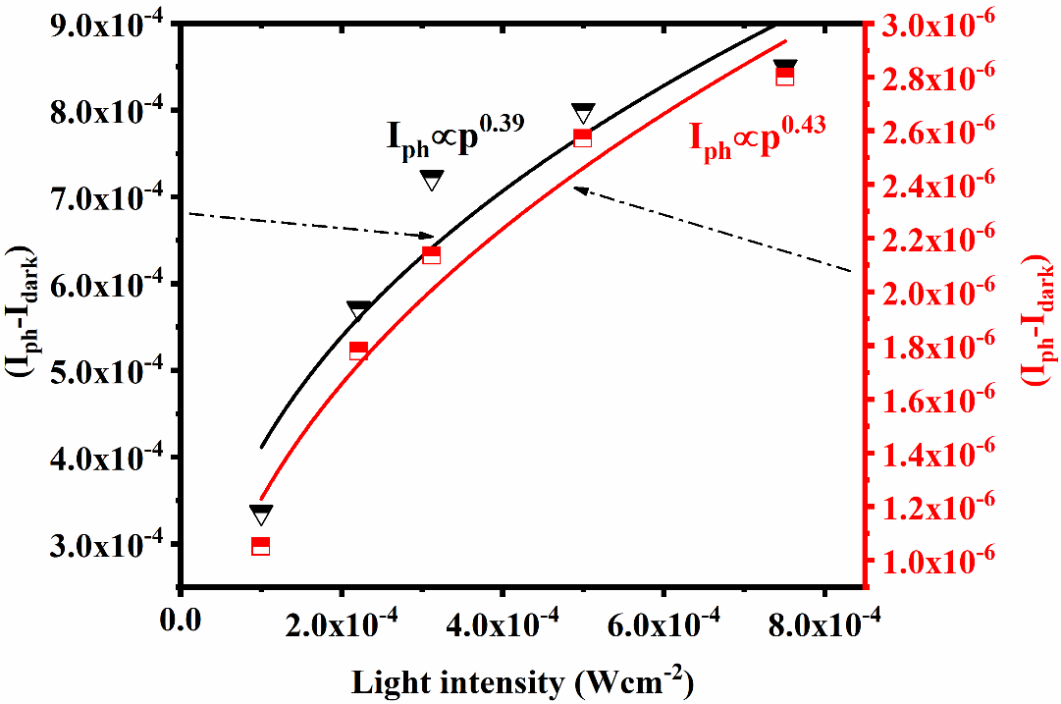
Figure.S6 Photocurrent as a function light intensity. The dependence of photocurrent on light intensity can be fitted by a simple power law equation: I_{ph}= AP^{α}, where I_{ph} is the photocurrent, A is a scaling constant, P is the light power, and α is an exponent.

Table.S2 summary of PL peak positions and FWHM value of PL peak for CdSe QDs and Graphene:CdSe QDs.
Growth time | CdSe QDs |  | Graphene: CdSe QDs
 | PL peak (nm) | FWHM (nm) | PL peak (nm) | FWHM (nm)
5min | 510 | 33 | 512 | 36
10 min | 512 | 34 | 518 | 37
15 min | 523 | 43 | 526 | 36
20 min | 530 | 37 | 533 | 36
30 min | 535 | 32 | 543 | 31

