Studies on Organic Mediated Synthesis of Y₂O₃:Eu³⁺ Nanophosphors and its Temperature Dependent Photoluminescence Properties
S. R. Abhila, Veena Lalan, T. S. Sreena, G. Dhanu Krishna, K. G Gopchandran*
Department of Optoelectronics, University of Kerala, Thiruvananthapuram 695 581, India

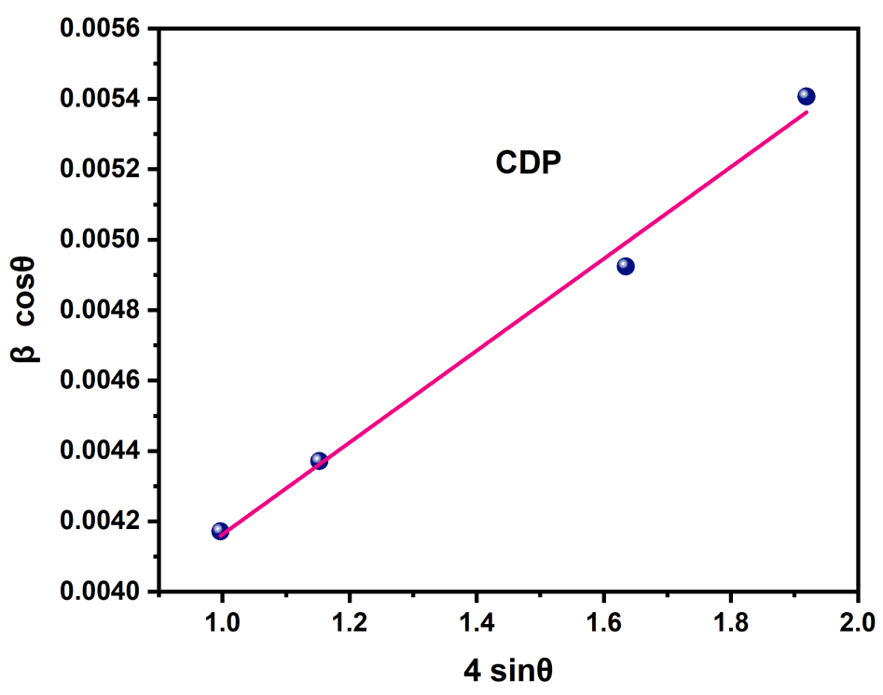
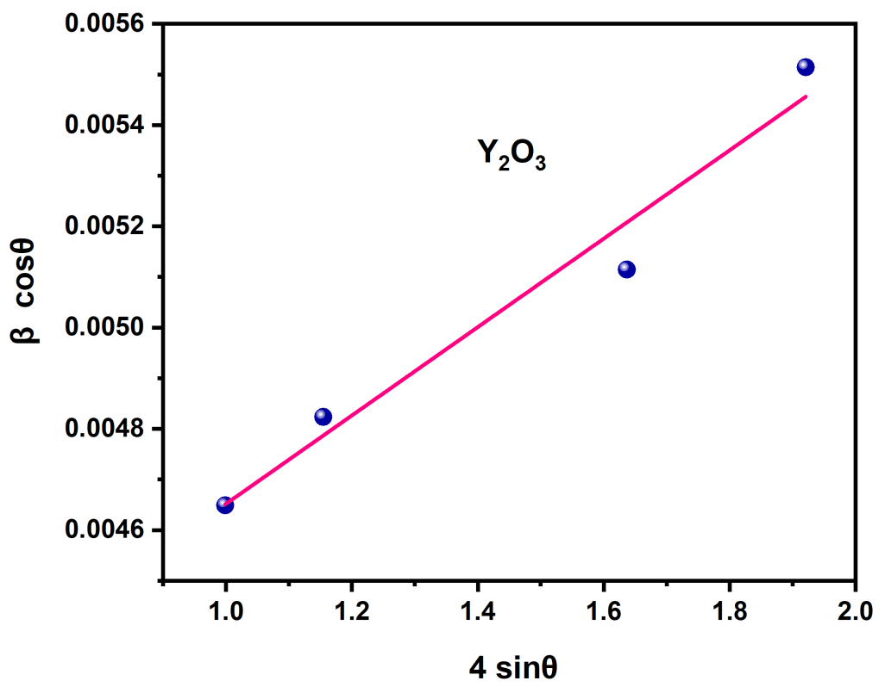
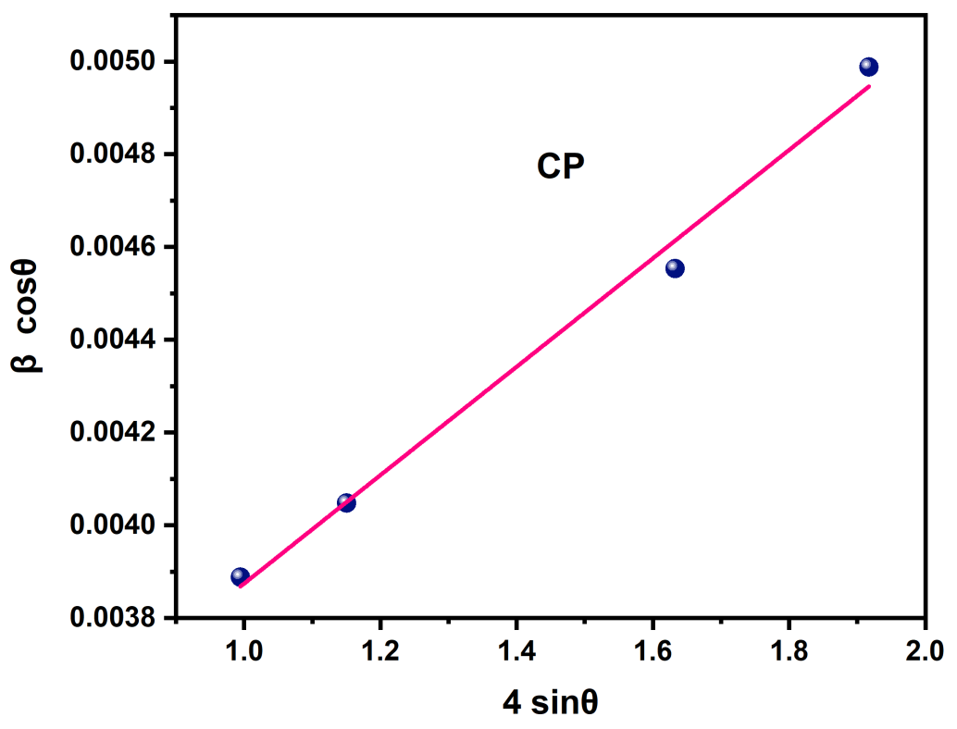

Fig. S1 W-H plot of Y₂O₃ and Y₂O₃: Eu³⁺ nanophosphors (CP and CDP)

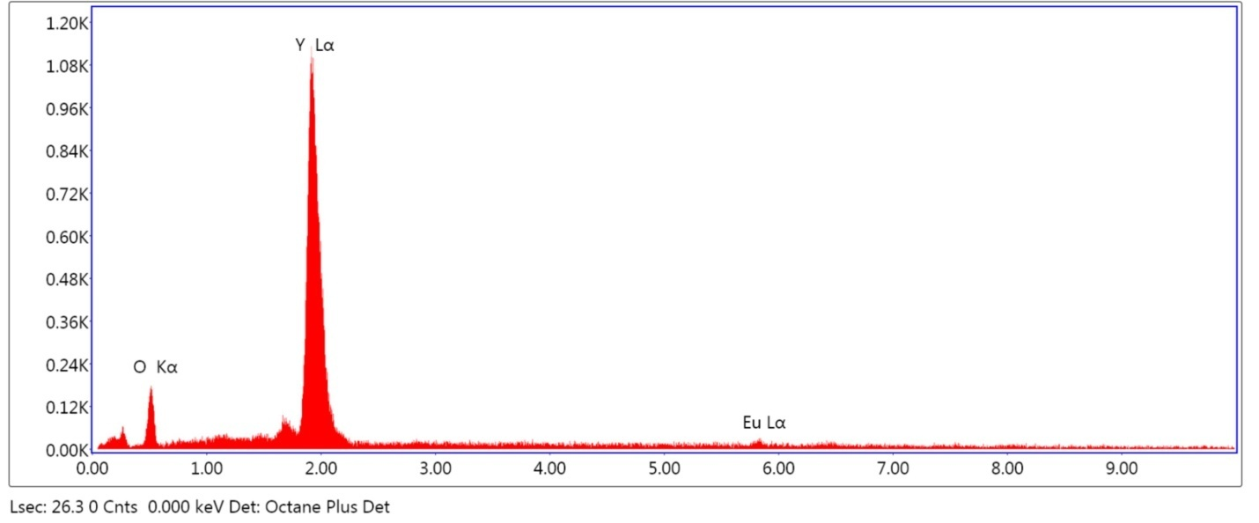
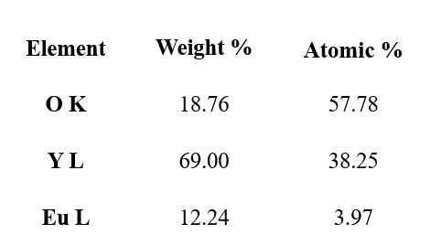
CP

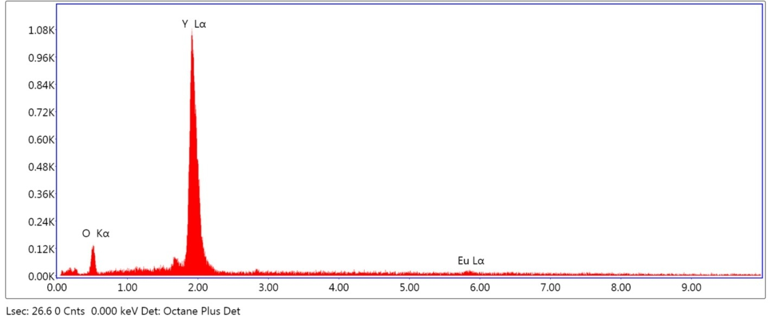
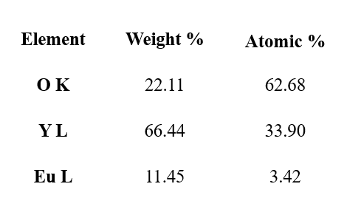
CDP

Fig. S2 Energy Dispersive Spectra of Y₂O₃:Eu³⁺ nanophosphors (CP and CDP)

