Supporting Information
Effect of potassium permanganate（KMnO₄） on sludge dewaterability under different pH conditions

Text S1: Detailed measurement methods of SRF
Sludge dewaterability was determined by measuring the SRF, using standard methods described in Qi et al. [1]. The SRF was determined using Eqs. (1) .Volume of filtrate was recorded every 10 s before surface cracking was observed.
$SRF=\frac{2PA^{2}}{μ}∙ω∙α$ (1)
Where in Eq. (1) P (kg/m³) is the pressure of filtration; A (m²) is the area of filtration; μ is the viscosity of the filtrate (Pa•s); ω (kg/m³) is the mass of cake solids deposited per volume of filtrate; α is the slope of the linear plot of t/V versus V. V (m³) is the volume of filtrate; and t (s) is the filtration time.
Text S2: EPS extraction protocols
Sludge sample (50 mL) was centrifuged at 6000rpm for 5 min, and then the supernatant can be collected as soluble EPS (S-EPS). The remaining pellets were then resuspended to 50 mL by adding preheated 0.05 wt.% NaCl solution (70 ℃). Subsequently, the sludge mixture was then shaken at 150rpm for 10min, followed by centrifugation at 6000rpm for 10 min, and the supernatant was loosely bound EPS (LB-EPS). Subsequently, the pellets was resuspended using 0.05% NaCl solution (70 ℃) and heated in a water bath at 80 ℃ for 30 min, followed by 150rpm for 10min at shaker. Eventtully, the mixture was centrifuged at 6000rpm for 15 min, and then supernatant can be collected as the tightly bound EPS (TB-EPS).

Text S3:Heavy Metal
The above sludge samples were dried in an oven at 105°C for 12 hours and then ground through a 100-mesh sieve. 0.2500g was weighed into a polytetrafluoroethylene plastic crucible, and 10ml of superior pure concentrated nitric acid was soaked for 24 hours. Heating on an electric hot plate for 30 minutes, the brown-yellow smoke produced at this time is a sample of nitric acid oxidation. When the brown-yellow smoke fades, add a little deionized water and hydrogen peroxide after cooling, and heat for oxidation reaction. No more than 10 ml), until no violent reaction, continue to heat until the remaining 5 ml dissolve, add 10 ml of hydrochloric acid after cooling, cover and heat for 30 minutes, add a small amount of deionized water after cooling, heat and boil until the solution remains 10 ml, After cooling, transfer it to a 25 ml colorimetric tube, dilute it to the mark with deionized water, shake it to a constant volume, let it stand for clarification, and take the supernatant on the machine for testing.

Text S4: Detailed descriptions of free radical
To determine the generation of .O₂⁻, an electron paramagnetic resonance spectrometer (EPR, A300, Bruker, Germany) was used. The sludge supernatant that filtered through the 0.45μm filter membrane was used as the reaction system and the 5,5-dimethyl-1-pyrroline N-oxide (DMPO) was used as the capture agent. The .O₂⁻was quenched with 0.1 M ethanol (EtOH) (quenching of·.O₂⁻), and the .O³⁻ was quenched with 0.1 M tert-butanol (TBA) (quenching of .O₂⁻) in quenching experiments.
As all of known that EPR usually is convinced to clealy express electronic transfer.Works emploied pH/KMnO4 in the dewaterability of sludge,and common intermediate state is Mn(III) in Mn oxides. As can be seen in Fig9(a) the EPR test showed that characteristic spectra with relative intensities of four peak of the peak of 1,2,4,6 performing strengenth,and the peak of 3,5 performing weaken.Mn(III) has been known as extremely active site among the Mn oxides,and intensely determines the oxidation of Mn oxides.As KMnO4 concentration increased that the signal of EPR was obviously increased after 2 minutes,10 minutes traetment in Fig.9. A sharp upward trend appeared after 2 min of reaction, indicating that the pH/KMnO4 combination is highly oxidative and can rapidly cleave the EPS structure resulting in the release of bound water.It clealy shown that O₂^{·-} had been formed，which played a major role in oxidation ability for pH/KMnO4 treatment.In this result claimed that the degradation of EPS and improvement of sludge dewaterability were impacted by free radicals that was generated in pH/KMnO4 process.

Text S5:Weight Loss
The weight loss was utilized to represent the dewaterability of sludge, and the effects of various pH and KMnO₄ dosageson improving sludge dewatering were discussed, as displayed in Fig.S2(a) ,(b),(c)and(d).When only adjust pH, filtrate can be quickly filtered out after vacuum filtration. It has been found that filtrate was the fastest effluence at pH=5,followlled by pH=7,then pH=3 and finally by raw slugde in FigS2. It can be found from Figure S2(a) that the addition of potassium permanganate cannot make the dehydration of the sludge faster under the condition of the original sludge, and the overall change is relatively consistent, and the weight loss is about 28 grams; After pH, there were obvious changes, and there were also obvious differences between the groups.As the addition of potassium permanganate,the filtrate gradually increased and the filtration rate increased sharply. Especially with the 20 mg/g TS KMnO₄ conditioning in pH=3,the weight loss was rapidly incrasing,however other three group were steady incrasement. It can be seen in Fig. S2(b)(c)(d) that the dewatering amount of the sludge is higher than that of the original sludge and the difference between the groups is also obvious, which shows that the potassium permanganate after pH adjustment It has a significant effect on sludge dewatering. It can be seen in Fig. S2(b)(c) that under the conditions of pH=5, 7 (KMnO4 content (0, 5, 10, 20 mg/g TS)), with time increases the dehydration of sludge is increasing steadily, from 0 g to about 40 g in about 350 s. In Figure S2(d), under the condition of pH=3 (the content of KMnO4 (0, 5, 10, 20 mg/g TS)), there is a sharp increase, from 0 g to about 40 g, which only took about 90 s.It was fully demonstrating the synergy between pH adjustment and KMnO4.Particularly,for raw sludge, it was little effect at different dose of KMnO4. However, KMnO4 played a strong oxidation role after pH adjustment. It may be safely said that weight loss sharply incraese owing to EPS struction was severely damage,so bound water was efflunce. Therefore,the dewaterability of sludge was strengthened.

Text S6:3D-EEM
However, in order to intuitive show the alterations of organic compounds, 3D-EEM PARAFAC was applied and the results are shown in Figure S3. It can be seen from the figure that the three component can be divided into peakA: ex/em:250/280nm,peakB: ex/em:245/270nm,peakC: ex/em:215/300nm, peakD:ex/em:275/340nm by peak intensity. They are tryptophan protein (ex/em:250/280nm) that was compotment 1 (C1), tyrosine protein (ex/em:245/270nm) that was compotment 2(C2), and microbial product-like materials (ex/em:215/300nm, ex/em:275/340nm) that was compotment 3(C3). Generally, it is out to be that pH/KMnO4 alter EPS element of sludge, and the powerful oxidation of KMnO4 actually destroyed EPS structure, and bound water can be effluent.

Table S1. The basic characteristics of the raw sludge

Indicator | Value
pH | 7.80
Total solids (TS, g/L) | 41.46
Capillary suction time (CST, s) | 167.2
Water content (Wt, %) | 95.8
Zeta potential (mV) | -11.4

Table S2. Five Ex/Em regions for FRI analysis
Region | Ex/Em (nm) | Fluorescence substances
Ⅰ | 200-250/280-330 | Aromatic-like proteins
Ⅱ | 200-250/330-380 | Tyrosine/tryptophan protein
Ⅲ | 200-250/380-500 | Fulvic acid-like materials
Ⅳ | 250-400/280-380 | Soluble microbial byproduct-like materials (SMBP)
Ⅴ | 250-400/380-500 | Humic acid-like materials

Table S4 Band assignments for the FT-IR spectra of the different EPS layers
Band assignment |  | Wavenumber (cm⁻¹)
 |  | RAW | pH=3 | pH/ KMnO₄
S-EPS | O–H stretching | 3292 | 3412 | 3449
 | C–H stretching of CH₂ | - | -
 | C=O stretch (amide I) | 1565 | 1600 | 1630
 | N–H, C–N stretches (amide II) | - | - | -
 | C–O stretching of COO–groups | 1412 | 1412 | 1412
 | C–OH, C–O, C–O amino acids | - | - | -
 | C–O–C ring vibrations | - | - | -
LB-EPS | O–H stretching | 3416 | 3391 | 3437
 | O–H stretching | - | - | -
 | O–H stretching | - | - | -
 | C–H stretching vibrations | - | - | -
 |  | - | - | 2176
 | C=O stretching (amide I) | 1647 | 1602 | 1600
 | C–O stretching of COO– groups (amide II) | 1405 | 1412 | 1412
 | C–O–C ring vibrations | 1078 | 1078 | 1078
TB-EPS | O–H stretching | 3195 | 3412 | 3388
 | C=O stretch (amide I) | 1640 | 1647 | 1650
 | N–H and C–N stretches in  –CO–NH– of proteins | - | - | -
 | C–O stretching of COO– groups | 1406 | 1412 | 1414
 | C–O–C ring vibrations | 1075 | - | -

Figuer S1: Weight Loss

Fig.2(a),(b),(c),(d)under different acidic conditions and different concentrations of potassium permanganate of Weight Loss

Figuer S2: Free radicals

Fig.S2 (a) under different acidic conditions and different concentrations of potassium permanganate of free radical in 2 minutes;(b) under different acidic conditions and different concentrations of potassium permanganate of free radical in 10 minutes

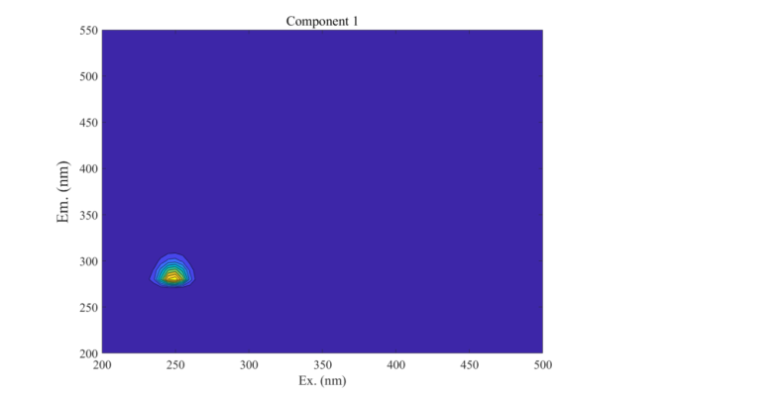
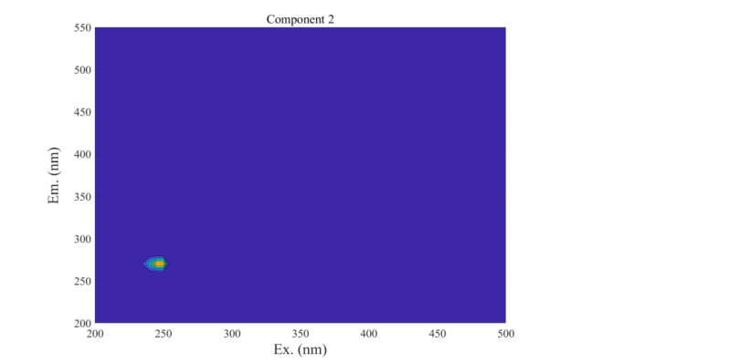
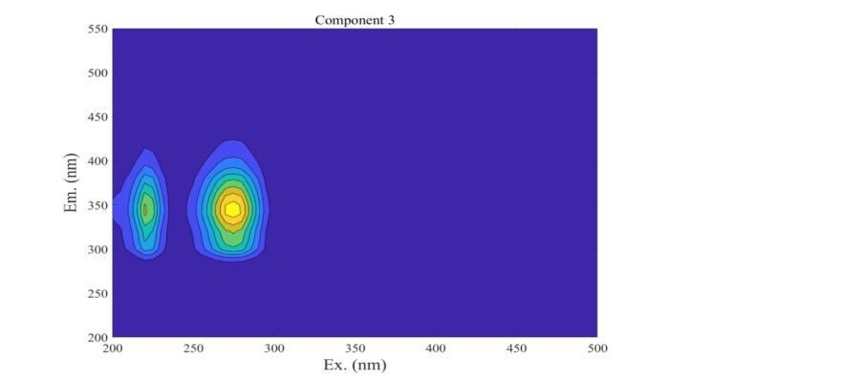
Figuer S3: 3D Fluorescence Parallel Factor

Figuer S4:3D-EEM
RAW LB-EPS,TB-EPS
pH=3 LB-EPS,TB-EPS
pH=5 S-EPS;LB-EPS;TB-EPS
pH=7 S-EPS;LB-EPS;TB-EPS
Fig.S5 Protein and polysaccharide contents

