Supplementary Tables

Table S1. Descriptive statistics for key variables
Variable | N | Mean | Std. Dev. | Min | Max
Nutrition outcomes
Wasting (WHZ<-2) | 1,271,886 | 0.13 | 0.33 | 0 | 1
Severe Wasting (WHZ<-3) | 1,271,886 | 0.05 | 0.22 | 0 | 1
Stunting (HAZ <-2) | 1,254,633 | 0.35 | 0.48 | 0 | 1
Severe Stunting (HAZ <-3) | 1,254,633 | 0.15 | 0.35 | 0 | 1
National-level indicators
Real food inflation, last 3 months | 1,271,886 | -0.10 | 2.24 | -10.67 | 13.71
Real food inflation, last 12 months | 1,271,886 | 0.25 | 3.10 | -10.32 | 19.96
Individual, mother, household indicators
Household owns no DHS assets (asset-poor) | 1,271,886 | 0.26 | 0.44 | 0 | 1
Household owns some (< 5 y) assets | 1,271,886 | 0.63 | 0.48 | 0 | 1
Household owns all 5 assets | 1,271,886 | 0.11 | 0.31 | 0 | 1
Mother has 9 or more years of schooling | 1,271,886 | 0.32 | 0.47 | 0 | 1
Household has piped water | 1,271,886 | 0.39 | 0.49 | 0 | 1
Household has flush toilet | 1,271,886 | 0.35 | 0.48 | 0 | 1
Child born in medical facility | 1,271,886 | 0.66 | 0.47 | 0 | 1
Mother received 4 or more ANC visits | 1,271,886 | 0.70 | 0.46 | 0 | 1
Child received all vaccinations | 1,271,886 | 0.42 | 0.49 | 0 | 1
Teenage mother (at birth) | 1,271,886 | 0.17 | 0.38 | 0 | 1
Mother has 4 or more children | 1,271,886 | 0.34 | 0.47 | 0 | 1
Household is rural | 1,271,886 | 0.70 | 0.46 | 0 | 1
Child is girl | 1,271,886 | 0.49 | 0.50 | 0 | 1
Household owns farmland | 1,049,200 | 0.54 | 0.50 | 0 | 1
Poor diet in past 24 hours (<4 of 7 foods) | 327,522 | 0.71 | 0.55 | 0 | 1
Diarrhea in past 2 weeks | 1,265,488 | 0.13 | 0.33 | 0 | 1
Fever in past 2 weeks | 1,257,720 | 0.20 | 0.40 | 0 | 1
Source: Authors’ estimates. See text for details on sources.

Table S2. Summary statistics for additional country level control variables used in robustness tests
Variable | N | Mean | Std. dev. | Min | Max
Growth in broad money (%) | 125 | 15.95 | 10.70 | -9.30 | 69.08
Battle deaths per 100,000 people | 129 | 107.55 | 324.23 | 0.00 | 1817.00
Growth in GDP per capita (%) | 130 | 0.00 | 0.00 | -0.01 | 0.02
Growth in food production (%) | 130 | 0.04 | 0.07 | -0.23 | 0.31
Growth in terms of trade (%) | 130 | 0.03 | 0.09 | -0.39 | 0.32
Source: Authors’ estimates. See text for details on sources.
Table S3. Mean prevalence of wasting and stunting prevalence by DHS round
Country | Survey start | Survey end | Mod/severe wasting | Mod/severe stunting
Albania | 2008 | 2009 | 10.0% | 23.9%
Albania | 2017 | 2018 | 2.2% | 12.6%
Armenia | 2005 | 2005 | 5.3% | 15.5%
Armenia | 2010 | 2010 | 4.2% | 22.2%
Armenia | 2015 | 2016 | 5.3% | 10.4%
Bangladesh | 2004 | 2004 | 14.6% | 49.6%
Bangladesh | 2007 | 2007 | 17.2% | 41.6%
Bangladesh | 2011 | 2011 | 15.9% | 40.6%
Bangladesh | 2014 | 2014 | 14.7% | 36.6%
Bangladesh | 2017 | 2018 | 8.8% | 31.3%
Benin | 2001 | 2001 | 9.9% | 38.6%
Benin | 2006 | 2006 | 9.0% | 43.4%
Benin | 2011 | 2012 | 17.5% | 47.0%
Benin | 2017 | 2018 | 5.3% | 32.9%
Bolivia | 2003 | 2003 | 2.2% | 33.5%
Bolivia | 2008 | 2008 | 1.7% | 26.4%
Burkina Faso | 2003 | 2003 | 24.1% | 42.9%
Burkina Faso | 2010 | 2010 | 16.0% | 34.2%
Burundi | 2010 | 2010 | 6.2% | 55.2%
Burundi | 2016 | 2017 | 5.1% | 54.5%
Cambodia | 2005 | 2005 | 8.6% | 44.8%
Cambodia | 2010 | 2010 | 12.0% | 40.1%
Cambodia | 2014 | 2014 | 10.3% | 32.6%
Cameroon | 2004 | 2004 | 6.2% | 35.2%
Cameroon | 2011 | 2011 | 5.9% | 31.7%
Cameroon | 2018 | 2019 | 4.1% | 28.3%
Chad | 2004 | 2004 | 18.4% | 42.7%
Chad | 2014 | 2015 | 15.1% | 42.9%
Colombia | 2005 | 2005 | 2.1% | 15.7%
Colombia | 2010 | 2010 | 1.1% | 14.5%
Congo, Rep. | 2005 | 2005 | 8.4% | 28.8%
Congo, Rep. | 2011 | 2012 | 5.7% | 26.8%
Congo (DRC) | 2007 | 2007 | 11.0% | 45.0%
Congo (DRC) | 2013 | 2014 | 8.7% | 44.0%
Dominican Rep. | 2002 | 2002 | 2.3% | 12.3%
Dominican Rep. | 2007 | 2007 | 2.2% | 11.4%
Dominican Rep. | 2013 | 2013 | 2.6% | 7.6%
Egypt | 2003 | 2003 | 5.1% | 20.1%
Egypt | 2005 | 2005 | 5.7% | 27.2%
Egypt | 2008 | 2008 | 8.3% | 29.7%
Egypt | 2014 | 2014 | 13.0% | 20.1%
Ethiopia | 2008 | 2016 | 12.4% | 36.4%
Ethiopia | 2011 | 2011 | 12.1% | 42.3%
Ghana | 2003 | 2003 | 9.6% | 36.1%
Ghana | 2008 | 2008 | 10.0% | 27.9%
Ghana | 2014 | 2014 | 5.1% | 19.2%
Guinea | 2005 | 2005 | 11.4% | 38.8%
Guinea | 2012 | 2012 | 11.3% | 30.7%
Guinea | 2018 | 2018 | 9.4% | 30.6%
Haiti | 2005 | 2006 | 9.7% | 29.5%
Haiti | 2012 | 2012 | 5.3% | 22.3%
Haiti | 2016 | 2017 | 3.8% | 21.4%
Honduras | 2005 | 2006 | 1.5% | 35.1%
Honduras | 2011 | 2012 | 1.5% | 25.4%
India | 2005 | 2006 | 19.2% | 43.5%
India | 2015 | 2016 | 21.1% | 38.1%
India | 2019 | 2021 | 18.6% | 35.9%
Jordan | 2002 | 2002 | 2.5% | 13.2%
Jordan | 2007 | 2007 | 9.1% | 16.1%
Jordan | 2009 | 2009 | 1.7% | 10.2%
Jordan | 2012 | 2012 | 2.4% | 8.8%
Kenya | 2003 | 2003 | 7.6% | 34.5%
Kenya | 2008 | 2009 | 8.9% | 34.2%
Kenya | 2014 | 2014 | 5.8% | 27.1%
Lesotho | 2004 | 2004 | 6.1% | 44.2%
Lesotho | 2009 | 2010 | 4.8% | 39.4%
Lesotho | 2014 | 2014 | 3.8% | 34.5%
Liberia | 2007 | 2007 | 8.3% | 38.3%
Liberia | 2013 | 2013 | 6.9% | 31.1%
Malawi | 2004 | 2004 | 6.9% | 52.3%
Malawi | 2010 | 2010 | 4.5% | 46.6%
Malawi | 2015 | 2016 | 3.4% | 35.5%
Maldives | 2009 | 2009 | 12.3% | 19.0%
Maldives | 2016 | 2017 | 9.5% | 15.1%
Mali | 2001 | 2001 | 13.7% | 42.1%
Mali | 2006 | 2006 | 17.2% | 38.1%
Mali | 2012 | 2013 | 14.0% | 37.5%
Mali | 2018 | 2018 | 9.8% | 27.5%
Mozambique | 2003 | 2003 | 5.3% | 45.4%
Mozambique | 2011 | 2011 | 5.7% | 39.5%
Namibia | 2006 | 2007 | 8.5% | 29.1%
Namibia | 2013 | 2013 | 8.8% | 22.4%
Nepal | 2006 | 2006 | 12.8% | 50.1%
Nepal | 2011 | 2011 | 10.9% | 41.5%
Nepal | 2016 | 2016 | 9.8% | 36.0%
Niger | 2006 | 2006 | 13.1% | 49.5%
Niger | 2012 | 2012 | 19.3% | 41.9%
Nigeria | 2003 | 2003 | 12.3% | 41.8%
Nigeria | 2008 | 2008 | 16.5% | 42.2%
Nigeria | 2013 | 2013 | 17.7% | 35.9%
Nigeria | 2018 | 2018 | 6.9% | 36.1%
Pakistan | 2012 | 2013 | 11.0% | 45.3%
Pakistan | 2017 | 2018 | 9.3% | 39.3%
Peru | 2003 | 2008 | 1.0% | 29.9%
Peru | 2009 | 2009 | 0.8% | 27.0%
Peru | 2010 | 2010 | 0.8% | 25.5%
Peru | 2011 | 2011 | 0.6% | 23.1%
Peru | 2012 | 2012 | 0.7% | 21.0%
Rwanda | 2005 | 2005 | 4.9% | 49.9%
Rwanda | 2010 | 2010 | 3.1% | 43.8%
Rwanda | 2014 | 2015 | 2.4% | 37.6%
Senegal | 2005 | 2005 | 9.6% | 20.8%
Senegal | 2010 | 2011 | 10.2% | 30.5%
Senegal | 2012 | 2013 | 10.6% | 20.2%
Senegal | 2014 | 2014 | 7.0% | 21.6%
Senegal | 2015 | 2015 | 8.3% | 22.0%
Senegal | 2016 | 2016 | 7.6% | 19.1%
Senegal | 2017 | 2017 | 9.6% | 19.2%
Senegal | 2019 | 2019 | 9.2% | 19.5%
Sierra Leone | 2008 | 2008 | 12.3% | 34.8%
Sierra Leone | 2013 | 2013 | 10.5% | 37.7%
Sierra Leone | 2019 | 2019 | 5.8% | 30.1%
Tajikistan | 2012 | 2012 | 10.5% | 25.2%
Tajikistan | 2017 | 2017 | 6.7% | 18.4%
Tanzania | 2004 | 2005 | 4.5% | 42.7%
Tanzania | 2010 | 2010 | 6.9% | 39.9%
Tanzania | 2015 | 2016 | 5.1% | 33.5%
Timor-Leste | 2009 | 2010 | 20.8% | 56.6%
Timor-Leste | 2016 | 2016 | 25.7% | 46.1%
Uganda | 2000 | 2001 | 5.7% | 44.9%
Uganda | 2006 | 2006 | 7.0% | 38.4%
Uganda | 2011 | 2011 | 5.8% | 32.5%
Uganda | 2016 | 2016 | 4.0% | 28.4%
Zambia | 2001 | 2002 | 6.4% | 53.2%
Zambia | 2007 | 2007 | 6.6% | 44.2%
Zambia | 2013 | 2014 | 6.9% | 39.5%
Zambia | 2018 | 2019 | 4.4% | 34.8%
Zimbabwe | 2005 | 2006 | 7.6% | 34.1%
Zimbabwe | 2010 | 2011 | 3.7% | 31.6%
Zimbabwe | 2015 | 2015 | 3.8% | 25.6%
Source: See Methods and Materials for data sources.
Table S4. Sample sizes and population shares pooled by country
Country | DHS observations | Population under-5 | Sample share | Population share
Albania | 3866 | 171,796 | 0.30% | 0.06%
Armenia | 4205 | 201,083 | 0.33% | 0.07%
Bangladesh | 34000 | 15,300,000 | 2.67% | 4.95%
Benin | 39814 | 1,558,812 | 3.13% | 0.50%
Bolivia | 17005 | 1,192,606 | 1.34% | 0.39%
Burkina Faso | 15218 | 2,842,946 | 1.20% | 0.92%
Burundi | 9534 | 1,578,653 | 0.75% | 0.51%
Cambodia | 11785 | 1,672,089 | 0.93% | 0.54%
Cameroon | 12927 | 3,462,007 | 1.02% | 1.12%
Chad | 14854 | 2,324,090 | 1.17% | 0.75%
Colombia | 28471 | 3,834,004 | 2.24% | 1.24%
Congo, Rep. | 8516 | 702,728 | 0.67% | 0.23%
Congo, DRC | 11719 | 12,100,000 | 0.92% | 3.92%
Dominican Rep. | 21963 | 989,582 | 1.73% | 0.32%
Egypt | 43689 | 9,744,422 | 3.43% | 3.15%
Ethiopia | 18738 | 14,200,000 | 1.47% | 4.59%
Ghana | 8309 | 3,587,524 | 0.65% | 1.16%
Guinea | 9345 | 1,771,639 | 0.73% | 0.57%
Haiti | 12196 | 1,263,146 | 0.96% | 0.41%
Honduras | 18973 | 1,036,071 | 1.49% | 0.34%
India | 477032 | 128,000,000 | 37.51% | 41.42%
Jordan | 20226 | 1,003,583 | 1.59% | 0.32%
Kenya | 28867 | 6,852,972 | 2.27% | 2.22%
Lesotho | 4394 | 249,721 | 0.35% | 0.08%
Liberia | 7679 | 370,759 | 0.60% | 0.12%
Malawi | 18293 | 2,632,444 | 1.44% | 0.85%
Maldives | 4771 | 33,981 | 0.38% | 0.01%
Mali | 34168 | 2,928,051 | 2.69% | 0.95%
Mozambique | 17784 | 4,176,654 | 1.40% | 1.35%
Namibia | 5592 | 288,161 | 0.44% | 0.09%
Nepal | 9987 | 3,022,827 | 0.79% | 0.98%
Niger | 8790 | 665,690 | 0.69% | 0.22%
Nigeria | 62933 | 27,700,000 | 4.95% | 8.96%
Pakistan | 6802 | 24,000,000 | 0.53% | 7.77%
Peru | 46281 | 3,004,452 | 3.64% | 0.97%
Rwanda | 11385 | 1,578,409 | 0.90% | 0.51%
Senegal | 47295 | 2,147,173 | 3.72% | 0.69%
Sierra Leone | 10703 | 1,054,666 | 0.84% | 0.34%
Tajikistan | 10564 | 987,283 | 0.83% | 0.32%
Tanzania | 23117 | 7,901,238 | 1.82% | 2.56%
Timor-Leste | 13843 | 160,956 | 1.09% | 0.05%
Uganda | 11663 | 6,266,988 | 0.92% | 2.03%
Zambia | 31231 | 2,486,008 | 2.46% | 0.80%
Zimbabwe | 13359 | 1,997,281 | 1.05% | 0.65%
Source: See Methods and Materials for data sources.
Table S5. Weighted multivariate linear probability models of severe wasting risks as a function of 5% increases in the real food price index over the past 3 months interacted with urban locality, gender, asset poverty and farmland ownership
 | (1) | (2) | (3) | (4) | (5) | (6)
Interaction variable | Poverty | Girl | Urban | Farmland | Multiple | Multiple
Sample | Full | Full | Full | Rural | Urban | Rural
Food inflation | 0.22*** | 0.23*** | 0.13* | 0.42*** | 0.22*** | -0.15***
 | (0.06 - 0.38) | (0.08 - 0.39) | (-0.01 - 0.26) | (0.31 - 0.52) | (0.09 - 0.35) | (-0.17 - -0.14)
Food inflation*urban | -0.14*** |  |  |  | -0.09**
 | (-0.22 - -0.05) |  |  |  | (-0.16 - -0.02)
Food inflation*girl |  | -0.12*** |  |  | -0.12*** | -0.15***
 |  | (-0.15 - -0.08) |  |  | (-0.15 - -0.09) | (-0.17 - -0.14)
Food inflation*asset-poor |  |  | 0.19** |  | 0.17** | 0.36***
 |  |  | (0.03 - 0.36) |  | (0.01 - 0.32) | (0.26 - 0.47)
Food inflation*farmland |  |  |  | -0.17*** |  | -0.17***
 |  |  |  | (-0.24 - -0.11) |  | (-0.24 - -0.11)
Urban locality |  |  |  | -0.00 |  | -0.00
 |  |  |  | (-0.01 - 0.00) |  | (-0.01 - 0.00)
Girl child | 0.03*** | 0.03*** | 0.03*** | 0.03*** | 0.03*** | 0.04***
 | (0.02 - 0.03) | (0.02 - 0.03) | (0.02 - 0.04) | (0.03 - 0.04) | (0.02 - 0.04) | (0.03 - 0.05)
Asset-poor | 0.01*** | 0.01*** | 0.01*** |  | 0.01***
 | (0.00 - 0.01) | (0.00 - 0.01) | (0.00 - 0.01) |  | (0.00 - 0.01)
Farmland ownership | -0.02*** | -0.02*** | -0.02*** | -0.02*** | -0.02*** | -0.02***
 | (-0.02 - -0.01) | (-0.02 - -0.01) | (-0.02 - -0.01) | (-0.02 - -0.01) | (-0.02 - -0.01) | (-0.02 - -0.01)
Observations | 1,271,886 | 1,271,886 | 1,271,886 | 719,457 | 1,271,886 | 719,457
R-squared | 0.06 | 0.06 | 0.06 | 0.05 | 0.06 | 0.05
Notes: 95% confidence intervals based on standard errors clustered at the country level are reported in parentheses. Regressions are weighted (See Methods and Materials). Coefficients represent the proportional change in wasting risks from a 5% increase in the real food price index over the past 3 months. The model also incorporates an extensive set of controls described in the Methods and Materials, including DHS variables, and various temporal effects and country fixed effects.
Table S6. Weighted multivariate linear probability models of wasting risks as a function of 5% increases in the real food price index over the past 3 months, controlling for other national level indicators
 | (1) | (2) | (3) | (5) | (6) | (7) | (8)
 | Base  model | Money  growth | Conflict  (battle deaths) | Exchange rate  changes | Food production  growth | Terms of trade  changes | All country  covariates
Food inflation | 0.09*** | 0.09*** | 0.08*** | 0.08*** | 0.08*** | 0.09*** | 0.08***
 | (0.03 - 0.14) | (0.03 - 0.14) | (0.02 - 0.13) | (0.03 - 0.14) | (0.03 - 0.14) | (0.04 - 0.13) | (0.03 - 0.14)
Broad money |  | -0.01 |  |  |  |  | -0.02
 |  | (-0.11 - 0.08) |  |  |  |  | (-0.11 - 0.08)
Battle deaths |  |  | 1.51 |  |  |  | 0.33
 |  |  | (-0.88 - 3.90) |  |  |  | (-1.89 - 2.55)
Exchange rate |  |  |  | -0.03 |  |  | -0.02
 |  |  |  | (-0.11 - 0.04) |  |  | (-0.07 - 0.04)
Food production |  |  |  |  | 0.04 |  | 0.03
 |  |  |  |  | (-0.07 - 0.15) |  | (-0.05 - 0.11)
Terms of trade |  |  |  |  |  | -0.18** | -0.17**
 |  |  |  |  |  | (-0.35 - -0.02) | (-0.33 - -0.01)
Observations | 1,271,886 | 1,271,886 | 1,271,886 | 1,271,886 | 1,271,886 | 1,271,886 | 1,271,886
R-squared | 0.06 | 0.06 | 0.06 | 0.06 | 0.06 | 0.06 | 0.06
Notes: 95% confidence intervals based on standard errors clustered at the country level are reported in parentheses. Regressions are weighted to be representative of the < 5 year population of children of all countries included in this DHS dataset. These coefficients can be interpreted as elasticities, or the proportion change in wasting risks from a 10% increase in the real food price index over the past 3 months. The model also incorporates an extensive set of controls as detailed in the Methods and Materials
Table S7. Weighted multivariate linear probability models of stunting risks as a function of 5% increases in the real food price index in the first 1000 days of life, interacted with urban locality, gender, asset poverty and farmland ownership
 | (1) | (2) | (3) | (4)
Interactions | Urban | Girl | Asset-poor | Farmland
Sample | Full sample | Full sample | Full Sample | Rural sample
Food inflation, prenatal | 0.01* | 0.01 | 0.02*** | -0.05*
 | (-0.00 - 0.02) | (-0.01 - 0.03) | (0.01 - 0.03) | (-0.11 - 0.01)
Food inflation, 1st year | 0.02** | 0.02*** | 0.02** | 0.01
 | (0.00 - 0.03) | (0.01 - 0.03) | (0.00 - 0.03) | (-0.00 - 0.02)
Food inflation, 2nd year | 0.01 | 0.00 | 0.02* | 0.00
 | (-0.01 - 0.03) | (-0.02 - 0.03) | (-0.00 - 0.04) | (-0.01 - 0.02)
Food inflation, prenatal*Urban | 0.03***
 | (0.01 - 0.05)
Food inflation, 1st year*Urban | 0.00
 | (-0.01 - 0.02)
Food inflation, 2nd year*Urban | 0.01
 | (-0.03 - 0.05)
Food inflation, prenatal*Girl |  | 0.01
 |  | (-0.01 - 0.03)
Food inflation, 1st year*Girl |  | 0.00
 |  | (-0.00 - 0.01)
Food inflation, 2nd year*Girl |  | 0.02*
 |  | (-0.00 - 0.04)
Food inflation, prenatal*Asset-poor |  |  | -0.01
 |  |  | (-0.03 - 0.00)
Food inflation, 1st year*Asset-poor |  |  | 0.00
 |  |  | (-0.01 - 0.01)
Food inflation, 2nd year*Asset-poor |  |  | -0.01
 |  |  | (-0.05 - 0.02)
Food inflation, prenatal*Farmland |  |  |  | 0.00
 |  |  |  | (-0.02 - 0.02)
Food inflation, 1st year*Farmland |  |  |  | -0.00
 |  |  |  | (-0.01 - 0.01)
Food inflation, 2nd year*Farmland |  |  |  | 0.00
 |  |  |  | (-0.03 - 0.04)
Urban locality | -0.05 | -0.02* | -0.02*
 | (-0.14 - 0.05) | (-0.04 - 0.00) | (-0.04 - 0.00)
Girl child | -0.01 | -0.03** | -0.01 | -0.01
 | (-0.03 - 0.01) | (-0.05 - -0.00) | (-0.03 - 0.01) | (-0.03 - 0.01)
Asset-poor | 0.15*** | 0.15*** | 0.15*** | 0.16***
 | (0.13 - 0.18) | (0.13 - 0.18) | (0.07 - 0.24) | (0.15 - 0.18)
Farmland ownership |  |  |  | -0.01
 |  |  |  | (-0.11 - 0.09)
Observations | 694,673 | 694,673 | 694,673 | 419,768
R-squared | 0.10 | 0.10 | 0.10 | 0.07
Notes: 95% confidence intervals based on standard errors clustered at the country level are reported in parentheses. Regressions are weighted (See Methods and Materials). Coefficients represent the proportional change in wasting risks from a 5% increase in the real food price index over the past 3 months. The model also incorporates an extensive set of controls described in the Methods and Materials, including DHS variables, and various temporal effects and country fixed effects.

Supplementary Figures
Figure S1. Local polynomial estimates of wasting (WHZ< -2) prevalence against child age in months for various DHS strata
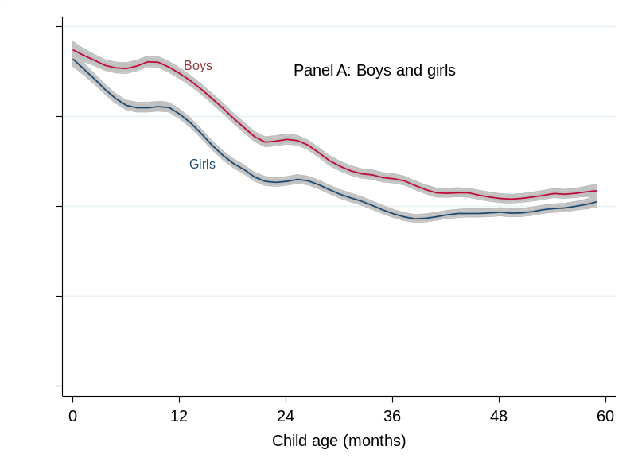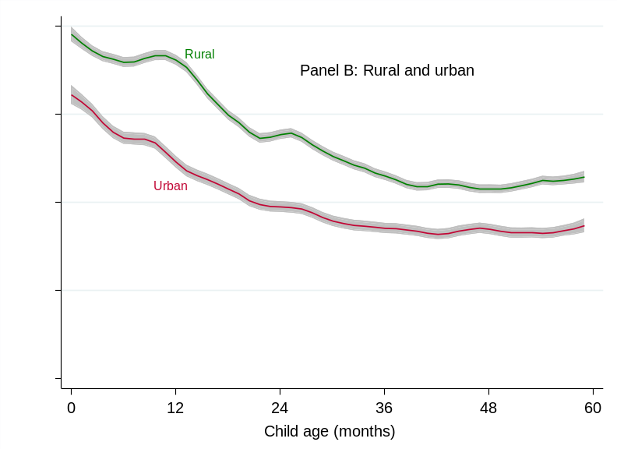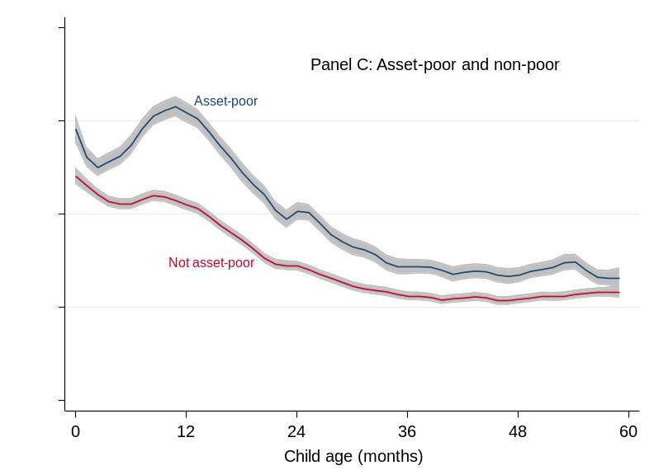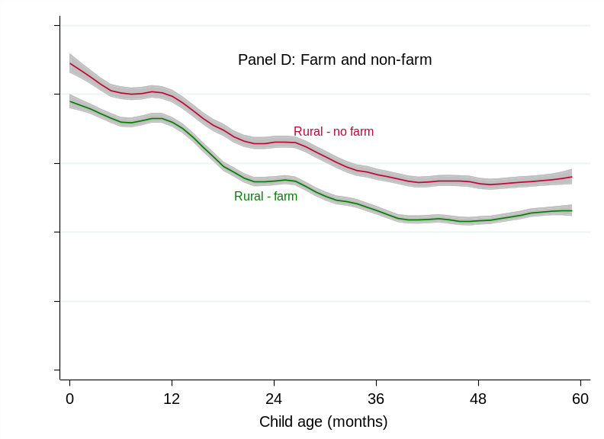
Source: Authors’ estimates from DHS data using the lpoly command in STATA™. Panel A excludes India, but results for India are reported in Supplement Figure S1.

Figure S2. Local polynomial estimates of wasting (WHZ< -2) prevalence against child age in months for children from asset-poor and non-poor households in India
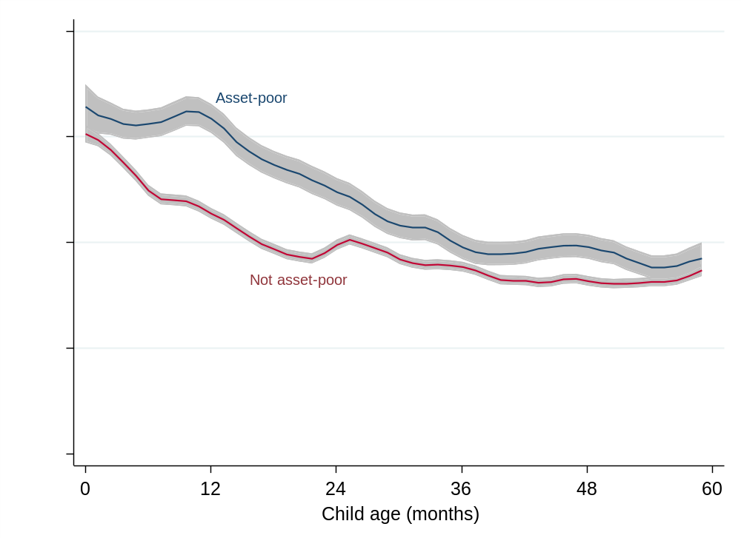
Source: Authors’ estimates from DHS data using the lpoly command in STATA™.

Figure S3. A histogram of real food price changes in the 3 months prior to wasting measurement
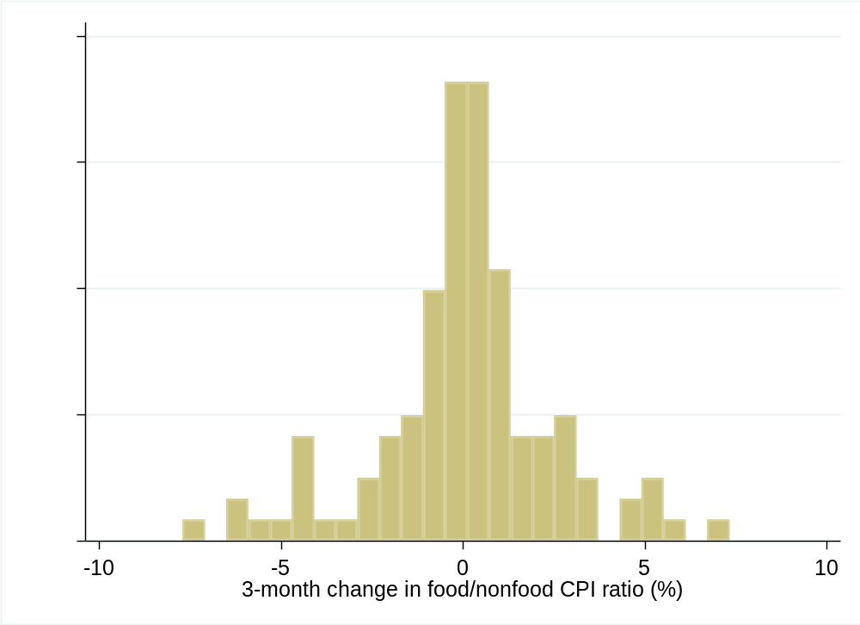
Source: Authors’ calculations from FAO consumer price index data.⁵⁷

Figure S4. Weighted multivariate linear probability models of wasting and stunting risks as a function of poor diet diversity in the past 24 hours and diarrhea or fever in the past two weeks
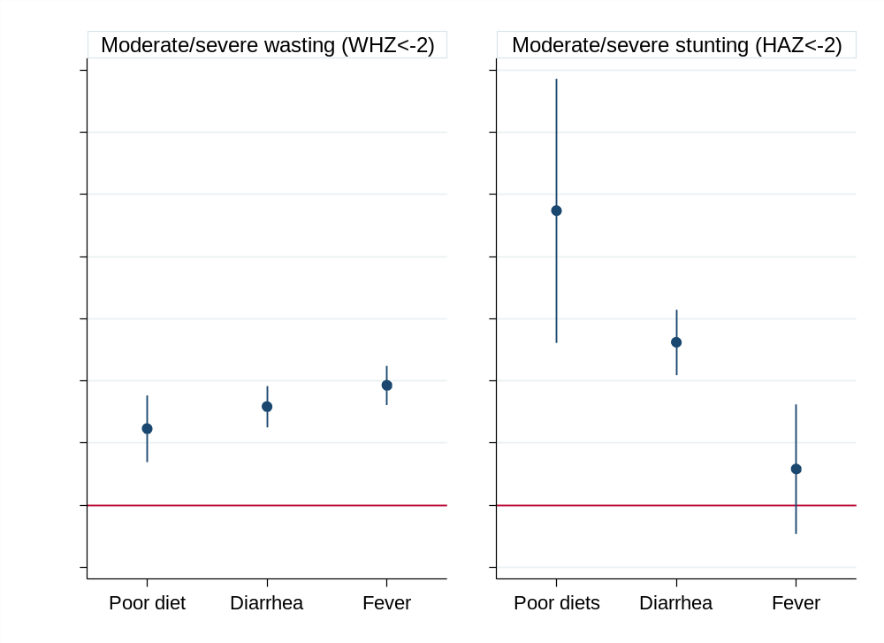
Notes: 95% confidence intervals based on standard errors clustered at the country level. Regressions are weighted (See Methods and Materials). The results show associations from two separate regressions for wasting and severe wasting. Coefficients represent the proportional change in wasting risks from a 5% increase in the real food price index over the past 3 months. The model also incorporates an extensive set of controls described in the Methods and Materials, including DHS variables, and various temporal effects and country fixed effects.

Figure S5. Weighted multivariate linear probability coefficients of wasting and severe wasting as a function of both food inflation and total inflation over the past 3 months
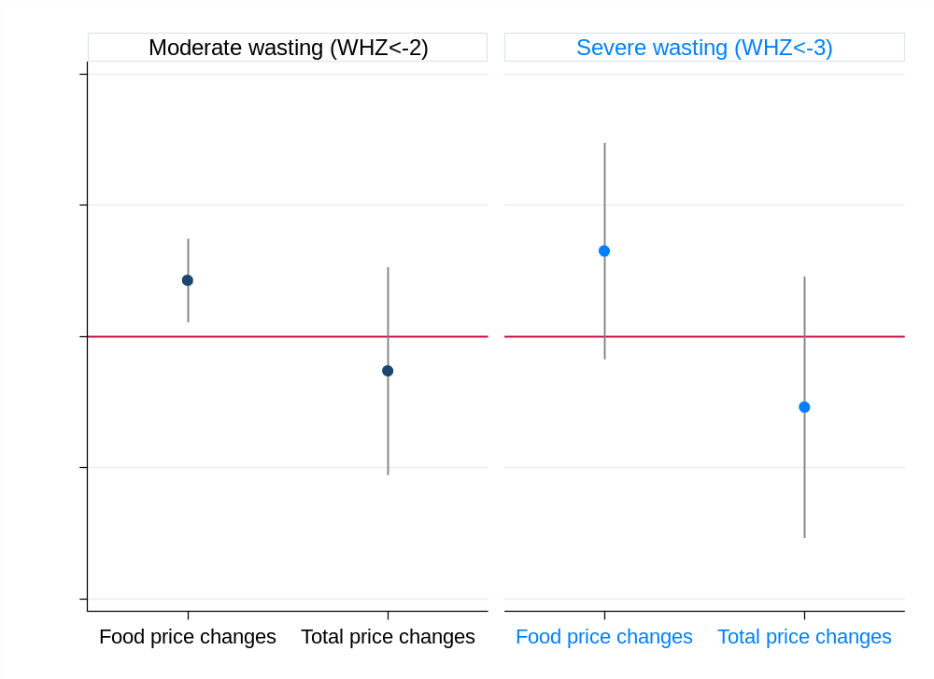
Notes: 95% confidence intervals based on standard errors clustered at the country level are reported in parentheses. Regressions are weighted (See Methods and Materials). Note that the results are not highly sensitive to inclusion/exclusion of either inflation measure. The model also incorporates an extensive set of controls described in the Methods and Materials, including DHS variables, and various temporal effects and country fixed effects.

Figure S6. Weighted multivariate linear probability coefficients of stunting and severe stunting for children 24-59 months as a function of food inflation and total inflation at various stages of the first 1000 days of life
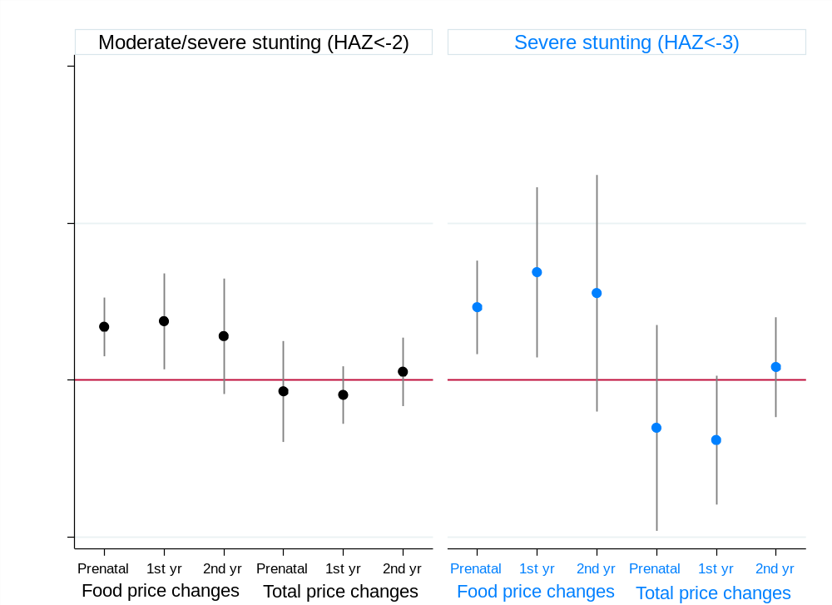
Notes: 95% confidence intervals based on standard errors clustered at the country level are reported in parentheses. Regressions are weighted (See Methods and Materials). However, the results are not sensitive to inclusion/exclusion of either inflation measure. The model also incorporates an extensive set of controls described in the Methods and Materials, including DHS variables, and various temporal effects and country fixed effects.

