Source apportionment of heavy metal(loid)s in sediments and the associated risk assessment based on chemical speciation: A case study from drinking-water reservoir in Southwest China

Table S1. The classification of risk assessment code (I_{geo}).

Range | Degree
I_{geo} ≤ 0 | Unpolluted
0 < I_{geo} ≤ 1 | Unpolluted to moderately polluted
1 < I_{geo} ≤ 2 | Moderately polluted
2 < I_{geo} ≤ 3 | Moderately to heavily polluted
3 <I_{geo} ≤ 4 | Heavily polluted
4 < I_{geo} ≤ 5 | Heavily to extremely polluted
I_{geo} > 5 | Extremely polluted

Table S2. The evaluation criteria of different toxicity levels (STU).
Range | Degree
STU＜4 | Low toxicity
4≤STU≤6 | Moderate toxicity
STU＞6 | High toxicity

Table S3 The extraction procedure, reagents and extraction components of European Community Bureau of Reference (BCR) standard method.
Step | Target phase | Extraction agent and procedures
1 | Exchangeable/acid-soluble fraction-F1 | Duplicate samples, 1.0 g+40 mL of 0.11 M CH₃COOH, Shaking for 16 h then centrifuge
2 | Reducible fraction-F2 | Step 1 residue sample, 40 mL NH₂OH-HCl 0.5 M (pH=1.5), Shaking for 16h then centrifuge
3 | Oxidizable fraction-F3 | Step 2 residue sample, 10 mL H₂O₂ (8.8 M) heat to 85 ºC for 1 h (Repeated once) and then add 50 mL CH₃COONH₄ 1 M (pH=2), Shaking for 16 h then centrifuge
4 | Residual fraction-F4 | Step 3 residue sample (0.2 g), digested by a mixture of acids including 5 mL HNO₃, 5 mL HF, and 3 mL HClO₄ in Teflon beakers, heating on a hot plate equipment

Table S4. The classification of pollution levels code (RSP).
Range | Degree
≤1 | Clean
≥1~2 | Light pollution
≥2~3 | Moderate pollution
＞3 | Severe pollution

Table S5. The classification of risk assessment code (RAC).
RAC | Degree
≤1 | No risk
≥1~10 | Light risk
≥10~30 | Medium risk
≥30~50 | High risk
＞50 | Very high risk

Table S6. The classification of risk assessment code (MRI).
Eir | MRI | Degree
＜40 | ＜190 | Low risk
≥40~80 | ≥190~380 | Moderate risk
≥80~160 | ≥380~760 | Considerable risk
≥160~320 | ≥760 | High risk
＞320 |  | Extremely high risk

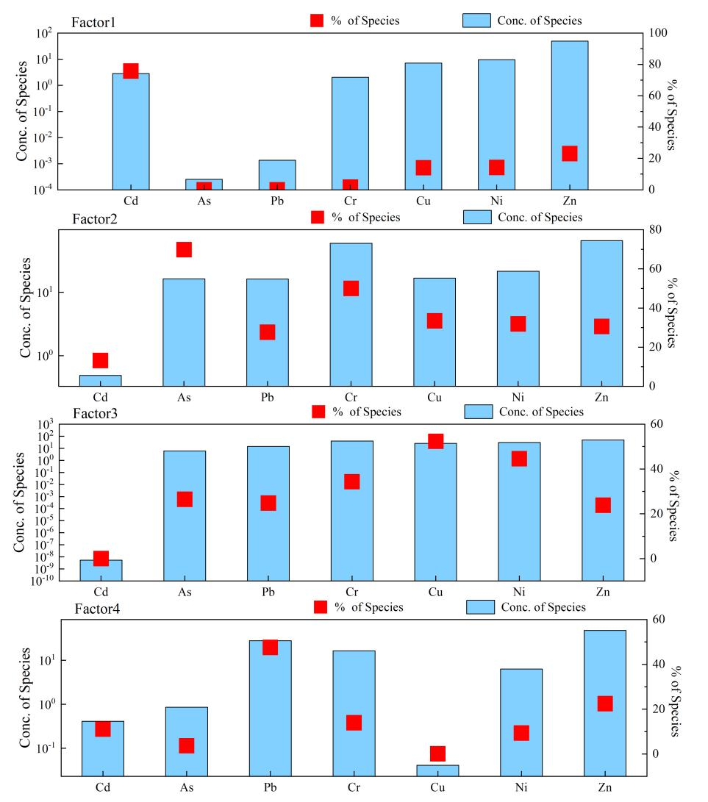
Fig. S1. Factors profiles and source contributions of HMs from PMF model.

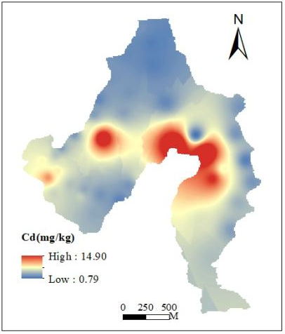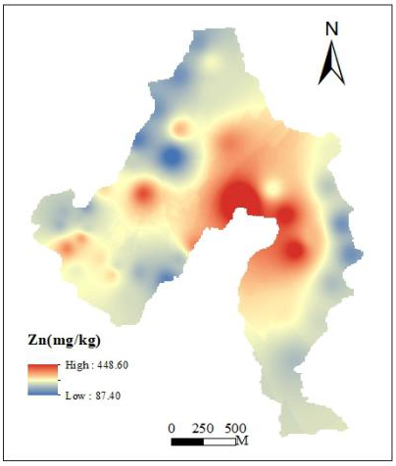
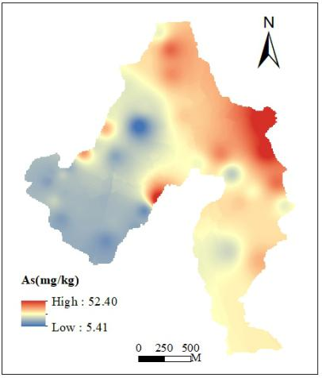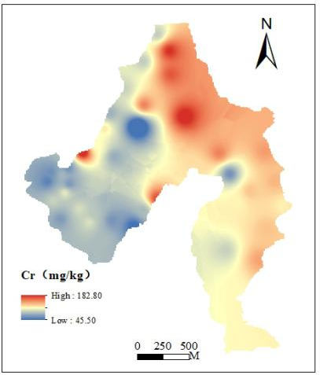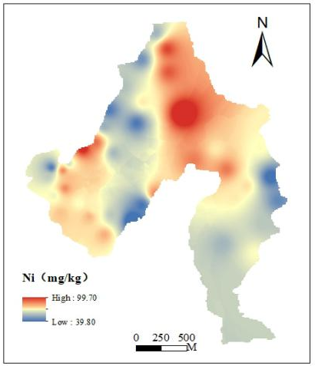
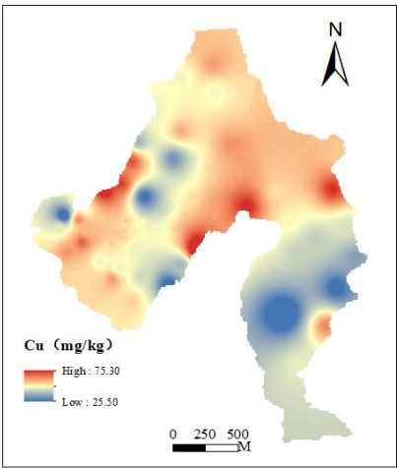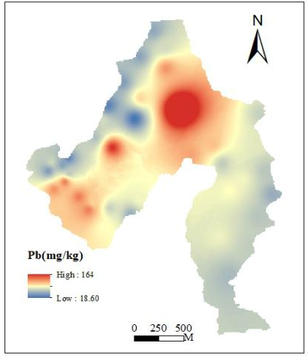
Fig. S2 Spatial distribution patterns of HMs in agricultural soils of the study area.

