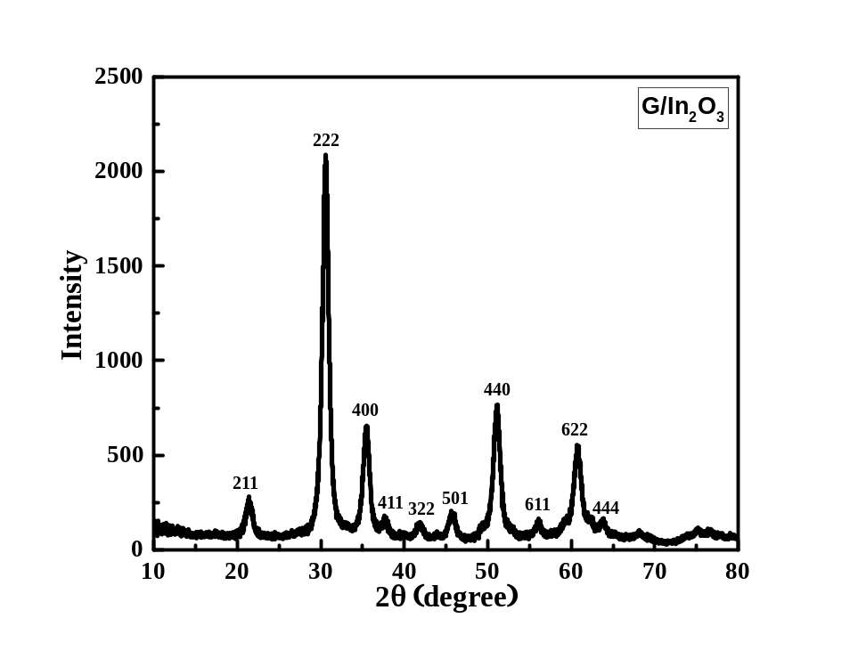

Fig. S1 XRD pattern of G/In₂O₃

Diffraction Pattern Graphics
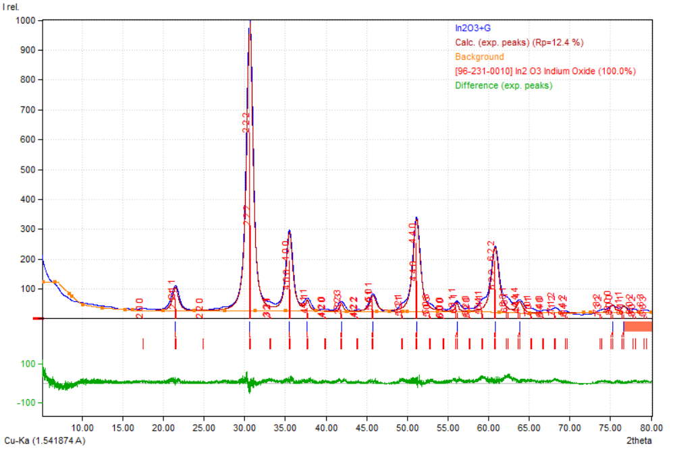
Match! Copyright © 2003-2021 CRYSTAL IMPACT, Bonn, Germany
Fig. S2. XRD pattern of G/In₂O₃ after Rietveld refinement using Match! supported Full proof Software.

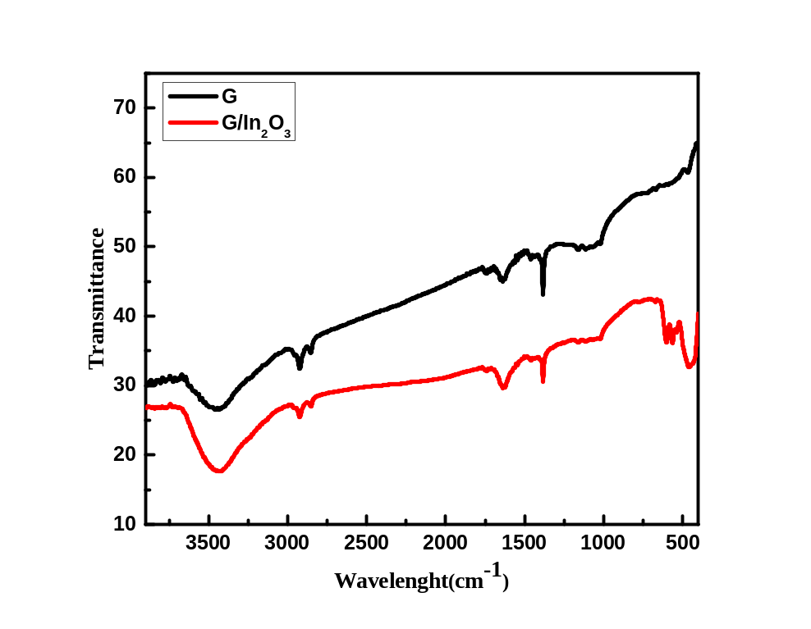

Fig. S3 FTIR spectra of graphene and G/In₂O₃

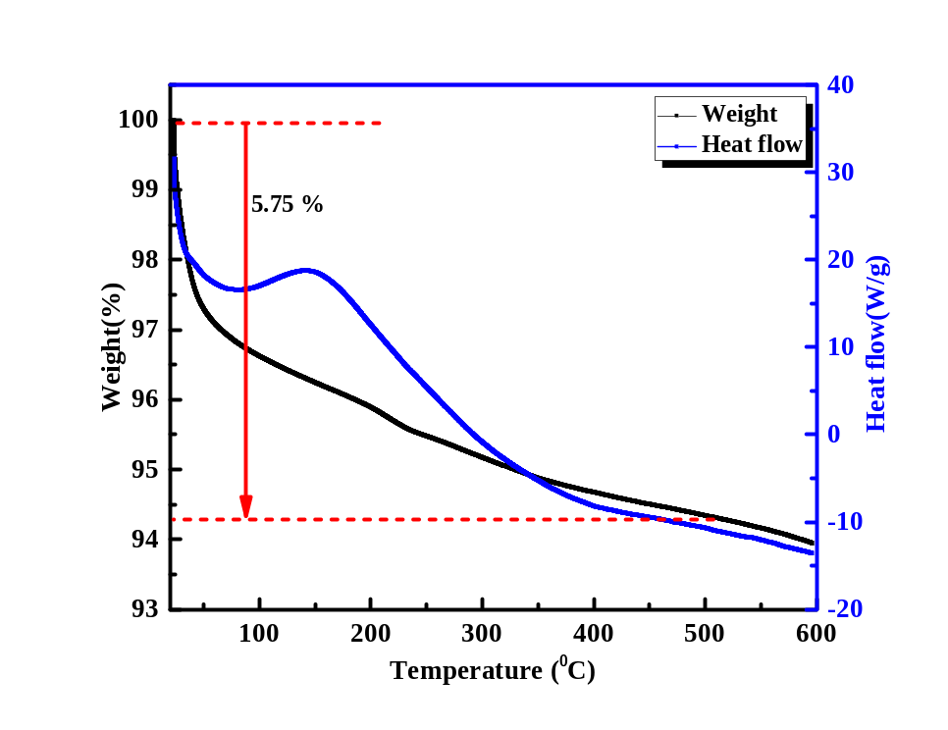

Fig. S4 TG-DSC of G/In₂O₃

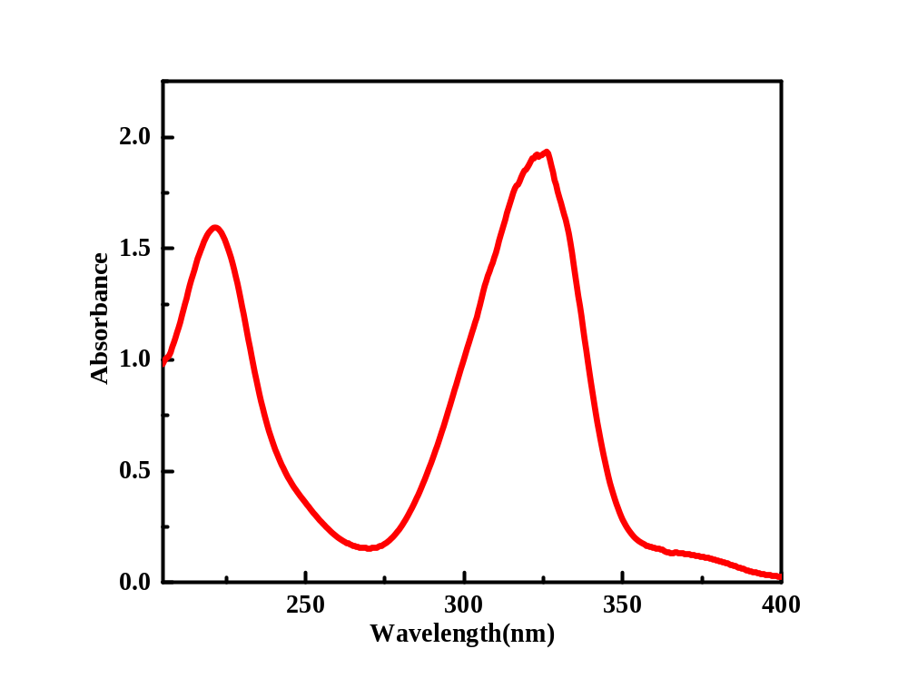

Fig. S5 UV-visible spectroscopy of FVP

