Supplementary Materials

Topology-mediated molecule nucleation anchoring enables high-throughput printing of organic semiconducting single crystals

Xiaobin Ren^{1,#}, Yuan Tan^{1,#}, Wei Deng^{1,}*, Xiaochen Fang¹, Yiming Wu², Zhengjun Lu¹, Xinyue Liu¹, Souren Grigorian³, Jialin Shi¹, Jiansheng Jie^{1,4}*, Xiaohong Zhang, and Xiujuan Zhang^{1,}*

¹Institute of Functional Nano & Soft Materials (FUNSOM), Jiangsu Key Laboratory for Carbon-Based Functional Materials & Devices, Soochow University, Suzhou, Jiangsu 215123, China
²Institute of Materials Research and Engineering, Agency for Science, Technology and Research (A*STAR), Singapore 138634, Singapore
³Department of Physics, University of Siegen, Siegen 57072, Germany
⁴Macao Institute of Materials Science and Engineering, Macau University of Science and Technology, Taipa, Macau SAR 999078, China
#These authors contributed equally: Xiaobin Ren, Yuan Tan
*Email: dengwei@suda.edu.cn; jsjie@suda.edu.cn; xjzhang@suda.edu.cn

Supplementary Table S1. Comparisons on the resolution of OSC patterns fabricated from inkjet printing.
No. | Material | Pixel Per Inch | Refs
1 | C₈-BTBT | 21 | 9
2 | TIPS-PEN | 44 | 18
3 | DTBTD-C₆ | 50 | 19
4 | TIPS-PEN | 90 | 20
5 | DiF-TES-ADT | 3 | 21
6 | CONPHINE | 36 | 22
7 | C₈-BTBT | 90 | 23
8 | TIPS-PEN | 14.4 | 24
9 | C₈-BTBT | 257 | This work

Supplementary Table S2. Performance comparison of devices based on printed OSC patterns in literatures and this work.
No. | Material | μ_{ave} (cm² V⁻¹ s⁻¹) | CV_{μ} (%) | Refs
1 | TIPS-PEN | 0.5 | 55.6 | 20
2 | DiF-TES-ADT | 0.07 | 52.6 | 21
3 | CONPHINE | 1.37 | 18.1 | 22
4 | C₈-BTBT | 6.31 | 23.5 | 23
5 | TIPS-PEN | 0.21 | 45 | 24
6 | TIPS-PEN | 0.88 | 26.6 | 25
7 | C₈-BTBT | 5.01 | 26.7 | Ref. sample
8 | C₈-BTBT | 12.5 | 16.7 | This work

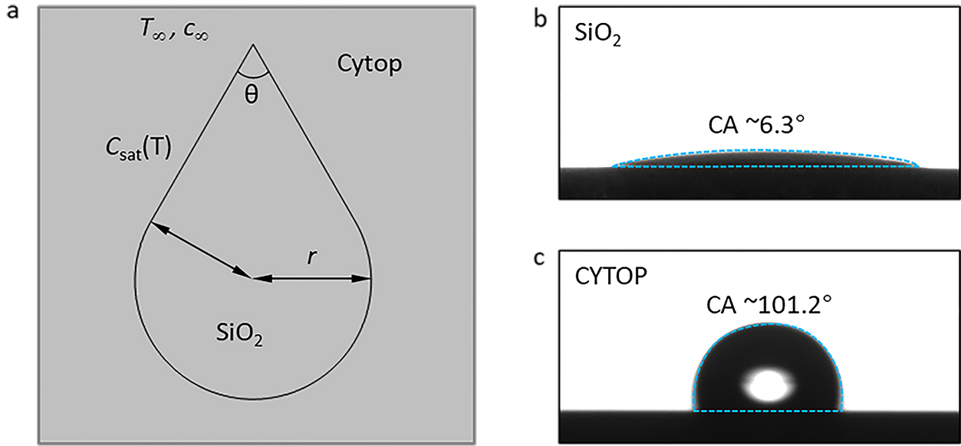
Figure S1. COMSOL simulation. (a) 2D geometry model of the solvent vapor diffusion and the solute deposition process. (b) The contact angle of SiO₂ inside the pattern. (c) The contact angle of CYTOP outside the pattern.

To simulate the diffusion of the solvent vapor in the air and the distribution of solute in the solution, we built a two-dimensional model. The simulation domain was divided into two parts, the gas domain and the solution domain with a pattern shape. The pattern consists of a combination of the circle and isosceles triangle. The edge of the triangle is tangent to the circle. The radius r of the circle was set as 50 μm. The top angle θ of the triangle was set as 60°. To ensure enough distance of solvent vapor diffusion, the air domain was set as a circle with a radius of 12 mm. Assume the solution is spread over the whole pattern at the initial moment of the simulation.
The evaporation and diffusion of the solvent were simulated by the transport of diluted species interface.
$$\frac{∂c_{v}}{∂t}+∇∙\left(J_{v}+uc_{v}\right)=R_{v}$$
$$J_{v}=-D_{v}∇c_{v}$$
where c_{v} is the concentration of the solvent vapor. The diffusion coefficient D_{v} was set to 7.47 × 10⁻⁶ m²/s. Assume the vapor concentration c∞ at the outer boundary of the air domain was set to 0 mol/m³. The vapor concentration c_{sat} at the edge of the pattern was controlled by the equation of state of ideal gas as c_{sat}=p_{v}/RT. The saturated vapor pressure p_{v} was controlled by the Antoine equation:
$$\log_{10}\left(p_{v}[bar]\right)=A+\frac{B}{T[K]+C}$$
where A = 6.9781, B = 1431.05, and C = -55.59.
The temperature field of the gas and liquid domain was simulated by the heat transfer in fluids interface:
$$ρC_{p}\left(\frac{∂T}{∂t}+\left(u_{c}∙∇\right)T\right)=∇∙(k∇T)$$
where C_{p} is the heat capacity of solution, T is the temperature, and k is the thermal conductivity. The outer boundary of gas domain was set equal to ambient temperature T∞. The boundary of the pattern was controlled by the evaporation cooling effect:
$$JL=-k∇T∙n$$
where J is the evaporation flux and solved by the transfer of diluted species equation. L is the latent of the solution. The simulation result of solvent evaporation was obtained by steady-state study. The solute deposition process was also controlled by the transfer of diluted species interface:
$$\frac{∂c_{s}}{∂t}+∇∙\left(J_{s}+uc_{s}\right)=R_{s}$$
$$J_{s}=-D_{s}∇c_{v}, -n∙J_{s}=J_{0,s}$$
where c_{s} is the solute concentration. The diffusion coefficient D_{s} was set to 1×10⁻⁹ m²/s. The pattern boundary was set as the boundary flux J_{0,s} to simulate the solute deposition process after solvent evaporation.

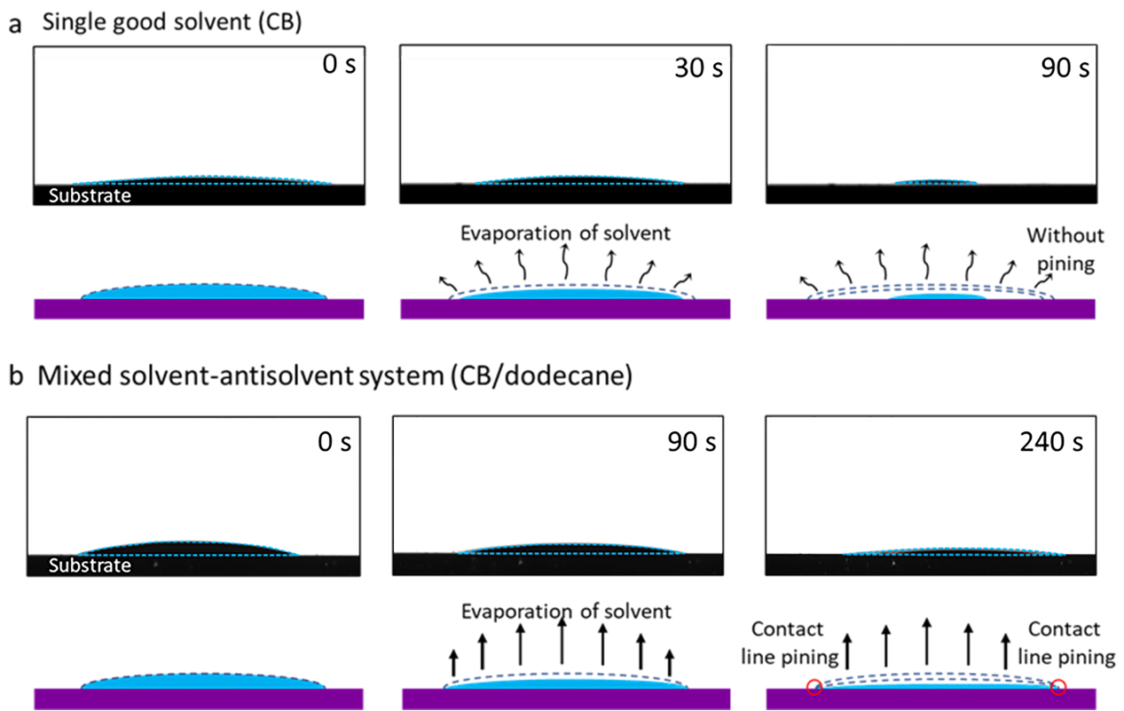
Figure S2. Outline variation of droplets. Temporal variations of (a) a single solvent (CB) droplet and (b) a mixed solvent (CB/dodecane) droplet during evaporation, respectively.

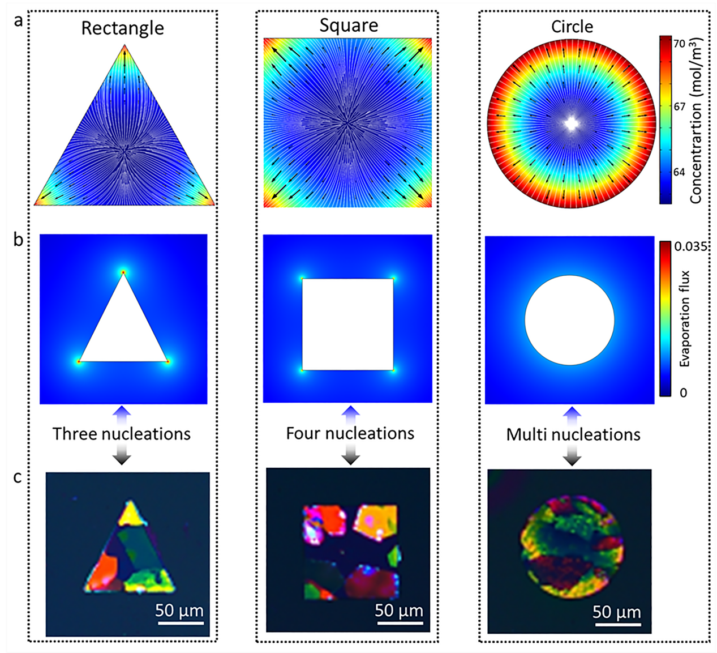
Figure S3. Effect of shapes of the lyophilic regions on nucleation and crystalline film morphology. (a, b) Finite element simulation results of solute concentration distribution, velocity field, and droplet evaporation on the lyophilic regions with different shapes. (c) POM images of the printed deposits on the lyophilic regions with different shapes.

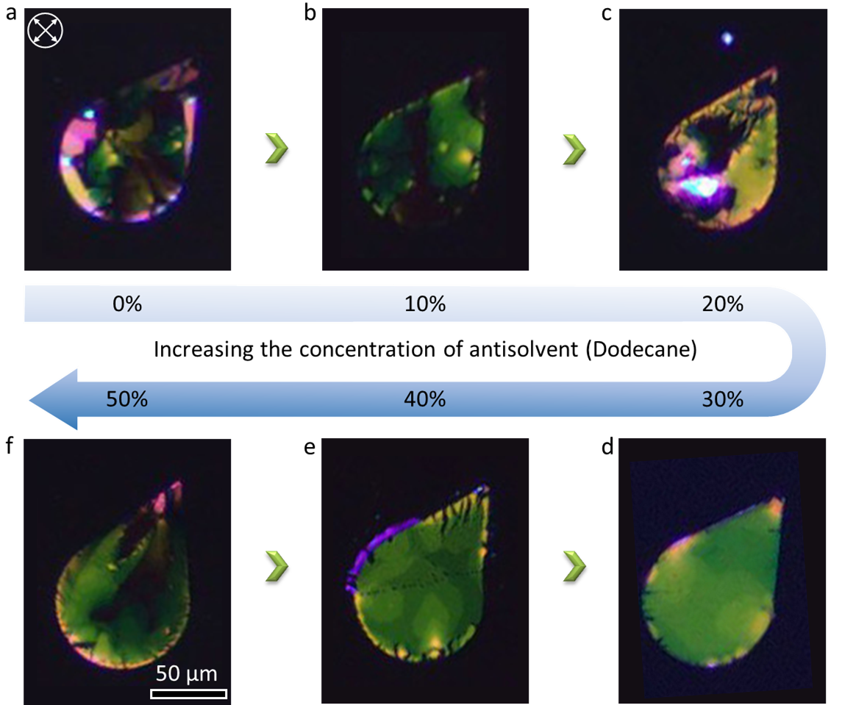
Figure S4. Effect of the antisolvent concentration on the morphology of C₈-BTBT crystals. (a-f) POM images of inkjet-printed C₈-BTBT crystals with different concentrations of antisolvent (dodecane).

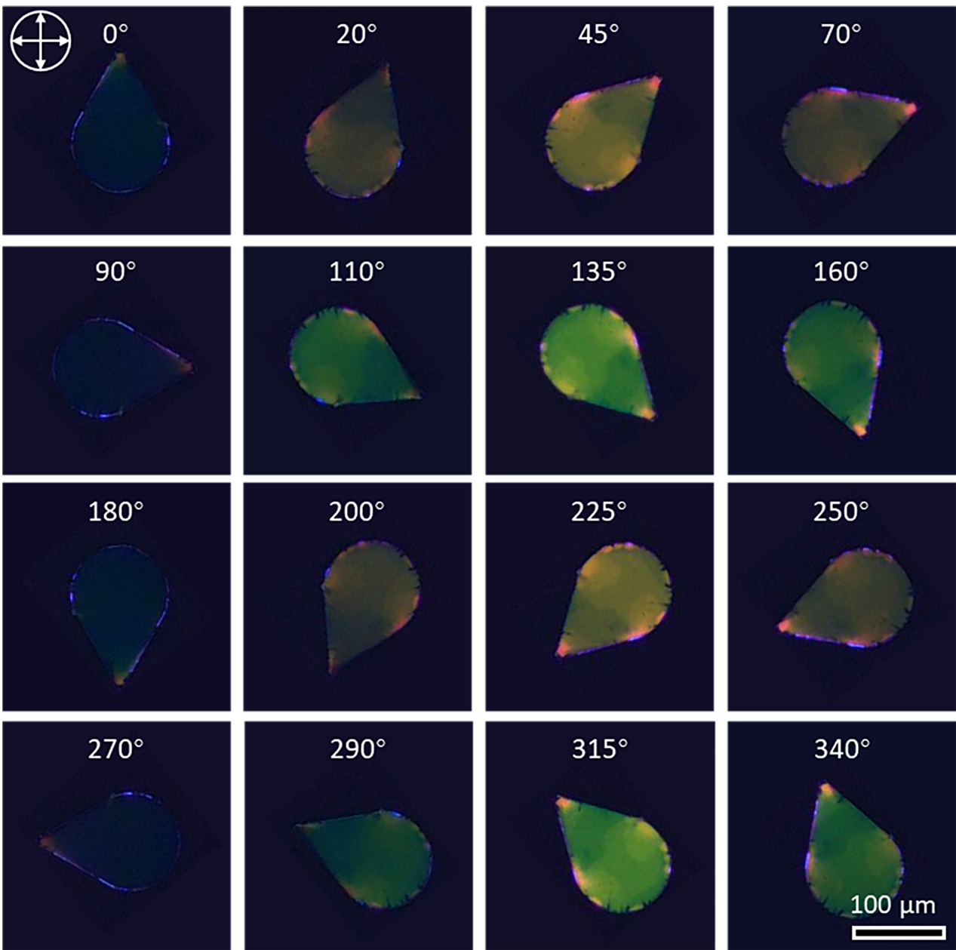
Figure S5. POM characterization. POM images of the inkjet-printed C₈-BTBT single crystal under different polarization angles.

Figure S6. POM characterization. POM images of the C₈-BTBT single crystal with 50 μm size under two polarization angles differing by 45°.

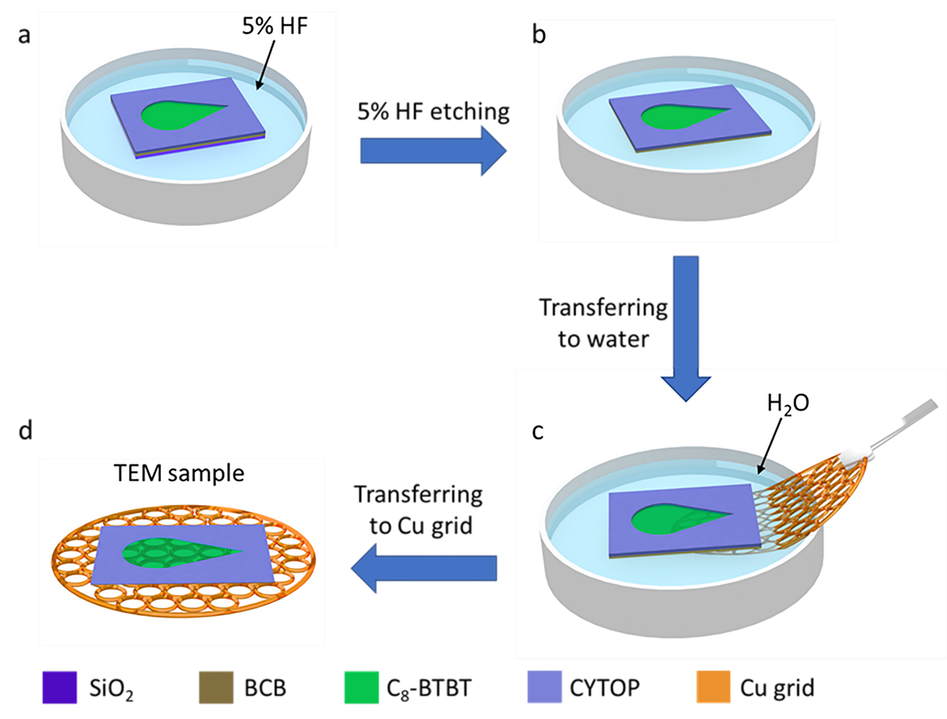
Figure S7. TEM sample preparation. Schematic diagram of the preparation process of the TEM sample.

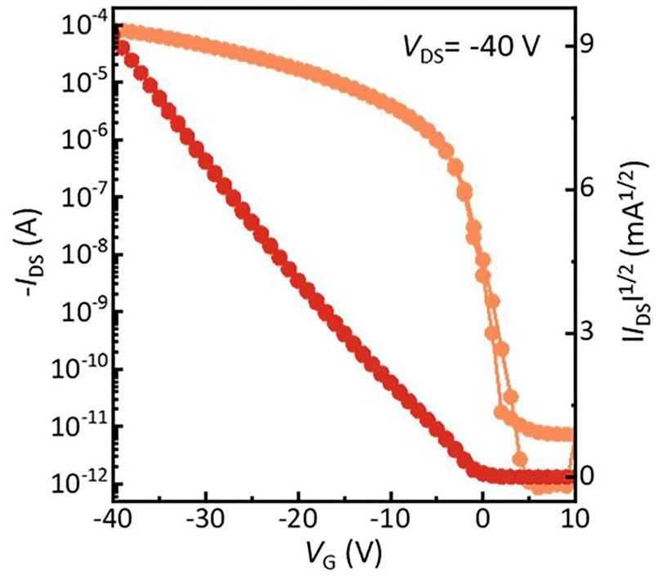
Figure S8. Calculation of bulk trap density. Transfer current-voltage characteristics of a C₈-BTBT single-crystal field-effect device.
Extraction of bulk trap density. The maximum contribution of bulk traps was calculated by:
$$D_{bulk}^{max}=\frac{c_{i}}{q^{2}t_{sc}}\left(\frac{qSS}{k_{B}T\ln\left(10\right)}-1\right)$$
where C_{i} is the capacitance of dielectrics, q is the electronic charge, k_{B} is Boltzmann’s constant, T is the absolute temperature, t_{sc} is the dielectric constant of C₈-BTBT, SS is the subthreshold. Here, C_{i} = 5.7 nF cm⁻² (Figure S16), q = 1.6 × 10⁻¹⁹ C, k_{B} = 1.38 × 10²³ J/K, T = 300 K, t_{SC} and SS were calculated as 20 nm and 738 mV dec⁻¹, respectively. Consequently, we obtained Dmax bulk is equal to 1.81 × 10¹⁶ cm⁻³ eV⁻¹

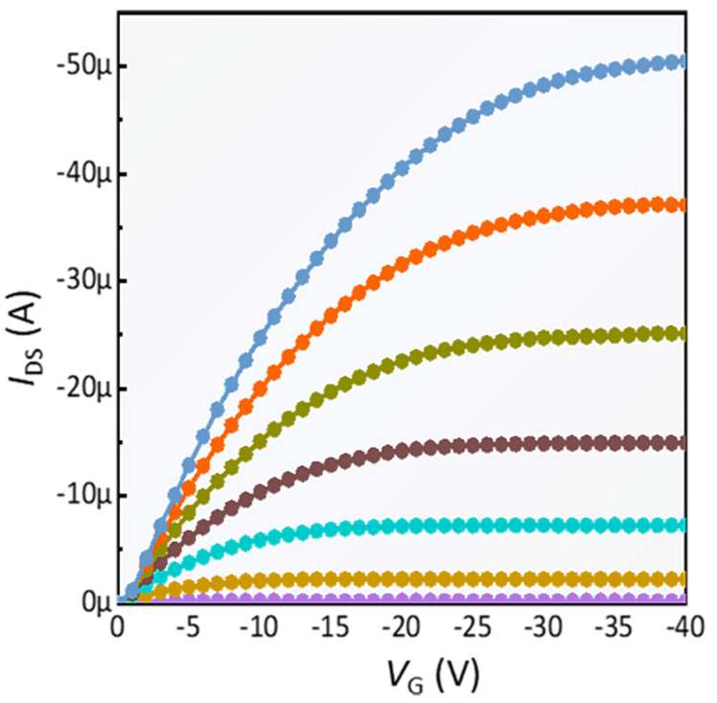
Figure S9. Electrical property of the C₈-BTBT single-crystal FET. Output curve of a representative FET from the 8 × 8 device array.

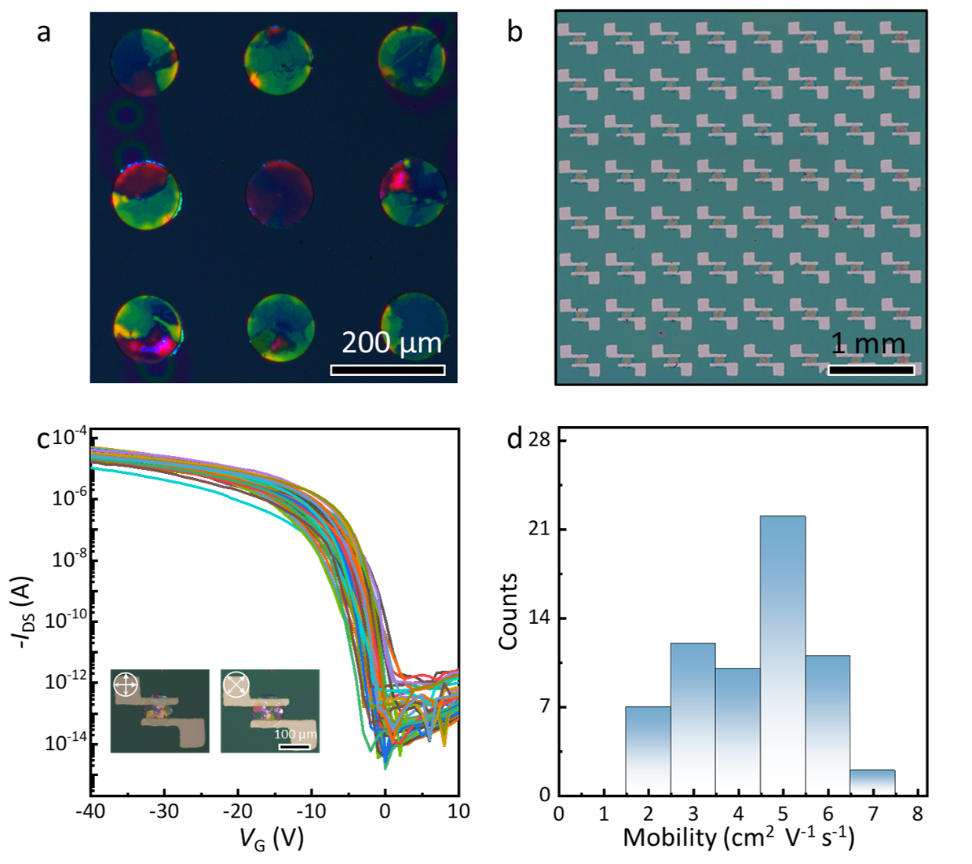
Figure S10. Inkjet-printed C₈-BTBT polycrystal FET array. (a) POM images of the inkjet-printed C₈-BTBT polycrystals. (b) Optical microscopy image of an 8 × 8 FET array based on the inkjet-printed C₈-BTBT polycrystals. (c) Transfer curves of the 64 FETs. Inset: POM images of a typical C₈-BTBT poly-crystal FET. (d) Statistics of mobility from the 64 transistors.

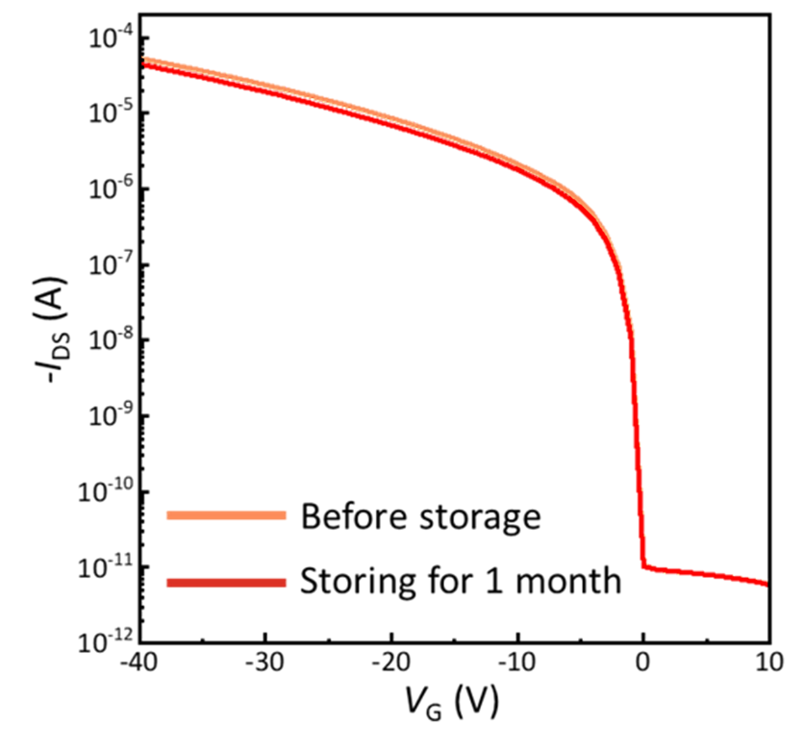
Figure S11. Device stability. Transfer curves of the C₈-BTBT single-crystal FET before storage and after storage for 1 month.

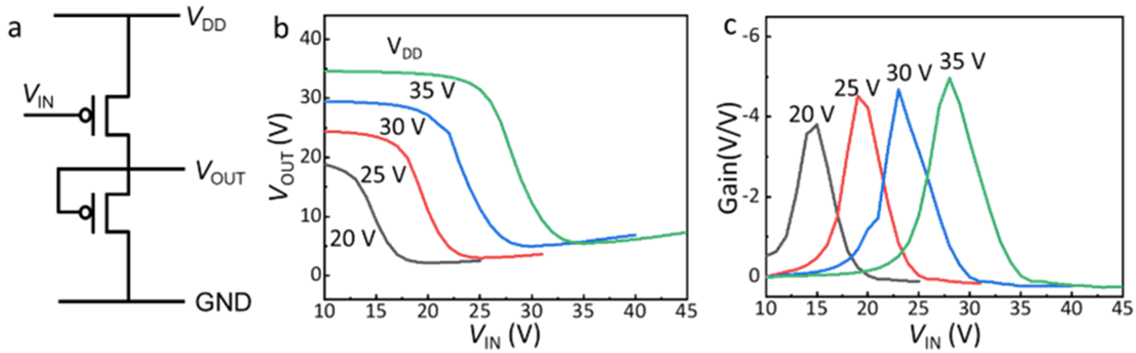
Figure S12. Inverter circuit. (a) Schematic diagram of the inverter circuit structure. (b) Output voltage and (c) gain of the inverter as a function of input voltage at different V_{DD}.

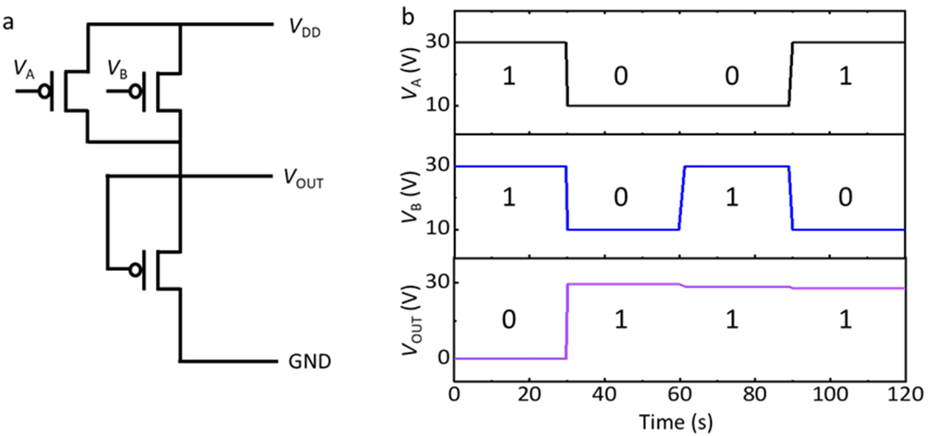
Figure S13. NAND circuit. (a) Schematic diagram of the NAND logic circuit. (b) Typical output characteristic of the NAND.

Figure S14. High-integration FET array. (a) POM image of the high-integration OFET array. (b) Transfer current-voltage characteristics of a FET.

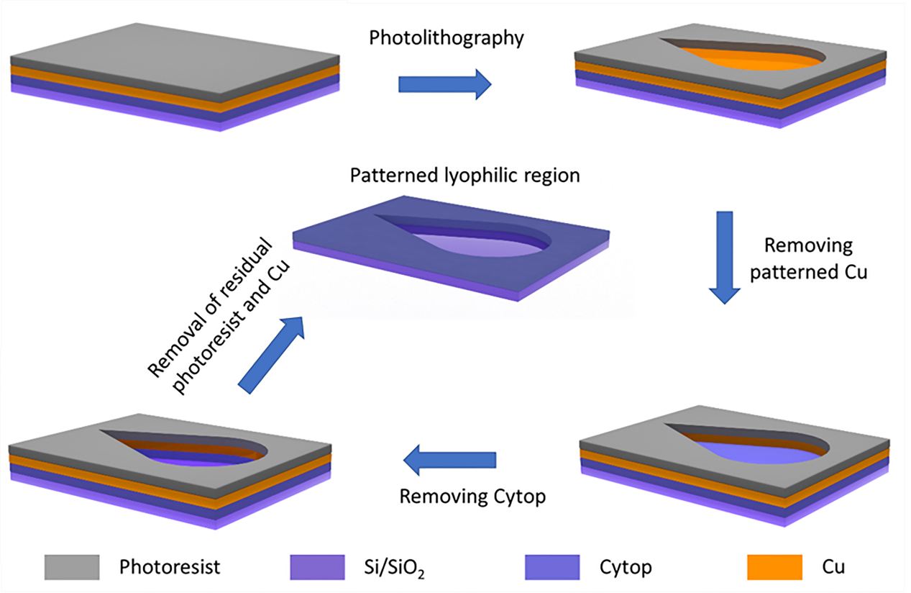
Figure S15. Fabrication of teardrop-shaped pattern. Schematic diagram of the fabrication process of the lyophilic patterns.

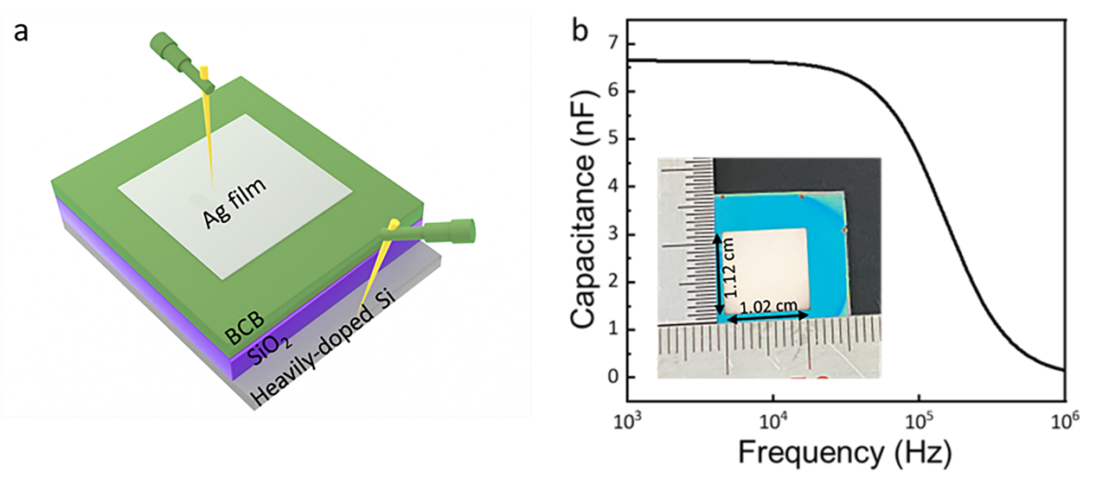
Figure S16. Capacitance measurement. (a) Schematic diagram of the sandwich structure (Au/insulator/heavily-doped Si) for the capacitance measurement. (b) Frequency dependence of capacitance for BCB-covered SiO₂ dielectrics measured with area 1.14 cm², indicating a unit-area capacitance of 5.7 nF cm⁻² at low frequency.

