Supplementary Information

Iron phosphide nanocrystals for highly active and stable heterogeneous catalysis of liquid-phase hydrogenation of nitrile

Tomohiro Tsuda,ª Min Sheng,ª Hiroya Ishikawa,ª Seiji Yamazoe,^{b} Jun Yamasaki,^{c} Sho Yamaguchi,ª Tomoo Mizugaki,^{a,d} Takato Mitsudome^{a,e}*

ªDepartment of Materials Engineering Science, Graduate School of Engineering Science, Osaka University, 1-3 Machikaneyama, Toyonaka, Osaka 560-8531, Japan
^{b}Department of Chemistry, Tokyo Metropolitan University, 1-1 Minami Osawa, Hachioji, Tokyo 192-0397, Japan
^{c}Research Center for Ultra-High Voltage Electron Microscopy, Osaka University, 7-1, Mihogaoka, Ibaraki, Osaka 567-0047, Japan
^{d}Innovative Catalysis Science Division, Institute for Open and Transdisciplinary Research Initiatives, Osaka University, Suita, Osaka 565-0871, Japan
ePRESTO, Japan Science and Technology Agency, 4-1-8 Honcho, Kawaguchi, Saitama 333-0012, Japan

*Correspondence to: mitsudom@cheng.es.osaka-u.ac.jp

Table of Contents

1. Characterization and kinetic study
Supplementary Fig. 1 Size distribution histograms (length and width) of Fe₂P NCs.
Supplementary Fig. 2 EDX analysis of the Fe₂P NC in the areas marked by the yellow squares.
Supplementary Fig. 3 P 2p XPS spectrum of Fe₂P NCs.
Supplementary Fig. 4 TEM images of Fe₂P NC/TiO₂, Fe₂P NC/C, and Fe₂P NC/SiO₂ catalysts before and after the reaction.
Supplementary Fig. 5 Fe 2p XPS spectra of Fe₂P NC/TiO₂ before and after the reaction.
Supplementary Fig. 6 Arrhenius plot of the hydrogenation of benzonitrile using Fe₂P NC/TiO₂.
Supplementary Fig. 7 Dependency of the initial reaction rate on the concentration of benzonitrile and the partial pressure of H₂ using Fe₂P NC/TiO₂.
Supplementary Fig. 8 H₂–D₂ exchange reactions of Fe₂P NCs, Fe₂P NC/TiO₂, Fe₂P NC/C, and Fe₂P NC/ SiO₂.
Supplementary Fig. 9 EXAFS fitting curves in k-space and R-space of Fe foil, bulk Fe₂P, Fe₂P NCs, and Fe₂P NC/TiO₂.
Supplementary Table 1 ICP-AES elemental analyses of Fe₂P NCs and Fe₂P NC/TiO₂
Supplementary Table 2 Curve-fitting results of Fe K-edge EXAFS for Fe foil, bulk Fe₂P, Fe₂P NCs, and Fe₂P NC/TiO₂

2. Comparison of the catalytic activity of Fe₂P NC/TiO₂ with the previously reported catalyst
Supplementary Scheme 1 Comparison of the catalytic activity of Fe₂P NC/TiO₂ with the previously reported Fe catalyst for the nitrile hydrogenation reaction.
3. Product identification
4. ¹H and ¹³C NMR spectra
5. References

1. Characterization and kinetic study

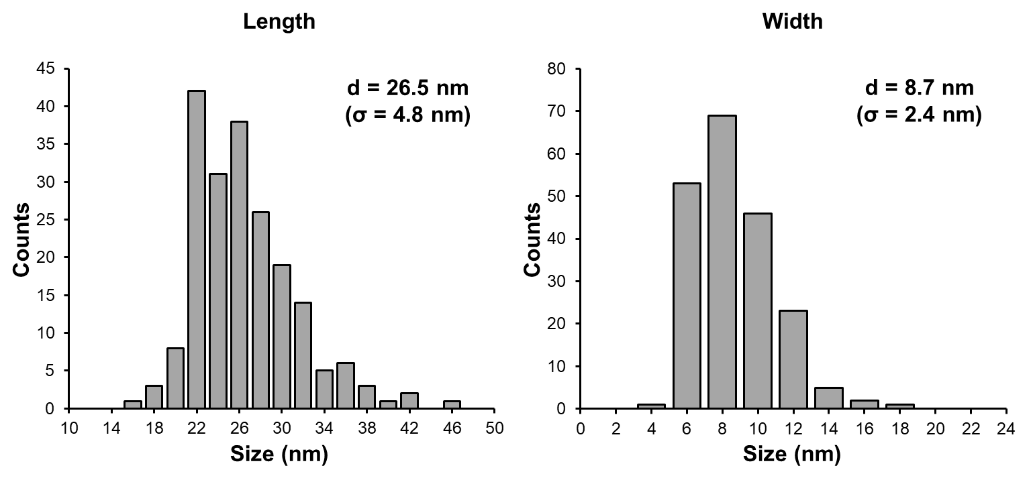
Supplementary Fig. 1|Size distribution histograms of Fe₂P NCs. (left) Length and (right) width of Fe₂P NC.

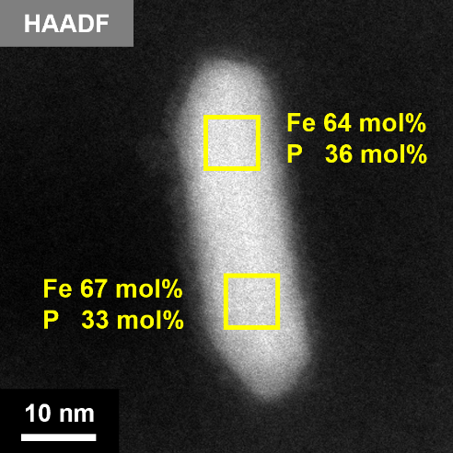
Supplementary Fig. 2|EDX analysis of the Fe₂P NCs. The yellow squares indicate the analysis areas.

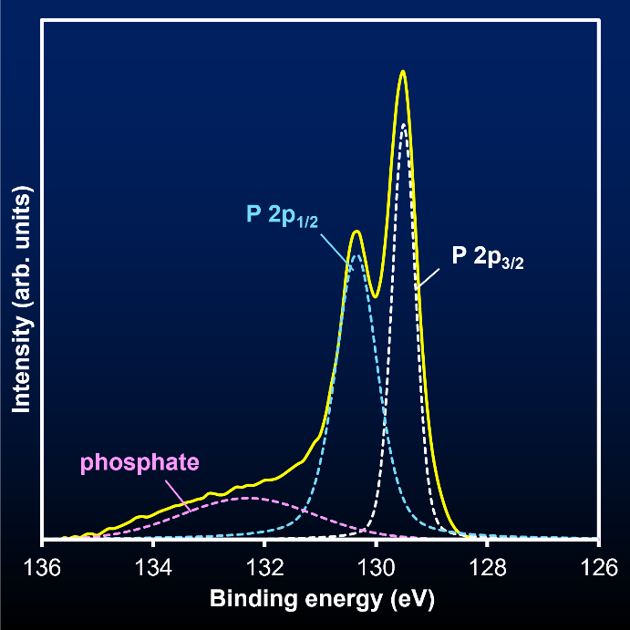
Supplementary Fig. 3|P 2p XPS spectrum of Fe₂P NCs. The solid line is the obtained spectrum. The dashed lines indicate the result of the curve-fitting.

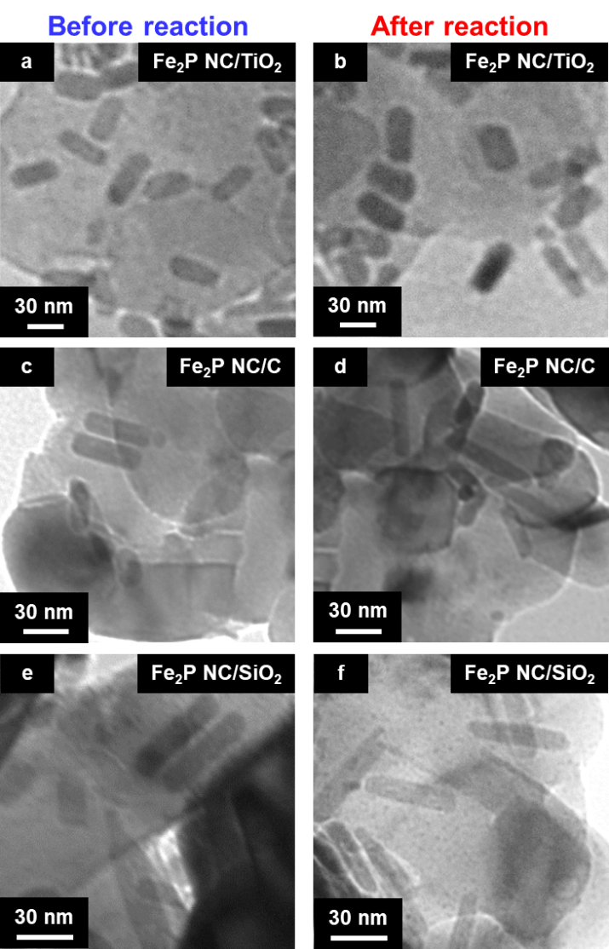
Supplementary Fig. 4|TEM images of supported Fe₂P NC. (a, b) Fe₂P NC/TiO₂, (c, d) Fe₂P NC/C, and (e, f) Fe₂P NC/SiO₂ catalysts before (left panels) and after (right panels) the reaction.
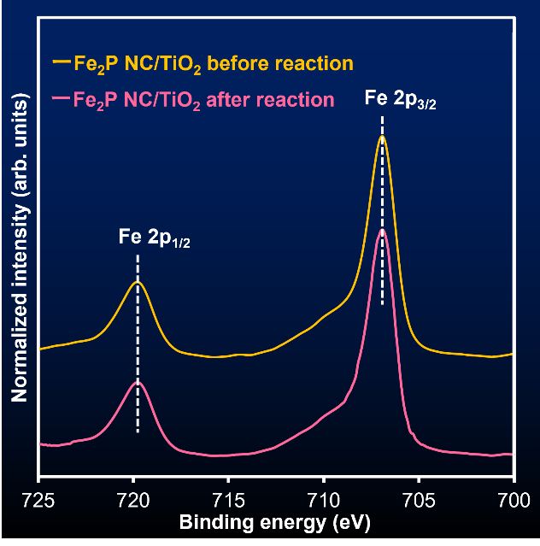
Supplementary Fig. 5|Fe 2p XPS spectra of Fe₂P NC/TiO₂. Before (orange line) and after (magenta line) the reaction.

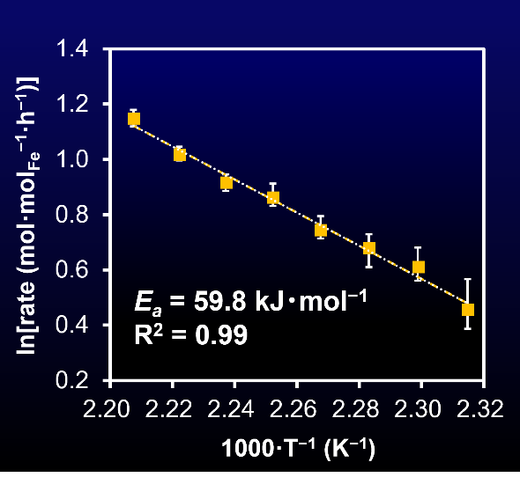
Supplementary Fig. 6|Arrhenius plot of the hydrogenation of benzonitrile using Fe₂P NC/TiO₂. Reaction conditions: Fe₂P NC/TiO₂ (0.1 g, Fe: 1.9 mol%), benzonitrile (2 mmol), 2-propanol (3 mL), H₂ (4 MPa), 432–453 K, 2 h.

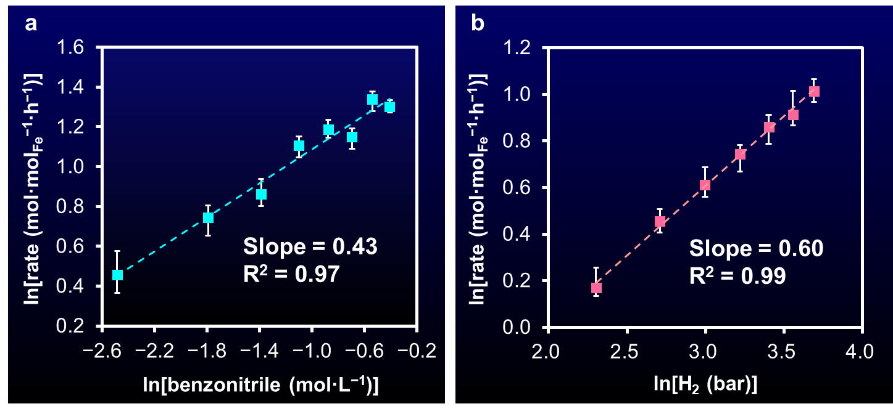
Supplementary Fig. 7|Dependency of the initial reaction rate on the concentration of benzonitrile and the partial pressure of H₂ using Fe₂P NC/TiO₂. a, Double logarithm plots of the concentration of benzonitrile and the initial reaction rate. b, Double logarithm plots of the partial pressure of H₂ and the initial reaction rate. Reaction conditions: Fe₂P NC/TiO₂ (0.1 g, Fe: 1.9–15.2 mol%), benzonitrile (0.25–2 mmol), 2-propanol (3 mL), H₂ (1–4 MPa), 453 K, 2 h.

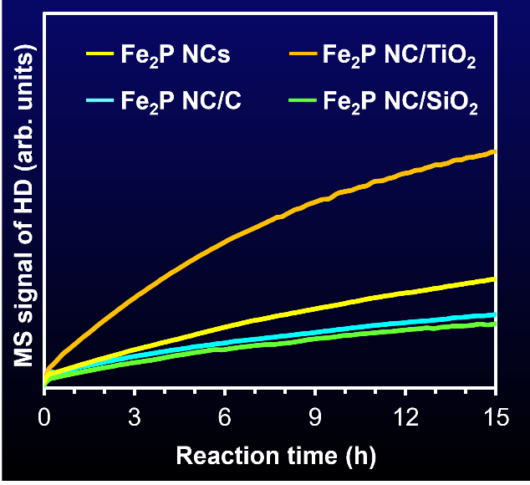
Supplementary Fig. 8|H₂–D₂ exchange experiments. Yellow, orange, light blue, and yellow green show the results obtained by Fe₂P NCs, Fe₂P NC/TiO₂, Fe₂P NC/C, and Fe₂P NC/SiO₂, respectively.

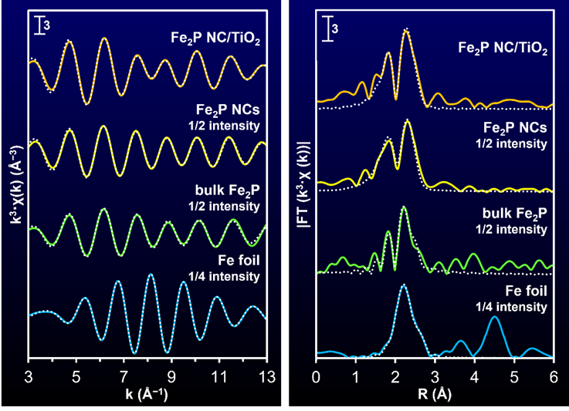
Supplementary Fig. 9|Curve-fitting analysis of Fe K-edge EXAFS spectra of Fe foil, bulk Fe₂P, Fe₂P NCs, and Fe₂P NC/TiO₂. EXAFS fitting curves in (left) k-space and (right) R-space of (right blue) Fe foil, (yellow green) bulk Fe₂P, (yellow) Fe₂P NCs, and (orange) Fe₂P NC/TiO₂. The solid lines are the obtained spectra. The dashed lines show the fitting curves.

Supplementary Table 1|ICP-AES elemental analyses of Fe₂P NCs and Fe₂P NC/TiO₂
Sample | Element | Amount (wt%) | Fe/P (molar ratio)
Fe₂P NCs | Fe | 76.6 | 2.09
Fe₂P NCs | P | 20.4 | 2.09
Fe₂P NC/TiO₂  before reaction | Fe | 2.30 | 1.62
Fe₂P NC/TiO₂  before reaction | P | 0.79 | 1.62
Fe₂P NC/TiO₂  after reaction | Fe | 2.11 | 1.56
Fe₂P NC/TiO₂  after reaction | P | 0.75 | 1.56

Supplementary Table 2|Curve-fitting results of Fe K-edge EXAFS for Fe foil, bulk Fe₂P, Fe₂P NCs, and Fe₂P NC/TiO₂
Sample | Shell | CNª | r (Å)^{b} | D.W.^{c} | R factor (%)
Fe foil | Fe–Fe | 7.3 ± 0.2 | 2.48 ± 0.02 | 0.006 ± 0.002 | 2.4
Fe foil | Fe–Fe | 4.5 ± 0.2 | 2.86 ± 0.03 | 0.007 ± 0.003 | 2.4
bulk Fe₂P | Fe–P | 0.5 ± 0.1 | 2.24 ± 0.04 | 0.001 ± 0.001 | 10.5
bulk Fe₂P | Fe–Fe | 1.8 ± 0.1 | 2.56 ± 0.03 | 0.003 ± 0.002 | 10.5
bulk Fe₂P | Fe–Fe | 0.8 ± 0.2 | 2.69 ± 0.03 | 0.001 ± 0.001 | 10.5
Fe₂P NCs | Fe–P | 2.2 ± 0.2 | 2.23 ± 0.04 | 0.006 ± 0.004 | 5.0
Fe₂P NCs | Fe–Fe | 3.7 ± 0.3 | 2.65 ± 0.03 | 0.011 ± 0.005 | 5.0
Fe₂P NC/TiO₂ | Fe–P | 1.4 ± 0.2 | 2.22 ± 0.04 | 0.003 ± 0.002 | 6.1
Fe₂P NC/TiO₂ | Fe–Fe | 4.2 ± 0.2 | 2.63 ± 0.03 | 0.010 ± 0.004 | 6.1
ªCoordination number. ^{b}Bond distance. ^{c}Debye–Waller factor.

2. Comparison of catalytic activity of Fe₂P NC/TiO₂ with the previously reported catalyst

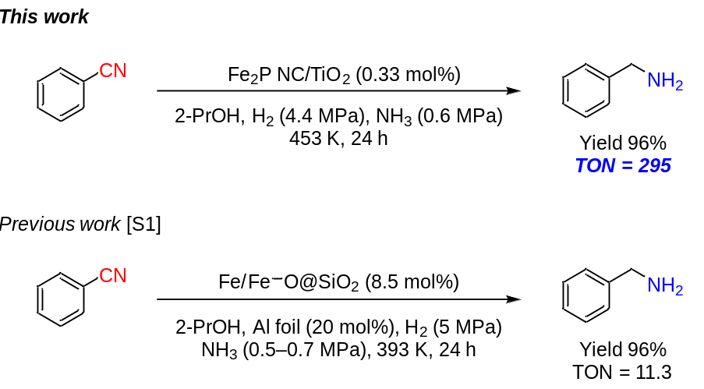
Supplementary Scheme 1|Comparison of the catalytic activity of Fe₂P NC/TiO₂ with the previously reported Fe catalyst for the nitrile hydrogenation reaction.

3. Product identification
All reaction products were characterized by GC and NMR spectroscopy. The ¹H and ¹³C NMR chemical shifts of the products agreed with those of authentic samples or previously reported values.

benzylamine hydrochloride (2a) [S2]
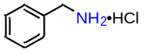
¹H NMR (DMSO-d₆, 400 MHz): δ = 8.49 (br s, 3H), 7.51–7.49 (m, 2H), 7.43–7.35 (m, 3H), 4.00 (s, 2H); ¹³C NMR (DMSO-d₆, 100 MHz): δ = 134.07, 128.88, 128.51, 128.35, 42.12.

o-methylbenzylamine hydrochloride (2b) [S3]
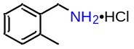
¹H NMR (DMSO-d₆, 400 MHz): δ = 8.59 (br s, 3H), 7.46–7.43 (m, 1H), 7.33–7.21 (m, 3H), 3.98 (s, 2H), 2.36 (s, 3H); ¹³C NMR (DMSO-d₆, 100 MHz): δ = 136.64, 132.33, 130.26, 129.20, 128.41, 126.03, 39.39, 18.83.

m-methylbenzylamine hydrochloride (2c) [S3]
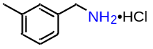
¹H NMR (DMSO-d₆, 400 MHz): δ = 8.45 (s, 3H), 7.32–7.28 (m, 3H), 7.20–7.18 (m, 1H), 3.96 (s, 2H), 2.32 (s, 3H); ¹³C NMR (DMSO-d₆, 100 MHz): δ = 137.68, 133.98, 129.45, 128.94, 128.47, 125.91, 42.07, 20.92.

p-methylbenzylamine hydrochloride (2d) [S3]
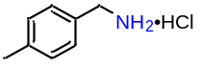
¹H NMR (DMSO-d₆, 400 MHz): δ = 8.38 (s, 3H), 7.37 (d, J = 8.4 Hz, 2H), 7.22 (d, J = 8.4 Hz, 2H), 3.95 (s, 2H), 2.30 (s, 3H); ¹³C NMR (DMSO-d₆, 100 MHz): δ = 137.64, 131.00, 128.97, 128.85, 41.80, 20.67.

p-tert-butylbenzylamine hydrochloride (2e) [S4]
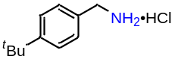
¹H NMR (DMSO-d₆, 400 MHz): δ = 8.36 (s, 3H), 7.45–7.40 (m, 4H), 3.96 (s, 2H), 1.28 (s, 9H); ¹³C NMR (DMSO-d₆, 100 MHz): δ = 150.95, 131.16, 128.68, 125.29, 41.82, 34.30, 31.02.

o-methoxybenzylamine hydrochloride (2f) [S2]
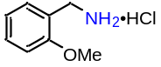
¹H NMR (DMSO-d₆, 400 MHz): δ = 8.17 (br s, 3H), 7.40–7.36 (m, 2H), 7.07–7.06 (m, 1H), 6.99–6.96 (m, 1H), 3.95 (q, J = 6.0 Hz, 2H), 3.83 (s, 3H); ¹³C NMR (DMSO-d₆, 100 MHz): δ = 157.20, 130.30, 130.25, 121.60, 120.30, 110.93, 55.51, 37.69.

m-methoxybenzylamine hydrochloride (2g) [S4]
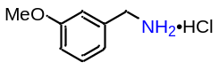
¹H NMR (DMSO-d₆, 400 MHz): δ = 8.62 (br s, 3H), 7.33–7.29 (m, 1H), 7.19 (s, 1H), 7.07–7.05 (m, 1H), 6.94–6.92 (m, 1H), 3.97 (s, 2H), 3.77 (s, 3H); ¹³C NMR (DMSO-d₆, 100 MHz): δ = 159.29, 135.56, 129.62, 120.95, 114.48, 113.92, 55.19, 42.05.

p-methoxybenzylamine hydrochloride (2h) [S5]
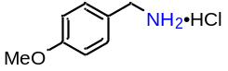
¹H NMR (DMSO-d₆, 400 MHz): δ = 8.40 (s, 3H), 7.43 (d, J = 8.4 Hz, 2H), 6.96 (d, J = 8.4 Hz, 2H), 3.93 (s, 2H), 3.79 (s, 3H); ¹³C NMR (DMSO-d₆, 100 MHz): δ = 159.22, 130.40, 125.86, 113.79, 55.07, 41.51.

o-chlorobenzylamine hydrochloride (2i) [S2]
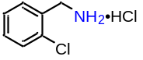
¹H NMR (DMSO-d₆, 400 MHz): δ = 8.66 (br s, 3H), 7.68–7.63 (m, 1H), 7.56–7.52 (m, 1H), 7.45–7.41 (m, 2H), 4.12 (s, 2H); ¹³C NMR (DMSO-d₆, 100 MHz): δ = 132.86, 131.62, 130.65, 130.34, 129.45, 127.49, 39.43.

m-chlorobenzylamine hydrochloride (2j) [S3]
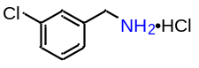
¹H NMR (DMSO-d₆, 400 MHz): δ = 8.63 (br s, 3H), 7.65 (s, 1H), 7.50–7.43 (m, 3H), 4.03 (s, 2H); ¹³C NMR (DMSO-d₆, 100 MHz): δ = 136.52, 133.04, 130.41, 128.91, 128.31, 127.75, 41.46.

p-chlorobenzylamine hydrochloride (2k) [S7]
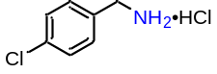
¹H NMR (DMSO-d₆, 400 MHz): δ = 8.55 (br s, 3H), 7.58–7.47 (m, 4H), 4.01 (s, 2H); ¹³C NMR (DMSO-d₆, 100 MHz): δ = 133.11, 133.08, 130.95, 128.47, 41.35.

p-bromobenzylamine hydrochloride (2l) [S7]
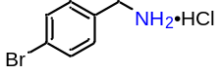
¹H NMR (DMSO-d₆, 400 MHz): δ = 8.53 (br s, 3H), 7.63 (d, J = 8.0 Hz, 2H), 7.46 (d, J = 8.0 Hz, 2H), 4.00 (s, 2H); ¹³C NMR (DMSO-d₆, 100 MHz): δ = 133.53, 131.39, 131.24, 121.66, 41.42.

p-fluorobenzylamine hydrochloride (2m) [S2, S8]
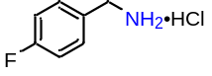
¹H NMR (DMSO-d₆, 400 MHz): δ = 8.47 (br s, 3H), 7.59–7.54 (m, 2H), 7.28–7.23 (m, 2H), 4.01 (q, J = 6.0 Hz, 2H); ¹³C NMR (DMSO-d₆, 100 MHz): δ = 162.07 (d, J = 244.0 Hz), 131.34 (d, J = 8.6 Hz), 130.36 (d, J = 2.9 Hz), 115.35 (d, J = 21.9 Hz), 41.38.

2,4-difluorobenzylamine hydrochloride (2n) [S9]
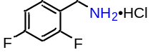
¹H NMR (D₂O, 400 MHz): δ = 7.46–7.40 (m, 1H), 7.04–6.97 (m, 2H), 4.17 (s, 2H); ¹³C NMR (D₂O, 100 MHz): δ = 165.05 (dd, J = 246.9, 12.4 Hz), 162.75 (dd, J = 247.9, 12.4 Hz), 134.08 (dd, J = 10.4, 4.7 Hz), 117.40 (dd, J = 15.2, 3.8 Hz), 113.65 (dd, J = 22.0, 3.8 Hz), 105.84 (dd, J = 25.7, 25.7 Hz), 38.19 (d, J = 3.8 Hz).

3,4-dichlorobenzylamine hydrochloride (2o) [S7]
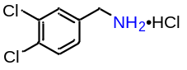
¹H NMR (CD₃OD, 400 MHz): δ = 7.70 (s, 1H), 7.64 (d, J = 8.4 Hz, 1H), 7.43 (d, J = 8.4 Hz, 1H), 4.15 (s, 2H); ¹³C NMR (CD₃OD, 100 MHz): δ = 135.02, 134.31, 133.97, 132.32, 132.29, 130.00, 43.14.

p-(trifluoromethyl)benzylamine hydrochloride (2p) [S5]
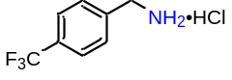
¹H NMR (DMSO-d₆, 400 MHz): δ = 8.48 (s, 3H), 7.81 (d, J = 8.0 Hz, 2H), 7.72 (d, J = 8.0 Hz, 2H), 4.14 (s, 2H); ¹³C NMR (DMSO-d₆, 100 MHz): δ = 138.76, 129.71, 128.62 (q, J = 31.5 Hz), 125.42 (q, J = 3.8 Hz), 122.76, 41.64.

p-aminobenzylamine hydrochloride (2q) [S10, S11]
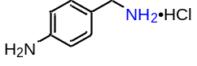
¹H NMR (DMSO-d₆, 400 MHz): δ = 8.46 (br s, 3H), 7.53 (d, J = 8.4 Hz, 2H), 7.30 (d, J = 8.4 Hz, 2H), 4.00 (q, J = 6.0 Hz, 2H); ¹³C NMR (DMSO-d₆, 100 MHz): δ = 134.70, 131.84, 130.31, 121.90, 41.63.

p-(N,N-dimethylamino)benzylamine hydrochloride (2r) [S4]
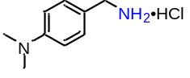
¹H NMR (DMSO-d₆, 400 MHz): δ = 8.29 (br s, 3H), 7.36 (d, J = 8.0 Hz, 2H), 6.95 (br s, 2H), 3.90 (q, J = 5.2 Hz, 2H), 2.94 (s, 6H); ¹³C NMR (DMSO-d₆, 100 MHz): δ = 148.01, 130.22, 115.32, 41.94, 41.70.

p-(methylthio)benzylamine hydrochloride (2s) [S1]
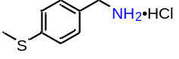
¹H NMR (DMSO-d₆, 400 MHz): δ = 8.32 (br s, 3H), 7.42 (d, J = 8.4 Hz, 2H), 7.30 (d, J = 8.4 Hz, 2H), 3.97 (s, 2H), 2.51–2.50 (m, 3H); ¹³C NMR (DMSO-d₆, 100 MHz): δ = 138.72, 130.40, 129.58, 125.83, 41.75, 14.59.

p-phenyoxybenzylamine hydrochloride (2t) [S4]
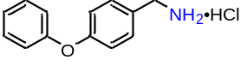
¹H NMR (DMSO-d₆, 400 MHz): δ = 8.43 (s, 3H), 7.53–7.51 (m, 2H), 7.43–7.39 (m, 2H), 7.19–7.15 (m, 1H), 7.05–7.00 (m, 4H), 3.99 (s, 2H); ¹³C NMR (DMSO-d₆, 100 MHz): δ = 156.83, 156.34, 130.97, 130.11, 129.04, 123.69, 118.72, 118.49, 41.56.

3,4-methylenedioxybenzylamine hydrochloride (2u) [S4]
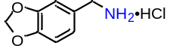
¹H NMR (DMSO-d₆, 400 MHz): δ = 8.29 (br s, 3H), 7.09 (s, 1H), 6.97–6.93 (m, 2H), 6.04 (s, 2H), 3.92 (s, 2H); ¹³C NMR (DMSO-d₆, 100 MHz): δ = 147.28, 127.59, 122.83, 109.40, 108.26, 101.20, 42.02.

2-phenylethaneamine hydrochloride (2v) [S12]
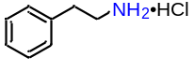
¹H NMR (DMSO-d₆, 400 MHz): δ = 8.07 (br s, 3H), 7.35–7.31 (m, 2H), 7.27–7.25 (m, 3H), 3.04–2.99 (m, 2H), 2.92–2.88 (m, 2H); ¹³C NMR (DMSO-d₆, 100 MHz): δ = 137.32, 128.54, 128.51, 126.60, 39.79, 32.86.

p-phenylbenzylamine hydrochloride (2w) [S4, S13]
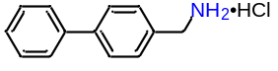
¹H NMR (DMSO-d₆, 400 MHz): δ = 8.61 (br s, 3H), 7.73–7.59 (m, 6H), 7.50–7.46 (m, 2H), 7.40–7.37 (m, 1H), 4.06 (s, 2H); ¹³C NMR (DMSO-d₆, 100 MHz): δ = 140.20, 139.52, 133.28, 129.58, 128.98, 127.68, 126.77, 126.69, 41.82.

1-naphthalenemethylamine hydrochloride (2x) [S14]
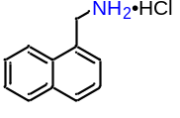
¹H NMR (DMSO-d₆, 400 MHz): δ = 8.39 (br s, 3H), 8.16–8.14 (m, 1H), 8.03–7.98 (m, 2H), 7.67–7.55 (m, 4H), 4.53 (s, 2H); ¹³C NMR (DMSO-d₆, 100 MHz): δ = 133.23, 130.64, 129.94, 129.11, 128.66, 127.27, 126.74, 126.26, 125.35, 123.42, 38.94.

4-picolylamine hydrochloride (2y) [S11]
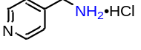
¹H NMR (DMSO-d₆, 400 MHz): δ = 9.06 (br s, 3H), 8.92 (d, J = 6.4 Hz, 2H), 8.08 (d, J = 6.4 Hz, 2H), 4.33 (s, 2H); ¹³C NMR (DMSO-d₆, 100 MHz): δ = 151.68, 143.29, 125.77, 41.03.

3-picolylamine hydrochloride (2z) [S15]
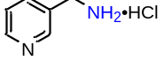
¹H NMR (DMSO-d₆, 400 MHz): δ = 8.95 (s, 1H), 8.83–8.81 (m, 1H), 8.68 (br s, 3H), 8.47–8.43 (m, 1H), 7.92–7.88 (m, 1H), 4.21 (q, J = 6.0 Hz, 2H); ¹³C NMR (DMSO-d₆, 100 MHz): δ = 145.11, 143.70, 142.77, 133.34, 126.26, 39.02.

5-aminomethylindole (2aa) [S16, S17]
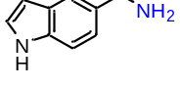
¹H NMR (DMSO-d₆, 400 MHz): δ = 10.95 (s, 1H), 7.43 (s, 1H), 7.33–7.27 (m, 2H), 7.04 (d, J = 8.4 Hz, 1H), 6.35 (s, 1H), 3.78 (br s, 2H), 1.78 (br s, 2H); ¹³C NMR (DMSO-d₆, 100 MHz): δ = 134.85, 127.54, 125.18, 121.04, 118.12, 110.95, 100.82, 46.30.

furfurylamine hydrochloride (2bb) [S4]
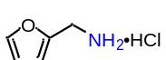
¹H NMR (DMSO-d₆, 400 MHz): δ = 8.50 (br s, 3H), 7.73–7.72 (m, 1H), 6.56–6.55 (m, 1H), 6.50–6.49 (m, 1H), 4.06 (s, 2H); ¹³C NMR (DMSO-d₆, 100 MHz): δ = 147.59, 143.71, 111.04, 110.43, 35.10.

2-thiophenemethylamine hydrochloride (2cc) [S4]
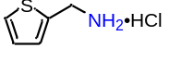
¹H NMR (DMSO-d₆, 400 MHz): δ = 8.57 (br s, 3H), 7.58–7.57 (m, 1H), 7.29–7.28 (m, 1H), 7.08–7.06 (m, 1H), 4.21 (s, 2H); ¹³C NMR (DMSO-d₆, 100 MHz): δ = 135.33, 129.08, 127.24, 127.20, 36.62.

1-pentanamine hydrochloride (2dd) [S18]
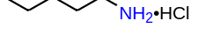
¹H NMR (DMSO-d₆, 400 MHz): δ = 8.04 (s, 3H), 2.73 (t, J = 7.6 Hz, 2H), 1.56–1.54 (m, 2H), 1.30–1.28 (m, 4H), 0.87–0.86 (m, 3H); ¹³C NMR (DMSO-d₆, 100 MHz): δ = 38.55, 27.86, 26.47, 21.50, 13.60.

1-octanamine hydrochloride (2ee) [S3]
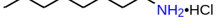
¹H NMR (DMSO-d₆, 400 MHz): δ = 8.06 (br s, 3H), 2.73 (t, J = 8.0 Hz, 2H), 1.57–1.51 (m, 2H), 1.32–1.19 (m, 10H), 0.88–0.85 (m, 3H); ¹³C NMR (DMSO-d₆, 100 MHz): δ = 38.61, 31.08, 28.41, 28.35, 26.84, 25.78, 21.99, 13.87.

1-decanamine hydrochloride (2ff) [S19]
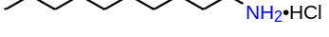
¹H NMR (DMSO-d₆, 400 MHz): δ = 7.75 (br s, 3H), 2.75 (t, J = 7.2 Hz, 2H), 1.54–1.50 (m, 2H), 1.28–1.22 (m, 14H), 0.86 (t, J = 7.2 Hz, 3H); ¹³C NMR (DMSO-d₆, 100 MHz): δ = 38.78, 31.20, 28.81, 28.76, 28.62, 28.46, 26.91, 25.74, 22.03, 13.91.

1-dodecanamine hydrochloride (2gg) [S6]
¹H NMR (DMSO-d₆, 400 MHz): δ = 7.80 (br s, 3H), 2.75 (t, J = 7.2 Hz, 2H), 1.54–1.49 (m, 2H), 1.31–1.22 (m, 18H), 0.86 (t, J = 7.2 Hz, 3H); ¹³C NMR (DMSO-d₆, 100 MHz): δ = 38.78, 31.27, 29.01, 28.99, 28.91, 28.81, 28.69, 28.50, 26.97, 25.78, 22.07, 13.95.

3-ethoxypropanamine hydrochloride (2hh) [Consistent with an authentic sample prepared from a commercial 2hh]
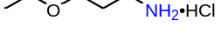
¹H NMR (DMSO-d₆, 400 MHz): δ = 8.18 (s, 3H), 3.44–3.40 (m, 4H), 2.81 (t, J = 7.2 Hz, 2H), 1.85–1.79 (m, 2H), 1.11 (t, J = 7.2 Hz, 3H); ¹³C NMR (DMSO-d₆, 100 MHz): δ =66.67, 65.31, 36.48, 27.20, 15.06.

neopentylamine hydrochloride (2ii) [S18]
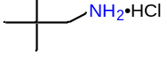
¹H NMR (DMSO-d₆, 400 MHz): δ = 7.97 (br s, 3H), 2.60 (s, 2H), 0.95 (s, 9H); ¹³C NMR (DMSO-d₆, 100 MHz): δ = 49.72, 30.15, 26.85.

cyclopropanemethylamine hydrochloride (2jj) [S15]
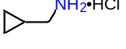
¹H NMR (DMSO-d₆, 400 MHz): δ = 8.10 (br s, 3H), 2.68–2.62 (m, 2H), 1.08–0.98 (m, 1H), 0.58–0.46 (m, 2H), 0.38–0.27 (m, 2H); ¹³C NMR (DMSO-d₆, 100 MHz): δ = 43.41, 8.52, 3.77.

cyclohexanemethylamine hydrochloride (2kk) [S4]
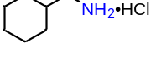
¹H NMR (DMSO-d₆, 400 MHz): δ = 8.09 (s, 3H), 2.60 (d, J = 6.8 Hz, 2H), 1.76–1.56 (m, 6H), 1.20–1.10 (m, 3H), 0.95–0.87 (m, 2H); ¹³C NMR (DMSO-d₆, 100 MHz): δ = 44.30, 35.33, 29.75, 25.61, 25.01.

1-adamantanemethylamine hydrochloride (2ll) [S20, S21]
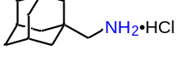
¹H NMR (DMSO-d₆, 400 MHz): δ = 7.96 (s, 3H), 2.46 (s, 2H), 1.96 (s, 3H), 1.69–1.52 (m, 12H); ¹³C NMR (DMSO-d₆, 100 MHz): δ = 49.84, 38.82, 36.05, 31.55, 27.32.

m-xylylenediamine dihydrochloride (2mm) [S21]
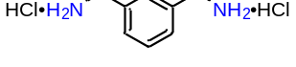
¹H NMR (DMSO-d₆, 400 MHz): δ = 8.35 (s, 6H), 7.53–7.49 (m, 4H), 4.03 (s, 4H); ¹³C NMR (DMSO-d₆, 100 MHz): δ = 134.36, 129.53, 129.00, 128.72, 42.09.

p-xylylenediamine dihydrochloride (2nn) [S22]
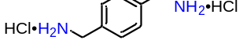
¹H NMR (DMSO-d₆, 400 MHz): δ = 8.60 (s, 6H), 7.53 (s, 4H), 4.01 (s, 4H); ¹³C NMR (DMSO-d₆, 100 MHz): δ = 134.15, 129.01, 41.69.

1,8-octanediamine dihydrochloride (2oo) [S22]
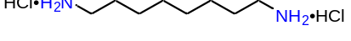
¹H NMR (DMSO-d₆, 400 MHz): δ = 7.90 (br s, 6H), 2.75 (t, J = 7.6 Hz, 4H), 1.58–1.51 (m, 4H), 1.34–1.26 (m, 8H); ¹³C NMR (DMSO-d₆, 100 MHz): δ = 38.70, 28.24, 26.88, 25.66.

1,10-decanediamine dihydrochloride (2pp) [S22]
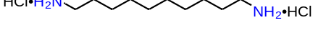
¹H NMR (DMSO-d₆, 400 MHz): δ = 7.97 (br s, 6H), 2.73 (t, J = 8.0 Hz, 4H), 1.58–1.51 (m, 4H), 1.32–1.23 (m, 12H); ¹³C NMR (DMSO-d₆, 100 MHz): δ = 38.86, 28.84, 28.65, 27.09, 25.99.
4. ¹H and ¹³C NMR spectra

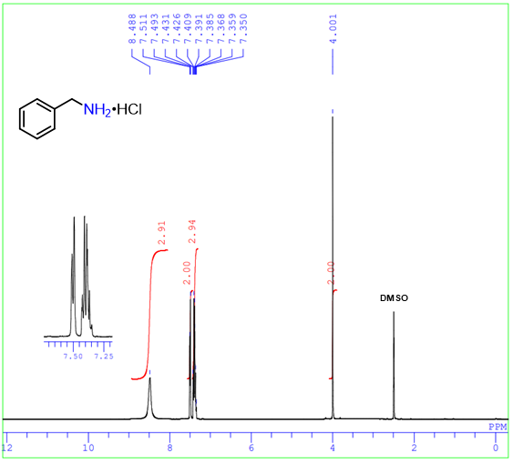
¹H NMR spectrum of benzylamine hydrochloride (2a)

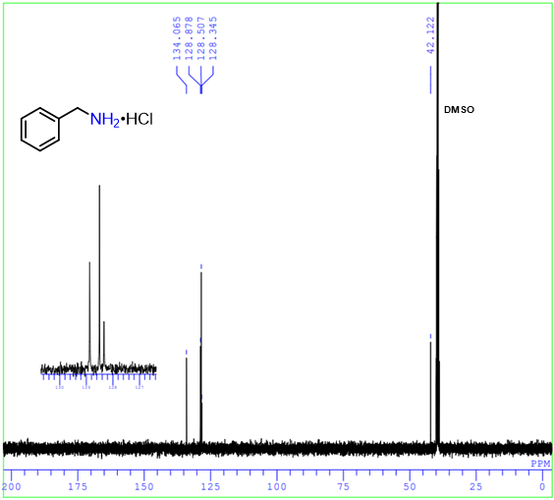
¹³C NMR spectrum of benzylamine hydrochloride (2a)

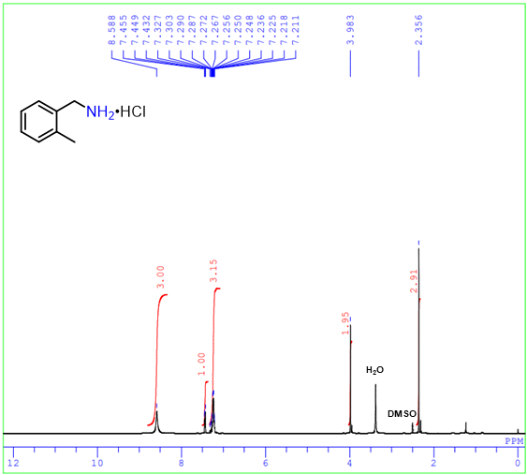
¹H NMR spectrum of o-methylbenzylamine hydrochloride (2b)

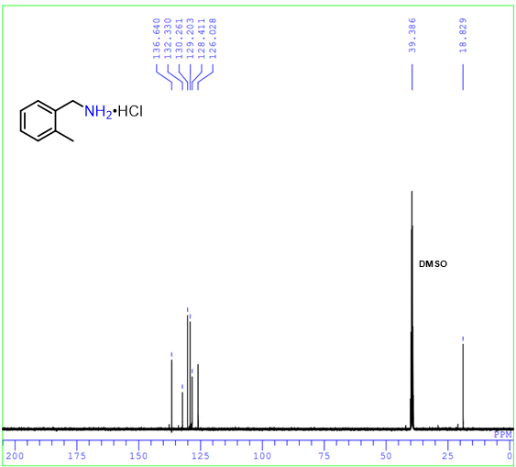
¹³C NMR spectrum of o-methylbenzylamine hydrochloride (2b)

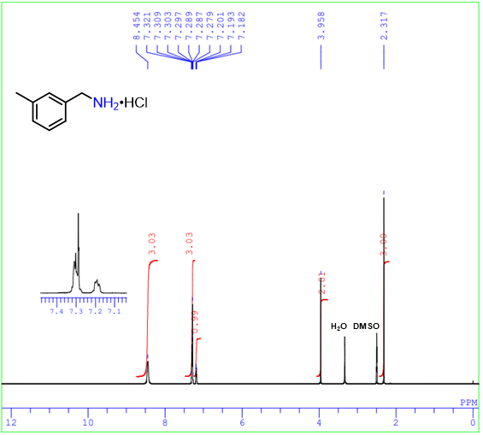
¹H NMR spectrum of m-methylbenzylamine hydrochloride (2c)

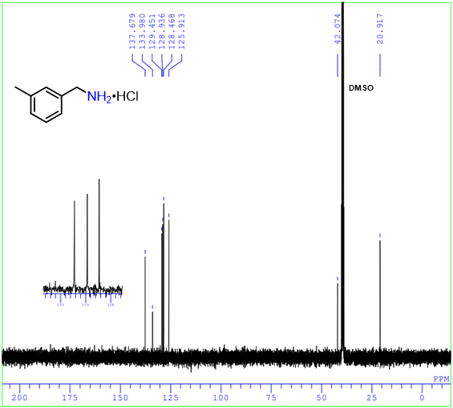
¹³C NMR spectrum of m-methylbenzylamine hydrochloride (2c)

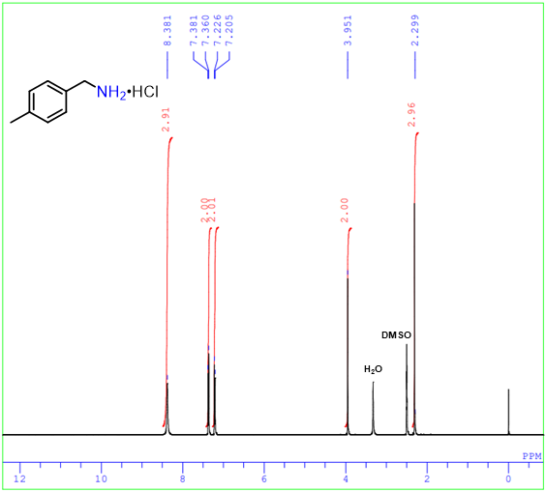
¹H NMR spectrum of p-methylbenzylamine hydrochloride (2d)

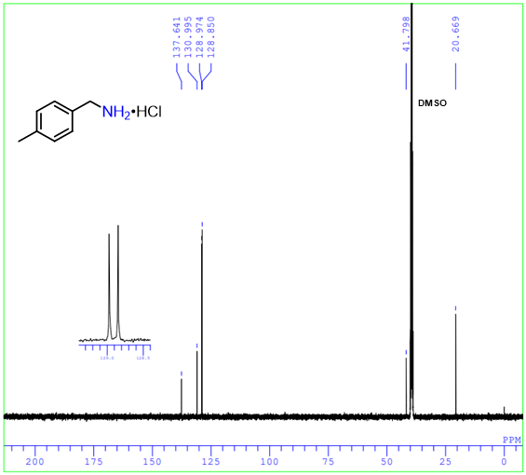
¹³C NMR spectrum of p-methylbenzylamine hydrochloride (2d)

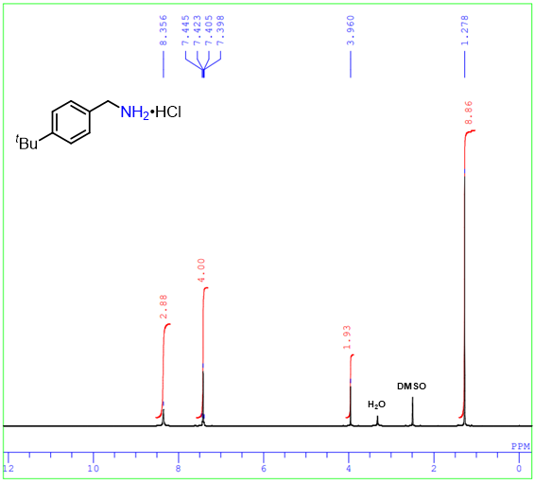
¹H NMR spectrum of p-tert-butylbenzylamine hydrochloride (2e)

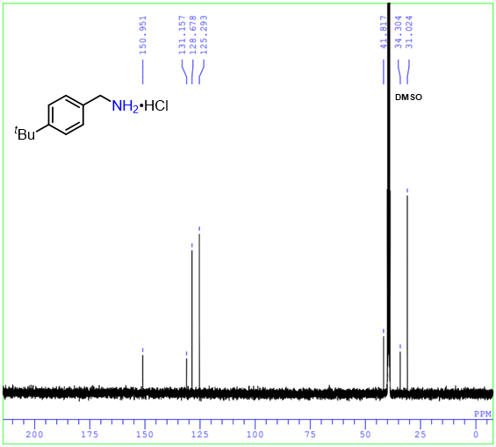
¹³C NMR spectrum of p-tert-butylbenzylamine hydrochloride (2e)

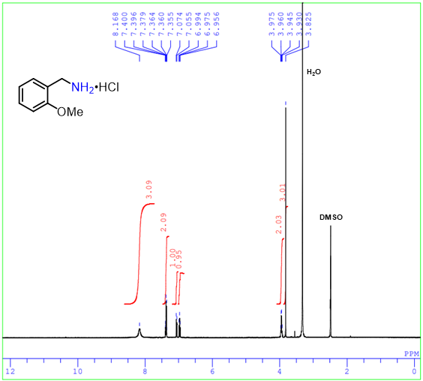
¹H NMR spectrum of o-methoxybenzylamine hydrochloride (2f)

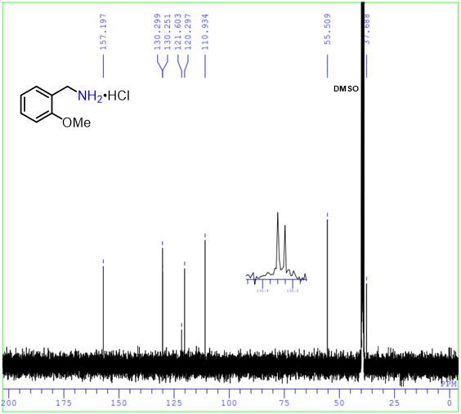
¹³C NMR spectrum of o-methoxybenzylamine hydrochloride (2f)

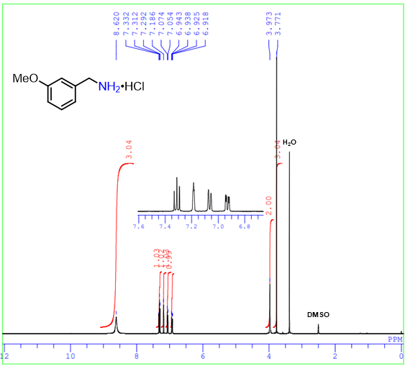
¹H NMR spectrum of m-methoxybenzylamine hydrochloride (2g)

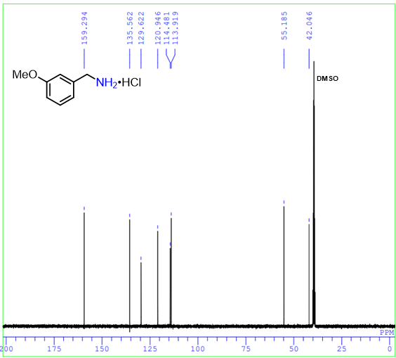
¹³C NMR spectrum of m-methoxybenzylamine hydrochloride (2g)

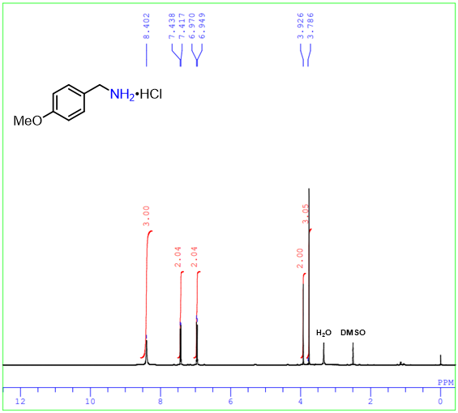
¹H NMR spectrum of p-methoxybenzylamine hydrochloride (2h)

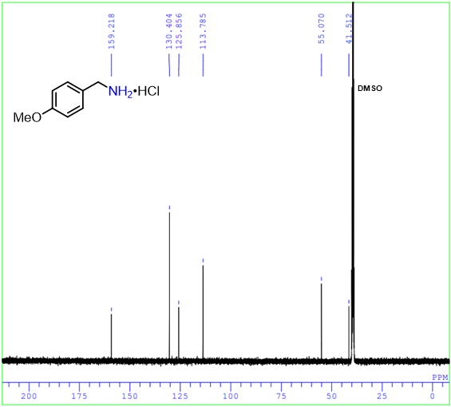
¹³C NMR spectrum of p-methoxybenzylamine hydrochloride (2h)

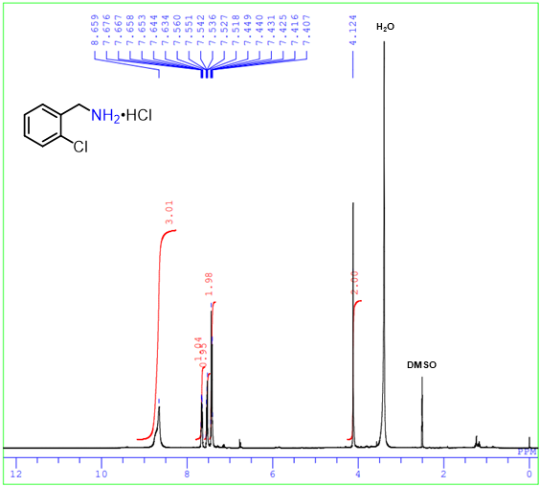
¹H NMR spectrum of o-chlorobenzylamine hydrochloride (2i)

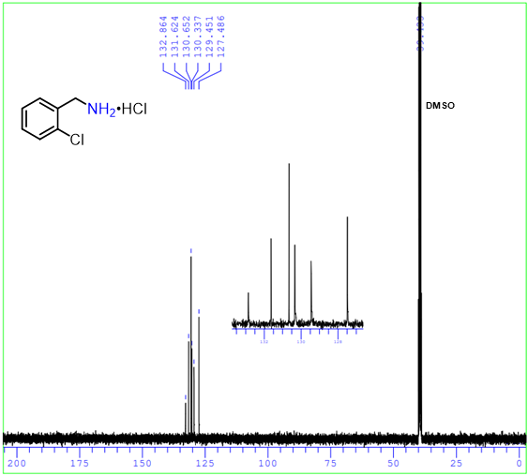
¹³C NMR spectrum of o-chlorobenzylamine hydrochloride (2i)

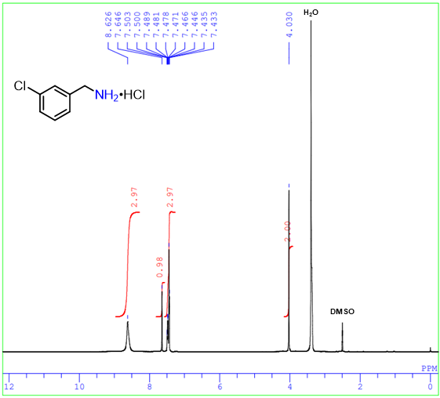
¹H NMR spectrum of m-chlorobenzylamine hydrochloride (2j)

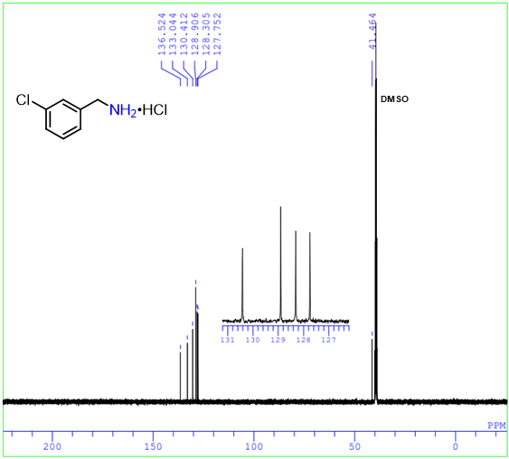
¹³C NMR spectrum of m-chlorobenzylamine hydrochloride (2j)

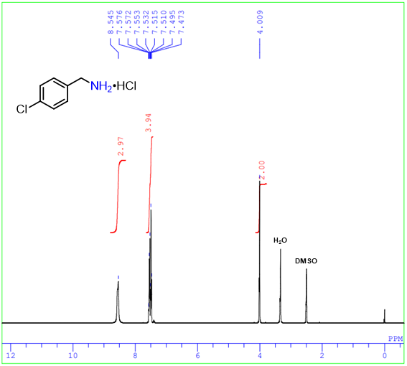
¹H NMR spectrum of p-chlorobenzylamine hydrochloride (2k)

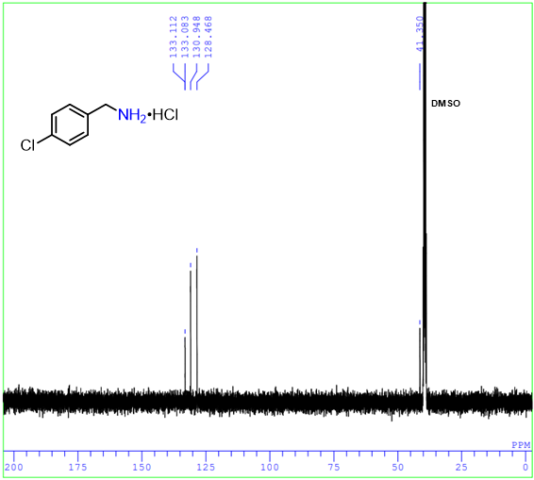
¹³C NMR spectrum of p-chlorobenzylamine hydrochloride (2k)

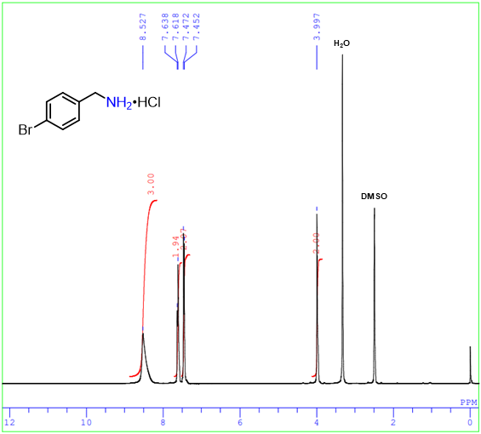
¹H NMR spectrum of p-bromobenzylamine hydrochloride (2l)

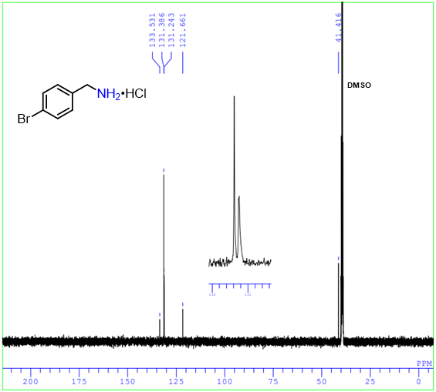
¹³C NMR spectrum of p-bromobenzylamine hydrochloride (2l)

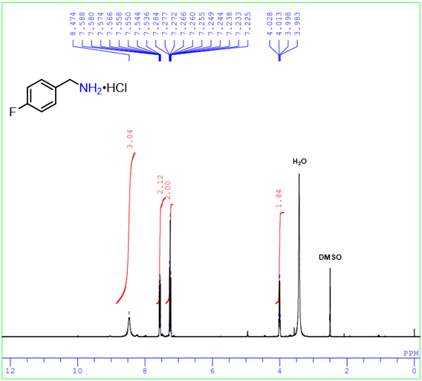
¹H NMR spectrum of p-fluorobenzylamine hydrochloride (2m)

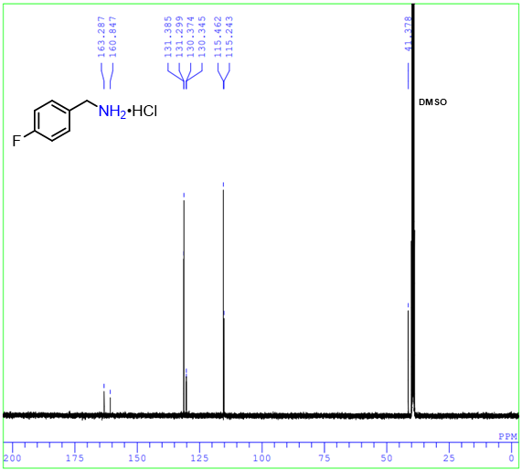
¹³C NMR spectrum of p-fluorobenzylamine hydrochloride (2m)

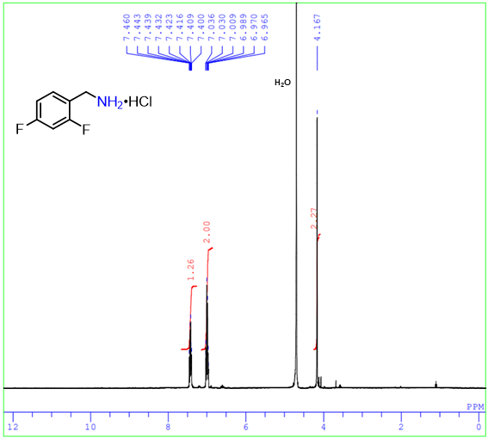
¹H NMR spectrum of 2,4-difluorobenzylamine hydrochloride (2n)

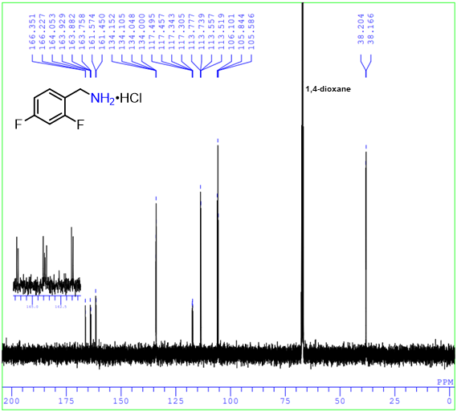
¹³C NMR spectrum of 2,4-difluorobenzylamine hydrochloride (2n)

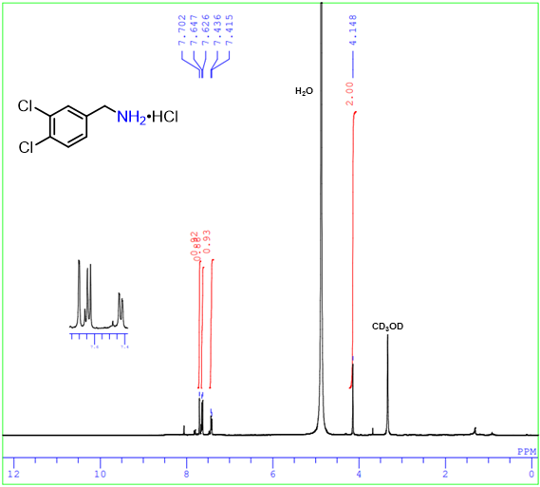
¹H NMR spectrum of 3,4-dichlorobenzylamine hydrochloride (2o)

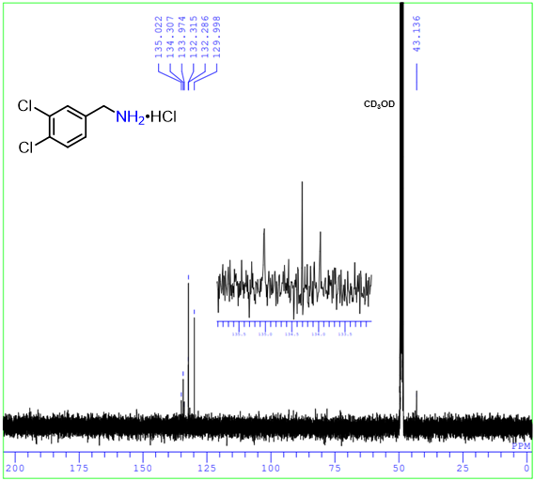
¹³C NMR spectrum of 3,4-dichlorobenzylamine hydrochloride (2o)

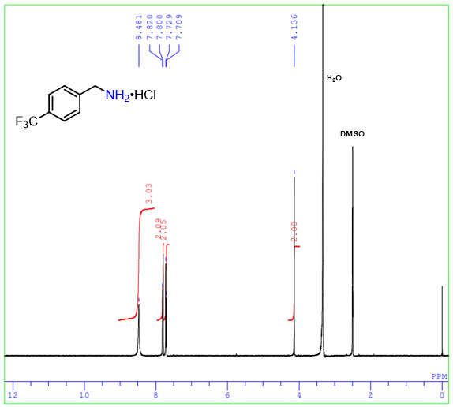
¹H NMR spectrum of p-(trifluoromethyl)benzylamine hydrochloride (2p)

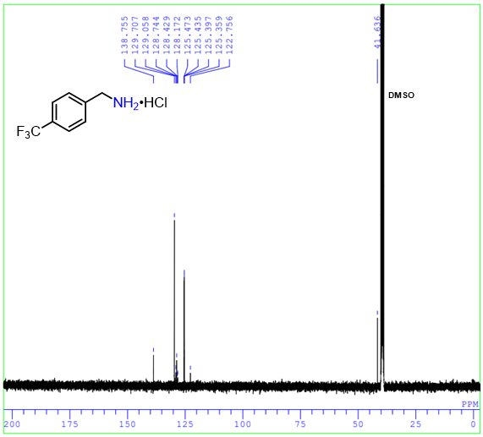
¹³C NMR spectrum of p-(trifluoromethyl)benzylamine hydrochloride (2p)

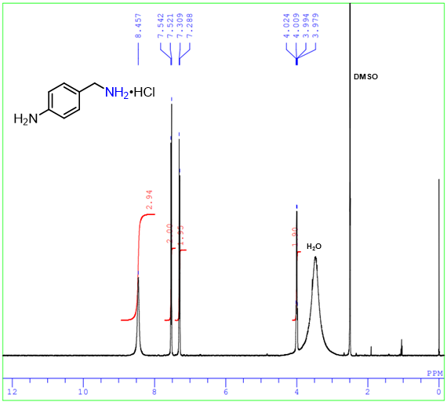
¹H NMR spectrum of p-aminobenzylamine hydrochloride (2q)

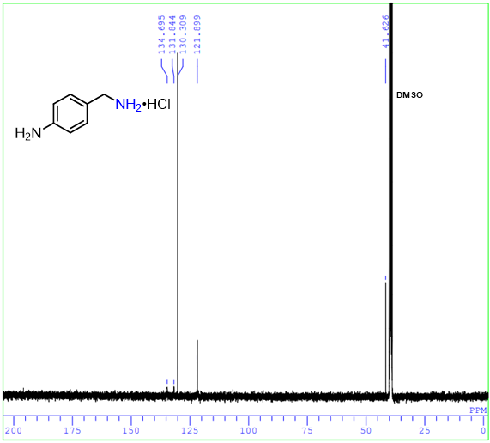
¹³C NMR spectrum of p-aminobenzylamine hydrochloride (2q)

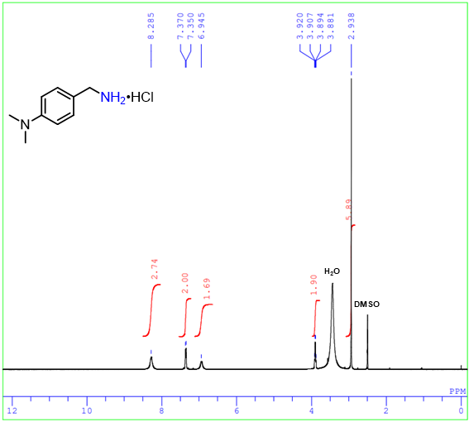
¹H NMR spectrum of p-(N,N-dimethylamino)benzylamine hydrochloride (2r)

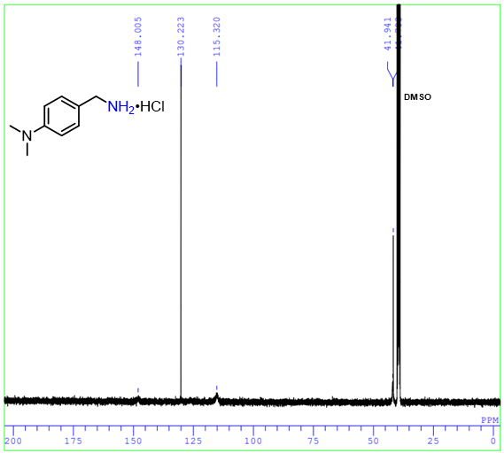
¹³C NMR spectrum of p-(N,N-dimethylamino)benzylamine hydrochloride (2r)

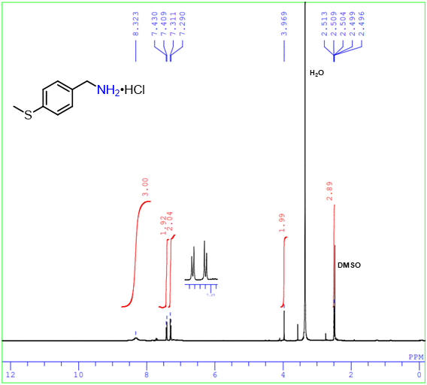
¹H NMR spectrum of p-(methylthio)benzylamine hydrochloride (2s)

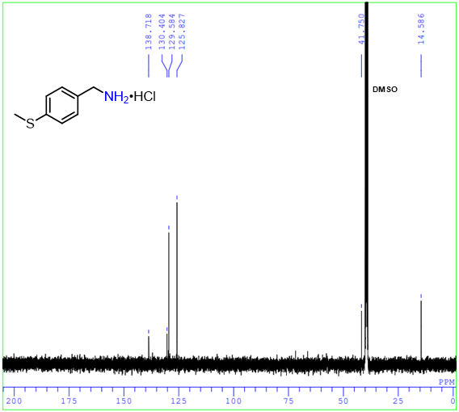
¹³C NMR spectrum of p-(methylthio)benzylamine hydrochloride (2s)

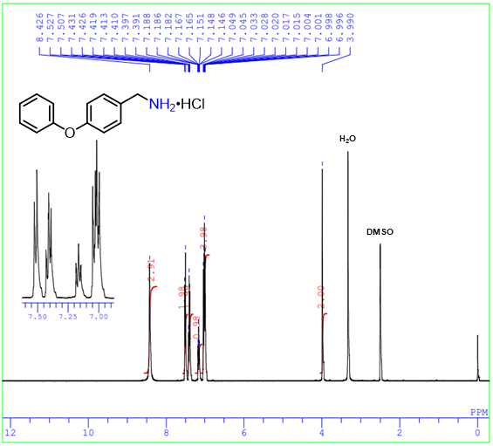
¹H NMR spectrum of p-phenyoxybenzylamine hydrochloride (2t)

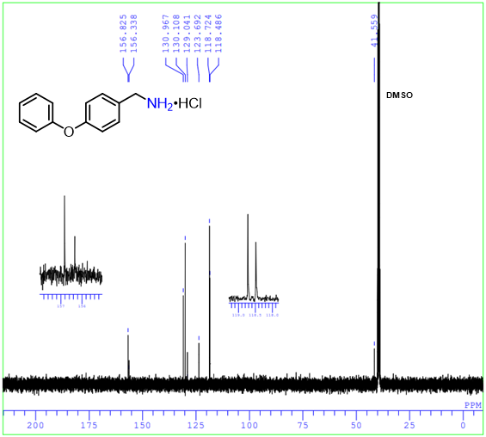
¹³C NMR spectrum of p-phenyoxybenzylamine hydrochloride (2t)

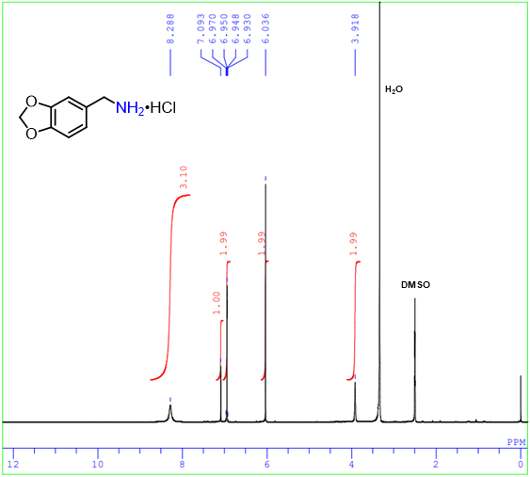
¹H NMR spectrum of 3,4-methylenedioxybenzylamine hydrochloride (2u)

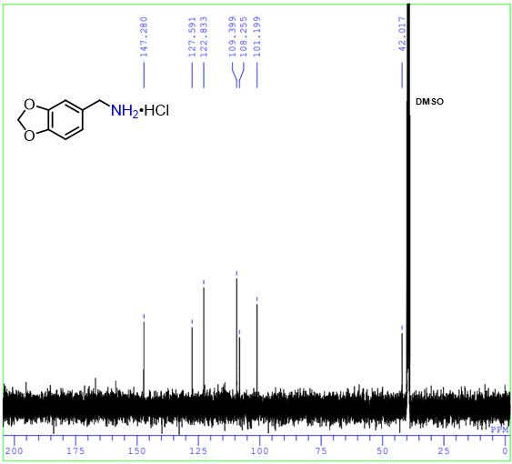
¹³C NMR spectrum of 3,4-methylenedioxybenzylamine hydrochloride (2u)

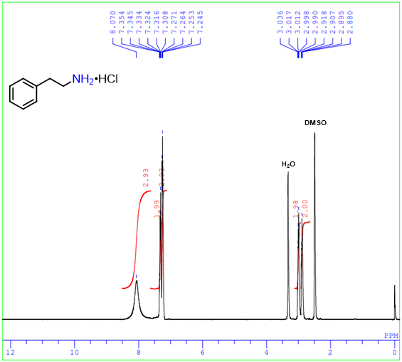
¹H NMR spectrum of 2-phenylethaneamine hydrochloride (2v)

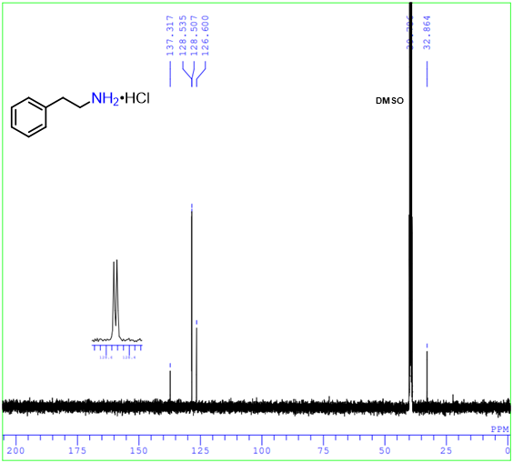
¹³C NMR spectrum of 2-phenylethaneamine hydrochloride (2v)

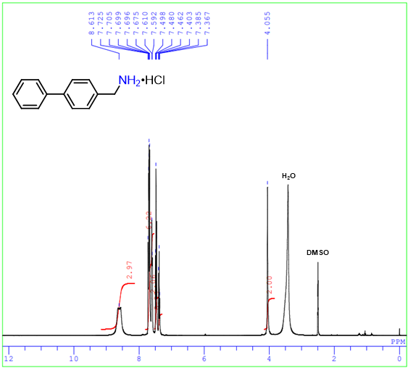
¹H NMR spectrum of p-phenylbenzylamine hydrochloride (2w)

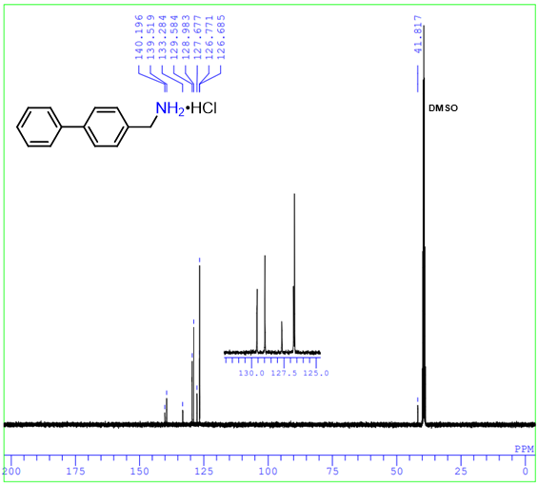
¹³C NMR spectrum of p-phenylbenzylamine hydrochloride (2w)

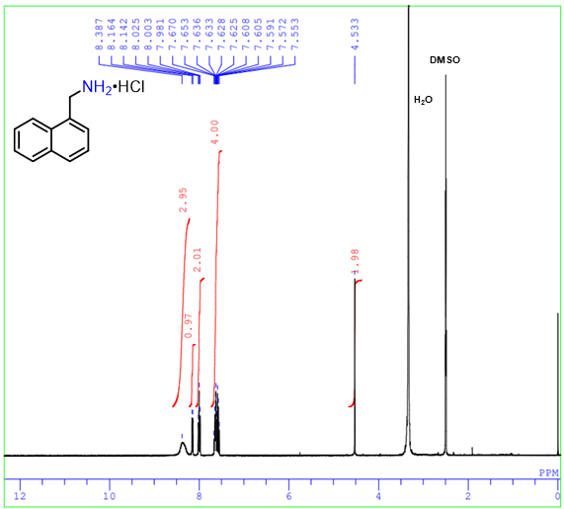
¹H NMR spectrum of 1-naphthalenemethylamine hydrochloride (2x)

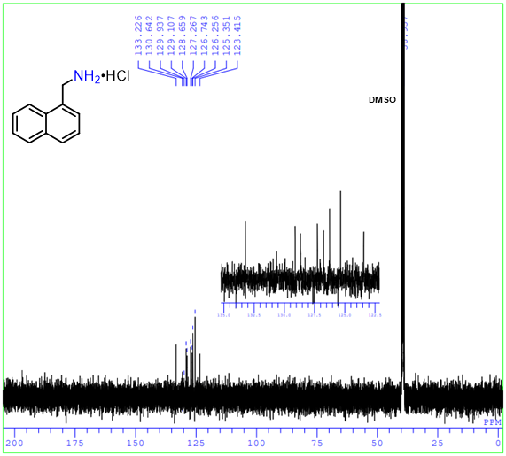
¹³C NMR spectrum of 1-naphthalenemethylamine hydrochloride (2x)

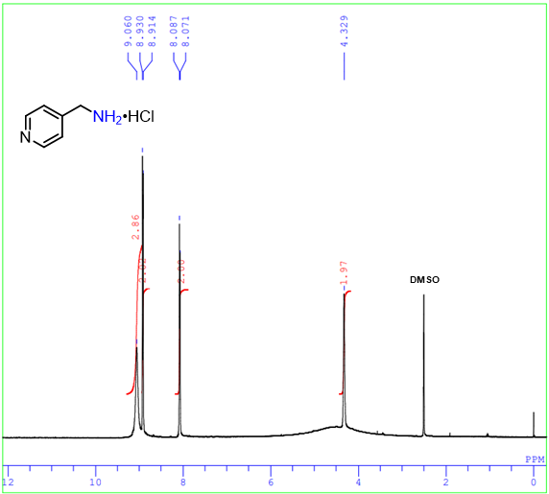
¹H NMR spectrum of 4-picolylamine hydrochloride (2y)

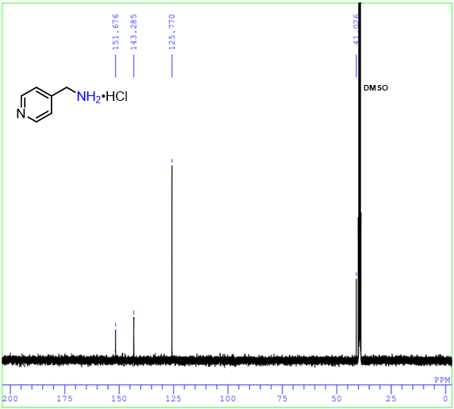
¹³C NMR spectrum of 4-picolylamine hydrochloride (2y)

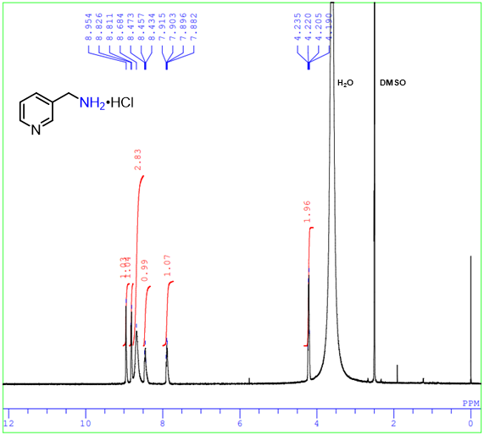
¹H NMR spectrum of 3-picolylamine hydrochloride (2z)

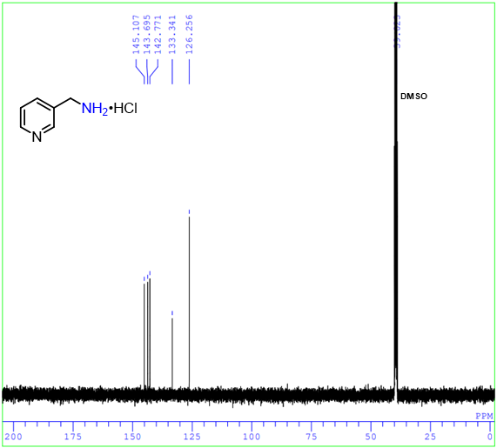
¹³C NMR spectrum of 3-picolylamine hydrochloride (2z)

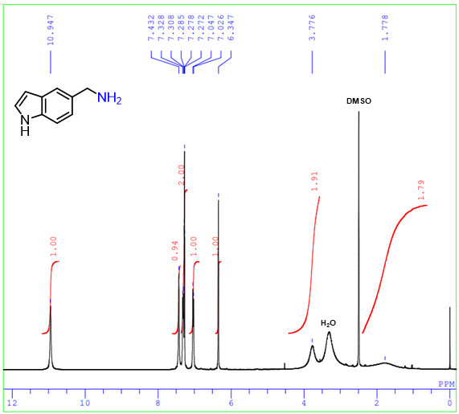
¹H NMR spectrum of 5-aminomethylindole (2aa)

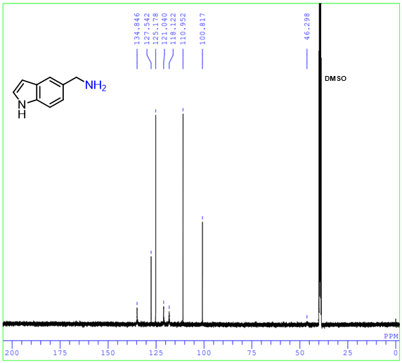
¹³C NMR spectrum of 5-aminomethylindole (2aa)

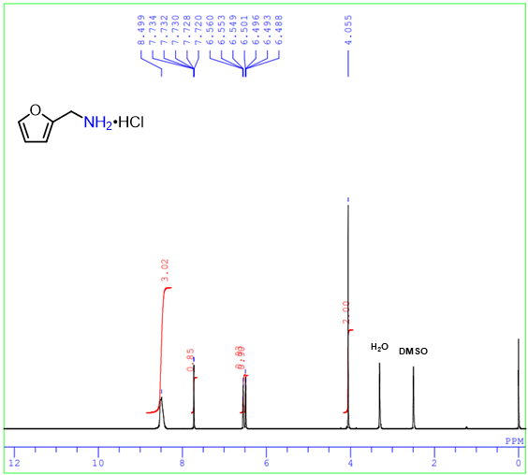
¹H NMR spectrum of furfurylamine hydrochloride (2bb)

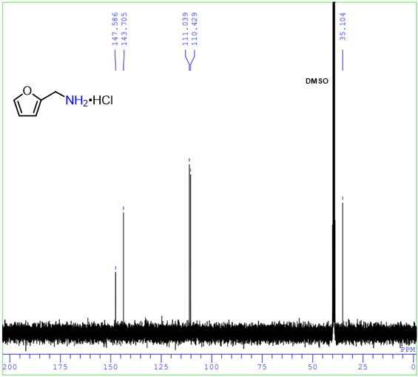
¹³C NMR spectrum of furfurylamine hydrochloride (2bb)

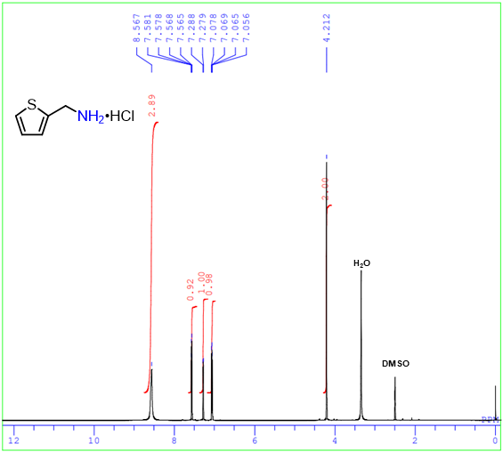
¹H NMR spectrum of 2-thiophenemethylamine hydrochloride (2cc)

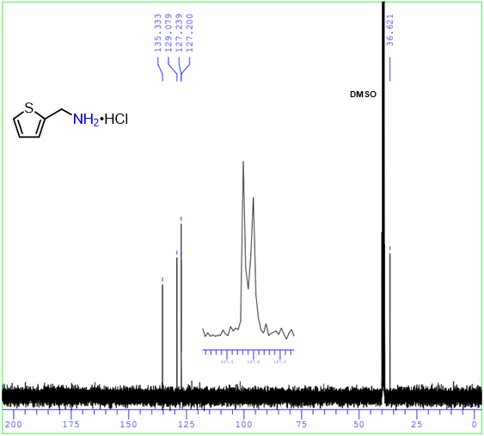
¹³C NMR spectrum of 2-thiophenemethylamine hydrochloride (2cc)

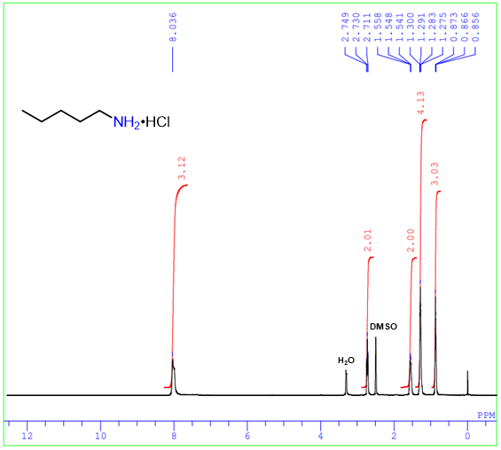
¹H NMR spectrum of 1-pentanamine hydrochloride (2dd)

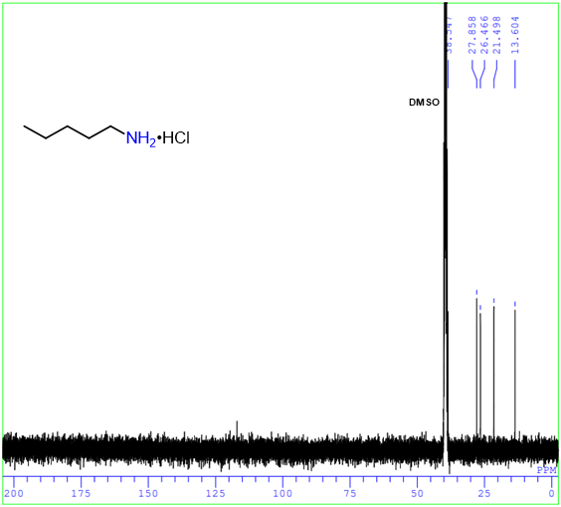
¹³C NMR spectrum of 1-pentanamine hydrochloride (2dd)

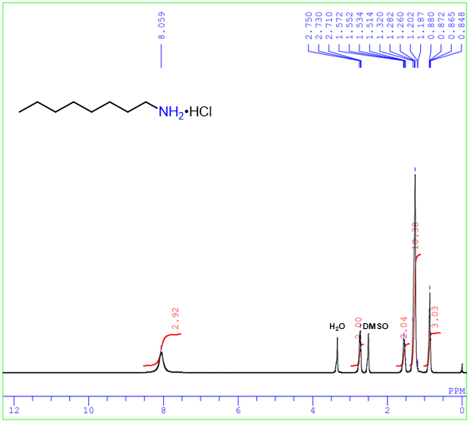
¹H NMR spectrum of 1-octanamine hydrochloride (2ee)

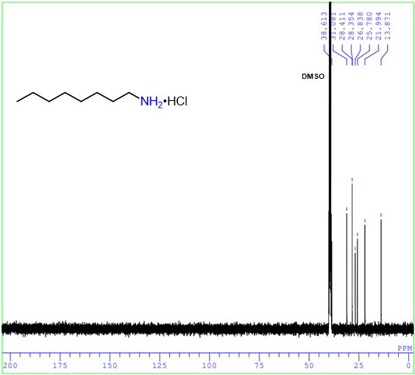
¹³C NMR spectrum of 1-octanamine hydrochloride (2ee)

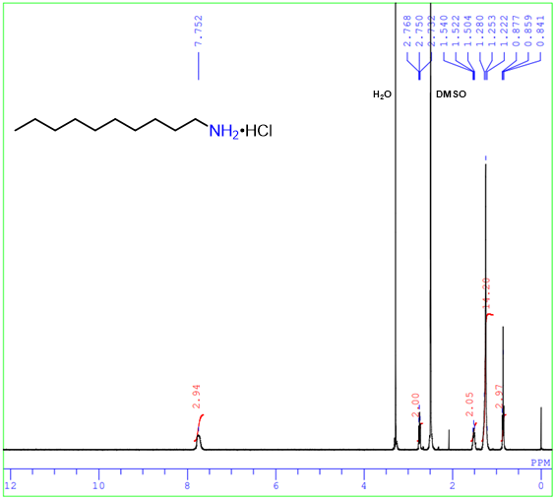
¹H NMR spectrum of 1-decanamine hydrochloride (2ff)

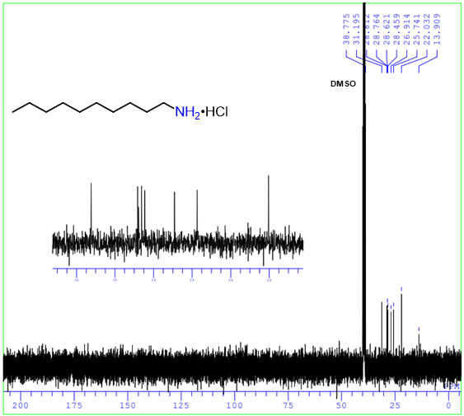
¹³C NMR spectrum of 1-decanamine hydrochloride (2ff)

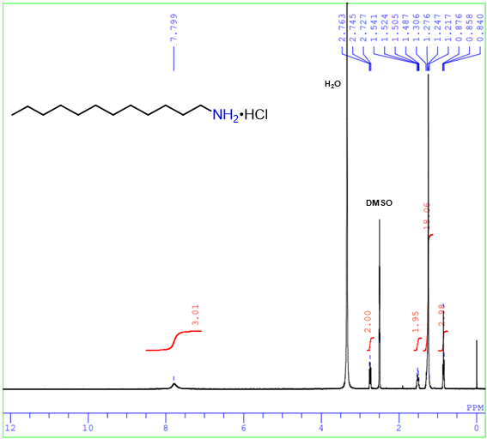
¹H NMR spectrum of 1-dodecanamine hydrochloride (2gg)

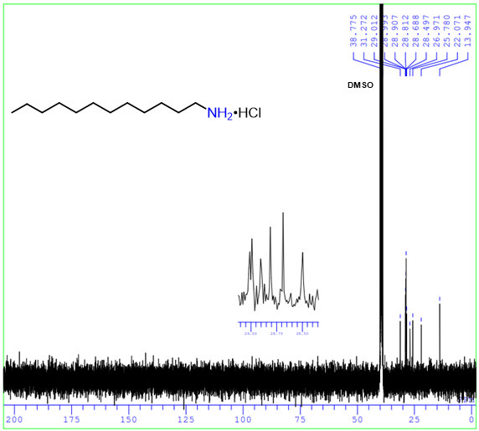
¹³C NMR spectrum of 1-dodecanamine hydrochloride (2gg)

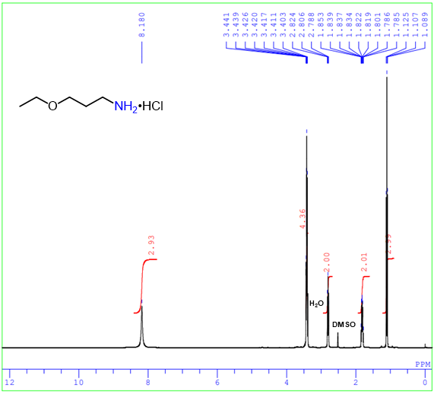
¹H NMR spectrum of 3-ethoxypropanamine hydrochloride (2hh)

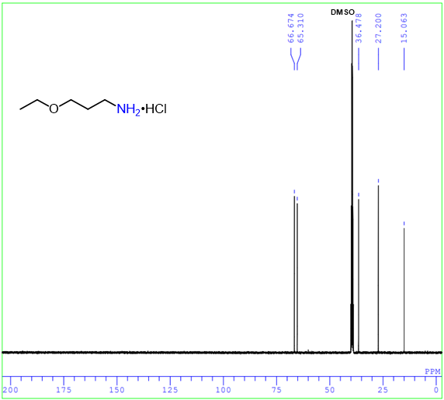
¹³C NMR spectrum of 3-ethoxypropanamine hydrochloride (2hh)

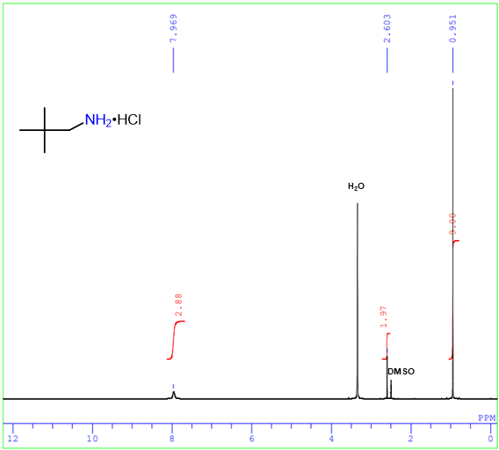
¹H NMR spectrum of neopentylamine hydrochloride (2ii)

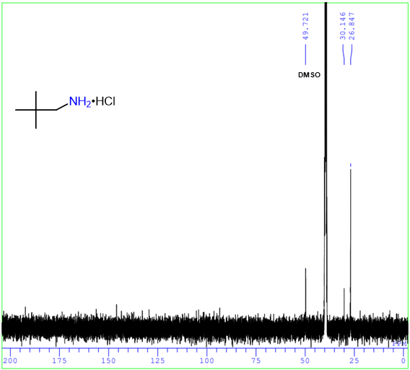
¹³C NMR spectrum of neopentylamine hydrochloride (2ii)

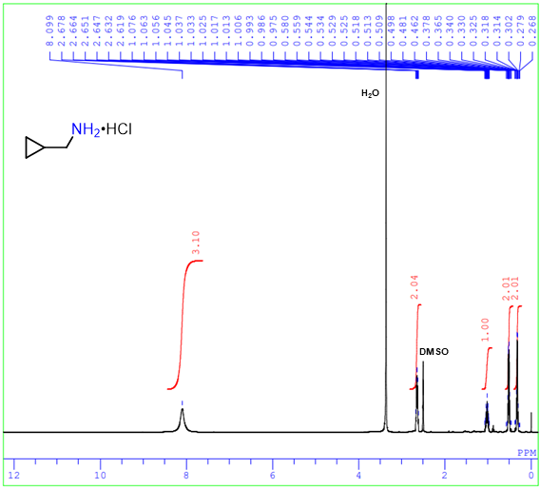
¹H NMR spectrum of cyclopropanemethylamine hydrochloride (2jj)

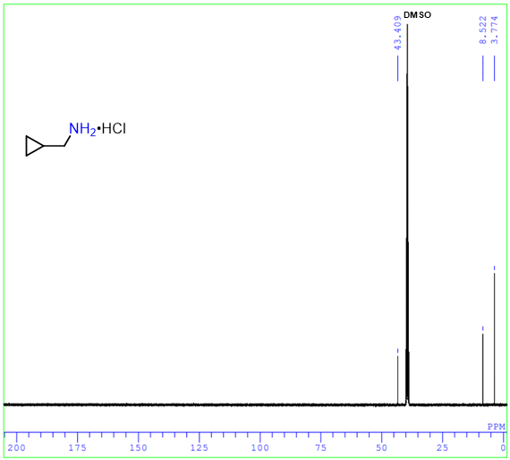
¹³C NMR spectrum of cyclopropanemethylamine hydrochloride (2jj)

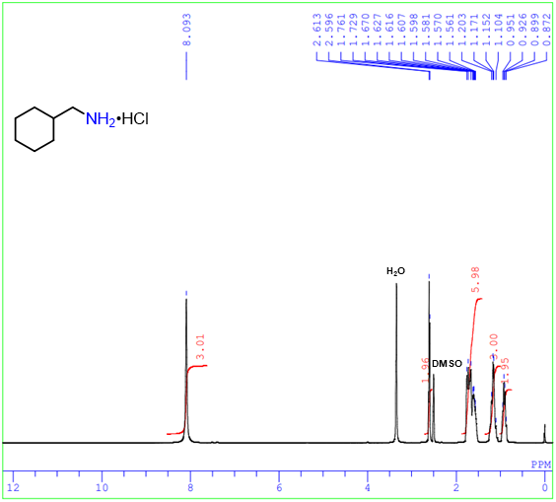
¹H NMR spectrum of cyclohexanemethylamine hydrochloride (2kk)

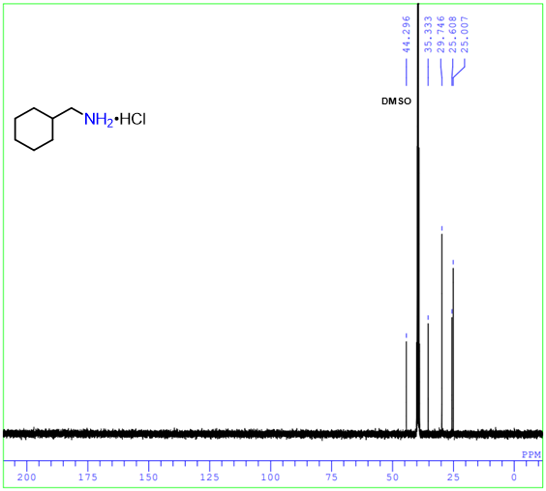
¹³C NMR spectrum of cyclohexanemethylamine hydrochloride (2kk)

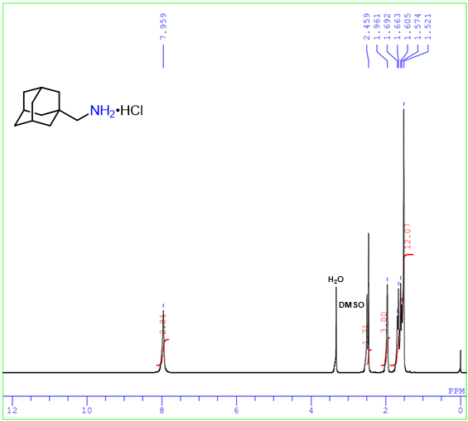
¹H NMR spectrum of 1-adamantanemethylamine hydrochloride (2ll)

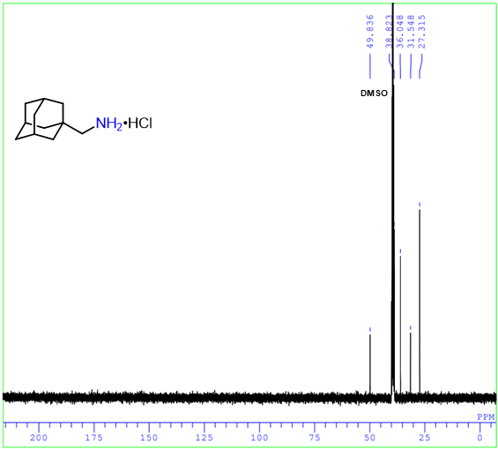
¹³C NMR spectrum of 1-adamantanemethylamine hydrochloride (2ll)

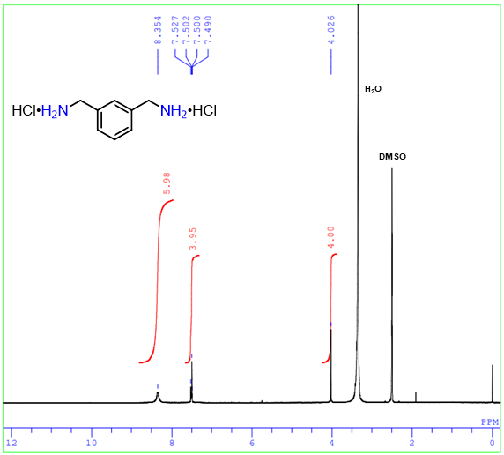
¹H NMR spectrum of m-xylylenediamine dihydrochloride (2mm)

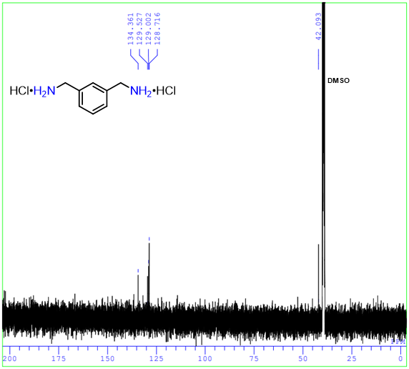
¹³C NMR spectrum of m-xylylenediamine dihydrochloride (2mm)

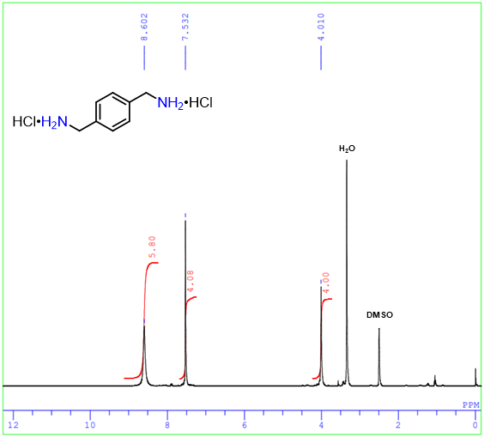
¹H NMR spectrum of p-xylylenediamine dihydrochloride (2nn)

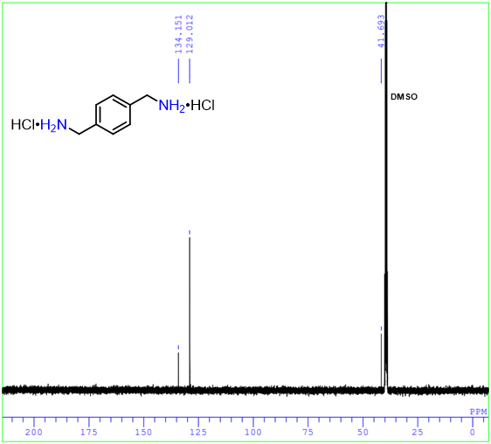
¹³CNMR spectrum of p-xylylenediamine dihydrochloride (2nn)

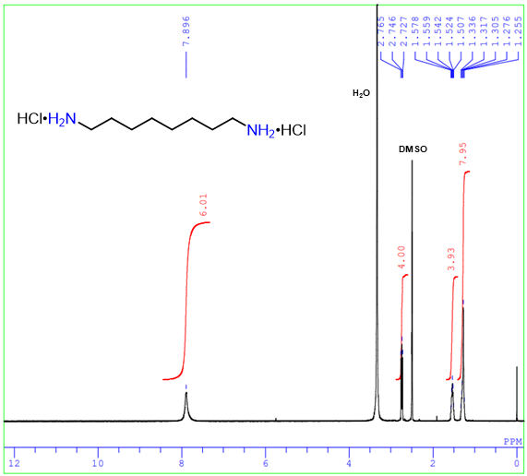
¹H NMR spectrum of 1,8-octanediamine dihydrochloride (2oo)

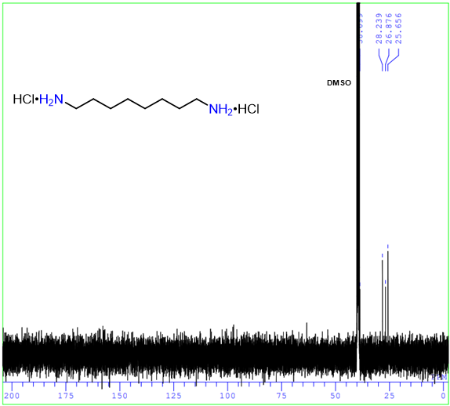
¹³C NMR spectrum of 1,8-octanediamine dihydrochloride (2oo)

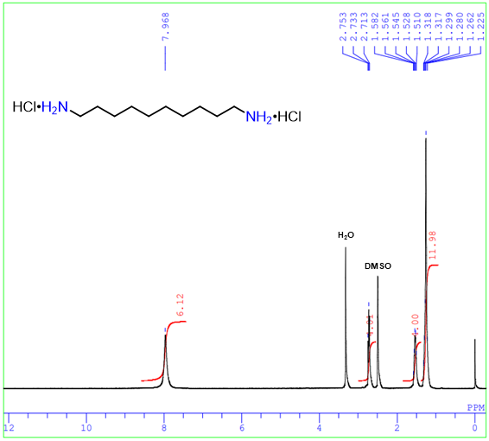
¹H NMR spectrum of 1,10-decanediamine dihydrochloride (2pp)

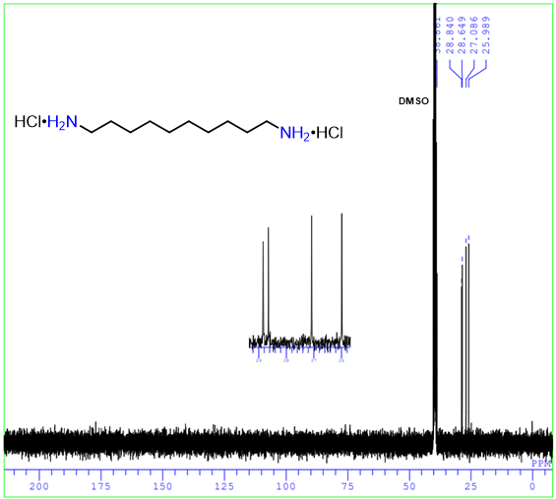
¹³C NMR spectrum of 1,10-decanediamine dihydrochloride (2pp)

5. References
[S1] Chandrashekhar, V. G. et al. Silica-supported Fe/Fe–O nanoparticles for the catalytic hydrogenation of nitriles to amines in the presence of aluminium additives. Nat. Catal. 5, 20–29 (2022). 10.1038/s41929-021-00722-x.
[S2] Chen, F. et al. Stable and inert cobalt catalysts for highly selective and practical hydrogenation of C≡N and C=O bonds. J. Am. Chem. Soc. 138, 8781–8788 (2016). 10.1021/jacs.6b03439.
[S3] Sanagawa, A. & Nagashima, H. Hydrosilane reduction of nitriles to primary amines by cobalt-isocyanide catalysts. Org. Lett. 21, 287–291 (2019). 10.1021/acs.orglett.8b03736.
[S4] Gautam, N. et al. Bicyclic (alkyl)(amino)carbene (BICAAC) as a metal-free catalyst for reduction of nitriles to amines. Chem. Commum. 58, 3047–3050 (2022). 10.1039/D1CC06962D.
[S5] Pandey, V. K., Tiwari, C. S. & Rit, A. Silver-catalyzed hydroboration of C–X (X = C, O, N) multiple bonds. Org. Lett. 23, 1681–1686 (2021). 10.1021/acs.orglett.1c00106.
[S6] Neumann, J., Bornschein, C., Jiao, H. J., Junge, K. & Beller, M. Hydrogenation of aliphatic and aromatic nitriles using a defined ruthenium PNP pincer catalyst. Eur. J. Org. Chem. 2015, 5944–5948 (2015). 10.1002/ejoc.201501007.
[S7] Elangovan, S. et al. Selective catalytic hydrogenations of nitriles, ketones, and aldehydes by well-defined manganese pincer complexes. J. Am. Chem. Soc. 138, 8809–8814 (2016). 10.1021/jacs.6b03709.
[S8] Bisai, M. K., Gour, K., Das, T., Vanka, K. & Sen, S. S. Lithium compound catalyzed deoxygenative hydroboration of primary, secondary and tertiary amides. Dalton Trans. 50, 2354–2358 (2021). 10.1039/D1DT00364J.
[S9] Yu, J. H. et al. Fabrication of ω-transaminase@metal-organic framework biocomposites for efficiently synthesizing benzylamines and pyridylmethylamines. Adv. Synth. Catal. 364, 380–390 (2022). 10.1002/adsc.202100997.
[S10] Reeves, J. T. et al. A practical procedure for reduction of primary, secondary and tertiary amides to amines. Adv. Synth. Catal. 355, 47–52 (2013). 10.1002/adsc.201200835.
[S11] Pandey, P. & Bera, J. K. Hydrosilylative reduction of primary amides to primary amines catalyzed by a terminal [Ni–OH] complex. Chem. Commun. 57, 9204–9207 (2021). 10.1039/D1CC03537A.
[S12] Wang, Y. et al. Generalized chemoselective transfer hydrogenation/hydrodeuteration. Adv. Synth. Catal. 362, 4119–4129 (2020). 10.1002/adsc.202000759.
[S13] Wübbolt, S. & Oestreich, M. Exhaustive chemoselective reduction of nitriles by catalytic hydrosilylation involving cooperative Si–H bond activation. Synlett 28, 2411–2414 (2017). 10.1055/s-0036-1588441.
[S14] Audubert, C., Bouchard, A., Mathieu, G. & Lebel, H. Chemoselective synthesis of amines from ammonium hydroxide and hydroxylamine in continuous flow. J. Org. Chem. 83, 14203–14209 (2018). 10.1021/acs.joc.8b02387.
[S15] Das, H. S. et al. Primary amides to amines or nitriles: a dual role by a single catalyst. Chem. Commun. 55, 11868–11871 (2019). 10.1039/C9CC05856G.
[S16] Yuan, H. & Silverman, R. B. Substrates and inhibitors of gamma-aminobutyric acid aminotransferase containing bioisosteres of the carboxylic acid group: design, synthesis, and biological activity. Bioorg. Med. Chem. 14, 1331–1338 (2006). 10.1016/j.bmc.2005.09.067.
[S17] Utsumi, T., Noda, K., Kawauchi, D., Ueda, H. & Tokuyama, H. Nitrile synthesis by aerobic oxidation of primary amines and in situ generated imines from aldehydes and ammonium salt with Grubbs catalyst. Adv. Synth. Catal. 362, 3583–3588 (2020). 10.1002/adsc.202000663.
[S18] Tokmic, K., Jackson, B. J., Salazar, A., Woods, T. J. & Fout, A. R. Cobalt-catalyzed and Lewis acid-assisted nitrile hydrogenation to primary amines: a combined effort. J. Am. Chem. Soc. 139, 13554–13561 (2017). 10.1021/jacs.7b07368.
[S19] Sheng, M. et al. Hydrotalcite-supported cobalt phosphide nanorods as a highly active and reusable heterogeneous catalyst for ammonia-free selective hydrogenation of nitriles to primary amines. ACS Sustainable Chem. Eng. 9, 11238–11246 (2021). 10.1021/acssuschemeng.1c03667.
[S20] Yao, W. B. et al. A BEt₃-base catalyst for amide reduction with silane. J. Org. Chem. 84, 6084–6093 (2019). 10.1021/acs.joc.9b00277.
[S21] Fujita, S. et al. Ni₂P nanoalloy as an air-stable and versatile hydrogenation catalyst in water: P-alloying strategy for designing smart catalysts. Chem. Eur. J. 27, 4439–4446 (2021). 10.1002/chem.202005037.
[S22] Heilmann, M. & Tiefenbacher, K. A modular phosphorylated glycoluril-derived molecular tweezer for potent binding of aliphatic diamines. Chem. Eur. J. 25, 12900–12904 (2019). 10.1002/chem.201902556.

