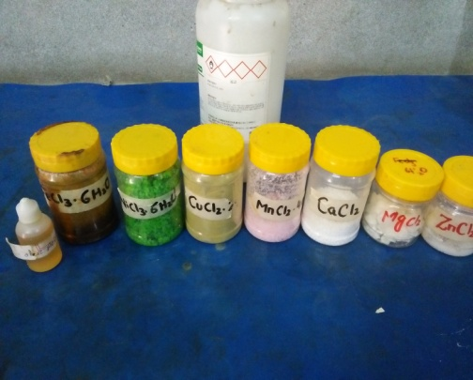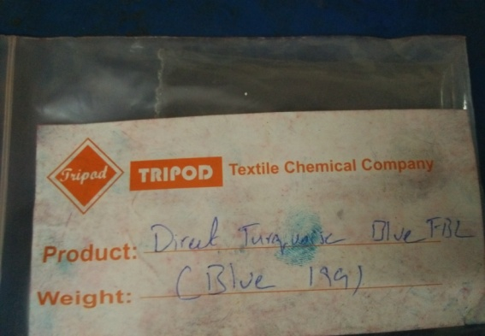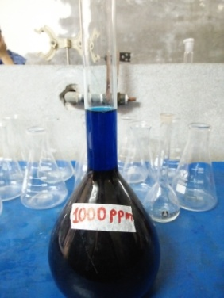
- (b) (c)
Fig S1 (a) Required Chemicals (b) Synthetic Direct Blue-199 Dye (c) DB-199 Dye Stock solution
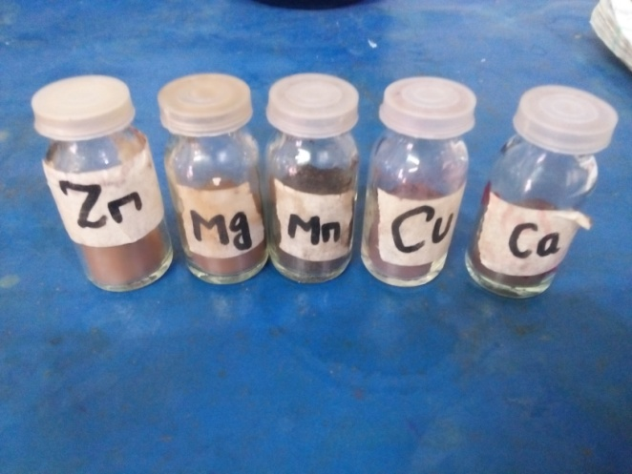
Fig. 2S Chemically synthesized Zinc, Magnesium, Manganese, Copper and Calcium doped nickel ferrite nanoparticles

