Electronic Supplementary Information (ESI)

A fluorescent probe based on the hydrazone Schiff base for the detection of Zn²⁺ and its application on test strips
Guo Xuª, Shu-Jie Maª, Hua-Hong Zhangª, Jing Jingª, Xing-Han Chen^{b}, Xiao-Peng Zhang^{a,*}
ª College of Chemistry and Chemical Engineering, Key Laboratory of Water Pollution Treatment & Resource Reuse of Hainan Province, Hainan Normal University, Haikou 571158, China
^{b} College of Chemical Engineering, Nanjing Forestry University, Nanjing 210037, China
Corresponding author: Xiao-Peng Zhang
E-mail address: zxp_inorganic@126.com

Fig. S1 ¹H NMR spectra of compound 1 in CDCl₃.
Fig. S2 ¹³C NMR spectra of compound 1 in CDCl₃.
Fig. S3 ¹H NMR spectra of compound SHK in DMSO-d₆.
Fig. S4 ¹³C NMR spectra of compound SHK in DMSO-d₆.
Fig. S5 Benesi-Hildebrand plot of SHK-Zn²⁺ complexes in DMSO/H₂O (9:1, v/v).
Fig. S6 Absorbance spectra of probe SHK (2.5 × 10⁻⁴ M) in DMSO/H2O (9 / 1, v/v) in the presence of different concentrations of Zn²⁺ ions (0~140 eq).
Fig. S7 UV-vis titration and calculation of banding constant of probe SHK for Zn²⁺ ions.
Fig. S8 UV-vis absorption spectra response of SHK in DMSO/H2O (9:1, v/v) upon adding different amounts of Zn²⁺.
Fig. S9 The stability of probe SHK in DMSO/H₂O (9/1, v/v).

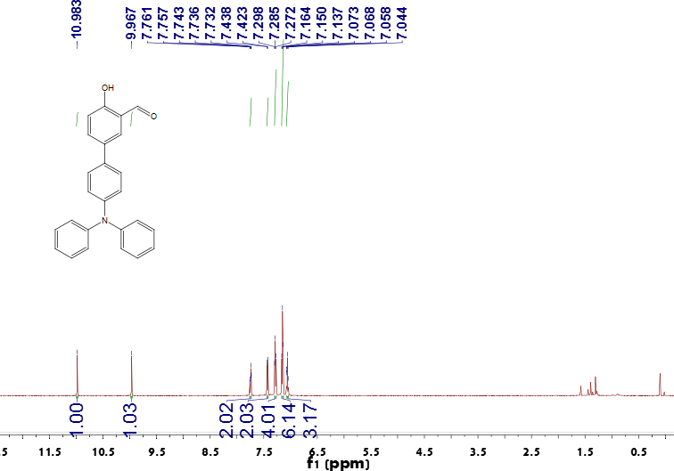
Fig. S1 ¹H NMR spectra of compound triphenylamine hydroxyl carbaldehyde in CDCl₃
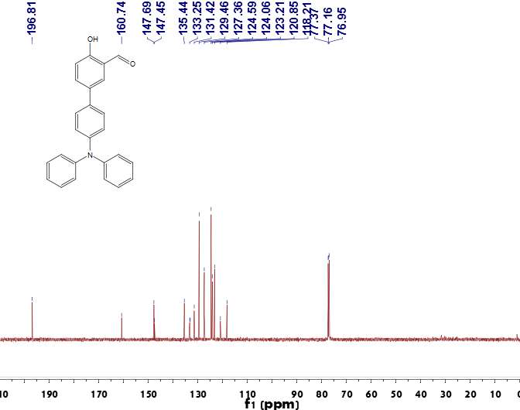
Fig. S2 ¹³C NMR spectra of compound triphenylamine hydroxyl carbaldehyde in CDCl₃
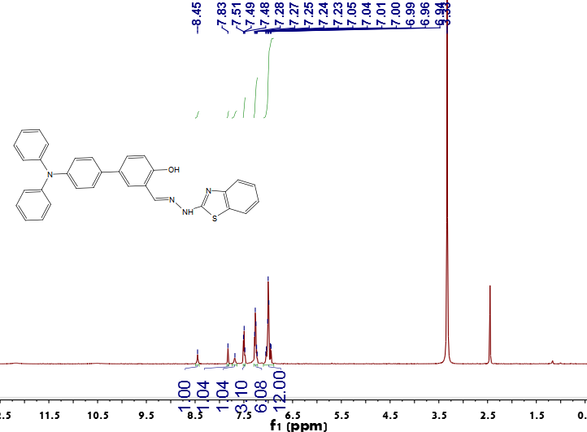
Fig. S3 ¹H NMR spectra of compound SHK in DMSO-d₆ 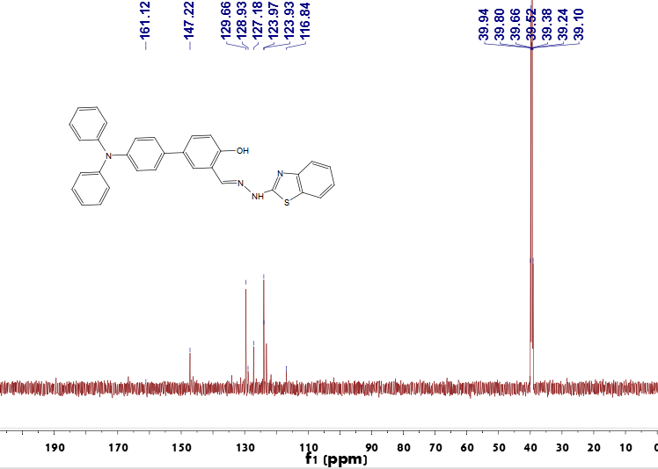Fig. S4 ¹³C NMR spectra of compound SHK in DMSO-d₆

Fig. S5 Benesi-Hildebrand plot of SHK-Zn²⁺ complexes in DMSO/H₂O (9:1, v/v)

Fig. S6 Absorbance spectra of probe SHK (2.5 × 10⁻⁴ M) in DMSO/H2O (9 / 1, v/v) in the presence of different concentrations of Zn²⁺ ions (0~140 eq)
Fig. S7 UV-vis titration and calculation of banding constant of probe SHK for Zn²⁺ ions
Fig. S8 UV-vis absorption spectra response of SHK in DMSO/H2O (9:1, v/v) upon adding different amounts of Zn²⁺
Fig. S9 The stability of probe SHK in DMSO/H₂O (9/1, v/v)

