2D/2D g-C₃N₄/BiOCl with oxygen vacancy heterostructure by grinding for improved visible-light-driven photocatalyst
Jianhua Hou ^{1 ⁎}, Haoyi Wang ¹, Rongrong Qin ², Qikai Zhang ², Di Wu ³, Zhenhua Hou^{3⁎}, Wei Yang ⁴, Muhammad Tahir, ⁵ Asif Hussain ¹, Weiqin Yin ¹, Yongcai Zhang ¹, Xiaozhi Wang¹ ⁎
¹ College of Environmental Science and Engineering, Yangzhou University, Yangzhou, 225000, China
^{2.} Beijing Xinfeng Aerospace Equipment Co., Ltd, Beijing, 100854, China
³ Jiangxi Xinda Hangke New Materials Technology Co., Ltd, Nanchang, 330096, China
⁴ Beijing System Design Institute of Electro-Mechanic Engineering, Beijing,100005, China
⁵ Department of Physics, Division of Science & Technology, University of Education, Lahore, Pakistan
∗ Corresponding author, E-mail address: jhhou@yzu.edu.cn (J. Hou), houzhenhualove@126.com (Z. Hou), xzwang@yzu.edu.cn (X.Wang)

Experimental section
1. Materials
Analysis of pure grades of dicyandiamide (C₂H₄N₄), thiourea (CH₄N₂S), RhB, methyl orange (MO), Bismuth nitrate pentahydrate (Bi(NO₃)₃ 5H₂O) and Potassium chloride (KCl)were purchased from Sinopagic Chemical Reagents Co., LTD. Carbon dioxide (CO₂) ≥ 99.99% purchased from Nanjing Special Gas Co., LTD.
2. Characterization
On the AXS D-8 ADVANCE, X-ray diffraction (XRD) was performed using Cu K radiation (= 1.5406 Å) with a 5 ͦ Hz scanning rate. TENSOR27 spectrometer was used to study FT-IR (Fourier Transform Infrared Spectroscopy) spectra. Brunauer-Emmett-Teller technique was used to estimate the surface area and pore size using (ASAP 2460, Micromeritics). X-ray photoelectrons spectroscopy (XPS) was utilized to figure out the chemical structure of the material and the surface element state (ESCALAB 250Xi, Thermo Fisher Scientific). Employing scanning electron microscopy (SEM) (Hitachi, S-4800) with high-resolution transmission electron microscopy (HRTEM), the surface nanostructures and morphology of the prepared trials were examined at high resolution with (Tecnai G2 F30S-Twin, FEI). A300-10/12 Bruker EPR spectrometer was used to study EPR (electron paramagnetic resonance). Investigation of optical properties was done using UV–visible diffuse reflectance spectroscopy (UV–vis DRS) (TU-1901, PERSEE). Renishaw in Via was used to investigate photoluminescence (PL). The FLS980 Series of Fluorescence Spectrometers was used in conjunction with a 325 nm pulsed laser diode to measure time-resolved photoluminescence (TRPL) decay curves. By using a typical three-electrode system of Ag/AgCl as the reference electrode, ITO conductive glass containing 5 mg of catalyst sample as the working electrode in 0.2 M Na₂SO₄ solution, and Pt as the counter electrode, the transient photo-current response and EIS (electrochemical impedance spectra) were tested. The AC voltage was 5 mV; the EIS frequency ranged from 0.01 to 100000 Hz.

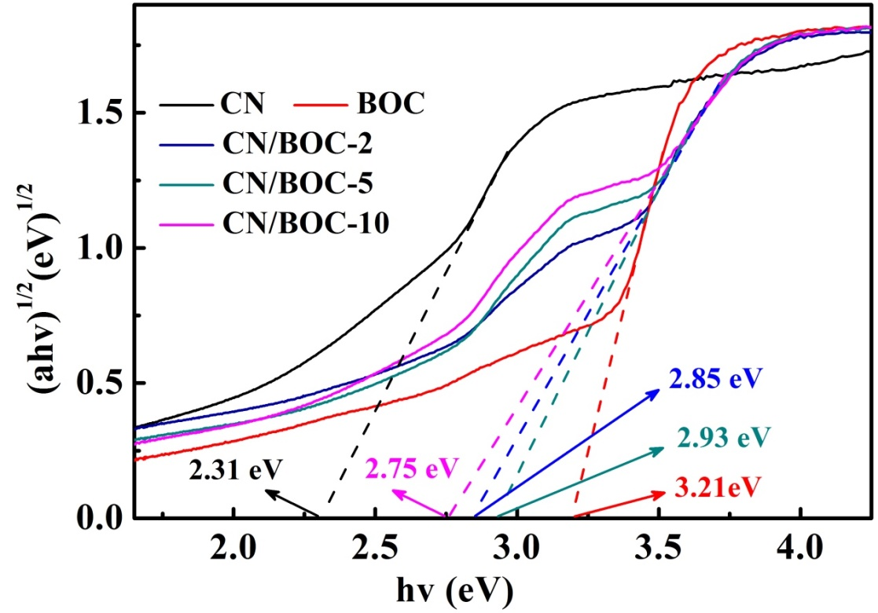
Fig. S1 plots of (ahv)^{1/2} versus hv of all samples.

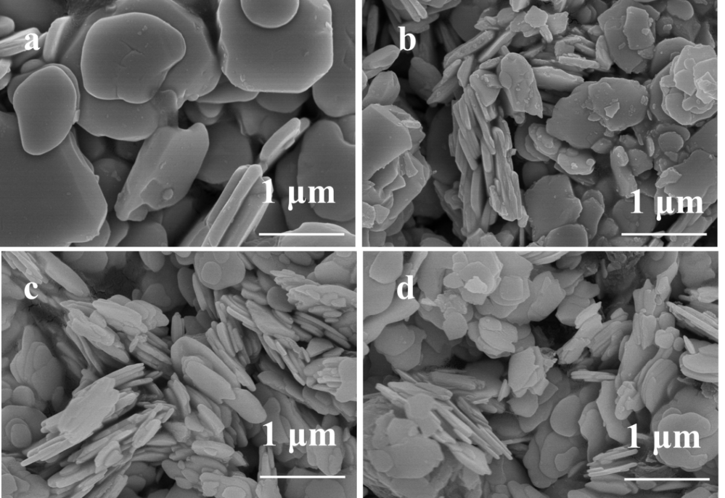
Fig. S2 SEM images of (a) BOC, (b) CN/BOC-2, (c) CN/BOC-5 and (d) CN/BOC-10.

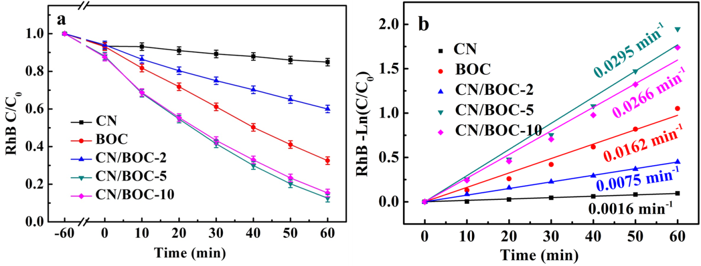
Fig. S3 (a) Photocatalytic degradation and (b) -ln(C/C₀) of RhB.

Table S1 Comparison of photocatalytic degradation of CN/BOC-5 (g-C₃N₄/ BiOCl-5) with other photocatalysts.
Photocatalyst | C_{catalyst} |  | C_{dye} | Degradation efficiency | Light source (Xe lamp) | Ref.
g-C₃N₄/Bi₅O₇I |  | 1.0 g·L⁻¹ | MO, 6.5 mg·L⁻¹ | 270 min, ca. 98% | 500 W, λ > 420 nm |  | S1
floating porous g-C₃N₄ |  | 2 g/L | TC, 5 mg·L⁻¹ | 240 min, ca. 70% | 300 W,λ > 420 nm |  | S2
BiOI(001)/  g-C₃N₄ (002) |  | 1.0 g·L⁻¹ | RhB, 100 mg·L⁻¹ | 240 min, ca. 90% | 300 W, λ > 420 nm |  | S3
10%Bi-Ox-CN |  | 1.0 g·L⁻¹ | TC,20 mg L⁻¹ | 180 min, ca. 90% | 350 W,λ > 420 |  | S4
CeO₂/g-C₃N₄-3 |  | 1.0 g·L⁻¹ | BPA, 10 mg·L⁻¹ | 80 min, ca. 94% | 300 W, λ > 420 nm |  | S5
BiOI/g-C₃N₄/CeO₂ |  | 1.6 g·L⁻¹ | TC, 20 mg·L⁻¹ | 120 min, ca. 90% | 300 W, λ > 420 nm |  | S6
g-C₃N₄/MnO₂/GO |  | 0.5 g g·L⁻¹ | TC,10 mg/L | 60 min, 91.4% min | 300 W, λ > 420 nm |  | S7
ZnO-g-C₃N₄-Go |  | 0.3 g·L⁻¹ | RhB, 10 mg·L⁻¹ | 100min, 98% | 350 W |  | S8
H₂O₂+3 %Fe-  MOF/C₃N₄ |  | 0.375 g·L⁻¹ | TC, 10 mg/L | 60 min, 100% | 300 W, (λ > 420 nm) |  | S9
G/CN-Co (3%) |  | 0.5 g·L⁻¹ | MB, 10 mg·L⁻¹ | 210 min, ca. 97% | 300 W, λ > 420 nm |  | S10
g-C₃N₄/BiOCl |  | 0.2 g·L⁻¹ | RhB, (0.02 mmol/L) | 120 min 96% | LED (5 W) |  | S11
BiOCl/g-C₃N₄ nanosheets |  | 1 g·L-1 | RhB,10 mg/L | 80 min, 96% | 300 W, λ > 420 nm |  | S12
rich OVs-BiOCl |  | 1 g·L⁻¹ | TC, 10 mg L⁻¹ | 40 min, < 70% | 500W,λ>420nm |  | S13
CN/BOC-5 |  | 0.4 g·L⁻¹ | RhB, 10 mg L⁻¹, TC, 10 mg L⁻¹ | 60 min, 87.5%  120 min, 89.8% | 500W, λ > 420 nm |  | Thiswork

Table S2 Comparison of CO₂ reduction performance of CN/BOC-5 (g-C₃N₄/ BiOCl-5) with other g-C₃N₄-based systems
Photocatalyst | Light source |  | Reaction medium | Performance  (µmol g⁻¹ h⁻¹) | Ref.
OCN-Tube |  | λ > 420 nm 350 W Xe lamp | CO₂ gas and H₂O vapor | 0.88, CH₃OH | S14
P-CeO₂/g-C₃N₄ |  | 300 W Xe lamp | CO₂ gas and H₂O vapor | 0.523 ,CO, | S15
g-C₃N₄/WO₃ |  | 500W Xe lamp | CO₂ gas and H₂O vapor | 0.83, CO | S16
g-C₃N₄/Ag/ m-CeO₂ |  | 8 W UV-light lamp | 0.1M NaOH/TEOA | 0.74 ,CO  1.94, CH₄ | S17
B-doped  12-FLTC/BCN |  | 300 W Xe lamp | CO₂ gas and H₂O  vapor | 2.88, CO | S18
Alkali-decorated  g-C₃N₄ |  | 300 W Xe lamp (λ≥420 nm) | CO₂ reduction | 0.90,CO,  0.28, CH₄,  0.68, CH₃OH | S19
Ti₃C₂/porous  g-C₃N₄ |  | 300 W Xe lamp:  (λ>420 nm) | CO₂ gas and 15  mL H₂O | CO: trace  CH₄:0.99 μmol g ⁻¹ h ⁻¹ | S20
g-C₃N₄/LaFeO₃ |  | 300 W Xe lamp | CO₂ gas and H₂O  vapor | 5, CO  1.25, CH₄ | S21
CN/BOC-5 |  | 300W Xe lamp | CO₂ gas and H₂O vapor | 2.00, CO | This work

References
[S1] Wang Q, Li Y, Huang L, Zhang F, Wang H, Wang C, Zhang Y, Xie M, Li H (2019) Enhanced photocatalytic degradation and antibacterial performance by GO/CN/BiOI composites under LED light. Appl Surf Sci (497):143753.
[S2] Tang J, Wang J, Tang L, Feng C, Zhu X, Yi Y, Feng H, Yu J, Ren X (2022) Preparation of floating porous g-C₃N₄ photocatalyst via a facile one-pot method for efficient photocatalytic elimination of tetracycline under visible light irradiation. Chem Eng J( 430):132669.
[S3] Yang Y, Bian Z, Zhang L, Wang H (2022) Bi@BiOx(OH)y modified oxidized g-C₃N₄ photocatalytic removal of tetracycline hydrochloride with highly effective oxygen activation. J Hazard Mater (427):127866.
[S4] Tian N, Huang H, Wang S, Zhang T, Du X, Zhang Y (2020) Facet-charge induced coupling dependent interfacial photocharge separation: A case of BiOI/g-C₃N₄ p-n junction. Appl Catal B (267) 118697.
[S5] Ma R, Zhang S, Li L, Gu P, Wen T, Khan A, Li S, Li B, Wang S, Wang X (2019) Enhanced Visible-Light-Induced Photoactivity of Type-II CeO₂/g‑C₃N₄ Nanosheet toward Organic Pollutants Degradation. ACS Sustain Chem Eng(7): 9699-9708.
[S6] Jiang X, Lai S, Xu W, Fang J, Chen X, Beiyuan J, Zhou X, Lin K, Liu J, Guan G, (2019) Novel ternary BiOI/g-C₃N₄/CeO₂ catalysts for enhanced photocatalytic degradation of tetracycline under visible-light radiation via double charge transfer process. J Alloys Compd (809): 151804.
[S7] Du C, Zhang Z, Tan S, Yu G, Chen H, Zhou L, Yu L, Su Y, Zhang Y, Deng F, Wang S (2021) Construction of Z-scheme g-C₃N₄/MnO₂/GO ternary photocatalyst with enhanced photodegradation ability of tetracycline hydrochloride under visible light radiation. Environ Res (200): 111427.
[S8] Zhang J, Li J, Liu X (2021) Ternary nanocomposite ZnO-g-C₃N₄-Go for enhanced photocatalytic degradation of RhB. Opt Mater (119): 111351.
[S9] Pan Y, Hu X, Bao M, Li F, Li Y, Lu J (2021) Fabrication of MIL-Fe (53)/modified g-C₃N₄ photocatalyst synergy H₂O₂ for degradation of tetracycline. Sep Purif Technol (279):119661.
[S10] Yang X, Tian Z, Chen Y, Huang H, Hu J (2020) One-pot calcination preparation of graphene/g-C₃N₄-Co photocatalysts with enhanced visible light photocatalytic activity. Int J Hydrog Energy (45):12889-12902.
[S11] Zhang R, Niu S, Xiang J, Zheng J, Jiang Z, Guo C (2021) Band-potential fluctuation in C₃N₄/BiOCl hetero-junction for boosting photo-catalytic activity. Sep Purif Technol (261):118258.
[S12] Zhang X, An D, Feng D, Liang F, Chen Z, Liu W, Yang Z, Xian M (2019) In situ surfactant-free synthesis of ultrathin BiOCl/g-C₃N₄ nanosheets for enhanced visible-light photodegradation of rhodamine B. Appl Surf Sci( 476):706-715.
[S13] Yang C, He Y, Zhong J, Li J (2022) hotocatalytic performance of rich OVs-BiOCl modified by polyphenylene sulfide, Adv Powder Technol (33): 103427.
[S14] Fu J, Zhu B, Jiang C, Cheng B, You W, Yu J (2017) Hierarchical Porous O-Doped g-C₃N₄ with Enhanced Photocatalytic CO₂ Reduction Activity. Small (13) 1603938.
[S15] Li W, Jin L, Gao F, Wan H, Pu Y, Wei X, Chen C, Zou W, Zhang C, L Dong, (2021) Advantageous roles of phosphate decorated octahedral CeO₂ {111}/g-C₃N₄ in boosting photocatalytic CO₂ reduction: charge transfer bridge and Lewis basic site. Appl Catal B(294): 120257.
[S16] Huang S, Long Y, Ruan S, Zeng Y (2019) Enhanced Photocatalytic CO₂ Reduction in Defect-Engineered Z-Scheme WO_{3–x}/g-C₃N₄ Heterostructures. ACS Omega (4):15593-15599.
[S17] Wang H, Guan J, Li J, Li X, Ma C, Huo P, Yan Y (2020) Fabricated g-C₃N₄/Ag/m-CeO₂ composite photocatalyst for enhanced photoconversion of CO₂. Appl Surf Sci(506):144931.
[S18] Wang H, Tang Q, Wu Z (2021) Construction of Few-Layer Ti₃C₂ MXene and Boron-Doped g-C₃N₄ for Enhanced Photocatalytic CO₂ Reduction. ACS Sustain Chem Eng(9): 8425-8434.
[S19] Sun Z, Fischer J, Li Q, Hu J, Q Tang, Wang H, Wu Z, Hankel M, Searles D, Wang L (2017) Enhanced CO₂ photocatalytic reduction on alkali-decorated graphitic carbon nitride. Appl Catal B (216):146-155.
[S20] Hu J, Ding J, Zhong, Q (2021) Ultrathin 2D Ti₃C₂ MXene Co-Catalyst Anchored on Porous g-C₃N₄ for Enhanced Photocatalytic CO₂ Reduction under Visible-Light Irradiation. J Colloid Interface Sci (582):647-657.
[S21] Khan I, Luo M, Guo L, Khan S, Shah S, Khan I, Khan A, Wang C, Ai B, Zaman S (2022) Synthesis of phosphate-bridged g-C₃N₄/LaFeO₃ nanosheets Z-scheme nanocomposites as efficient visible photocatalysts for CO₂ reduction and malachite green degradation, Appl Catal A-Gen, (629): 118418.

