Table S1. Modern reference fibres with their extraction treatments, catalogue numbers and gathering times and locations.
Sample |  | Species |  | Treatment | Catalogue  number | Gathering  time in 2018
Root A |  | Linum  usitatissimum  cultivar |  | Retted | (2016-0076) | 31.7.
Crown A |  |  |  | Retted | (2016-0076) | 31.7.
Stem B |  |  |  | ? | ? | ?
Root C |  | Urtica dioica  hybrid var. dioica  x var. holosericea |  | Retted | (1994-0244) | 31.7.
Stem C |  |  |  | Retted | (1994-0244) | 31.7.
Crown C |  |  |  | Retted | (1994-0244) | 31.7.
Root D |  | Urtica dioica ssp. dioica |  | Retted | (1994-0807) | 31.7.
Root E |  | Urtica dioica |  | Retted | (2007-0272) | 31.7.
Stem E |  |  |  | Retted | (2007-0272) | 31.7.
Crown E |  |  |  | Retted | (2007-0272) | 31.7.
Stem F |  |  |  | Retted |  | 4.7.
Root G |  | Cannabis sativa |  | Dried | (2016-0292) | 14.9.
Root H |  |  |  | Retted | (2016-0292) | 31.7
Root I |  |  |  | Dried | (2018-0174) | 14.9.
Stem J |  |  |  | Retted | (2016-0292) | 4.7.

Table S2. Ethnographic fibres and their origins. Adapted from Suomela et. al, 2020
Sample name | Origin | Condition | Identification by optical microscopy
Sample 2a | Weft from an upper part of a female shirt rätsinä | Visible worn in the end of the yarn | Nettle
Sample 5a | Female shirt rätsinä | Curves of the weave are clearly visible | Flax
Sample 9b | From a sleeve of a female shirt rätsinä | Yarn is flattened and ruffled | Nettle
Sample 48b | Weft from a female headgear sorokka | Yarn is ruffled from the end. | Flax
Sample 49a | Front part of female headgear | Yarn is ruffled from the surface. | Flax
Sample 73ba | Socks of deceased | Yarn is roughly processed | Hemp
Sample 85d | Hem lining of a dress | Tightly spun yarn. Strange crystals and fibres have ravelled from worn. | Nettle
Sample 1a | Female shirt rätsinä | fibres are in good condition; convolutions are even. | Cotton
Sample 1d | Sewing yarn of female shirt rätsinä | Yarn is plied from 6 extremely thin strands. Fibres are in bad condition, only few convolutions in the fibres | Cotton
Sample 82c blue | Dress, sarafan. Checked fabric from the lining | Uneven quality fibres | Cotton
Sample 82c orange | Dress, sarafan. Checked fabric from the lining | Uneven quality fibres | Cotton
Sample 85a | Sewing yarn from a dress. | Extremely rough quality fibres | Cotton
Sample 95b red | Embroidery yarn from a towel käspaikka | Dyed as a yarn (colour has not penetrated thoroughly) | Cotton
Sample 99c blue | Lining of a female under headgear | Uneven colour | Cotton

Table S3. Archaeological fibre samples from Ravattula Ristimäki.
Sample name | Origin | Condition
Sample TYA 912:523D | Sheath of a knife with bronze plate. Next to the head. Sample is from top of the sheath. | Only few preserved pieces of fibre. Surfaces are covered with residue and are eroded.
Sample TYA 933:214:9:50 | From the upper body. Sample was attached to a glass bead, close to a silver coin. | Fibres are in fairly good condition.
Sample TYA 914:1607:8A | Twisted bronze bracelet. Sample is from the top and under the bracelet. | Fibres are in good condition.
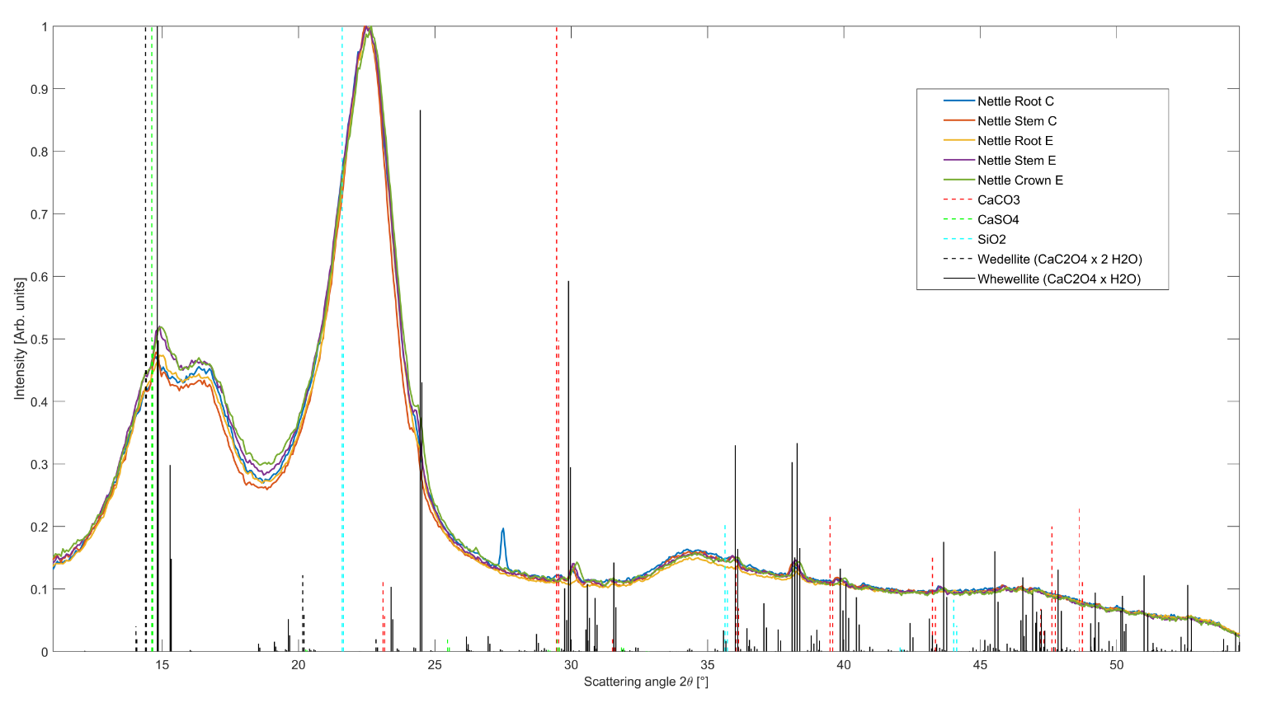
Figure S1. The integrated data of the studied nettle samples. Common minerals of Ca and Si are indicated with dashed lines.

The numbers refer to taxon catalogue of The Finnish Museum of Natural History, University of Helsinki.

