Supplementary Material

Utilization of liquid product through pyrolysis of LDPE and C/LDPE as commercial wax

Hasret Akgün, Ece Yapıcı, Zerrin Günkaya, Aysun Özkan, Müfide Banar
Department of Environmental Engineering, Eskişehir Technical University 26555, Eskişehir, Turkey
aysunozkan@eskisehir.edu.tr

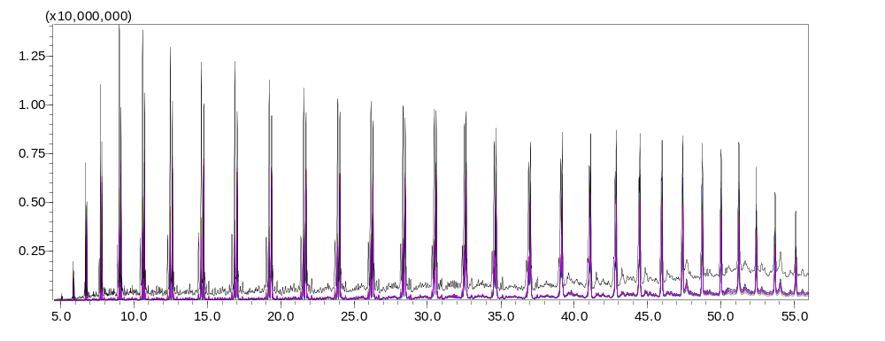
Figure S1. Chromatogram of 5 °C/min heating rate and at 800 °C LDPE pyrolysis liquid product with GC-MS.

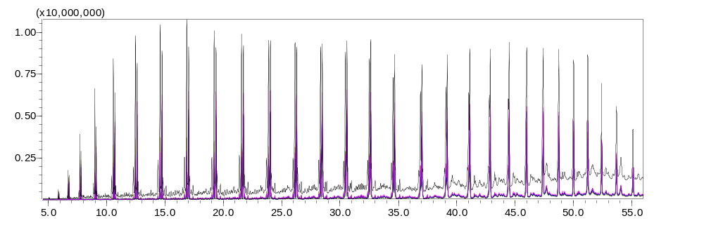
Figure S2. Chromatogram of 5 °C/min heating rate and at 600 °C C/LDPE pyrolysis liquid product with GC-MS.

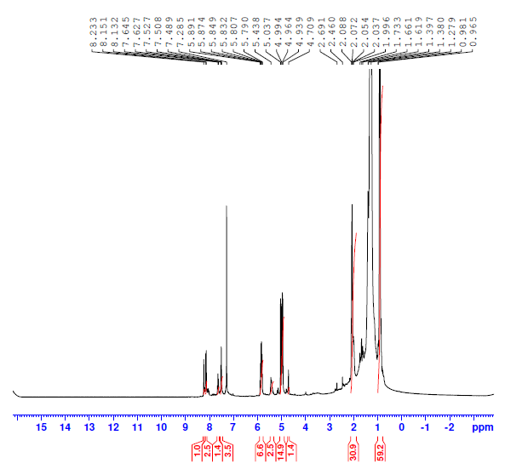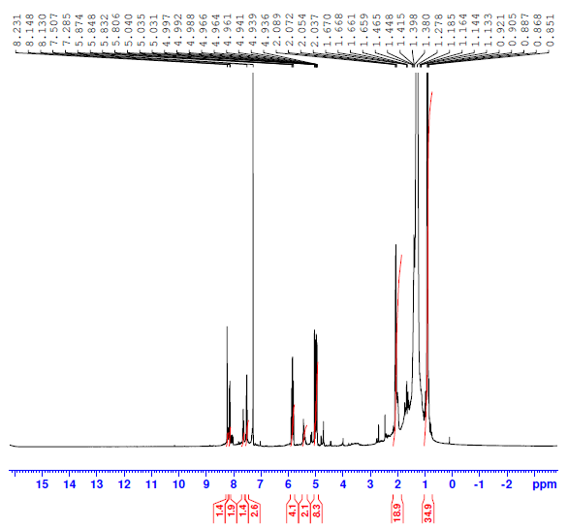
(a) (b)
Figure S3. The H-NMR spectrum of liquid products a) LDPE (5°C/min at 800°C) b) C/LDPE (5°C/min at 600°C)

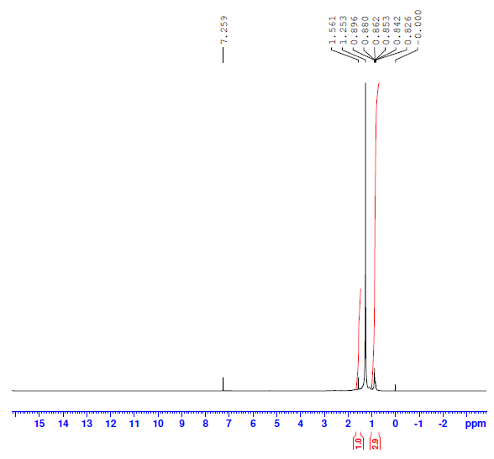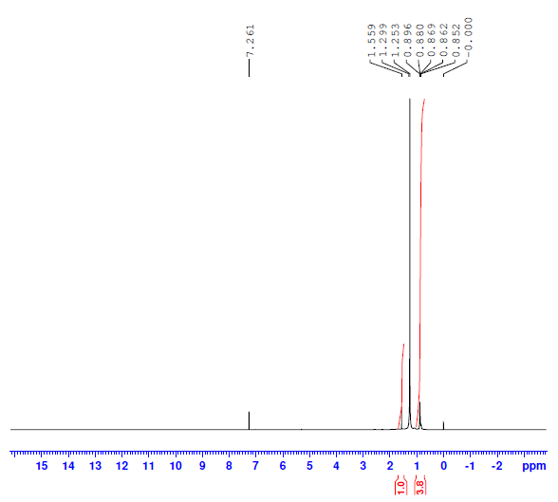
(a) (b)
Figure S4. The H-NMR spectrum of commercial a) heavy wax and b) bright wax

