Supplementary Data
Table S1. Primer sequences of the genes selected for RT-PCR analysis
Gene | Sequences
XYL1 I (Xylose reductase) | Forward: 5′-GTGCTATCAAGACCGGTTAC-3′  Reverse: 5′-CTGGGAAGTGGATCAAGAAC-3′
XYL2(Xylitol dehydrogenase) | Forward: 5′-CTCTAAGTTGGGTTCCGTTG-3′  Reverse: 5′-CTTGGAGTTGAAGGTGTGAG-3′
XKS1(Xylulokinase) | Forward: 5′-TTCCTCGGGTTCGATCTT-3′  Reverse: 5′-CCGTCCTTCTTCATGTCTTC-3′
XUT4 I (Xylose transporter) | Forward: 5′-GAGGAGCCCATTGTATGTTC-3′  Reverse: 5′-ATCTCTCTCCGCCTTCAA-3′
XUT5(xylose transporter) | Forward: 5′-GTGAGCTCCAAGAGCAATAC-3′  Reverse: 5′-AGACATCCGGAAAGAGCA-3′
XUT7-1(xylose transporter) | Forward: 5′-GCGGCTGTTCTCTTTGTT-3′  Reverse: 5′-CAAGTTCGTTCGCTCTTAGG-3′
Sc-adh1(Alcohol dehydrogenase) | Forward: 5′-AGGCCAACGAATTGTTGATCA-3′  Reverse: 5′-GTGTCAACAACGTATCTACCA-3′

Table S2. Reaction cocktail for cDNA synthesis using Invitrogen superscript III one step qRT-PCR kit
2X reaction mixture | 10 μl
RNA template | 1 μg
Forward primer (10 μM) | 1 μL
Reverse primer (10 μM) | 1 μL
Superscript III^{RT} Platinum Taq mix | 1 μL
Nuclease free water | 6 μL

Table S3. RT-PCR reaction mix
Nuclease free water | 27.5 μL
Forward primer | 8.25 μL
Reverse primer | 8.25 μL
SyBR (Takara) | 55 μL

Table S4. Growth of strains on different concentrations of Cycloheximide
Concentration  (ppm) | Cycloheximide
Concentration  (ppm) | P. stipitis NCIM 3498 | S. cerevisiae LN
Control | + | +
50 | + | -
100 | + | -
200 | + | -

Table S5 a. Protein expression in fusants as compared to P. stipitis NCIM 3498
Strain |  | Total spots | Unique spots | Differentially expressed spots | Upregulated | Down  regulated | Two fold increase
P. stipitis NCIM 3498 |  | 201 | 155
1a.23 |  | 246 | 199
Comparison with P. stipitis NCIM 3498 |  |  |  | 29 | 23 | 6 | 22
1a.30 | 200 |  | 155
Comparison with P. stipitis NCIM 3498 |  |  |  | 34 | 26 | 8 | 18

Table S5 b. Protein expression in fusants as compared to S. cerevisiae LN
Strain | Total spots | Unique spots | Differentially expressed spots | Upregulated | Down  regulated | Two fold increase
S. cerevisiae LN | 184 | 121/137
1a.23 | 246 | 183
Comparison with S. cerevisiae LN |  |  | 40 | 24 | 16 | 16
1a.30 | 201 | 152
Comparison with S. cerevisiae LN |  |  | 25 | 13 | 12 | 10

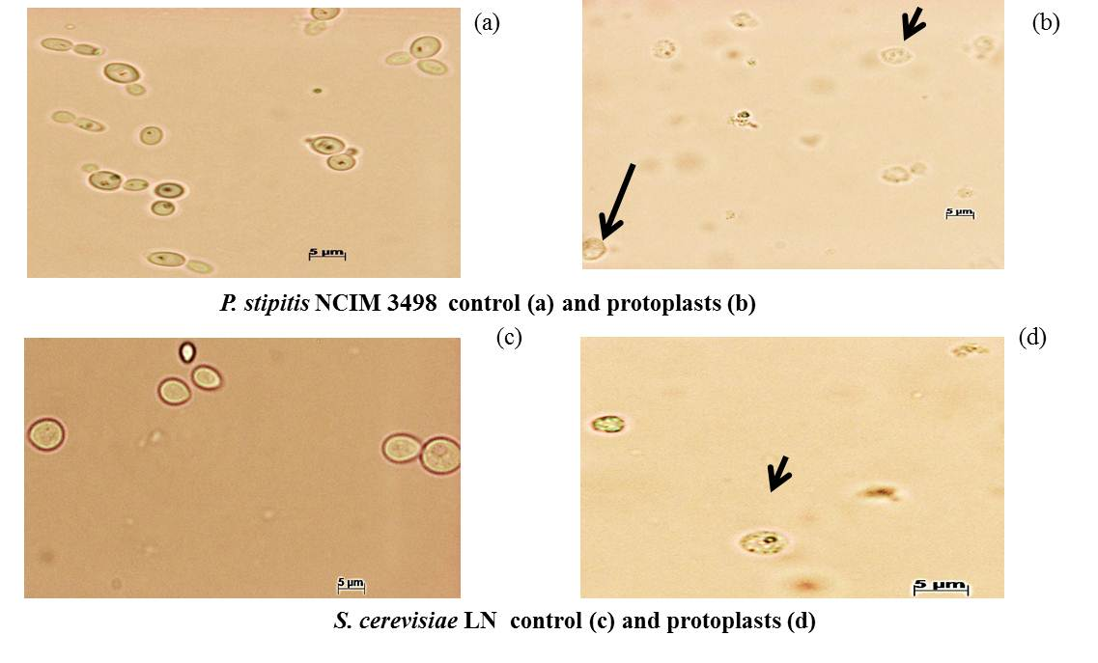
Fig. S1. Protoplasts of S. cerevisiae LN and P. stipitis NCIM 3498 after treatment with glucanex enzyme

Fig. S2. Growth pattern of both strains on 10% ethanol

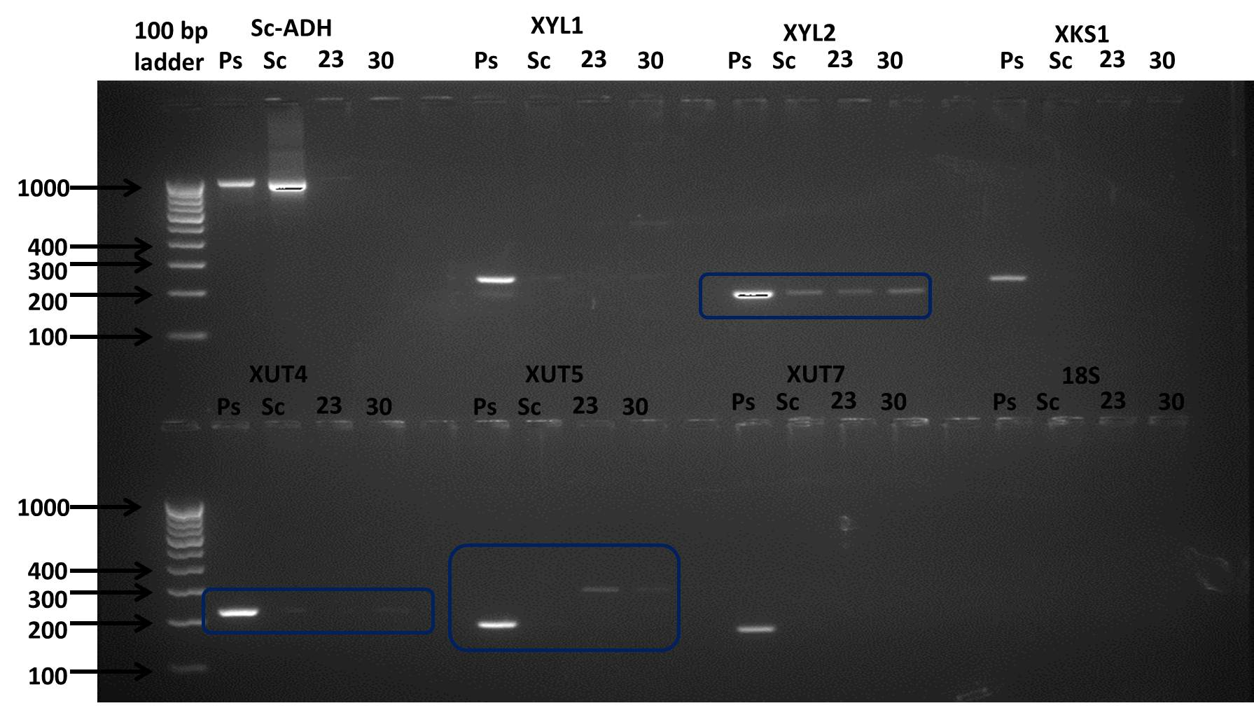
Fig. S3. Agarose gel showing bands for xylose metabolizing and transporter genes amplified using cDNA primers (Ps: P. stipitis NCIM 3498; Sc: S. cerevisiae LN).

