Evaluation effect of recombinant lytic polysaccharide monooxygenases added to Aspergillus fumigatus var. niveus cocktail in saccharification of sugarcane bagasse
Aline Larissa Gonçalvesª, Paula Macedo Cunhaª, Awana da Silva Limaª, Júlio César dos Santosª and Fernando Segato^{a*}
ª Department of Biotechnology, Lorena School of Engineering, University of São Paulo, Lorena, SP, Brazil

* Corresponding author:
Fernando Segato
Department of Biotechnology, Lorena School of Engineering, University of São Paulo, Estrada Municipal do Campinho s/n, Lorena, SP, 12602-810
E-mail address: segato@usp.br
ORCID id 0000-0002-6715-9601

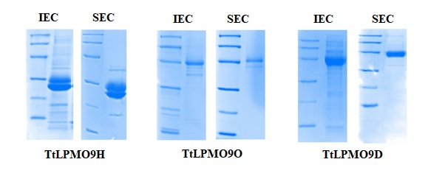
Supplementary Figure 1: SDS-PAGE of recombinant TtLPMO9H, TtLPMO9O and TtLPMO9D. IEC - ion exchange chromatography. SEC - size exclusion chromatography.

MODEL EQUATION = +0.029459 * (A) -49.98867 * (B) -104.32849 * (C) -36.88085 * (D) + 67.85503 * (A) * (B) + 133.60565 * (A) * (C) + 47.69322 * (A) *(D)+0.081828 * (A) * (E)+30.47799 * (B) * (C)-36.10567 * (B) * (D) +12.95529 * (B) * (E) +59.37461 * (C) * (D) +26.27659 * (C) * (E) +38.10751 * (D) * (E) -7.41796 * (A) * (B) * (E) -33.45710 * (A) * (C) * (E) -46.10599 * (A) * (D) * (E) -17.81856 * (B) * (C) * (E) -34.73272 * (C) * (D) * (E) -5.69120E-003 * (A) * (E)2 -1.20682 * (B) * (E)2 -1.44710 * (C) * (E)2 -3.76444 * (D) * (E)2 +1.61221 * (A) * (B) * (E)2 + 1.84644 * (A) * (C) * (E)2 +4.54152 * (A) * (D) * (E)2 +1.14119 * (B) * (C) * (E)2 +2.80047 * (C) * (D) * (E)2

Supplementary Figure 2: Statistical model equation (real components and actual factors), correlating the variables: AFUMN secretome (A), TtLPMO9H (B), TtLPMO9O (C), TtLPMO9D (D) and ascorbic acid used as electron donor to the LPMOs (E) in the release of reducing sugars.

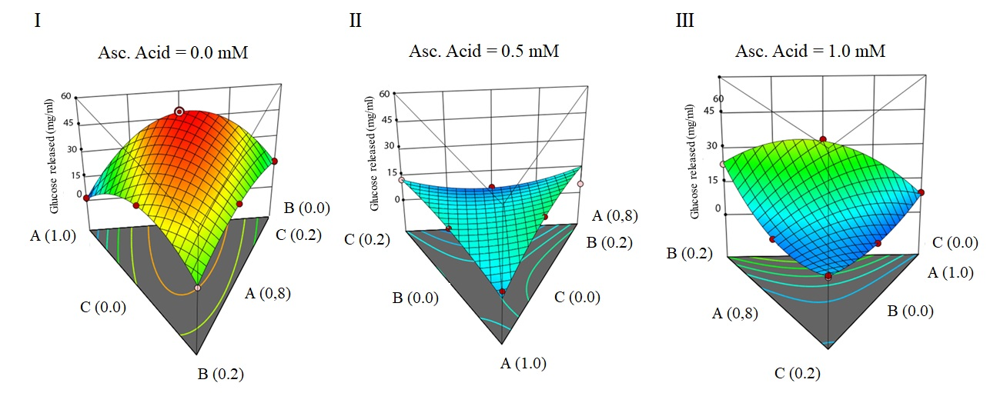
Supplementary Figure 3: Response surface for saccharification of SEB using AFUMN secretome and LPMOs from T. terrestris. The graphics were generated as a function of AFUMN secretome, TtLPMO9H and TtLPMO9O, considering 0% of TtLPMO9D. Protein concentration of AFUMN secretome was defined in a range of 80-100% and LPMOs complementation in a range of 0-20%. The influence of electron donor in the glucose release was evaluated without the addition of ascorbic acid (I) and added in concentrations of 0.5 mM (II) and 1 mM (III) in the reaction. Legend: shades close to red indicates high sugar release and shades close to blue indicates low sugar release. Concentration of AFUMN secretome (A); Concentration of TtLPMO9H (B) and concentration of TtLPMO9 (C).

