Pre-immune serum for CD39  A  Pre-immune serum for CD39 | CD39  B  CD39
Pre-immune serum for CD73  C  Pre-immune serum for CD73 | CD73  D  CD73

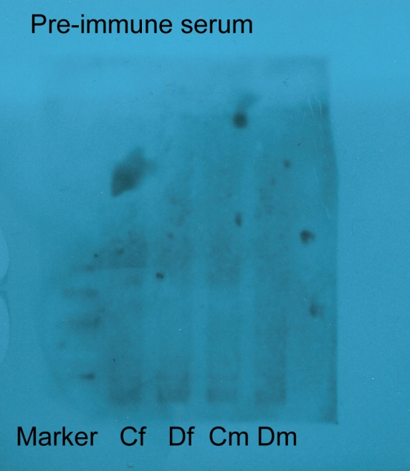Pre-immune serum for CD39

