Supplementary Information for

Technology enabled science: investigation of a fin-shaped rock by the Yutu-2 rover on the lunar farside
Liang Ding¹*†, Ruyi Zhou¹†, Tianyi Yu²†, Huaiguang Yang¹, Ximing He², Haibo Gao¹*, Juntao Wang^{3,4}, Ye Yuan¹, Jia Wang², Zhengyin Wang¹, Huanan Qi¹, Jian Li²*, Wenhao Feng¹, Xin Li², Chuankai Liu^{2,5}, Shaojin Han², Xiajia Zeng^{3,4}, Yu-Yan Sara Zhao^{6,4}, Guangjun Liu⁷, Wenhui Wan⁸, Yuedong Zhang², Saijin Wang², Lichun Li², Zongquan Deng¹, Jianzhong Liu^{3,4}*, Guolin Hu², Rui Zhao², Kuan Zhang²
¹State Key Laboratory of Robotics and System, Harbin Institute of Technology; Harbin 150080, China.
²Beijing Aerospace Control Center; Beijing 100094, China.
³Center for Lunar and Planetary Sciences, Institute of Geochemistry, Chinese Academy of Science; Guiyang 550081, China.
⁴CAS Center for Excellence in Comparative Planetology; Hefei 230026, China.
⁵Key Laboratory of Science and Technology on Aerospace Flight Dynamics; Beijing 100049, China.
⁶International Center for Planetary Science, College of Earth Science, Chengdu University of Technology; Chengdu 610059, China.
⁷Department of Aerospace Engineering, Ryerson University; Toronto, ON M5B 2K3, Canada.
⁸State Key Laboratory of Remote Sensing Science, Aerospace Information Research Institute, Chinese Academy of Sciences; Beijing 100101, China.
*Corresponding author. Email: liangding@hit.edu.cn (L.D.), gaohaibo@hit.edu.cn (H.G.), lisirjian@163.com (Jian Li) and liujianzhong@mail.gyig.ac.cn (Jianzhong Liu).
†These authors contributed equally to this work

This PDF file includes:
Section S1
Supplementary Figure 1 to 2
Supplementary Table 1 to 8
Other Supplementary Information for this manuscript includes the following:
Source Data of Fig. 4 (Excel format): The 1 and 2 μm band center positions of rocks investigated in the CE-4 mission with pyroxenes measured by Adams (1974)
Source Data of Extended Data Fig. 8 (Excel format): Spectra data of the six rocks investigated in the CE-4 mission

S1. Nomenclature
A_{t}, B_{t}, C_{t} | normal vector of the wheel-terrain contact plane
A₁, A₂, A₃ | node of the triangular terrain mesh
b | wheel width
c | cohesion of the soil
c₁, c₂ | coefficients of the wheel-terrain interaction angle
c₃ | coefficient of the exit angle
f_{DP} | resistance force
F_{N} | normal force
F_{DP} | drawbar pull
F_{L} | lateral force
F_{u} | force beneath the wheel due to shear motion
F_{s} | resistance force acting on the side face of the wheel
F_{e} | vector of equivalent forces in the initial frame
^{e}F_{e} | vector of external forces acting on the wheel center
h | grouser height
j | shearing deformation of the soil
j_{x} | longitudinal shearing deformation of the soil
j_{y} | lateral shearing deformation of the soil
k_{c} | cohesive modulus of the soil
k_{φ} | frictional modulus of the soil
K_{s} | equivalent stiffness modulus of the soil
K_{x} | longitudinal shearing deformation modulus of the soil
K_{y} | lateral shearing deformation modulus of the soil
M_{R} | driving resistance torque
M_{S} | steering resistance torque
M_{O} | overturning torque
M_{e} | vector of equivalent torques in the initial frame
^{e}M_{e} | vector of external torques acting on the wheel center
n₀ | static sinkage exponent
n₁ | dynamic sinkage exponent
N | variable sinkage exponent of the wheel-terrain interaction
p_{c} | position of the wheel center
P₁, P₂, P₃, P_{i} | coordinate point
r | wheel radius
r_{s} | equivalent shearing radius of a grouser wheel
R_{e} | rotation matrix of the wheel-terrain interaction frame relative to the initial frame
s | slip ratio
T | driving torque
T_{c} | homogeneous transform matrix of the wheel-terrain interaction frame relative to the initial frame
v | forward linear velocity
v_{x} | longitudinal travelling velocity
v_{y} | lateral travelling velocity
W | wheel load
z | wheel sinkage
β | side slip angle
θ₁ | entrance angle
θ₂ | exit angle
θ_{i} | solar incidence angle
θ_{m} | maximum stress angle
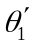 | equivalent entrance angle of a grouser wheel
λ | wavelength
λ_{s} | lug shearing coefficient
σ | normal stress
σ_{m} | maximum normal stress
τ | shear stress
τ_{x} | longitudinal shear stress
τ_{xm} | maximum longitudinal shear stress
τ_{y} | lateral shear stress
τ_{ym} | maximum lateral shear stress
φ | internal friction angle of the soil
φ_{y} | external friction angle of the soil
ω | angular velocity
Σ_{I} | inertial frame
Σ_{e} | wheel-terrain interaction frame
Σ_{c} | wheel center frame

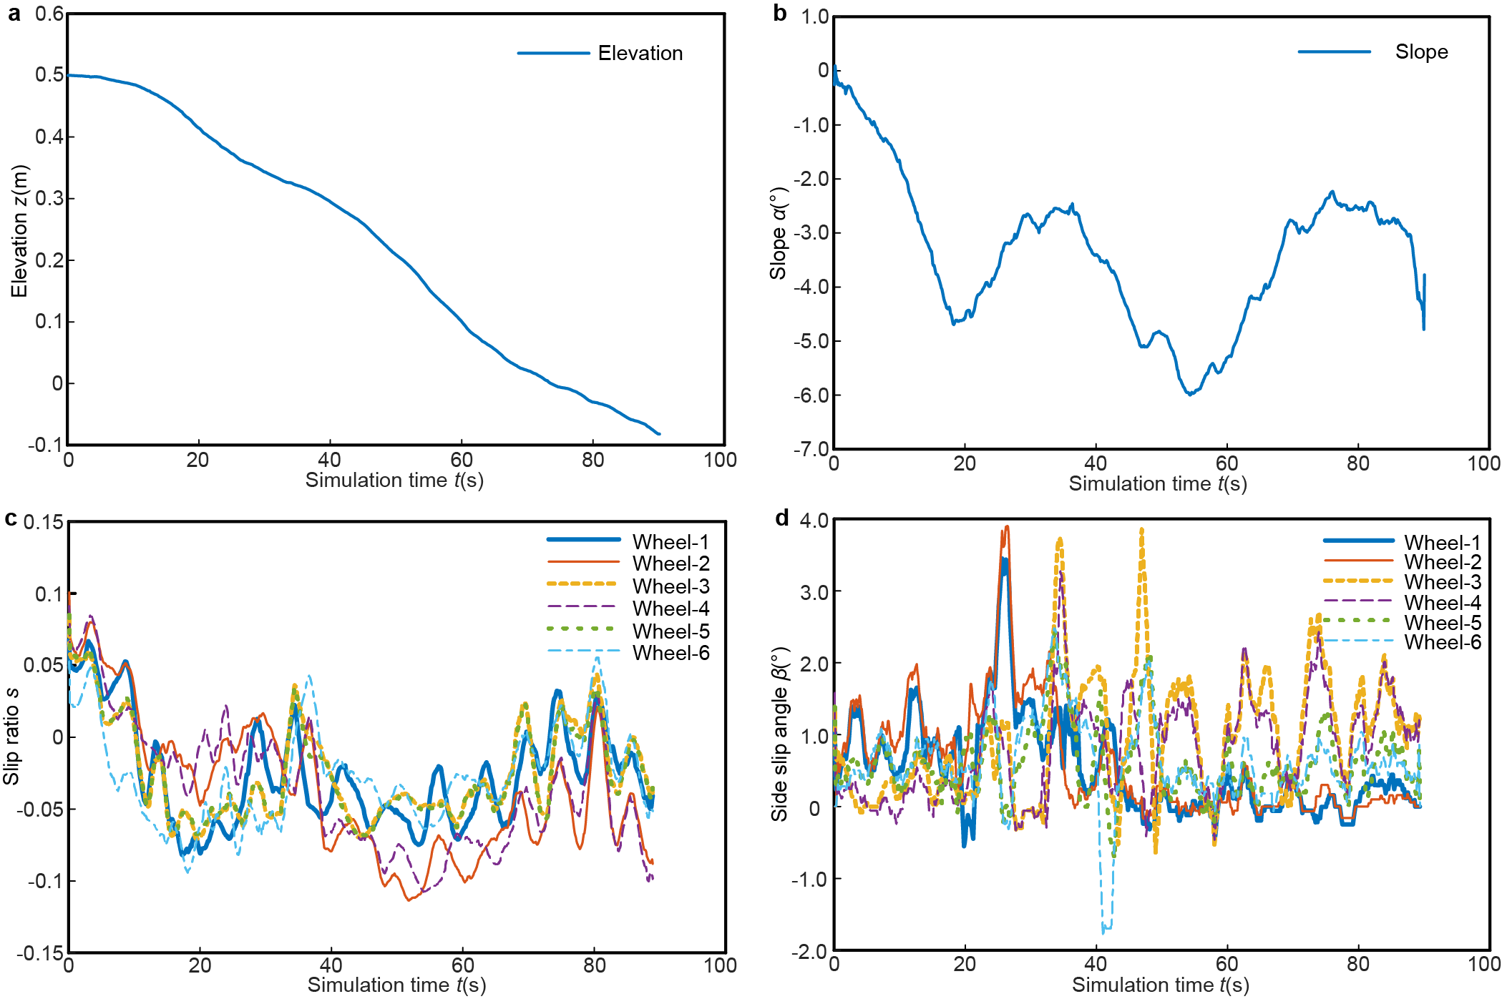

Supplementary Fig. 1. Simulation results of the outboard traverse conditioned on φ=25°, K_{y}=40 mm. Data is collected at 10 Hz. a, Terrain elevation of the outboard traverse. b, Terrain slope of the outboard traverse. c, Slip ratio of six wheels during the outboard traverse. The slip ratio data is further smoothed with 20 points using the Adjacent-Averaging filter. d, Side slip angle of six wheels during the outboard traverse. The side slip angle data is further smoothed with 20 points using the Adjacent-Averaging filter.

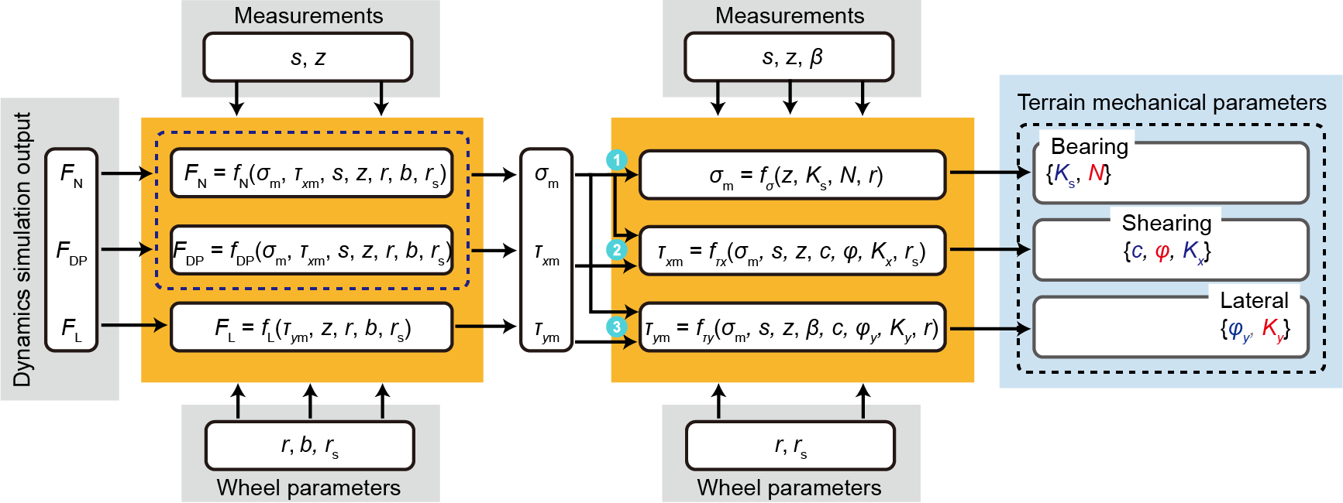
Supplementary Fig. 2. Regolith parameter estimation. Parameters in gray box are input of the framework, and they are fixed parameters set according to wheel parameters or obtained by the dynamic solution or external measurements. Equations in the orange boxes are key equations for parameter identification. Parameters in blue box are the output of the framework and are specific to terrain bearing, shearing and lateral parameters.

Supplementary Table 1. The planned path and associated parameters.
Phase |  | Movement type | Coordinate of the start point (m) | Rover heading direction at the start point | Coordinate of the end point (m) | Rover heading direction at the end point | Curvature (m⁻¹) | Curve length (m)
Outbound journey | 1 | Ture in place | (-1.442, -17.871) | -90.718° | (-1.442, -17.871) | 156.436° | -
Outbound journey | 1-2 | Curve | (-1.442, -17.871) |  | (-5.036, -17.404) |  | 0.154 | 3.674
Outbound journey | 2-3 | Curve | (-5.036, -17.404) |  | (-9.227, -16.862) |  | -0.132 | 4.282
Outbound journey | 3-4 | Curve | (-9.227, -16.862) |  | (-10.812, -15.914) |  | -0.138 | 1.852
Outbound journey | 4 | Ture in place | (-10.812, -15.914) | 141.796° | (-10.812, -15.914) | -136.810° | -
Outbound journey | 4-5 | Straight line | Move forward straightly
Return journey | 5 | Turn in place | (-10.847, -15.939) | -139.483° | (-10.847, -15.939) | -40.366° | - | -
Return journey | 5-6 | Curve | (-10.847, -15.939) |  | (-5.741, -17.655) |  | 0.138 | 5.518
Return journey | 6-7 | Curve | (-5.741, -17.655) |  | (-1.504, -18.168) |  | -0.084 | 4.292
Return journey | 7 | Turn in place | (-1.504, -18.168) | -12.735° | (-1.5035, -18.168) | 165.000° | - | -
Note: A positive curvature represents that the rover is moving and turning right, while a negative curvature represents a left turn of the rover. In the 1-2, 2-3, 3-4 sections, the rover moves according to settled constructions, while in the 4-5 section, it’s movement to approach the rock target for investigation is pendent.

Supplementary Table 2. Setting of the terrain mechanical parameters in the simulation.
Phase | Number of groups | K_{s}(kPa/m^{N}) | N | c(Pa) | φ(°) | K_{x}(mm) | φ_{y}(°) | K_{y}(mm)
Outboard journey | 7 | 827 | 1.0 | 520 | 25-55 | 17.8 | 0.3×φ | 40
Outboard journey | 7 | 827 | 1.0 | 520 | 40 | 17.8 | 0.3×φ | 15-45
Return journey | 1(unrectified) | 827 | 1.0 | 520 | 42 | 17.8 | 12.6 | 20
Return journey | 1(rectified) | 827 | 0.9 | 520 | 38.95 | 17.8 | 12.6 | 40

Supplementary Table 3. Parameters of terrestrial soil samples.
Terrain | n | k_{c}(kPa/m^{N-1}) | k_{φ}(kPa/m^{N}) | K_{s}(kPa/m^{N}) | c(kPa) | φ(°)
Dry sand (Land Locomotion Lab., LLL) | 1.1 | 0.99 | 1528.43 | 1535.03 | 1.04 | 28
Sandy loam (LLL) | 0.7 | 5.27 | 1515.04 | 1550.17 | 1.72 | 29
Sandy loam Michigan (Strong, Buchele) | 0.9 | 52.53 | 1127.97 | 1478.17 | 4.83 | 20
Sandy loam (Hanamoto) | 0.3 | 2.79 | 141.11 | 159.71 | 13.79 | 22
Clayey soil (Thailand) | 0.5 | 13.19 | 692.15 | 780.08 | 4.14 | 13
Lean clay (WES) | 0.2 | 16.43 | 1724.69 | 1834.22 | 68.95 | 20
LETE sand (Wong) | 0.79 | 102 | 5301 | 5981 | 1.3 | 31.1
Upland sandy loam (Wong) | 1.1 | 74.6 | 2080 | 2577 | 3.3 | 33.7
Rubicon sandy loam (Wong) | 0.66 | 6.9 | 752 | 798 | 3.7 | 29.8
North Gower clayey loam (Wong) | 0.73 | 41.6 | 2471 | 2748 | 6.1 | 26.6
Grenville loam (Wong) | 1.01 | 0.06 | 5880 | 5880 | 3.1 | 29.8
Snow (U.S.) | 1.6 | 4.37 | 196.72 | 225.85 | 1.03 | 19.7
Snow (Sweden) | 1.44 | 10.55 | 66.08 | 136.41 | 6 | 20.7
Note: n, k_{c}, k_{φ}, c, φ are original data from reference⁴⁷, while the values of K_{s} for terrains are derived based on k_{c} and k_{φ} when the wheel width is 0.15 m.

Supplementary Table 4. Parameters of lunar soil obtained in other lunar exploration missions²⁷.
Mission (year) | Landing site | Identification method | c(kPa) | φ(°)
Apollo 11 (1969) | Mare Tranquilliatis | Penetrometer | 0.25-0.85 | 38-42
Apollo 12 (1969) | Ocean of Storms | Vacuum Direct Shear | 0-0.7 | 28-35
Apollo 12 (1969) | Ocean of Storms | Direct Shear (Surveyor 3) | 0.1-3.1 | 13-56
Apollo 12 (1969) | Ocean of Storms | Triaxial Shear (Surveyor 3) | 0-1 | 51-59
Luna 16 (1970) | Mare Fecunditatis | Direct Shear and Coulomb Device | 3.9-5.9 | 20-25
Luna 20 (1972) | Apollonius Hightlands | Direct Shear and Coulomb Device | 3.9-5.9 | 20-25
Lunokhod 2 (1973) | Le Monnier Crater | Estimated | 0.4 | 40

Supplementary Table 5. The parameters of the Yutu-2 lunar rover.
Group | Parameter name | Value
Rover | Mass m (kg) | 135
Rover | Size l×w×h (m) | 1.5×1.1×1.0
Rover | Number of wheels | 6
Rover | Maximum driving speed v_{max} (m/h) | 200
Rover | Maximum climbable slope (°) | 20
Rover | Climbable obstacle (mm) | 200
Rover | Track (mm) | 950
Rover | Wheelbase (mm) | 600
Rover | Steering offset (mm) | 106
Wheel | Wheel radius r (m) | 0.15
Wheel | Wheel width b (m) | 0.15
Wheel | Height of the wheel grouser h (m) | 0.01
Wheel | Number of wheel grousers | 24
Wheel | Equivalent shearing radius of a wheel r_{s} (m) | 0.1565

Note: Six wheels on the Yutu-2 can drive, and only four corner wheels have steering motors. Track is the distance between the left and right wheels. Wheelbase is the distance between the centers of the front wheels and the middle wheels, or the distance between the centers of the middle wheels and the rear wheels. The distance between the centers of the front and middle wheels is the same as the that between the centers of the middle wheels and the rear wheels for Yutu-2 rover. The 24 wheel grousers are arranged in two staggered rows, and the grousers in each row are evenly arranged on the wheel’s outer cylinder surface.

Supplementary Table 6. Major specifications of the Pancam⁴⁸, Navcam and Hazcam.
Camera | Parameter | Value
Pancam  (stereo; two modes) | Baseline | 270 mm
Pancam  (stereo; two modes) | Waveband | red: 640 nm, green: 540 nm, blue: 470 nm @ color mode
Pancam  (stereo; two modes) | Waveband | 420-700 nm @ panchromatic mode
Pancam  (stereo; two modes) | Field of view | 19.6°×14.5°
Pancam  (stereo; two modes) | Image resolution | 2,352×1,728 pixels @ color mode
Pancam  (stereo; two modes) | Image resolution | 1,176×864 pixels @ panchromatic mode
Pancam  (stereo; two modes) | Resolving power | 0.15 mrad (about 120 pixels/degree)
Navcam  (stereo) | Baseline | 270 mm
Navcam  (stereo) | Focal length | 17.7 mm
Navcam  (stereo) | Field of view | 46.6°
Navcam  (stereo) | Image resolution | 1024×1024 pixels
Hazcam | Field of view | 170°
(stereo; fisheye camera) | Image resolution | 1024×1024 pixels
Note: The Pancam can acquire a 360° panoramic view by taking 56 pairs of images (28 different azimuth angles at 2 elevation angles).

Supplementary Table 7. Major specifications of the visible and near-infrared imaging spectrometer (VNIS)⁴⁹.
Description | Specification
Description | VIS/NIR | SWIR
Spectral range (nm) | 450-950 | 900-2400
Spectral resolution (nm) | 2.4-6.5 | 3.6-9.6
Field of view (°) | 8.5×8.5 | Φ3.58
Bit resolution | 256×256 | 1
Signal to noise ratio (dB) | >33 | >31
Power consumption (W) | 16.95
Weight (kg) | 4.65 (probe part)
Weight (kg) | 0.7 (electronics part)

Supplementary Table 8. Kinematics parameters of Yutu-2 rover.
Coordinate | Actuated | X axis (m) | Y axis (m) | Z axis (m) | θ_{x} | θ_{y} | θ_{z}
{∑₀}→{∑₁} |  | 0 | D₉ | -D₁ | 0 | θ₁ | 0
{∑₀}→{∑₂} |  | 0 | -D₉ | -D₁ | 0 | θ₂ | 0
{∑₁}→{∑₃} |  | -D₆ | 0 | -D₂ | 0 | θ₃ | 0
{∑₂}→{∑₄} |  | -D₆ | 0 | -D₂ | 0 | θ₄ | 0
{∑₁}→{∑₅} |  | D₈ | 0 | -D₂ | 0 | 0 | θ₅
{∑₂}→{∑₆} |  | D₈ | 0 | -D₂ | 0 | 0 | θ₆
{∑₁}→{∑₇} |  | -D₇ | 0 | -D₂ | 0 | 0 | θ₇
{∑₂}→{∑₈} |  | -D₇ | 0 | -D₂ | 0 | 0 | θ₈
{∑₅}→{∑_{w1}} |  | 0 | D₄ | -D₃+D₂ | 0 | θ₉ | 0
{∑₆}→{∑_{w2}} |  | 0 | -D₄ | -D₃+D₂ | 0 | θ₁₀ | 0
{∑₇}→{∑_{w3}} |  | 0 | D₄ | -D₃+D₂ | 0 | θ₁₁ | 0
{∑₈}→{∑_{w4}} |  | 0 | -D₄ | -D₃+D₂ | 0 | θ₁₂ | 0
{∑₃}→{∑_{w5}} |  | D₆-D₅ | D₄ | -D₃+D₂ | 0 | θ₁₃ | 0
{∑₄}→{∑_{w6}} |  | D₆-D₅ | -D₄ | -D₃+D₂ | 0 | θ₁₄ | 0

Note: x, y, z, θ_{x}, θ_{y}, θ_{z}: transform parameters with respect to the parent frame; θ_{i} represents the variable of the joint angle.

