Supplementary Materials for

Leaf-venation-directed cellular alignment for macroscale cardiac constructs with tissue-like functionalities

Mao Mao, Xiaoli Qu, Yabo Zhang, Bingsong Gu, Chen Li, Rongzhi Liu, Xiao Li, Hui Zhu, Jiankang He*, Dichen Li

*Corresponding author. Email: jiankanghe@mail.xjtu.edu.cn

This PDF file includes:

Supplementary Text
Figs. S1 to S10
Tables S1
Legend for Movies S1 to S5

Other Supplementary Materials for this manuscript include the following:

Movies S1 to S5

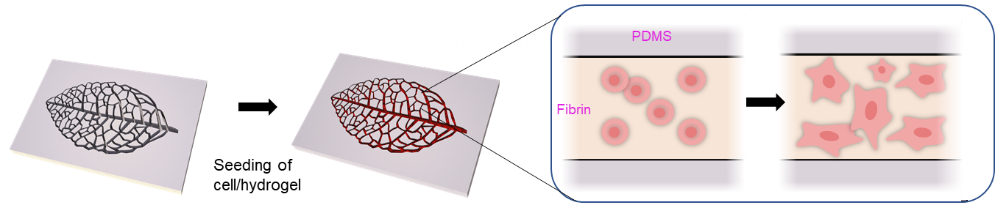

Fig. S1.
Schematic illustration of cells/hydrogel growth within non-amphiphilic-treated PDMS.

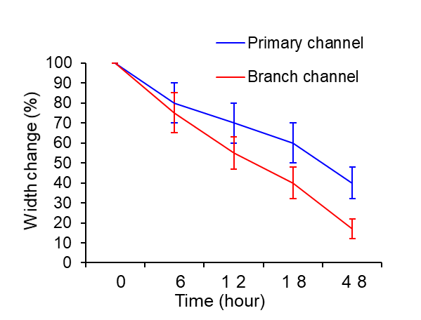

Fig. S2.
The width change of the LVD tissues in the primary channel and branch channel.

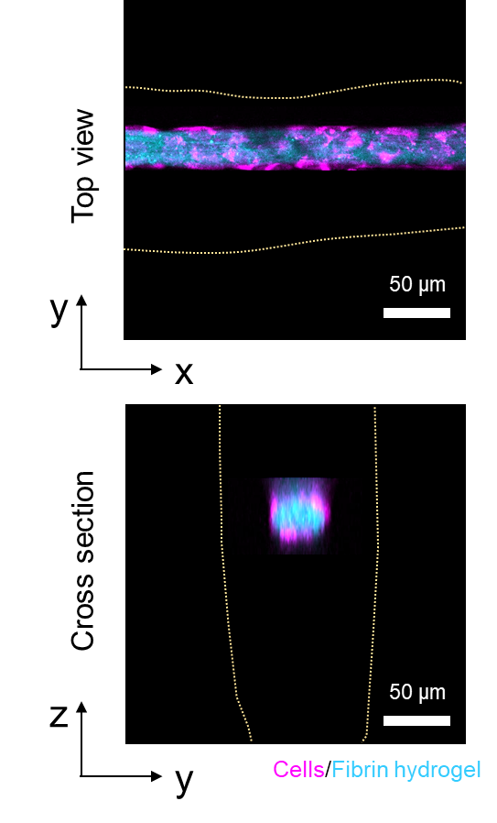

Fig. S3.
The tubular structure of LVD tissues after 48 hours of culture.

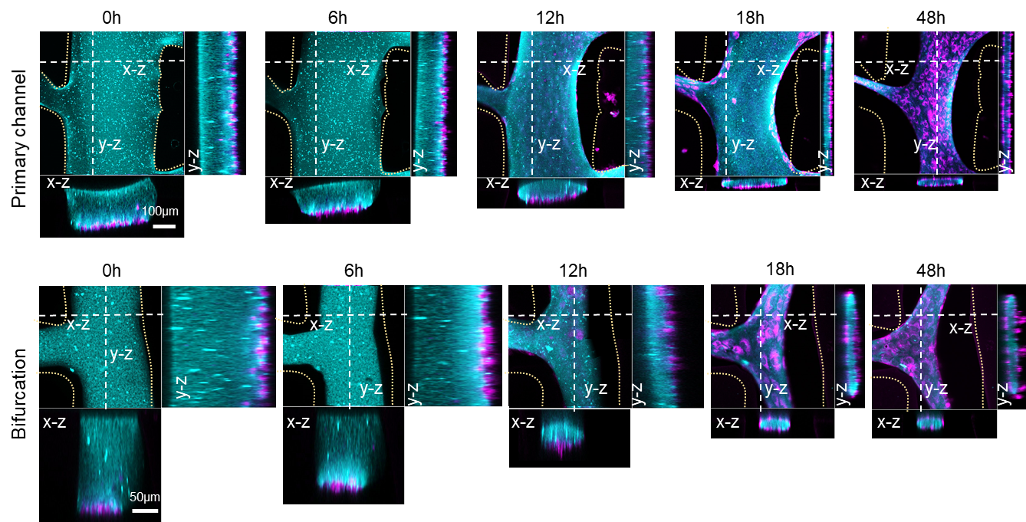

Fig. S4.
LVD self-assembly of cells (magenta)/fibrin hydrogel (cyan) into tubular structures in primary channel and bifurcation regions.

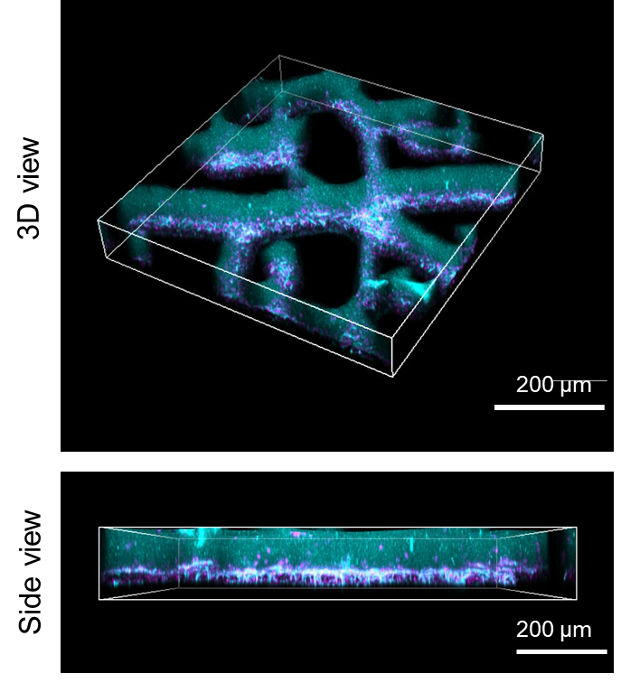

Fig. S5.
Distribution of cells (magenta)/fibrin hydrogel (cyan) in the control (non-amphiphilic-treated PDMS) after 48 hours of culture.

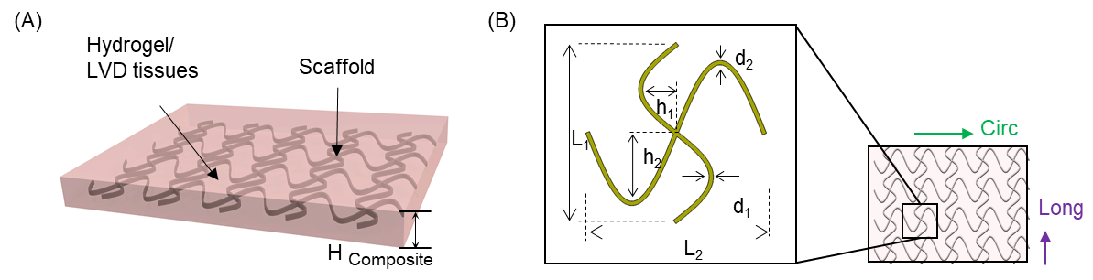

Fig. S6.
The crucial geometrical parameters of the 3D composite tissue model for FEA calculation. For simplicity of FEA calculations, the assembled pre-vascularized cardiac constructs was taken as the 3D composite tissue model (A) incorporating EHD-printed PCL scaffold (elastic modulus: ~300 MPa) in soft fibrin hydrogel (elastic modulus: ~0.5 KPa), given that the enclosed LVD tissues, featuring a relatively small volume and ultra low modulus, were calculated as fibrin hydrogel. In this case, there existed several crucial geometrical parameters: w1, w2, L1, L2, H1, H2, H-scaffold, H-composite, denoting the microfiber widths along x and y directions, lengths of the unit cell along x and y directions, height of snake arc along x and y directions and thickness of the scaffold and elastomer composite respectively (B).

By tuning the value of these parameters, we could independently tailor the directionally dependent mechanical property of the tissue composite along the circumferential (CIRC) and longitudinal (LONG) axes, thus providing access to tissue-like anisotropic, nonlinear mechanical properties. To predict the stress-strain curves of the rat right ventricular myocardium, a series of FEA calculations are conducted by adjusting the geometrical parameters: w1, w2, L1, L2, H1,H2, H-scaffold, H-composite, which were finally predetermined as 0.1mm, 0.1mm, 4mm, 4mm, 0.75mm, 1.6mm, 0.3mm, 0.5mm respectively through reverse design.

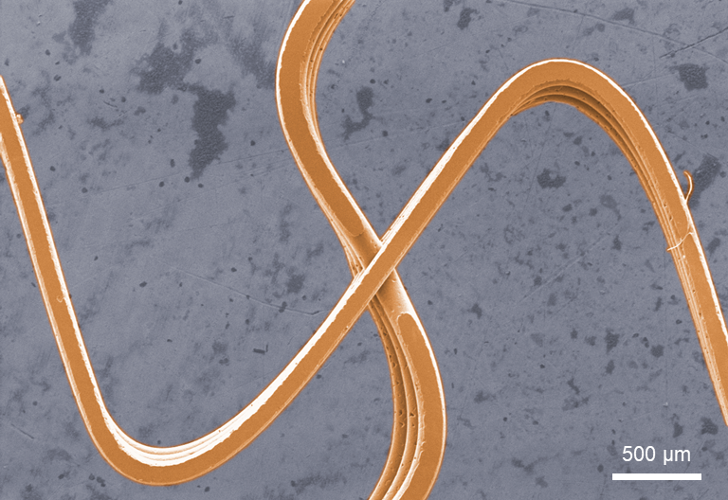

Fig. S7.
The EHD-printed PCL scaffolds with the predesign serpentine structure.

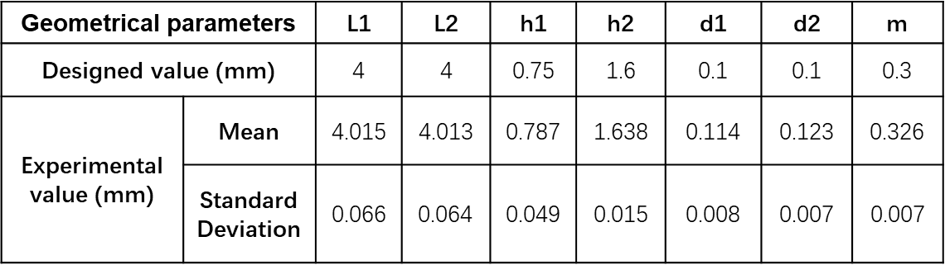

Fig. S8.
The measured value of the printed scaffold’s geometrical parameters, compared to the designed value.

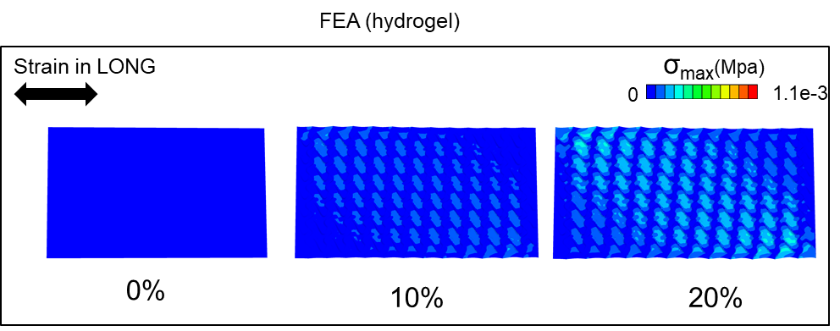

Fig. S9.
FEA simulations of strain distribution in the scaffold of the 3D tissue composite upon uniaxial stretching (from top to bottom: 0%, 10%, and 20%) along the CIRC direction.

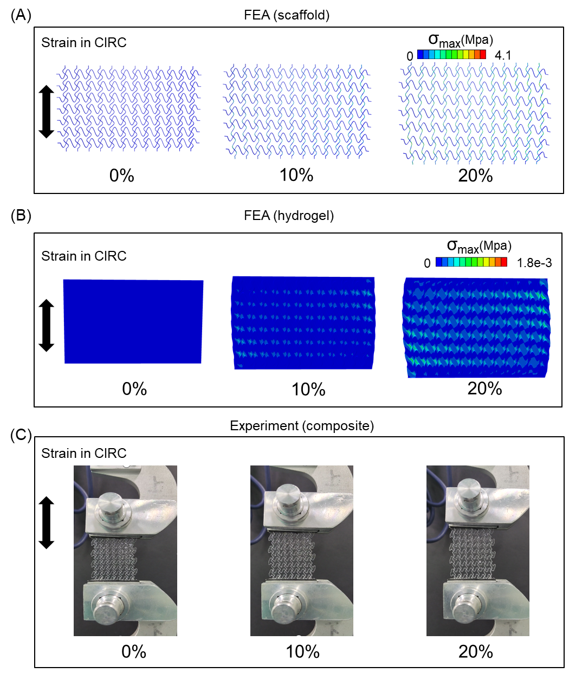

Fig. S10.
FEA simulations and macroscopic images of the 3D tissue composites upon uniaxial stretching (from top to bottom: 0%, 10%, and 20%) along the CIRC direction. FEA simulations of strain distribution in the scaffold (A) and hydrogel (B) of the composites. (C) Macroscopic images of uniaxial stretching of the 3D tissue composites.

Table S1.
List of qPCR primers.

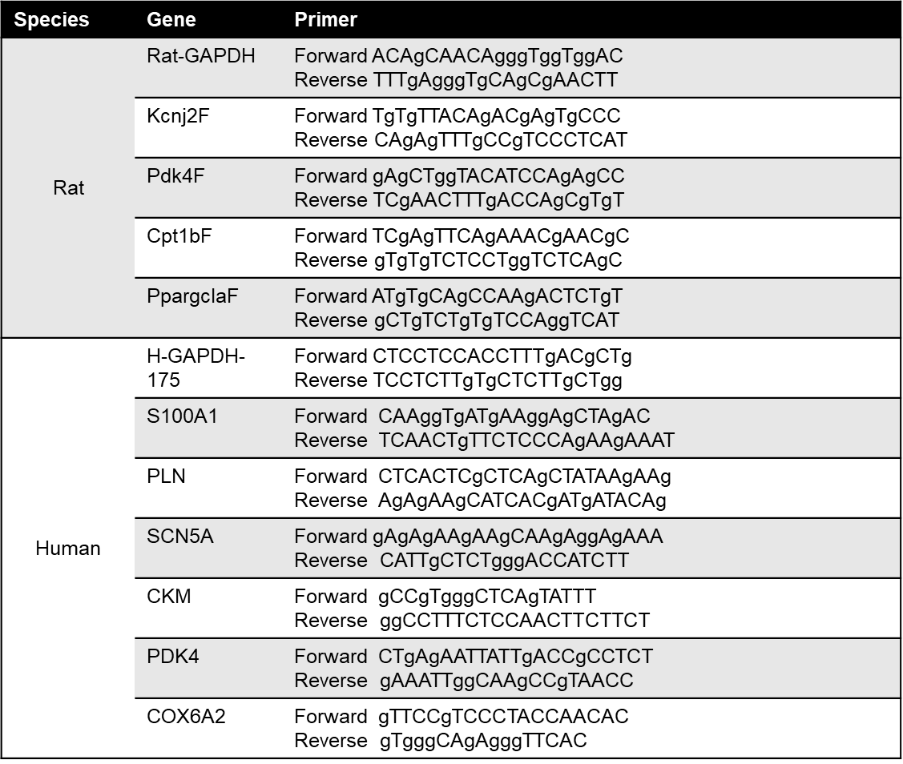

Movie S1.
Calcium transients in the primary-channel region of LVD neonatal rat cardiac tissues after 5 days of culture.

Movie S2.
Calcium transients in the branch-channel region of LVD neonatal rat cardiac tissues after 5 days of culture.

Movie S3.
Calcium transients in the primary-channel region of control neonatal rat cardiac tissues after 5 days of culture.

Movie S4.
Calcium transients in the branch-channel region of control neonatal rat cardiac tissues after 5 days of culture.

Movie S5.
Beating of LVD cardiac tissue from hiPSC-CMs after 2 days of culture.

