
Supporting Information for:
Bathymetry-based submarine landslide volume assessments
Thore F. Sager^{1*}, Morelia Urlaub¹, Christian Berndt¹
¹GEOMAR Helmholtz Centre for Ocean Research Kiel, Kiel, Germany
*Corresponding author: tsager@geomar.de
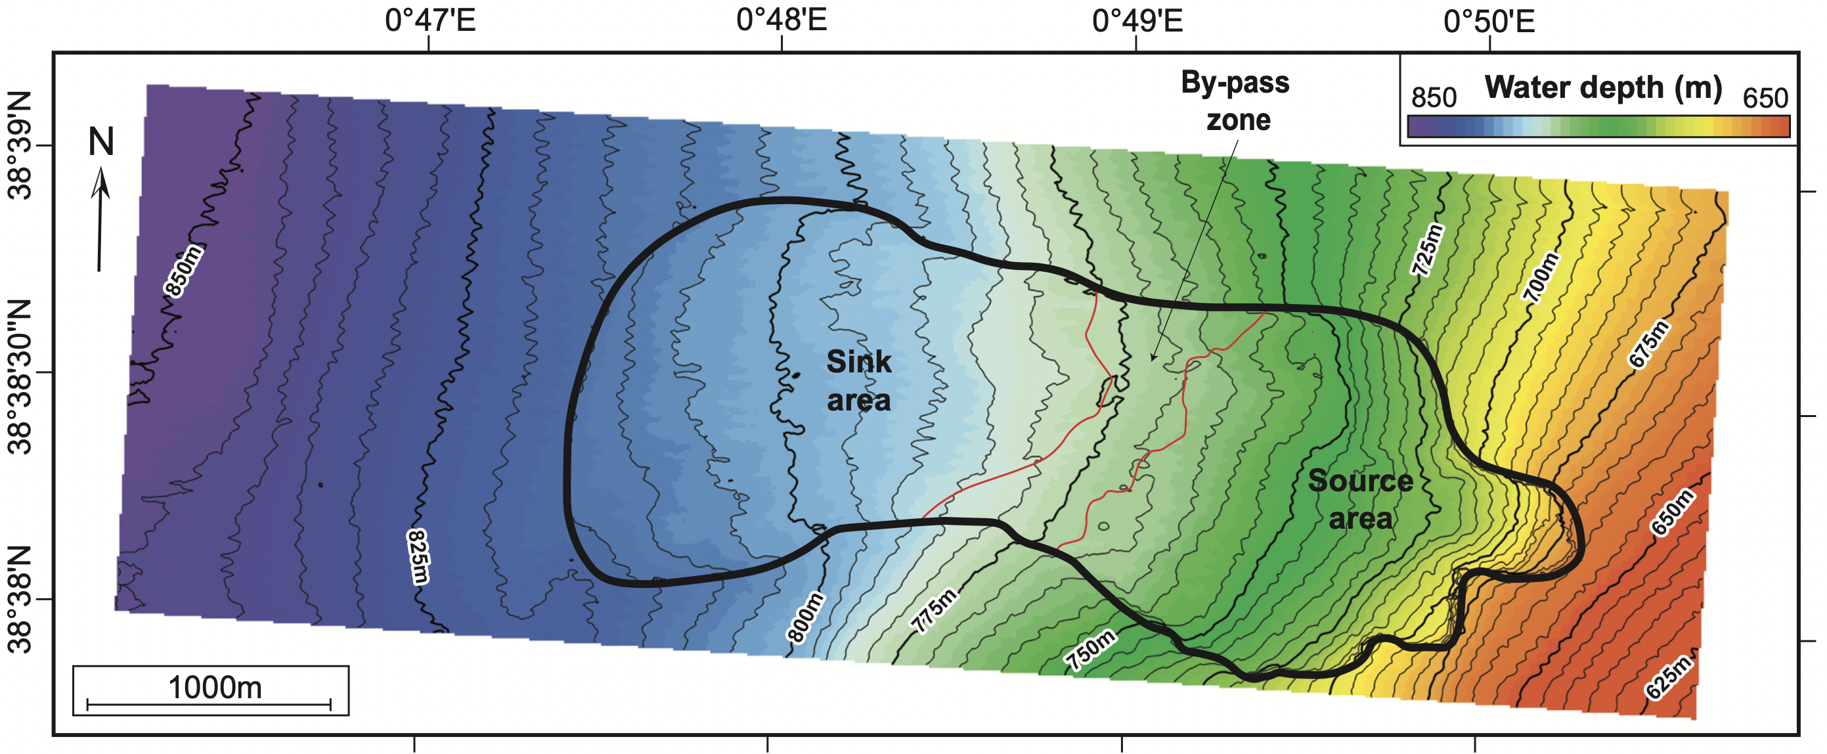
Figure 1: Planview map of the seafloor reflector SFR (depth converted with Vp = 1500 m/s). The source area, by-pass zone, and sink area are highlighted in which the pre-failure seafloor is reconstructed using several approaches presented in this supporting information.

Pre-failure seafloor reconstructions for the source and sink areas of Ana Slide
Probably the largest uncertainty for volume estimation of Ana Slide results from the reconstruction of the pre-failure seafloor. Here, we treat the landslide body as a void in the grid and adopt several approaches: 1) a linear interpolation across the void; 2) a manual reconstruction fitted optically to the surrounding seafloor topography inside the source area; and 3) the horizon-flattening that concerns recent tectonic movement performed inside the sink areas (sensu Sager et al., 2022) (Figure 1) . Both the manual and horizon-flattening reconstructions consider the equilibrium line concept: Ve ≥ Va.

Linear reconstruction (landslide scar)
We calculate the 10 m contour-lines from the bathymetric map in ArcMap (CD178). This is imported into IHS Kingdom Suite 2018/2020 and used as a culture. Then, we map arbitrary seismic lines that connect between the northern and southern intersection of the landslide scar and the 10m contour-lines (Figure 2). On these seismic profiles the seafloor is reconstructed by a manually picked horizon between both sides of the landslide scar with two points as a straight line. This pre-failure seafloor is then gridding for the whole landslide scar with different gridding parameters (flex gridding: maximum, medium, and minimum values). The linear reconstructed horizon as the input for gridding with different parameters is presented in Figure 2 and the results of volume estimates for the source and sink areas using this approach are shown in Table 2a – f. Using different gridding algorithms has little influence on the result of 0.027 km³ of evacuated landslide material from the source area and 0.006 km³ of material that accumulated inside the sink area. We do not prefer these estimated volumes as the pre-failure seafloor reconstruction is unrealistic for Ana Slide and the results respectively overestimate and underestimate Ve inside the source and Va inside the sink areas.
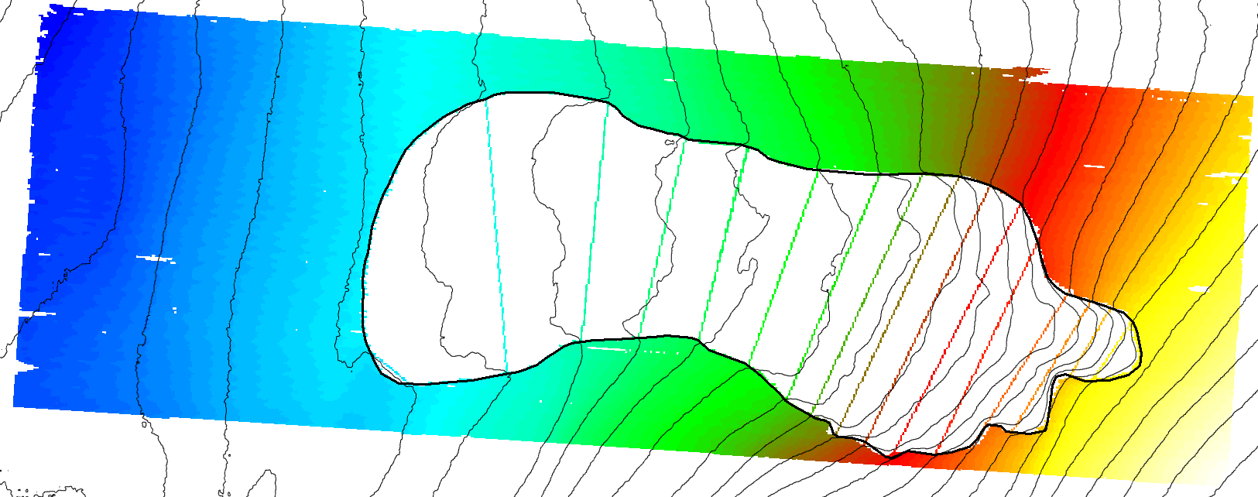
Figure 2: Straight contour-lines mapped between the interception of contour-lines (10m spacing from CD178 bathymetric grid) and the landslide scar for pre-failure seafloor reconstruction using the linear interpolation. Grid is in seconds TWTT.

Manual reconstruction approach (source area)
For estimation of the evacuated volume of landslide material from the source area, we use the manual reconstruction. For this, we map the present-day seafloor called SFR as a horizon that is then erased from inside the landslide scar. We then use the spline gridding algorithm that considers the trend of local contour-lines outside the landslide scar to reconstruct their trend inside of it. This reconstructed pre-failure seafloor is preferred for volume estimation of Ve and is presented in Figure 3 with results shown in Table 2g. A total of 0.016 km³ landslide material was evacuated from the source area. This value represents the preferred estimate of Ve as the pre-failure seafloor is reconstructed most realistically.
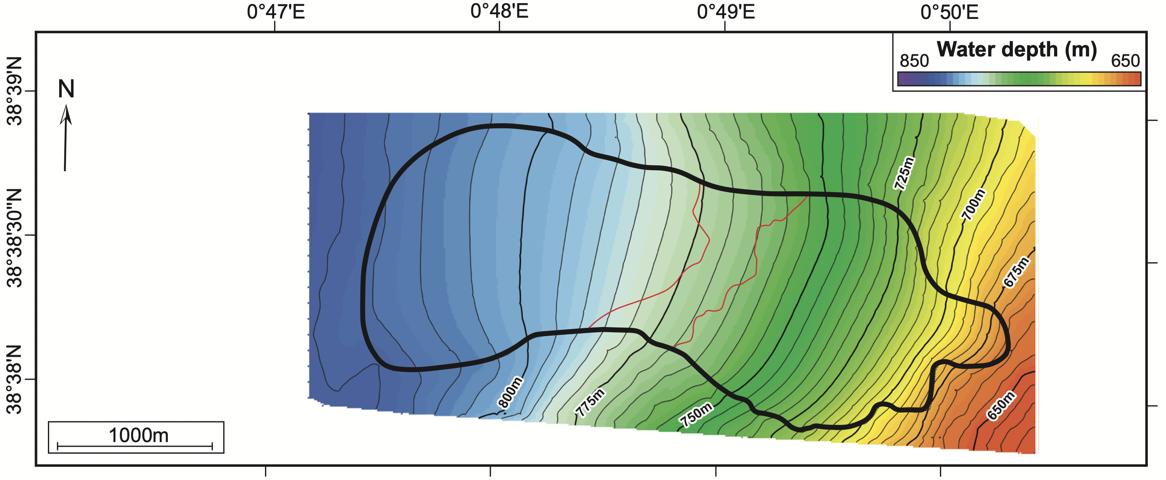
Figure 3: Manual reconstruction of the pre-failure seafloor using the spline gridding algorithm. Grid is depth-converted with a seismic velocity of Vp = 1500 m/s.

Removal of recent tectonic movement – horizon-flattening reconstruction inside the sink area
Analysis of the development of Ana Slide presented by Sager et al., 2022 shows that a local en-echelon fault system modified the seafloor morphology inside the sink area prior to failure of Ana Slide. The previous means of pre-failure reconstruction (linear and manual reconstruction) are dependent on the shape and local morphology of the landslide scar, which is modified along the southern sink area. These approaches are thus not able to consider recent vertical tectonic movement as they do not include any sub-seafloor information.
The important assumption to this approach of pre-failure seafloor reconstruction is that sediments inside the study area have been deposited since before Ana Slide at a relatively steady and most importantly predictable pace thus resulting in a predictable thickness between Ref and SFR (sensu Sager et al., 2022). By using horizon-flattening on Ref, the thickness between Ref and SFR can thus be predicted inside the sink area and thus this approach to pre-failure seafloor reconstruction is called the horizon-flattening approach.
We map Ref and SFR as a horizon and erased the latter from inside the sink area. Then, we horizontally flatten Ref and reconstruct the trend of SFR inside the sink area by straight lines (manual picks) that connected between the up- and downslope extent of SFR (Figure 4). Afterwards, we de-flatten Ref and estimate the volume of accumulated landslide material inside the sink area between the reconstructed and present-day seafloor that is represented by SFR. The resulting pre-failure seafloor from the horizon-flattening approach performed inside the sink area is presented in Figure 5 and the estimation of Va that is preferred is shown in Table 2h. Thus, the amount of accumulated landslide material inside the sink area is Va = 0.016 km³.
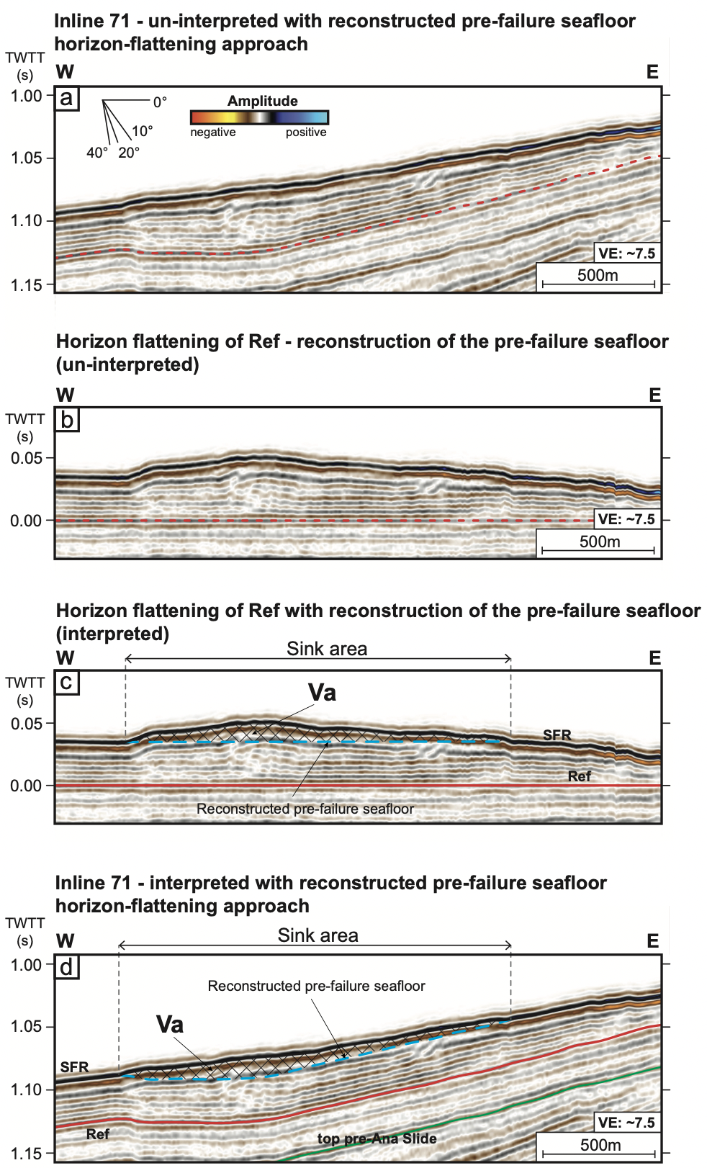
Figure 4: Application of the horizon-flattening approach demonstrated from inline 71 of the 3D reflection seismic dataset. a) the un-interpreted profile is examined with Ref highlighted, b) Ref is horizontally flattened, c) Ref (red) and SFR (black) are mapped and the up- and downslope extent of the sink area is determined. The pre-failure seafloor (stippled light blue) is reconstructed by a straight line in in-line direction that perpendicular to the strike of local tectonic features. The volume of accumulated landslide material can then be calculated between the reconstructed pre-failure seafloor and SFR inside the sink area (hatched area). d) Ref is horizontally un-flattened to show the reconstructed seafloor prior to the failure inside the sink area of Ana Slide.
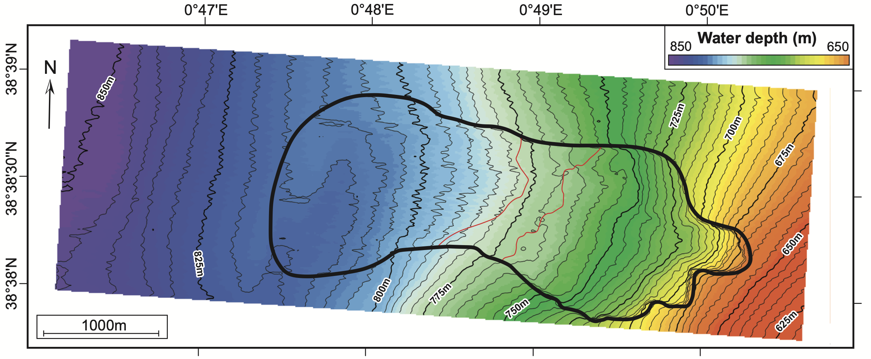
Figure 5: Horizon-flattening pre-failure seafloor reconstruction inside the sink area. Grid is depth-converted with a seismic velocity of Vp = 1500 m/s..

Validity of the pre-failure seafloor reconstructions performed
To check the validity of pre-failure seafloor reconstructions performed for Ana Slide, we use a similar approach as presented by Lastras et al., (2004) where they calculate the “volume of affected sediment” between a lower and upper surface inside the landslide scar. Following this approach, here, the lower and upper surfaces correspond to Ref and the preferred reconstructed pre-failure seafloors inside the source and sink areas (manual and horizon-flattening approaches), respectively. Also, Ref and SFR are used inside of the by-pass zone (Table 2i-k). The results show that 0.040 km³ of material involved in Ana Slide were originally located inside the source area, while 0.012 km³ and 0.068 km³ were originally located inside the by-pass zone and sink area, respectively. These volumes add up to 0.120 km³ of inherent material (Table 2l) that makes up Ana Slide. Importantly this volume is equal to that calculated between Ref and SFR as presented in the main article – Table 1a. Ultimate to the pre-failure seafloor reconstructions performed is to then calculate the actual amount of evacuated and accumulated landslide material which is presented in the main article in Figure 2e.

 | Reconstruction | Parameters | Figure reference | Polygon | lower surface | upper surface | Volume (km³)
a | linear reconstruction | maximum | 2 | source area | seafloor (SFR) | - | 0.027
b | linear reconstruction | middle | 2 | source area | seafloor (SFR) | - | 0.027
c | linear reconstruction | minimum | 2 | source area | seafloor (SFR) | - | 0.027
d | linear reconstruction | maximum | 2 | sink area | - | seafloor (SFR) | 0.006
e | linear reconstruction | middle | 2 | sink area | - | seafloor (SFR) | 0.006
f | linear reconstruction | minimum | 2 | sink area | - | seafloor (SFR) | 0.006
g | manual reconstruction | - | 3 | source area | seafloor (SFR) | - | 0.016
h | horizon-flattening | - | 4 and 5 | sink area | - | seafloor (SFR) | 0.016
i | manual reconstruction | - | - | source area | reference (Ref) | manual reconstruction | 0.040
j | seafloor (SFR) | - | - | by-pass zone | reference (Ref) | seafloor (SFR) | 0.012
k | horizon-flattening | - | - | sink area | reference (Ref) | horizon-flattening | 0.068
l |  |  |  |  |  |  | 0.120

Table 2: Results from volume estimation between a lower and upper bounding surface from several means of pre-failure seafloor reconstruction. The polygon marks the area inside of which Ve and Va are estimated. Surfaces marked by – represent the input seafloor generated by the reconstruction approach stated. The preferred pre-failure seafloor used to estimate Ve is presented in g while that of Va is presented in h.

Errors and uncertainties of volume calculation
Here, we list in detail all individual uncertainties related to volume estimates for Ana Slide and how they sum up to the overall uncertainties that are given in the manuscript (in % of the total volume). Note that because all volumes for Ana Slide were derived from the 3D reflection seismic data, we here have to also consider uncertainties related to the reflection seismic method and data. The uncertainties will be different for other case studies and where volumes are derived from bathymetric data alone:
- Positive seismic velocity anomalies have previously been observed inside of submarine landslides compared to un-deformed background sediments (e.g., Sun & Alves, 2020). The seismic velocity is increased due to a coupled response of the seafloor immediately beneath accumulated landslide material from compaction, loading, and de-watering. This uncertainty primarily affects volume calculation performed inside the sink area (Va) which is underestimated by up to 5% (Table 2a).
- Picking errors related to the vertical seismic resolution and those related to the horizontal resolution are affected by the data quality and processing. The vertical seismic resolution introduces uncertainties that are proportional to the thickness of a submarine landslide while the horizontal resolution is inversely proportional to the areal extent of submarine landslides. In general, the picking of seismic reflectors is related to the size and thickness of a landslide and the acquisition of reflection seismic data, for Ana Slide this uncertainty is up to 5% (Table 2b). Related to the horizontal resolution of the reflection seismic dataset, an uncertainty of 2% is introduced (Table 2c).
- The pre-failure seafloor for the source area (Ve) of Ana Slide is reconstructed from the trend of local contour-lines that follow the regional trend. This pre-failure seafloor, however, could have been locally modified by the presence of an underlying older landslide. Subsequent deposition of slope sediments may have infilled the source area but possibly not to an extent to even out compared to the non-failed neighbouring area. The exact uncertainty is impossible to quantify but we suggest a potential overestimation for the calculation Ve of up to 10% (Table 2d).
- The manual reconstruction of the pre-failure seafloor performed inside the source area (Ve) is inherently subjective. For Ana Slide this approach introduces both a positive and negative uncertainty of up to 10% (Table 2e).
Further insignificant uncertainties may be introduced by 1) basal erosion and/or entrainment of seafloor sediment that can incorporated into the landslide and increase the volume of accumulated landslide material inside the sink area (Va) (e.g., Nugraha et al., 2022; Sobiesiak et al., 2018) and 2) lateral variations in seismic velocities which are expected for large submarine landslides. The effect of these processes could be significant but are neglected here because of the excellent knowledge of the emplacement processes of Ana Slide derived from the data in a previous publication (Sager et al., 2022) and because of the relatively small area in which the Ana Slide occurred. The ghost-artefacts have no influence on the volume-calculation as they cancel out throughout the 3D reflection seismic data because positive and negative variations are the same. The horizon-flattening pre-failure seafloor reconstruction performed inside the sink area is primarily affected by the ghost-artefacts that contribute no uncertainty.
The resulting uncertainties affected the volume calculation of evacuated landslide material from the source are from Ve = 0,016 km³ to a maximum of 0.021 km³ and minimum of 0.013 km³, thus the uncertainty is +30% and -16%. For accumulated landslide material Va = 0.016 km³ the maximum deviation due to the uncertainties sums to a maximum of 0.018 km³ and minimum of 0.015 km³, thus +12% and -7%. See Table 2 for an overview.
 | Error Description | Type of Error | Uncertainty | Source  max (+) | min (-) | Sink  max (+) | min (-)
a | Unknown positive  seismic velocity | External and landslide process | 5 |  |  | x
b | Picking of the seismic  reflector (vertical resolution) | Data | 5 | x | x | x | x
c | Polygons of volume  estimation (horizontal resolution) | Data | 2 | x | x | x | x
e | Shape of pre-Ana Slide  seafloor inside source area of Ana Slide | External | 10 | x
f | Manual reconstruction  (inside the source area) | Reconstruction | 10 | x | x
 | Source area | Maximum volume | 0,021 | 30 %
 |  | Ve | 0,016
 |  | Minimum volume | 0,013 | -16 %
 | Sink area | Maximum volume | 0,018 | 12 %
 |  | Va | 0,016
 |  | Minimum volume | 0,015 | -7 %
Table 2: Uncertainties and errors that influence the volume estimation of submarine landslides. These uncertainties differently for the source and sink area and furthermore their positive (max (+)) or negative (min (-)) influence is highlighted. The uncertainties are summed and calculated in respect to Ve and Va, thus providing an uncertainty range of volume estimates specifically for Ana Slide.
Data availability statement
The 3D reflection seismic data from Ana Slide are available at the World Data Centre Pangaea (https://doi.pangaea.de/10.1594/PANGAEA.943523).

References
Lastras, G., Canals, M., Urgeles, R., Hughes-Clarke, J. E., & Acosta, J. (2004). Shallow slides and pockmark swarms in the Eivissa Channel, western Mediterranean Sea: Shallow slides and pockmark swarms. Sedimentology, 51(4), 837–850. https://doi.org/10.1111/j.1365-3091.2004.00654.x
Nugraha, H. D., Jackson, C. A.-L., Johnson, H. D., Hodgson, D. M., & Clare, M. A. (2022). Extreme erosion by submarine slides. Geology, 50(10), 1130–1134. https://doi.org/10.1130/G50164.1
Sager, T. F., Urlaub, M., Kaminski, P., Papenberg, C., Lastras, G., Canals, M., & Berndt, C. (2022). Development and Emplacement of Ana Slide, Eivissa Channel, Western Mediterranean Sea. Geochemistry, Geophysics, Geosystems, 23(11). https://doi.org/10.1029/2022GC010469
Sobiesiak, M. S., Kneller, B., Alsop, G. I., & Milana, J. P. (2018). Styles of basal interaction beneath mass transport deposits. Marine and Petroleum Geology, 98, 629–639. https://doi.org/10.1016/j.marpetgeo.2018.08.028
Sun, Q., & Alves, T. (2020). Petrophysics of fine-grained mass-transport deposits: A critical review. Journal of Asian Earth Sciences, 192, 104291. https://doi.org/10.1016/j.jseaes.2020.104291

