D-xylose accelerated death of pentose metabolizing Saccharomyces cerevisiae

Jeroen G. Nijland, Xiaohuan Zhang and Arnold J.M. Driessen

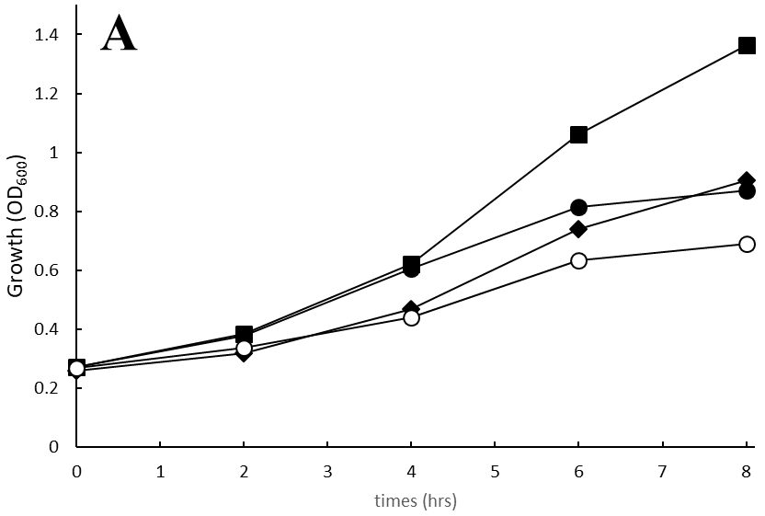
Supplemental data
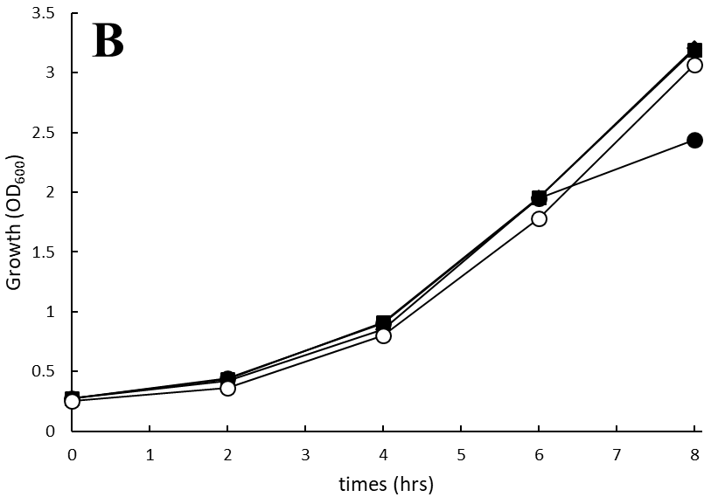
Supplemental Figure 1. Aerobic growth of the IMX730H strain complemented with the pRS313-P7T7-Hxk2 plasmid in mineral medium containing D-xylose (A) or D-glucose (B) at 0.25% (), 0,5% (), 2.0% (), and 8.0% () sugar.
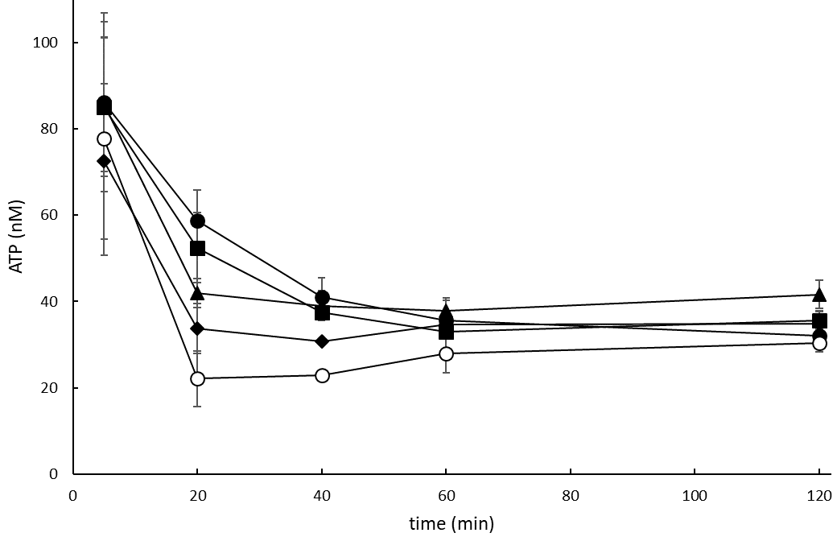

Supplemental Figure 2. Intracellular ATP analysis after adding 0.5% D-xylose (), 1.0% D-xylose (), 2.0% D-xylose (), 4.0% D-xylose () and 8.0% D-xylose () in the IMX730H strain complemented with the pRS313-P7T7-Hxk2 plasmid. The IMX730H-Hxk2 pre-culture was grown aerobically for 16 hours in minimal medium supplemented with 0.5% D-xylose. Error bars were obtained from biological duplicates.

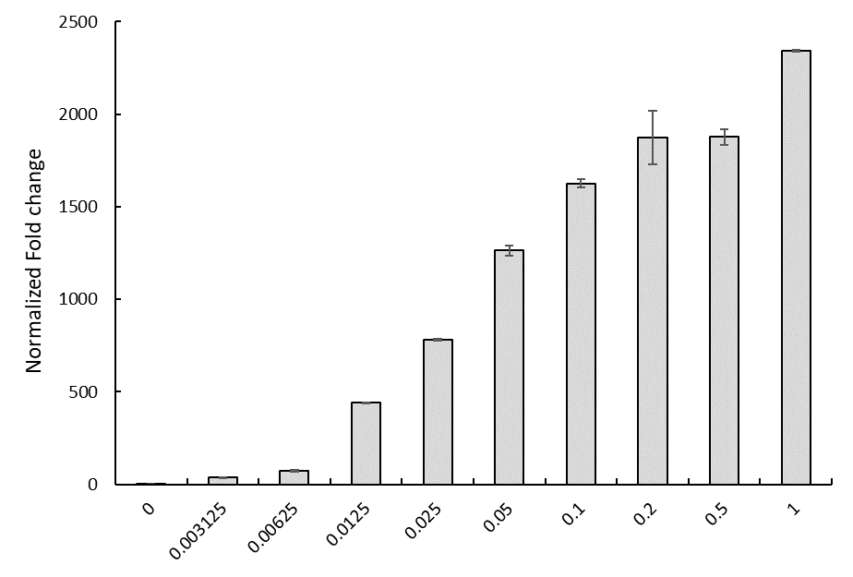
Supplemental Figure 3. Transcript fold change levels of GAL1 in IMX730-pGAL at various galactose concentrations ranging from 0% to 1%. Cells were incubated aerobically with 0.5% D-xylose and 2 hours after the addition of the galactose RNA was isolated. Error bars were obtained from biological duplicates.

Supplemental Table 1. Strains and plasmids used in this study
Strain/plasmid | Relevant genotype and/or characteristics | Source or reference
Strains
IMX730 | MATa ura3-52 his3-1 leu2-3112 MAL2-8c SUC2 glk1::Sphis5, hxk1::KlLEU2 gal1::cas9- amdS gre3::pTDH3 RPE1 pPGK1 TKL1, pTEF1 TAL1 pPGI1 NQM1 pTPI1 RKI1 pPYK1 TKL2 can1::(pTPI xylA tCYC)∗9 pTEF1-XKS1 hxk2::PcaraT | (1)
IMX730H | IMX730 ::Sphis5 | This study
IMX730-pGAL | IMX730H pGAL XKS1 | This study
Plasmids
pMel10 | E. coli/yeast vector, uracil autotrophic marker | (2)
pMel10-His5  pMel16 | pMel10, expressing sgRNA His5  E. coli/yeast vector, histidine autotrophic marker | This study  (2)
pMel16-Pgal10 | pMel16, expressing sgRNA linker pTEF1 and XKS1 | This study

Supplemental Table 2. Oligonucleotides used in Cas9 related deletion or integration.
Name | Sequence (5’ 3’)
F Tar spHis5  R Tar spHis5  F Rep spHis5  R Rep spHis5  F chk KO spHis5  R chk KO spHis5  F tar Pgal10  F tar Pgal10  F Rep Pgal10  R Rep Pgal10  F chk Gal10  R chk Xks1 | TGCGCATGTTTCGGCGTTCGAAACTTCTCCGCAGTGAAAGATAAATGATCAATTCCAGCTGCTACCGAAAGTTTTAGAGCTAGAAATAGCAAGTTAAAATAAGGCTAGTCCGTTATCAAC  GTTGATAACGGACTAGCCTTATTTTAACTTGCTATTTCTAGCTCTAAAACTTTCGGTAGC  AGCTGGAATTGATCATTTATCTTTCACTGCGGAGAAGTTTCGAACGCCGAAACATGCGCACGCA  CGCCCATATAAATATCCGCTATCAACAGAACCCCCAACCCCCCCATCAGTGCCCAACTCAACTTACCATCTTCTCTCCTTTATATATATATATATATATGTATATTTTCAGTGTATATAC  GTATATACACTGAAAATATACATATATATATATATATATAAAGGAGAGAAGATGGTAAGTTGAGTTGGGCACTGATGGGGGGGTTGGGGGTTCTGTTGATAGCGGATATTTATATGGGC  ACGCGGCGCTTGCACCCCGC  GTGTCATTGTTCAACACGTATGCG  TGCGCATGTTTCGGCGTTCGAAACTTCTCCGCAGTGAAAGATAAATGATCCAGCATACTTCGGGAACCGTGTTTTAGAGCTAGAAATAGCAAGTTAAAATAAGGCTAGTCCGTTATCAAC  GTTGATAACGGACTAGCCTTATTTTAACTTGCTATTTCTAGCTCTAAAACACGGTTCCCGAAGTATGCTGGATCATTTATCTTTCACTGCGGAGAAGTTTCGAACGCCGAAACATGCGCA  TGAAAACCTTGCTTGAGAAGGTTTTGGGACGCTCGAAGGCTTTAATTTGCACGGATTAGAAGCCGCCGAGC  ATTGTGTTGGAAACCTCTCTTGTCTGTCTCTGAATTACTGAACACAACATGGTTTTTTCTCCTTGACGTTAAAGTA  TGGGGTAATTAATCAGCGAAGCG  CTAGAGCCTCTAACCACATGGC
- Underlined represents the gene specific target

Supplemental Table 3. Oligonucleotides RT-PCR.
Name | Sequence (5’ 3’)
F Act1  R Act1  F Gal2  R Gal2  F Xks1  R Xks1 | GGATTCTGAGGTTGCTGCTTTGG  GAGCTTCATCACCAACGTAGGAG
  TCAATGGAGAGTTCCATTAGGGC
  CCAGAGGATCCTGCCGTCCAG
  GGGTCCTGCCAGCAGCACGG
  CTTTGCAGTACTGTGGTCTTGCC

1. Verhoeven MD, de Valk SC, Daran J-MG, van Maris AJA, Pronk JT. Fermentation of glucose-xylose-arabinose mixtures by a synthetic consortium of single-sugar-fermenting Saccharomyces cerevisiae strains. FEMS Yeast Res [Internet]. 2018 Dec 1 [cited 2019 Jan 28];18(8). Available from: https://academic.oup.com/femsyr/article/doi/10.1093/femsyr/foy075/5054444
2. Mans R, van Rossum HM, Wijsman M, Backx A, Kuijpers NGA, van den Broek M, et al. CRISPR/Cas9: a molecular Swiss army knife for simultaneous introduction of multiple genetic modifications in Saccharomyces cerevisiae. FEMS Yeast Res [Internet]. 2015 Mar 19 [cited 2016 Nov 21];15(2):fov004–fov004. Available from: http://femsyr.oxfordjournals.org/cgi/doi/10.1093/femsyr/fov004

