Supplemental materials

Table S1. The list of participating centers

1 | State Budgetary Healthcare Institution of the city of Moscow City Clinical Hospital named after S.P. Botkin of Moscow City Healthcare Department.
2 | State Budgetary Health Institution of the Nizhny Novgorod Region "Nizhny Novgorod Regional Clinical Hospital named after N.A. Semashko".
3 | State Autonomous Healthcare Institution of the Sverdlovsk Region "Sverdlovsk Regional Clinical Hospital N 1"
4 | State Budgetary Health Institution "Volgograd Regional Clinical Oncology Center".

Supplemental material S2.

Inclusion Criteria:
- Flow cytometry confirmation of immunophenotype with CD5, CD19, CD20, CD23, CD79b, and surface Ig prior to Visit 2.
- Proven diagnosis autoimmune hemolytic anemia or pure red cell aplasia.
- Relapse of AIHA/PRCA after steroids, splenectomy or rituximab or refractoriness to glucocorticosteroid hormones.
- No more than 2 lines of antileukemia treatment.
- Hematology values must be within the following limits:
  - Absolute neutrophil count 1000/mm3 independent of growth factor support
  - Platelets 100.000/mm3 or 50.000/mm3 if bone marrow involvement independent of transfusion support in either situation.
- Biochemical values within the following limits:
  - Alanine aminotransferase and aspartate aminotransferase less 3 upper limit of normal (ULN).
  - Total bilirubin less 1.5x ULN unless bilirubin rise is due to Gilbert's syndrome or of non-hepatic origin.
  - Serum creatinine less 2 x ULN or estimated Glomerular Filtration Rate more 40 mL/min/1.73 m2.
- Age ≥ 18 years.
- ECOG Performance Status of 0-2.
- Life expectancy of at least 6 months
- Women of childbearing potential and men who are sexually active must be practicing a highly effective method of birth control during and after the study consistent with local regulations regarding the use of birth control methods for subjects participating in clinical trials. Men must agree to not donate sperm during and after the study. For females, these restrictions apply for 1 month after the last dose of study drug. For males, these restrictions apply for 3 months after the last dose of study drug.
- Sign (or their legally-acceptable representatives must sign) an informed consent document indicating that they understand the purpose of and procedures required for the study, including biomarkers, and are willing to participate in the study.
Exclusion Criteria:
- CNS involvement.
- Richer transformation.
- History of stroke or intracranial hemorrhage within 6 months prior to randomization.
- HIV or positive hepatitis B or C serology.
- Serious comorbidities, e.g., cardiac disease.
- Other previous malignancies within 5 years.
- Signs of active infection.
- Requirement in treatment with P2Y12 antagonists or strong CYP3A inhibitors.
- Women who are pregnant or breastfeeding.

Table S3. Dose reductions and interruptions (reasons, number of episodes, number of patients, duration)

A. Reasons for dose Reductions
 | Number of episodes (%) | Number of patients | Median duration, range (days)
Pharmacokinetics | 5 (26,32%) | 5 | 7 (6–14)
Neutropenia | 4 (21,05%) | 4 | 1214 (450–1379)
Hemorrhagic complications | 3 (15,79%) | 2 | 1086 (21–1311)
Atrial fibrillation | 2 (10,53%) | 2 | 264 (7–521)
Myalgia/arthralgia | 1 (5,26%) | 1 | 1065
Skin eruptions | 1 (5,26%) | 1 | 10
Infections | 1 (5,26%) | 1 | 1
Headache | 1 (5,26%) | 1 | 80

B. Reasons for dose Interruptions
 | Number of episodes (%) | Number of patients | Median duration, range (days)
Surgical operations/biopsies/manipulations | 9 (34,62%) | 5 | 7 (3–17)
Atrial fibrillation | 6 (23,08%) | 3 | 5 (3–15)
Pharmacokinetics | 5 (19,23%) | 5 | 7 (6–12)
Infections | 4 (15,38%) | 4 | 9,5 (1–28)
Unhealing wound | 1 (3,85%) | 1 | 7
Hemorrhagic complications | 1 (3,85%) | 1 | 7

Figure S4. Lactate dehydrogenase (LDH) level dynamics.

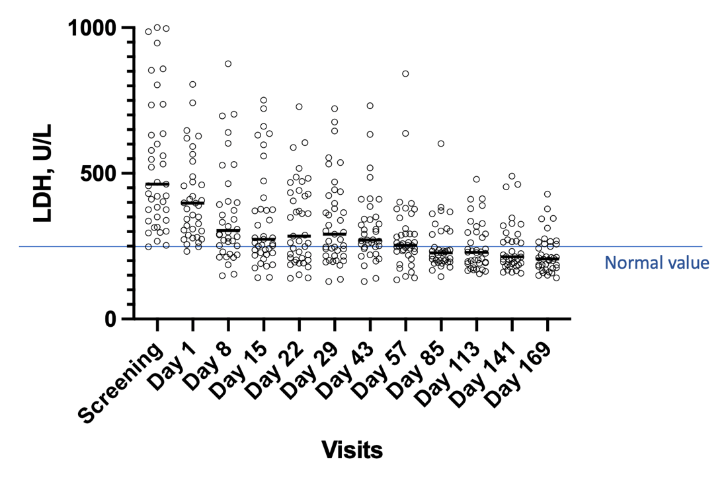

*Values above 1000 U/L at screening and day 1 are not shown.

Figure S5. Time to hemoglobin (Hb) normalization depending on the division into groups. A. Autoimmune complication (AIC) status: steroid refractoriness versus relapse. B. Chronic lymphocytic leukemia (CLL) response: complete response (CR) and nodular partial remission (nodPR) versus other responses. C. Hemoglobin (Hb) level at screening: >7.5 g/dL versus <7.5 g/dL. D. 17p deletion status at screening: no deletion 17p (del17p) versus del17p.
A.
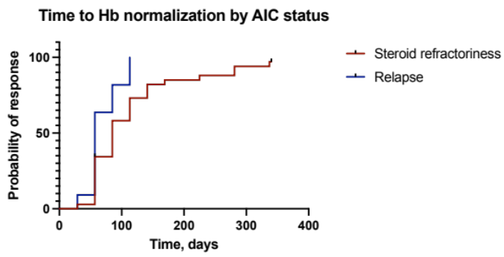
B.
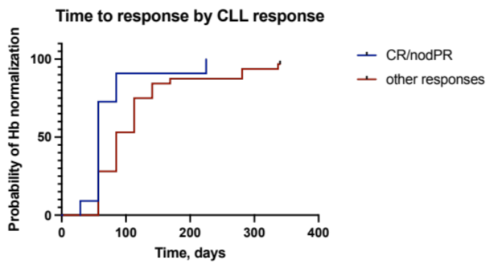
C.
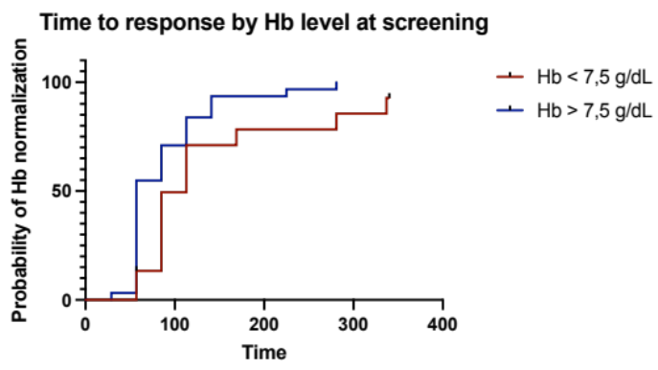
D.
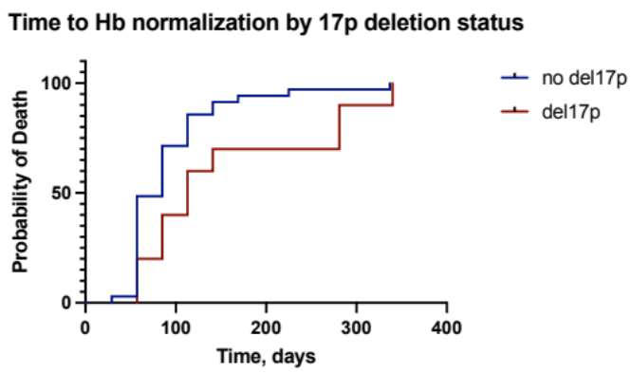

Figure S6. Time to direct antiglobulin test negative (DAT “-“ ) responseм depending on the division into groups. A. Lactate dehydrogenase (LDH) level: LDH >500U/L versus LDH<500U/L. B. Autoimmune complication (AIC) status: steroid refractoriness versus relapse.

A.
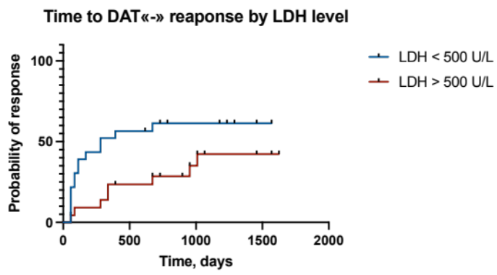
B.
