Supplementary Information
Acoustic-Driven Magnetic Skyrmion Motion
Yang Yang^{1#}, Le Zhao^{2#}, Di Yi^{3#}, Teng Xu², Yahong Chai¹, Chenye Zhang¹, Dingsong Jiang¹, Yahui Ji¹, Wanjun Jiang^{2*}, Jianshi Tang¹, Pu Yu², Huaqiang Wu¹, Tianxiang Nan^{1*}
¹ School of Integrated Circuits and Beijing National Research Center for Information Science and Technology (BNRist), Tsinghua University, Beijing, China.
² Department of Physics, Tsinghua University, Beijing, China.
³ School of Materials Science and Engineering, Tsinghua University, Beijing, China.
# These authors contributed equally.
* Corresponding author, e-mail: jiang_lab@tsinghua.edu.cn; nantianxiang@mail.tsinghua.edu.cn

- Characterization of the devices
Fig. S1a shows the out-of-plane magnetic hysteresis loop of the sample characterized by a polar magneto-optic Kerr effect (MOKE) microscope. Upon applying an in-plane magnetic field pulse (H_{ip} = 30 mT) with a zero out-of-plane magnetic field, the maze domain transforms into Néel-type magnetic skyrmions (Fig. S1b). We fit an individual skyrmion profile by a Gaussian fitting (Fig. S1c). The shear horizontal (SH) wave is a leaky surface acoustic wave (SAW) for the free surface of the 64°Y-cut LiNbO₃ substrate. The use of heavy metal interdigital electrodes allows acoustic energy to concentrate on the surface and increases SH wave amplitude. The SH-type leaky SAW is confined on the surface using interdigital transducers (IDTs) consisting of heavy metal Pt electrodes on top of the LiNbO₃ substrate. The optical microscopic image of the sample is shown in Fig. S1d.
a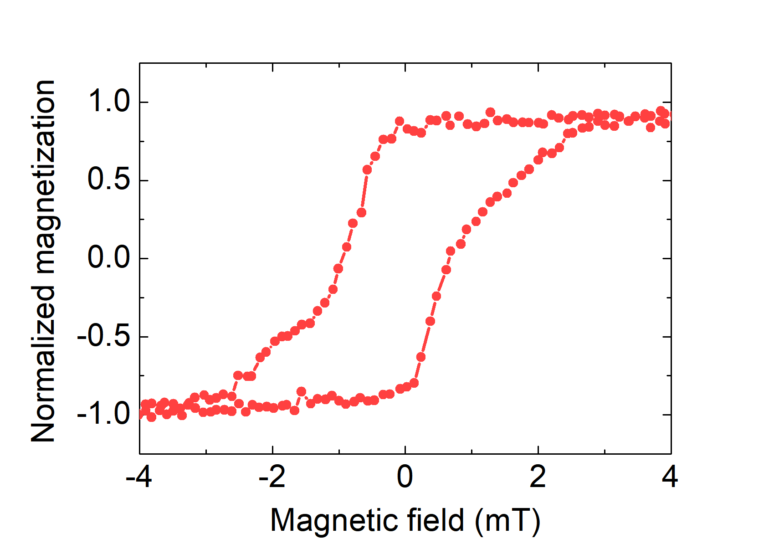
b 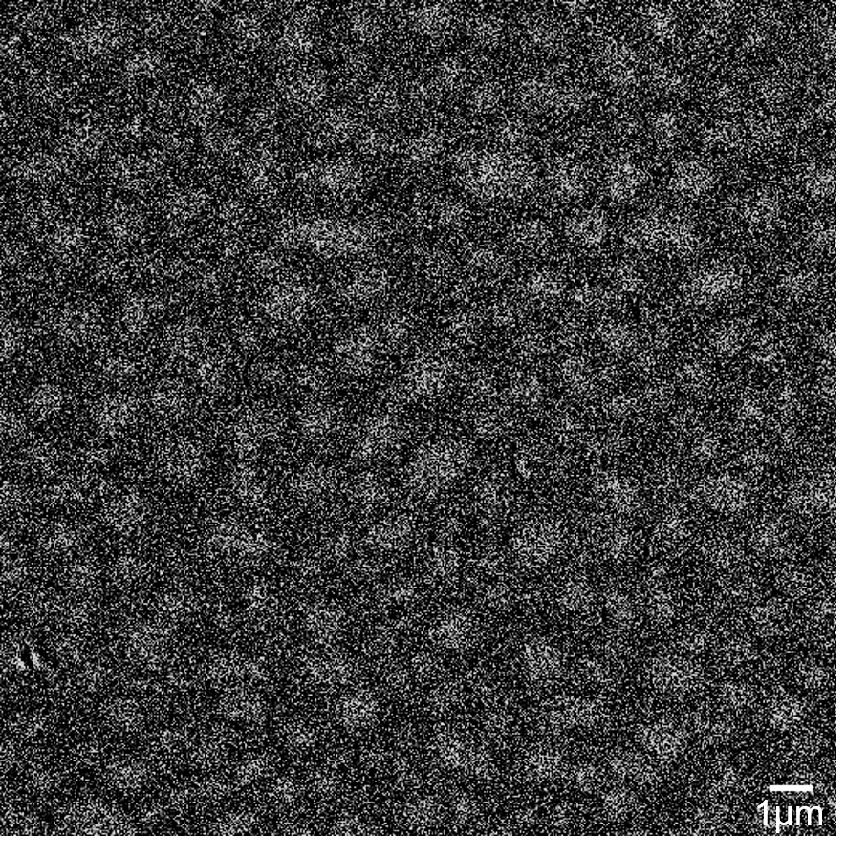
c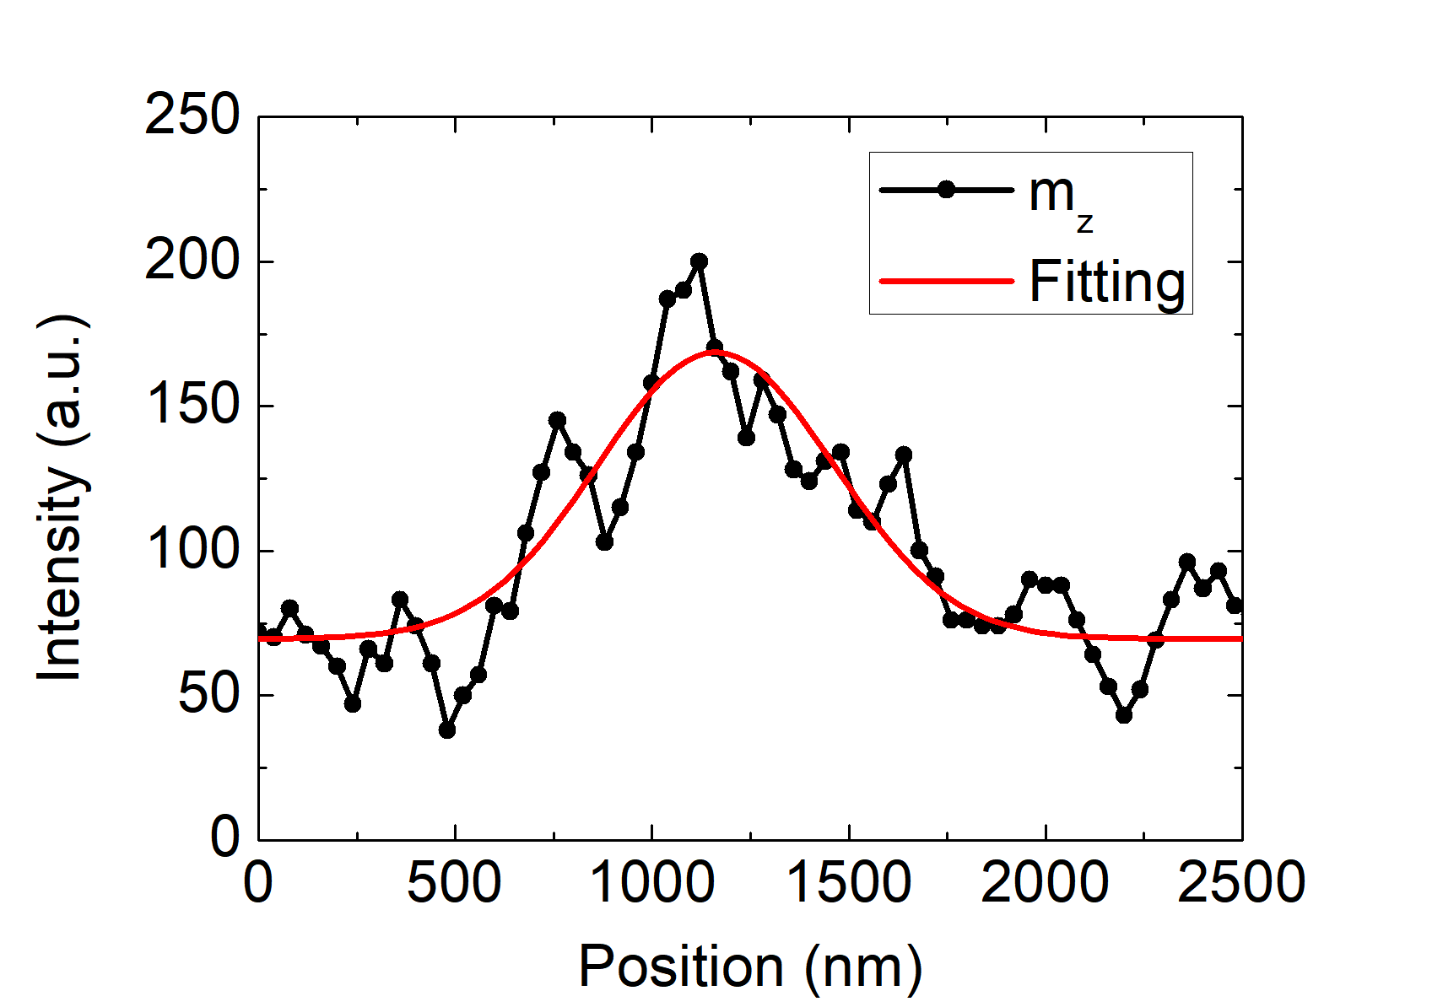

d
Supplementary Fig. S1 | The magnetic hysteresis loop, skyrmion image, the diameter of a skyrmion, and the optical microscopic image. a, The measured out-of-plane magnetic hysteresis loop of Ta/Co₂₀Fe₆₀B₂₀/MgO/Ta by a polar magneto-optic Kerr effect (MOKE) microscope. b, The MOKE image of the magnetic skyrmions after applying an in-plane magnetic field pulse with a zero out-of-plane magnetic field. c, A Gaussian fitting of an individual skyrmion profile. d, The optical microscopic image of the sample device.
- Simulation method
The micromagnetic simulation is implemented by solving the Landau–Lifshitz–Gilbert equation including interfacial Dzyalosinskii-Moriya interaction, exchange interaction, magnetic anisotropy, magnetostatic, and magnetoelastic coupling contributions using MuMax3¹⁻³.
The SH wave and Rayleigh wave are simulated by using a finite element model (FEM). The SH wave is generated as a fundamental mode with the wave propagation direction parallel to the X axis of 64°Y-cut LiNbO₃ (x axis). The piezoelectric constant matrix is defined by
(S1)
The Rayleigh wave is generated as a fundamental mode with the wave propagation direction perpendicular to the X axis of 64°Y-cut LiNbO₃ (y axis). The piezoelectric constant matrix is transformed to
(S2)
The simulated displacement distributions and admittances of the SH wave and Rayleigh wave are shown in Fig. S2.
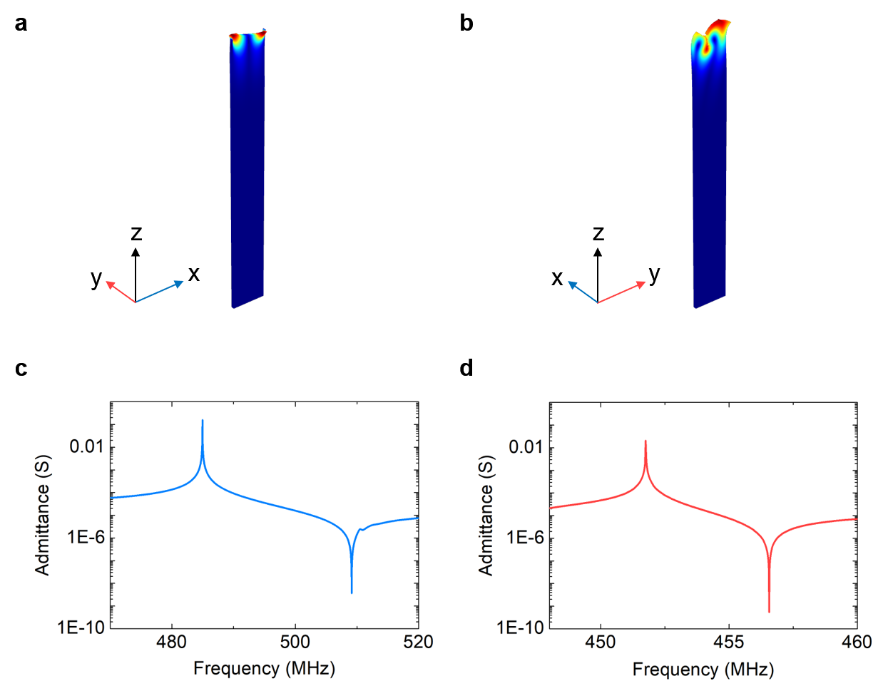
Supplementary Fig. S2 | The simulated displacement distributions and admittances of the SH wave and Rayleigh wave. a, The simulated displacement distribution of the SH wave. b, The simulated displacement distribution of the Rayleigh wave. c, The simulated admittances of the SH wave. d, The simulated admittances of the Rayleigh wave. The wavelength is 8 μm.

- Analysis of skyrmions motion
When an SH wave propagates along the x axis in thin films, the spatiotemporally varying shear displacement (u_{y}=Asin(kx-ωt)) component is dominant for an SH wave, where A, k, ω, and t are the amplitude, the wavenumber, the angular frequency of the SAW, and time, respectively. The shear strain (ε_{XY}=kAcos(kx-ωt)) component of an SH wave is dominant over the others. In the case of considering only the strain ε_{XY}, spatially inhomogeneous in-plane magnetoelastic effective fields are generated in the x and y axes:
(S3)
(S4)
where m is the normalized magnetization component, M_{s} is the saturation magnetization, and B₂ is the magnetoelastic coupling constant. It can be seen that increasing B₂, A, and k are beneficial for the enhanced magnetoelastic coupling.
The SH wave with a wavelength of 10 μm also moves skyrmions, as shown in Fig. S3.
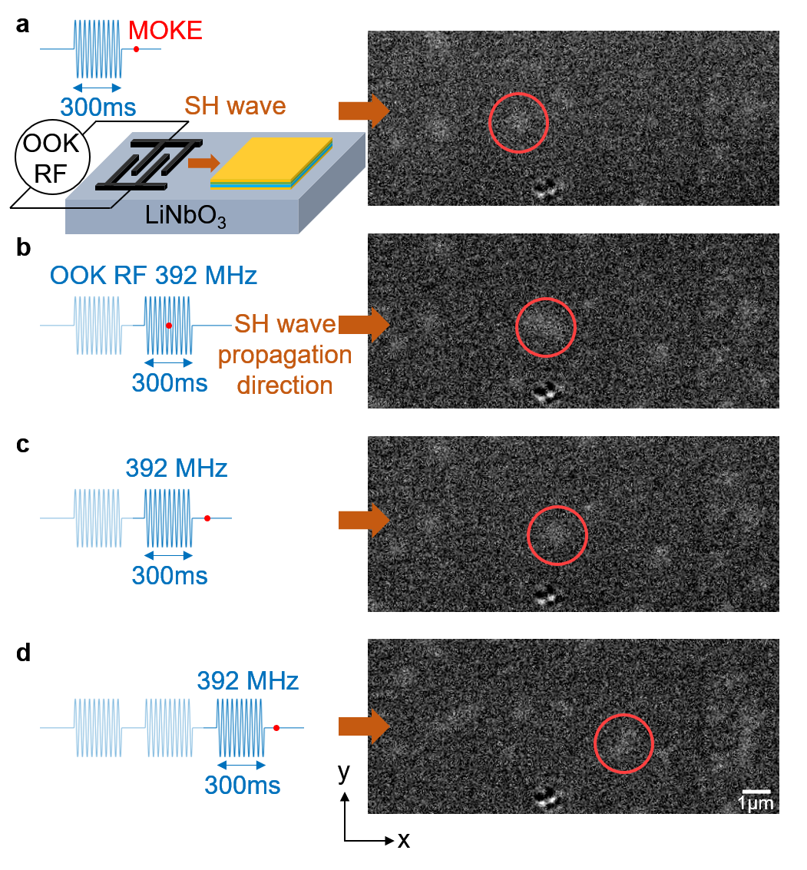
Supplementary Fig. S3 | The skyrmion motion driven by SH waves with the wavelength of 10 μm. a, The creation of magnetic skyrmions by exciting a propagating SH wave pulse (λ_{SAW} = 10 μm) with a duration of 300 ms. b, The motion of a magnetic skyrmion during the propagating SH wave. c, The MOKE image after exciting an SH wave pulse with a duration of 300 ms. d, The MOKE image after exciting an SH wave pulse with a duration of 300 ms once again. The wavelength is 10 μm. The RF power is 26.6 dBm. The scale bar is 1 μm.
We also discuss the factors influencing the skyrmion motion distances. The effect of the wavelength on the motion distances of skyrmions is investigated in experiments, as shown in Fig. S4a. The Rayleigh wave does not drive the motion of skyrmions in experiments. We focus on the skyrmions with the motion distances over 1 μm. Statistically, 32% of skyrmion population shows motion distance d>1 μm when the wavelength of the SH wave is 8 μm. 17.2% of skyrmion population shows motion distance d>1 μm when the wavelength increases to 10 μm. The reduction in a wavelength from 10 μm to 8 μm produces enhanced strains of SH waves, results in more skyrmion numbers in improved motion distances. Most of the skyrmions moving less than 1 μm indicate creep motions in a low-depinning regime and are easily trapped by pinning sites. The effect of exciting RF power that controls wave amplitude on the motion distances of skyrmions is also investigated. The amplitude of the strain generated by a SAW is proportional to the RF power before the saturation power of SAW. The number of moving skyrmions reduces when the RF power decreases from 26.6 dBm to 20 dBm, as shown in Fig. S4b. Increasing RF powers and decreasing the wavelength are effective methods for depinning, together with an increased motion distance.
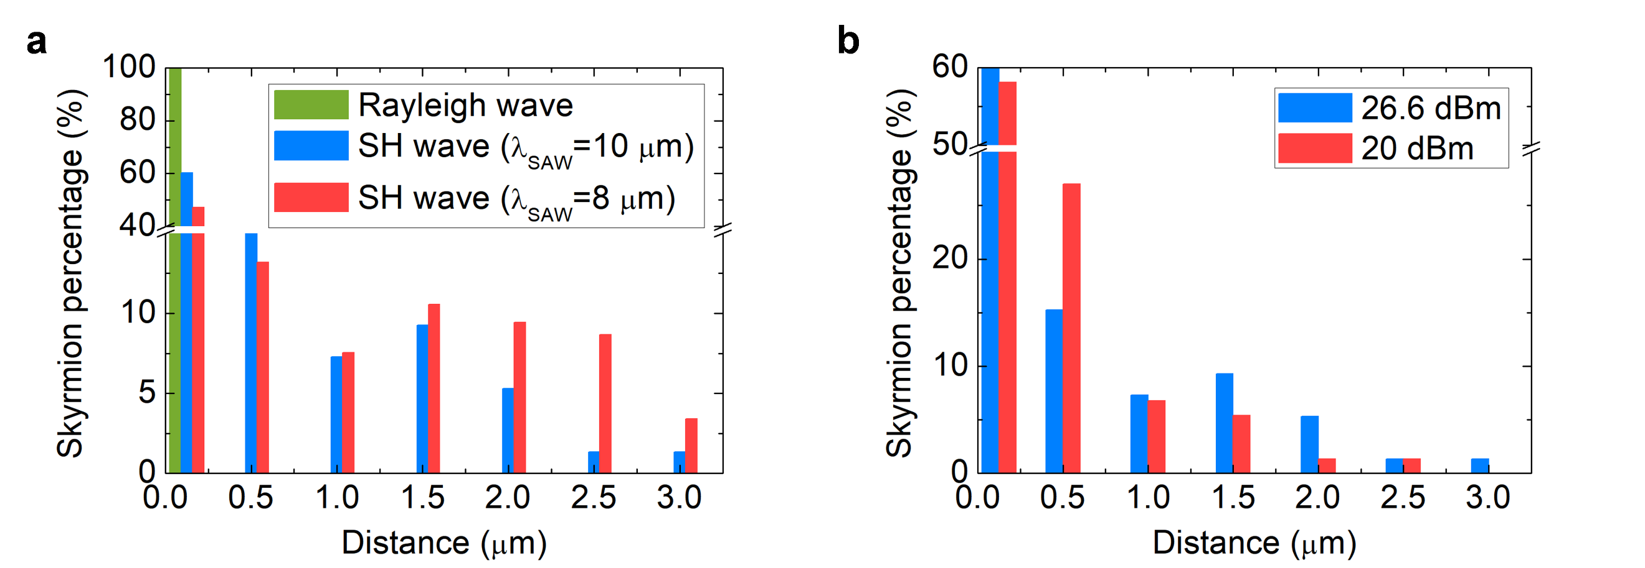
Supplementary Fig. S4 | Statistical analysis of skyrmions motion distances. a, The measured skyrmions motion distances driven by SH waves with different wavelengths. b, The relationship between skyrmions motion distances and RF powers.
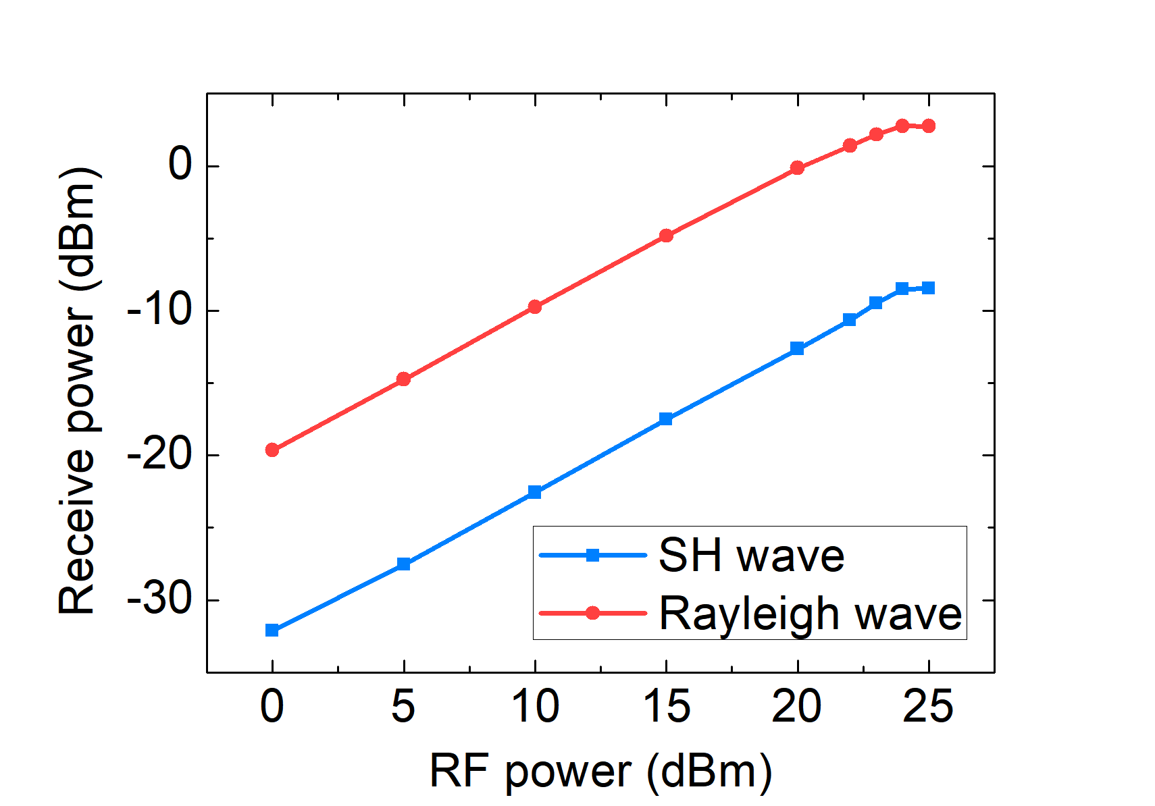
Supplementary Fig. S5 | The received power of the receiving IDTs as a function of RF power for the SH wave and Rayleigh wave.
The skyrmion motion driven by the SAW can be described by a modified Thiele equation⁴:
(S5)
where G = (0, 0, −4πQ) is the gyromagnetic coupling vector. Q is the topological charge. α is the Gilbert damping parameter. D is the dissipative force tensor. V = (V_{x}, V_{y}) is the skyrmion velocity along the x and y axes. F = (F_{x}, F_{y}) is the effective magnetoelastic forces along the x and y axes. The effective magnetoelastic forces are proportion to the magnetoelastic coupling constants. The skyrmion velocity is defined by
(S6)
It can be found that the skyrmion velocity is related to the Gilbert damping parameter. The skyrmion deflection angle is defined by
(S7)
Fig. S6 shows the deflection angle as a function of damping parameters with different F_{y}/F_{x}. An increased damping parameter from 0.01 to 0.07 results in a reduced deflection angle. The deflection angle of the skyrmion motion driven by an SH wave is also influenced by F_{y}/F_{x}. F_{x} and F_{y} are proportional to the shear strain gradient. They are nonzero for the SH wave, and therefore also influence the deflection angle.
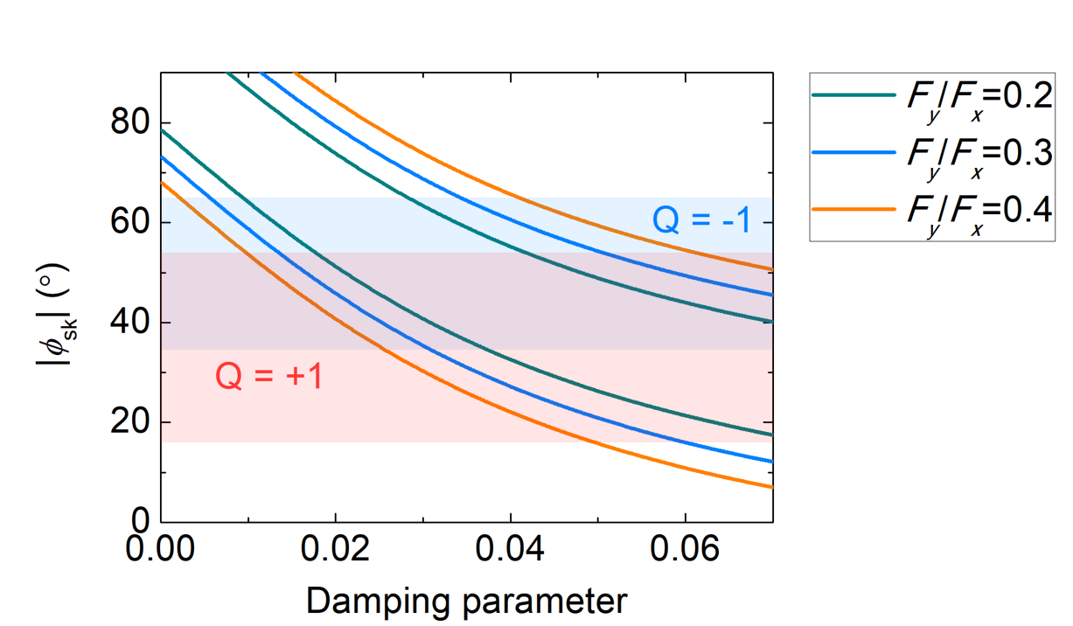
Supplementary Fig. S6 | The experimental (blue and red regions) and numerically calculated (curves) skyrmion deflection angles (ϕ_{sk}) versus the damping parameters with different F_{y}/F_{x}.
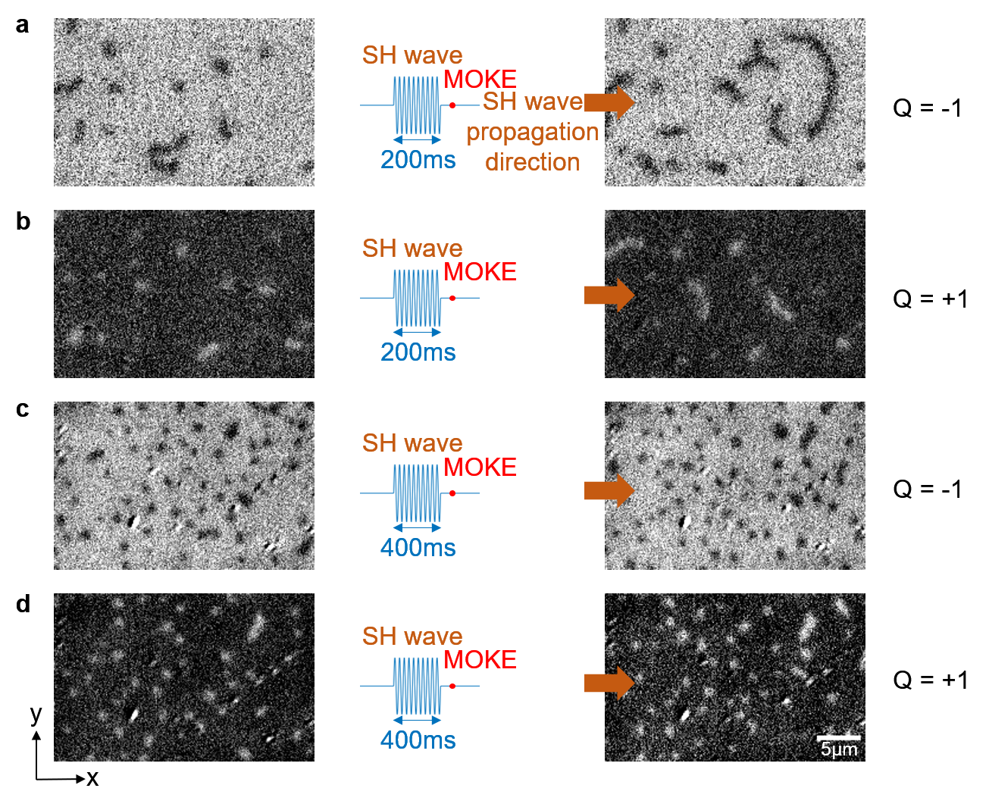
Supplementary Fig. S7 | Evolution of magnetic textures by applying SH waves. a, MOKE images of Q = -1 skyrmions after exciting 200 ms SH waves. b, MOKE images of Q = +1 skyrmions after exciting 200 ms SH waves. c, MOKE images of Q = -1 skyrmions after exciting 400 ms SH waves. d, MOKE images of Q = +1 skyrmions after exciting 400 ms SH waves. The wavelength is 8 μm. The RF power is 26 dBm.

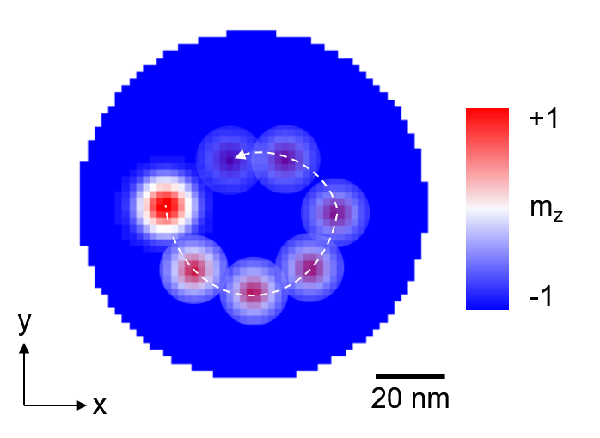
Supplementary Fig. S8 | The micromagnetic simulation for the motion of a skyrmion driven by an SH wave in a circular magnetic film. The wavelength is 8 μm.

- Analysis of the effective power density to drive skyrmion motion
The effective power density for a single skyrmion driven by a SAW is defined by
(S8)
where P_{SAW} is the applied RF power, β is the SAW propagation loss, W is the width of the magnetic film, and L is the length of the magnetic film. The effective power density for a single skyrmion with a speed of around 10 μm/s is 74.6 W/cm² when the applied RF power is 26 dBm. Table. S1 lists the performance of our work compared with other driven methods.

Supplementary Table. S1 Comparison of different skyrmion driven methods
Skyrmion Driven method | Mechanism | Power density | Active skyrmion area | Local heating | Material system | Reference
Current | Spin-orbit torques (SOT) | 4.4×10³~2.26×10⁴ W/cm² | 10 μm×50 μm | Yes | YIG/TmIG/Pt | [5]
Current | SOTs | 1.5×10⁴ W/cm² | 2 μm×5 μm | Yes | [Pt/Co/Ta]₁₅ | [6]
Thermal gradient | Repulsive and entropic forces, thermal SOTs | 425 W/cm² | 4 μm×30 μm | Yes | [Ta/CoFeB/MgO]₁₅ | [7]
Surface acoustic waves | Magnon-phonon interaction | 74.6 W/cm² | 200 μm×200 μm | No | Ta/CoFeB/MgO/Ta | This work

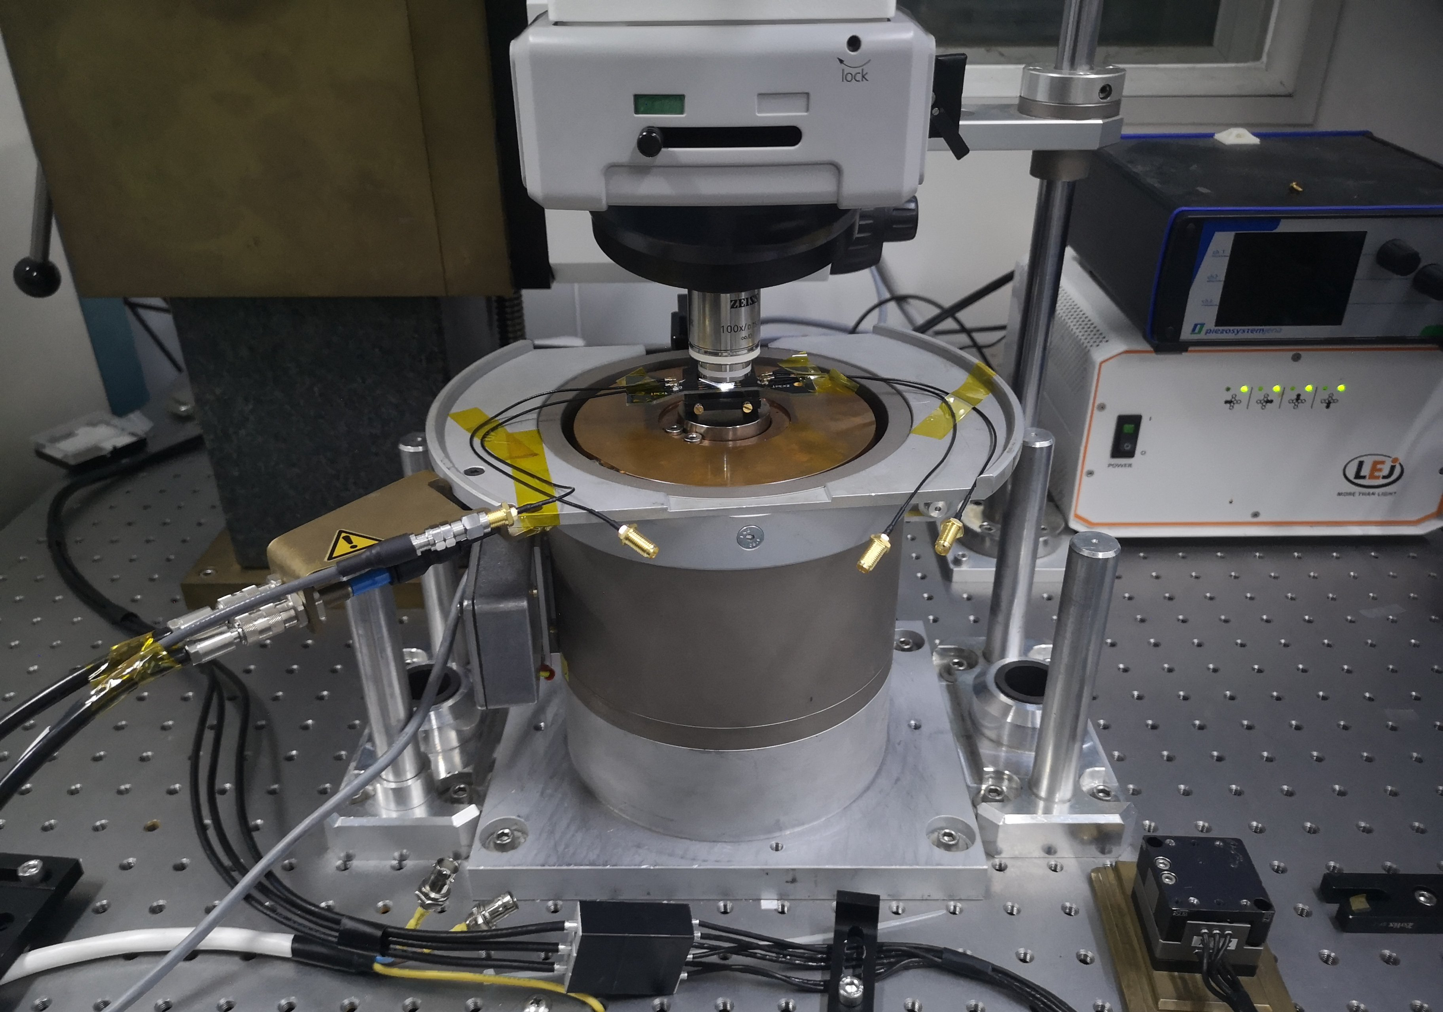
Supplementary Fig. S9 | The setups of the MOKE microscope for SAWs-driven skyrmion experiments.

Supplementary Movie 1:
Motion pictures of skyrmion motion with Q=+1 skyrmion driven by SH waves shown in Fig. 3a-d.

Supplementary Movie 2:
Motion pictures of skyrmion motion with Q=-1 skyrmion driven by SH waves shown in Fig. 3e-h.

References
Vansteenkiste, A., Leliaert, J., Dvornik, M., Helsen, M., Garcia-Sanchez, F. & Waeyenberge, B. V. The design and verification of MuMax3, AIP Adv. 4, 107133 (2014).
Mulkers, J., Waeyenberge, B. Van, Milošević, M. V. Effects of spatially engineered Dzyaloshinskii-Moriya interaction in ferromagnetic films. Phys. Rev. B 95(14), 144401 (2017).
Vanderveken, F., Mulkers, J., Leliaert, J. et al. Finite difference magnetoelastic simulator. Open Research Europe 1(35), 1-23 (2021).
Thiele, A. A. Steady-state motion of magnetic domains. Physical Review Letters, 30(6), 230-233 (1973).
Vélez, S., Ruiz-Gómez, S., Schaab, J. et al. Current-driven dynamics and ratchet effect of skyrmion bubbles in a ferrimagnetic insulator. Nat. Nanotechnol. 17, 834–841 (2022).
Woo, S., Litzius, K., Krüger, B. et al. Observation of room-temperature magnetic skyrmions and their current-driven dynamics in ultrathin metallic ferromagnets. Nat. Mater. 15, 501–506 (2016).
Wang, Z., Guo, M., Zhou, HA. et al. Thermal generation, manipulation and thermoelectric detection of skyrmions. Nat. Electron. 3, 672–679 (2020).

