SI APPENDIX

Table S1. PSD parameters
Parameter | Equation
Geometric mean of particle size (mm) | $$x_{g}=\log^{-1}\left[\sum{\left(m_{i}{logx}_{si}\right)/\sum{m_{i}}}\right]$$
Standard deviation,  dimensionless | $$s_{g}=\log^{-1}\sqrt{\sum{\left(m_{i}{\left({logx}_{si}-{logx}_{g}\right)}^{2}\right)}}/\sum{m_{i}}$$
Geometric mean of particle size on the i-th sieve (mm) | $$x_{si}=\sqrt{x_{i}x_{i-1}}$$
Part of mass material finer than size x | $$Y=1-exp\left(-{\left(x/{x_{R}}\right)}^{n}\right)$$
Particle size with part of mass material Y | $$x=x_{R}{\left[-ln\left(1-\frac{Y}{100}\right)\right]}^{1/n}$$
Graphic mean of particle size (mm) | $$x_{gm}=\left(x_{16}+x_{50}+x_{84}\right)/3$$
Inclusive graphic standard deviation (mm) | $$σ_{ig}=\left(x_{84}-x_{16}\right)/4+\left(x_{95}-x_{5}\right)/6.6$$
Uniformity index (%) | $$I_{u}=100x_{5}/x_{90}$$
Size guide numer | $$N_{sg}=100x_{50}$$
Particle size variation ranges (%) | $$S_{v}=100\left(x_{84}-x_{16}\right)/2x_{50}$$
Mass relative span | $$S_{l}=\left(x_{90}-x_{10}\right)/x_{50}$$
Coefficient of uniformity | $$C_{u}=x_{60}/x_{10}$$
Coefficient of gradation | $$C_{g}=x_{30}^{2}/\left(x_{10}x_{60}\right)$$
Inclusive graphic skewness | $$S_{ig}=\left(x_{16}+x_{84}-{2x}_{50}\right)/2\left(x_{84}-x_{16}\right)+\left(x_{5}+x_{95}-{2x}_{50}\right)/2\left(x_{95}-x_{5}\right)$$
Graphic kurtosis | $$K_{g}=\left(x_{95}-x_{5}\right)/2.44\left(x_{75}-x_{25}\right)$$
Geometric STD of high region | $${STD}_{h}=x_{84}/x_{50}$$
Geometric STD of low region | $${STD}_{l}=x_{50}/x_{16}$$
Geometric STD of total region | $${STD}_{t}=\sqrt{x_{84}/x_{16}}$$
x_{g}, geometric mean of particle size; m_{i}, mass of material on i-th sieve; x_{si}, geometric mean of particle size on the i-th sieve; s_{g}, standard deviation, dimensionless; x_{i}, holes diagonal of i-th sieve; x_{(i–1)}, diagonal of sieve hole which is above the i-th sieve; Y, part of mass material finer than size x; x, particle size, receiving from the equivalent of diagonal sieve opening through which would come Y part of material; n, Rosin-Rammler-Sperling-Bennett particle size distribution parameter; x_{R}, particle size for 63.2% of mass distribution, Rosin-Rammler-Sperling-Bennett parameter; x_{gm}, graphic mean of particle size; x₅, x₁₀, x₁₆, x₂₅, x₃₀, x₅₀, x₆₀, x₇₅, x₈₄, x₉₀ and x₉₅ are corresponding particle sizes at 5, 10, 16, 25, 30, 50, 60, 75, 84, 90 and 95 percentile of cumulated undersize mass distribution, respectively; σ_{ig}, – inclusive graphic standard deviation, describes scattering of components in particle size distribution in relations to mean value; I_{u}, uniformity index; N_{sg}, size guide number, statistical particles size; S_{v}, particle size variation ranges; S_{l}, mass relative span; C_{u}, coefficient of uniformity; C_{g}, coefficient of gradation; S_{ig}, inclusive graphic skewness, asymmetry, indicates position of particle distribution curve in relation to mode value particle; K_{g}, graphic kurtosis, flatten of particle size distribution curve; STD_{h}, STD_{l}, and STD_{t}, geometric STD of high low and total regions, respectively.

Table S2. The average values and standard deviations of PSD parameters for raw, milled, cut-milled pine and poplar shavings and determined on the basis of research and calculated form the RRSB model
Parameter | Raw shavings |  | Milled shavings |  | Cut-milled shavings
 | pine | poplar | pine | poplar | pine | poplar
x_{g}, mm | 6.21^{c} ± 0.18 | 5.94^{b} ± 0.16 | 0.60ª ± 0.03 | 0.62ª ± 0.01 | 0.51ª ± 0.01 | 0.45ª ± 0.01
s_{g}, – | 2.15^{d} ± 0.04 | 1.92ª ± 0.02 | 2.06^{bc} ± 0.05 | 2.10^{cd} ± 0.03 | 1.89ª ± 0.01 | 2.03^{b} ± 0.04
s_{gw}, mm | 26.2^{d} ± 0.5 | 19.8^{c} ± 0.4 | 2.29^{b} ± 0.08 | 2.49^{b} ± 0.08 | 1.63ª ± 0.03 | 1.70ª ± 0.06
x_{R}, mm | 6.07 ± 0.20 | 5.93 ± 0.20 | 0.73 ± 0.03 | 0.75 ± 0.02 | 0.68 ± 0.01 | 0.60 ± 0.01
n, – | 1.40 ± 0.04 | 1.61 ± 0.03 | 1.56 ± 0.06 | 1.63 ± 0.03 | 1.77 ± 0.05 | 1.50 ± 0.04
x₅, mm | 0.73 ± 0.06 | 0.94 ± 0.07 | 0.11 ± 0.01 | 0.12 ± 0.01 | 0.13 ± 0.01 | 0.08 ± 0.01
x₁₀, mm | 1.22 ± 0.08 | 1.47 ± 0.09 | 0.17 ± 0.01 | 0.19 ± 0.01 | 0.19 ± 0.01 | 0.13 ± 0.01
x₁₆, mm | 1.75 ± 0.11 | 2.01 ± 0.11 | 0.24 ± 0.02 | 0.26 ± 0.01 | 0.25 ± 0.01 | 0.19 ± 0.01
x₂₅, mm | 2.5 ± 0.13 | 2.74 ± 0.13 | 0.33 ± 0.02 | 0.35 ± 0.01 | 0.34 ± 0.01 | 0.26 ± 0.01
x₃₀, mm | 2.91 ± 0.14 | 3.13 ± 0.14 | 0.38 ± 0.02 | 0.40 ± 0.01 | 0.38 ± 0.01 | 0.30 ± 0.01
x₅₀, mm | 4.67 ± 0.18 | 4.72 ± 0.18 | 0.57 ± 0.03 | 0.60 ± 0.01 | 0.55 ± 0.01 | 0.47 ± 0.01
x₆₀, mm | 5.70 ± 0.20 | 5.62 ± 0.19 | 0.69 ± 0.03 | 0.71 ± 0.02 | 0.65 ± 0.01 | 0.57 ± 0.01
x₇₅, mm | 7.66 ± 0.23 | 7.26 ± 0.21 | 0.89 ± 0.03 | 0.92 ± 0.02 | 0.82 ± 0.01 | 0.75 ± 0.01
x₈₄, mm | 9.35 ± 0.25 | 8.64 ± 0.22 | 1.07 ± 0.03 | 1.09 ± 0.03 | 0.96 ± 0.01 | 0.90 ± 0.02
x₉₀, mm | 11.00 ± 0.28 | 9.96 ± 0.23 | 1.24 ± 0.03 | 1.25 ± 0.02 | 1.09 ± 0.02 | 1.05 ± 0.02
x₉₅, mm | 13.3 ± 0.3 | 11.7 ± 0.2 | 1.47 ± 0.04 | 1.47 ± 0.03 | 1.26 ± 0.03 | 1.25 ± 0.03
I_{u}, % | 6.65 ± 0.47 | 9.41 ± 0.47 | 8.61 ± 0.74 | 9.75 ± 0.2 | 11.57 ± 0.96 | 8.00 ± 0.47
N_{sg}, – | 467 ± 18 | 472 ± 18 | 57.2 ± 2.6 | 59.8 ± 1.3 | 55.2 ± 0.8 | 47.2 ± 1.3
S_{v}, % | 81.4 ± 2.4 | 70.2 ± 1.6 | 72.7 ± 3.1 | 69.4 ± 1.0 | 64.0 ± 1.8 | 76.1 ± 2.0
S_{l}, – | 2.09 ± 0.06 | 1.80 ± 0.04 | 1.87 ± 0.08 | 1.77 ± 0.03 | 1.63 ± 0.05 | 1.94 ± 0.04
C_{u}, – | 4.69 ± 0.21 | 3.83 ± 0.11 | 4.04 ± 0.20 | 3.77 ± 0.10 | 3.42 ± 0.11 | 4.26 ± 0.11
C_{g}, – | 1.22 ± 0.01 | 1.19 ± 0.01 | 1.21 ± 0.02 | 1.20 ± 0.03 | 1.17 ± 0.01 | 1.19 ± 0.04
x_{gm}, mm | 5.25 ± 0.17 | 5.12 ± 0.17 | 0.63 ± 0.02 | 0.65 ± 0.01 | 0.59 ± 0.01 | 0.52 ± 0.01
σ_{ig}, – | 3.80 ± 0.09 | 3.29 ± 0.06 | 0.41 ± 0.01 | 0.41 ± 0.01 | 0.35 ± 0.01 | 0.36 ± 0.01
S_{ig}, – | 0.30 ± 0.01 | 0.24 ± 0.01 | 0.26 ± 0.02 | 0.23 ± 0.01 | 0.20 ± 0.02 | 0.27 ± 0.01
K_{g}, – | 1.00 ± 0.01 | 0.98 ± 0.01 | 0.98 ± 0.01 | 0.98 ± 0.01 | 0.97 ± 0.01 | 0.99 ± 0.01
STD_{h}, – | 2.00 ± 0.04 | 1.83 ± 0.02 | 1.87 ± 0.05 | 1.82 ± 0.01 | 1.74 ± 0.03 | 1.92 ± 0.03
STD_{l}, – | 2.68 ± 0.07 | 2.35 ± 0.04 | 2.40 ± 0.09 | 2.33 ± 0.04 | 2.19 ± 0.04 | 2.54 ± 0.08
STD_{t}, – | 2.32 ± 0.05 | 2.08 ± 0.03 | 2.12 ± 0.07 | 2.06 ± 0.02 | 1.95 ± 0.03 | 2.21 ± 0.05
* – In each row differences between values with the same letter are statistically insignificant at p < 0.05.
x_{g}, geometric mean of particle size; s_{g}, standard deviation, dimensionless; s_{gw}, standard deviation; x_{R}, particle size for 63.2% of mass distribution; n, Rosin-Rammler-Sperling-Bennett’s particle size distribution parameter; x₅, x₁₀, x₁₆, x₂₅, x₃₀, x₅₀, x₆₀, x₇₅, x₈₄, x₉₀ and x₉₅ are corresponding particle sizes at 5, 10, 16, 25, 30, 50, 60, 75, 84, 90 and 95 percentile of cumulated undersize mass distribution, respectively; I_{u}, uniformity index; N_{sg}, size guide number, statistical particles size; S_{v}, particle size variation ranges; S_{l}, mass relative span; C_{u}, coefficient of uniformity; C_{g}, coefficient of gradation; x_{gm}, graphic mean of particle size; σ_{ig}, inclusive graphic standard deviation describing scattering of components in particle size distribution in relation to the mean value; S_{ig}, inclusive graphic skewness, where asymmetry indicates a position of particle distribution curve in relation to the mode value; K_{g}, graphic kurtosis, flatten of particle size distribution curve; STD_{h}, STD_{l}, and STD_{t}, geometric STD of high, low and total regions, respectively.

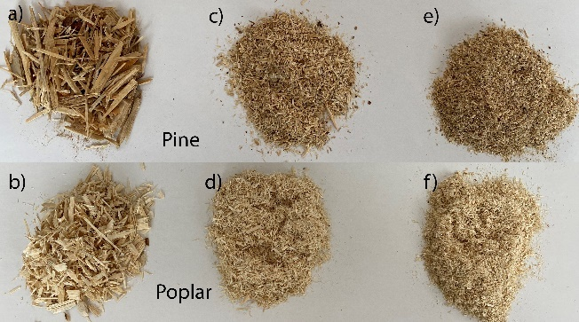
Fig. S1. Analysed samples; a) raw pine shavings, b) raw poplar shavings, c) milled pine shavings, d) milled poplar shavings, e) cut-milled pine shavings, f) cut-milled poplar shavings

Fig. S2. Mass distribution during cutting-milling of pine shavings in the knife mill; m_{c} – cumulative mass (measured on an electronic scales, recalculated into dry matter), m_{cG} –cumulative mass according to the modified Gompertz model, m_{i} – instantaneous mass, t – time (points on the graph represent instantaneous mass values measured with 0.5 s interval)

Fig. S3. Synchronisation of the cut-milled pine shavings mass distribution and the knife mill power requirement; P_{bL1}, P_{bL2}, P_{bL3} – power under load on each of 3 phases, respectively, P_{e} – effective power, sum of 3 phases, m_{c} – cumulative mass, m_{i} – instantaneous mass, t – time

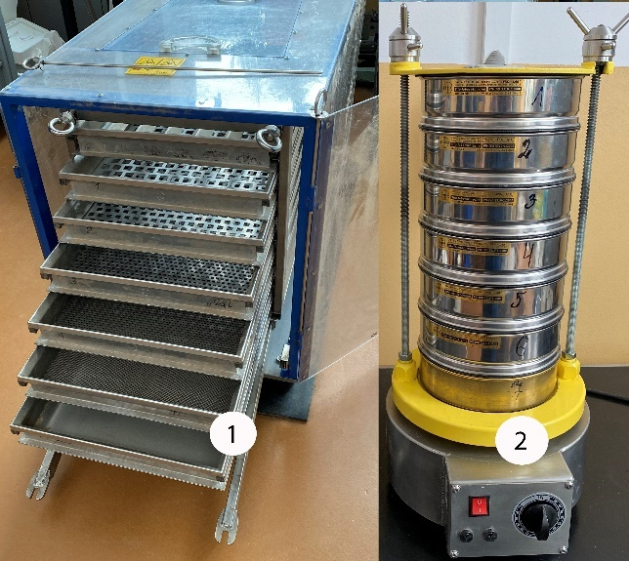
Fig. S4. Screen separators: 1 – oscillating separator used for raw shavings separation, 2 – vibrating separator LAB-11-200/IP for cut and cut-milled shavings separation

Fig. S5. The PSD according to RRSB, normal, lognormal and logistic models and against the background of measurement values (triangles) for pine (a, c, e) and poplar (b, d, f); a, b) raw shavings; c, d) milled shavings; e, f) cut-milled shavings

Fig. S6. Shear stress τ related to the relative shift Δl/D for different consolidation stress of 20, 30, 40, 50 and 60 kPa; a) cut-milled pine shavings, b) cut-milled poplar shavings

