Layer-by-Layer Assembly of Cationic Guar Gum, Cellulose Nanocrystals and Hydroxypropyl methylcellulose based Multilayered Composite Films
Arun Sainiª, Deepak Sharma^{b}, Yuanyuan Xiaª, Aman Saini^{c}, Xiangyu Youª, Ying Su^{d}, Lihong Chen^{e}, Chandravati Yadav^{a,}* and Xinping Li^{a,}*
ªShaanxi Provincial Key Laboratory of Papermaking Technology and Specialty Paper Development, College of Bioresources Chemical and Materials Engineering, Shaanxi University of Science & Technology, Xi'an, Shaanxi 710021, China
^{b}Chemistry and Bioprospecting Division, Forest Research Institute (Indian Council of Forestry Research and Education) Dehradun, Uttarakhand 248006, India
^{c}Department of Chemistry, Maharaj Singh College, Chaudhary Charan Singh University, Meerut, Uttar Pradesh 250001, India
^{d}Key Laboratory of Auxiliary Chemistry and Technology for Chemical Industry, Ministry of Education, Shaanxi University of Science & Technology, Xi'an, Shaanxi 710021, China
^{e}Front-line Science and Technology Transfer Institute, Shaanxi University of Science & Technology, Xi'an, Shaanxi 710021, China

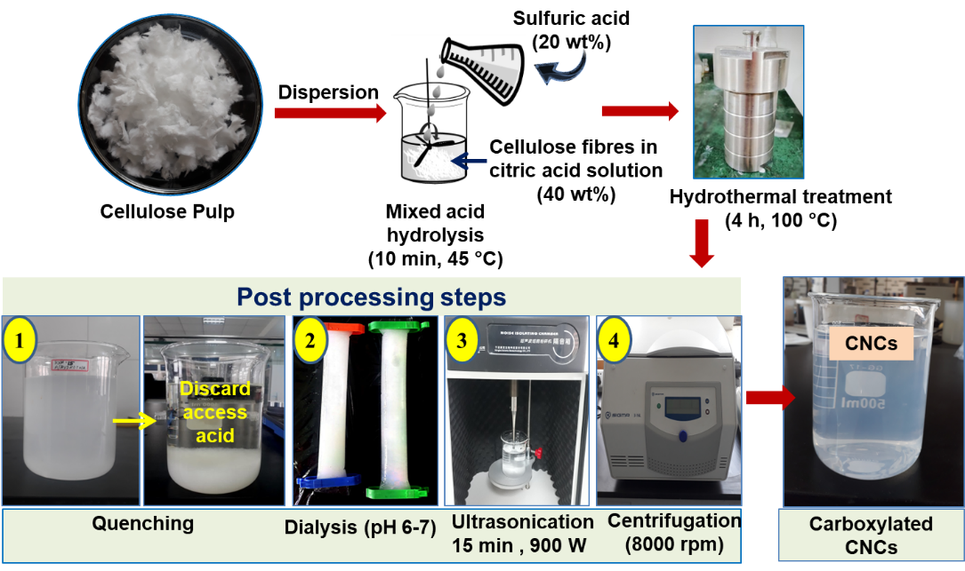
Fig. S1. Schematic of mixed-acid assisted hydrothermal process for the preparation of carboxylated cellulose nanocrystals (cCNCs).
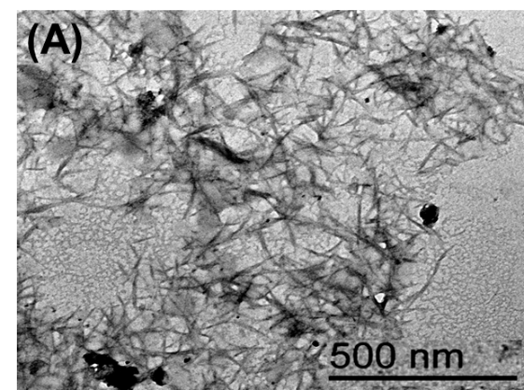
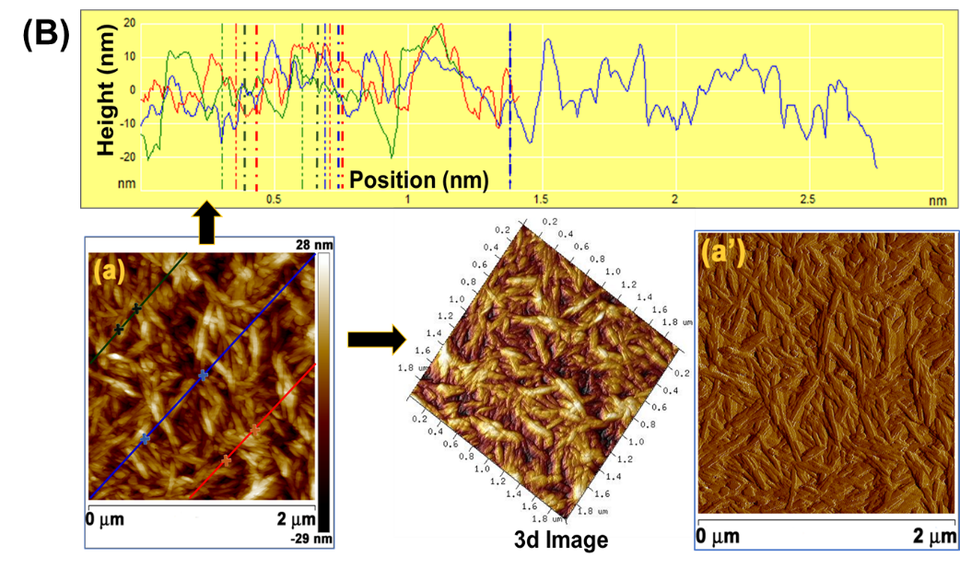
Fig. S2. (A) TEM image of cCNCs and (B) AFM images of cCNCs (a) topography image, 3D image and (a’) phase image
Table S1. Solvent uptake ability of CGg/cCNCs/HPMC multilayer composite film.
Time (h) | Solvent uptake (wt%)
 | Water | Acetone | THF | DMAc
6 | 542.13 | 1.03 | 5.14 | 3.13
12 | n.a. | 3.08 | 9.60 | 5.31
24 | n.a. | 4.19 | 11.51 | 14.76
48 | n.a. | 6.73 | 13.34 | 16.95

