Supporting information

Identification of spiro-acridine derivatives as fungi chitinase inhibitor by target fishing and in vitro studies

Jéssika de Oliveira Vianaª, Éden Silva e Souza^{b}, Nicolau Sbaraini^{c}, Marilene Henning Vainstein^{c}, Joilly Nilce Santana Gomes^{d}, Ricardo Olímpio de Moura^{d}, Euzébio Guimarães Barbosa^{a,e}*

ª Post-graduate Program in Bioinformatics, Bioinformatics Multidisciplinary Environment, Federal University of Rio Grande do Norte, Natal, Brazil.
^{b} School of Biomolecular and Biomedical Science & BiOrbic - Bioeconomy Research Center, University College Dublin, Ireland.
^{c} Biotechnology Center, Postgraduate Program in Cellular and Molecular Biology, Federal University of Rio Grande do Sul, Porto Alegre, Brazil.
^{d} Department of Biological Sciences, State University of Paraíba, Campina Grande, Brazil.
^{e} Post-graduate Program in Pharmaceutical Sciences, Faculty of Pharmacy, Federal University of Rio Grande do Norte, Natal, Brazil.
* Corresponding author: Email address euzebiogb@gmail.com

Table of contents
1 | Tables S1-S6 mentioned as supplementary material. | 2 - 11
2 | Figures S1 - S3 mentioned as supplementary material. | 12 - 15

Table S1. The best targets obtained in IVS prediction.

Protein | PDB ID | Ligand | Organism | Score
Chitinase B | 2A3B | Caffeine | Aspergillus fumigatus | -10.6
Chitinase B | 4Z2I | Macrolide inhibitor | Serratia marcescens | -10.4
Chitinase B | 3WD1 | syn-triazole inhibitor | Serratia marcescens | -10.3
Pteridine Reductase 1 | 2QHX | FE1 inhibitor | Leishmania major | -10.1
Chitinase B | 4Z2G | Macrolide inhibitor | Serratia marcescens | -9.6
Chitinase B | 4Z2J | Macrolide inhibitor | Serratia marcescens | -9.5
Chitinase B | 4Z2L | Macrolide inhibitor | Serratia marcescens | -9.4
Chitinase | 3WQV | Piperazine | Ostrinia furnacalis | -9.4
Chitinase A | 3ARP | Dequalinium | Vibrio harveyi | -9.3
Chitinase B | 3WD2 | Azide inhibitor | Serratia marcescens | -9.2
Chitinase B | 4Z2K | Macrolide inhibitor | Serratia marcescens | -9.2

Table S2. Docking score of acridine derivatives for A. fumigatus. All scores are presented in kJ/mol.

Compounds | AfChiB
1 | -8.5
2 | -9.3
3 | -9.4
4 | -9.4
5 | -10.9
6 | -9.1
7 | -10.1
8 | -9.3
9 | -10.6
10 | -8.9
11 | -10.1
12 | -10.2
13 | -9.2
14 | -10.1
15 | -9.9
16 | -10.0
17 | -10.2
18 | -10.0
19 | -10.2
20 | -9.6
21 | -9.0
22 | -9.1
23 | -9.0
24 | -9.9
25 | -9.3
26 | -10.0
27 | -8.9
28 | -9.4
Caffeine | -6.3

Table S3. Docking score of acridine derivatives for T. harzianum. All scores are presented in kJ/mol.

Compounds | Chit42 | Chit33
1 | -9.1 | -7.5
2 | -8.7 | -5.9
3 | -9.2 | -7.6
4 | -9.5 | -7.4
5 | -9.8 | -7.8
6 | -9.5 | -7.4
7 | -9.5 | -7.3
8 | -9.3 | -7.4
9 | -9.3 | -7.7
10 | -9.2 | -7.3
11 | -9 | -6.8
12 | -9.3 | -6.8
13 | -9.1 | -6.1
14 | -8.8 | -7.1
15 | -8.3 | -7.2
16 | -8.1 | -7.2
17 | -8.3 | -6.9
18 | -8 | -6.7
19 | -8 | -6.8
20 | -9.2 | -6.8
21 | -9.5 | -6.8
22 | -8.7 | -6
23 | -0.5 | -7.1
24 | -9.3 | -7.2
25 | -9.2 | -6.7
26 | -9.3 | -7.2
27 | -9.5 | -6.4
28 | -8.7 | -7.1
Plumieridine | -7.5 | -6.6

Table S4. Acridine derivatives listed in this study.

Name | Structure | IUPAC Name | Reference
1 | 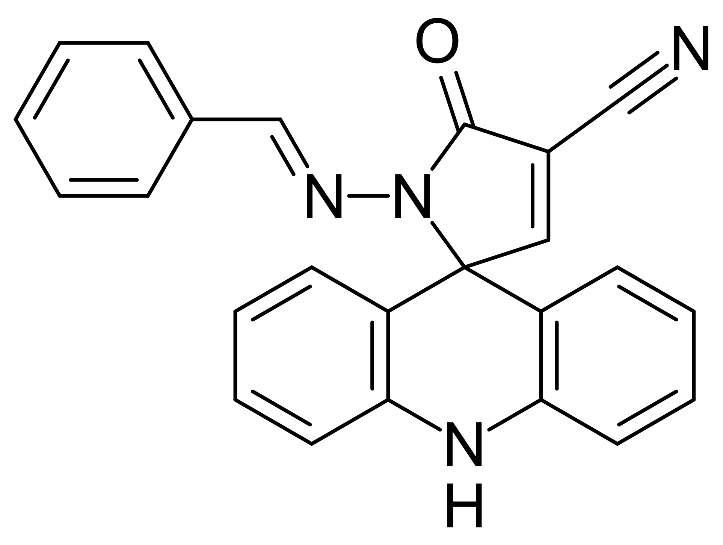 | (E)-1 -(benzylideneamino)-5 -oxo-1 ,5 -dihydro-10Hspiro[acridine-9,2 -pyrrole]-4 -carbonitrile | [26]
2 | 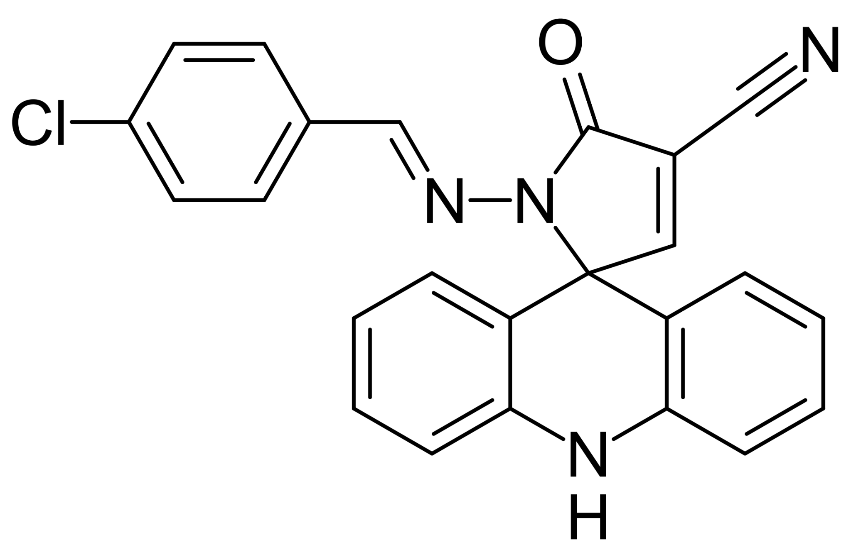 | 1-(4-chlorobenzylideneamino)-5-oxo-1,5-dihydro-10H-spiro[acridine-9,2- pyrrole]-4-carbonitrile | [26]
3 | 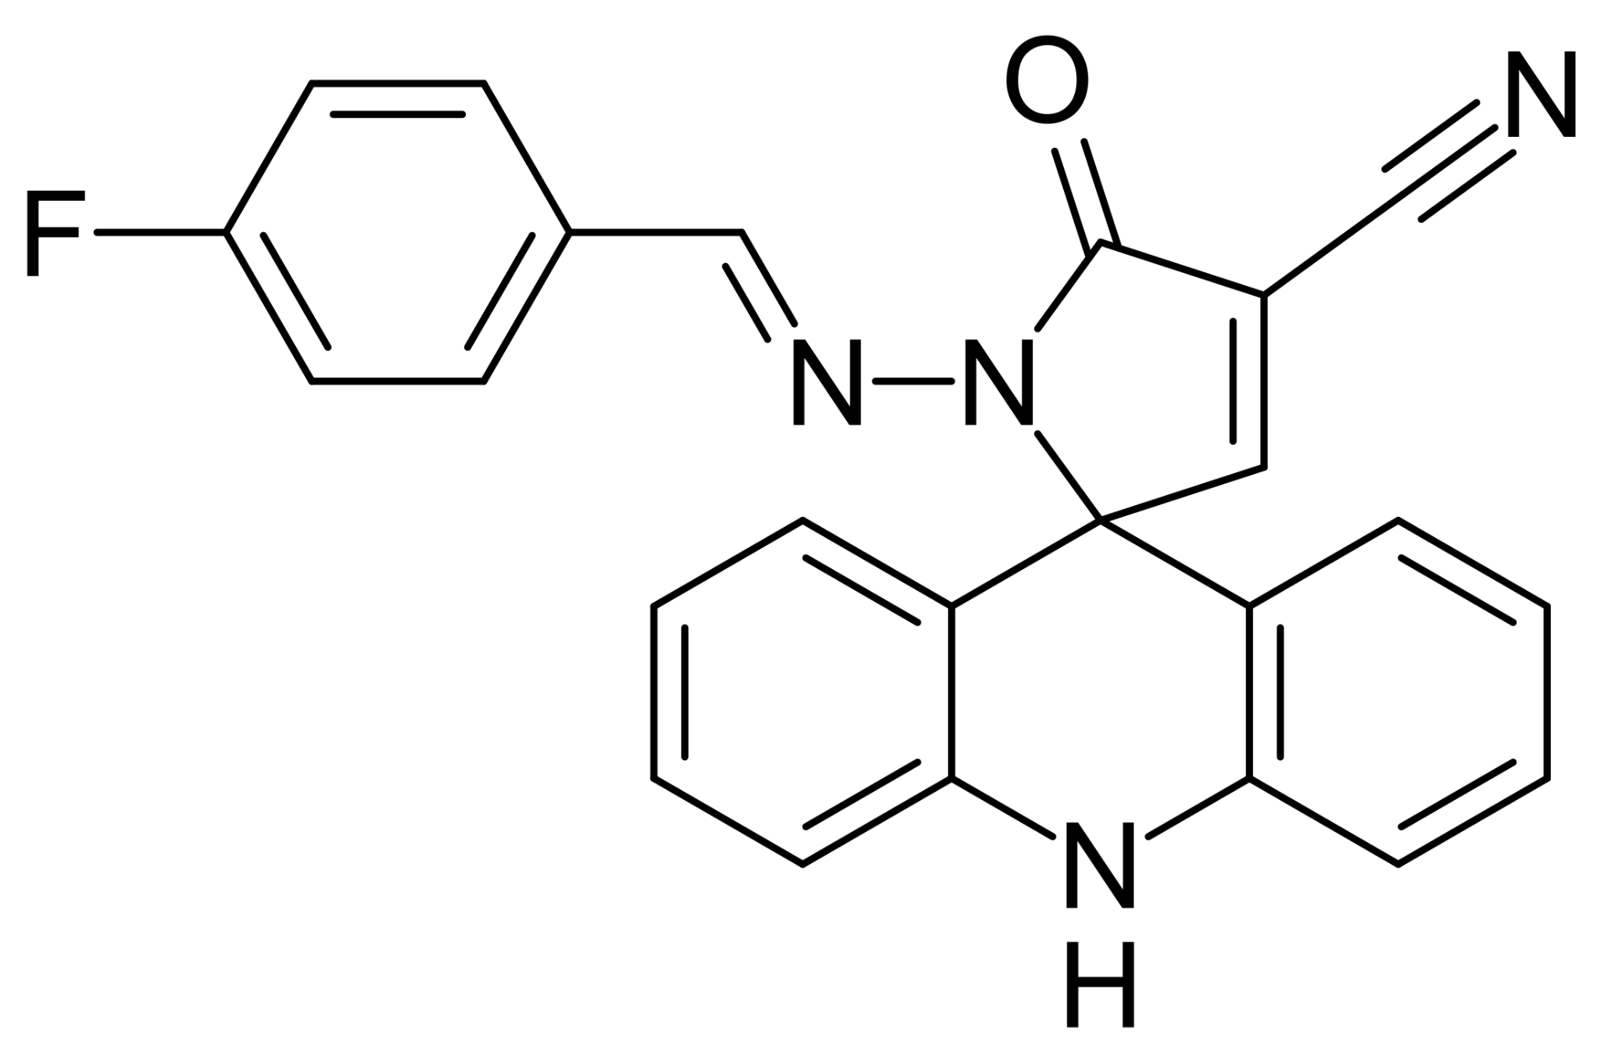 | 1-(4-fluorobenzylideneamino)-5'-oxo-1,5-dihydro-10H-spiro[acridine-9,2- pyrrole]-4-carbonitrile | [26]
4 | 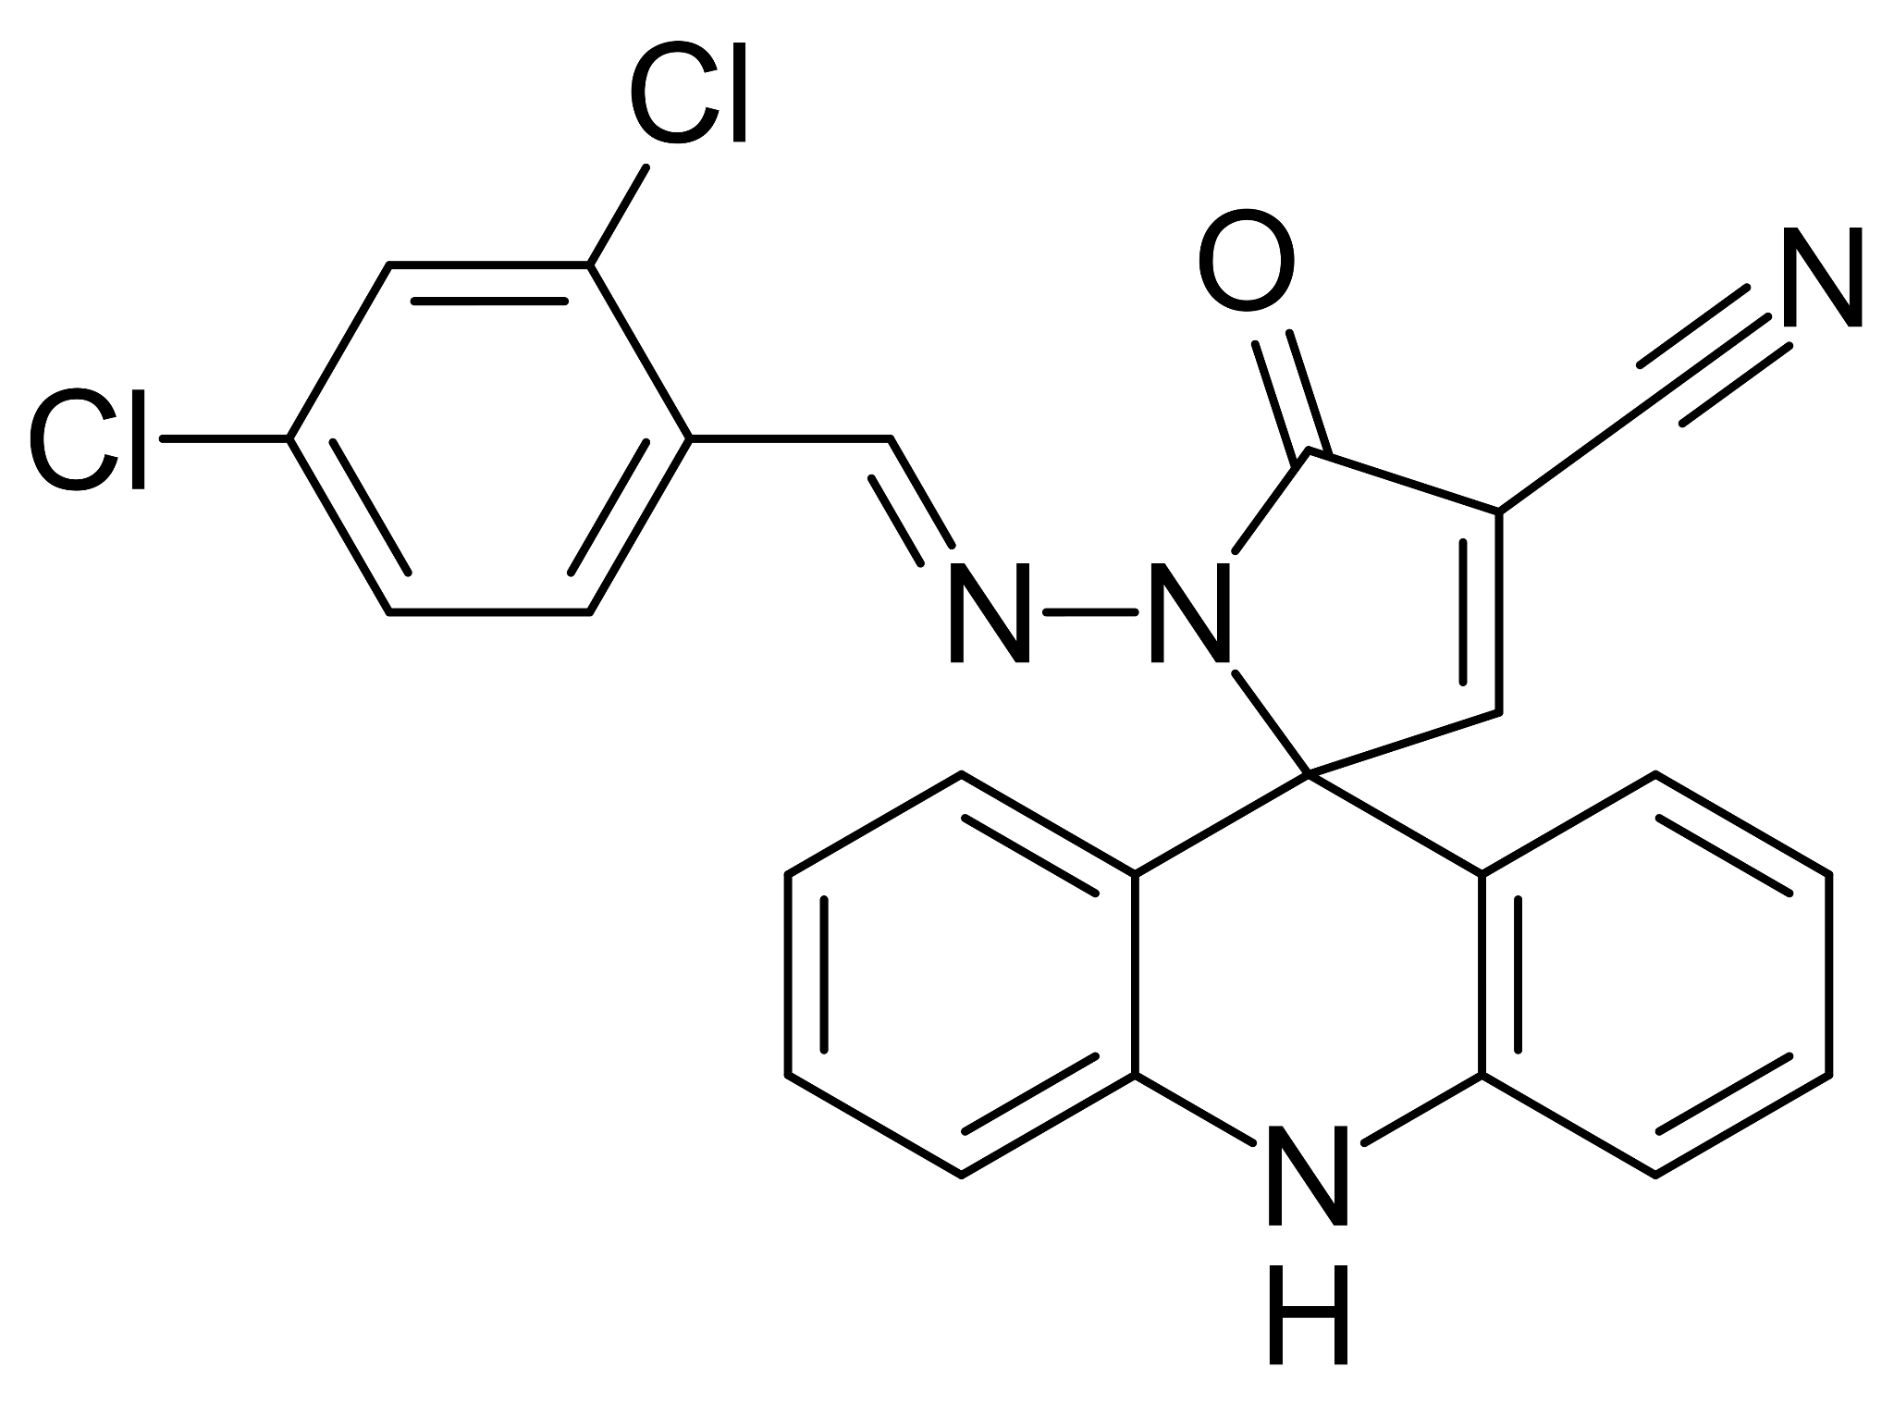 | 1-(2,4-dichlorobenzylideneamino)-5-oxo-1,5-dihydro-10H-spiro[acridine-9,2- pyrrole]-4-carbonitrile | [26]
5 | 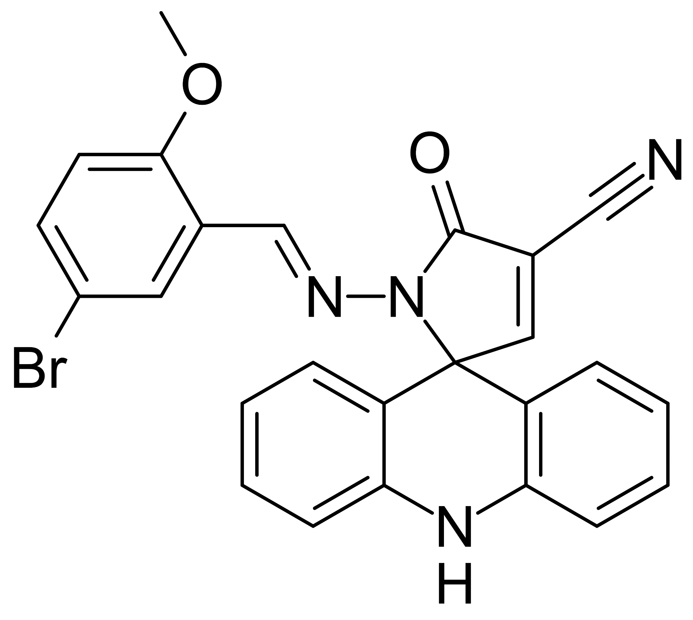 | 1-(5-bromo-2-methoxybenzylideneamino)-5-oxo-1,5-dihydro-10H-spiro[acridine9,2-pyrrole]-4-carbonitrile | [26]
6 | 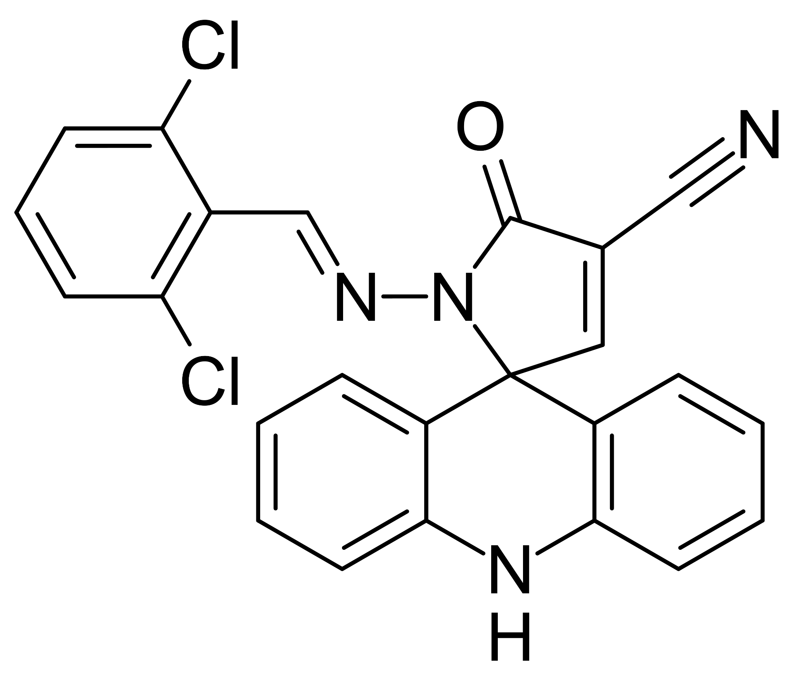 | 1-(2,6-dichlorobenzylideneamino)-5-oxo-1,5-dihydro-10H-spiro[acridine-9,2- pyrrole]-4-carbonitrile | [26]
7 | 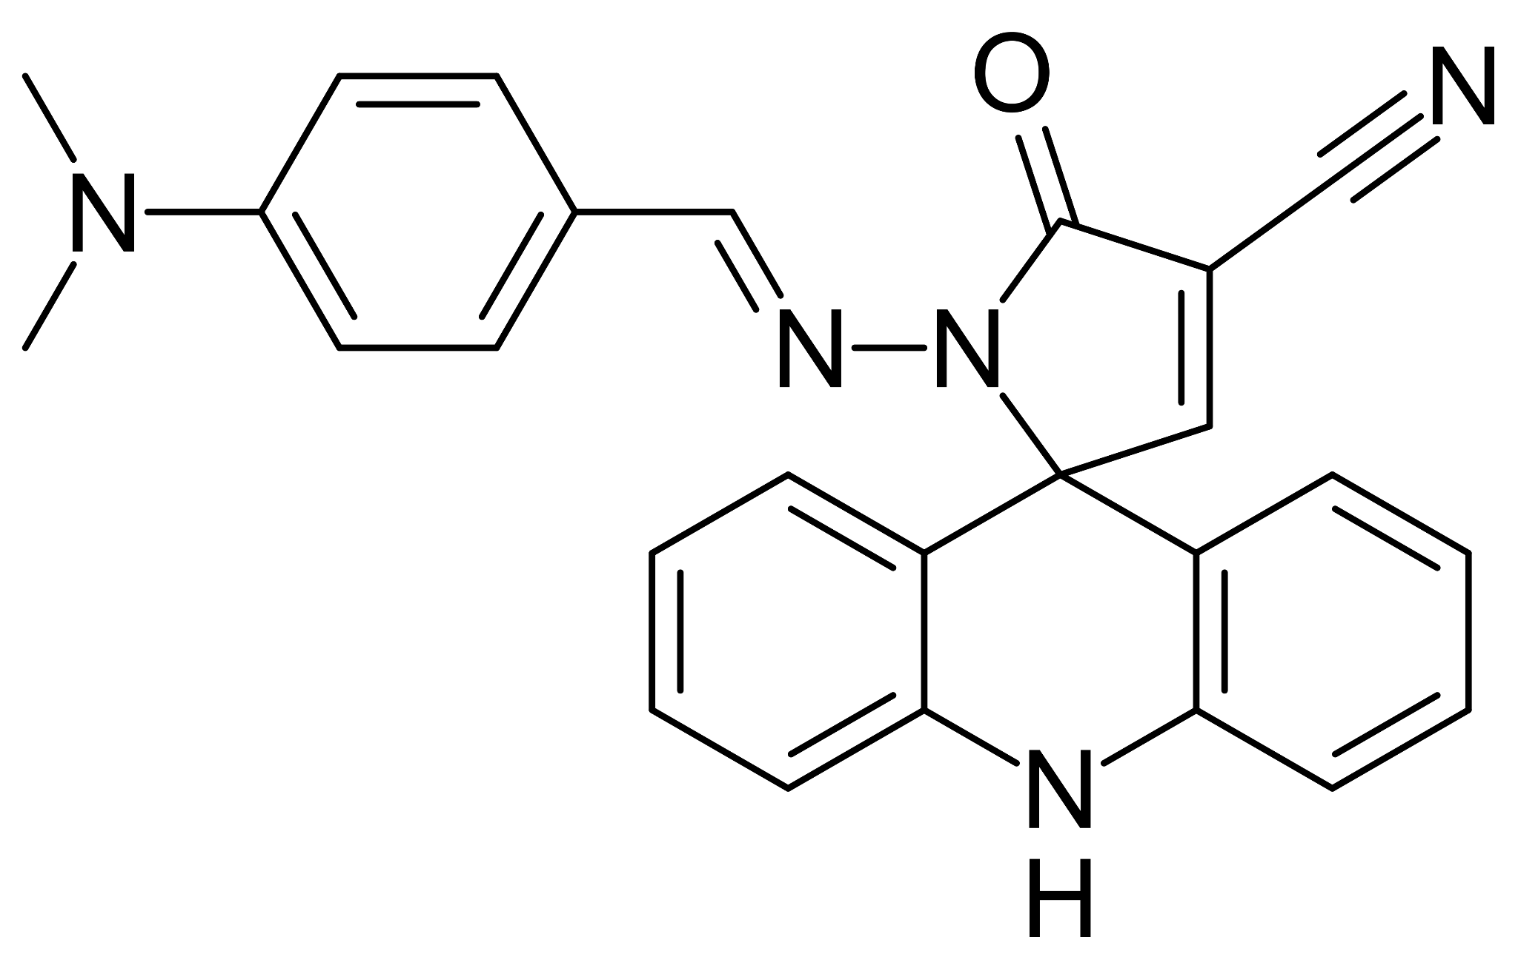 | 1-(4-dimethylaminobenzylideneamino)-5-oxo-1,5-dihydro-10H-spiro[acridine9,2-pyrrole]-4-carbonitrile | [26]
8 | 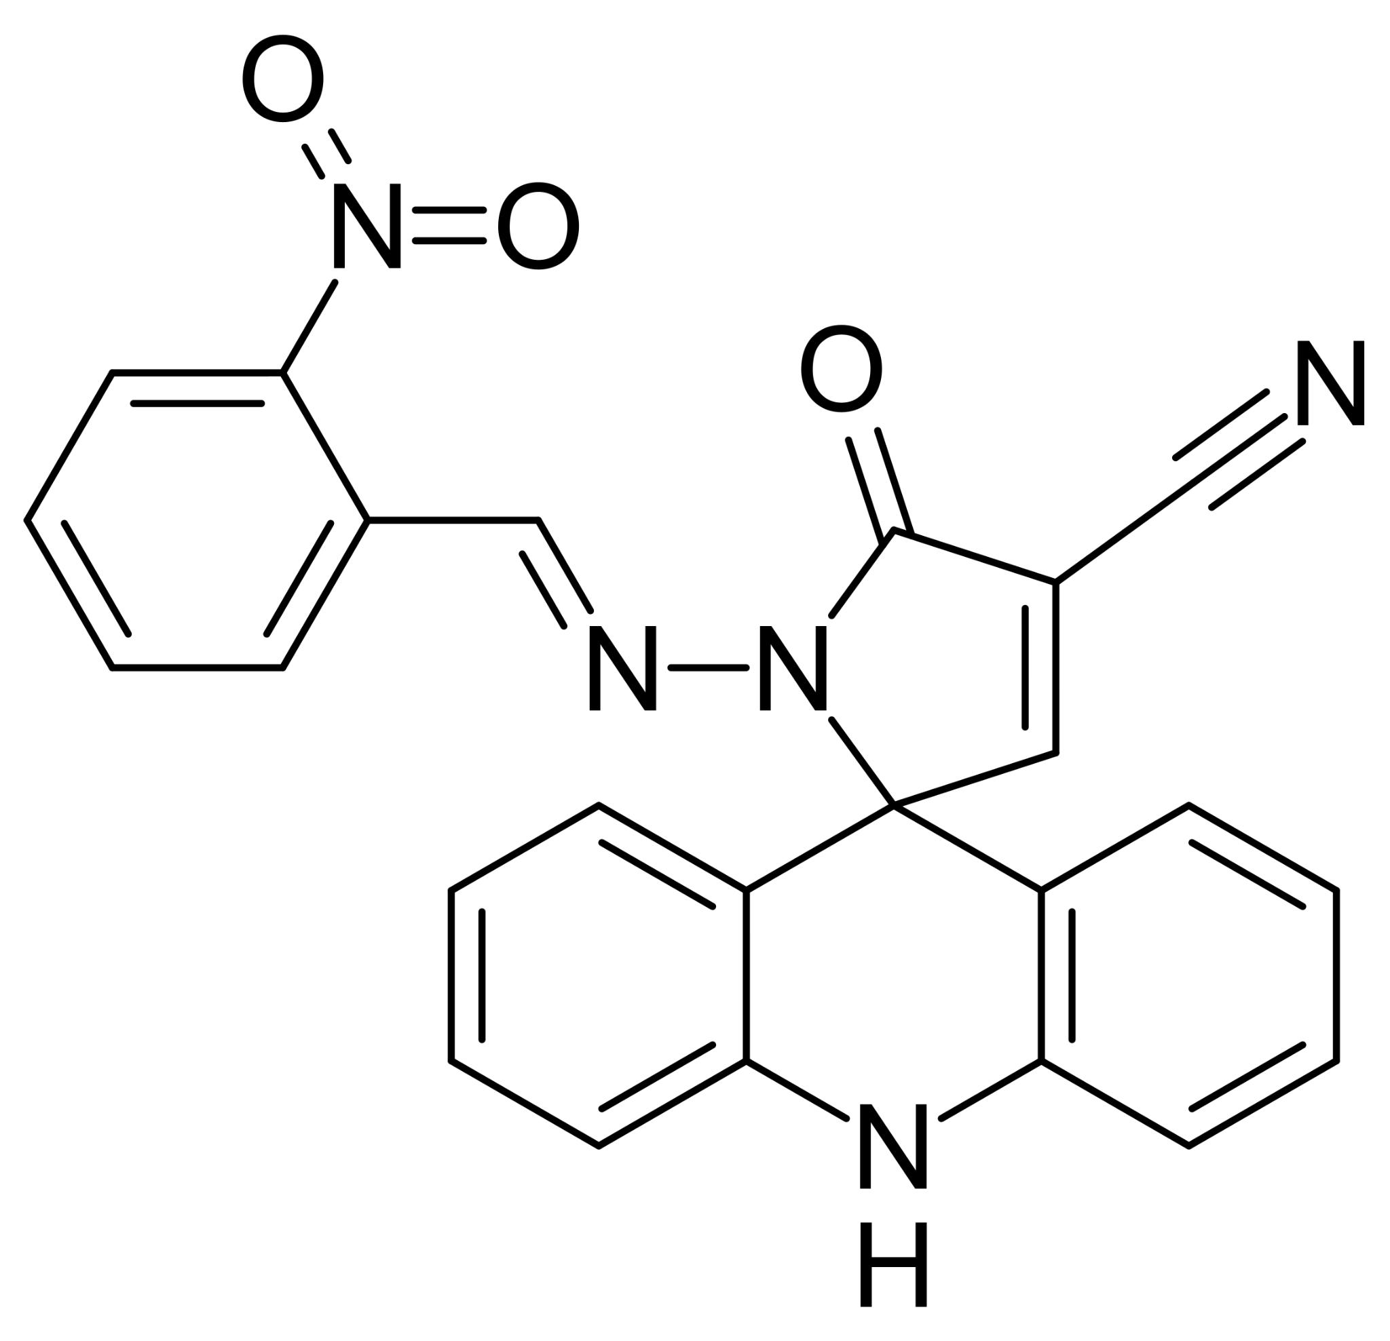 | 1-(2-nitrobenzylideneamino)-5-oxo-1,5-dihydro-10H-spiro[acridine-9,2-pyrrole]- 4-carbonitril | [26]
9 | 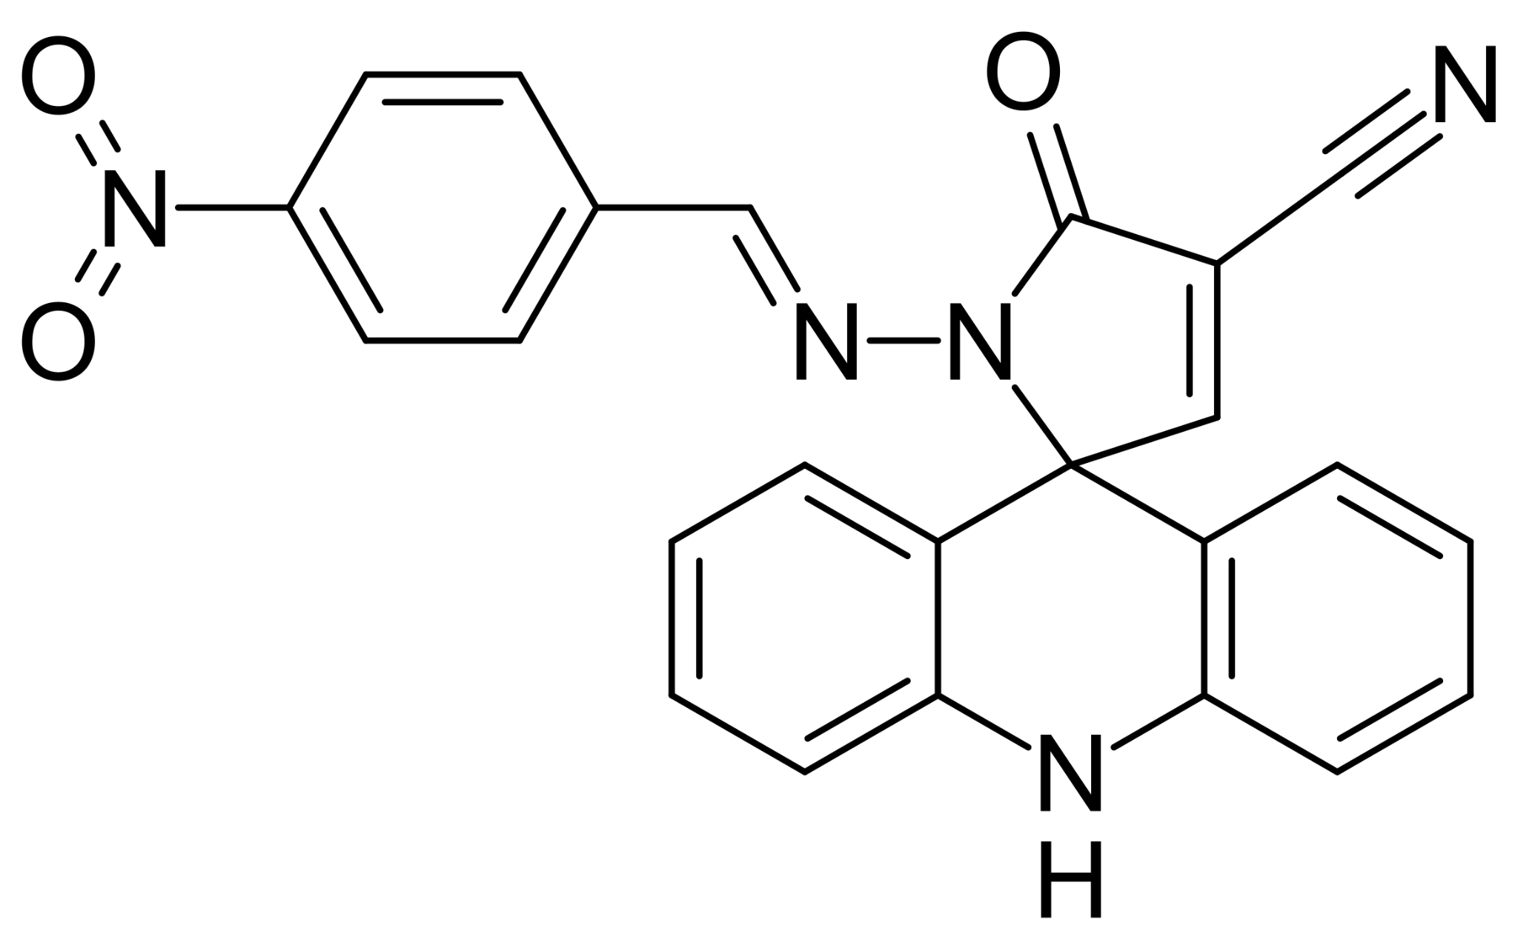 | 1-(4-nitrobenzylideneamino)-5-oxo-1,5-dihydro-10H-spiro[acridine-9,2-pyrrole]- 4-carbonitril | [26]
10 | 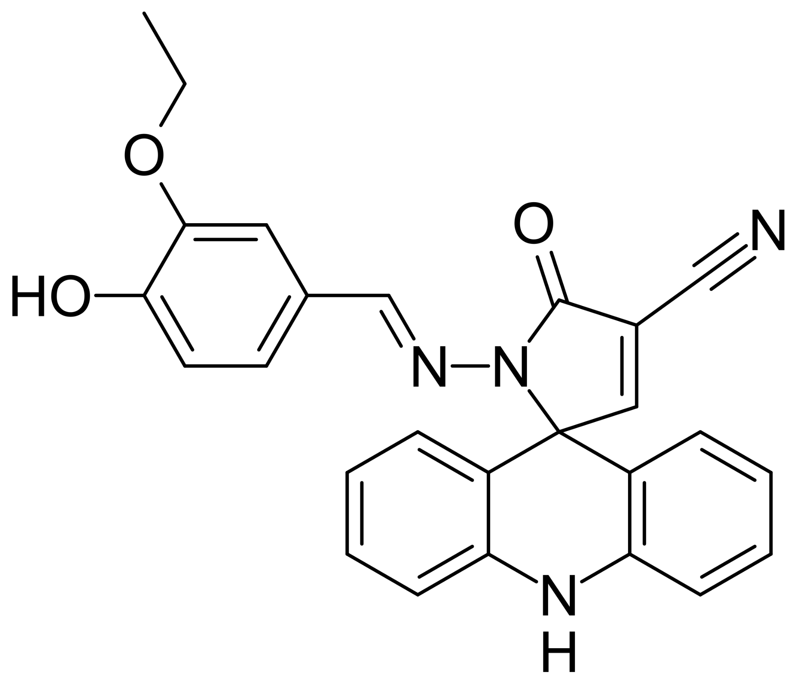 | 1-(3-ethoxy-4-hydroxybenzylideneamino)-5-oxo-1,5-dihydro-10H-spiro[acridine9,2-pyrrole]-4-carbonitrile | [26]
11 | 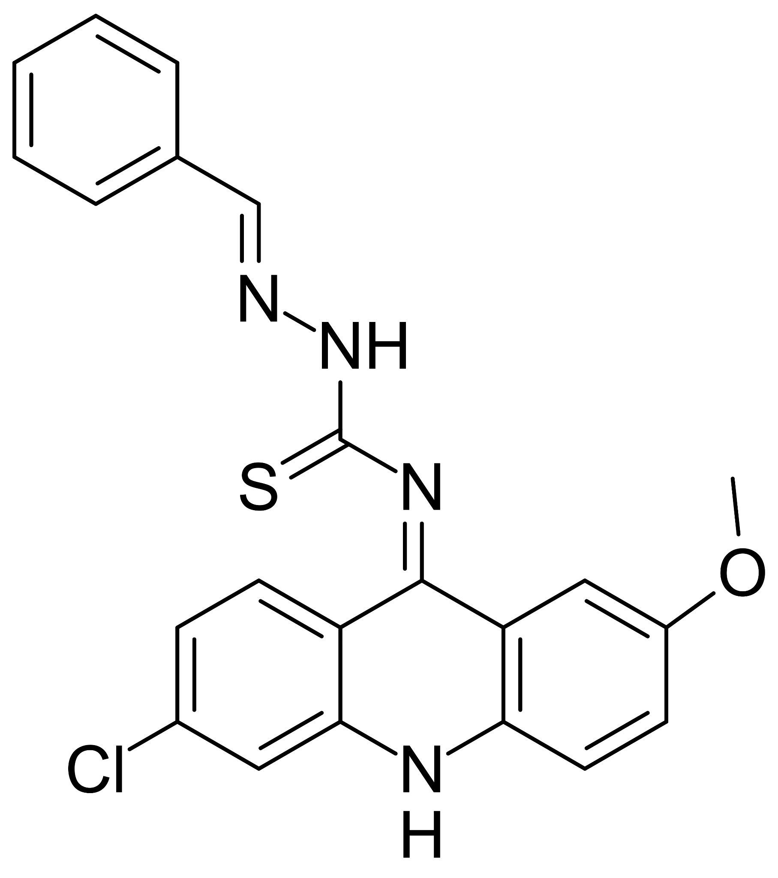 | (2E,NE)-2-Benzylidene-N-(6-chloro-2-methoxycridin-9(10H)-ylidene)hydrazinecarbothioamide | [27]
12 | 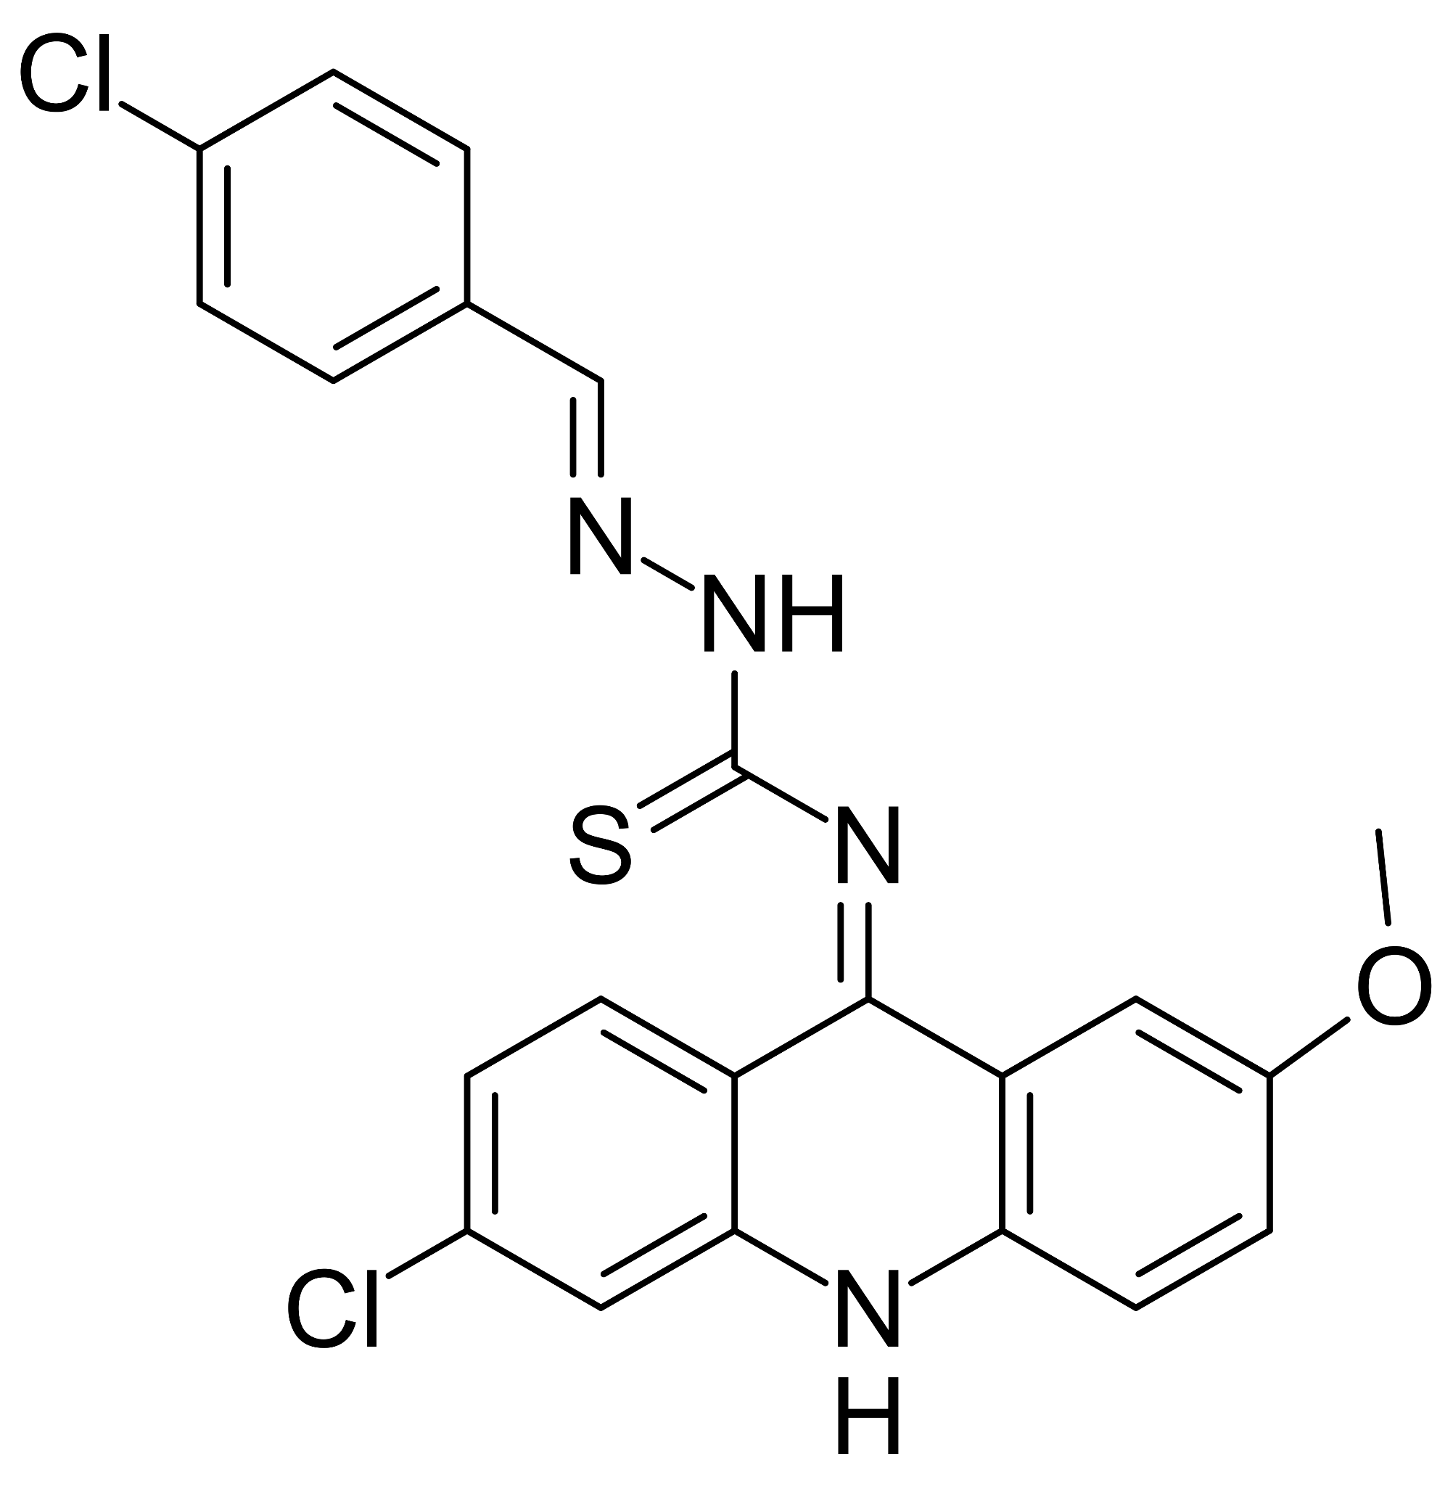 | (2E,NE)-N-(6-chloro-2-methoxycridin-9(10H)-ylidene)-2-(4-chlorobenzylidene)hydrazinecarbothioamide | [27]
13 | 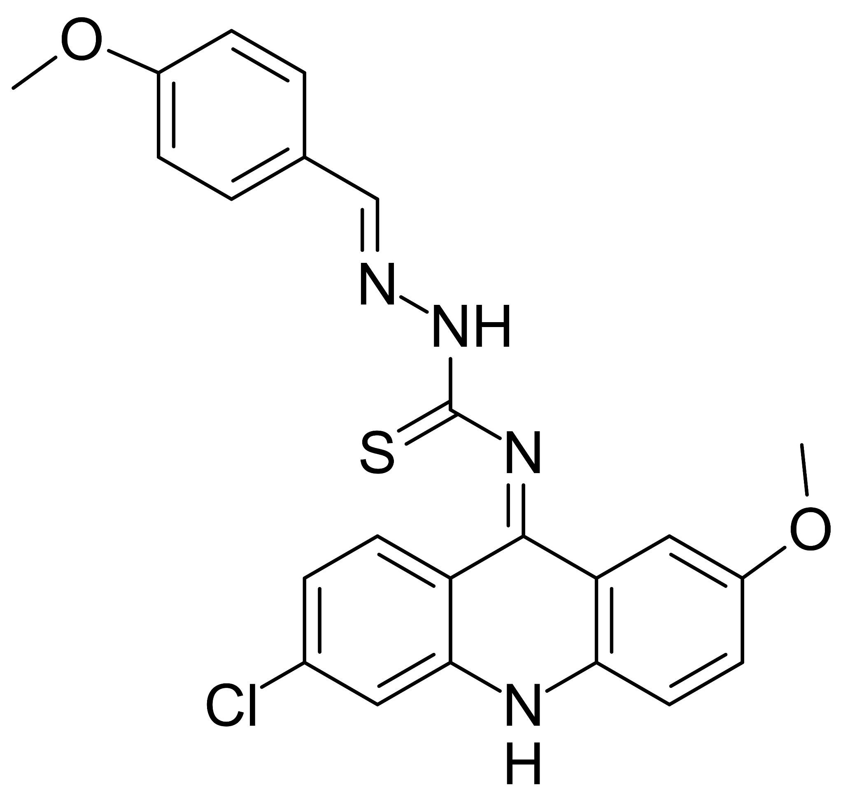 | (2E,NE)-N-(6-chloro-2-methoxycridin-9(10H)-ylidene)-2-(4-methoxybenzylidene)hydrazinecarbothioamide | [27]
14 | 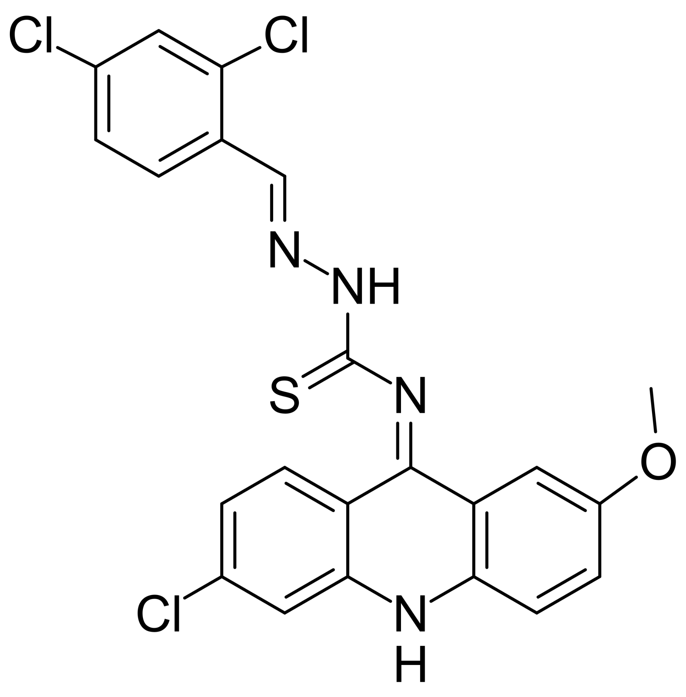 | (2E,NE)-N-(6-chloro-2-methoxycridin-9(10H)-ylidene)-2-(4-dichlorobenzylidene)hydrazinecarbothioamide | [27]
15 | 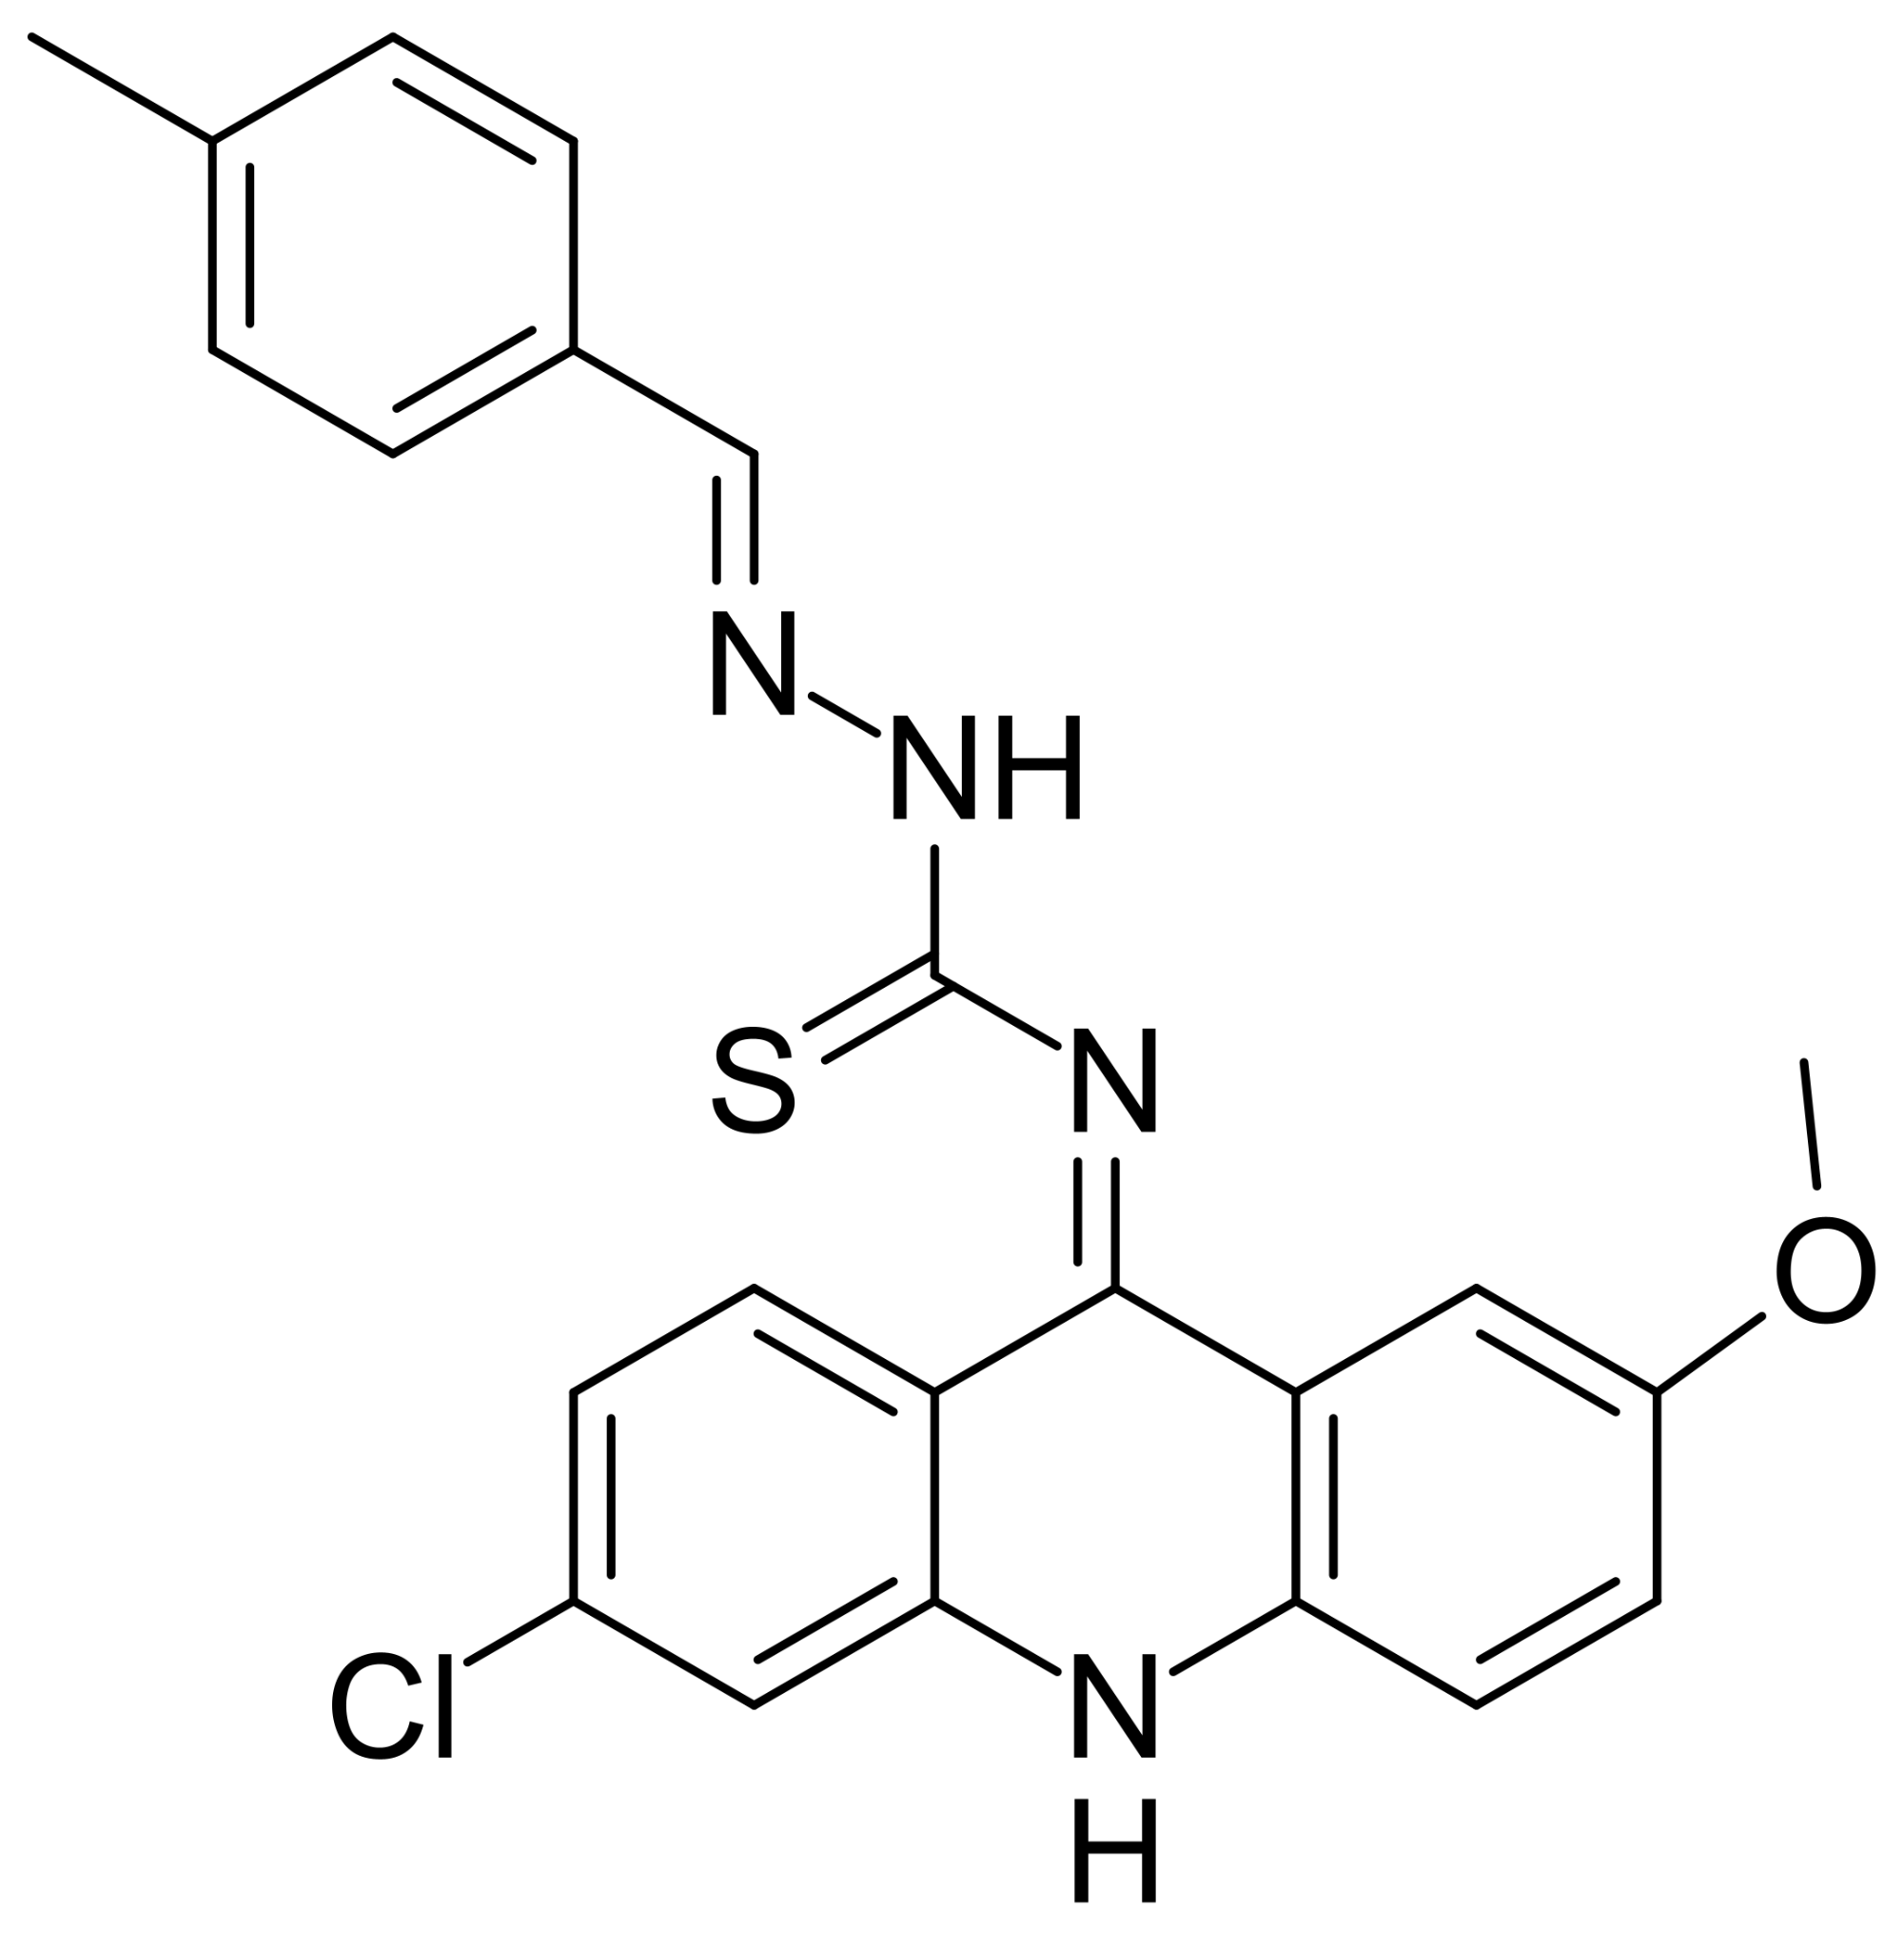 | (2E,NE)-N-(6-chloro-2-methoxycridin-9(10H)-ylidene)-2-(4-methylbenzylidene)hydrazinecarbothioamide | [27]
16 | 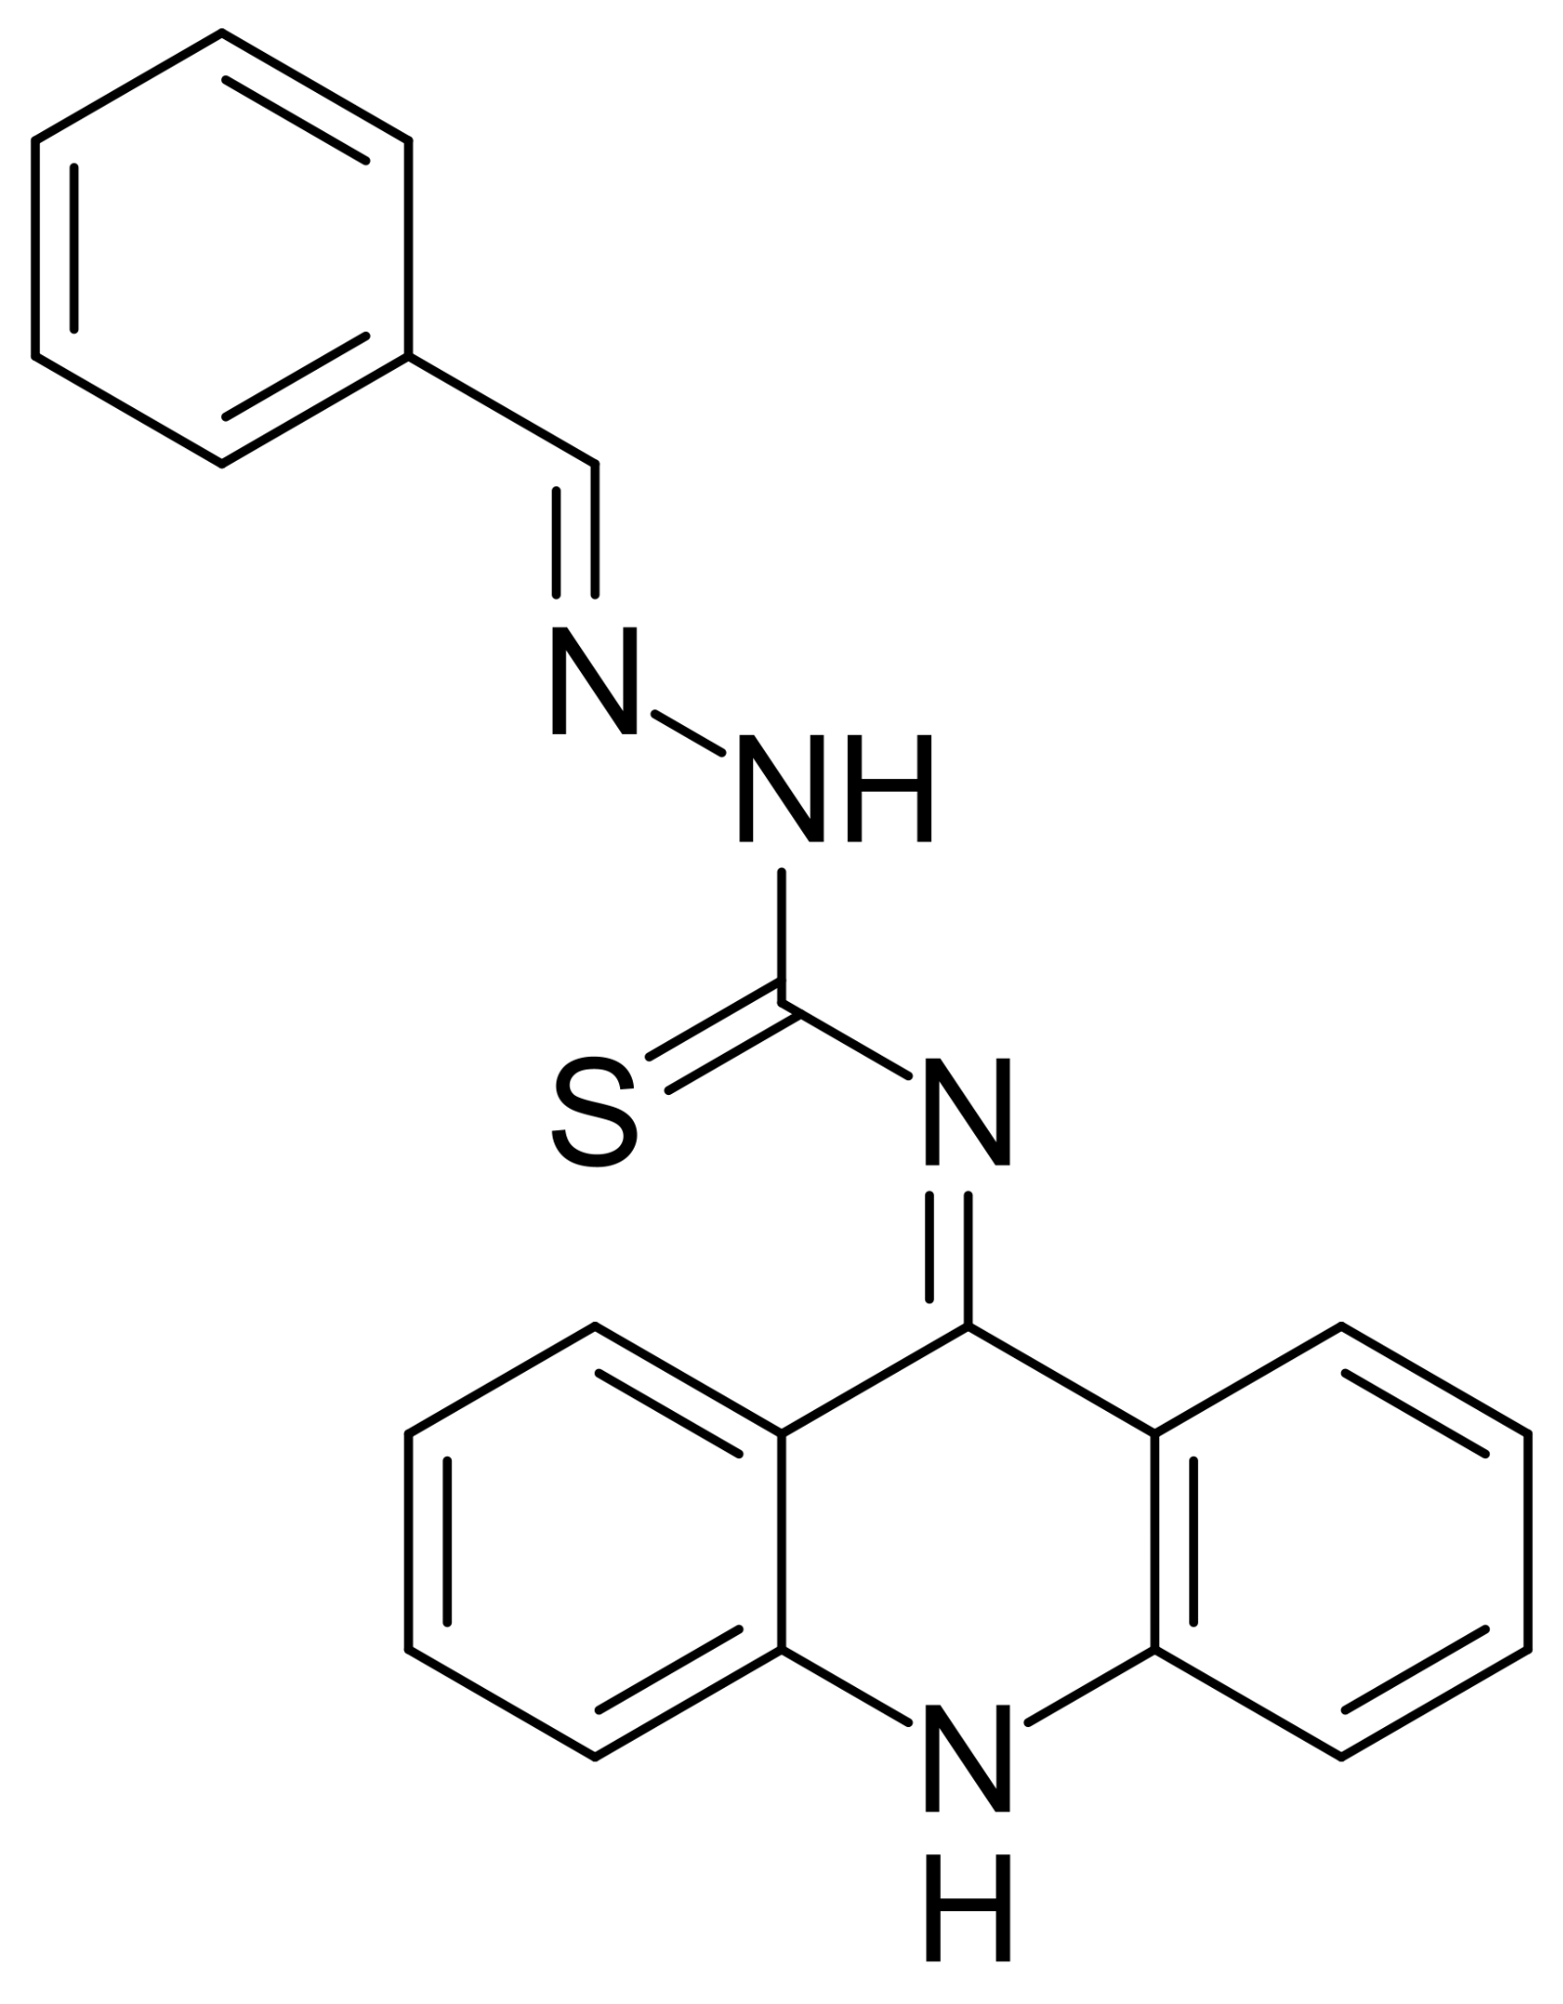 | (E)-N-(acridin-9(10H)-ylidene)-2-benzylidenehydrazinecarbothioamide | [27]
17 | 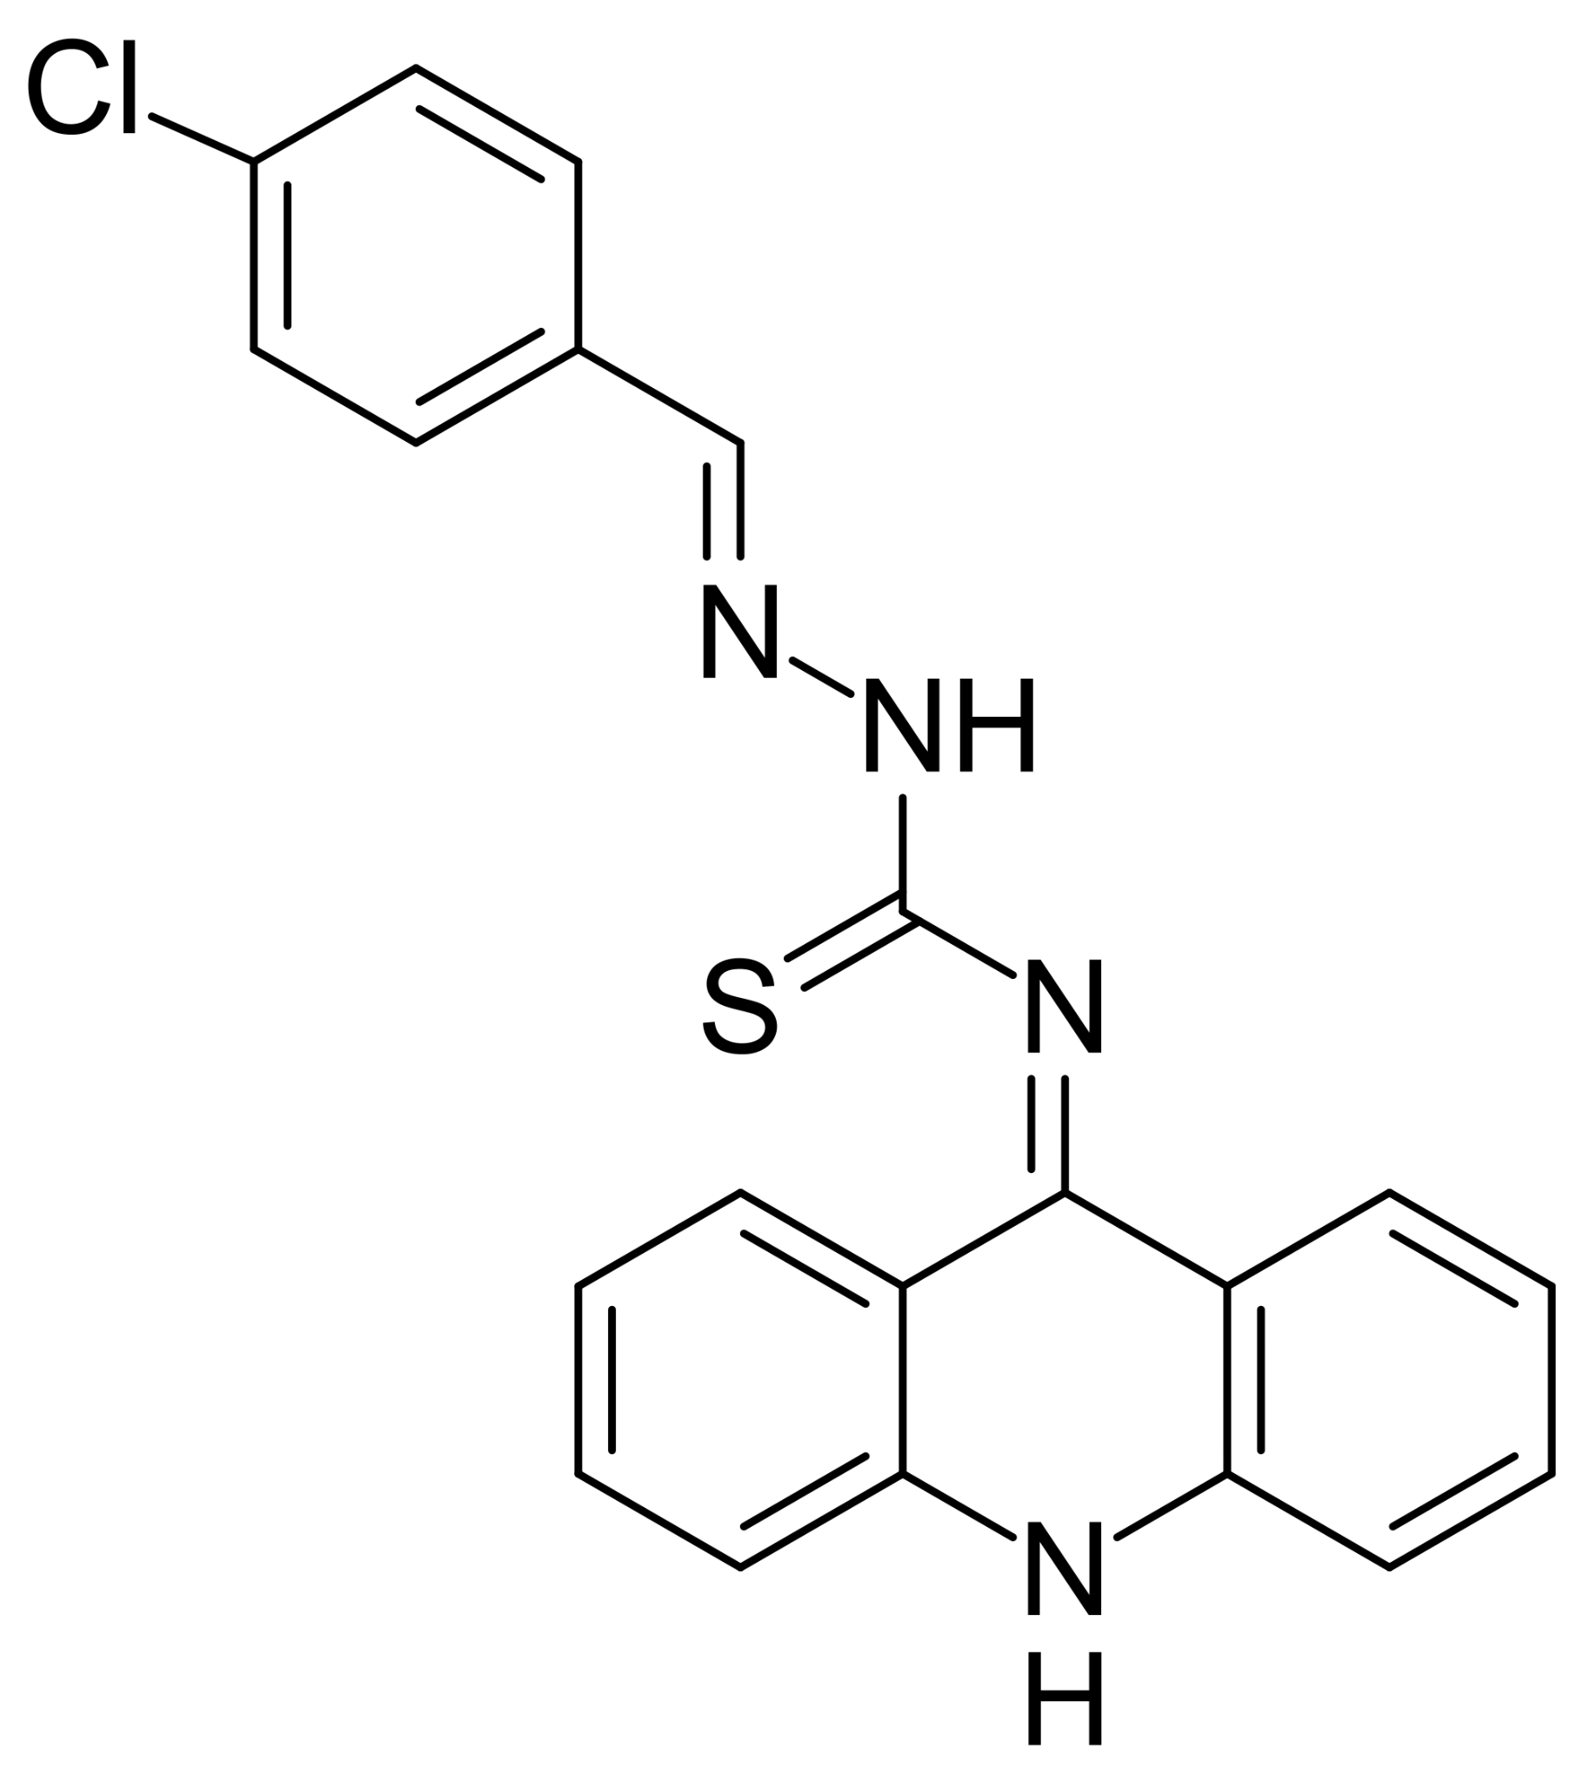 | (E)-N-(acridin-9(10H)-ylidene)-2-(4-chlorobenzylidene)hydrazinecarbothioamide | [27]
18 | 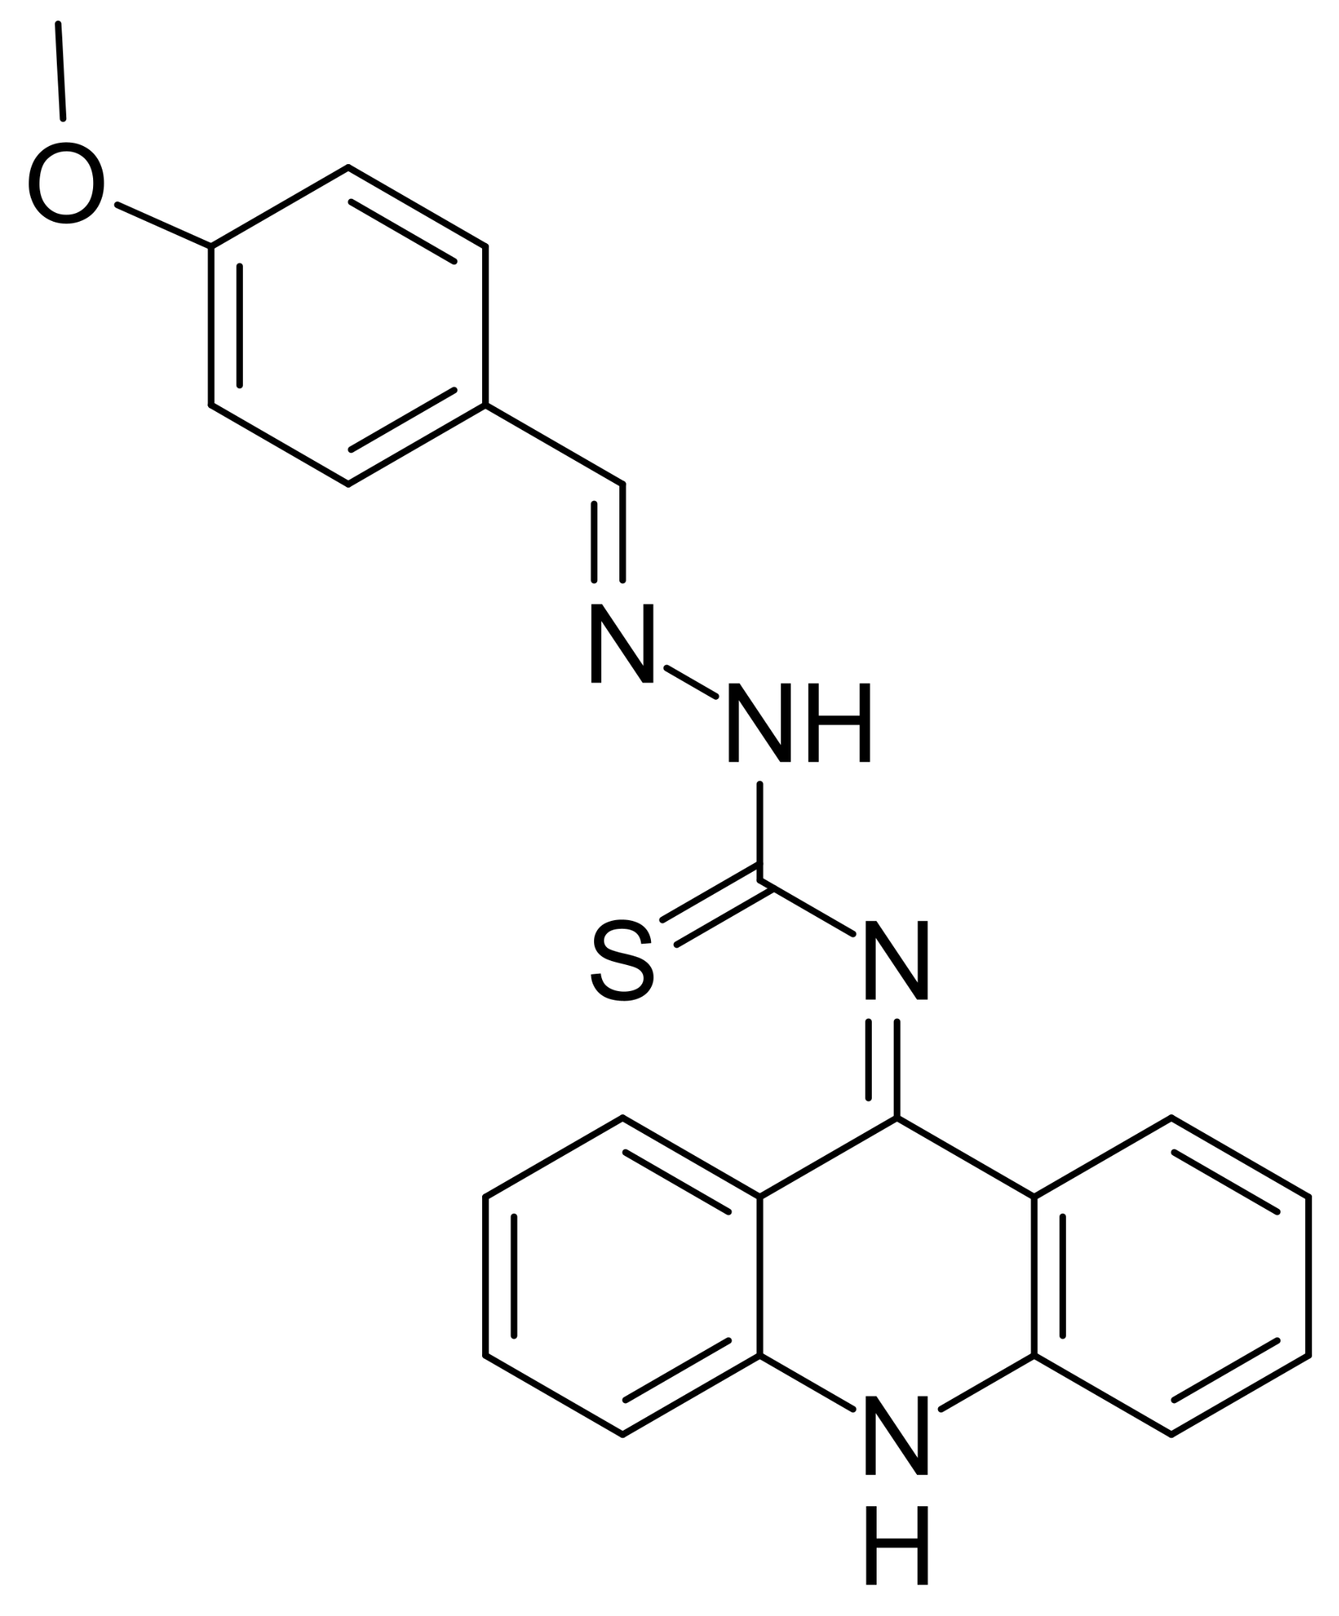 | (E)-N-(acridin-9(10H)-ylidene)-2-(4-methoxybenzylidene)hydrazinecarbothioamide | [27]
19 | 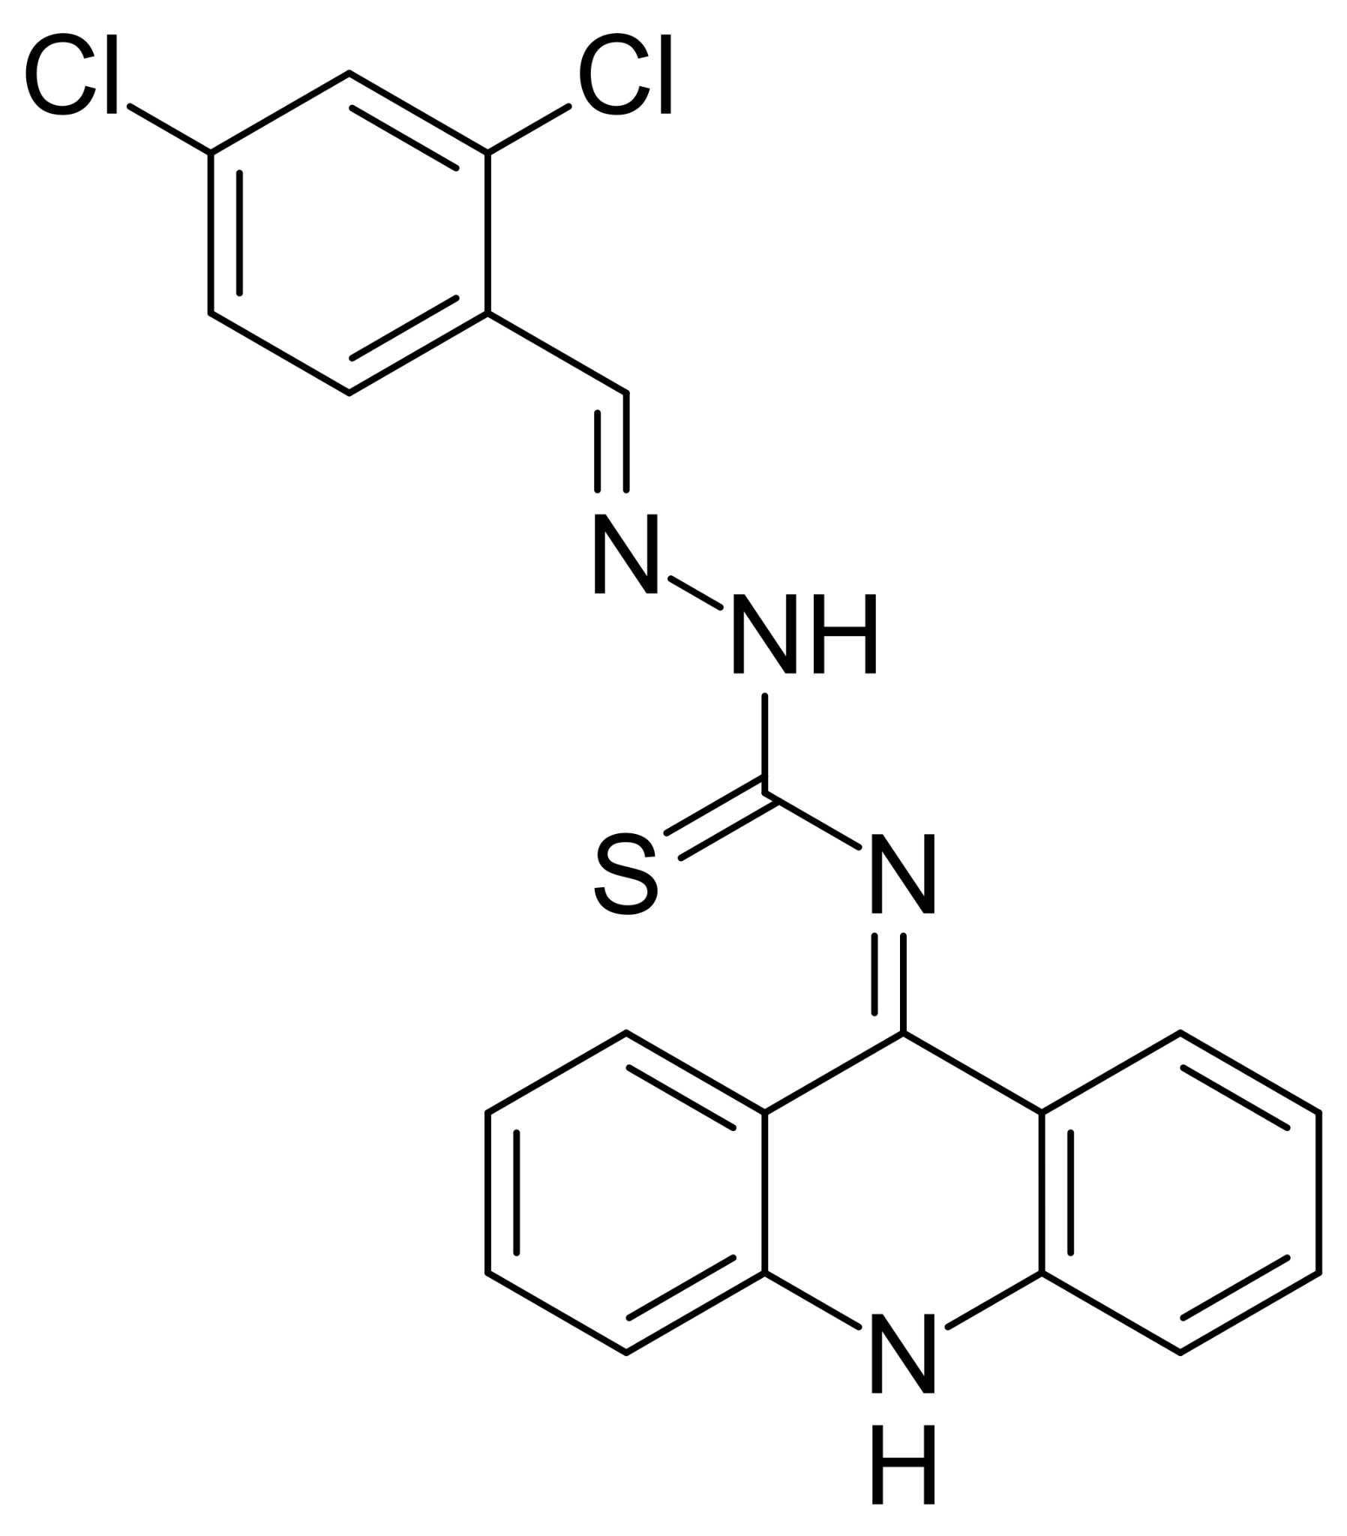 | (E)-N-(acridin-9(10H)-ylidene)-2-(2,4-dichlorobenzylidene)hydrazinecarbothioamide | [27]
20 | 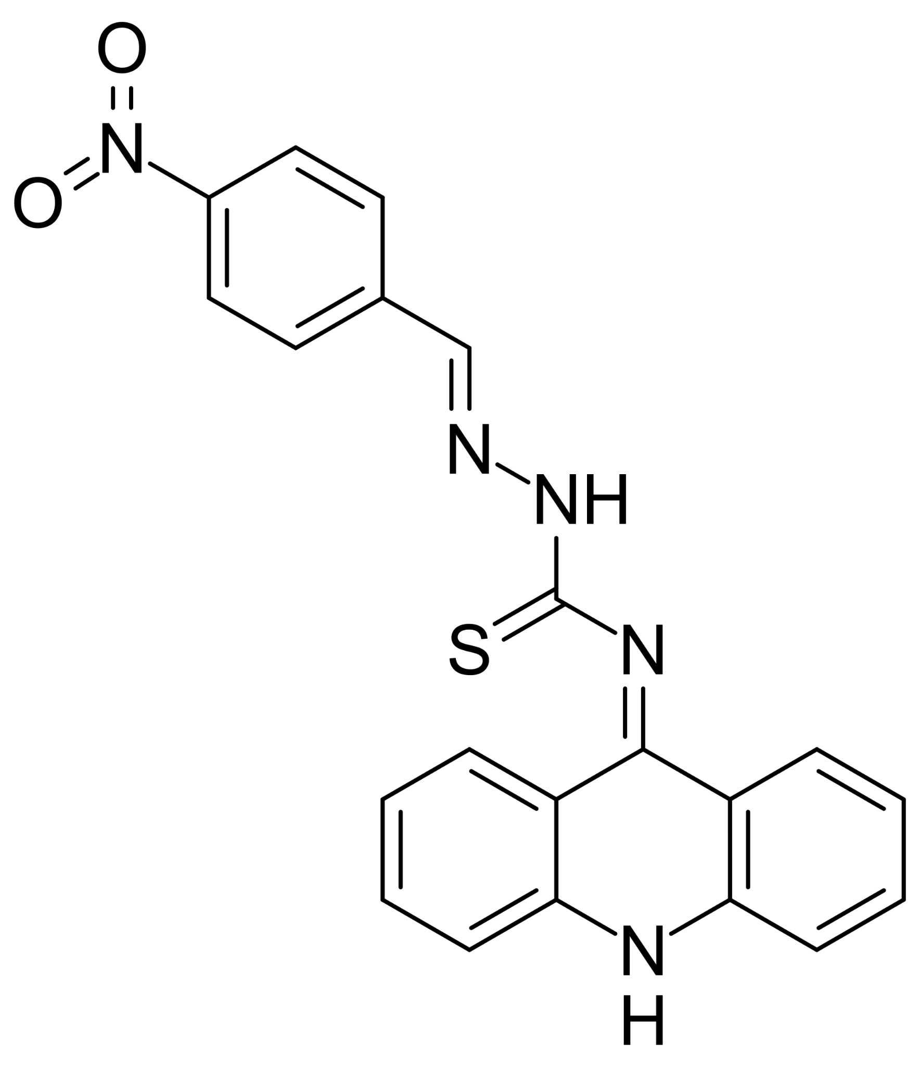 | (E)-N-(acridin-9(10H)-ylidene)-2-(4-nitrobenzylidene)hydrazinecarbothioamide | [27]
21 | 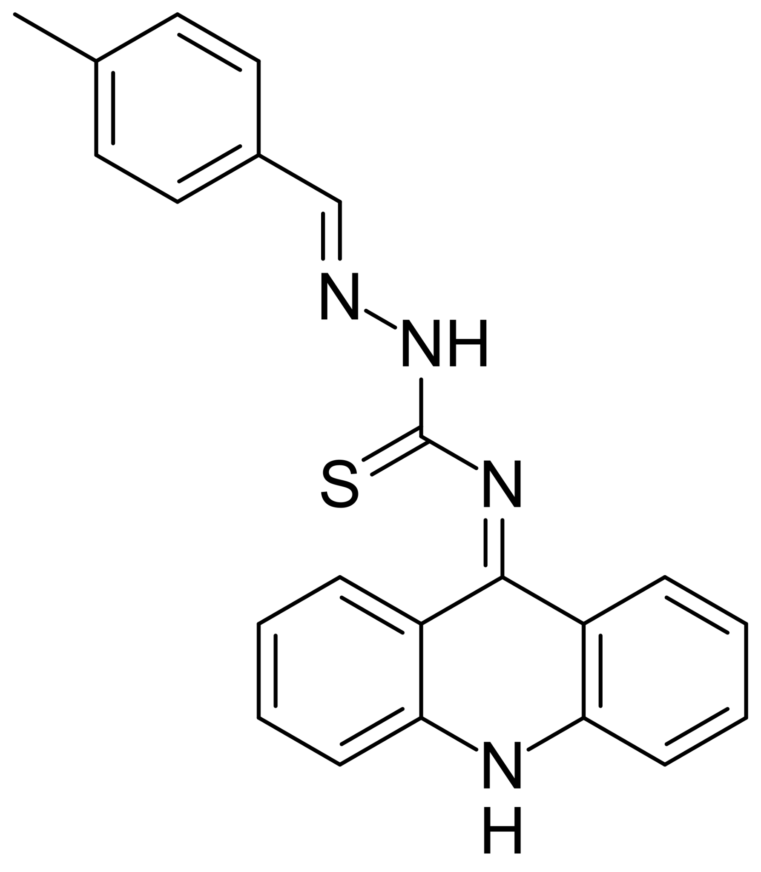 | (E)-N-(acridin-9(10H)-ylidene)-2-(4-methylbenzylidene)hydrazinecarbothioamide | [27]
22 | 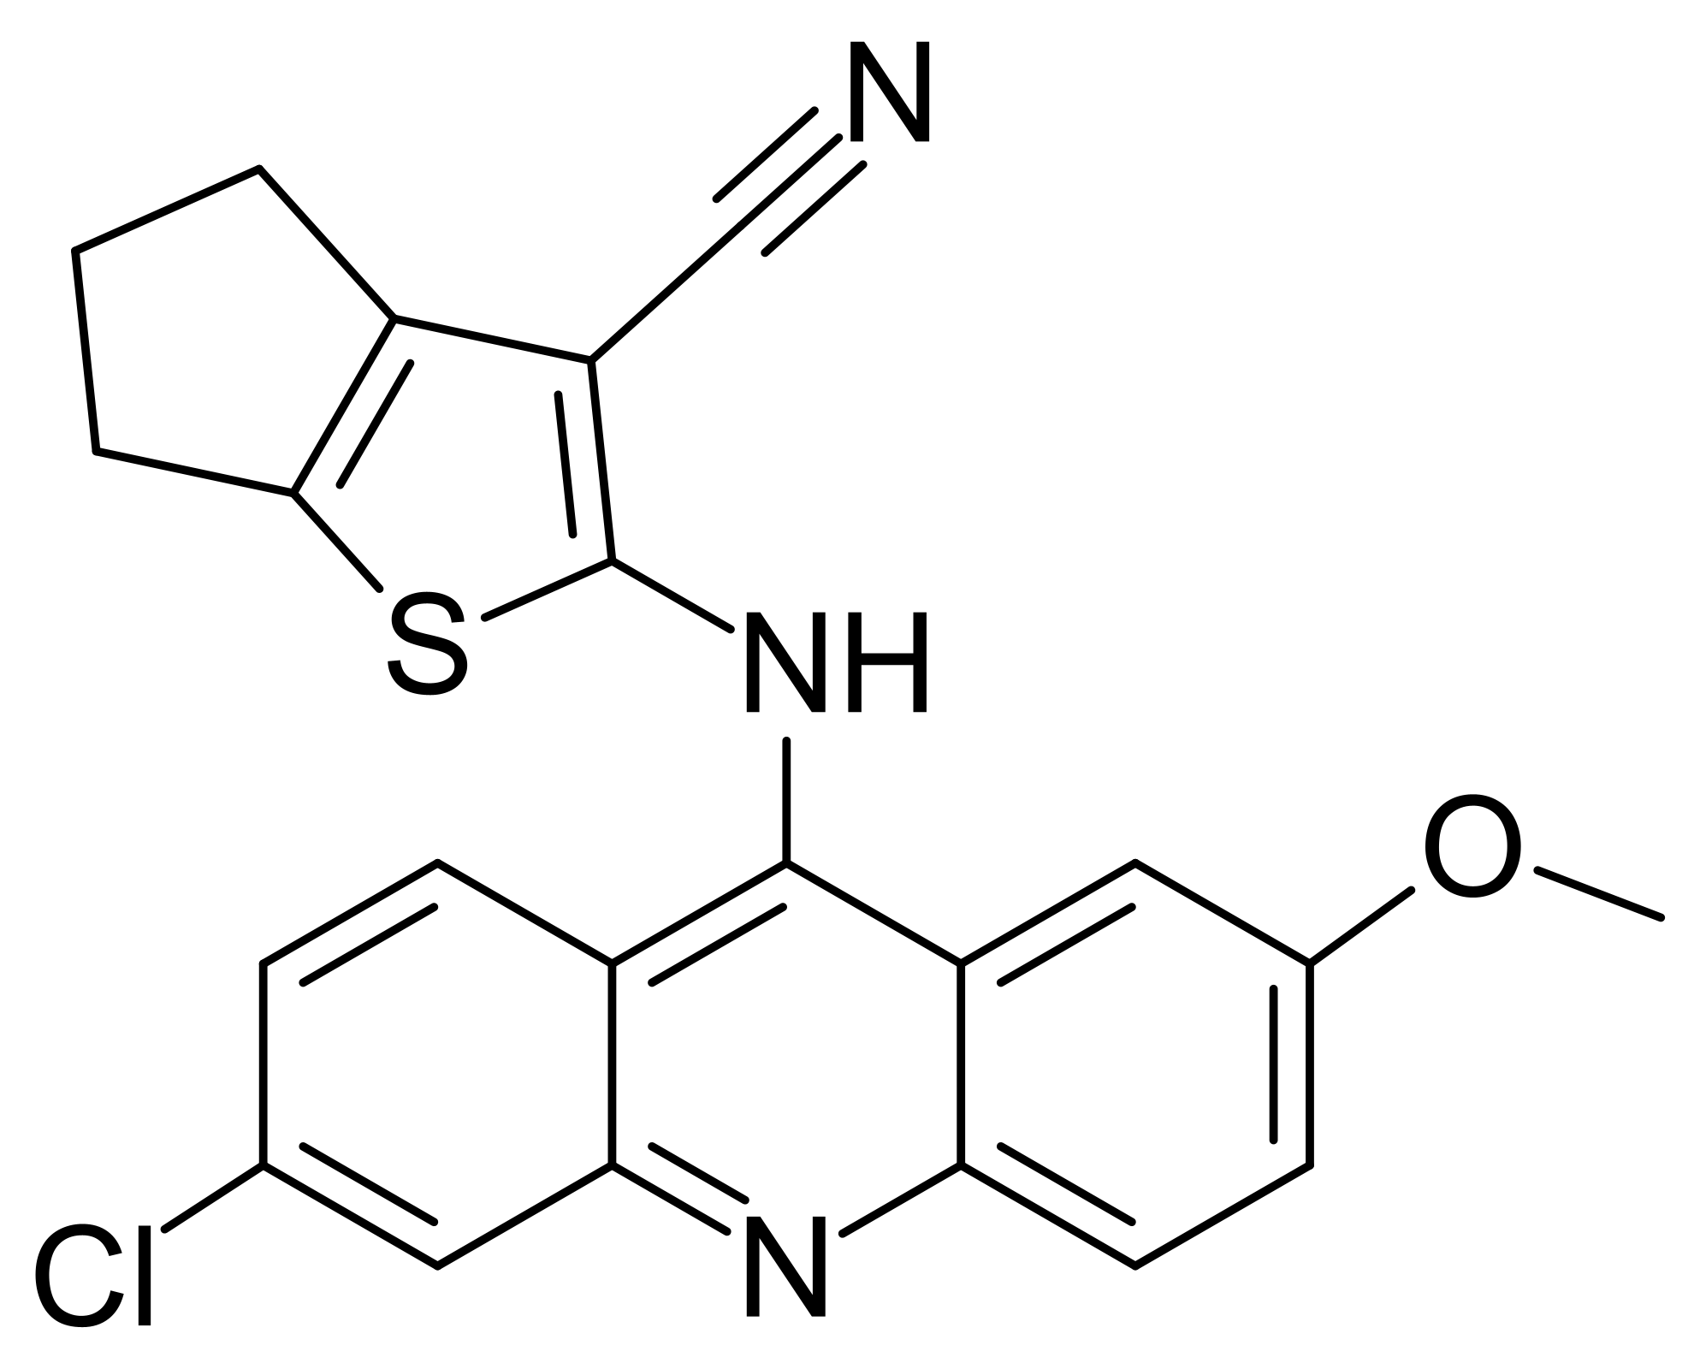 | 2-(6-chloro-2-methoxy-acridin-9-ylamino)-5,6-dihydro-4H-cyclopenta[b]- thiophene-  3-carbonitrile | [17]
23 | 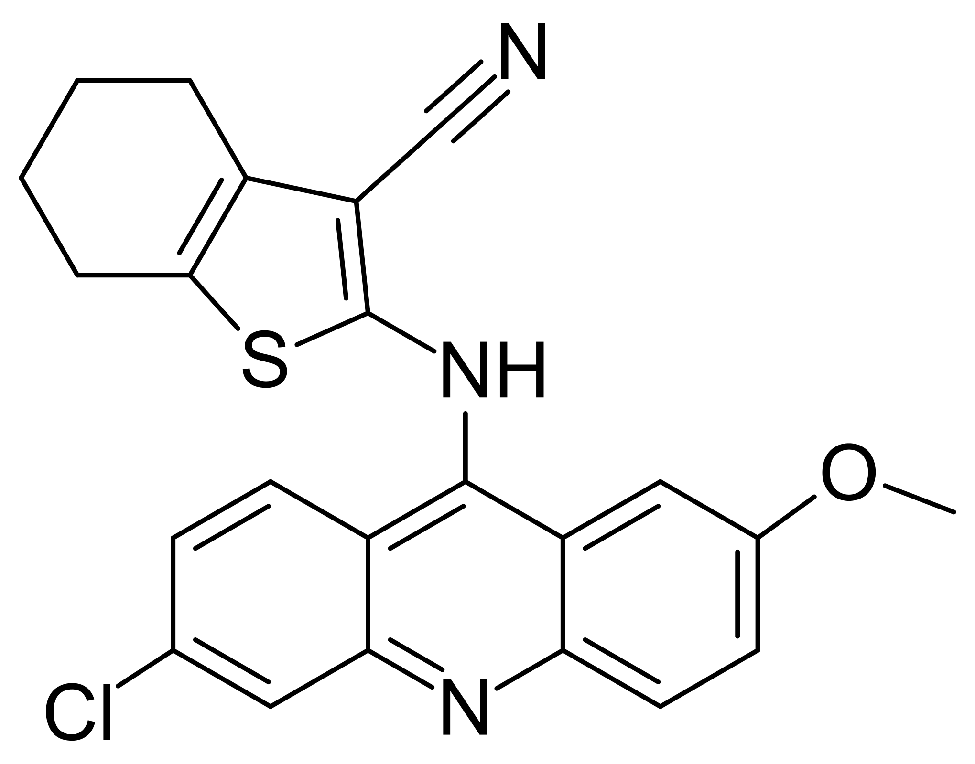 | 2-(6-Chloro-2-methoxy-acridin-9-ylamino)-4,5,6,7-tetrahydro-benzo[b]-thiophene-3-carbonitrile | [17]
24 | 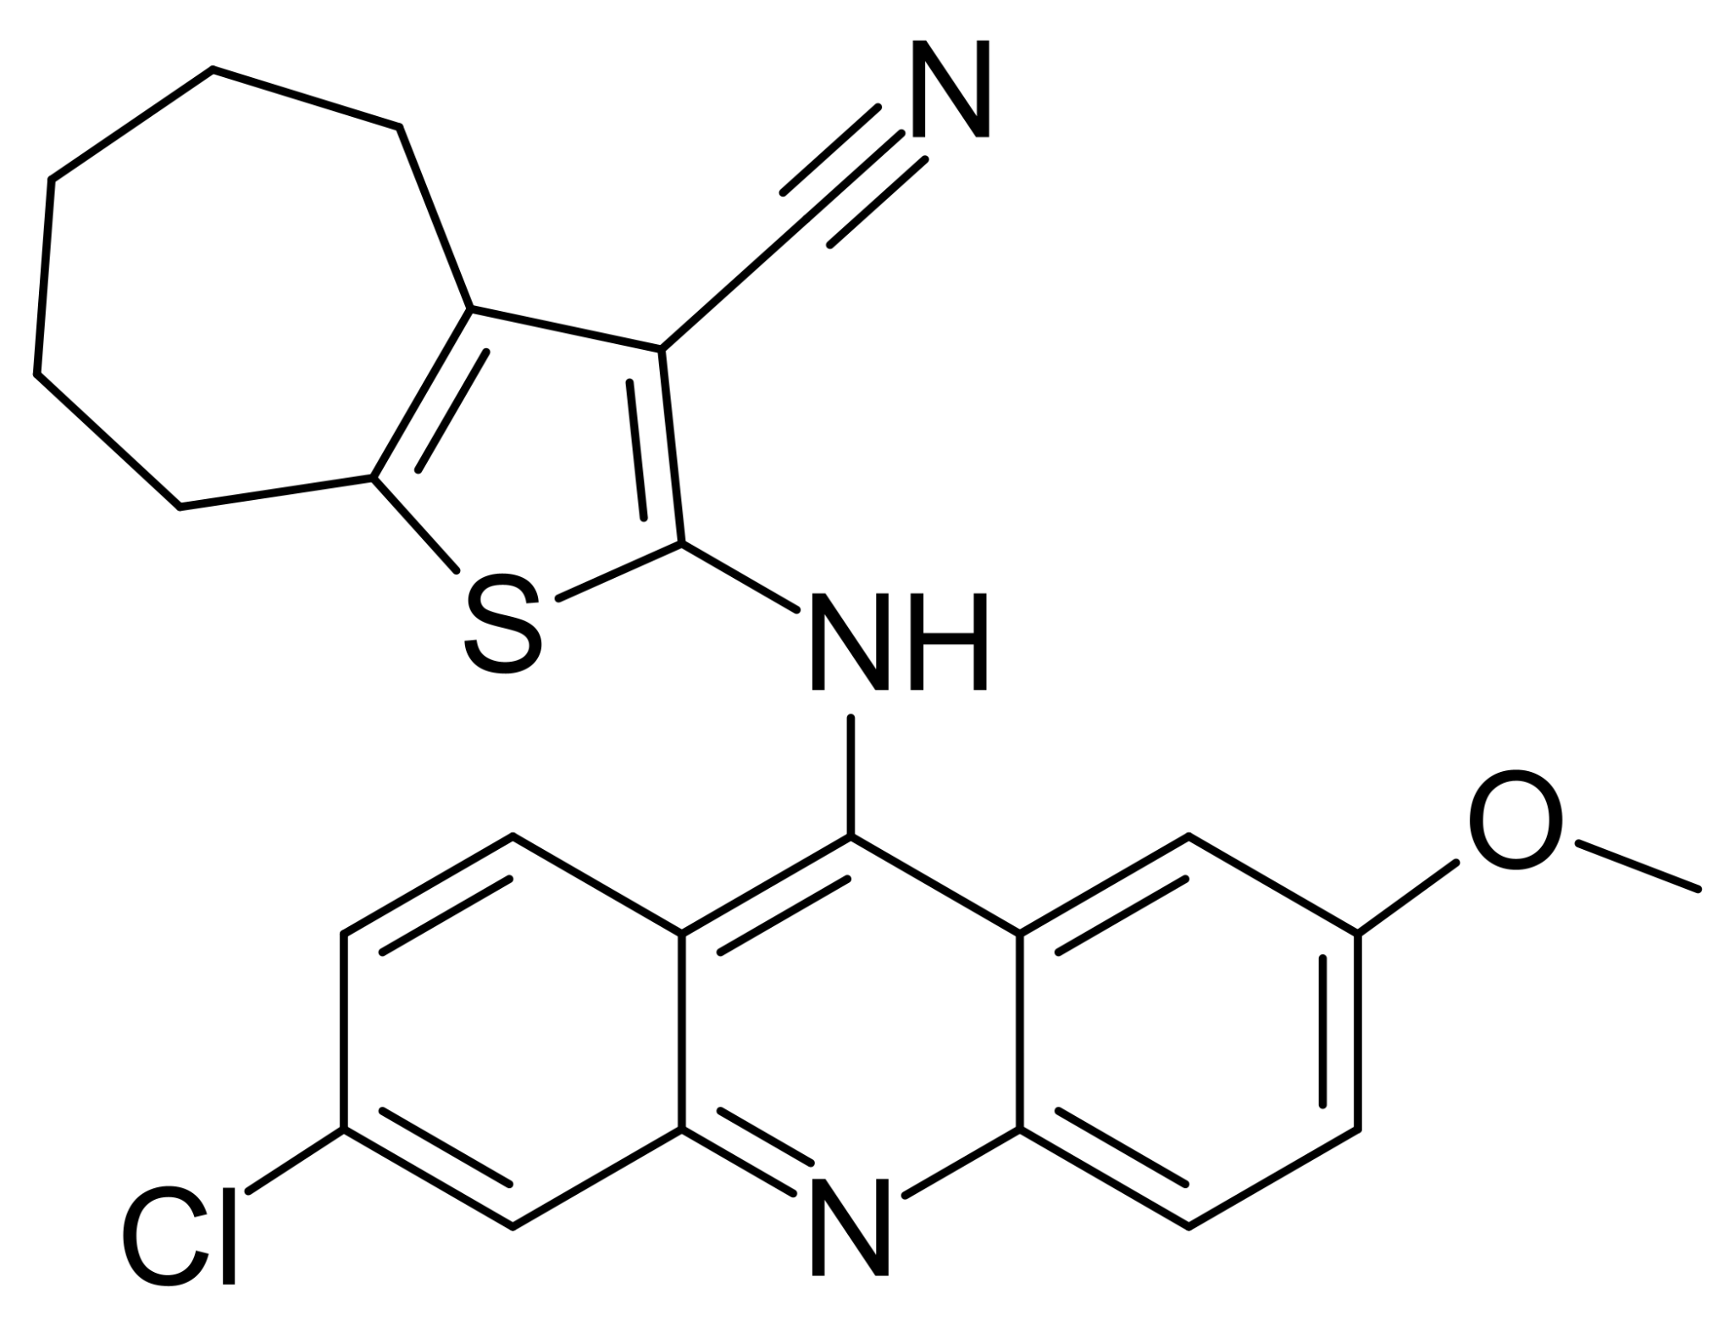 | 2-(6-Chloro-2-methoxy-acridin-9-ylamino)-5,6,7,8-tetrahydro-4H-cyclohepta[b]-thiophene-3-carbonitrile | [17]
25 | 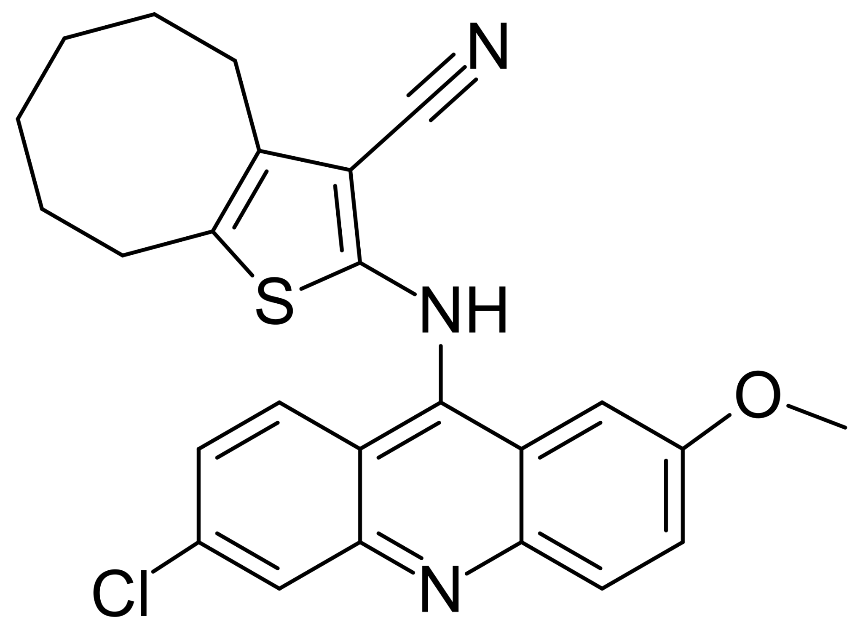 | 2-(6-Chloro-2-methoxy-acridin-9-ylamino)-4,5,6,7,8,9-hexahydro-cycloocta[b]-  thiophene-3-carbonitrile | [17]
26 | 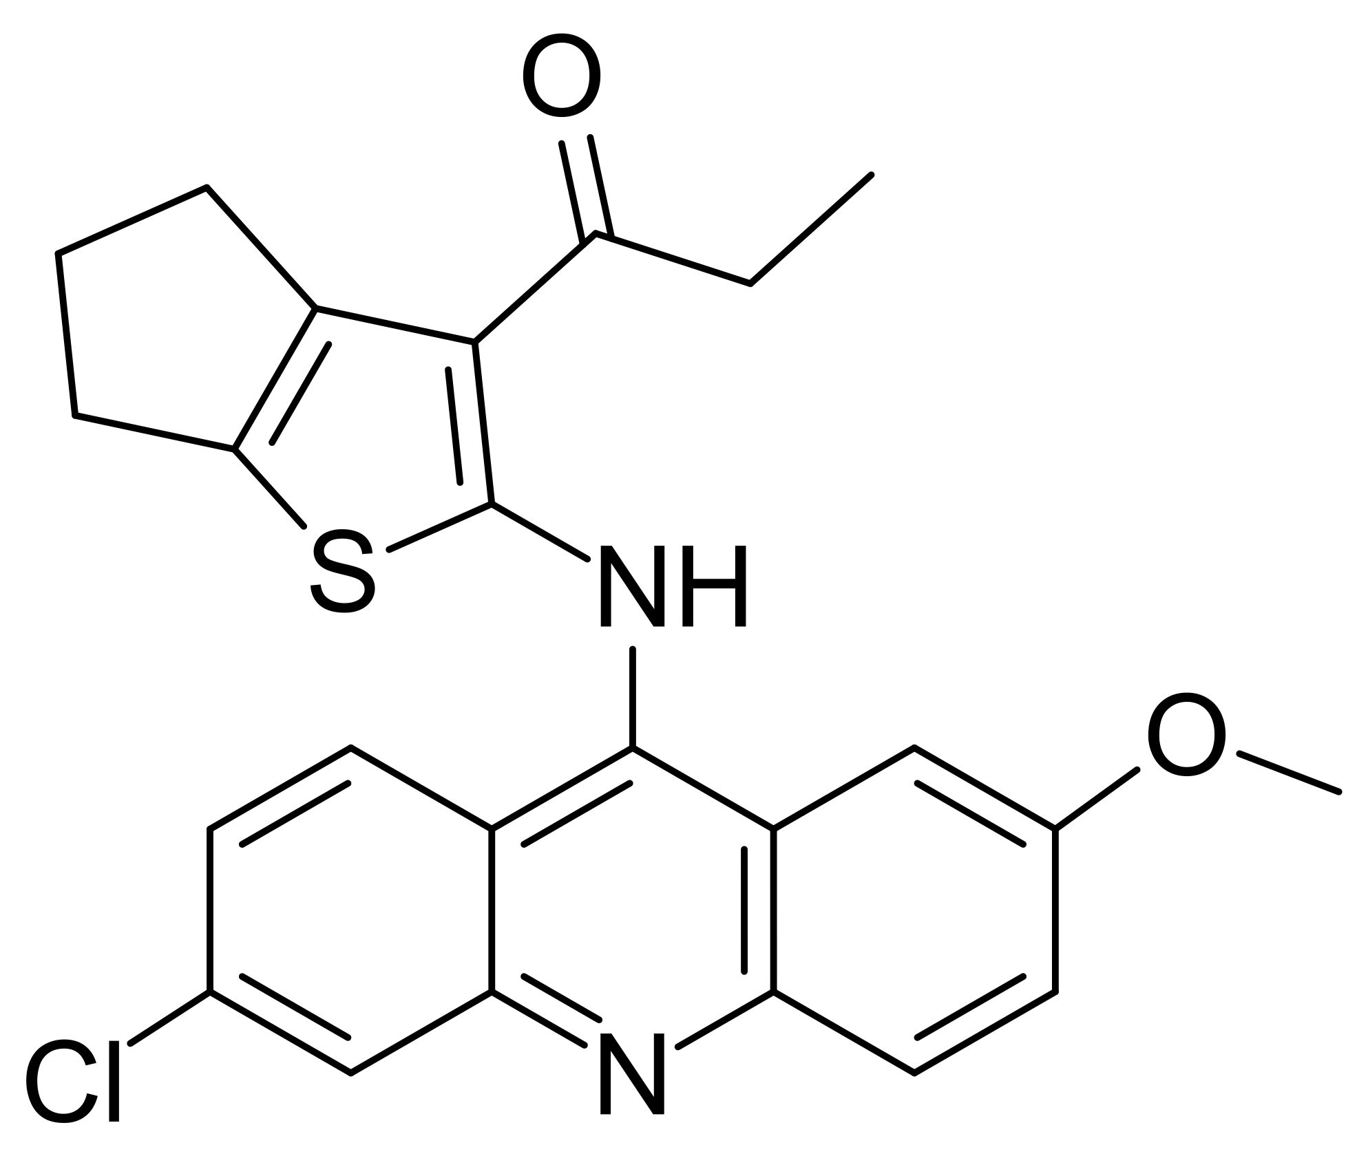 | 2-(6-Chloro-2-methoxy-acridin-9-ylamino)-4,5,6,7-tetrahydro-benzo[b]thiophene-3-  carboxylic acid ethyl ester | [17]
27 | 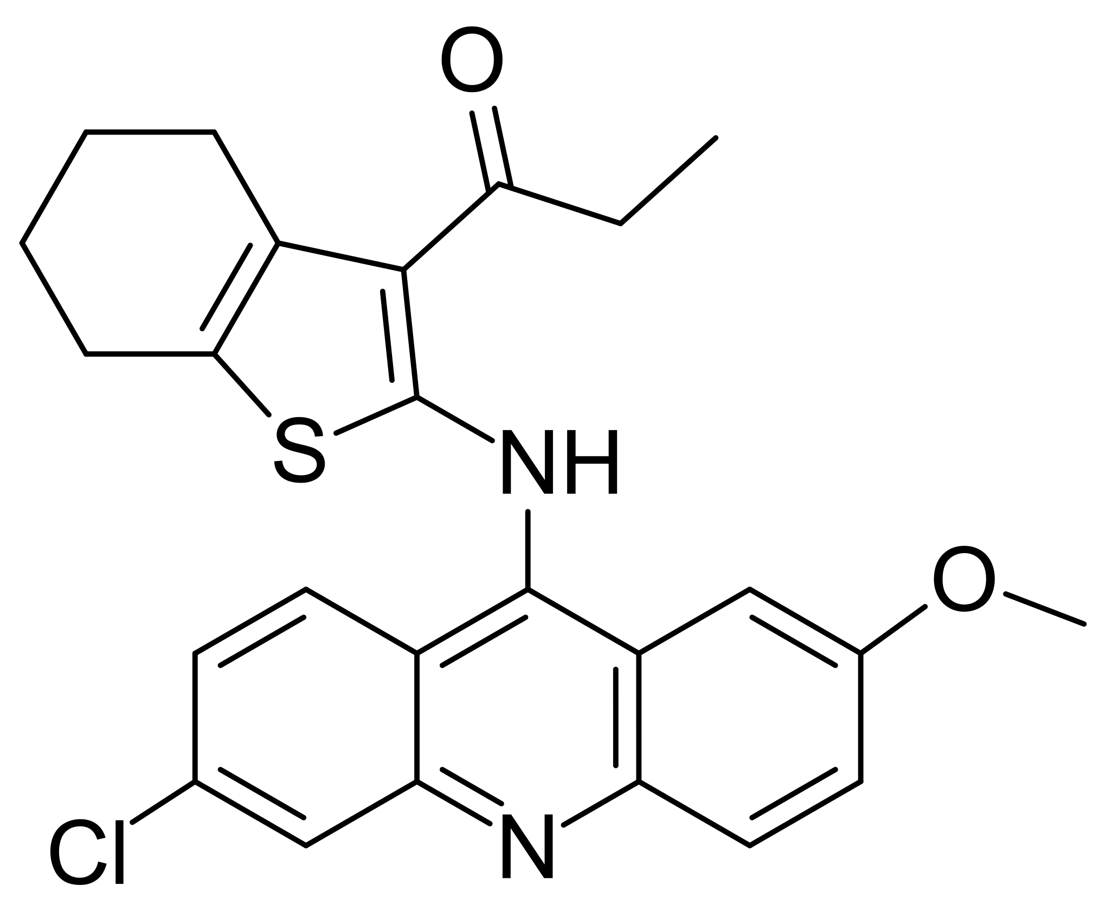 | 2-(6-Chloro-2-methoxy-acridin-9-ylamino)-5,6,7,8-tetrahydro-4H-cyclohepta[b]  thiophene-3-carboxylic acid ethyl ester | [17]
28 | 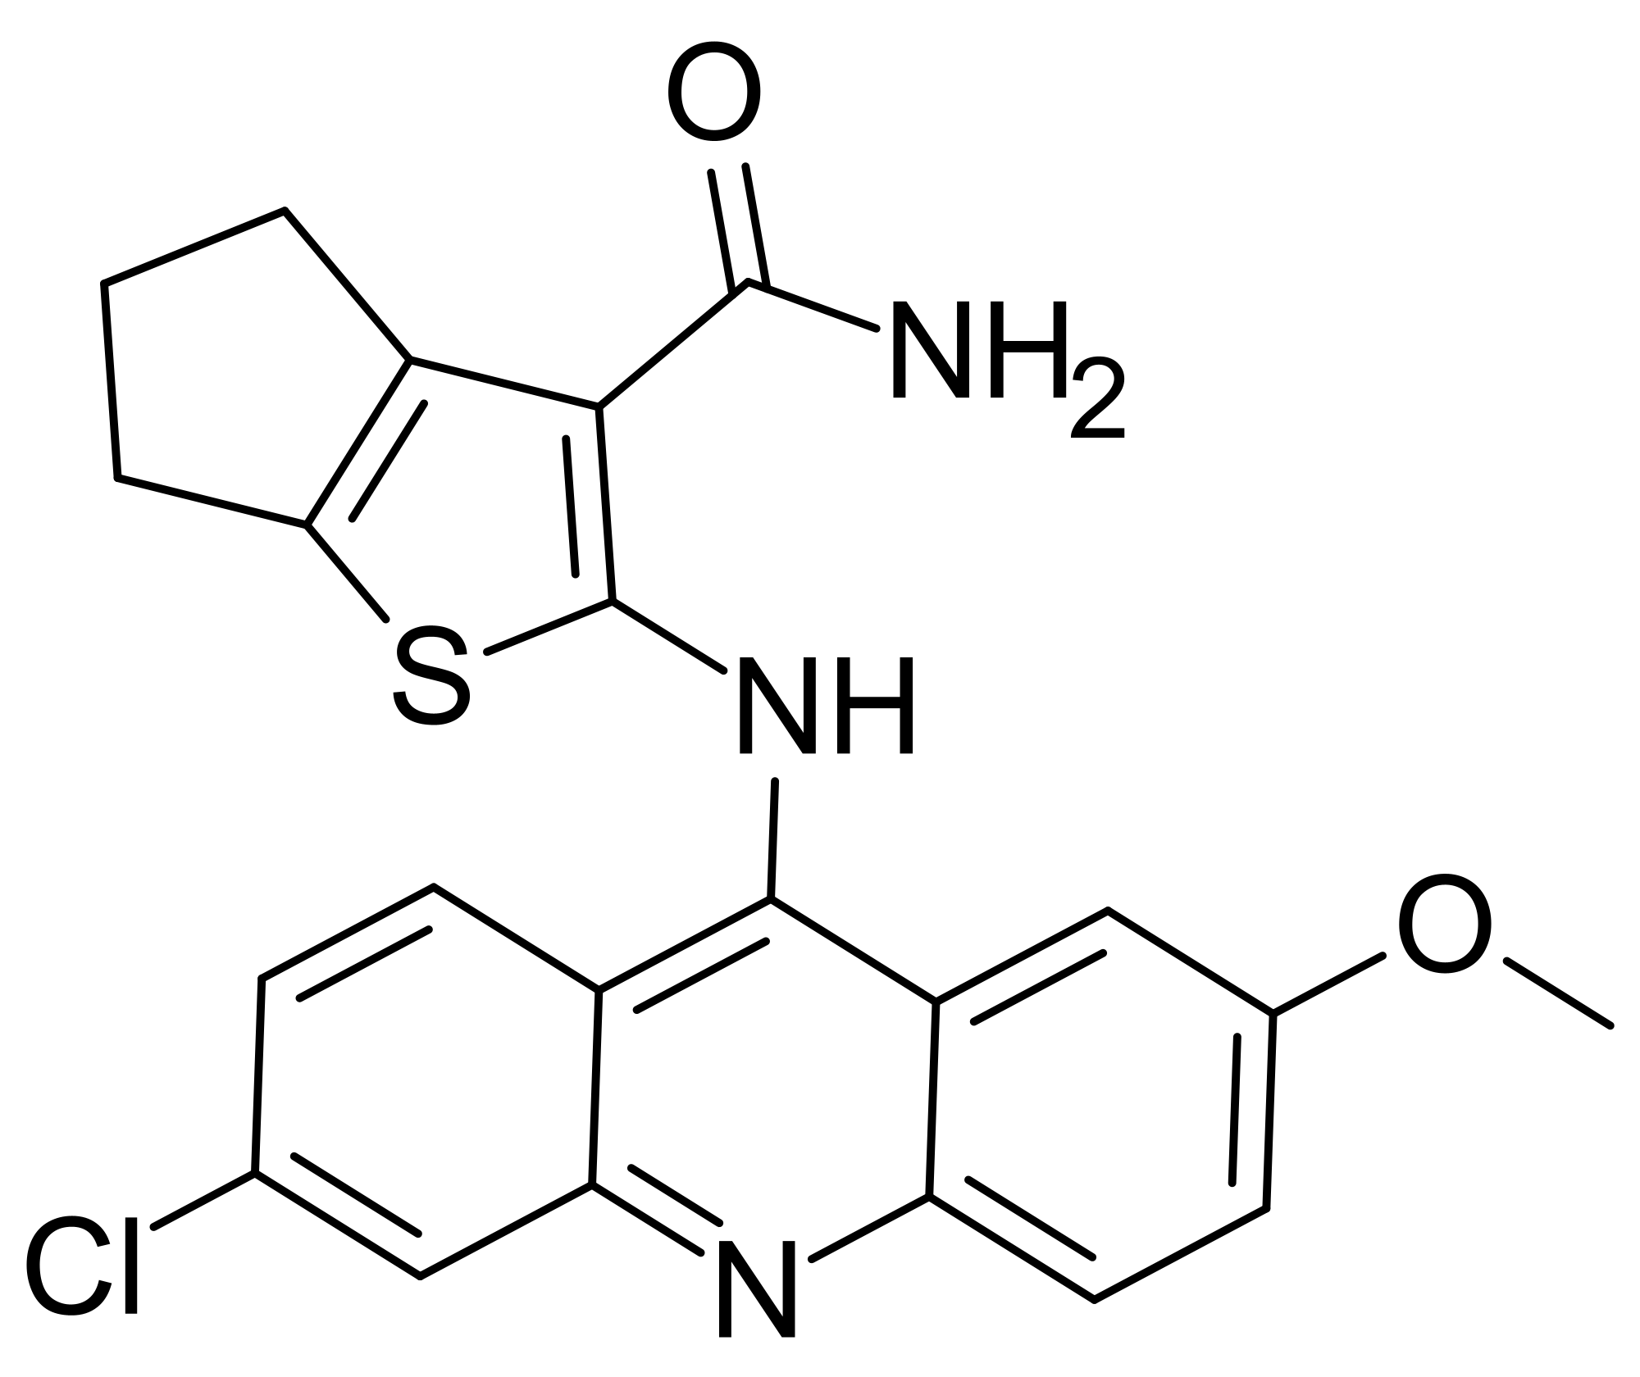 | 2-(6-Chloro-2-methoxy-acridin-9-ylamino)-4,5,6,7-tetrahydro-benzo[b]thiophene-3-  carboxylic acid amide | [17]

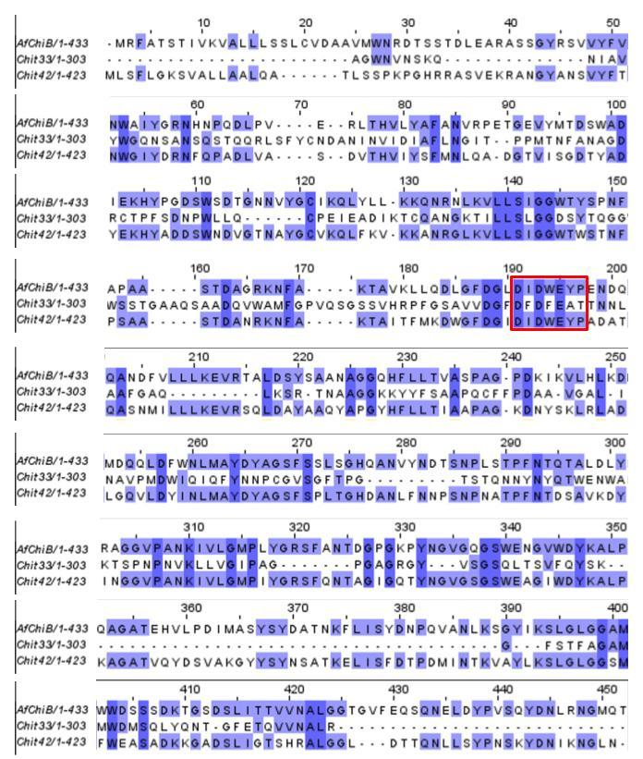
Figure S1. Alignment of chitinases enzymes belonging to the GH18 family of A. fumigatus (AfChiB) and T. harzianum species (Chit33 and Chit42). Colored in purple, the identity of the sequences is marked. The red box is the DXDXE domain.

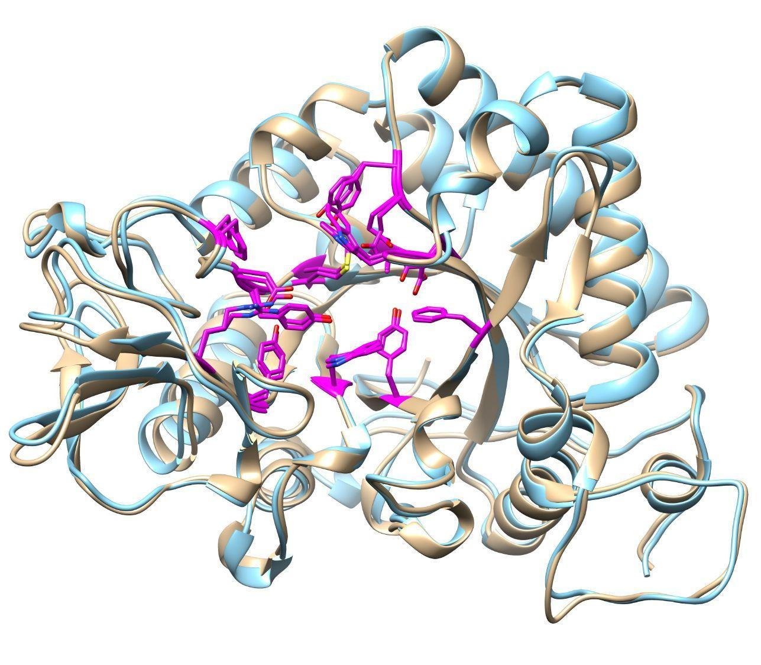 | 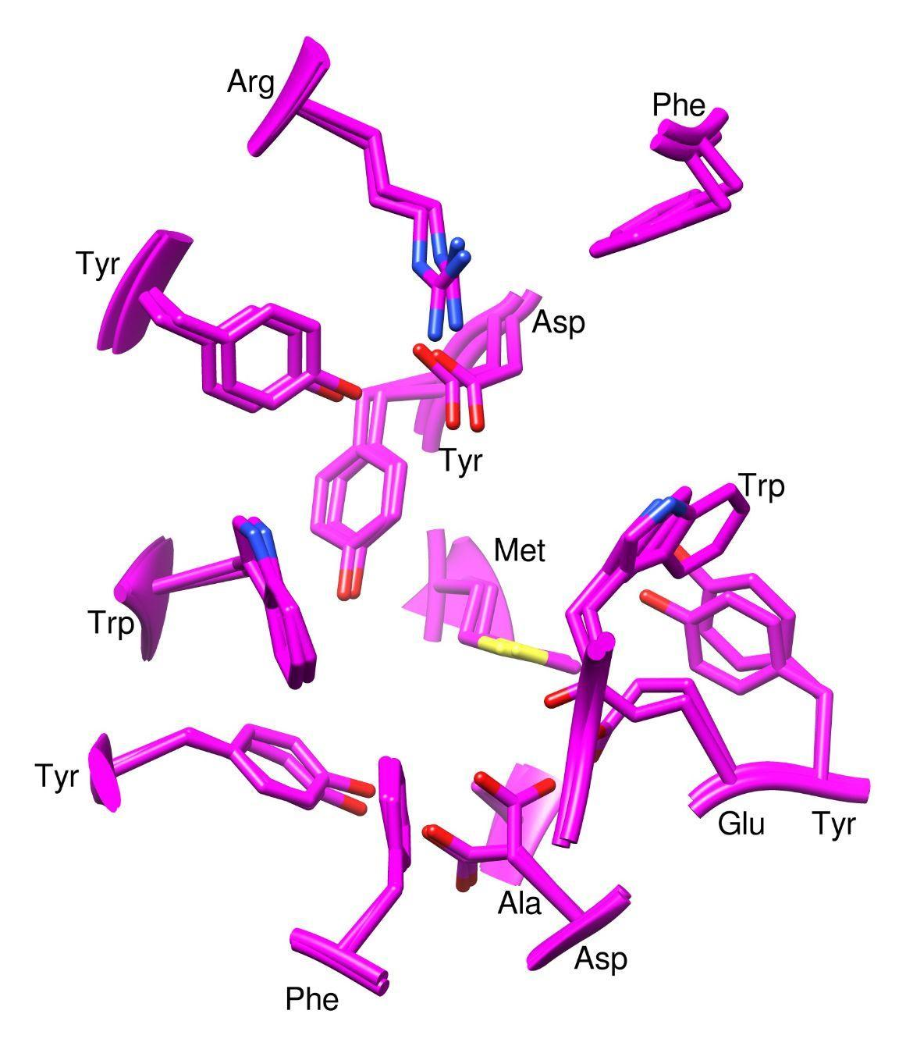
Figure S2. 3D Alignment of chitinases enzymes belonging to the GH18 family of A. fumigatus (AfChiB, in blue color) and T. harzianum species (Chit42, in gold color). The active site is presented in pink color.

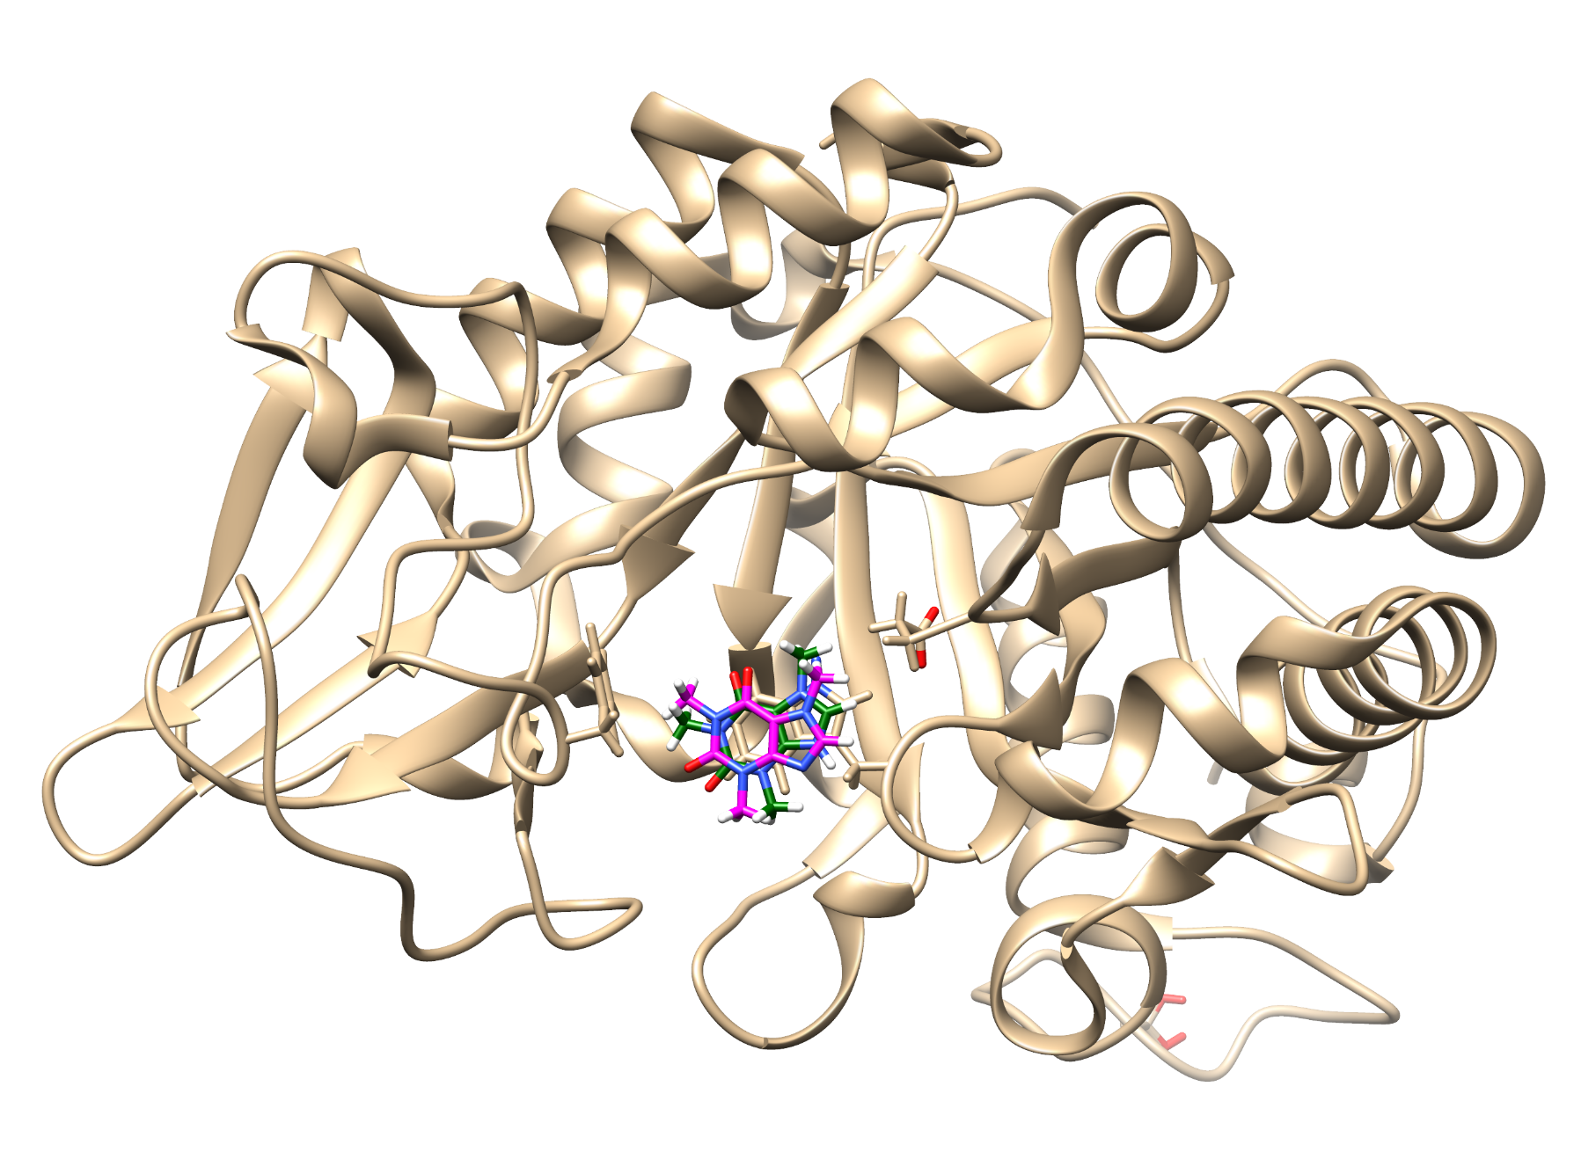 | 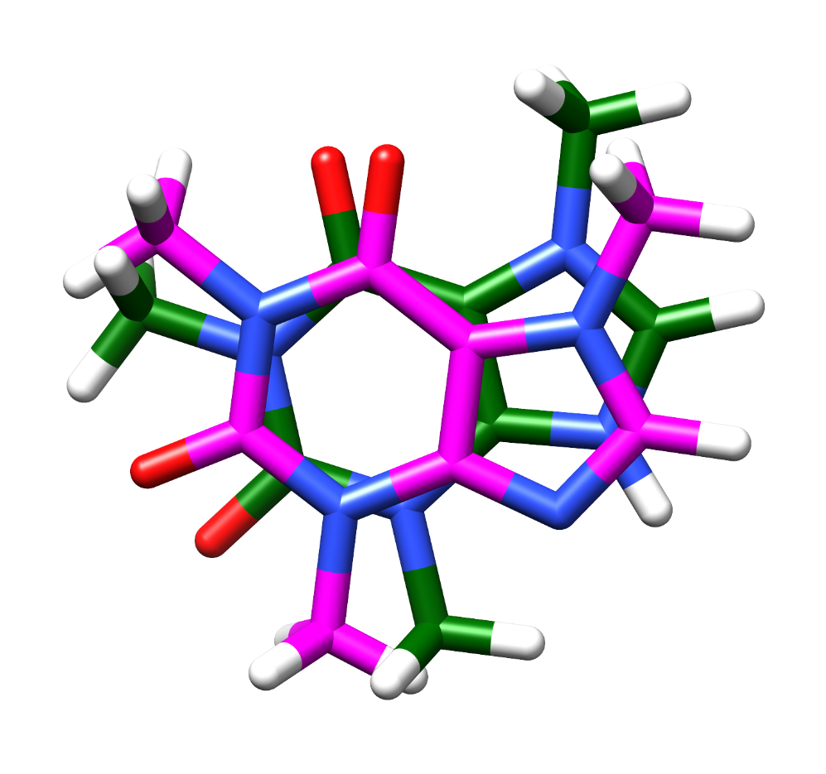
Figure S3. Redocking performed for the A. fumigatus chitinase inhibitor (PDB ID 2A3B). The protein is represented in a gold color. Colored pink is crystallized caffeine. The caffeine simulated is in green color. The other colors in the ligand represent the heteroatoms present in the structure: red is oxygen, blue is nitrogen and white is hydrogen.

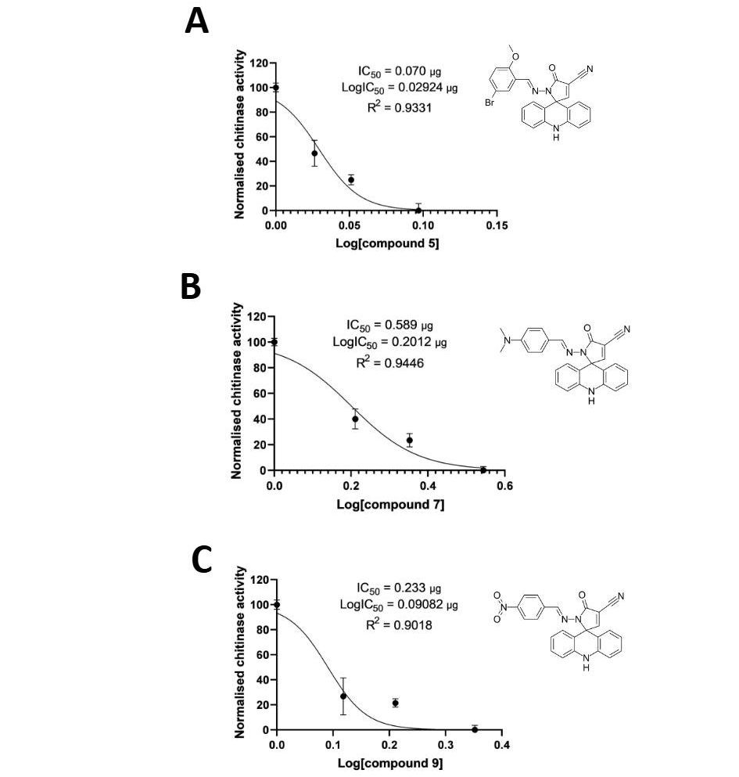
Figure S4. Graph of IC₅₀ value at 50% inhibition of three best acridine derivatives. (A) compound 7 (B) compound 9 and (C) compound 5.

