Table 1. Chemical structures of the analyzed bis-imidazolium chloride derivatives differentiated by type of substituent R and linker length n.
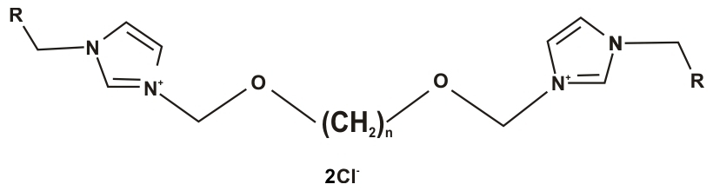
n-C₂H₅
No. | 1 | 2 | 3 | 4 | 5 | 6 | 7 | 8 | 9 | 10 | 11 | 12 | 13 | 14
R | CH₃ | C₂H₅ | C₃H₇ | C₄H₉ | C₅H₁₁ | C₆H₁₃ | C₇H₁₅ | C₈H₁₇ | C₉H₁₉ | C₁₀H₂₁ | C₁₁H₂₃ | C₁₂H₂₅ | C₁₄H₂₉ | C₁₆H₃₃
n-C₃H₇
No. | 15 | 16 | 17 | 18 | 19 | 20 | 21 | 22 | 23 | 24 | 25 | 26 | 27 | 28
R | CH₃ | C₂H₅ | C₃H₇ | C₄H₉ | C₅H₁₁ | C₆H₁₃ | C₇H₁₅ | C₈H₁₇ | C₉H₁₉ | C₁₀H₂₁ | C₁₁H₂₃ | C₁₂H₂₅ | C₁₄H₂₉ | C₁₆H₃₃
n-C₄H₉
No. | 29 | 30 | 31 | 32 | 33 | 34 | 35 | 36 | 37 | 38 | 39 | 40 | 41 | 42
R | CH₃ | C₂H₅ | C₃H₇ | C₄H₉ | C₅H₁₁ | C₆H₁₃ | C₇H₁₅ | C₈H₁₇ | C₉H₁₉ | C₁₀H₂₁ | C₁₁H₂₃ | C₁₂H₂₅ | C₁₄H₂₉ | C₁₆H₃₃
n- C₅H₁₁
No. | 43 | 44 | 45 | 46 | 47 | 48 | 49 | 50 | 51 | 52 | 53 | 54 | 55 | 56
R | CH₃ | C₂H₅ | C₃H₇ | C₄H₉ | C₅H₁₁ | C₆H₁₃ | C₇H₁₅ | C₈H₁₇ | C₉H₁₉ | C₁₀H₂₁ | C₁₁H₂₃ | C₁₂H₂₅ | C₁₄H₂₉ | C₁₆H₃₃
n- C₆H₁₃
No. | 57 | 58 | 59 | 60 | 61 | 62 | 63 | 64 | 65 | 66 | 67 | 68 | 69 | 70
R | CH₃ | C₂H₅ | C₃H₇ | C₄H₉ | C₅H₁₁ | C₆H₁₃ | C₇H₁₅ | C₈H₁₇ | C₉H₁₉ | C₁₀H₂₁ | C₁₁H₂₃ | C₁₂H₂₅ | C₁₄H₂₉ | C₁₆H₃₃
n- C₇H₁₅
No. | 71 | 72 | 73 | 74 | 75 | 76 | 77 | 78 | 79 | 80 | 81 | 82 | 83 | 84
R | CH₃ | C₂H₅ | C₃H₇ | C₄H₉ | C₅H₁₁ | C₆H₁₃ | C₇H₁₅ | C₈H₁₇ | C₉H₁₉ | C₁₀H₂₁ | C₁₁H₂₃ | C₁₂H₂₅ | C₁₄H₂₉ | C₁₆H₃₃
n- C₈H₁₇
No. | 85 | 86 | 87 | 88 | 89 | 90 | 91 | 92 | 93 | 94 | 95 | 96 | 97 | 98
R | CH₃ | C₂H₅ | C₃H₇ | C₄H₉ | C₅H₁₁ | C₆H₁₃ | C₇H₁₅ | C₈H₁₇ | C₉H₁₉ | C₁₀H₂₁ | C₁₁H₂₃ | C₁₂H₂₅ | C₁₄H₂₉ | C₁₆H₃₃
n- C₉H₁₉
No. | 99 | 100 | 101 | 102 | 103 | 104 | 105 | 106 | 107 | 108 | 109 | 110 | 111 | 112
R | CH₃ | C₂H₅ | C₃H₇ | C₄H₉ | C₅H₁₁ | C₆H₁₃ | C₇H₁₅ | C₈H₁₇ | C₉H₁₉ | C₁₀H₂₁ | C₁₁H₂₃ | C₁₂H₂₅ | C₁₄H₂₉ | C₁₆H₃₃
n- C₁₀H₂₁
No. | 113 | 114 | 115 | 116 | 117 | 118 | 119 | 120 | 121 | 122 | 123 | 124 | 125 | 126
R | CH₃ | C₂H₅ | C₃H₇ | C₄H₉ | C₅H₁₁ | C₆H₁₃ | C₇H₁₅ | C₈H₁₇ | C₉H₁₉ | C₁₀H₂₁ | C₁₁H₂₃ | C₁₂H₂₅ | C₁₄H₂₉ | C₁₆H₃₃
n- C₁₂H₁₇
No. | 127 | 128 | 129 | 130 | 131 | 132 | 133 | 134 | 135 | 136 | 137 | 138 | 139 | 140
R | CH₃ | C₂H₅ | C₃H₇ | C₄H₉ | C₅H₁₁ | C₆H₁₃ | C₇H₁₅ | C₈H₁₇ | C₉H₁₉ | C₁₀H₂₁ | C₁₁H₂₃ | C₁₂H₂₅ | C₁₄H₂₉ | C₁₆H₃₃

