Extended Data figures
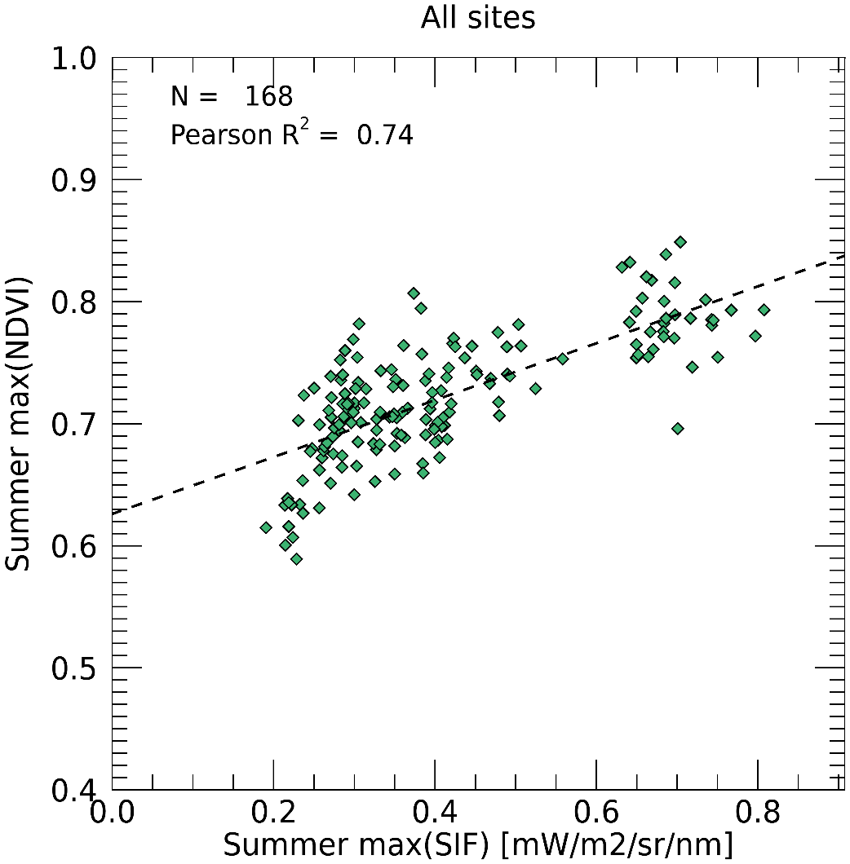
Extended Data Figure 1 | Comparison of AVHRR NDVI and downscaled merged GOME-2 and TROPOMI SIF for 2007-2018. The summer maximum SIF at flux stations is compared with the summer maximum NDVI used in GPP and ER algorithms to consider the strength of photosynthesis of evergreen boreal forests of each investigated EASE Grid cell.

a
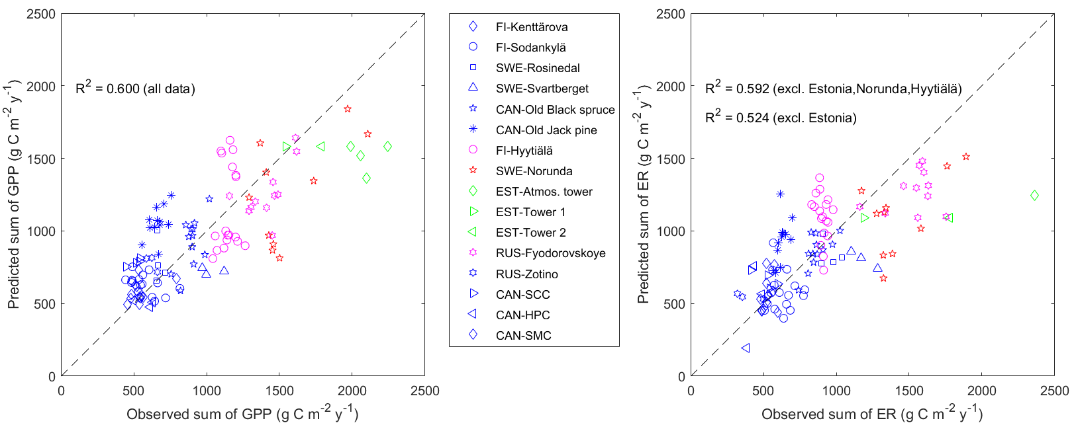
b
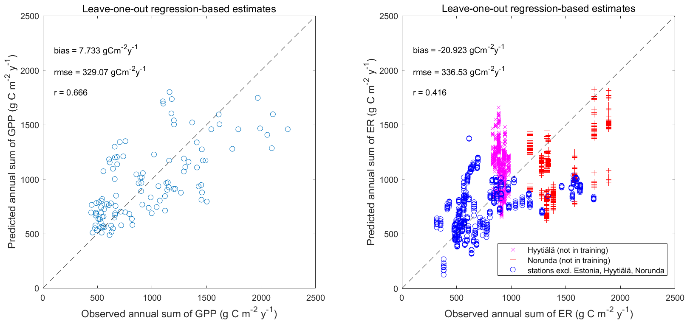
Extended Data Figure 2 | Regression algorithm performance in the estimation of mean annual GPP and ER from passive microwave radiometry and NDVI data. a, Algorithm performance using the same eddy covariance (EC) flux dataset in training and testing, i.e., the developed algorithm (proxy). b, Algorithm performance in leave-one-out analysis used for determining the error bounds of GPP and ER estimates.

a
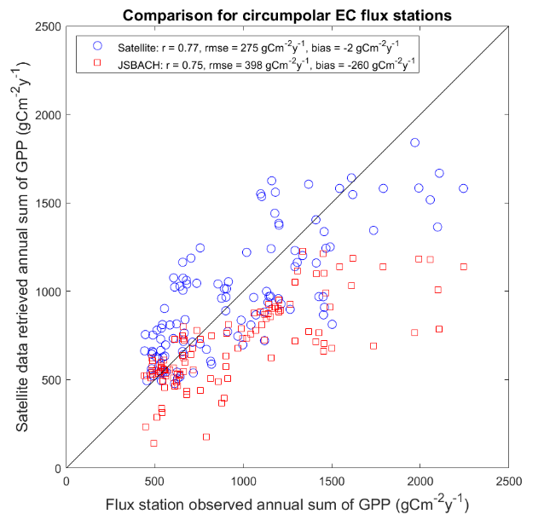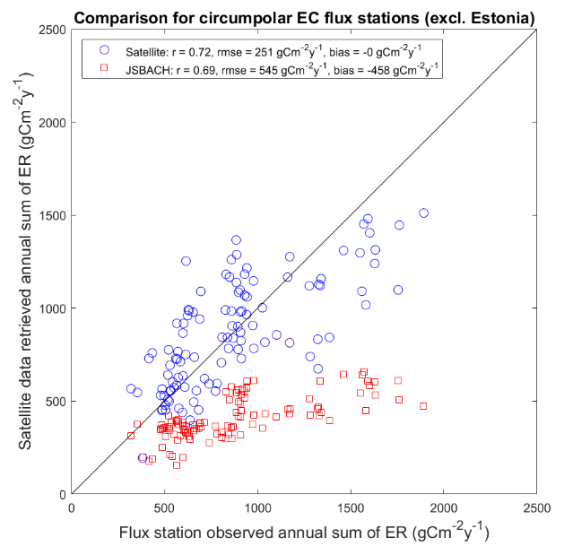
b
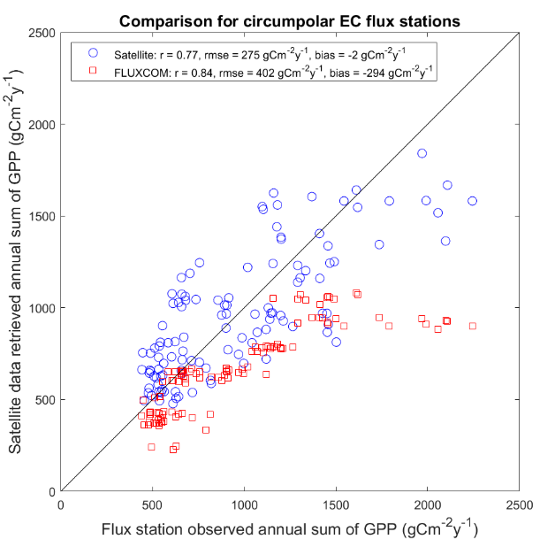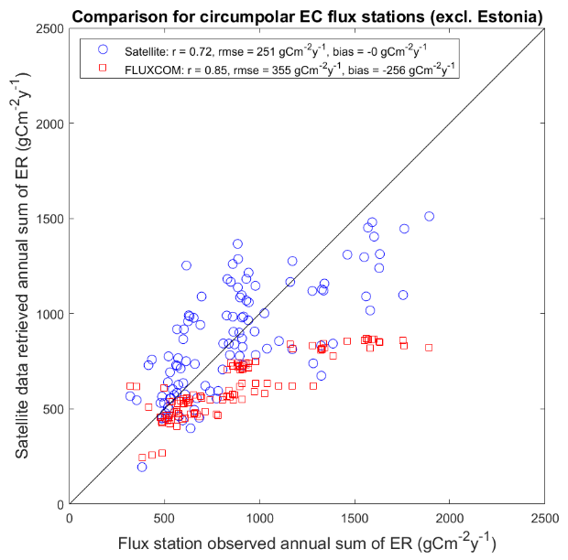
Extended Data Figure 3 | Estimation error of mean annual GPP and ER for grid cells corresponding to different eddy covariance (EC) flux stations. a, comparison of the observed EC tower fluxes with satellite proxies (in blue) and JSBACH simulations (in red). b, comparison of the observed EC tower fluxes with satellite proxies (in blue) and FLUXCOM data (in red).

a
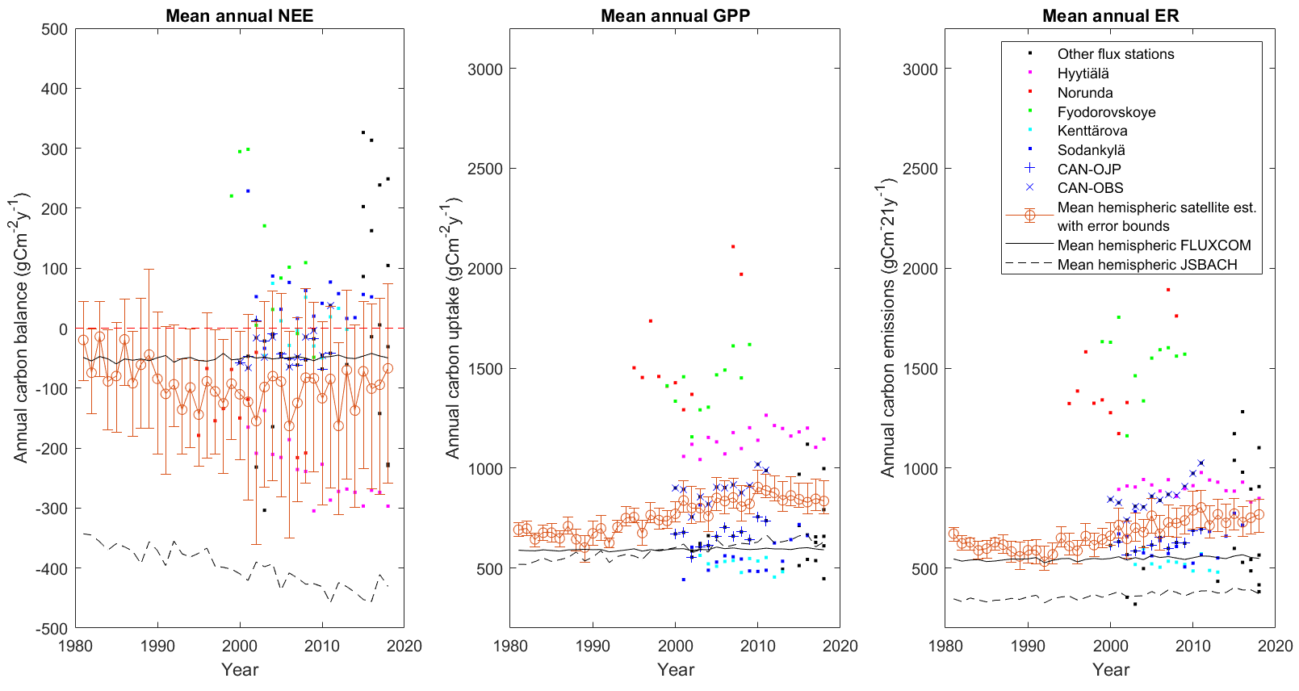
b
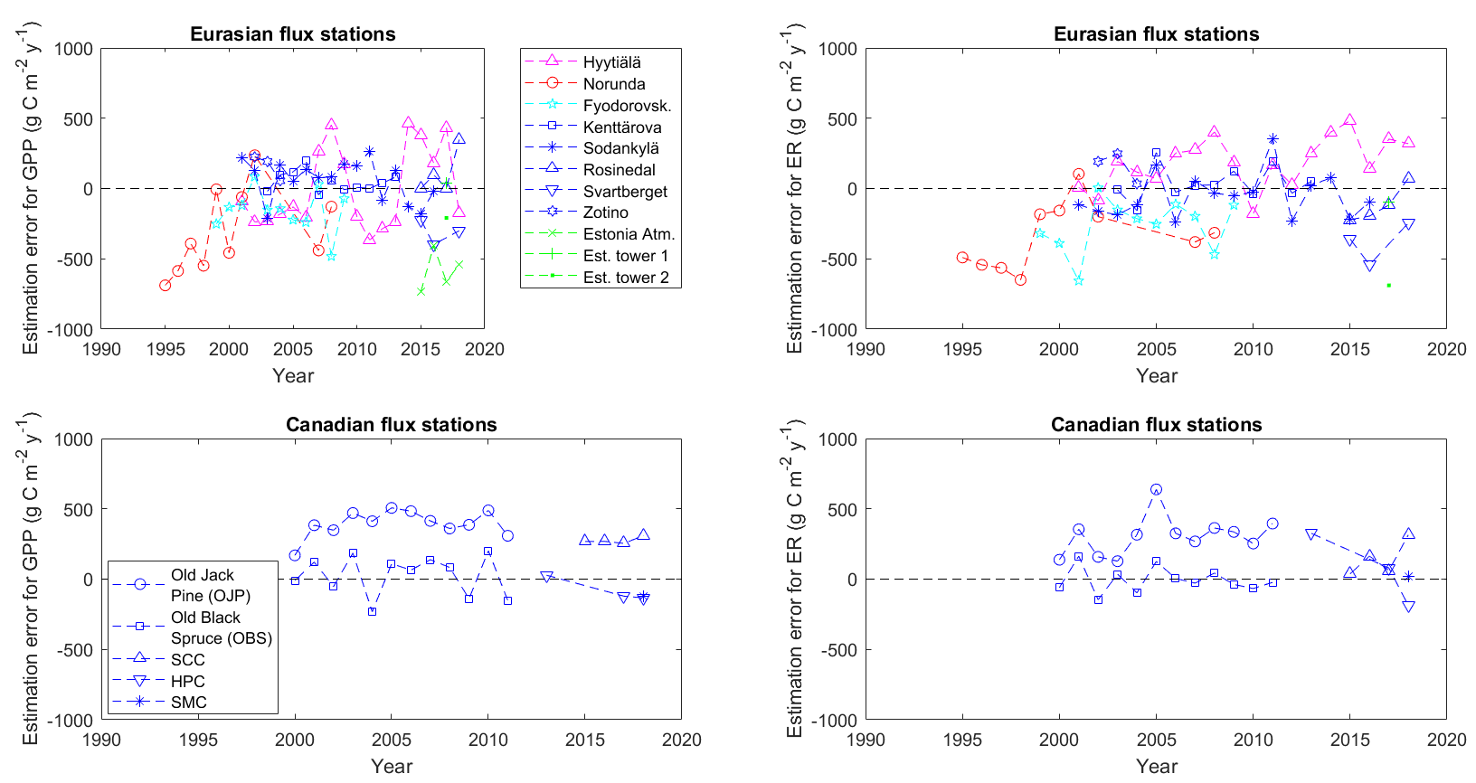
Extended Data Figure 4 | Comparison of mean annual circumpolar NEE, GPP and ER with flux site observations. a, Hemisperic predictions across the evergreen boreal forest are obtained by the developed satellite proxy, FLUXCOM and JSBACH simulations. b, yearly estimation errors for different stations (using satellite estimates of each flux station).
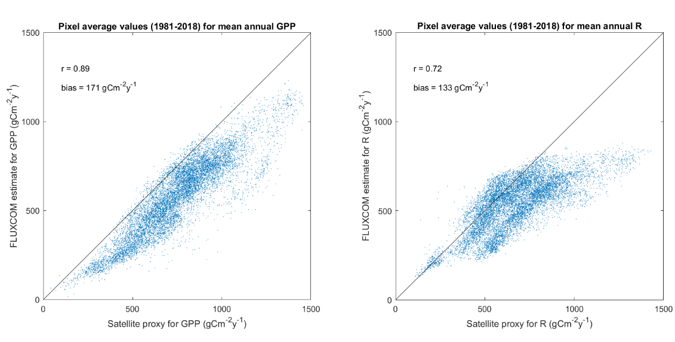
Extended Data Figure 5 | Comparison of satellite proxy and FLUXCOM averages for 1981-2018. Comparison of pixel-wise mean annual GPP and ER is carried out through the investigated period across the circumpolar evergreen boreal forest.
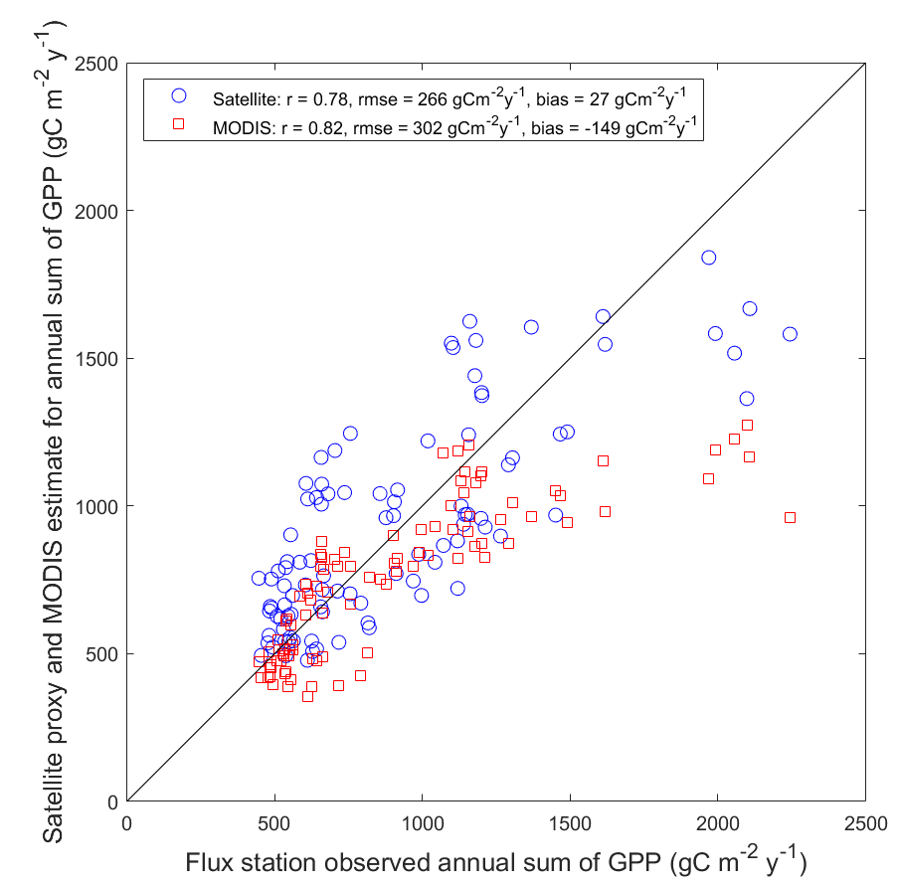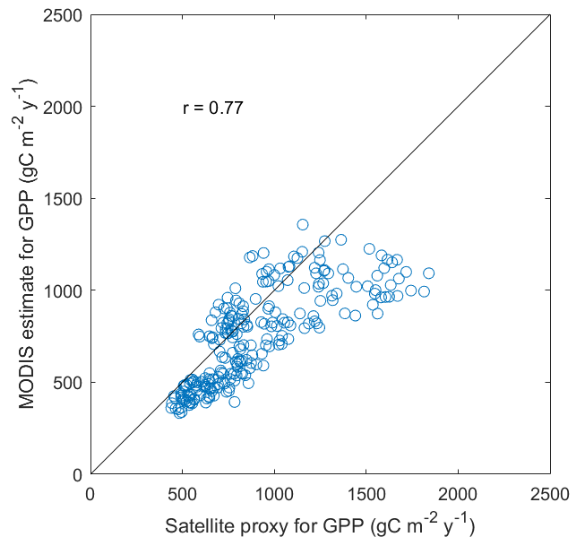
Extended Data Figure 6 | Comparison of satellite proxy and MODIS GPP. Left: MODIS GPP and satellite proxy against flux data-derived mean annual GPP. Right: Comparison of estimated mean annual values of GPP at the locations of the employed circumpolar flux stations through the period 2002-2018. The MODIS GPP is based on observations by Aqua and Terra satellites³⁸.
Extended Data tables

Extended Data Table 1 | Characteristics of flux sites and flux dataset. | CAN SMC⁵¹ | Canada (N63.15, W123.25) | 2018 | Northern boreal, discont. perma-frost | Black spruce | - | Peat soil | 171/171/ 171 | 10.2/6.7 | ªYears with daily flux observations.  ^{b}During the flux data acquisition period.  ^{c}Based on satellite observations of cryosphere status.  ^{d}Based on daily flux dataset.
 | CAN HPC⁵⁰ | Canada (N68.32, W133.52) | 2013, 2017, 2018 | Northern boreal, cont. perma-frost | Black spruce | - | - | 176/196/ 243 | 10.8/7.2
 | CAN SCC⁴⁹ | Canada (N61.31, W121.30) | 2015-2018 | Northern boreal, sporadic perma-frost | Black spruce | - | Mineral and peat soil | 152/ 167.5/175 | 6.5/5.8
 | BERMS OBS⁴⁸ | Canada (N53.99, W105.12) | 2000-2011 | Southern boreal, seasonal soil frost | (Old) Black spruce | 120 | Mineral and peat soil | 123/147/ 202 | 9.3/9.8
 | BERMSOJP⁴⁸ | Canada (N53.92, W104.69) | 2000-2011 | Southern boreal, seasonal soil frost | (old) Jack pine | 70 | Mineral soil | 111/143/ 184 | 7.6/7.6
 | Estonia tower2⁴⁷ | Estonia  (N58.28,E27.31) | 2017 | Hemi-boreal, seasonal soil frost | Birch, aspen, S. pine | - | Mineral soil | 81/81/81 | 19.0/18.4
 | Estonia tower1⁴⁷ | Estonia  (N58.28,E27.31) | 2017 | Hemi-boreal, seasonal soil frost | Scots pine | - | Mineral soil | 81/81/81 | 18.3/13.3
 | Estonia atmos. tower⁴⁷ | Estonia (N58.27,E27.27) | 2015-2018 | Hemi-boreal, seasonal soil frost | Norway spruce, birch | 70 | Mineral soil | 76/79/87 | 26.8/33.3
 | Zotino⁴⁶ | Russia (N60.80, E89.35) | 2002-2004 | Northern boreal, seasonal soil frost | Scots pine | up to 200 | Mineral soil | 194/197/ 201 | 8.9/5.9
 | Fyodor-ovskoye⁴⁵ | Russia (N56.46, E32.92) | 1999-2009 | Southern boreal, seasonal soil frost | Norway spruce | 150 | Mineral-peat soil | 62/117/ 129 | 17.9/16.7
 | Svart-berget⁴⁴ | Sweden (N64.26, E19.78) | 2015-2016, 2018 | Northern boreal, seasonal soil frost | Scots pine, N. spruce | 110 | Mineral soil | 141/147/ 158 | 9.9/13.0
 | Rosine-dal⁴³ | Sweden (N64.17, E19.74) | 2015-2018 | Northern boreal, seasonal soil frost | Scots pine | 90 | Mineral soil | 107/  148.5/162 | 6.6./9.7
 | Norunda^{41,10} | Sweden (N60.09, E17.48) | 1995-2002, 2007- 2008 | Southern boreal, seasonal soil frost | Norway spruce, S. pine | 60-110 | Mineral soil | 23/89/162 | 16.3/17.7
 | Kenttä-rova^{42,10} | Finland (N67.98, E24.25) | 2003-2013 | Northern boreal, seasonal soil frost | Norway spruce | 70-160 | Mineral soil | 151/184/ 195 | 8.1/5.8
 | Sodan-kylä¹⁰ | Finland (N67.37, E26.63) | 2001-2016 | Northern boreal, seasonal soil frost | Scots pine | 80-180 | Mineral soil | 121/  174.5/196 | 8.8/10.1
 | Hyytiälä^{41,10} | Finland (N61.85, E24.28) | 2001-2018 | Southern boreal, seasonal soil frost | Scots pine | 40-50 | Mineral soil | 42/117.5/196 | 12.9/8.9
 |  | Country (lat, lon) | Years of flux obs.ª | Forest, climate & frost zone | Tree species | Tree age^{b} (years) | Soil type | Number of freeze days^{a,c} (min/med/max) | Max. daily GPP/ER^{d} (gCm⁻²d⁻¹)

Extended Data Table 2 | Correlation between the drivers of the developed satellite proxy and annual cumulative GPP and ER [g C m⁻² y⁻¹].
Variables | Excluded stations | Number of data points | Correlation coefficient (r)
Length of 6-m spring thaw vs. January-June sum of GPP | - | 114 | 0.743
Length of 6-m spring thaw vs. annual sum of GPP | - | 114 | 0.735
Length of annual thaw vs. annual sum of ER | - | 114 | 0.679
Length of annual thaw vs. annual sum of ER | Estonian stations | 108 | 0.681
Summer max. NDVI vs. annual sum of GPP | - | 114 | 0.474
Summer max. NDVI vs. max. daily GPP [gC m⁻² d⁻¹] | - | 114 | 0.481
Correlations at individual stations when number of available years (data points) $≥$ 10
Variables | Station | Number of data points | Correlation  coefficient (r)
Length of 6-m spring thaw vs. January-June sum of GPP | Norunda (Sweden) | 10 | 0.576
 | Hyytiälä (Finland) | 18 | 0.151
 | Sodankylä (Finland) | 16 | -0.265
 | Kenttärova (Finland) | 11 | 0.505
 | Fyodorovskoye (Russia) | 11 | 0.792
 | BERMS – Old Black Spruce (Canada) | 12 | 0.752
 | BERMS – Old Jack Pine (Canada) | 12 | 0.694
Length of annual thaw vs. annual sum of ER | Norunda (Sweden) | 10 | 0.632
 | Hyytiälä (Finland) | 18 | 0.081
 | Sodankylä (Finland) | 16 | 0.050
 | Kenttärova (Finland) | 11 | 0.465
 | Fyodorovskoye (Russia) | 11 | 0.355
 | BERMS – Old Black Spruce (Canada) | 12 | 0.512
 | BERMS – Old Jack Pine (Canada) | 12 | 0.557
Results are determined by comparing satellite estimates obtained for EASE Grid cells matching with the circumpolar eddy covariance (EC) flux stations.

