Ethical proof of animal experiments
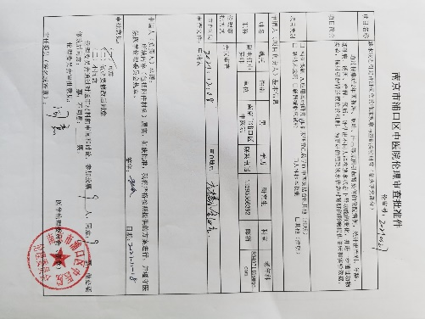
General information on laboratory animals

1、Weight of mice at week 16 (g)

Number | BC | BC+WD | DM | DM+WD | FXR^{-/-}+BC | FXR^{-/-}+DM | FXR^{-/-}+DM+WD
1 | 45.7 | 44.5 | 29.9 | 28.1 | 38.2 | 25.1 | 31.1
2 | 50.6 | 43.2 | 29.5 | 27 | 36.9 | 26.3 | 30.2
3 | 48.1 | 37.8 | 27.8 | 24.4 | 43.7 | 28 | 30.5
4 | 49.2 | 42.1 | 29.5 | 26.2 | 36.9 | 28.2 | 33
5 | 48.7 | 43.5 | 27.2 | 28.3 | 46.9 | 34.9 | 30.1

2、Water intake of mice at week 16 (ml/24 hours)( Normal drinking days record)
Number | BC | BC+WD | DM | DM+WD | FXR^{-/-}+BC | FXR^{-/-}+DM | FXR^{-/-}+DM+WD
1 | 4.2 | 8 | 15 | 18 | 3 | 8 | 7.5
2 | 7 | 7 | 15 | 12.5 | 3 | 10 | 6.3
3 | 5 | 5 | 13.3 | 18 | 4 | 10 | 10
4 | 5 | 7.5 | 10 | 18.5 | 3.5 | 9.5 | 9
5 | 6 | 6.5 | 16.7 | 15 | 4 | 9 | 8.5
3、Urine volume of mice at week 16 (ml/24 hours) ( Normal drinking days record)
Number | BC | BC+WD | DM | DM+WD | FXR^{-/-}+BC | FXR^{-/-}+DM | FXR^{-/-}+DM+WD
1 | 1.4 | 0.4 | 3.8 | 6 | 0.1 | 5 | 3.6
2 | 1.6 | 0.2 | 3 | 7 | 0.4 | 4 | 0.8
3 | 1.8 | 0.3 | 2 | 7 | 1.5 | 3.2 | 4.5
4 | 1.5 | 1.5 | 6 | 5.1 | 1.6 | 4.5 | 2.7
5 | 0.6 | 0.3 | 4.4 | 10.5 | 1.3 | 4.3 | 4
4、At week 16, 24-hour urine protein was quantified(mg/24h)
Number | BC | BC+WD | DM | DM+WD | FXR^{-/-}+BC | FXR^{-/-}+DM | FXR^{-/-}+DM+WD
1 | 2.3 | 0.363 | 5.6 | 5.1 | 1.5 | 5.33 | 4.5
2 | 2.5 | 2 | 4.03 | 8.49 | 1.6 | 5.4 | 6.4
3 | 3.03 | 1.534 | 2.8 | 9.2 | 1.9 | 3.3 | 4
4 | 1.9 | 2.153 | 5.3 | 7 | 2 | 5.5 | 5.1
5 | 2.8 | 1.947 | 2.5 | 10.5 | 1.8 | 4.92 | 5.4
number | BC | BC+WD | DM | DM+WD | FXR^{-/-}+BC | FXR^{-/-}+DM | FXR^{-/-}+DM+WD
1 | 5.4 | 5.5 | 22.3 | 26.1 | 5.5 | 22.3 | 21.9
2 | 6.2 | 7.3 | 15.4 | 22.2 | 7.3 | 20.2 | 16.1
3 | 8.9 | 7.7 | 18.3 | 26.4 | 5.3 | 21.9 | 17.2
4 | 9.3 | 7 | 17 | 18.9 | 7.1 | 23.8 | 19
5 | 7.4 | 6.2 | 26.4 | 19.7 | 8.7 | 13.8 | 21.1
5、Fasting blood glucose after 16 weeks(mmol/L)
6、Creatinine after 16 weeks (umol/L)
Number | BC | BC+WD | DM | DM+WD | FXR^{-/-}+BC | FXR^{-/-}+DM | FXR^{-/-}+DM+WD
1 | 15.6 | 14.8 | 11.9 | 20 | 16 | 25.6 | 17.4
2 | 12.6 | 16.3 | 14.8 | 18.9 | 13.7 | 19.7 | 16.4
3 | 12.6 | 20 | 17.8 | 23 | 16.4 | 18.5 | 14.8
4 | 14.5 | 14.5 | 13 | 62(outlier) | 16.4 | 17.8 | 13.4
5 | 16 | 15.2 | 13 | 22.7 | 16.1 | 19.2 | 16.8
7、Urea nitrogen after 16 weeks(mmol/L)
Number | BC | BC+WD | DM | DM+WD | FXR^{-/-}+BC | FXR^{-/-}+DM | FXR^{-/-}+DM+WD
1 | 7.5 | 5.82 | 10.79 | 15.22 | 5.11 | 8.33 | 7.24
2 | 6.12 | 7.1 | 7.09 | 7.7 | 4.37 | 5.84 | 6.78
3 | 5.78 | 7.66 | 8.7 | 10.24 | 3.36 | 6.75 | 7.7
4 | 4.93 | 6.83 | 8.58 | 14.24 | 5 | 9.4 | 7.04
5 | 6.03 | 10.34 | 8.39 | 12.6 | 4.56 | 7.94 | 7.82
8、After 16 weeks uric acid(mmol/L)
Number | BC | BC+WD | DM | DM+WD | FXR^{-/-}+BC | FXR^{-/-}+DM | FXR^{-/-}+DM+WD
1 | 114 | 113 | 147 | 150 | 168 | 104 | 133
2 | 115 | 147 | 157 | 140 | 142 | 185 | 162
3 | 121 | 156 | 187 | 158 | 106 | 92.5 | 126
4 | 127 | 201 | 174 | 210 | 130 | 118 | 106
5 | 159 | 201 | 175 | 169 | 153 | 80 | 208
9、fasting blood glucose levels at 4-week intervals (mmol/L)
weeks | BC |  |  |  |  | BC+WD |  |  |  |  | DM |  |  |  |  | DM+WD
1 | 4.7 | 5.2 | 5.7 | 6.1 | 6.4 | 5.8 | 4.8 | 5 | 5.7 | 5.8 | 5.6 | 6.2 | 4.4 | 6.9 | 4.7 | 4.7 | 6.8 | 5.3 | 5.7 | 6.2
4 | 5.1 | 5.4 | 6 | 7 | 6.8 | 6 | 5.1 | 5.7 | 6.2 | 6.1 | 24.8 | 17.8 | 17 | 21.6 | 24.8 | 24.4 | 25.8 | 32.2 | 24.1 | 16.9
8 | 6.2 | 5.9 | 7.4 | 7.5 | 7.8 | 6.4 | 6.3 | 7.4 | 6.8 | 6 | 26.1 | 17.6 | 16.5 | 21.9 | 20.5 | 27.6 | 23.9 | 23.2 | 20.5 | 19.6
12 | 7.7 | 6.2 | 7.9 | 8.3 | 8.4 | 7.1 | 7.3 | 7.7 | 7 | 6.2 | 22.3 | 15.4 | 18.3 | 24.8 | 26.4 | 26.1 | 22.2 | 26.4 | 18.9 | 18.7
16 | 7.5 | 6.7 | 7.8 | 8.1 | 7.4 | 6.9 | 7.4 | 7.3 | 6.7 | 7.2 | 21.9 | 18.1 | 17.7 | 20.6 | 24.9 | 20.6 | 21.4 | 22.7 | 20.9 | 19.1

FXR^{-/-}+BC |  |  |  |  | FXR^{-/-}+DM |  |  |  |  | FXR^{-/-}+DM+WD
5.1 | 7.8 | 7.3 | 7.9 | 6.8 | 6.3 | 7.2 | 8.5 | 8.3 | 7.6 | 7.3 | 6.1 | 7.6 | 6.9 | 6.2
5.4 | 8.1 | 7.1 | 7.6 | 6.6 | 14.8 | 16.7 | 17.1 | 19.2 | 15.4 | 12.7 | 8.1 | 9.6 | 9.6 | 11.2
6.5 | 8.5 | 7.3 | 7.9 | 7.1 | 10 | 13.6 | 12.3 | 16.3 | 14.9 | 10.7 | 11.2 | 9.9 | 9.3 | 9.2
5.3 | 9.6 | 7.5 | 8.1 | 7.4 | 12.375 | 15.48 | 13.5 | 13.7 | 12.3 | 9.4 | 12.5 | 13.4 | 11.7 | 10.3
6.2 | 7.4 | 6.8 | 7.3 | 6.9 | 9.3 | 13.8 | 12.2 | 11.8 | 10.8 | 10.4 | 13.2 | 11.5 | 10.4 | 9.4

Laboratory animal pathology
1、HE、PAS staining
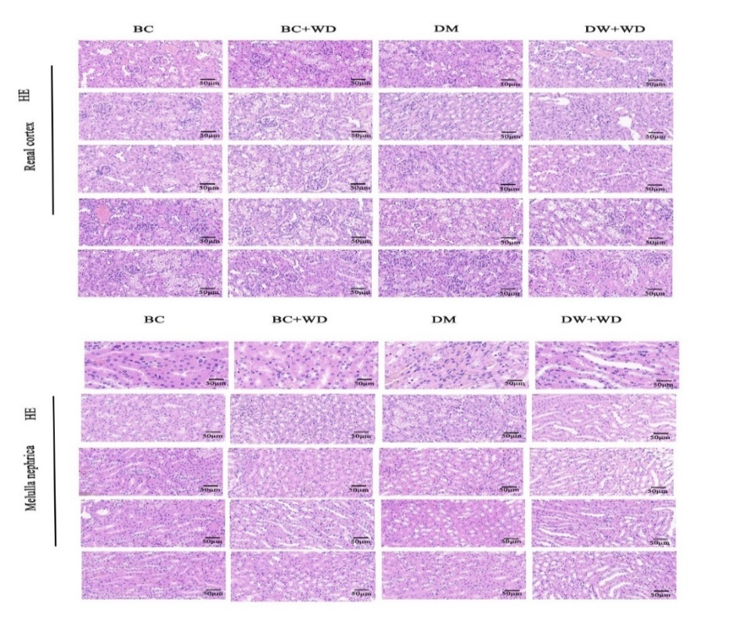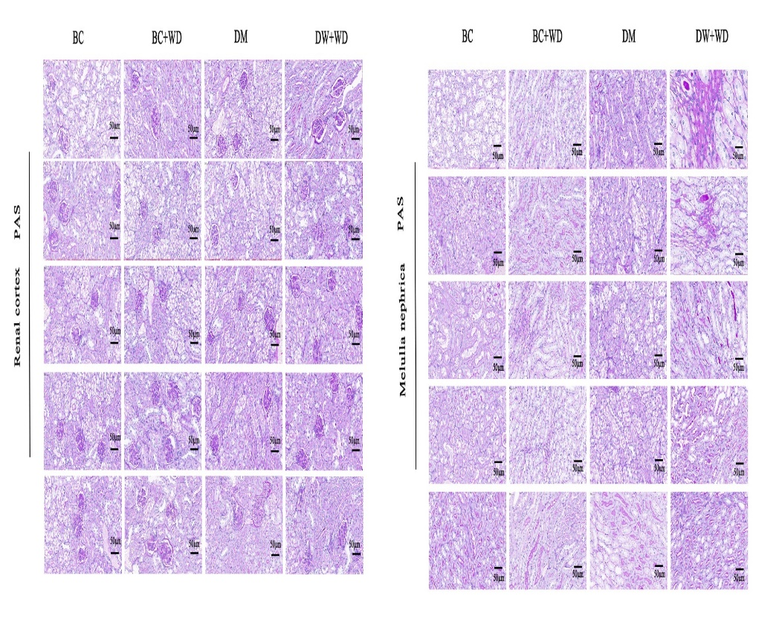

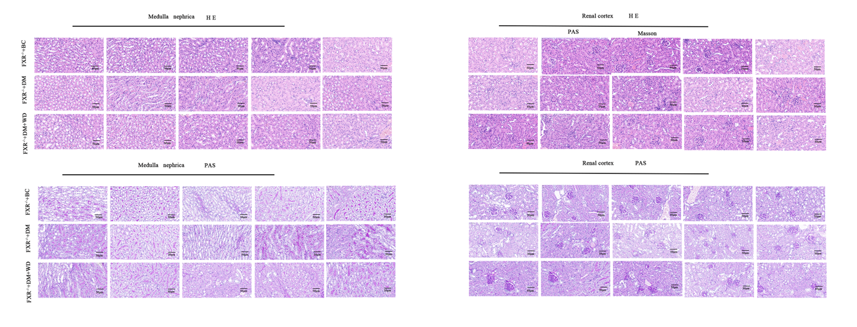

2、Masson 染色
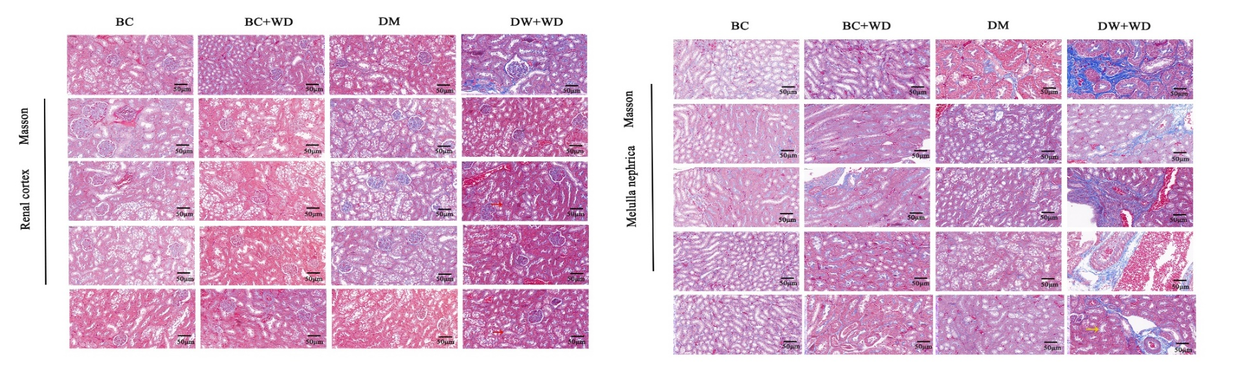

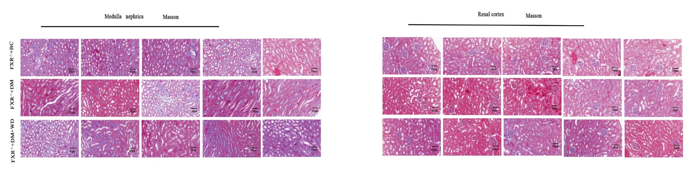

Renal cortex integral

BC | BC+WD | DM | DM+WD | FXR^{-/-}+BC | FXR^{-/-}+DM | FXR^{-/-}+DM+WD
4.9 | 5.6 | 7.2 | 7.5 | 5.2 | 8.5 | 7.7
5.3 | 6.2 | 8.1 | 9.3 | 7.3 | 7.8 | 8.8
5.7 | 5.9 | 6.3 | 7.6 | 6.9 | 8.2 | 8.3
5 | 7 | 7.8 | 8.4 | 6.1 | 6.4 | 7.9
4.8 | 6 | 6.2 | 7.9 | 6.3 | 8.7 | 6.1

Renal nephrica integral

BC | BC+WD | DM | DM+WD | FXR^{-/-}+BC | FXR^{-/-}+DM | FXR^{-/-}+DM+WD
5.1 | 5.7 | 7.2 | 10 | 7.9 | 6.2 | 9.2
6.3 | 6.1 | 8.1 | 10.1 | 5.3 | 8.8 | 7.2
5.2 | 5.7 | 7.5 | 11.4 | 5.7 | 7.2 | 8.5
6.2 | 7.4 | 6.3 | 12.5 | 5 | 9.1 | 7.6
4.5 | 6.3 | 8 | 11.9 | 6.8 | 8.4 | 9.4

Immunofluorescence related data
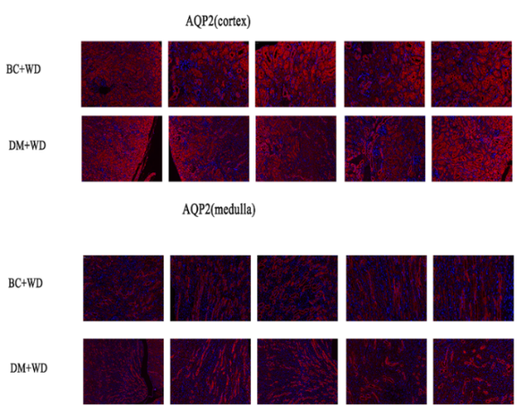

AQP2
BC | BC+WD | DM | DM+WD | FXR^{-/-}+BC | FXR^{-/-}+DM | FXR^{-/-}+DM+WD
14.5 | 35.3 | 26.2 | 30.6 | 5.3 | 6.9 | 5.6
10.6 | 26.2 | 16.5 | 41.3 | 5.9 | 5.2 | 4.7
15.1 | 35.8 | 26.5 | 51.6 | 4.5 | 6.2 | 5.6
15.5 | 37.3 | 26.8 | 41.4 | 4.8 | 4.2 | 6.1
14.3 | 36 | 27.4 | 40.9 | 6.7 | 5.5 | 5.9

Gp91
BC | BC+WD | DM | DM+WD | FXR^{-/-}+BC | FXR^{-/-}+DM | FXR^{-/-}+DM+WD
3.2 | 16.6 | 7 | 22.2 | 11.9 | 14.2 | 15.2
4.1 | 17.2 | 8.9 | 23.3 | 12.3 | 10.8 | 16.2
5.4 | 15.9 | 6.4 | 27.8 | 13.7 | 15.2 | 15.5
5.2 | 16.3 | 6.9 | 24.5 | 11.2 | 12.1 | 19.3
4.5 | 17.2 | 9.3 | 18.9 | 14.8 | 15.9 | 14.4

FXR
BC | BC+WD | DM | DM+WD | FXR^{-/-}+BC | FXR^{-/-}+DM | FXR^{-/-}+DM+WD
6.2 | 19.6 | 11.8 | 25.3 | 3.3 | 4.3 | 3.8
7.1 | 20.2 | 8.3 | 26.1 | 5.4 | 2.8 | 2.7
8.4 | 15.2 | 10.4 | 30.1 | 3.5 | 4.2 | 2.6
9.1 | 17.3 | 9.9 | 28.5 | 4.3 | 5.1 | 3.1
7.9 | 19.3 | 10.1 | 29.9 | 4.7 | 3.5 | 4.6

TonEBP
BC | BC+WD | DM | DM+WD | FXR^{-/-}+BC | FXR^{-/-}+DM | FXR^{-/-}+DM+WD
4.2 | 11.6 | 7.8 | 15.3 | 3.3 | 6.3 | 10.8
5.1 | 10.2 | 8.3 | 16.1 | 5.4 | 8.2 | 9.7
6.4 | 13.2 | 7.4 | 20.1 | 3.5 | 8.2 | 13.6
7.1 | 9.3 | 9.9 | 18.5 | 4.3 | 9.8 | 8.1
5.9 | 15.3 | 6.1 | 19.9 | 4.7 | 7.5 | 10.6

Western blot

WB statistical process

ToneEBP
BC | BC+WD | DM | DM+WD |  | FXR^{-/-}+BC | FXR^{-/-}+DM | FXR^{-/-}+DM+WD
1 | 2.2 | 1.4 | 5.1 |  | 1 | 2.15 | 3.29
1 | 1.4 | 1.4 | 2.8 |  | 1 | 1.27 | 1.63
1 | 1.7 | 1.2 | 3.7 |  | 1 | 0.83 | 2

Gp91
BC | BC+WD | DM | DM+WD |  | FXR^{-/-}+BC | FXR^{-/-}+DM | FXR^{-/-}+DM+WD
1 | 1.6 | 2.1 | 3.1 |  | 1 | 2 | 3.5
1 | 1.8 | 0.5 | 2.8 |  | 1 | 1.15 | 2
1 | 1.5 | 1.3 | 2.7 |  | 1 | 1.6 | 2.5

SOD1
BC | BC+WD | DM | DM+WD
1 | 1.2 | 2.5 | 3.6
1 | 1.3 | 2.5 | 3.4
1 | 1.4 | 3.3 | 2.3

UT2
BC | BC+WD | DM | DM+WD |  | FXR^{-/-}+BC | FXR^{-/-}+DM | FXR^{-/-}+DM+WD
1 | 1.4 | 1.5 | 1.4 |  | 1 | 1.13 | 2.6
1 | 1.2 | 1 | 1.9 |  | 1 | 1.07 | 2.6
1 | 1.2 | 1.6 | 1.7 |  | 1 | 0.85 | 1.54

AQP2
BC | BC+WD | DM | DM+WD |  | FXR^{-/-}+BC | FXR^{-/-}+DM | FXR^{-/-}+DM+WD
1 | 1.5 | 1.4 | 2.7 |  | 1 | 0.77 | 0.68
1 | 1.8 | 2.2 | 2.4 |  | 1 | 0.7 | 1.1
1 | 1.6 | 2.2 | 3.3 |  | 1 | 1.7 | 2.1

FXR
BC | BC+WD | DM | DM+WD |  | FXR^{-/-}+BC | FXR^{-/-}+DM | FXR^{-/-}+DM+WD
1 | 1.1 | 1.2 | 2.1 |  | 1 | 0.78 | 0.83
1 | 1.6 | 1.5 | 2.4 |  | 1 | 1 | 1.06
1 | 1.5 | 2.1 | 3.2 |  | 1 | 1.05 | 0.57

