Supplementary information

Additional file 1: Table S1. Codes used in the UK Biobank study to identify type 2 diabetes and dementia.
Additional file 2: Table S2. Low-risk lifestyle factors definitions.
Additional file 3: Table S3. The association of lifestyle score with all-cause and cause-specific dementia among individuals with or without type 2 diabetes.
Additional file 4: Table S4. Association of weighted lifestyle score with all-cause and cause-specific dementia among individuals with or without type 2 diabetes.
Additional file 5: Figure S1. Flowchart of participants included in the analysis.
Additional file 6: Figure S2. The HR (95% CI) between healthy lifestyle score and (A) all-cause dementia, (B) cause-specific dementia of AD, VD, and NAVD in people aged over 60 years at baseline.

Table S1. Codes used in the UK Biobank study to identify T2DM and dementia
 | Field IDs | ICD-9 | ICD-10
T2DM
Type 2 diabetes |  | 250 | E11
Age at onset of T2DM | 2976 (Age diabetes diagnosed)  130708 (Date E11 first reported (non-insulin-dependent diabetes mellitus))
Insulin use | 6153 (Medication for cholesterol, blood pressure, diabetes, or take exogenous hormones in female)  6177 (Medication for cholesterol, blood pressure or diabetes in male)
Dementia
All-cause dementia |  | 290.1 | F00, F01, F02, F03, G30, G310, G311, G318
Alzheimer's disease |  | 290.1 | F00, G30
Vascular dementia |  |  | F01
Non-Alzheimer non-vascular dementia |  |  | F02, F03, G310, G311, G318
Age at onset of dementia | 130836 (Date F00 first reported (Alzheimer's disease))  130838 (Date F01 first reported (Vascular dementia)) 130840 (Date F02 first reported (Other diseases classified elsewhere))  42018 (Date of all cause dementia report)  42020 (Date of Alzheimer’s disease report)  42024 (Date of frontotemporal dementia report)

Table S2. Low-risk lifestyle factors definitions
Lifestyle factor | Low-risk lifestyle factors definitions |  |  |  |  | Field IDs
Smoking status | Never smoker |  |  |  |  | 20116
Physical activity | ≥150 minutes moderate activity per week OR ≥ 75 minutes vigorous activity per week OR equivalent combination |  |  |  |  | 884, 894, 904, 914
Social connection | At least 1 of the following 3 conditions:  1. Participation in social activities at least once a week  2. Friends and family visit at least once a month 3. Not living alone |  |  |  |  | 6160, 709, 1031
Alcohol consumption | Moderate alcohol consumption defined as no more than 14 g ethanol on a relatively regular frequency |  |  |  |  | 1568, 1578, 1588, 1598, 1608, 4407, 4418, 4429,4440, 4451, 4462, 5364
Sedentary time | In a typical day, spend less than 4 hours watching TV |  |  |  |  | 1070
Sleep duration | Get 6-9 hours' sleep in every 24 hours |  |  |  |  | 1160
Diet | At least 6 of the following 10 food groups:  1. Fruits: ≥ 3 servings/day  2. Vegetables: ≥ 3 servings/day  3. Whole grains: ≥ 3 servings/day  4. (Shell) Fish: ≥2 servings/week  5. Diary: ≥2 servings/week  6. Vegetable oils ≥2 servings/day  7. Refined grains ≤2 servings/day  8. Processed meats ≤1 serving/week  9. Unprocessed meats ≤2 serving/week  10. Sugar-sweetened beverages: Don’t drink |  |  |  |  | 1289, 1299,1309, 1319, 1329, 1339,1349, 1359, 1408, 1418, 1428, 1438, 1448, 1458, 1468, 2654, 3680, 6144
Table S3. The association of lifestyle score with all-cause and cause-specific dementia among individuals with or without T2DM *
 |  | Adjusted HR (95% CI) *
 |  | All-cause dementia | Alzheimer's disease | Vascular Dementia | Non-Alzheimer non-vascular dementia
Lifestyle score
No T2DM + 0-1 |  | 1.54 (1.30, 1.82) | 1.14 (0.86, 1.51) | 1.63 (1.14, 2.34) | 1.76 (1.44, 2.16)
No T2DM + 2-3 |  | 1.30 (1.21, 1.40) | 1.09 (0.97, 1.21) | 1.32 (1.11, 1.56) | 1.36 (1.24, 1.49)
No T2DM + 4 |  | 1.11 (1.03, 1.20) | 1.00 (0.90, 1.12) | 1.18 (0.99, 1.40) | 1.16 (1.05, 1.27)
No T2DM + 5-7 |  | 1 | 1 | 1 | 1
T2DM + 0-1 |  | 3.14 (2.34, 4.21) | 1.92 (1.12, 3.31) | 4.05 (2.53, 6.50) | 3.62 (2.56, 5.12)
T2DM + 2-3 |  | 2.31 (1.98, 2.68) | 1.76 (1.39, 2.24) | 2.99 (2.28, 3.92) | 2.27 (1.88, 2.74)
T2DM + 4 |  | 2.36 (1.99, 2.79) | 1.91 (1.46, 2.49) | 2.47 (1.78, 3.43) | 2.29 (1.85, 2.84)
T2DM + 5-7 |  | 2.20 (1.84, 2.65) | 1.91 (1.44, 2.53) | 2.33 (1.62, 3.35) | 2.24 (1.78, 2.82)
Every 2 points
No T2DM |  | 0.82 (0.78, 0.86) | 0.93 (0.86, 0.99) | 0.83 (0.74, 0.92) | 0.77 (0.73, 0.82)
T2DM |  | 0.85 (0.76, 0.97) | 0.95 (0.77, 1.16) | 0.75 (0.61, 0.93) | 0.78 (0.67, 0.91)
* All HRs were adjusted for age at last follow up, sex, race/ethnicity, educational years, income level, body mass index (BMI), HbA1c level, hypertension status, depressive status, CVD status and APOE4 allele status.

Table S4. Association of weighted lifestyle score with all-cause and cause-specific dementia among individuals with or without T2DM *
Weighted Lifestyle Score Category † | Adjusted HR (95% CI) *
Weighted Lifestyle Score Category † | All-cause dementia | Alzheimer's disease | Vascular Dementia | Non-Alzheimer non-vascular dementia
No T2DM + 1 | 1.47 (1.35, 1.61) | 1.23 (1.09, 1.38) | 1.38 (1.13, 1.69) | 1.63 (1.46, 1.81)
No T2DM + 2 | 1.25 (1.14, 1.36) | 1.10 (0.97, 1.25) | 1.24 (1.01, 1.54) | 1.28 (1.15, 1.43)
No T2DM + 3 | 1.11 (1.01, 1.22) | 1.09 (0.95, 1.24) | 1.00 (0.79, 1.25) | 1.17 (1.04, 1.33)
No T2DM + 4 | 1 | 1 | 1 | 1
T2DM + 1 | 2.67 (2.29, 3.11) | 2.29 (1.82, 2.89) | 3.09 (2.32, 4.13) | 2.94 (2.44, 3.55)
T2DM + 2 | 2.47 (2.06, 2.97) | 2.01 (1.48, 2.73) | 3.07 (2.15, 4.39) | 2.56 (2.01, 3.27)
T2DM + 3 | 2.66 (2.14, 3.29) | 2.36 (1.64, 3.38) | 2.25 (1.47, 3.45) | 2.75 (2.06, 3.66)
T2DM + 4 | 2.07 (1.60, 2.69) | 1.89 (1.32, 2.71) | 2.20 (1.34, 3.61) | 2.59 (1.95, 3.45)
Every 2 points
No T2DM | 0.83 (0.79, 0.86) | 0.91 (0.86, 0.98) | 0.89 (0.84, 0.93) | 0.77 (0.73, 0.82)
T2DM | 0.86 (0.78, 0.95) | 0.91 (0.77, 1.08) | 0.86 (0.78, 0.95) | 0.79 (0.69, 0.90)
* All HRs were adjusted for age at last follow up, sex, race/ethnicity, educational years, income level, body mass index (BMI), HbA1c level, hypertension status, depressive status, CVD status and APOE4 allele status. †A weighted lifestyle score was derived based on β coefficients of each lifestyle factor in the Cox proportional hazards regression model with all 7 lifestyle factors and adjustment for age at last follow up, race/ethnicity, educational years, income level, body mass index (BMI), hypertension status, depressive status, CVD status and APOE4 allele status. The binary lifestyle variables were multiplied by the β coefficients, summed, divided by the sum of the β coefficients, and multiplied by 7. We then categorized it into four groups based on the distribution of the simple additive lifestyle score: 1, 2, 3 and 4.

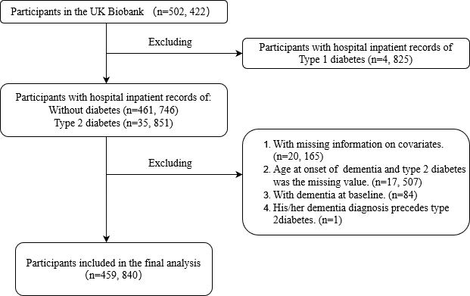
Figure S1. Flowchart of participants included in the analysis

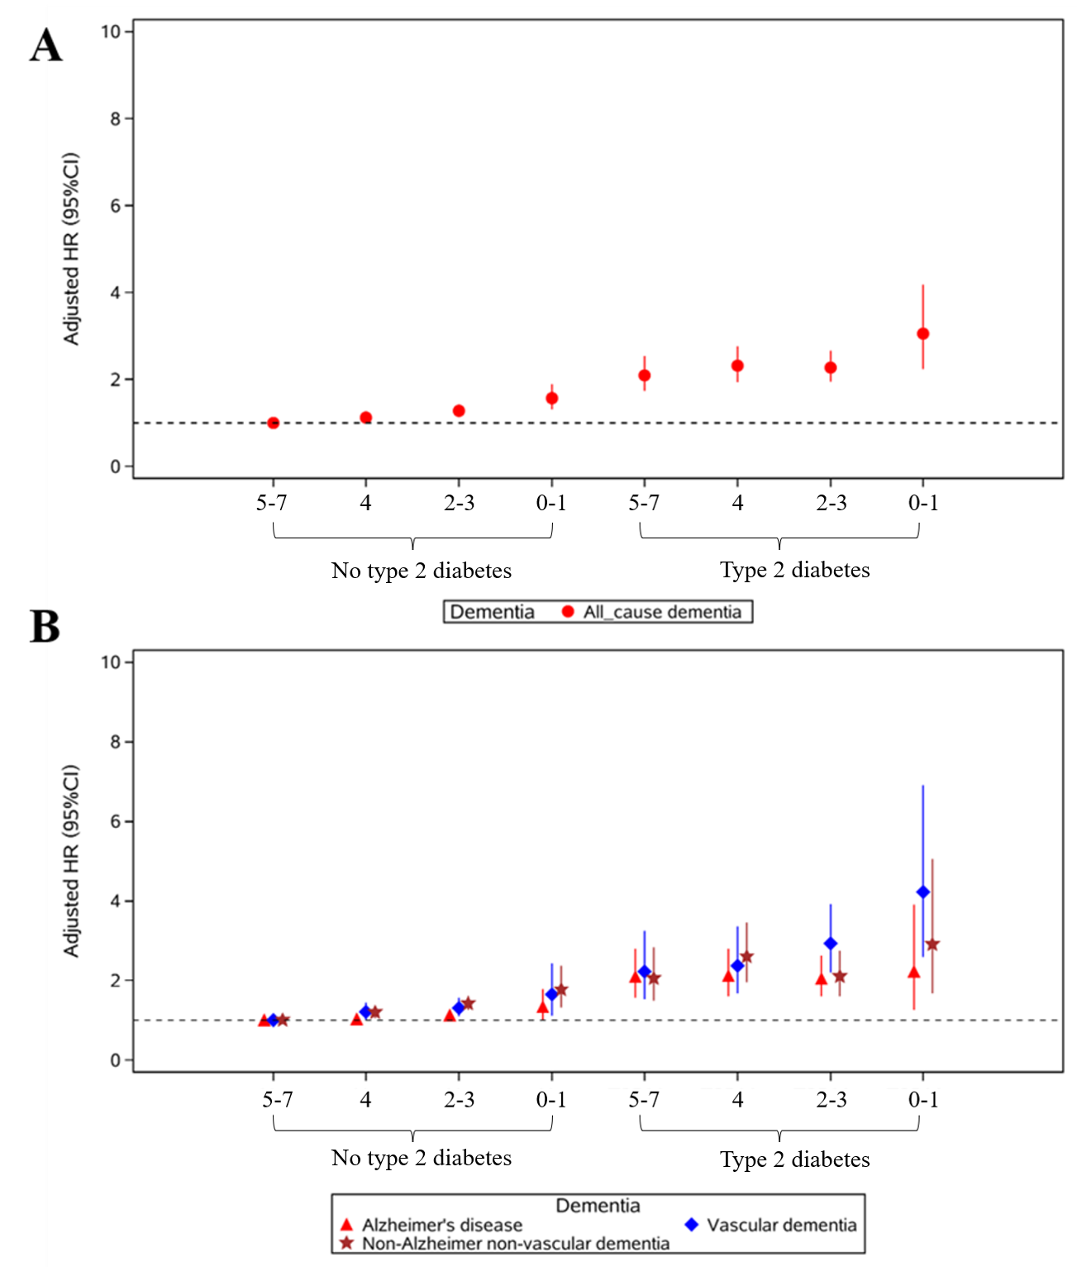
Figure S2. The HR (95% CI) between healthy lifestyle score and (A) all-cause dementia, (B) cause-specific dementia of AD, VD, and NAVD in people aged over 60 years at baseline. All HRs were adjusted for age at last follow up, sex, race/ethnicity, educational years, income level, body mass index (BMI), HbA1c level, hypertension status, depressive status, CVD status and APOE4 allele status.

