Supplemental Figures
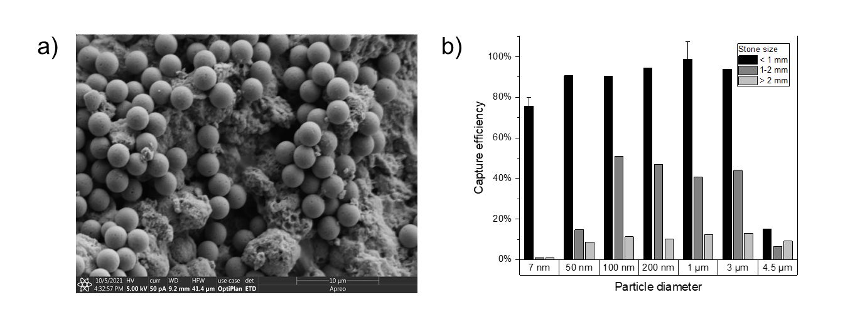
Figure S1. a) SEM image of 100% CaP stone coated with 3 micron diameter superparamagnetic iron oxide beads. b) Capture efficiency of SPIONs and larger superparamagnetic iron oxide beads for 100% CaP stones of different sizes.

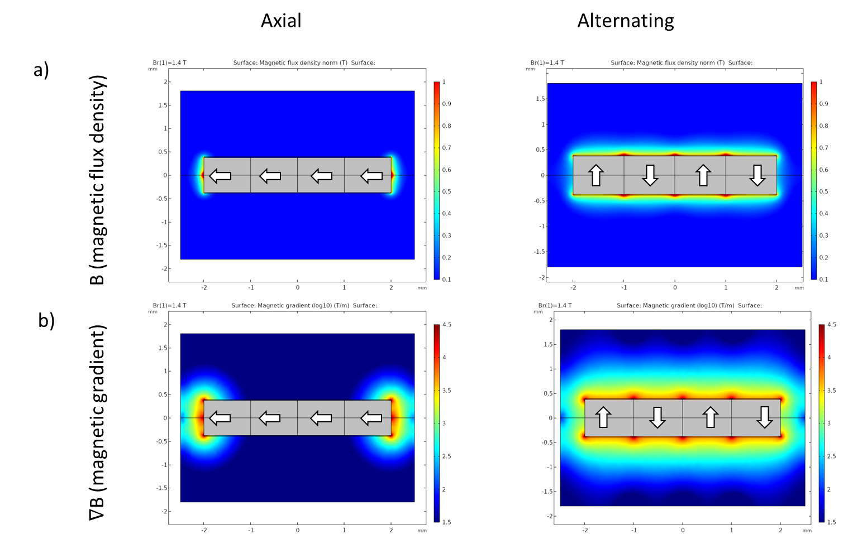
Figure S2. a) Simulated magnetic flux density (T) of magnets with unidirectional axial polarities (left) versus alternating diametric polarities (right). b) Simulated magnetic gradients (T/m) of magnets with unidirectional axial polarities (left) versus alternating diametric polarities (right). White arrows point to the north pole of the magnet.
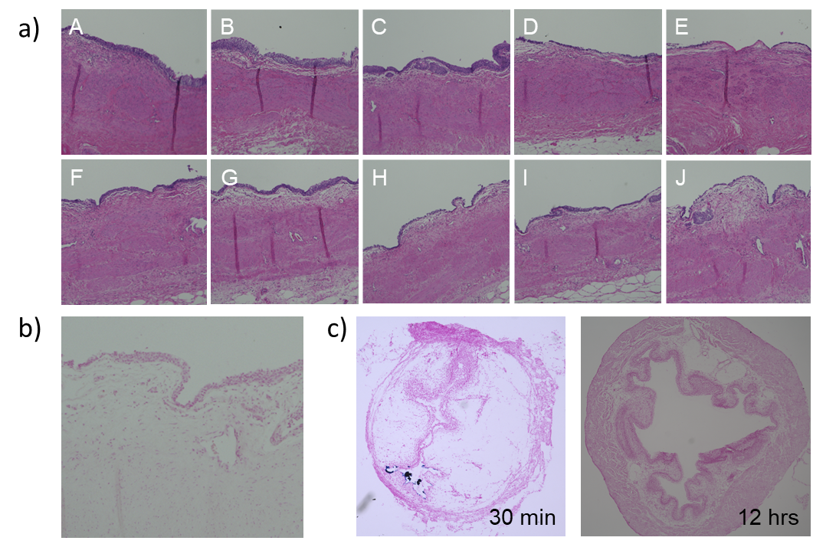
Figure S3. a) Lower magnification images of hematoxylin & eosin-stained human urothelium (Figure 4) incubated with hydrogel components ex vivo. Compared to normal urothelium (A), urothelium exposed to (B) 0.05% w/v chitosan for 1 minute or (C) 0.5% w/v chitosan for 1 minute did not show reductions in urothelial thickness. Urothelium exposed for longer durations to (D) 0.05% w/v chitosan for 30 minutes or (E) 0.5% w/v chitosan for 30 minutes showed significant exfoliation of the urothelial cell layers. Compared to normal urothelium (F), urothelium exposed to (G) 0.1x CF hydrogel or (H) 1x CF hydrogel for 1 minute showed minimal changes in urothelial thickness. Urothelium exposed to (I) 0.1x CF hydrogel or (J) 1x CF hydrogel for 30 minutes showed loss of superficial cell layers, though to a lower extent compared to urothelium exposed to the same time and concentration of chitosan. b) Prussian blue-stained human urothelium exposed to 1x CF hydrogel for 30 minutes ex vivo. No residual iron-containing CF hydrogel (dark blue) is seen. c) Prussian blue-stained murine bladder exposed to 1x CF hydrogel for 15 minutes. The mouse was allowed to void and was sacrificed at 30 minutes or 12 hours post exposure. A small amount of iron-containing CF hydrogel is present within the lumen of the bladder at 30 minutes, but no hydrogel remains at 12 hours.

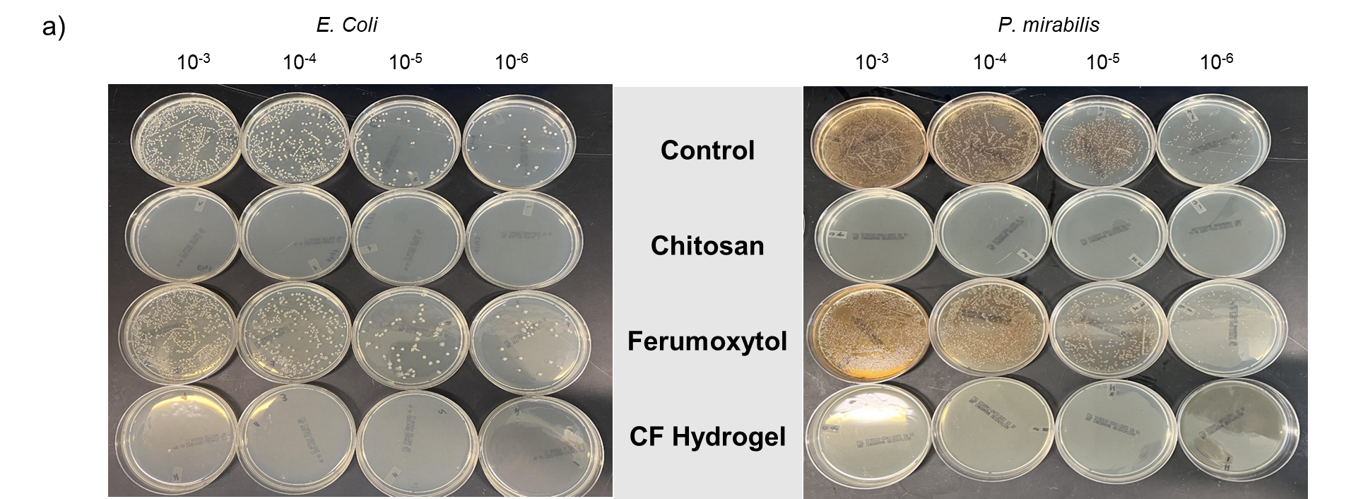
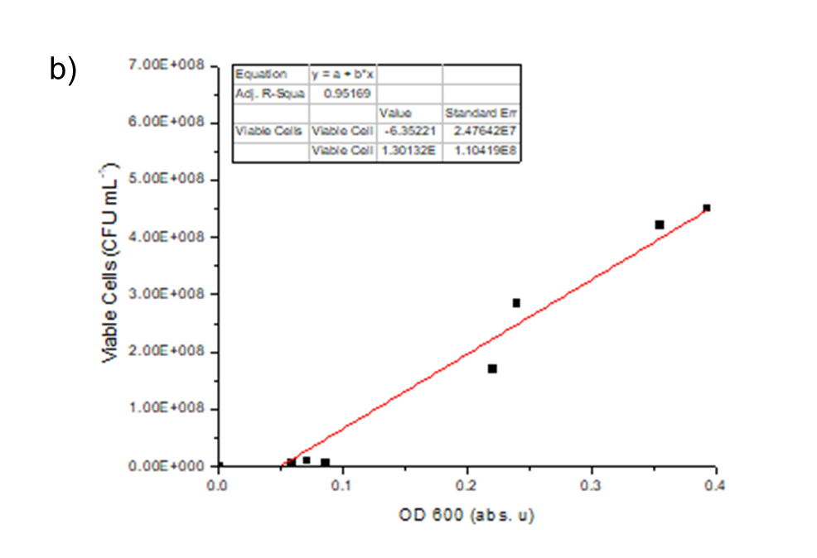
Figure S4. a) E. coli and P. mirabilis agar plates with 10-fold serial dilutions (10⁻³ to 10⁻⁶) from each culture condition after 240 minutes of incubation. The plain control and ferumoxytol cultures grew to 10⁸ CFU/mL while the chitosan and CF hydrogel inhibited bacterial growth. b) Linear relationship between OD600 and the number of viable cells (CFU/mL).
Figure S5. Excess CF hydrogel is rapidly cleared from solution by the magnetic wire. While ferumoxytol alone is not magnetically separated as the magnetophoretic motion of a small (7 nm) particle is outweighed by Brownian motion and drag, CF hydrogel forms larger aggregates of ferumoxytol particles which are quickly captured by the magnet. > 90% of CF hydrogel is cleared within the first ten seconds of exposure to the magnet, and ~99% is cleared by 1 minute of exposure.

Supplemental Methods
Magnetic retrieval of kidney stone fragments with larger superparamagnetic nanoparticles and beads. Stone fragments were hydrated by mixing with 50 µL of normal saline. The excess fluid was removed. 25 µL of iron oxide nanoparticles (7 nm: ferumoxytol (30 mg iron/mL) (AMAG Pharmaceuticals, Waltham, MA); 50-100 nm: SuperMag Carboxyl Beads (10 mg/mL) (Ocean NanoTech, San Diego, CA)) or beads (1 µm: DynaBeads MyOne Carboxylic Acid (10 mg/mL) (Thermo Fisher Scientific, Waltham, MA); 3-4.5 µm MonoMag Carboxyl Beads (30 mg/mL) (Ocean NanoTech, San Diego, CA)) at their stock solution was pipetted on top of the stones. The stones were then incubated at 37 °C for 3 minutes. 450 µL of normal saline was added to the solution. The magnetic wire was then inserted into the solution and withdrawn. Any stone fragments which remained attached to the magnetic wire were removed and allowed to air dry for 24 hours. The dried fragments were weighed, and the capture efficiency was determined as the dry weight of the captured fragments divided by the starting stone dry weight.
Hydrogel clearance. 25 uL of 30 mg/mL ferumoxytol, with or without 50 uL of 0.5% w/v chitosan, was mixed in 500 uL total volume of 0.9% saline in a 1.5 mL Eppendorf tube (final ferumoxytol concentration 1.5 mg/mL). A 2 cm length of magnetic wire was placed into the tube for the given cumulative time without further agitation or mixing. At each time interval, the wire was removed and wiped clean. The mixture was vortexed and the A475nm (corresponding to the absorbance peak of ferumoxytol) of the solution was measured using a Nanodrop 2000. Measurements were taken in triplicate. A calibration curve of A475 versus concentration was created for ferumoxytol to determine the percentage of ferumoxytol remaining in solution.
Blood clearance. Human blood (15 g/dL hemoglobin) was diluted 50 fold in 0.9% saline to represent a typical concentration of blood which would begin to obscure vision during ureteroscopy. 25 uL of 30 mg/mL ferumoxytol, with or without 50 uL of 0.5% w/v chitosan, was mixed with the diluted blood in 500 uL total volume in a 1.5 mL Eppendorf tube. A 2 cm length of magnetic wire was placed into the tube for the given cumulative time without further agitation or mixing. At each time interval, the wire was removed and wiped clean. The mixture was vortexed and the A540nm of the solution (corresponding to the absorbance peak of hemoglobin) was measured using a Nanodrop 2000. Measurements were taken in triplicate. A calibration curve of A540 versus concentration was created for both blood and blood with ferumoxytol to determine the amount/percentage of hemoglobin remaining in solution.

Supplemental Notes – see attached PDF

