Changes in soil particulate and mineral-associated organic carbon contents under nitrogen addition

Peng Qi^{a,b}, Ji Chen^{c,d,e}, Xiaojiao Wang^{*f}, Renzhi Zhangª, Liqun Caiª, Yapeng Jiao^{g}, Zhiqiang Liª, Guojun Hanª

a. College of Resources and Environmental Sciences, Gansu Agricultural University, Lanzhou 730070, China
b. Gansu Provincial Key Laboratory of Arid Land Crop Science, Gansu Agricultural University, Lanzhou 730070, China
c. Department of Agroecology, Aarhus University, 8830 Tjele, Denmark
d. Aarhus University Centre for Circular Bioeconomy, Aarhus University, 8830 Tjele, Denmark
e. iCLIMATE Interdisciplinary Centre for Climate Change, Aarhus University, 4000 Roskilde, Denmark
f. College of Management, Gansu Agricultural University, Lanzhou 730070, China
g. College of Natural Resources and Environment Northwest A&F University, Yangling 712100, China
*Corresponding author: Xiaojiao Wang, Email: gsauxiaojiao@163.com, Tel: +86–13893281460

Supplementary information

Table S1 The retrieval terms used for identifying impacts of N addition on SOC physical fractions until December 31, 2021
Type | Search term
Soil organic carbon  physical fractions | TS = (nitrogen OR mineral OR inorganic OR organic OR manure) AND (fertiliz* OR deposition OR addition OR enrichment OR elevated) AND soil AND (physical fraction* OR particulate organic carbon OR POC OR free particulate organic carbon OR FPOC OR mineral-associated organic carbon OR MAOC OR MOC OR occluded particulate organic carbon OR OPOC) AND china

Table S2 The summary information of 101 studies in the present meta-analysis.
References | sites | Fertilization measures |  | Soil classification
References | sites | inorganic | organic | Soil classification
Bai et al., 2020 | 36°10´N, 106°21´E |  |  | Aridisols
Cao et al., 2021 | 36°47´N, 113°01´E |  |  | Inceptisols
Cao et al., 2020 | 128°28´N, 42°24´E |  |  | Andisols
Chai et al., 2014 | 38°37´N, 102°4´E |  |  | Alfisols
Cheng et al., 2018 | 41°42´N, 127°38´E |  |  | Inceptisols
Chen et al., 2018 | 29°42´N, 103°14´E |  |  | Inceptisols
Chen et al., 2020 | 27°42´ N, 117°45´E |  |  | Alfisols
Chen et al., 2020 | 39°55´N, 115°20´E |  |  | Alfisols
Chen et al., 2012 | 23°20′N, 113°30′E |  |  | Ultisols
Chen et al., 2012 | 23°10′N, 112°10′E |  |  | Ultisols
Chen et al., 2021 | 35°58′N, 101°53′E |  |  | Inceptisols
Chen et al., 2010 | 42°57′N, 148°57′E |  |  | Mollisols
Fang et al., 2014 | 37°37′N, 101°19′E |  |  | Inceptisols
Geng et al., 2019 | 26°44´N,115°04´E |  |  | Inceptisols
Geng et al., 2020 | 26°44′N, 115°03′E |  |  | Ultisols
Gong et al., 2008 | 35°00′N, 114°24′E |  |  | Entisols
Guo et al., 2021 | 33°39´N, 112°07´E |  |  | Alfisols
Han et al., 2008 | 40°48´N, 123°33´E |  |  | Alfisols
He et al., 2020 | 34°16´N, 118°17´E |  |  | Entisols
He et al., 2015 | 43°30′N, 124°48′E  34°47′N, 113°40′E  26°45′N, 111°52′E |  |  | Vertisols  Inceptisols  Inceptisols
Huang et al., 2008 | 116°2´N, 28°15´E |  |  | Ultisols
Jiang et al., 2017 | 43°58′N, 87°25′E |  |  | Aridisols
Lan et al., 2017 | 35°28´N, 104°44´E |  |  | Inceptisols
Liang et al., 2014 | 41°31´N, 123°24´E |  |  | Aridisols
Li et al., 2012 | 47°26´N, 126°38´E |  |  | Vertisols
Li et al., 2018 | 35°11´N, 111°05´E |  |  | Entisols
Liu et al., 2013 | 35°16´N, 107°30´E |  |  | Inceptisols
Liu et al., 2018 | 36°51´N, 109°19´E |  |  | Inceptisols
Liu et al., 2010 | 43°57´N, 87°46´E |  |  | Aridisols
Li et al., 2009 | 43°30´N, 124°28´E |  |  | Vertisols
Li et al., 2019 | 35°01′N, 114°34′E |  |  | Inceptisols
Mao et al., 2015 | 30°5´N, 120°3´E |  |  | Alfisols
Tian et al., 2013 | 30°25′N, 104°36′E |  |  | Entisols
Tian et al., 2017 | 36°54′N, 120°42′E |  |  | Entisols
Tian et al., 2016 | 26°44′N, 115°03′E |  |  | Ultisols
Tong et al., 2008 | 26°45´N, 111°52´E  34°47´N, 113°40´E |  |  | Ultisols
Wang et al., 2021 | 33°59´N, 113°58´E |  |  | Vertisols
Wang et al., 2015 | 30°26´N, 120°25´E |  |  | Inceptisols
Wang et al., 2015 | 39°24´N, 111°24´E |  |  | Alfisols
Wang et al., 2020 | 35°28´N, 104°44´E |  |  | Inceptisols
Xie et al., 2014 | 43°30´N, 124°48´E |  |  | Ertisols
Xie et al., 2018 | 34°4′N, 108°2′E |  |  | Alfisols
Xie et al., 2019 | 34°17′N, 108°0´E |  |  | Alfisols
Xu et al., 2020 | 49°19´N, 119°56´E |  |  | Vertisols
Yang et al., 2012 | 34°17´N, 108°00´E |  |  | Aridisols
Ye et al., 2018 | 43°38´N, 116°42´E |  |  | Mollisols
Yuan et al., 2020 | 37◦36′ N, 101◦19′E |  |  | Inceptisols
Yuan et al., 2008 | 116°20´N, 28°15´E |  |  | Ultisols
Yu et al., 2020 | 23°09´N, 112°31´E |  |  | Oxisols
Zhang et al., 2012 | 28°37'N, 116°26'E |  |  | Ultisols
Zhang et al., 2019 | 35°28´N, 104°44´E |  |  | Inceptisols
Zhang et al., 2017 | 26°42'N, 115°4'E |  |  | Ultisols

Table S3 Results of total heterogeneity test for each variable
Variables | Effize value | Qt | P value | Df
RR-SOC | 0.1833 | 20059.24 | <0.0001 | 310
RR-POC | 0.3770 | 83223.62 | <0.0001 | 322
RR-MAOC | 0.1049 | 6315.72 | <0.0001 | 253
RR-AGB | 0.2295 | 700.72 | <0.0001 | 12
RR-BGB | 0.1802 | 84.61 | <0.0001 | 10
RR-SW | 0.0635 | 175.85 | <0.0001 | 16
RR-BD | -0.1679 | 114727.84 | <0.0001 | 25
RR-pH | -0.0369 | 6432.71 | <0.0001 | 84
RR-NH₄⁺-N | 0.4125 | 601.19 | <0.0001 | 35
RR-NO₃⁻-N | 0.8757 | 3888.16 | <0.0001 | 45
RR-C/N | 0.0067 | 366.18 | <0.0001 | 48
RR-MBC | 0.1860 | 5271.34 | <0.0001 | 93
RR-MBN | 0.0676 | 681.71 | <0.0001 | 28
RR-PLFA | 0.1983 | 369.18 | <0.0001 | 24
RR-fungi | 0.1075 | 372.08 | <0.0001 | 26
RR-bacteria | 0.1120 | 643.49 | <0.0001 | 32
RR-ACT | 0.1773 | 293.80 | <0.0001 | 20
RR-G⁺/G⁻ | 0.0952 | 101.57 | <0.0001 | 26
RR-AMF | -0.1546 | 132.18 | <0.0001 | 10
RR-IN | 0.4180 | 283.08 | <0.0001 | 21
RR-βG | 0.1404 | 331.39 | <0.0001 | 22
RR-NAG | 0.1487 | 255.19 | <0.0001 | 16
RR-LAP | 0.3326 | 306.33 | <0.0001 | 13
RR-PHO | -0.0241 | 30.16 | 0.025 | 17
RR-CAT | 0.0718 | 17182.45 | <0.0001 | 17
RR-UR | 0.5011 | 325.52 | <0.0001 | 21
RR represents effect size. SOC, soil organic carbon; POC, particulate organic carbon; MAOC, mineral-associated organic carbon; AGB, aboveground biomass; BGB, belowground biomass; SW, soil water; BD, soil bulk density; C/N, soil carbon to nitrogen ratio; MBC, soil microbial biomass carbon; MBN, soil microbial biomass nitrogen; PLFA, phospholipid fatty acid; ACT, actinomycete; G+/G-, gram-positive bacteria to gram-negative bacteria; AMF, arbuscular mycorrhiza fungi; IN, invertase; βG, β-glucosidase; NAG, N-acetylglucosaminidase; LAP, L-aminopeptidase, PHO, polyphenol oxidase; CAT, catalase; UR, urease. Qt is the heterogeneity in variables. N is the sample size.

Table S4 Results of publication bias test using Egger’s regression and the sensitivity analysis by comparing adjusted response ratios (lnRR) using the trim and fill method with non-adjusted response ratios
Variables | N | Egger’s regression |  | Fail-Safe coefficient |  | Non-adjusted  mean lnRR |  |  | Adjusted mean lnRR
Variables | N | z | p  value | value | result | Effect size | 95% CI (%) |  | Effect size | 95% CI (%)
RR-SOC | 311 | -0.57 | 0.57 | 1128804 | > 5N + 10
RR-POC | 323 | -1.91 | 0.06 | 2126715 | > 5N + 10
RR-MOOC | 254 | -1.93 | 0.05 | 250788 | > 5N + 10
RR-AGB | 13 | -1.92 | 0.06 | 2685 | > 5N + 10
RR-BGB | 11 | -3.77 | 0.07 | 559 | > 5N + 10
RR-SW | 17 | -1.86 | 0.06 | 836 | > 5N + 10
RR-BD | 26 | 1.27 | 0.20 | 810690 | > 5N + 10
RR-pH | 85 | -3.28 | 0.15 | 156961 | > 5N + 10
RR-NH₄⁺-N | 36 | 4.19 | 0.08 | 4260 | > 5N + 10
RR-NO₃⁻-N | 46 | 1.19 | 0.23 | 62292 | > 5N + 10
RR-C/N | 49 | 1.62 | 0.11 | 54687 | > 5N + 10
RR-MBC | 94 | -2.29 | 0.09 | 34476 | > 5N + 10
RR-MBN | 29 | 2.27 | 0.02 | 198 | > 5N + 10 | 0.07 | (-0.20, 0.34) |  | 0.14 | (-0.01, 0.28)
RR-PLFA | 25 | 2.57 | 0.09 | 1883 | > 5N + 10
RR-fungi | 27 | 1.82 | 0.07 | 347 | > 5N + 10
RR-bacteria | 33 | 1.82 | 0.07 | 1340 | > 5N + 10
RR-ACT | 21 | 3.81 | <0.001 | 502 | > 5N + 10 | 0.17 | (0.01, 0.33) |  | 0.16 | (0.04, 0.28)
RR-G⁺/G⁻ | 27 | -0.24 | 0.81 | 539 | > 5N + 10
RR-AMF | 11 | -3.46 | <0.001 | 4 | <5N + 10 | -0.16 | (-0.71, 0.38) |  | 0 | (-0.28, 0.28)
RR-IN | 22 | -2.62 | 0.07 | 4458 | > 5N + 10
RR-βG | 23 | 0.51 | 0.62 | 485 | > 5N + 10
RR-NAG | 17 | -0.82 | 0.41 | 560 | > 5N + 10
RR-LAP | 14 | 1.07 | 0.28 | 1635 | > 5N + 10
RR-PHO | 18 | -1.43 | 0.15 | 518 | > 5N + 10
RR-CAT | 18 | -0.97 | 0.33 | 22768 | > 5N + 10
RR-UR | 22 | -1.02 | 0.31 | 9553 | > 5N + 10
Note: N is the sample size. For Egger’s regression test, p (> 0.05) indicates the absence of publication bias. For Fail-Safe Analysis, coefficients (> 5N + 10) indicate the weighted effect sizes of variables are statistically significant.
Figure S1 Conceptual model of hypothesized relationships showing how N addition affects environmental variables which regulate the physical fractions of SOC in China. 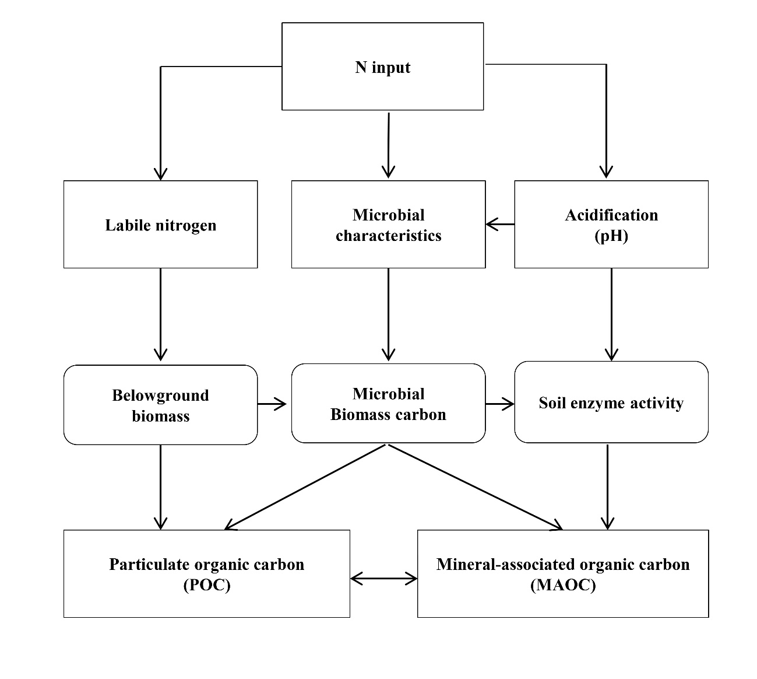

Figure S2 Linear relationships between MBC and MBN responses of N addition.

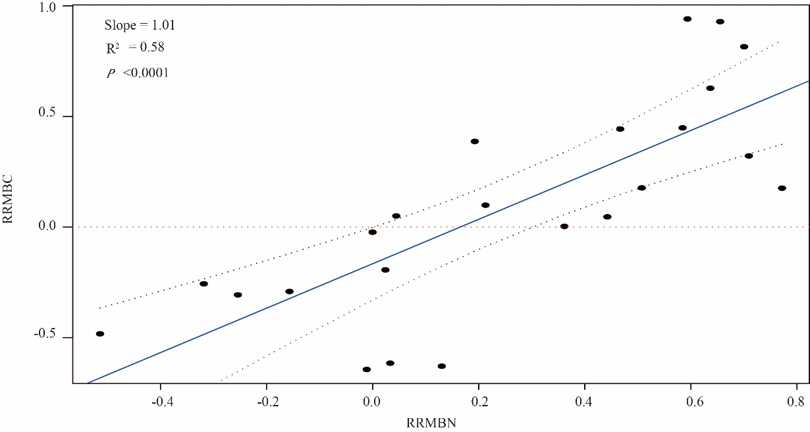

Figure S3 Frequency distribution of the effect sizes of N addition on SOC, POC and MAOC.

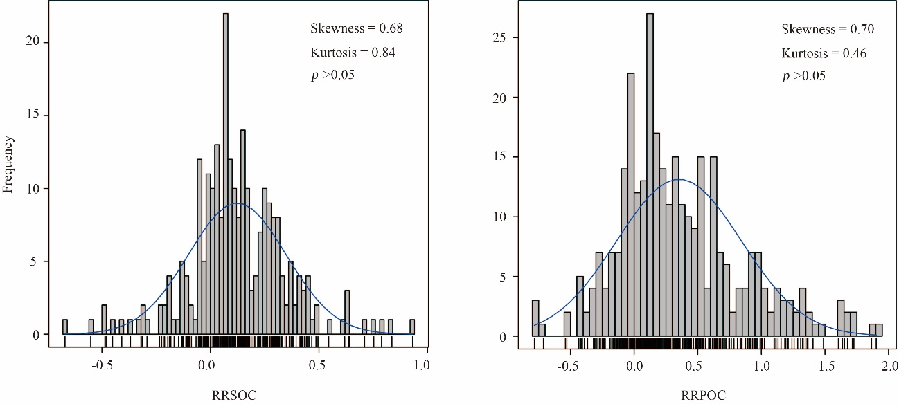
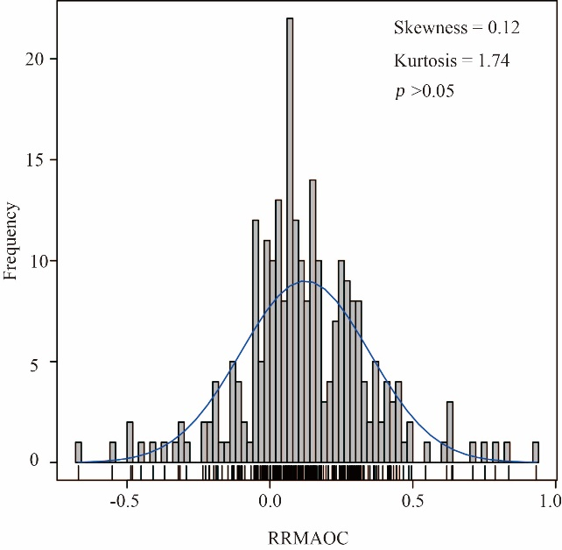

Figure S4 Effects of N addition on SOC, POC and MAOC related to nitrogen form, soil classification, ecosystem types and humidity index.

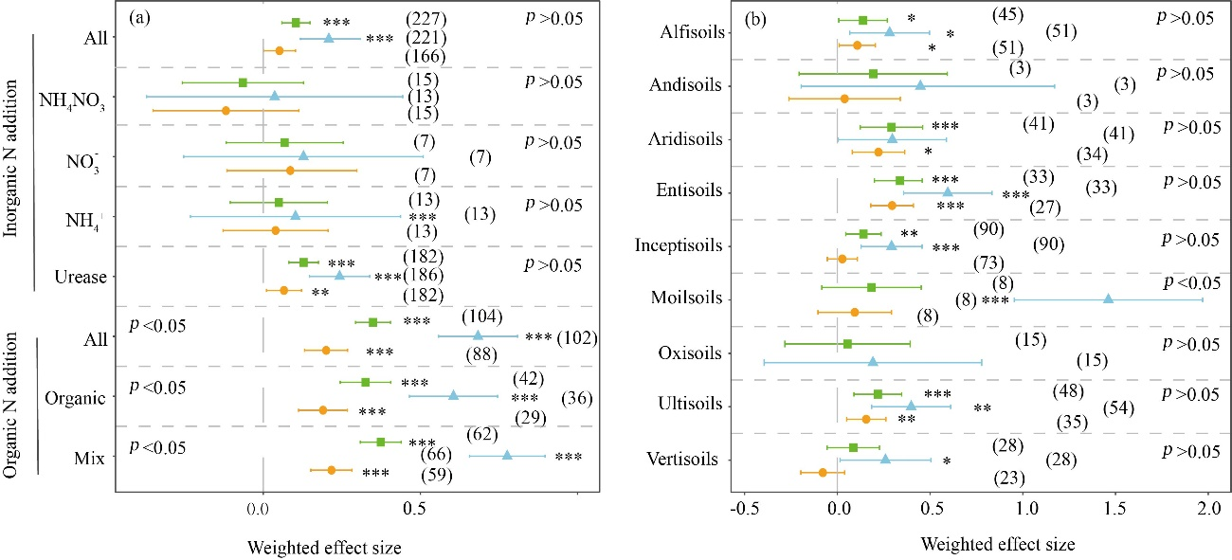
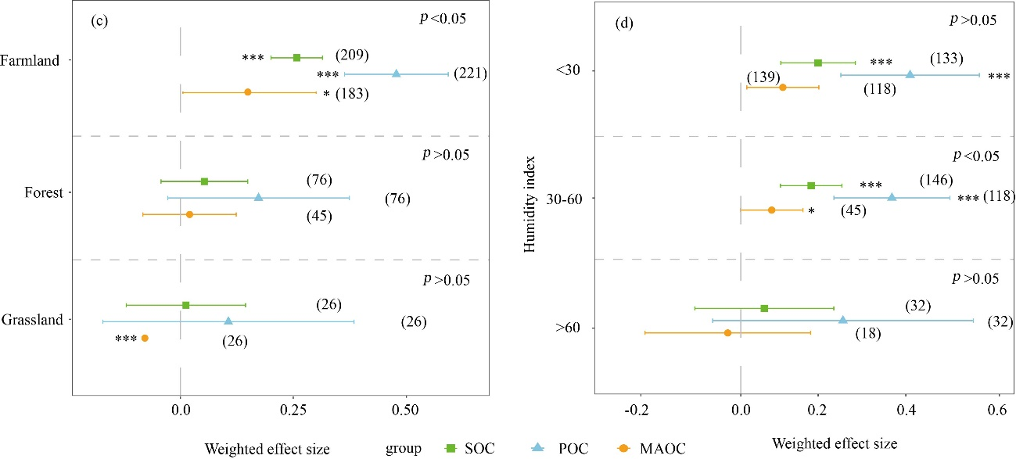
Figure S5 Temporal variance about the effect sizes on POC and MAOC. Time-interval is years since nitrogen addition. Among them, a-b, c-d and e-f represent the result of N addition, inorganic N addition and organic N addition, respectively.

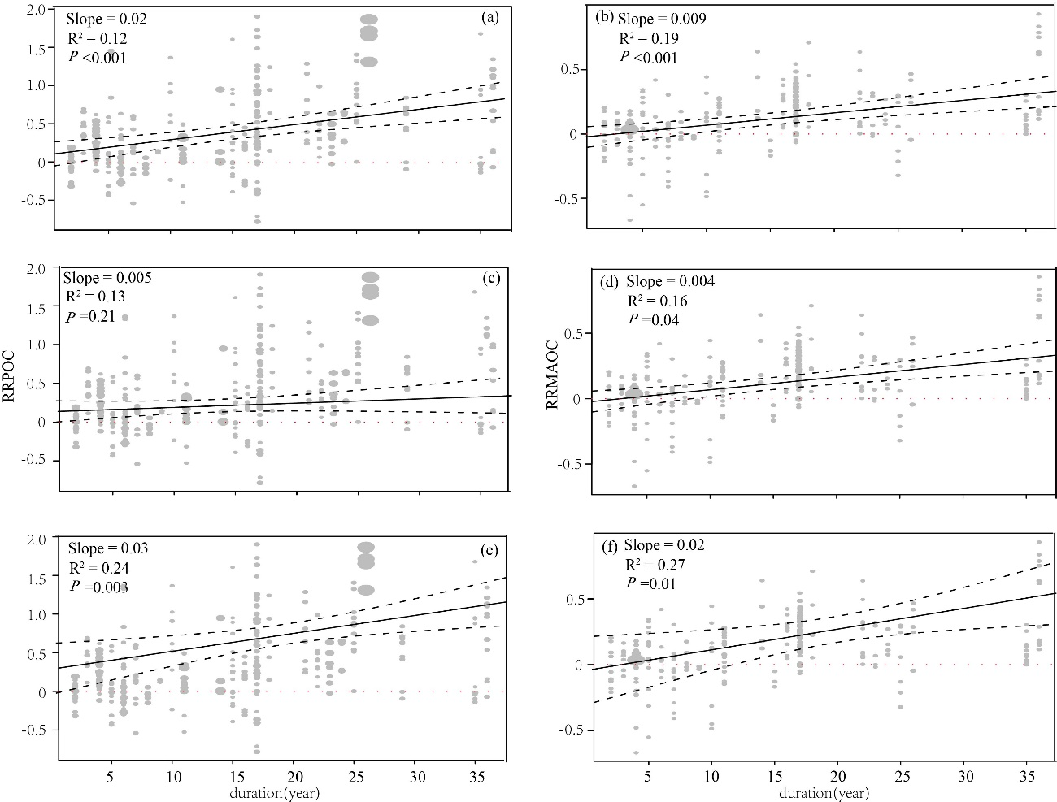

Figure S6 Effects of N addition about nitrogen form on environmental index.

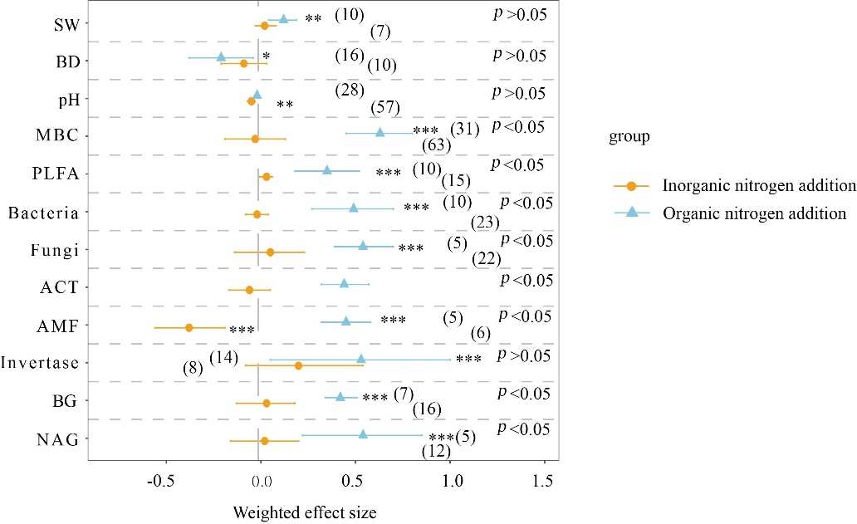

Figure S7 Variable importance of moderators on the responses of POC, MAOC to N addition under inorganic N addition (a, b) and organic N addition (c, d), respectively.
The importance values were calculated according to weighted random forest analysis. R² is interpretation of variables. ISOC, initial soil organic carbon; HI, humidity index.

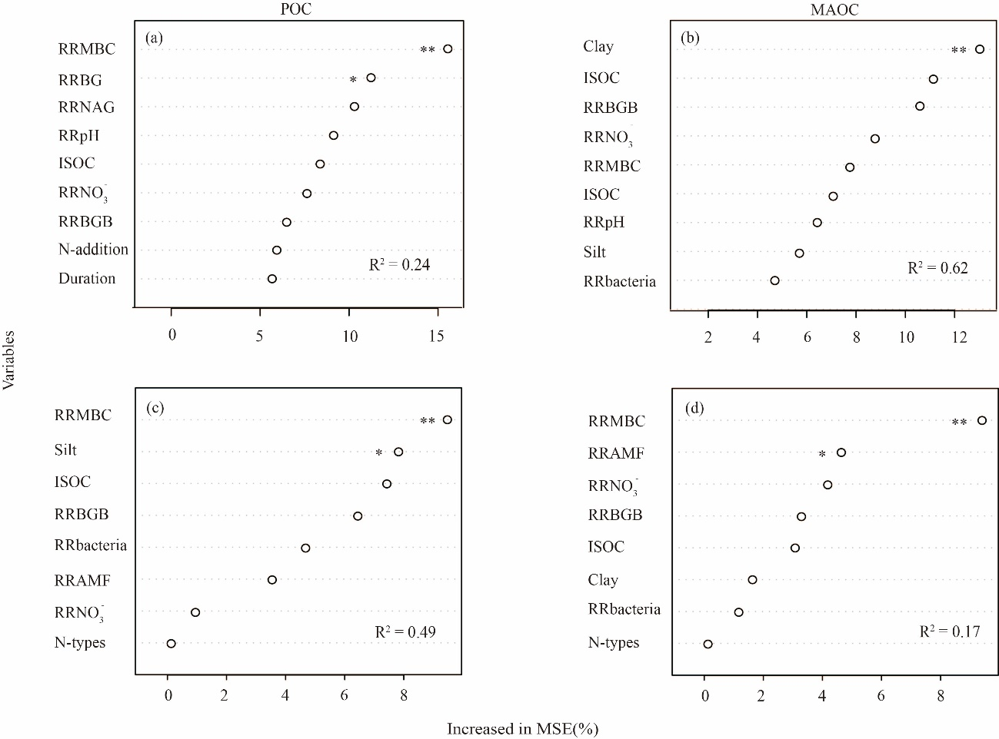

Figure S8 Temporal variations of the effect sizes (LnRR, response ratio) of partial environmental variables. Time interval is years since N addition.
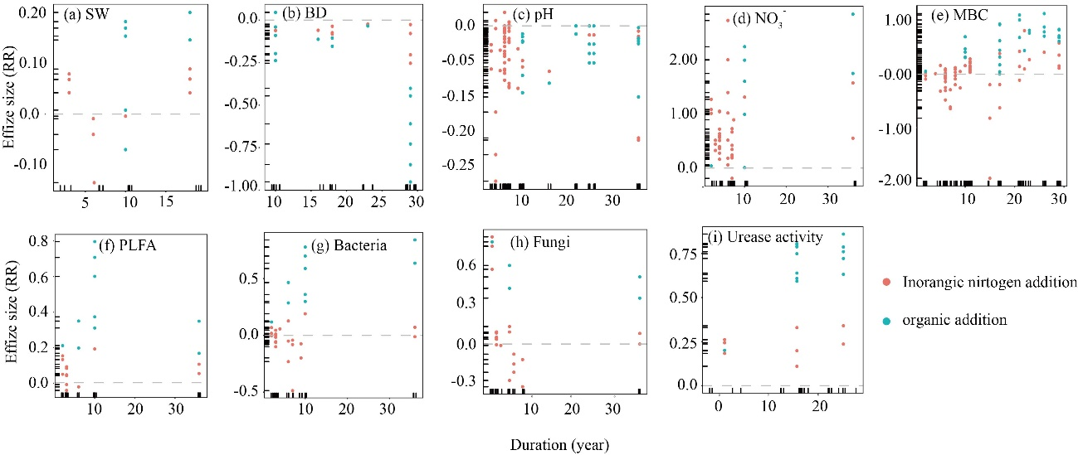

Figure S9 PRISMA flow diagram showing the procedure used for selection of studies for synthesis.
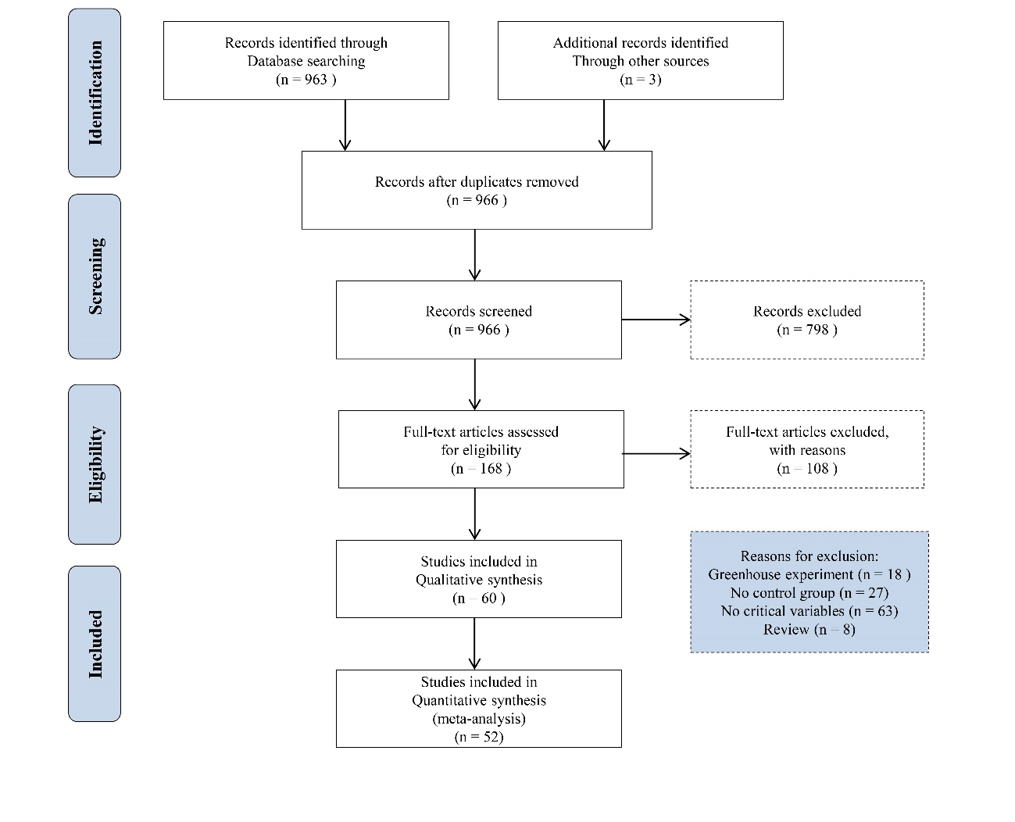

All 52 studies included in the presented meta-analysis
- Bai T. S., Wang P., Hall S. J., Wang F. W., Ye C. L., Li Z., Li S. J., Zhou L. Y., Qiu Y. P., Guo J. X., Guo H., Wang Y., & Hu S. J. (2020). Interactive global change factors mitigate soil aggregation and carbon change in a semi‐arid grassland. Global Change Biology, 26, 5320-5332.
- Cao H. B., Xie J. Y., & Hong J. P., (2021). Variation characteristics of organic carbon fractions within macroaggregates under long-term different fertilization regimes in the reclaimed soil. Journal of China Coal Society, 46, 1046-1055.
- Cao Z. C., Cheng S. L., Fang H. J., Xu M., Geng J., Lu M. Z., Yang Y., & Li Y. N. (2020). Responses of Soil Organic Carbon Dynamics and Microbial Community Structure to Organic Nitrogen Fertilization in the Temperate Needle-broadleaved Mixed Forest. Acta Prataculturae Sinica, 57, 963-974.
- Chai Y. J. (2014). Study on Aggregate Stability and Its Carbon Sequestration Mechanism for The Irrigated Desert Soil. Chinese Academy of Agricultural Sciences Dissertation.
- Cheng S. L., Fang H. J., & Yu G. R. (2018). Threshold responses of soil organic carbon concentration and composition to multi-level nitrogen addition in a temperate needle-broadleaved forest. Biogeochemistry, 137, 219-233.
- Chen G. T., Tu L. H., Chen G. S., Hu J. Y., & Han Z. L. (2018). Effect of six years of nitrogen additions on soil chemistry in a subtropical Pleioblastus amarus forest, Southwest China. Journal of Forestry Research, 29, 1657-1664.
- Chen J. G., Xiao W., Zheng C. Y., & Zhu B. (2020). Nitrogen addition has contrasting effects on particulate and mineral-associated soil organic carbon in a subtropical forest. Soil Biology & Biochemistry, 142, 107708.
- Chen J. G., Ji C. J., Fang J. Y., He H. B, & Zhu B. (2020). Dynamics of microbial residues control the responses of mineral-associated soil organic carbon to N addition in two temperate forests. Science of the Total Environment, 748, 141318.
- Chen X. M., Liu J. X., Deng Q., Yan J. H., & Zhang D. Q. (2012). Effects of elevated CO2 and nitrogen addition on soil organic carbon fractions in a subtropical forest. Plant & Soil, 357, 25-34.
- Chen X. M., Li Y. L., Mo J. M., Otieno D., Tenhunen J., Yan J. H., Liu J. X., & Zhang D. Q. (2012). Effects of nitrogen deposition on soil organic carbon fractions in the subtropical forest ecosystems of S China. Journal of Plant Nutrition & Soil Science, 175, 947-953.
- Chen Y., Liu X., Hou Y. H., Zhou S. R., & Zhu B. (2021). Particulate organic carbon is more vulnerable to nitrogen addition than mineral-associated organic carbon in soil of an alpine meadow. Plant & Soil, 458, 93-103.
- Chen Y., Zhang X. D., He H. B., Xie H. T., Yan Y., Zhu P., Ren J., & Wang L. C. (2010). Carbon and nitrogen pools in different aggregates of a Chinese Mollisol as influenced by long-term fertilization. Journal of Soils & Sediments, 10, 1018-1026.
- Fang H. J., Cheng S. L., Yu G. R., Yang X. M., Xu M. J., Wang Y. S., Li L. S., Dang X. S., Wang L., & Li Y. N. (2014). Nitrogen deposition impacts on the amount and stability of soil organic matter in an alpine meadow ecosystem depend on the form and rate of applied nitrogen. European Journal of Soil Science, 65, 510-519.
- Geng J., Cheng S. L., Fang H. J., Pei J., Xu M., Lu M. Z., Yang Y., Cao Z. C, & Li Y. N. (2019). Different Molecular Characterization of Soil Particulate Fractions under N Deposition in a Subtropical Forest. Forests, 10, 914.
- Geng J., Cheng S. L., Fang H. J., Pei J., Xu M., Lu M. Z., Yang Y., & Cao Z. C. (2020). Nitrogen fertilization changes the molecular composition of soil organic matter in a subtropical plantation forest. Soil Science Society of America Journal, 84, 68-81.
- Gong W., Yan X. Y., Cai Z. C., Wang J. Y., Hu T. X., Gong Y. B., & Ran H. (2008). Effects of long-term fertilization on soil particulate organic carbon and nitrogen in awheat maize cropping system. Chinese Journal of Applied Ecology, 2375-2381.
- Guo X. W., Luo Z. K., & Sun O. J. X. (2021) Long-term litter type treatments alter soil carbon composition but not microbial carbon utilization in a mixed pine-oak forest. Biogeochemistry, 152, 327-343.
- Han X. R., Wang L. L., Yang J. F., Zhan X. M., Liu X. H., Wang Y. Q., & Ma L. L. (2008). Effect of Long- term Fertilizations on Particulate Organic Carbon and Enzyme Activities in a Brown Earth. Chinese Journal of Soil Science, 266-269.
- He W., Wang H., Han F., Hu G. Q., Lou Y. H., Song F. P., Pan H., Wei M., & ZhuGe Y. P. (2020). Effect of Long-term Application of Organic Manure Expanding Organic Carbon Fractions in Fluvo-aquic Soil. Acta Prataculturae Sinica, 57, 425-434.
- He Y. T., Zhang W. J., Xu M. G., Tong X. G., Sun F. X., Wang J. Z., Huang S. M., Zhu, P., & He X. H. (2015). Long-term combined chemical and manure fertilizations increase soil organic carbon and total nitrogen in aggregate fractions at three typical cropland soils in China. Science of the Total Environment, 532, 635-644.
- Huang Q., R. (2008). Characteristics of Soil Fertility of Nitrogen under Long-term Fertilization in Paddy Soil Derived From Red Earth. Nanjing Agricultural University.
- Jiang M. B., Wang X. H., Liusui Y. H., Han C., Zhao C. Y., & Liu H. (2017). Variation of soil aggregation and intra-aggregate carbon by long-term fertilization with aggregate formation in a grey desert soil. Catena, 149, 437-445.
- Lan M. J. (2017). Response of dry farmland soil organic carbon and its liable organic carbon fractions to nitrogen fertilization in Loess Plateau of central Gansu province. GanSu Agricultural University.
- Liang C. H., Yin Y., & Chen Q. (2014). Dynamics of Soil Organic Carbon Fractions and Aggregates in Vegetable Cropping Systems. Pedosphere, 24, 605-612.
- Li H. B., Han X. Z., & You M. Y. (2012). Particulate Organic Carbon Distribution in Aggregates Differing in Land Use and Long-term Fertilization in Black Soil. Research of Soil & Water Conservation. 26, 184-189.
- Li J. (2018). Response of soil organic carbon and microbial properties within aggregates to high-input fertilizer practices under an intensive agricultural system. China Agricultural University.
- Liu E. K., Yan C. R., Mei X. R., Zhang Y. Q., & Fan T. L. (2013). Long-term effect of manure and fertilizer on soil organic carbon pools in dryland farming in northwest China. PLoS One, 8, e56536.
- Liu H. F., Zhang J. Y., Ai Z. M., Wu Y., Xu H. W., Li Q., Xue S., & Liu G. B. (2018). 16-Year fertilization changes the dynamics of soil oxidizable organic carbon fractions and the stability of soil organic carbon in soybean-corn agroecosystem. Agriculture, Ecosystems & Environment, 265, 320-330.
- Liu H., Tong X. G., Ma X. W., Wang X. H., Zhang W. J., Xu Y. M., & Xu M. G. (2010). Content and evolution characteristics of organic carbon associated with particle-size fractions of grey desert soil under long-term fertilization. Chinese Journal of Applied Ecology, 21, 84-90.
- Li W. F., Xie H. T., Bai Z., Chen Y., Yan Y., & Zhang X. D., (2009). Effects of Long-Term Fertilization on Distribution of Soil Particulate Organic Matter and Its Carbon and Nitrogen Concentrations in a Mollisol. Chinese Journal of Soil Science, 40, 267-271.
- Li Z. Q., Li D. D., Ma L., Yu Y. Y., Zhao B. Z., & Zhang J. B. (2019). Effects of straw management and nitrogen application rate on soil organic matter fractions and microbial properties in North China Plain. Journal of Soils & Sediments, 19, 618-628.
- Mao X. L., Lu K. P., Sun T., Zhang X. K., He L. Z., & Wang H. L. (2015). Effect of Long-term Fertilizer Application on the Stability of Organic Carbon in Particle Size Fractions of a Paddy Soil in Zhejiang Province, China. Environmental Science, 36, 1827-1835.
- Tian J., Lu S. H., Fan M. S., Li X. L., & Kuzyakov Y. (2013). Integrated management systems and N fertilization: effect on soil organic matter in rice-rapeseed rotation. Plant & Soil, 372, 53-63.
- Tian J., Lou Y. L., Gao Y., Fang H. J., Liu S. T., Xu M., Blagodatskaya E., & Kuzyakov Y. (2017). Response of soil organic matter fractions and composition of microbial community to long-term organic and mineral fertilization. Biology & Fertility of Soils, 53, 523-532.
- Tian J., Wang J. Y., Dippold M., Gao Y., Blagodatskaya E., & Kuzyakov Y. (2016). Biochar affects soil organic matter cycling and microbial functions but does not alter microbial community structure in a paddy soil. Science of the Total Environment, 556, 89-97.
- Tong X. G., Xu M. G., Zhang W. J., & Lu C. A. (2008). Influence of Long-term Fertilization on Content and Distribution of Organic Carbon in Particle-size Fractions of Red Soil and Fluvo-aquic Soil in China. Scientia Agricultura Sinica, 3664-3671.
- Wang L. F., Sun J. T., Kang J., Zhang Z. Y., Shangguan Z. P., & Wang C. Y. (2021). Influence of nitrogen addition on the changes in nitrogen and carbon fractions in soil profiles of wheat fields. Land Degradation & Development, 32, 2540-2553.
- Wang S. L. (2015). Effect of long-term fertilization on organic carbon fractions and turnovers of cinnamon soil. HuNan Agricultural University.
- Wang Y. D., Hu N., Xu M. G., Li Z. F., Lou Y. L., Chen Y., Wu C. Y., & Wang Z. L. (2015). 23-year manure and fertilizer application increases soil organic carbon sequestration of a rice–barley cropping system. Biology & Fertility of Soils, 51, 583-591.
- Wang X. J., Qi P., Cai L. Q., Chen X. L., Xie J. H., Gan H. J., & Zhang R. Z. (2020). Effects of alternative fertilization practices on components of the soil organic carbon pool and yield stability in rain-fed maize production on the Loess Plateau. Acta Prataculturae Sinica, 29, 58-69.
- Xie H. T., Li J. W., Zhu P., Peng C., Wang J. K., He H. B., & Zhang X. D. (2014). Long-term manure amendments enhance neutral sugar accumulation in bulk soil and particulate organic matter in a Mollisol. Soil Biology & Biochemistry, 78, 45-53.
- Xie J., Peng B., Wang R., Batbayar J., Hoogmoed M., Yang Y., Zhang S., Yang X., & Sun B. (2018). Responses of crop productivity and physical protection of organic carbon by macroaggregates to long-term fertilization of an Anthrosol. European Journal of Soil Science, 69, 555-567.
- Xie J. Y., Peng B., Wang R. J., Zhang S. L., & Yang X. Y. (2019). Effects of long-term different fertilizations on organic carbon fractions of macroaggregates in Anthrosol. Journal of Plant Nutrition & Fertilizers, 25, 1073-1083.
- Xu M., Xu L. J., Fang H. J., Cheng S. L., Yu G. X., Yang Y., & Lu M. Z. (2020). Alteration in enzymatic stoichiometry controls the response of soil organic carbon dynamic to nitrogen and water addition in temperate cultivated grassland. European Journal of Soil Biology, 101, 103248.
- Yang X. Y., Ren W. D., Sun B. H., & Zhang S. L. (2012). Effects of contrasting soil management regimes on total and labile soil organic carbon fractions in a loess soil in China. Geoderma, 177-178, 49-56.
- Ye C. L., Chen D. M., Hall S. J., Pan S., Yan X. B., Bai T. S., Guo H., Zhang Y., Bai Y. F., & Hu, S. J. (2018). Reconciling multiple impacts of nitrogen enrichment on soil carbon: plant, microbial and geochemical controls. Ecology Letters, 21, 1162-1173.
- Yuan X., Qin W. K, Xu, H., Zhang Z. H., Zhou H. K., & Zhu B. (2020). Sensitivity of soil carbon dynamics to nitrogen and phosphorus enrichment in an alpine meadow. Soil Biology and Biochemistry, 150, 107984.
- Yuan Y. H., Li H. X., Huang Q. R., Hu F., Pan G. X., & Fan H. B. (2008). Effects of long -term fertilization on particulate organic carbon and mineral organic carbon of the paddy soil. Acta Ecologica Sinica, 353-360.
- Yu M. X., Wang Y. P., Baldock J. A., Jiang J., Mo J. M., Zhou G. Y., & Yan J. H. (2020). Divergent responses of soil organic carbon accumulation to 14 years of nitrogen addition in two typical subtropical forests. Science of the Total Environment, 707, 136104.
- Zhang J. Y., Zhang W. J., Xu M. G., Huang Q. H., & Luo K. (2012). Response of soil organic carbon and its particle-size fractions to different long-term fertilizations in red soil of China. Plant Nutrition and Fertilizer Science, 18, 868-875.
- Zhang S. H., Wu J., Cai L. Q., Qi P., & Zhang J. (2019). Effects of Different Nitrogen Addition Levels on Soil Particulate Organic Carbon in Dry Farmland of Central Gansu Province on the Loess Plateau. Research of Soil & Water Conservation. 26, 7-11.
- Zhang X. L., Wang F. C., Fang X. M., He P., Zhang Y. F., Cheng F. S., & Wang H. M. (2017). Responses of soil organic carbon and its labile fractions to nitrogen and phosphorus additions in Cunninghamia lanceolata plantations in subtropical China. Chinese Journal of Applied Ecology, 28, 449-455.

