ADDENDUM
SUGGESTED RESEARCH: HYDROCOLLOID WOUND DRESSING (DUODERM) POTENTIAL EFFECT ON TISSUE MICROCALCIFICATIONS.
Recent research done by this author using hydrocolloid wound dressing (HCWD) material, Strip (7) and Paste (8) demonstrated an unusual property of HCWD which is energy penetration through a 1 mm glass barrier altering the human hair follicle metabolism, as well as increasing the size of human forehead skin and lizard’s tail harvested lipid droplets. HCWD material qualifies for inclusion in future cancer research protocols. Penetrating energy through a glass barrier altering human and reptile lipid droplets qualifies placement in future cancer research protocols.

DUODERM PASTE (HYDROCOLLOID) ENERGY PENETRATING A 1 mm GLASS BARRIER SHOWING
EFFECT ON HUMAN SKIN LIPID DOPLETS
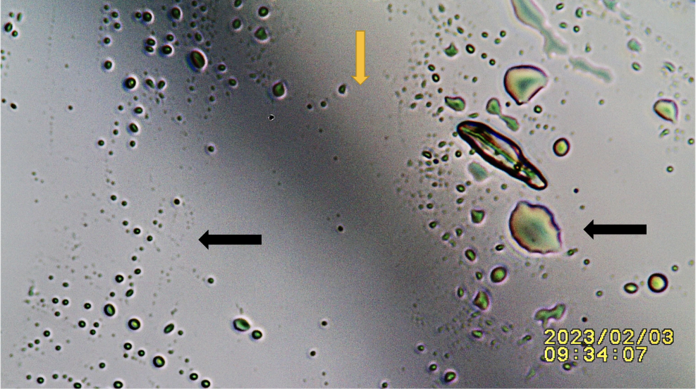
Figure. Showing top slide of sandwiched hydrocolloid wound dressing paste (HCWP) effect on human lipid droplets. Orange arrow: Out of focus outline of hydrocolloid paste boundary in bottom slide. Black Arrow Right. Deformed amplified lipid droplets when directly over HCWP area. Black Arrow Left: Unaltered lipid droplets unexposed to HCWP. (IJRG23_Ao2_5032 In Print).

