Supplementary Material
The decrease in fluorescence intensity of various mutant forms of mSAASoti is described by an exponential function. Each mutant form may have its own photochemical and photophysical characteristics, which leads to the appearance of parallel and/or sequential phototransformations. The process can be described by a mono- and bi-exponential equation (Gavshina et al. 2021). In this case, the values can be compared using the weighted average k_{off} = (A₁*k₁+A₂*k₂)/(A₁+A₂)

Table S1. Kinetic parameters in the photoswitching on-to-off reaction A₁, k₁, A₂, k₂ parameters were used for calculation mean rate constants (k_{off} = (A₁*k₁+A₂*k₂)/(A₁+A₂).

Green form | A₁ | k₁*1000 | A₂ | k₂*1000
mSAASoti | 1.25 | 5.9 | -0.34 | 13.5
C21N | 1.19 | 5.6 | -0.28 | 16
M163A |  | 46
F177S | 1.09 | 37 | -0.13 | 130
Green form
M163T |  | 590
C21N/M163A |  | 385
C21N/M163T |  | 1020
C21N/M163G |  | 690
C21N/F177A |  | 310
C21N/F177N | 3271 | 310 | -565 | 1010
C21N/F177T | 3600 | 210 | 767 | 4
Red form | I₁ |  | I₂
M163A |  | 11
F177S | 173 | 15 | 173
M163T |  | 44±2
C21N/M163T* |  | 47
Red form (Lumencor)
M163A | – | 7.8±0.1
F177S | 0.2 | 150 | 0.8 | 12
C21N/M163T | – | 50±5
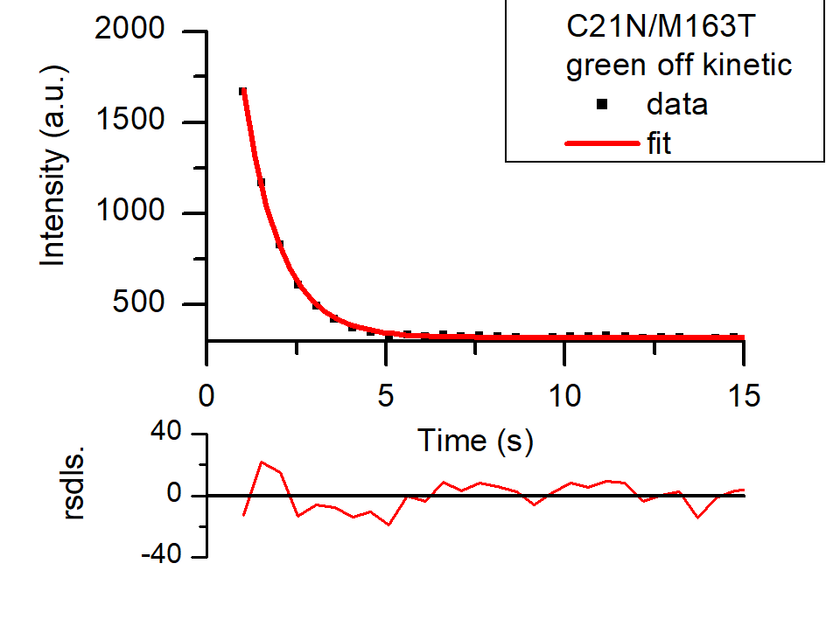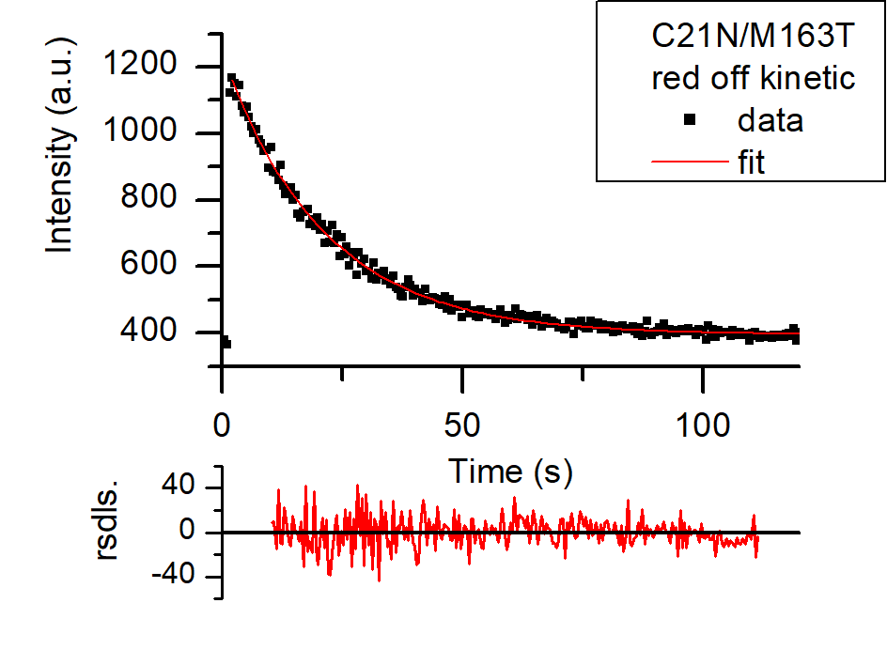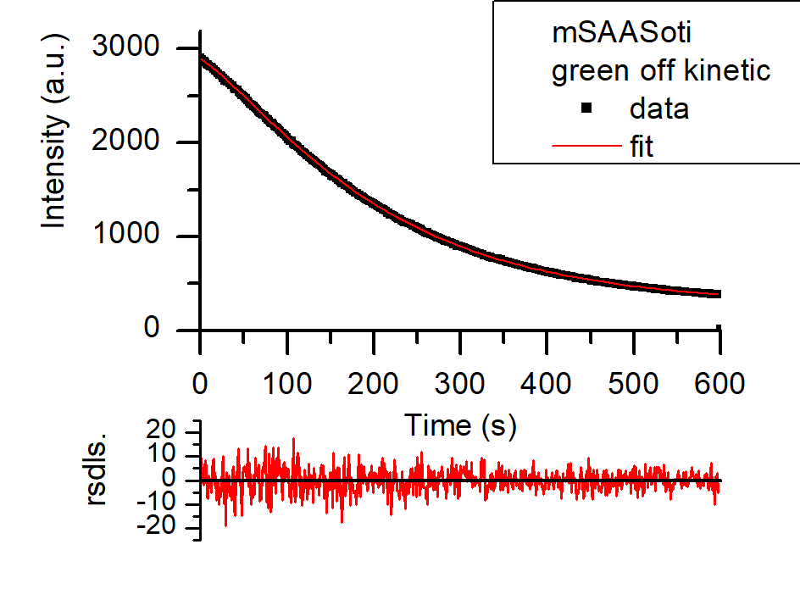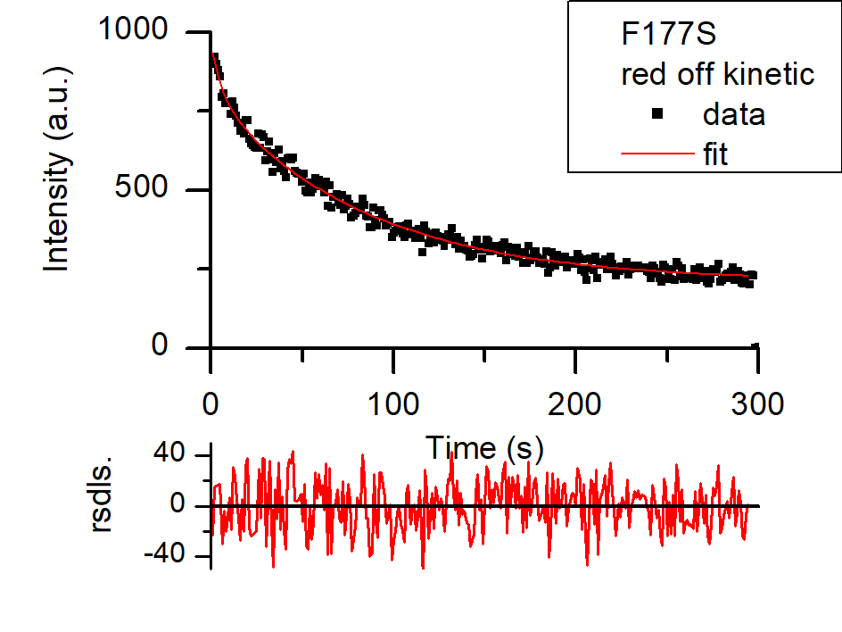
Figure S1. Exponential fitting. C21N/M163T green and red off kinetic curves were fitted using monoexponential model. mSAASoti green and F177S red off kinetic curves were fitted using biexponential model.

pKa values were calculated using modified Henderson-Hasselbalch equation as described in (Solovyev et al. 2018) according to equation S1:
$$H^{+}+{Chrom}^{-}\underset{⇔}{K} ChromH$$
$I\left(\left[H^{+}\right]\right)=\frac{I_{0}*K}{K+[H^{+}]}$+c (S1)
where I correspond to fluorescence intensity at current pH value, I₀ – maximum fluorescence intensity at higher pH (anionic chromophore form), K – equilibrium constant, [H⁺] – current equilibrium proton concentration, c – background including residual intensity of protonated chromophore state. Data analysis was performed by fitting of experimental data according to formula (S1) using Origin 8.5 software package.

M163A
Reduced Chi-Sqr | 239.014
Adj. R-Square | 0.989
 | Value | SE
I₀ | 343.8 | 11.3
K | 2.236E-7 | 3.64E-8
c | 5.28 | 8.17
C21N/M163G
Reduced Chi-Sqr | 8.099
Adj. R-Square | 0.997
 | Value | SE
I₀ | 148.5 | 1.9
K | 9.37E-8 | 5.12E-9
c | 0 | -

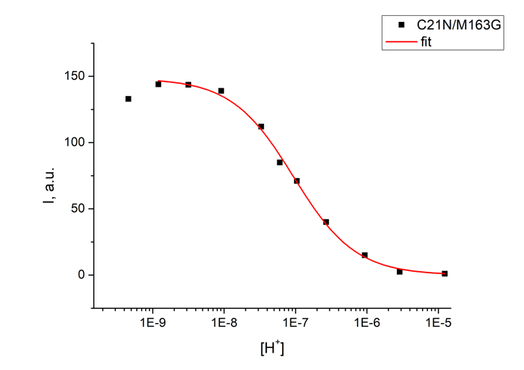
Figure S2. Dependence of the fluorescence intensity on the pH value measured for pK calculation for the green M163A and F177S mSAASoti mutants.

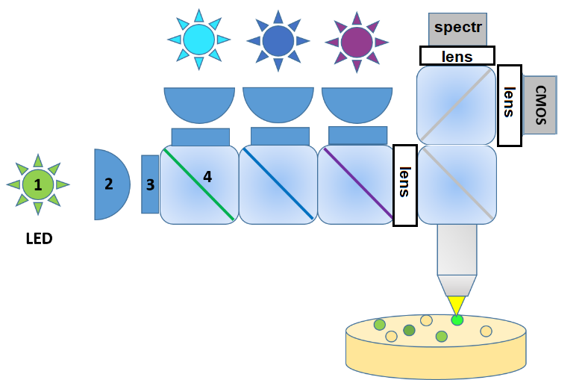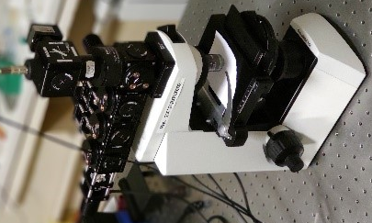
Figure S3. Optical scheme and photo of the photochemical screening setup. 1) LEDs; 2) condenser lenses 3) bandpass filters; 4) dichroic mirror.

