Immunoinformatics design of novel peptide vaccines against Epstein-Barr virus with over 99% global population coverage: A Reverse Vaccinology approach
Hassan Yousaf ^{1*}; Anam Naz ¹
Affiliation 1: Institute of Molecular Biology and Biotechnology (IMBB), University of Lahore, Pakistan
Corresponding Author: hassanysf98@gmail.com

gB  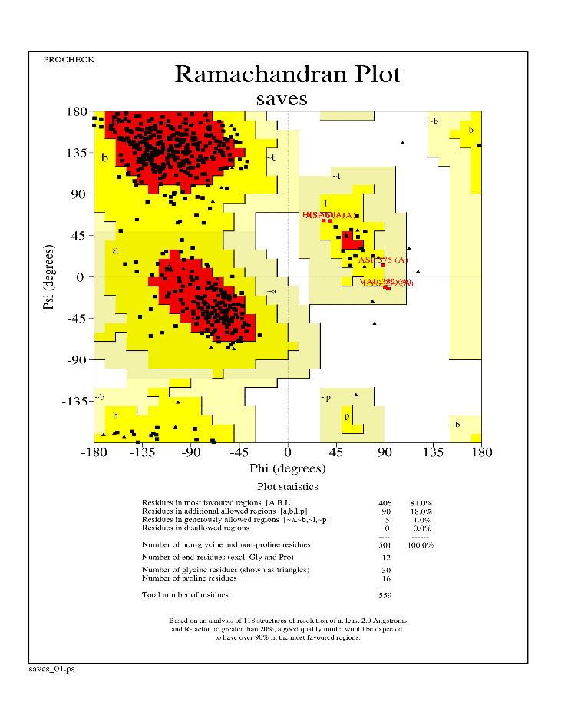 | gH  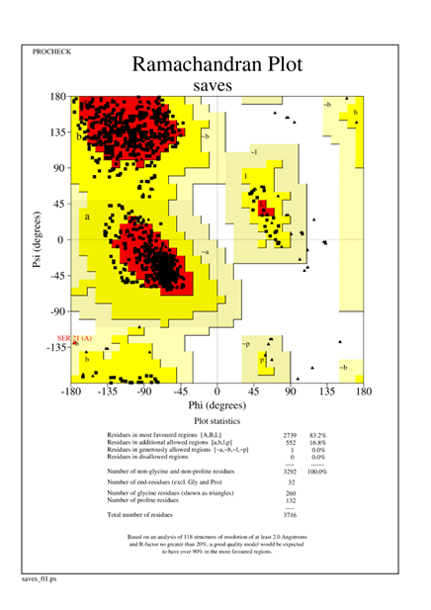
gL  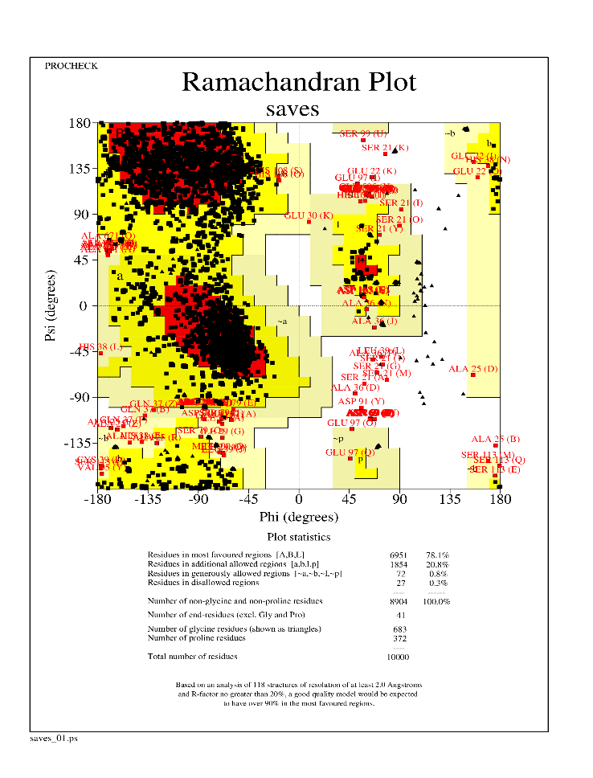 | gp42  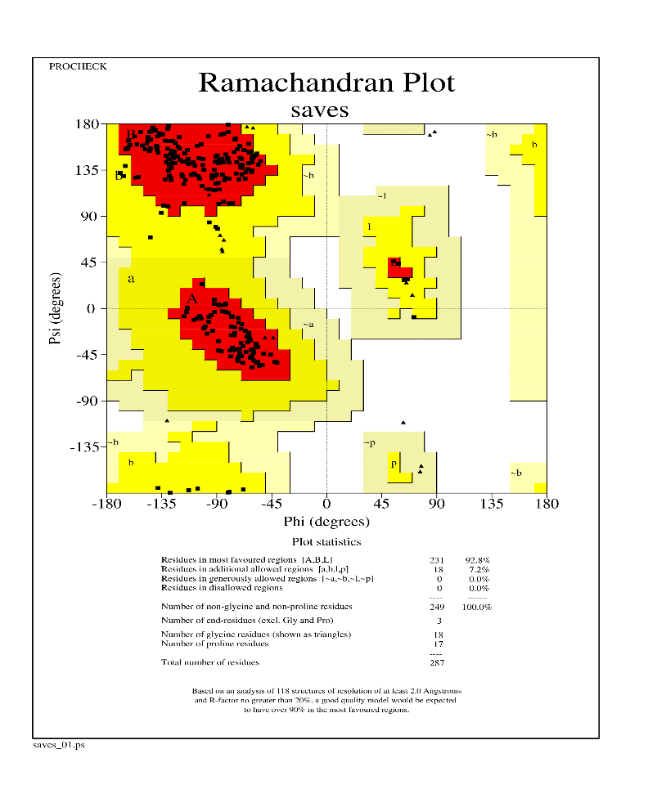
gM  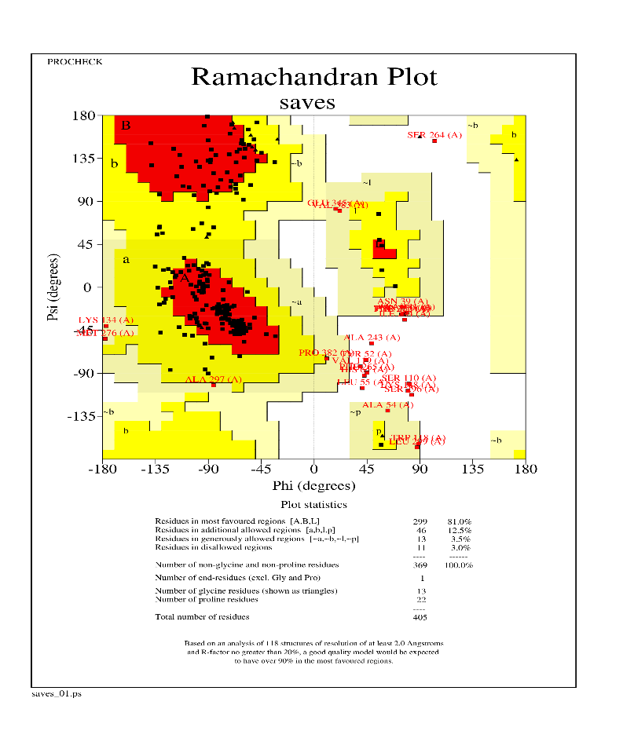 | gN  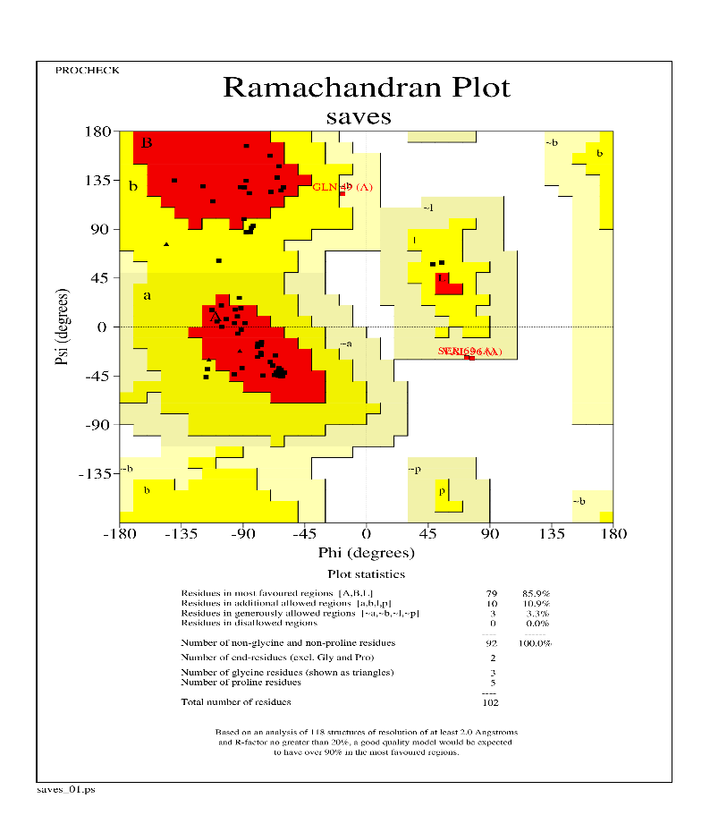
gp350  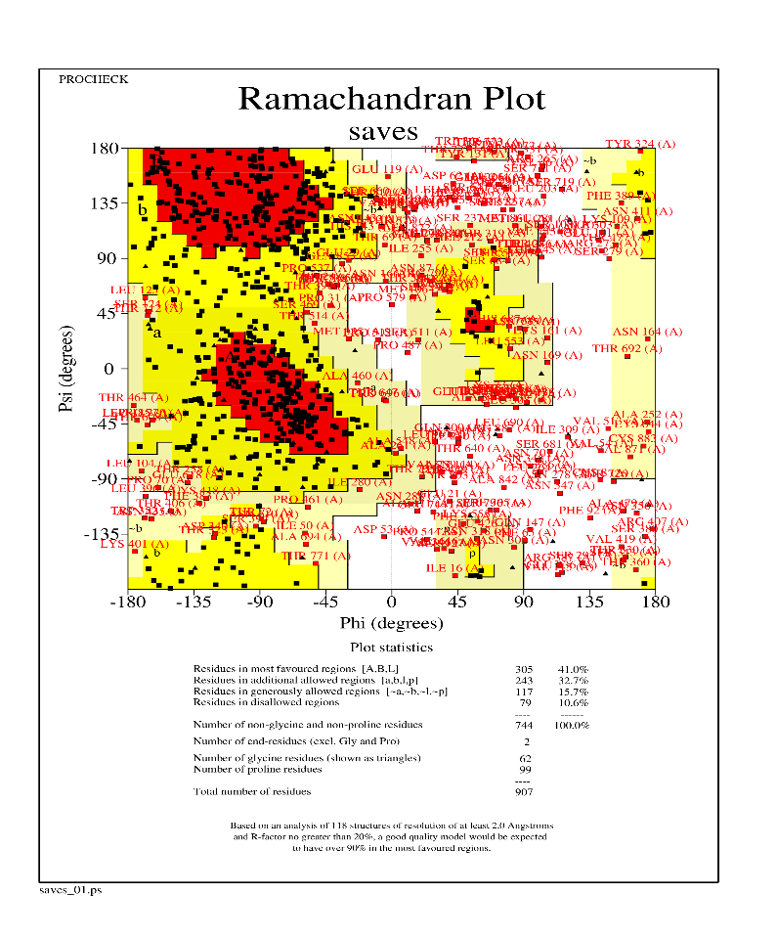 | tegument  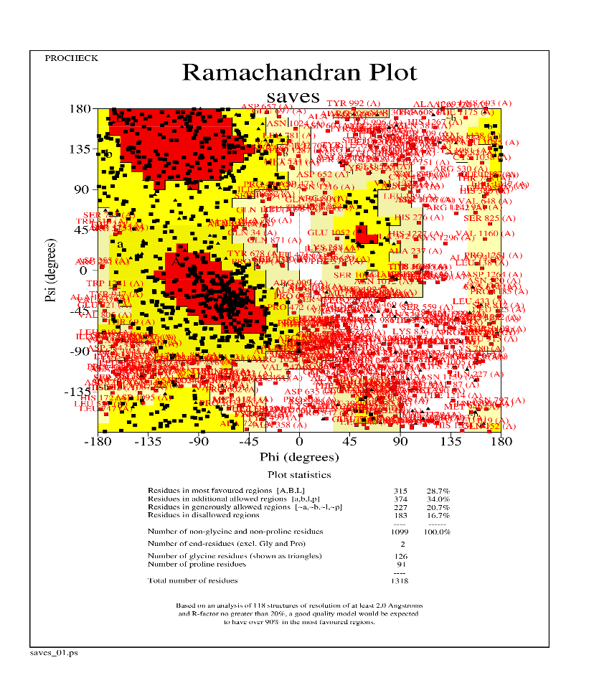
Portal
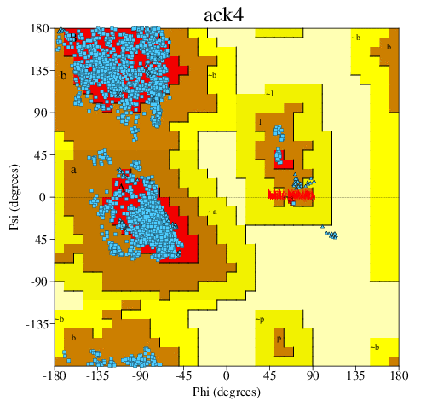

Fig S1. Ramachandran plots for the EBV target proteins.
- Contact Map  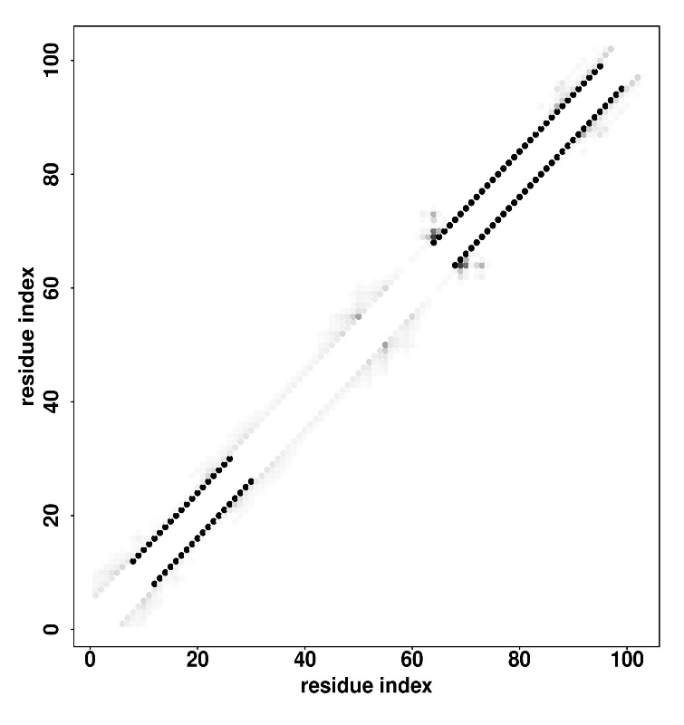 | - Distance Map  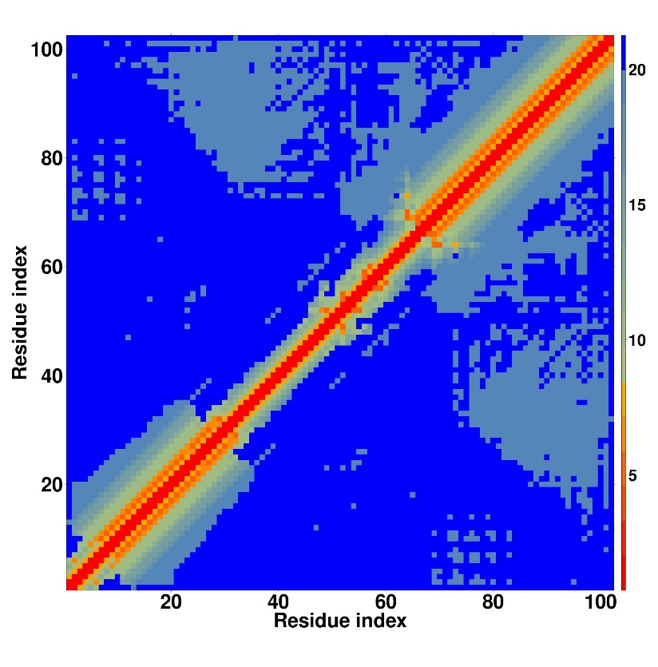
- Scoring Map  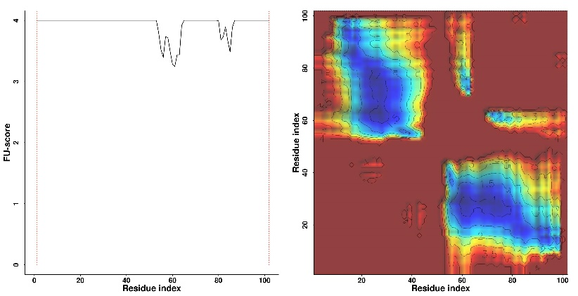 | - Predicted Molecular Function  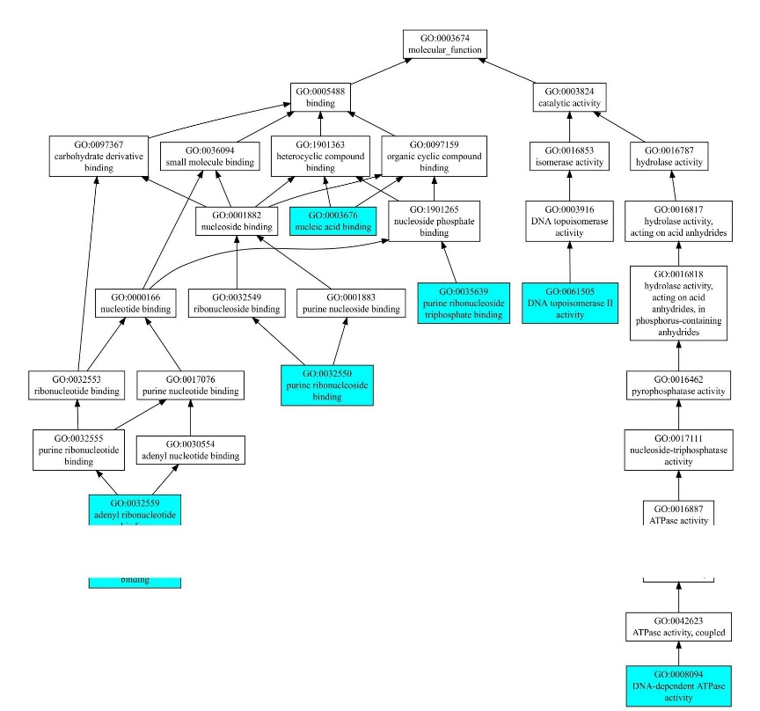

Figure S2. LOMETS structural modelling predictions of the contact, distance and scoring maps for the gN protein.

- Contact Map  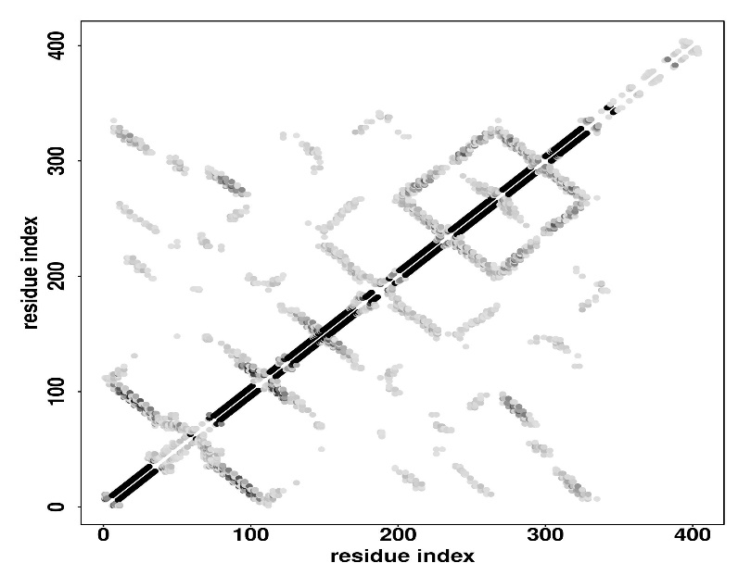 | - Distance Map  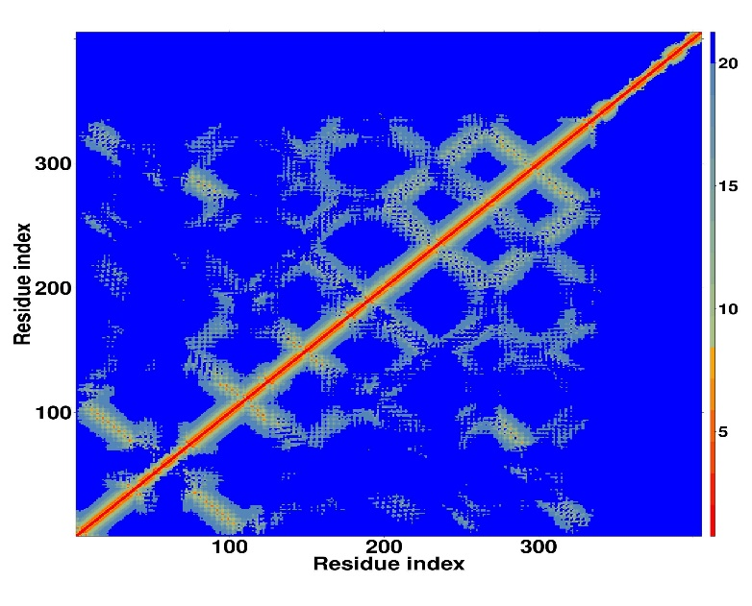
- Contact Map  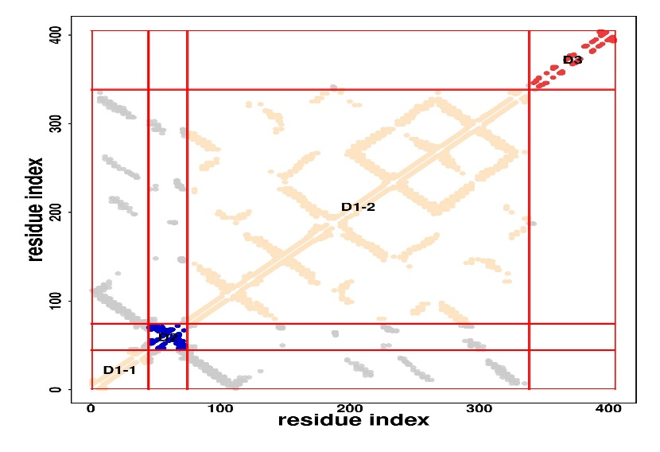 | - Scoring Map  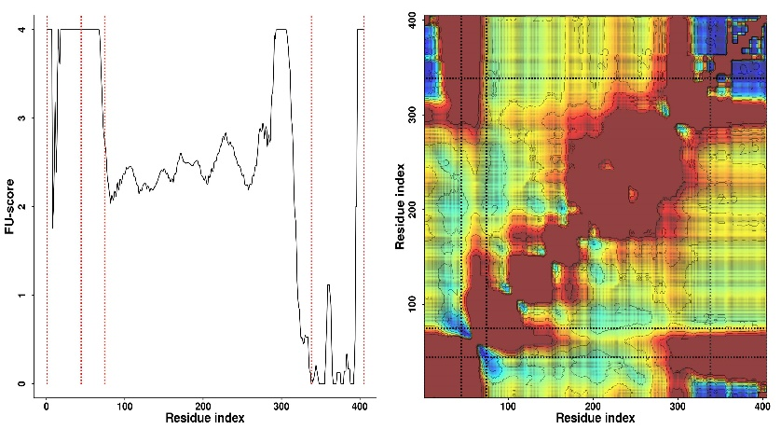
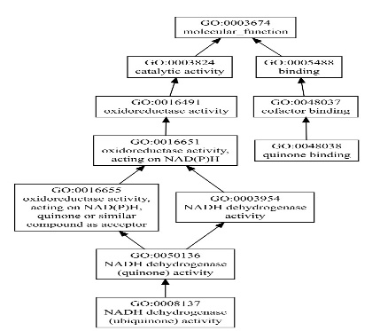
Figure S3. LOMETS structural modelling predictions of the contact, distance and scoring maps for the gM protein.

- Contact Map  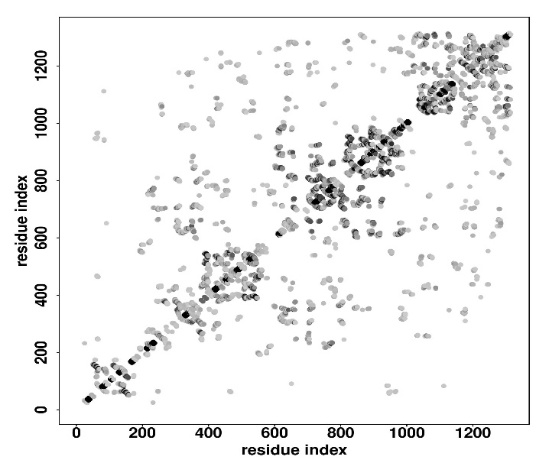 | - Distance Map  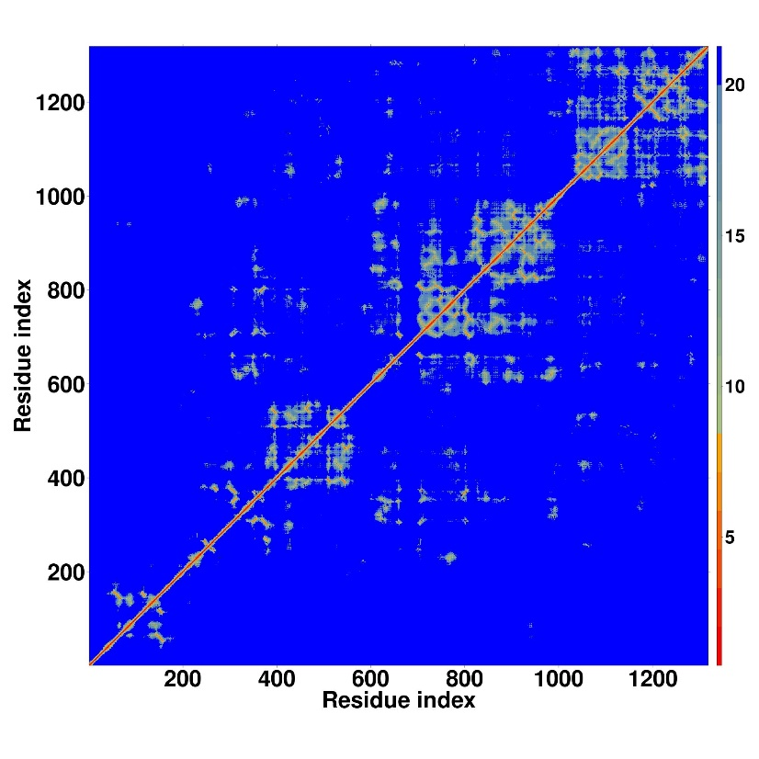
- Contact Map  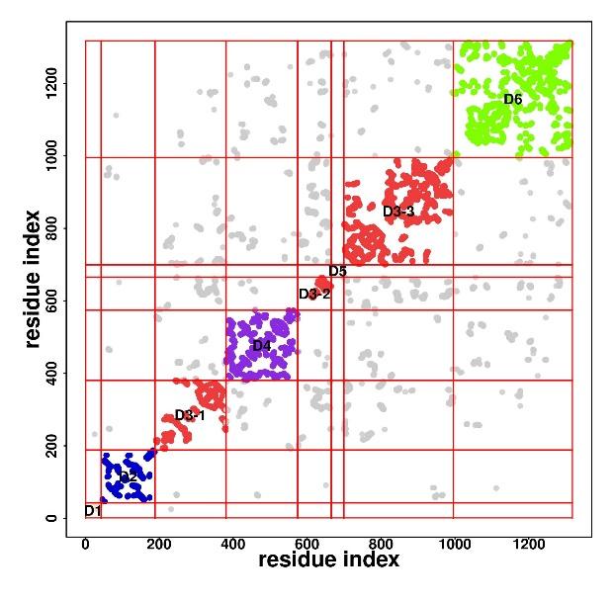 | - Scoring Map  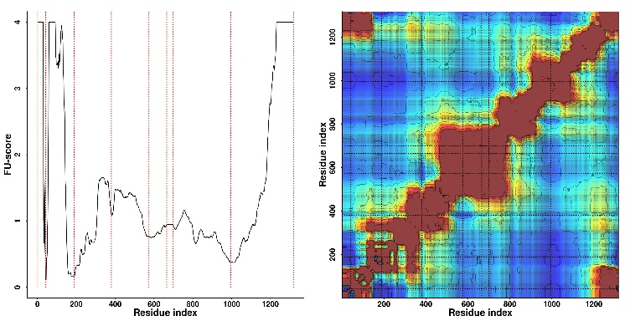

Figure S4. LOMETS structural modelling predictions of the contact, distance and scoring maps for the tegument protein.
Vaccine 1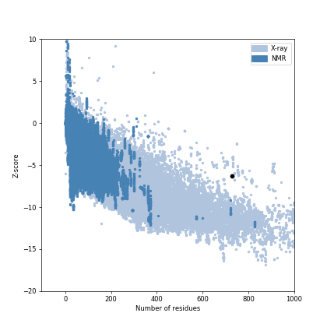  Z score = -6.3 | 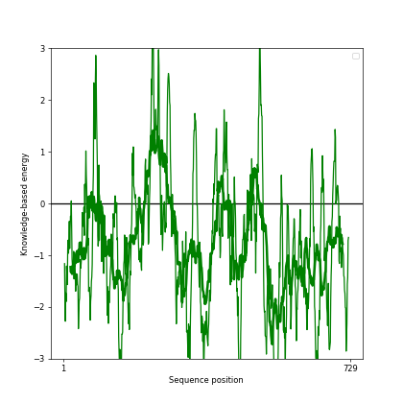
Vaccine 2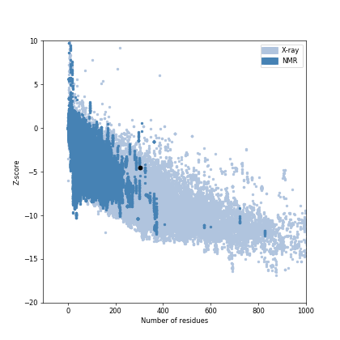  Z score = -4.54 | 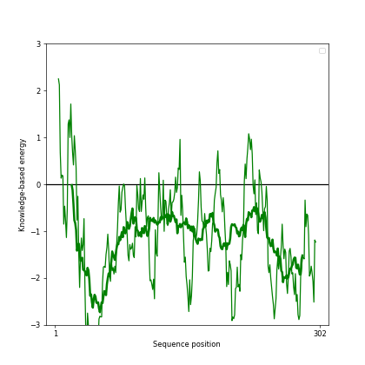
Vaccine 3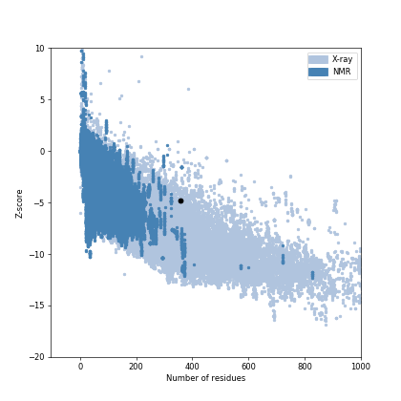
Z score = -4.83

Figure 5. ProsaWeb generated Z-score values and energy plots of vaccine 1, 2 and 3.

Vaccine 1 + TLR-4 complex (Molecular Interactions)

Vaccine 1 + CD21 complex (Molecular Interactions)

Vaccine 2 + TLR-4 complex (Molecular Interactions)

Vaccine 2 + CD21 complex (Molecular Interactions)

Vaccine 3 + TLR-4 complex (Molecular Interactions)

Vaccine 3 + CD21 complex (Molecular Interactions)

Cons1-tlr4
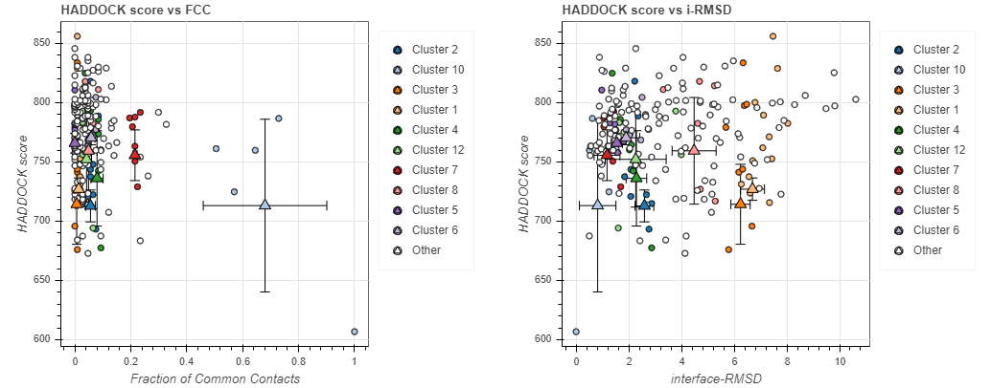

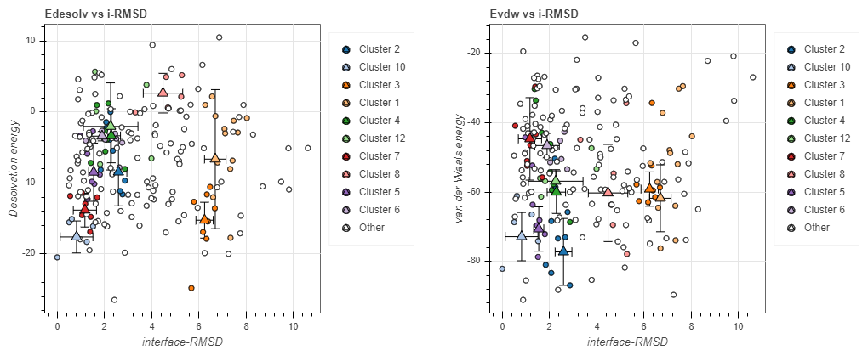

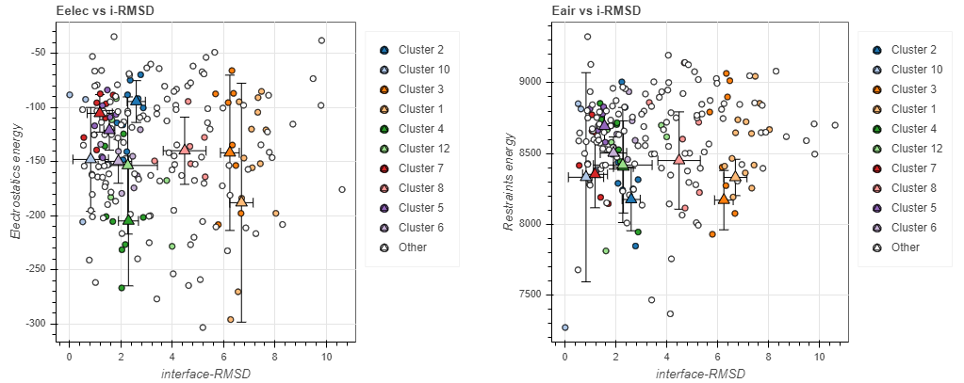

Construct 1 + CD21
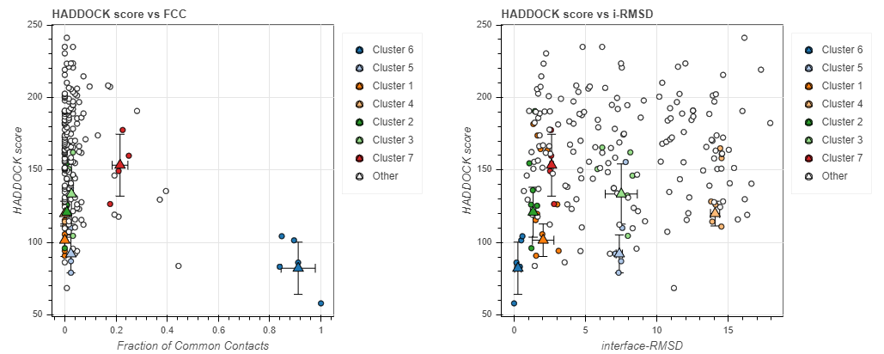

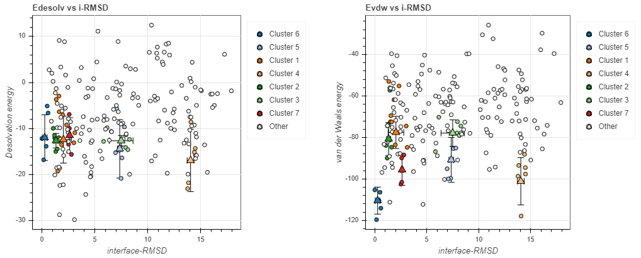

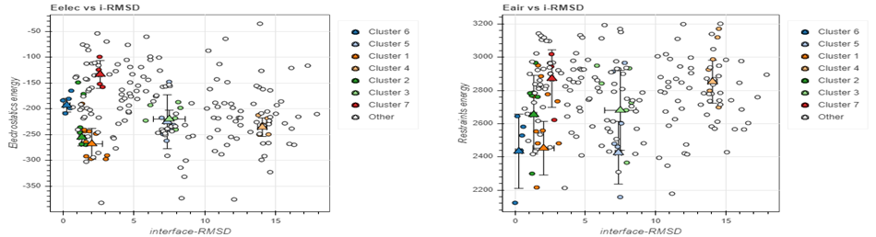

Construct 2 + TLR4
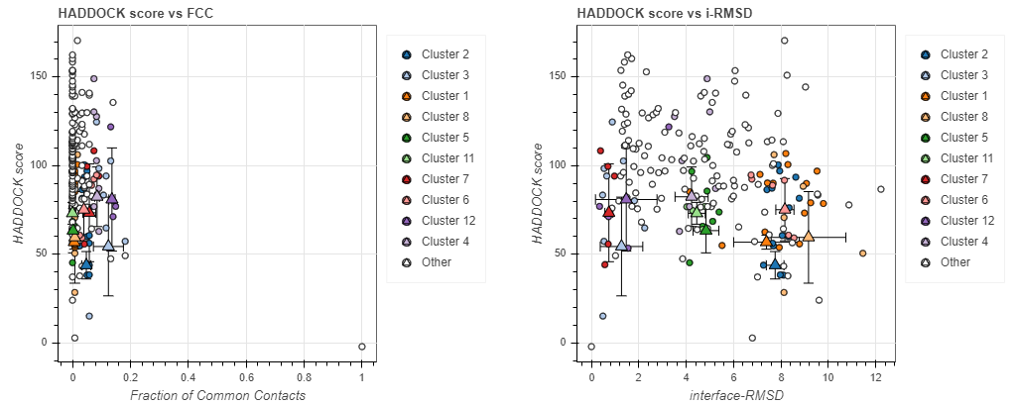

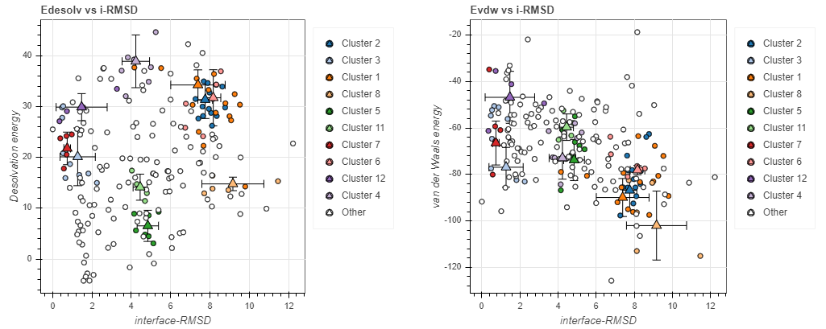

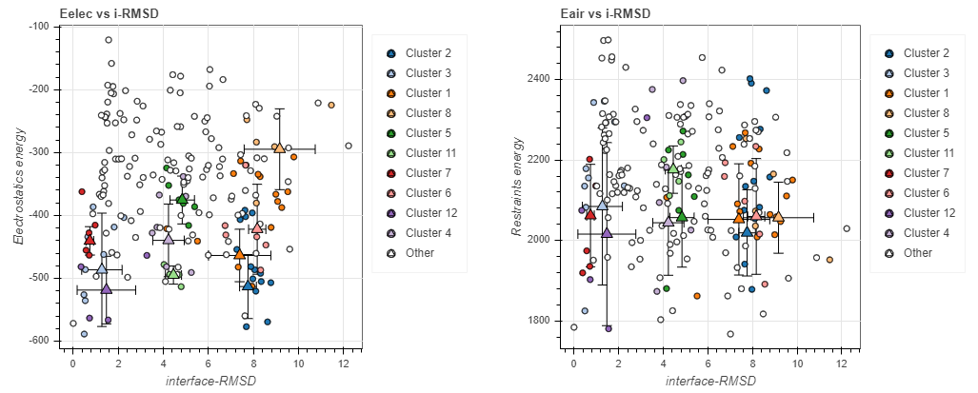

URL to Abpred Results:
Vaccine 1: https://protein-sol.manchester.ac.uk/results/abpred/abseq-d56aa43ed21c5b6e4316/results.html
Vaccine 2: https://protein-sol.manchester.ac.uk/results/abpred/abseq-f95b05149e6cde9a4f13/results.html
Vaccine 3: N/A

