Supplemental material
Supplemental figures
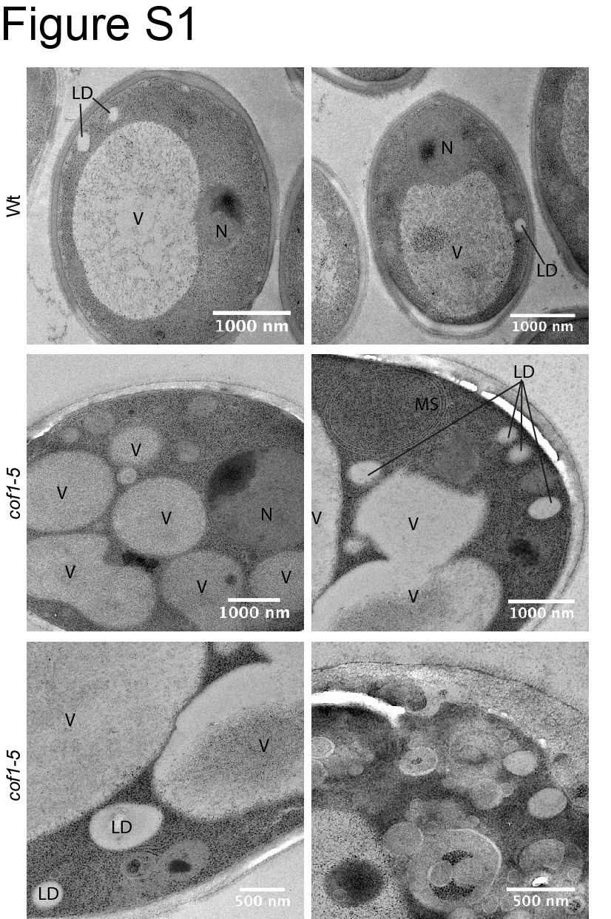
Figure S1. EM micrographs support the observation that vacuoles in cof1-5 can appear highly fragmented. V, vacuole; LD, lipid droplet; N, nucleus; MS, membrane stack.

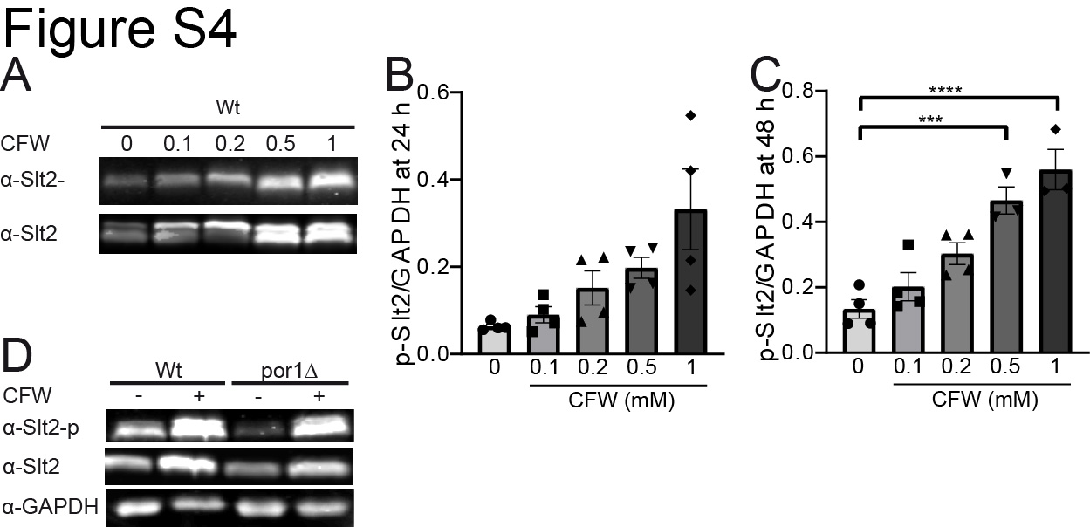
Figure S4. Slt2-phosphorylation is responsive to calcofluor white treatment. (A-C) Anti-phospho-Slt2 immunoblotting shows increased Slt2-phosphorylation upon calcofluor white (CFW) treatment in a concentration dependent manner. A representative immunoblot at 24 h (A) and quantifications of immunoblots at 24 h (B) and 48 h (C) are shown. Slt2-phosphorylation is reduced in por1∆ (D). Statistical significance in (B) was assessed using Welch ANOVA and ordinary one-way ANOVA was performed in (C).

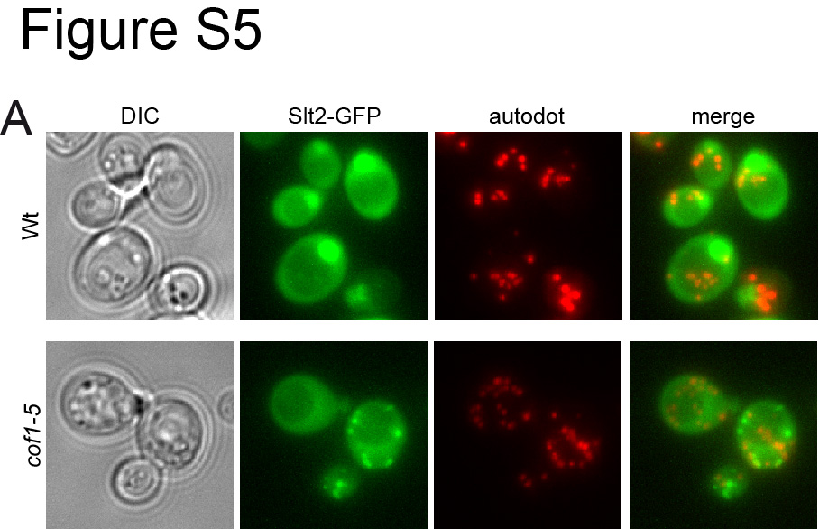
Figure S5. (A) Fluorescence microscopy pictures of Slt2-GFP expressing cells with autodot staining for LDs. Slt2-GFP-foci in cof1-5 do not colocalise with LDs (autodot staining in red).
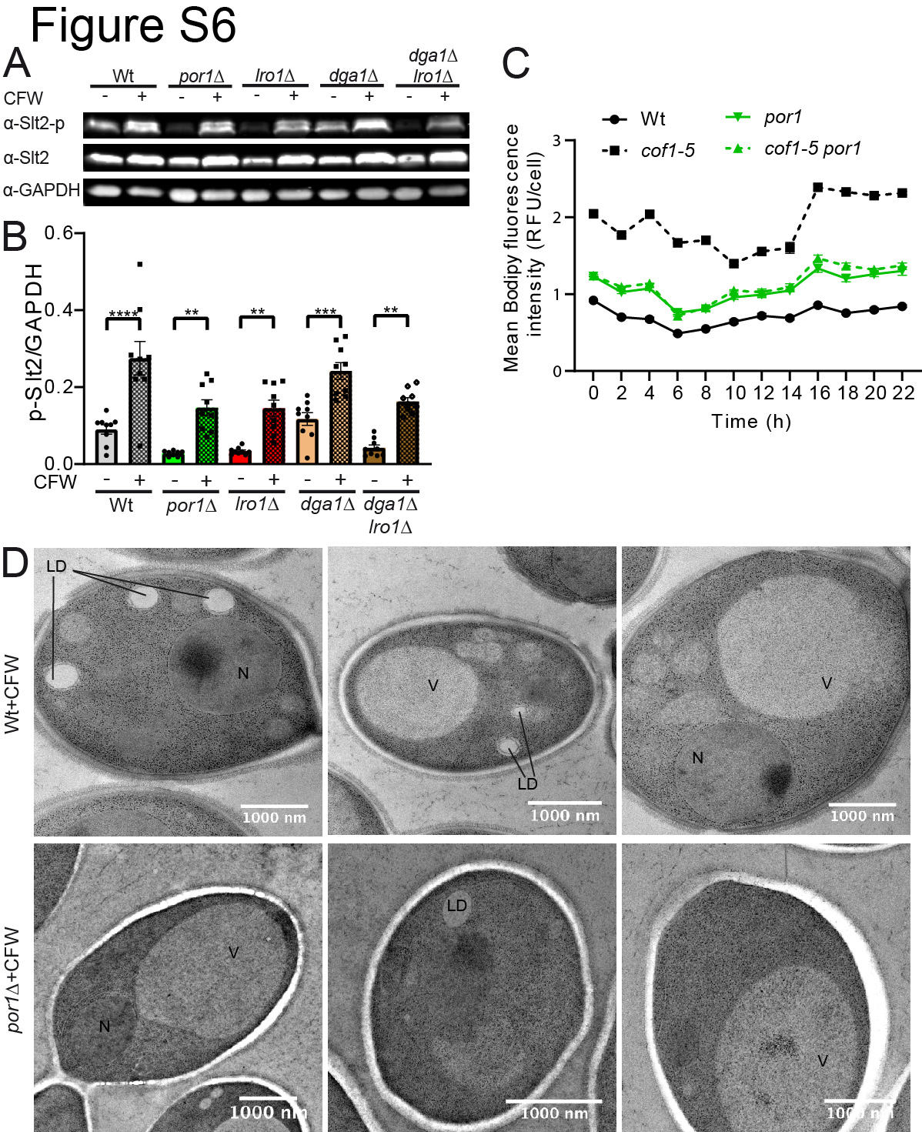
Figure S6. (A, B) Slt2-phosphorylation was reduced in gene knock-outs of LRO1 and LRO1 DGA1 DKO. A representative immunoblot is shown in (A) and quantitative results are presented in (B). (C) Bodipy mean fluorescence intensity was measured in a time-course experiment. The mean Bodipy intensity is constantly increased in cof1-5 cells. (D) EM micrographs support the observations made by fluorescence microscopy suggesting that CFW treatment triggers an increase in LD numbers. V, vacuole; LD, lipid droplet; N, nucleus. Statistical significance in (B) was assessed using 2-way-ANOVA.
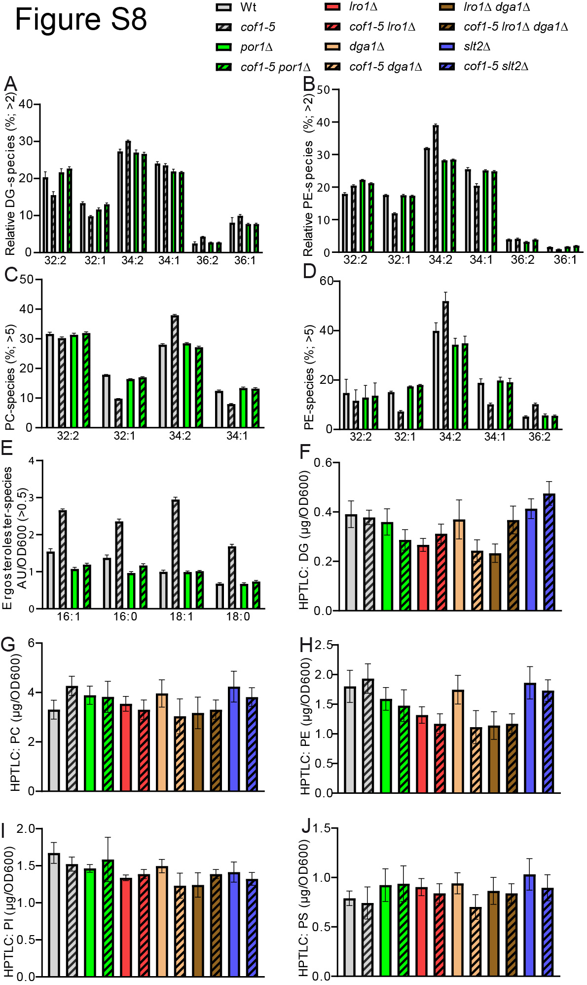
Figure S8. Relative phospholipid species as measured by MS-assisted lipidomics are shown in (A-D): (A) relative DG-species over 2 %, (B) relative PE-species over 2 %, (C) relative PC-species over 5 %, (D) relative PA-species over 5 %. (E) Ergosterolester species as quantified by MS-assisted lipidomics are homogenously increased in cof1-5. (F-J) HPTLC-assisted total lipid quantification of DG (F), PC (G), PE (H), PI (I), and PS (J).

Supplemental Tables
Table S1 – Genes upregulated in act1-159
GO Process | Genes upregulated in act1-159 cells vs wild type
Response to stress | FLO1,EDE1,ZTA1,FRM2,MXR2,GRX1,HSP30,YDL124W,NTH1,REG1,NRG1,UPC2,MHR1,TSA2,FRD1,HPA3,HSP12,SUT1,ASK10,SLT2,GRE3, DOT5,IML2,IXR1,UBR2,HAP1,GAD1,CUE1,DDR2,USV1,OPY2
cellular amino acid metabolic process | GDH3,ADH5,ILV6,CIT2,HOM2,TRP4,HPA3,UGA1,GTF1,DIA4,ARG4,THR1,LYS12,BNA1,BNA2,CPA2,STR2,MET17,NAM2,CAR2,LEU3,ADI1,ARG80,GAD1,HER2,IDH1,MET4,MET2,CIT1,IDH2,MSY1,SAM4
cell wall organization or biogenesis | FLC2,TIP1,SPS22,SED1,DIT1,HKR1,ZRG8,GSC2,CRH1,SLT2,KIC1,QDR1,YPS6,MHP1,CWP1,PIR3,KTR2,YPS3,NCW2,CCW14,MYO5,ROT1,DFG5,SLA2,RIM21,KRE1,PKH2,HPF1,PTP2,MKK1,SRL1,FLC1
ion transport | DRS2,FLC2,BAP2,FTH1,PCA1,ENA5,DNF2,CCC2,PIC2,AVT6,FTR1,AUA1,AFT1,VHT1,TPO2,CCH1,MTM1,HSE1,YKE4,MRS3,COX19,FRE6,UPS1,FET3,ALP1,ATO2,PHO91,FRE7,MCH5,COT1,FLC1,TPO3
carbohydrate metabolic process | DEP1,ADH5,MAL33,MAL32,GLK1,CIT2,NTH1,REG1,HKR1,GLC3,GPP2,SAK1,IGD1,HXK1,PYC1,AMS1,GSC2,CRH1,ENO1,MAL12,AAP1,GRE3,TDH1,SIP4,CBF1,RGT1,XYL2,GSY2,TSL1,GCR2,GDB1
chromatin organization | SWC3,DEP1,LDB7,CYC8,RIF1,NSI1,REG1,HDA2,SUM1,EAF1,DOT6,RPH1,EPL1,PNC1,TRA1,ORC6,YAP5,CBF1,JHD2,MLP1,IFH1,NAT4,ESC1,ZDS1,UBP10,SIN3,SAS5
mitochondrion organization | SSA1,ATG8,MIC12,SLM3,SED1,NUM1,MHR1,SDH6,SOM1,MDJ1,RPO41,MTO1,AIM17,MAS2,ARC15,NCA3,HOT13,PUF3,COX19,VPS13,COA4,ACO1,ATP11,YOR019W,MIP1,HSP82,ATG41
mitochondrial translation | MRPS9,IMG1,MRPL11,RSM10,MRX14,MRPL1,MRPL7,MHR1,MRP1,MRP20,MRF1,MRPS35,MRP4,DIA4,MAM33,RSM25,MRPL8,RSM7,MEF1,NAM2,MRPL4,YML6,MRPL3,MRPL19,RSM19,MSY1
signaling | FUS3,EDE1,SSK22,SNF3,SOK1,AFR1,HKR1,STE2,GPG1,MDS3,SIP2,PDE1,MSB2,SLT2,KOG1,SLN1,TPK1,SSK1,CMK2,PKH2,BAG7,PTP2,MKK1,RLM1,CLN2,OPY2
cytoskeleton organization | ABP1,NUM1,HSP42,LSB1,CAP2,ARC15,PRK1,PAN1,BBC1,MHP1,CAP1,SSK1,POM34,ENT2,VRP1,CTF13,ROT1,SPO1,SLA2,BNI1,PCL1,SCD5,ASR1,PIN3
generation of precursor metabolites and energy | ADH5,GLK1,REG1,SDH4,GLC3,IGD1,HXK1,ENO1,AAP1,MAM33,TDH1,PET10,PUF3,HAP1,GSY2,ACO1,PPA2,IDH1,GCR2,CIT1,IDH2,GDB1
endocytosis | DRS2,SWH1,EDE1,ECM21,FTH1,SDS24,OSH2,DNF2,RIM8,PRK1,PAN1,ALY2,OSH6,ENT2,VRP1,MYO5,YPT53,JJJ1,SLA2,SCD5,HRR25
protein phosphorylation | FUS3,YIH1,SSK22,SAK1,SIP2,SLT2,PRK1,SLN1,TPK1,HSL1,SSK1,PCL1,CMK2,PKH2,PTP2,MKK1,HRK1,YPL150W,HRR25,CLN2
transposition | YBL005W-B,FUS3,YBR012W-B,YDR261W-B, RTT103, YER160C, YGR027W-B,YGR109W-A,YGR109W-B,YGR161C-D,YHL009W-B, YIL082W,YIL082W-A,YJL113W,YJR029W,YLR035C-A, YMR045C, YMR050C,YNL284C-B,YOR142W-B

Table S2 – Genes downregulated in act1-159

GO Process | Genes downregulated in act1-159 cells vs wild type
lipid metabolic process | HST4, CHO1, ERG28, ATF2, NEM1, EPT1, FAA3, APQ12, MCD4, ERG13, ERG5, GPI15,PSD1, ARE2, ALG8, ALE1, EEB1
regulation of organelle  organization | GEM1, SPC19, DAD4, PET122, DAD2, YPT7,PSD1, ASE1, CLB2
organelle fission | SWI5, ALK1, SOH1, IME4, DBF2, RFA3,MCK1, SPO19, MCM16
protein complex biogenesis | SPC19, DAD4, PET122, MPS2, VMA21,VOA1, DAD2, ASE1
meiotic cell cycle | SOH1, IME4, RFA3, SUR7, RIM9, MCK1,SPS4, SPO19
transcription from RNA polymerase II promoter | SWI5, NPL3, SOH1, RPI1, PHD1, GAT2,IZH2, RPB10
mitotic cell cycle | SWI5, ALK1, CDC6, HOF1, MCK1, ASE1, MCM16, CLB2
Nucleobasecontaining small  molecule metabolic process | CAB5, QCR9, IMD2, ADE13, URA4, ADE17, NRK1, ADE2
Cytoskeleton organization | SPC19, DAD4, MPS2, DAD2, SPC24, ASE1,CLB2
Chromosome segregation | SPC19, DAD4, SOH1, DAD2, SPC24, MCK1,MCM16

