Supplementary Material
Fig. S1. Parkin expression in mOCs was colocalized with tubulin but not actin. mOCs from WT mice grown on glass coverslips were stained with phalloidin probe (for F-actin; red), Cy™3-conjugated antibodies (for β-tubulin; yellow), or/and FITC-conjugated antibodies (for parkin; green), counterstained for nuclei (DAPI, blue), and observed by confocal microscopy.

Fig. S2. Inflammatory cytokines reduce parkin expression. (A, B) BMMs (A) and RANKL-primed OCs (B) were treated with inflammatory cytokines, such as TNF-α (10 ng/ml) or IL-1β (10 ng/ml) for 48 h, and parkin protein expression was analyzed by western blot analysis. Densitometric quantification of parkin was compared to β-actin using ImageJ software. Data are represented as means ± SD. *P < 0.005, **P < 0.005, and ***P < 0.001 vs. buffer control.

Fig. S3. Depletion of parkin enhances IL-1β-induced OC activity. (A-C) Depletion of parkin does not affect differentiation but increases OC activity. BMMs from WT or Parkin^{-/-} mice in osteoclastogenic media were treated with IL-1β, fixed, and TRAP-stained. The (A) numbers of TRAP⁺ MNCs (≥3 nuclei), (B) TRAP⁺ MNCs with actin rings, and (C) the area of TRAP⁺ MNCs were quantified under a light microscope. Data are the mean ± SD; *P < 0.05, **P < 0.005, and ***P < 0.001 between the indicated groups. P-values were calculated by Tukey's test for multiple comparisons.

Table S1. Primer information for cloning of parkin-deletion mutants.
Gene | Oligo |  | Amplicon size (bp)
Mt1 of parkin | Parkin_EcoR1-F | 5'-TTGCGGCCGCGAATTCAatgatagtgtttgtcaggttcaactcc-3' | 672
Mt1 of parkin | Mt1_EcoRV-R | 5'-TCGACTGGTACCGATATCctatgaggttgggtgtgctcc-3' | 672
Mt2 of parkin | Parkin_EcoR1-F | 5'-TTGCGGCCGCGAATTCAatgatagtgtttgtcaggttcaactcc-3' | 951
Mt2 of parkin | Mt2_EcoRV-R | 5'-TCGACTGGTACCGATATCctactgctcttctccaaggatcctg-3' | 951
Mt3 of parkin | Parkin_EcoR1-F | 5'-TTGCGGCCGCGAATTCAatgatagtgtttgtcaggttcaactcc-3' | 1236
Mt3 of parkin | Mt4_EcoRV-R | 5'-TCGACTGGTACCGATATCctaggcctcctcccagcg-3' | 1236

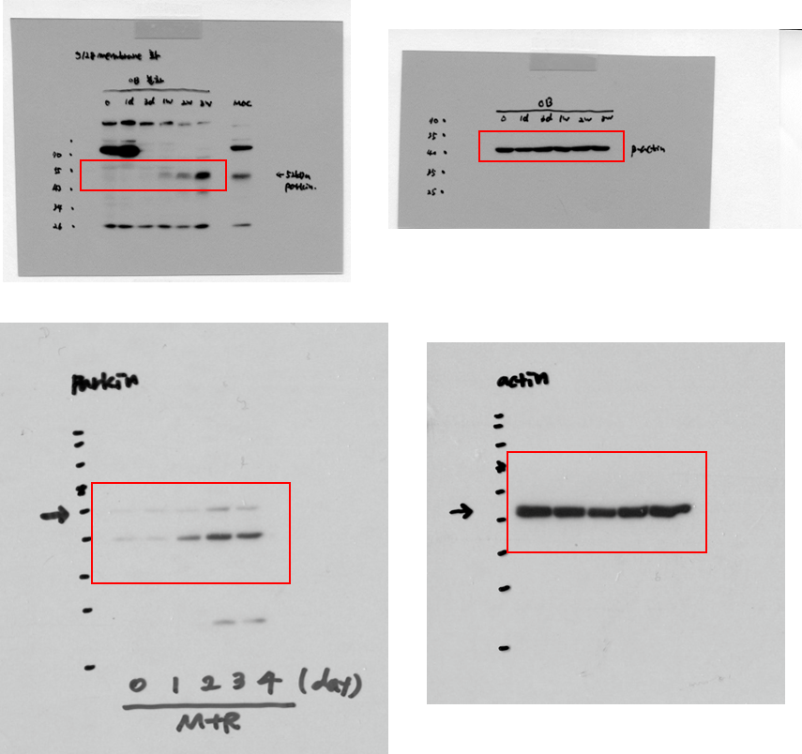
Figure 1C. Full gel image of western blot

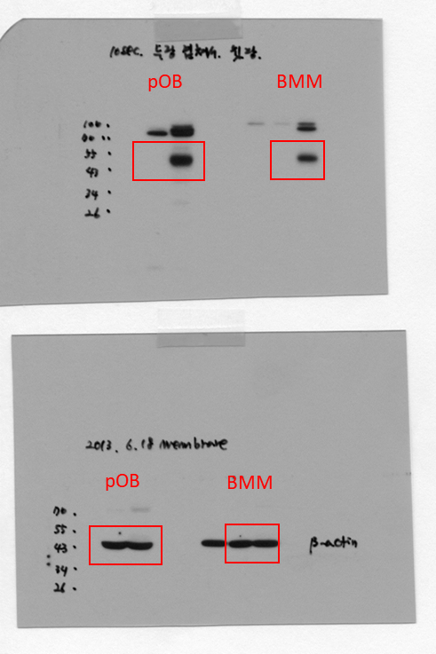
Figure 1D and 1E. Full gel image of western blot

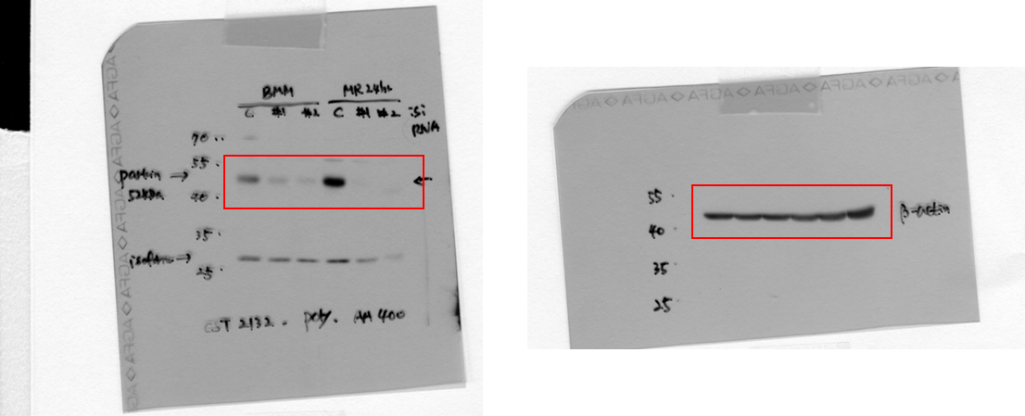
Figure 1F. Full gel image of western blot

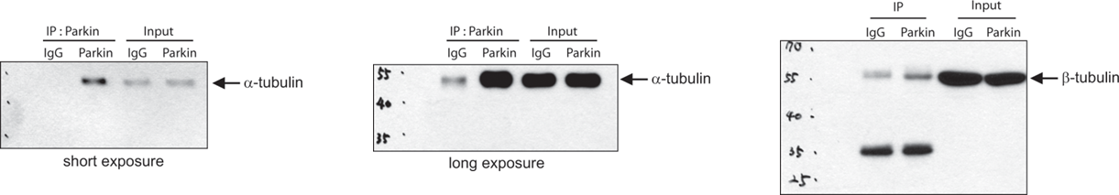
Figure 3B. Full gel image of western blot

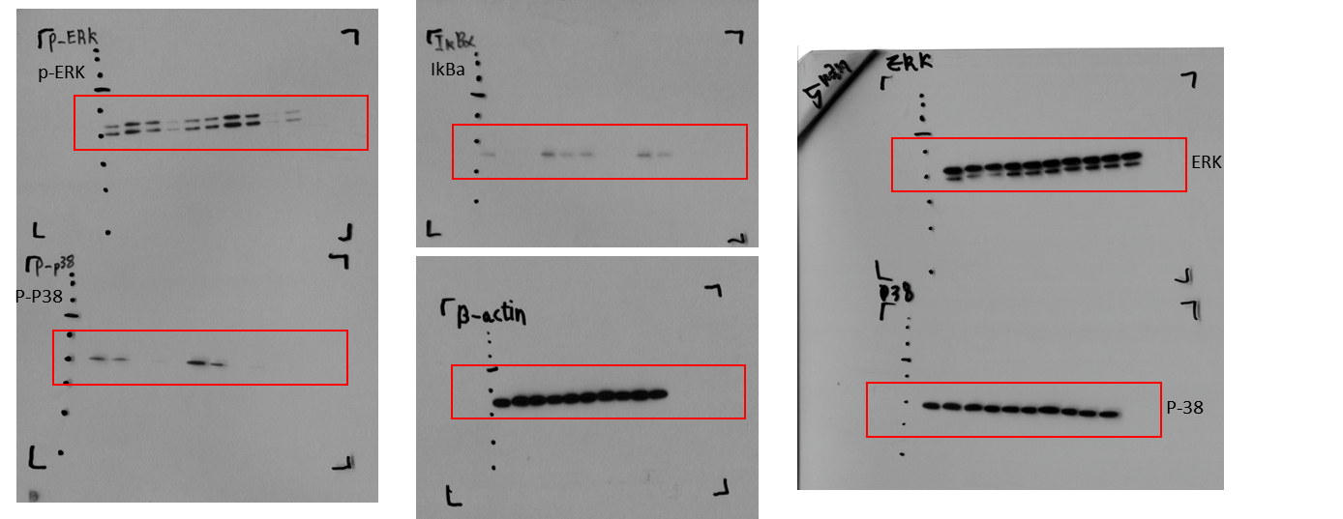
Figure 3D. Full gel image of western blot

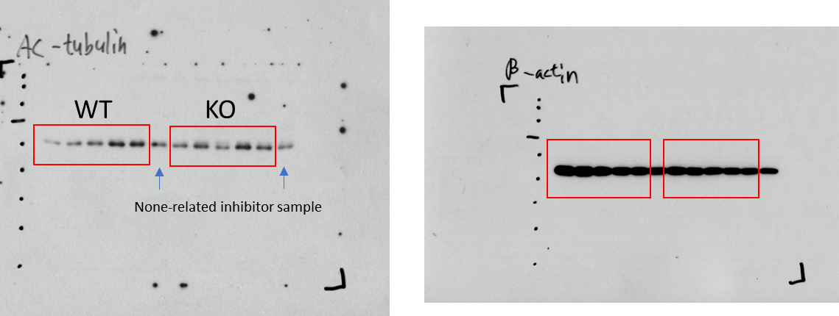
Figure 3E. Full gel image of western blot

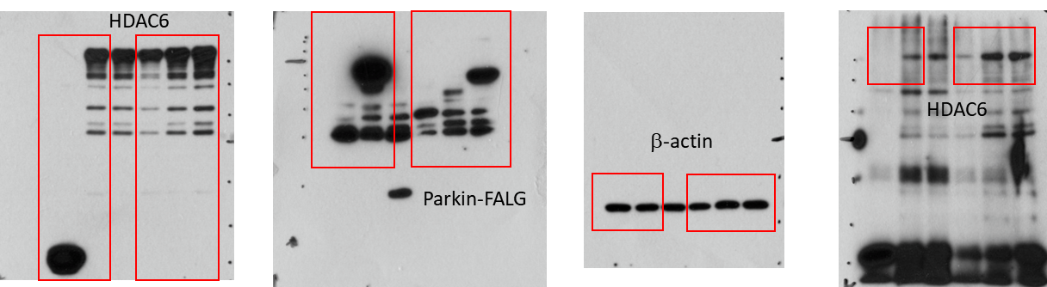
Figure 4B. Full gel image of western blot

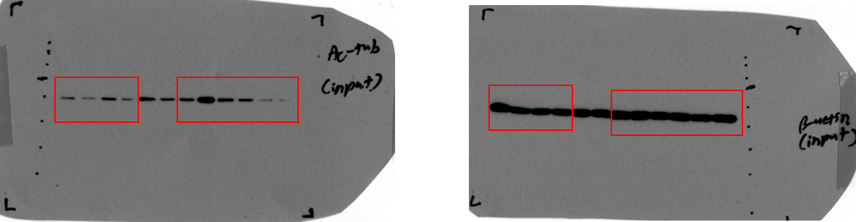
Figure 4C. Full gel image of western blot

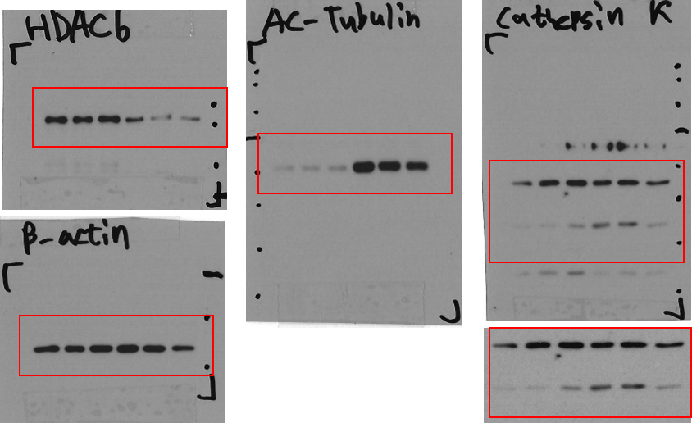
Figure 4D. Full gel image of western blot

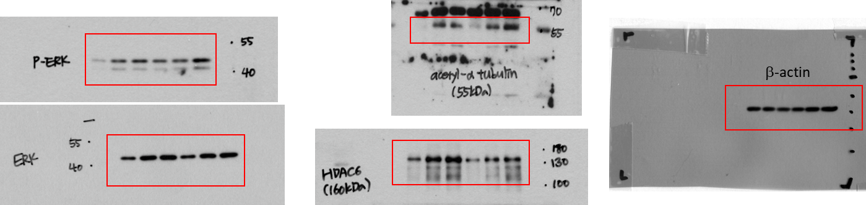
Figure 7A. Full gel image of western blot

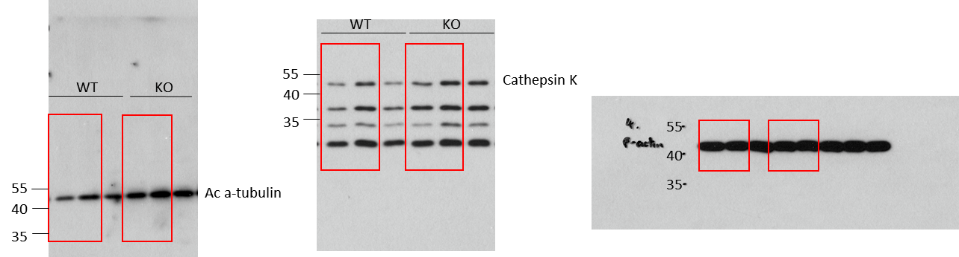
Figure 7C. Full gel image of western blot

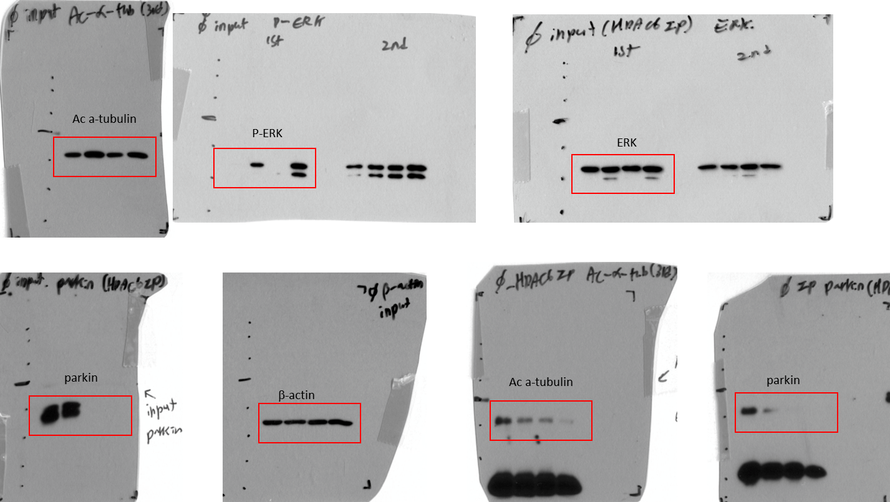
Figure 7D. Full gel image of western blot

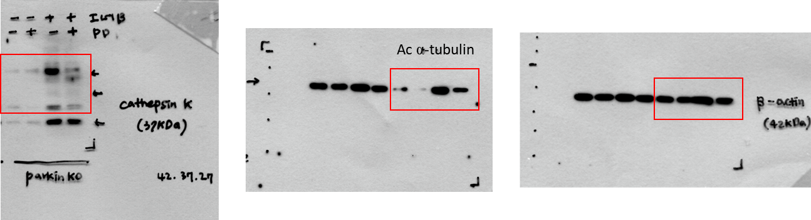
Figure 7E. Full gel image of western blot

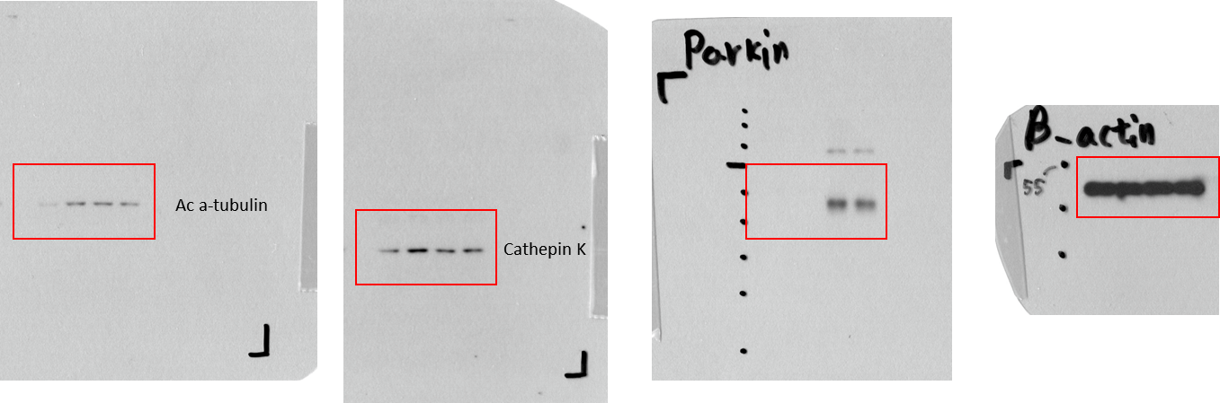
Figure 7G. Full gel image of western blot

