Table 1 characteristics of cases for delineation
case | location | stage | primary tumor | involved lymph node(s)
1 | UTE | T3N0M0 | 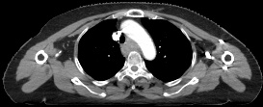
2 | MTE | T3N1M0 | 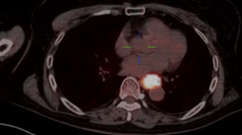 | 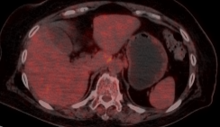
3 | LTE | T3N2M0 | 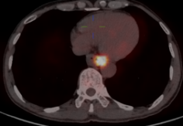 | 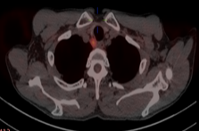 | 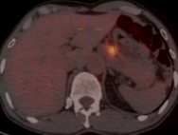
4 | UTE | T3N1M0 | 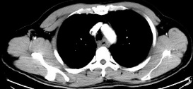 | 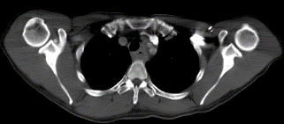
5 | MTE | T3N1M0 | 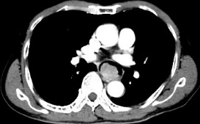 | 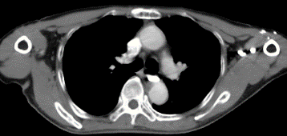
6 | LTE | T3N2M0 | 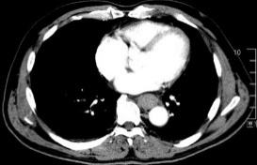 | 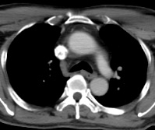 | 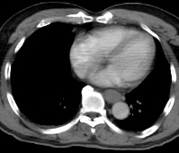
7 | UTE | T3N1M0 | 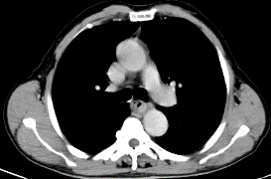 | 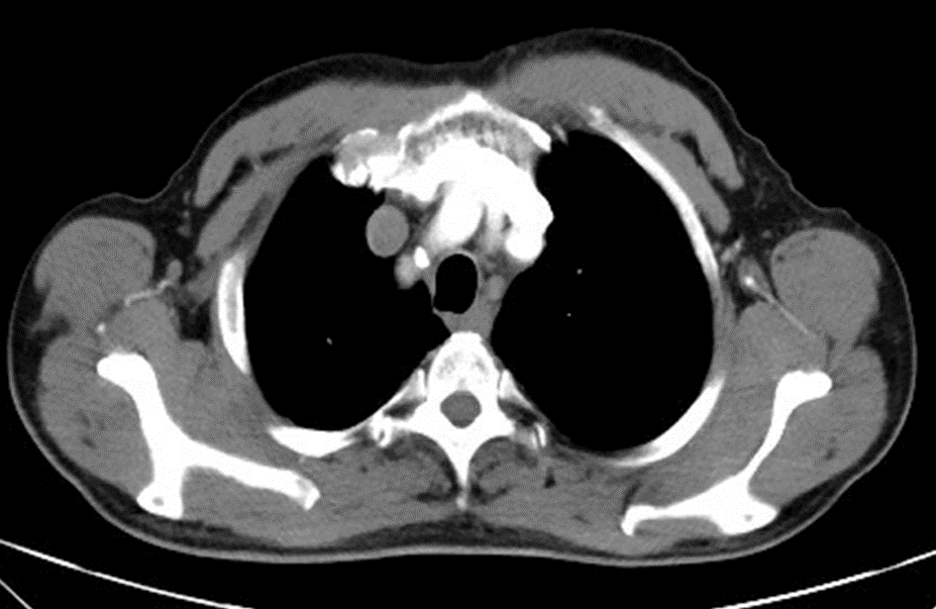
8 | MTE | T3N0M0 | 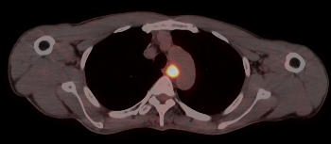
9 | LTE | T3N1M0 | 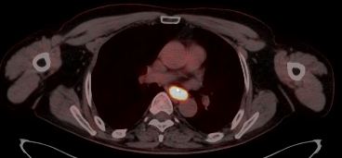 | 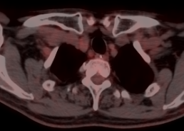

Table 2 GTVp delineation agreement between centers
 | DSC, mean (SD) |  |  |  | Hmean, mean (SD), mm |  |  |  | Volume, mean (SD), cm³
 | Round 1 | Round 2 | P |  | Round 1 | Round 2 | P |  | Round 1 | Round 2 | P
UTE | 0.81(0.07) | 0.87(0.31) | 0.016 |  | 1.73(0.83) | 1.23(0.50) | 0.258 |  | 38.65(7.20) | 24.69(2.92) | 0.000
MTE | 0.77(0.06) | 0.81(0.07) | 0.237 |  | 3.63(1.44) | 2.12(1.08) | 0.035 |  | 36.79(11.49) | 27.59(6.32) | 0.053
LTE | 0.80(0.06) | 0.80(0.09) | 0.735 |  | 2.68(1.56) | 2.38(1.99) | 0.735 |  | 33.88(6.84) | 22.53(5.87) | 0.007

Table 3 CTVtotal delineation agreement between centers
 | DSC, mean (SD) |  |  |  | Hmean, mean (SD), mm |  |  |  | Volume, mean (SD), cm3
 | Round 1 | Round 2 | P |  | Round 1 | Round 2 | P |  | Round1 | Round2 | P
UTE | 0.63(0.13) | 0.81(0.03) | 0.001 |  | 5.66(2.86) | 2.11(0.53) | 0.000 |  | 148.89(44.47) | 83.91(18.25) | 0.001
MTE | 0.64(0.08) | 0.76(0.05) | 0.008 |  | 5.81(1.67) | 2.90(0.61) | 0.001 |  | 139.53(31.76) | 81.33(16.27) | 0.000
LTE | 0.63(0.12) | 0.80(0.09) | 0.019 |  | 7.34(3.55) | 3.14(1.62) | 0.005 |  | 165.31(54.27) | 95.71(25.59) | 0.002

