Table 1. View application form for midwifery in this study
Pre-existing applications
This application uses Excel and is not integrated with the WEB  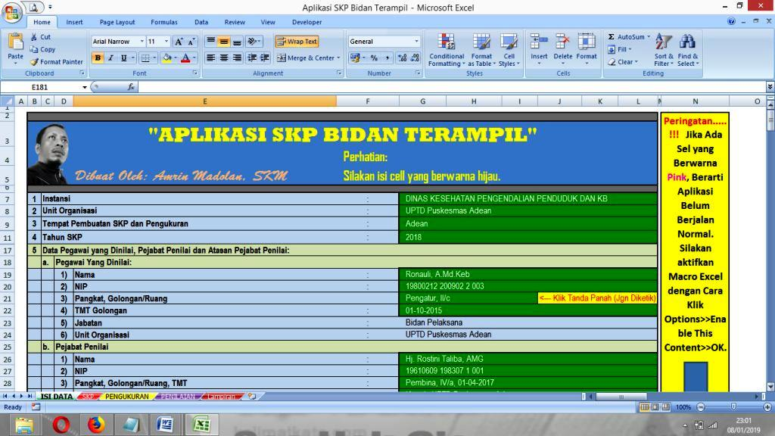 | The input process is still manual and not integrated with the credit score of civil servant midwifes  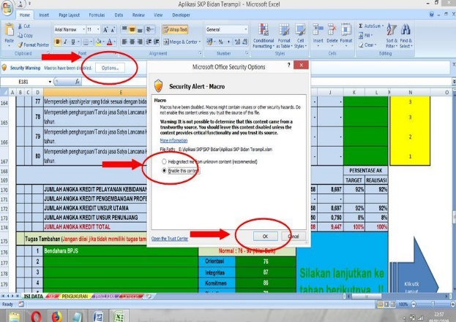
This application is specifically for teachers, only specifically for calculating credit scores  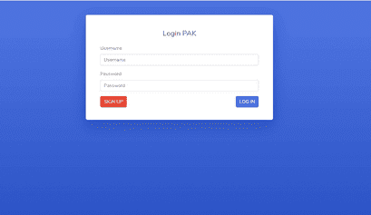 | The process of inputting and analyzing credit numbers is still a manual system  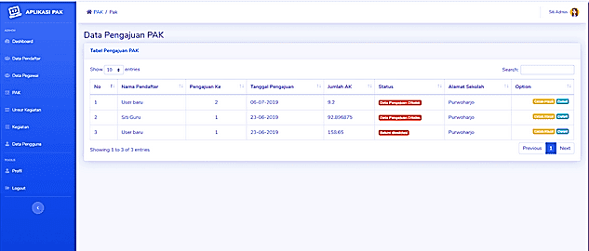
This application is specifically for midwifes, but just for detection maternal and newborn  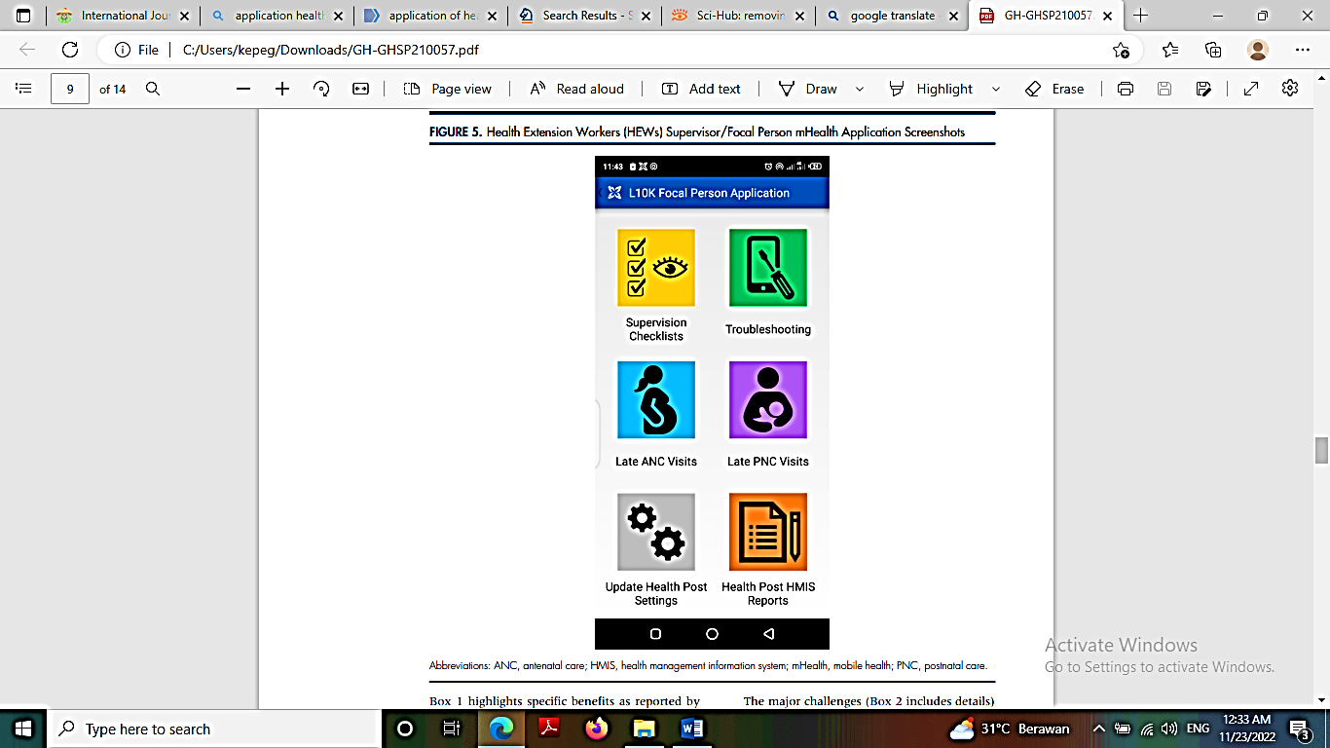 | 