Supplementary Material
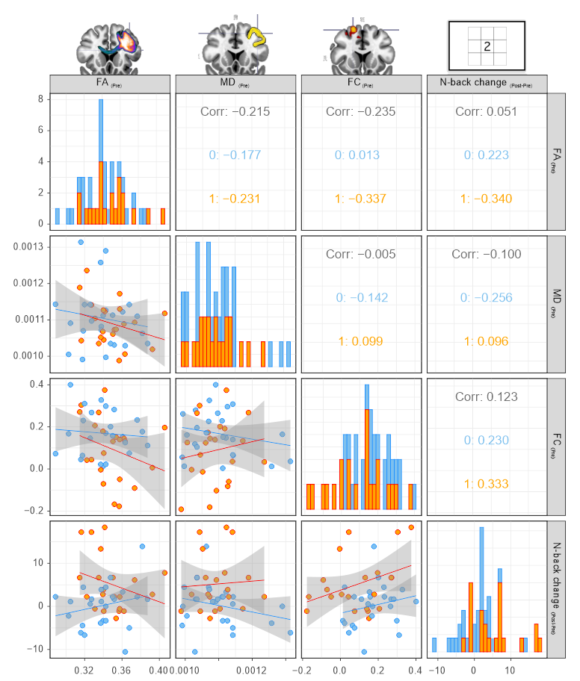
Supplementary Figure 1. Scatterplots for correlations between Baseline FA, MD, and FC (values at Pre) with individual performance gain (N-back change). FA, fractional anisotropy. MD, mean diffusivity. FC, functional connectivity. Blue bars/points/0: sham group. Orange bars/points/1: anodal tDCS group.

