Supplementary material
Role of size-dependent damping due to electron-surface scattering on the Al nanoparticle-based deep ultraviolet surface enhanced fluorescence
T. Mahata, P. Patar#, S. Sahoo#, A. Mandal, V. R. Dantham*
#Equal contribution
Department of Physics Indian Institute of Technology Patna, Bihar 801103, India
*Corresponding author.
Tel.: 0612-302-8140
Email address: dantham@iitp.ac.in

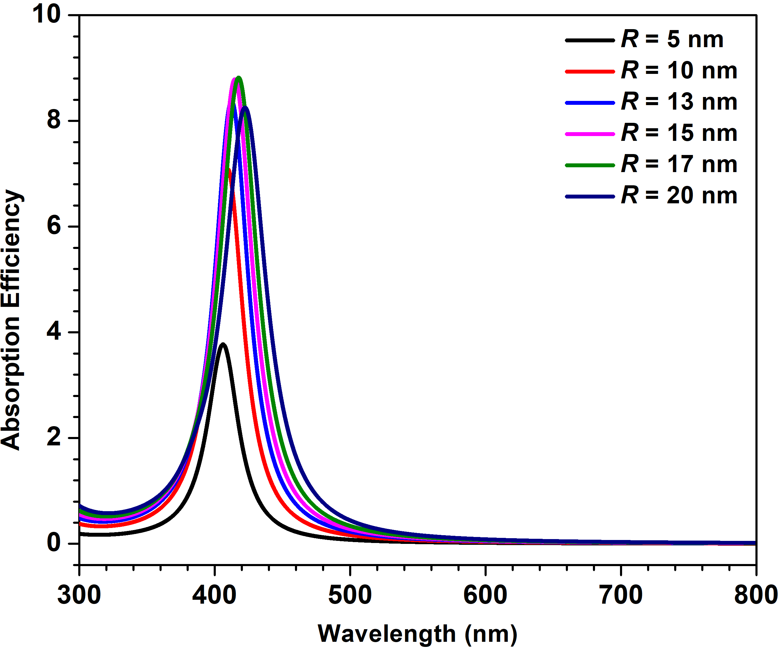  (c)  (a) | 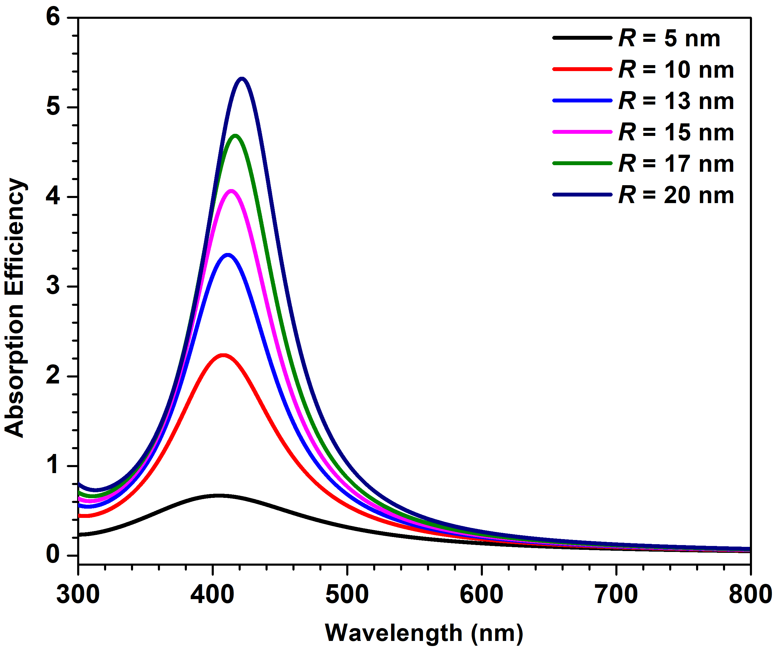  (d)  (b)
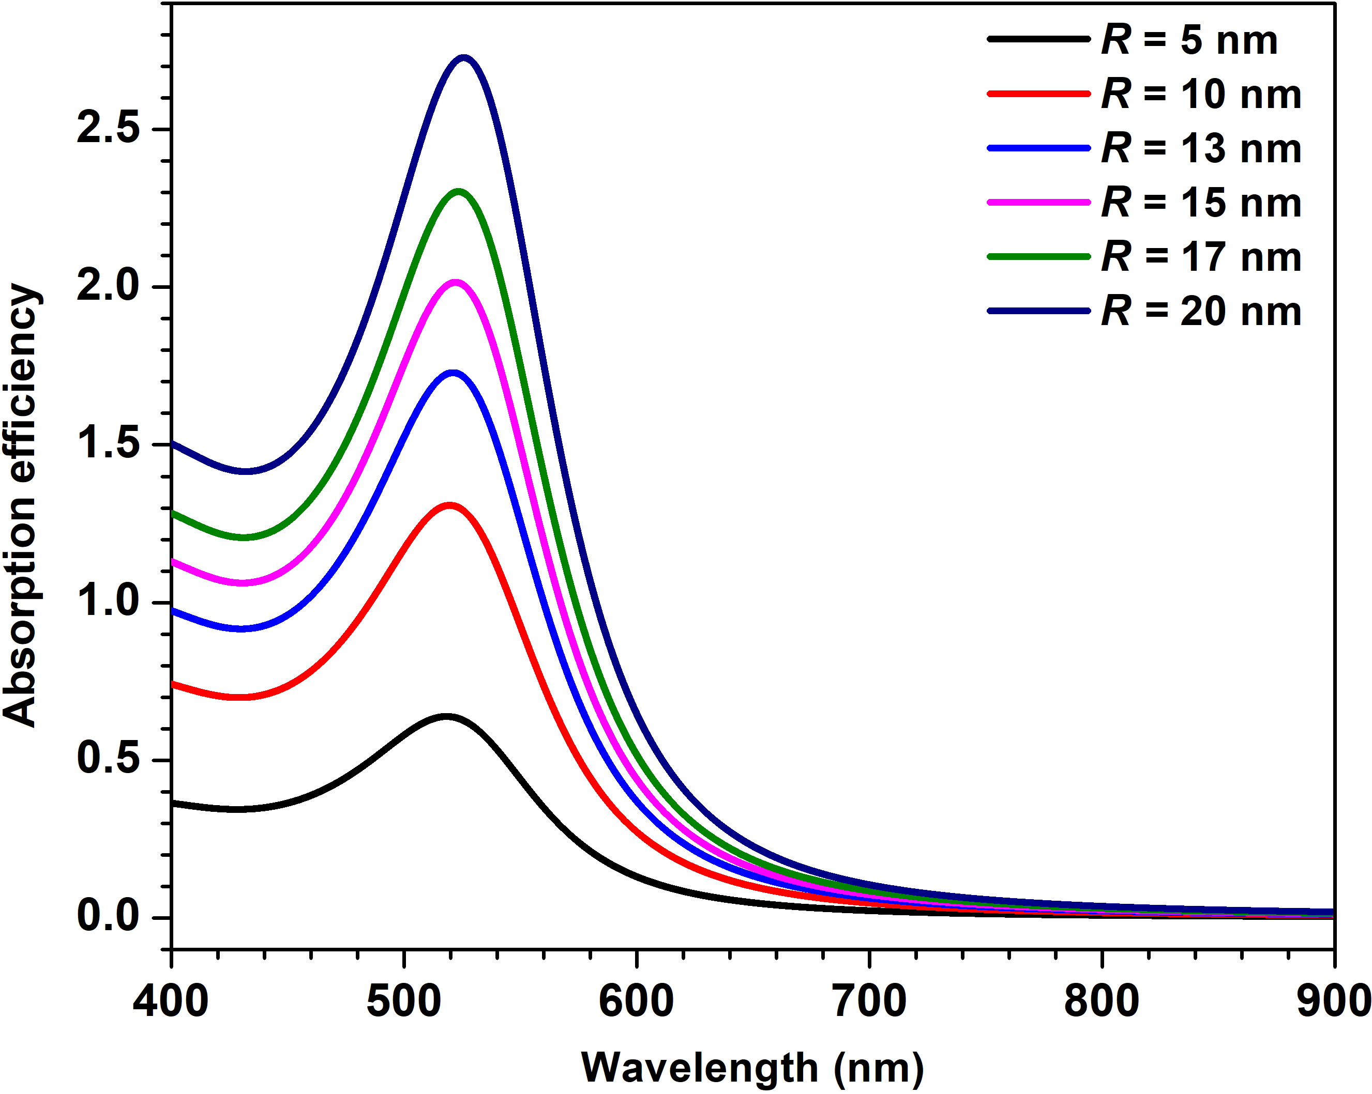 | 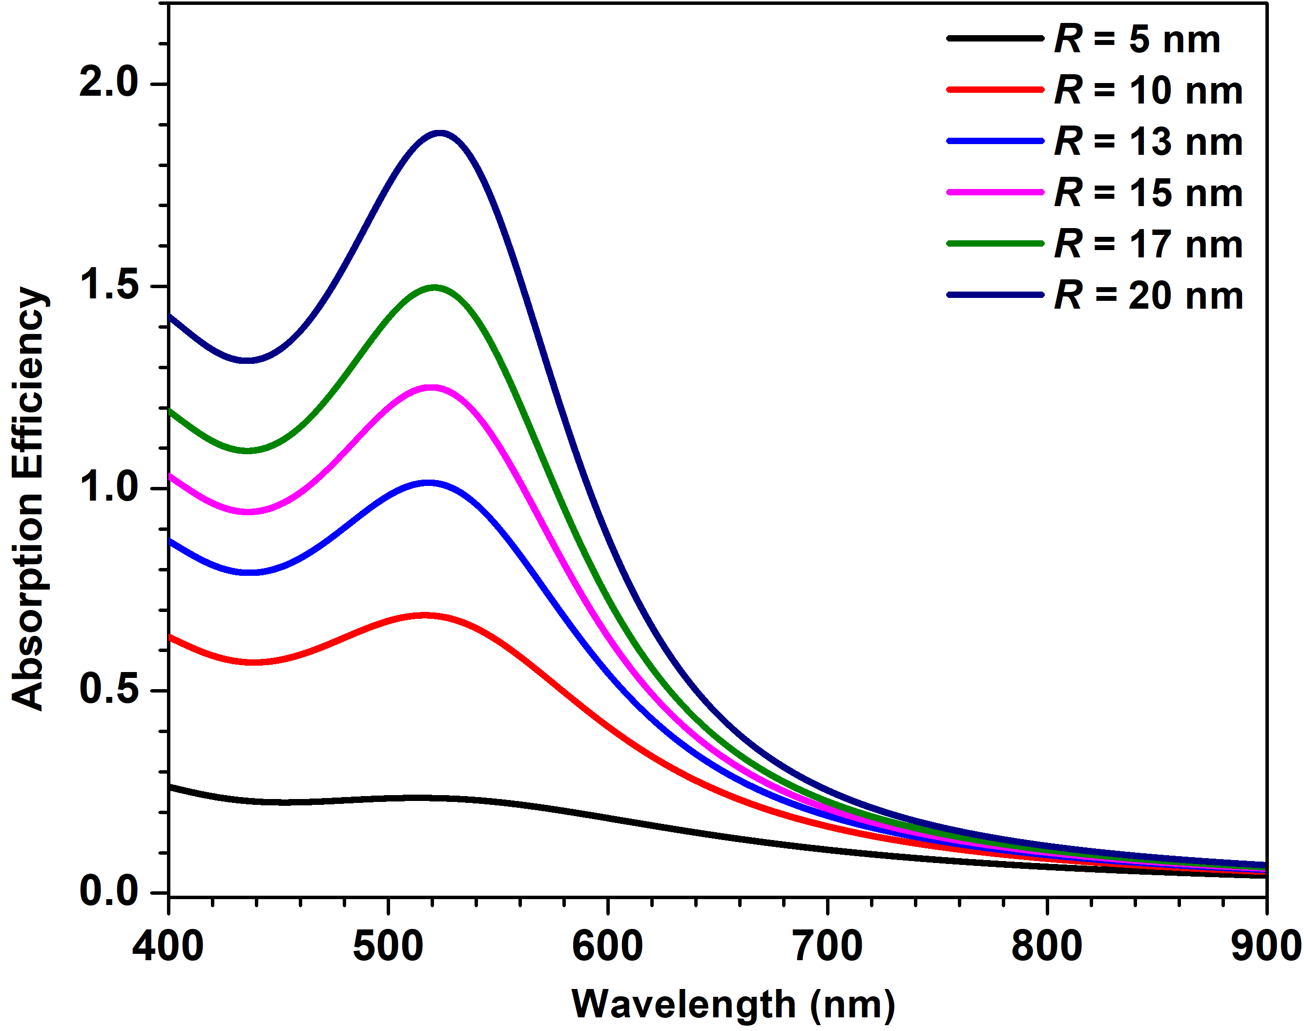
Fig. S1. Panels (a) and (b) represent absorption efficiency spectra in the absence and presence of SDD in single Ag nanospheres of different R, respectively. Panels (c) and (d) represent absorption efficiency spectra in the absence and presence of SDD in single Ag nanospheres of different R, respectively. For all cases, the n_{med} value is fixed at 1.333.

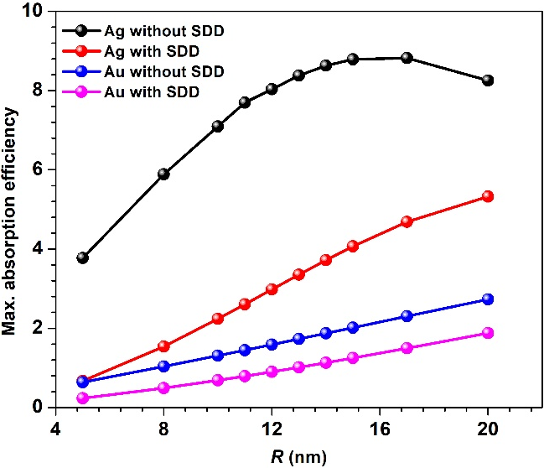  (a) | 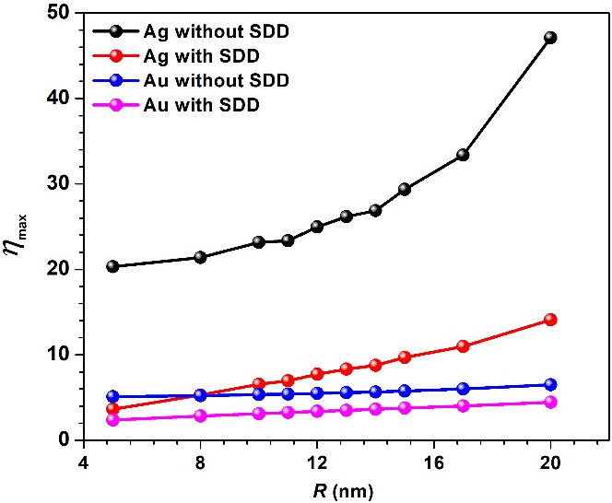  (b)
Fig. S2 Panel (a) represents the maximum absorption efficiency values in the presence and absence of SDD in single Ag and Au nanospheres with different R values. Panel (b) shows $η_{max}$versus R curves in the presence and absence of SDD in Ag and Au nanospheres.

