Supplementary Material

Supplementary Table

Supplementary Table 1 ： Primer used for real-time RT-PCR.

Primer | Forward primer sequence | Reverse primer sequence
ALKBH1 | AAACTTTTCCGCTTCTACCGTC | TTTGAGTCCATAGGCTTGCCA

Supplementary Table 2: Multivariate cox analysis of m1Ascore.
ID | HR | HR.95L | HR.95H | p-value
age | 2.46450785 | 1.806571458 | 3.362058509 | 1.25E-08
gender | 1.425501299 | 1.071364616 | 1.896696908 | 0.014972561
m1Ascore | 0.974002844 | 0.958456827 | 0.989801015 | 0.001333226

Supplementary Figure

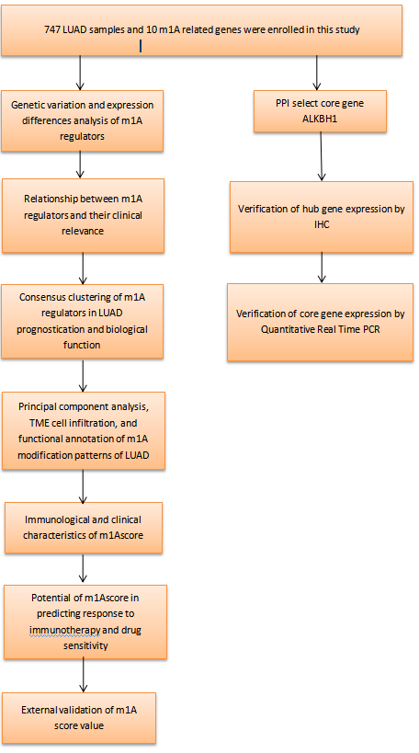
Supplementary Figure 1: A flow chart to the study design.

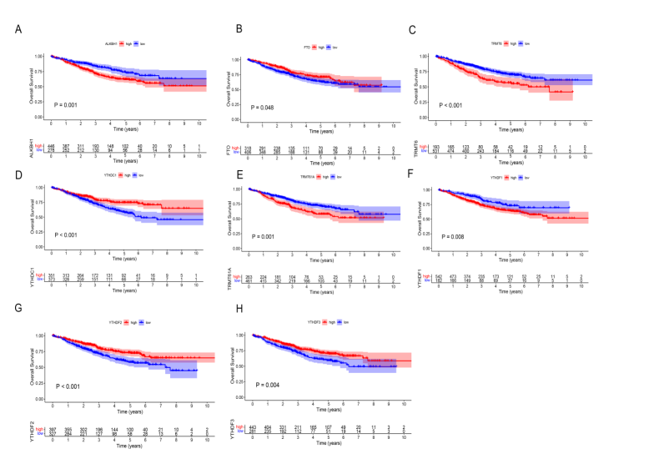
Supplementary Figure 2: Survival rate analysis of m1A regulatory factor in patients with LUAD. (A) ALKBH1 survival analysis; (B) FTO survival analysis; (C) TRMT6 survival analysis; (D) YTHDC1 survival analysis; (E) TRM61A survival analysis; (F) YTHDF1 survival analysis; (G) YTHDF2 survival analysis; (H) YTHDF3 survival analysis.

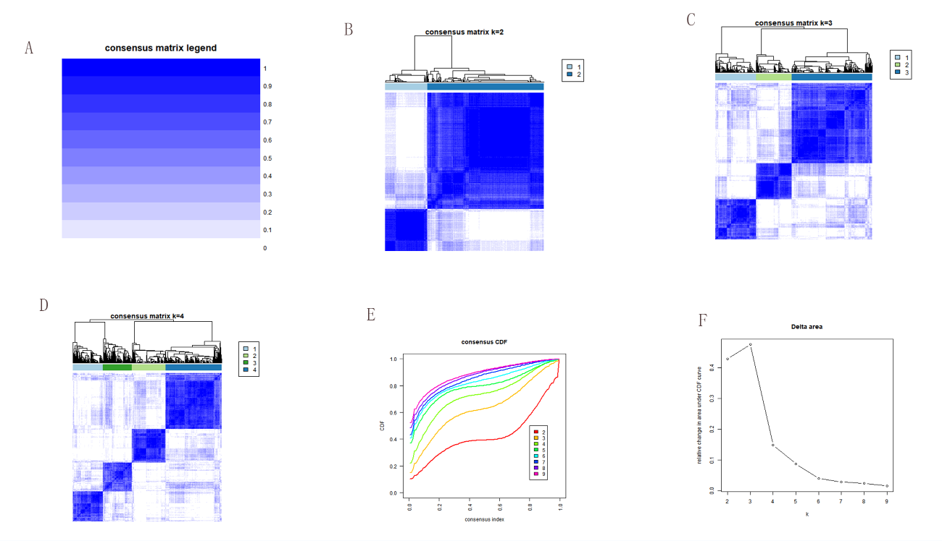

Supplementary Figure 3: Without supervision consensus clustering of 10 m1A regulatory factors in patients with LUAD. (A-D) Consensus matrices of the training cohort for K = 2-4. (E) Cumulative distribution function (CDF). (F) Relative change of area under CDF curve.

Supplementary Figure 4: Cell immersion in the TME of LUAD. (A-D) The violin chart shows differences in TME scores under different m1A modification patterns, including immune score, matrix score, estimated score, and tumor purity. (E-H) The violin diagram showed the differences in TME index scores under gene clustering, including immune score, matrix score, estimated score, and tumor purity. (*, P < 0.05; **, P < 0.01; ***, P < 0.001; ns, not significant).

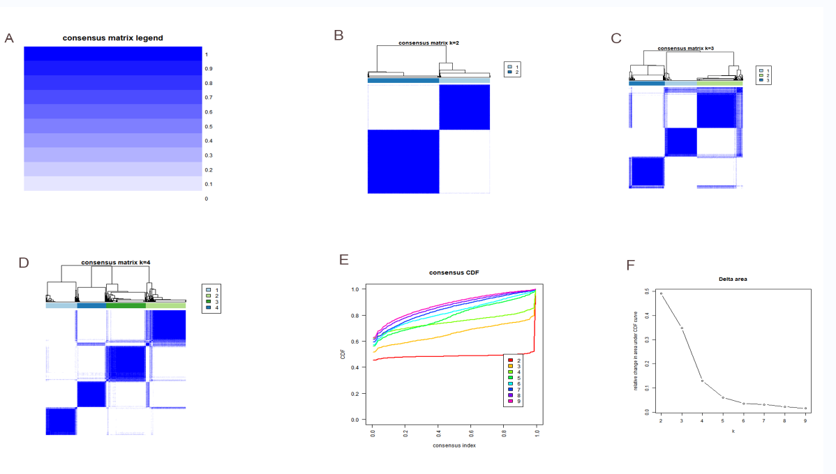
Supplementary Figure 5: Non-monitored cluster of 219 m1A phenotype-related genes in patients with LUAD. (A-D) Consensus matrices of the training cohort for K = 2-4. (E) Cumulative distribution function (CDF). (F) Relative change in area under the CDF curve.

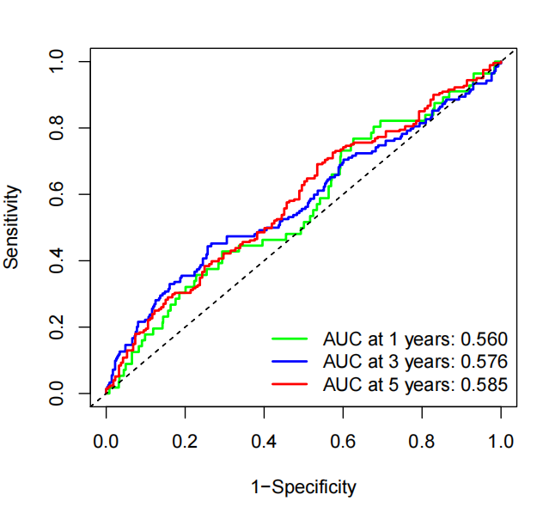

Supplementary Figure 6: The time-ROC analysis for m1AScore for predicting OS rate.

