Supplement Figure Legends

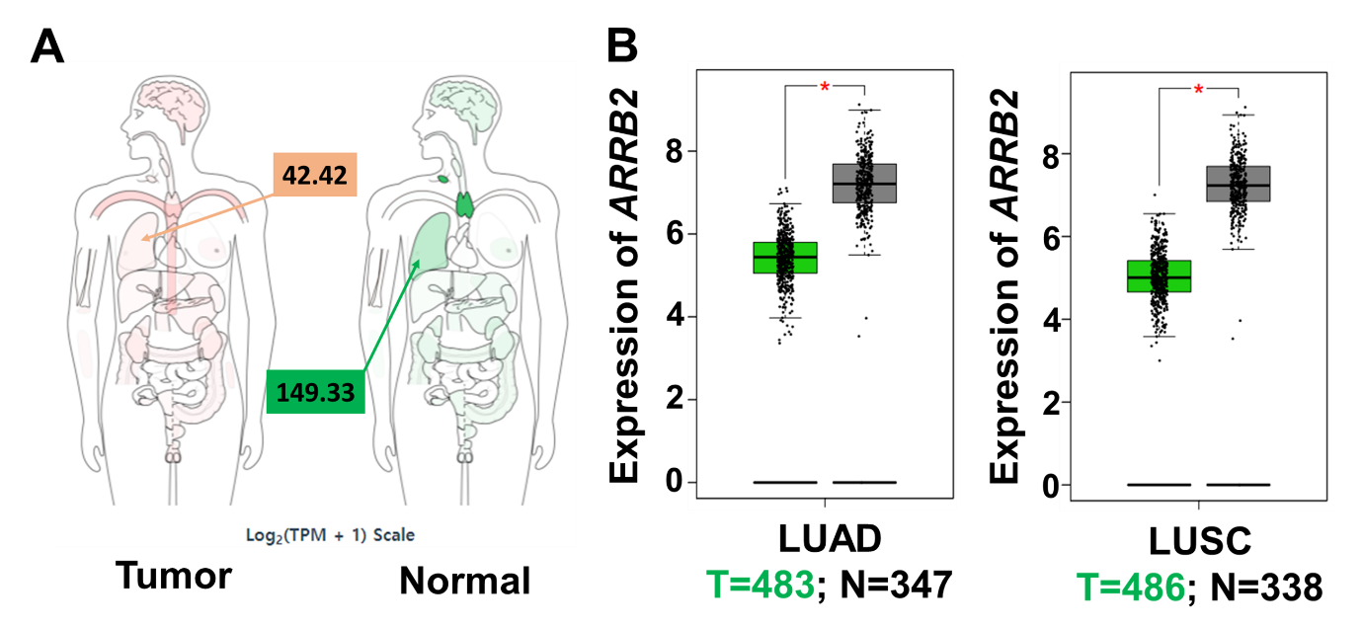
Supplementary Fig. S1 ARRB2 expression in LUAD (Lung adenocarcinoma) and LUSC (Lung squamous cell carcinoma). A and B) ARRB2 expression was analyzed with data from The Cancer Genome Atlas through Gene expression Profiling Interactive Analysis (GEPIA, http://gepia.cancer-pku.cn/detail.php?gene=ARRB2###). Interactive bodymap was represented (A). ARRB2 expression on box plots was showed in LUAD and LUSC (B: left, LUAD; right, LUSC). * p < 0.05.

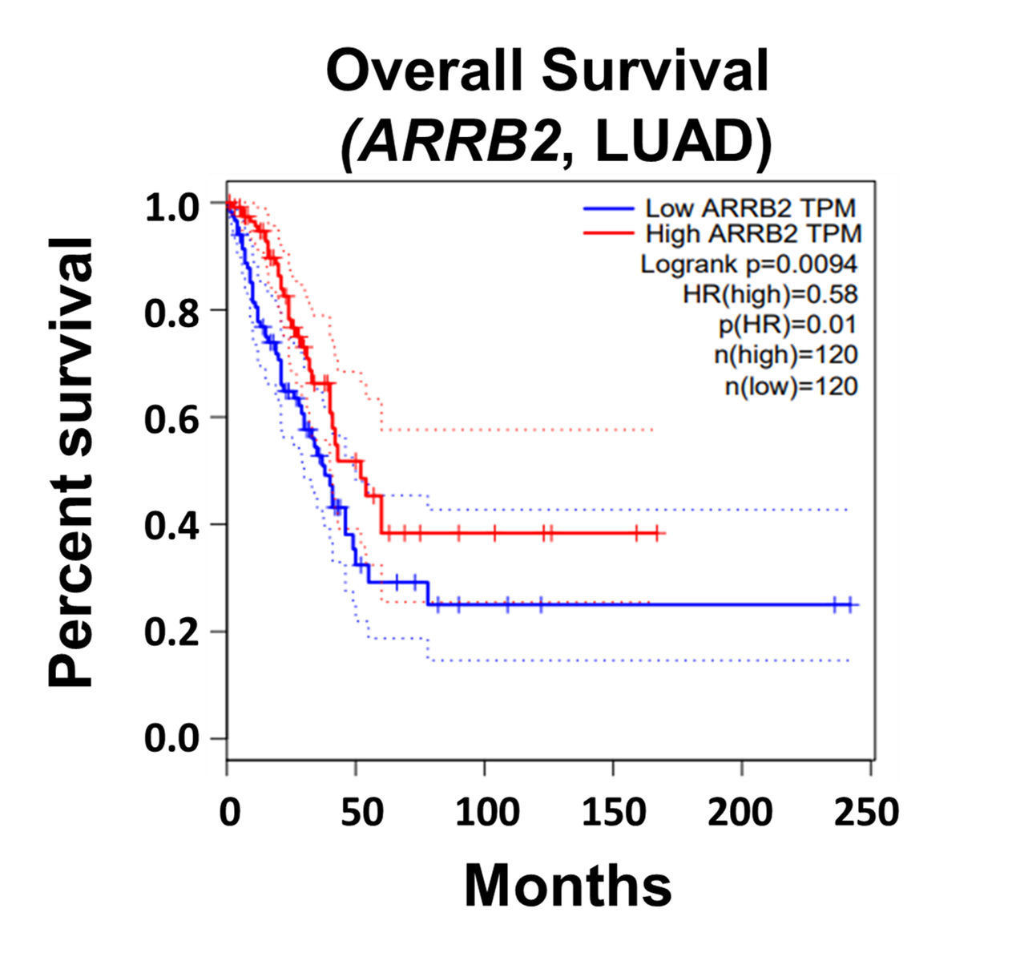
Supplementary Fig. S2 Overall survival of LUAD patients. Overall survival data was obtained from The Cancer Genome Atlas through Gene expression Profiling Interactive Analysis (GEPIA, http://gepia.cancer-pku.cn/detail.php?gene=ARRB2###). p=0.0094, low ARRB2 vs. high ARRB2.

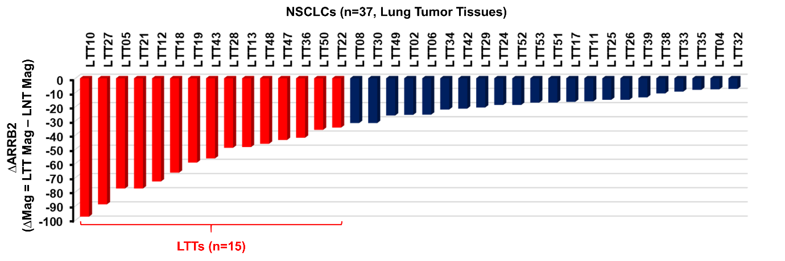
Supplementary Fig. S3. Differential magnitude of ARRB2 expression between lung tumor tissues (LTTs) and matched lung normal tissues (LNTs) of NSCLC patients (n=37). Magnitude difference of ARRB2 (∆ARRB2) was obtained from the pre-processed microarray data between LTTs (n=37) and matched LNTs (n=37, ∆Mag = LTT Mag – LNT Mag). Top 15 LTTs with the downregulated ARRB2 were selected, as indicated in red boxes.

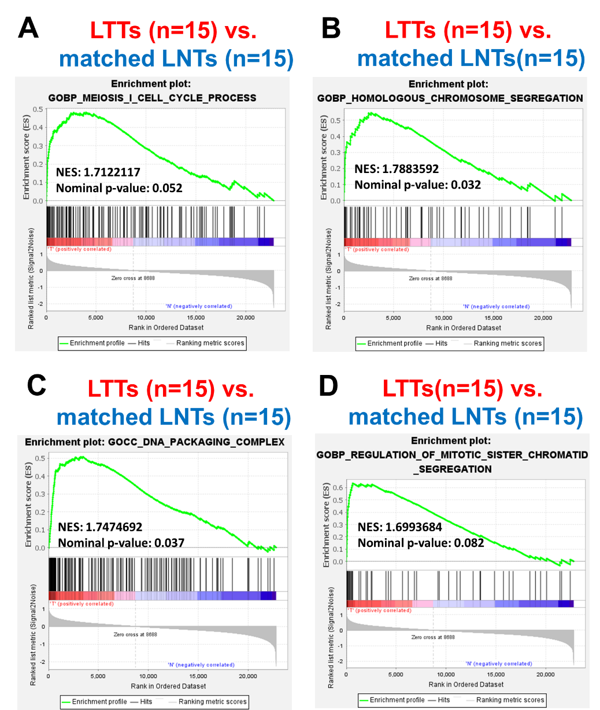
Supplementary Fig. S4. Gene Set Enrichment Analysis (GSEA) between 15 LTTs and matched 15 LNTs of NSCLC patients. A-D According to the different magnitude of ARRB2 in LTTs vs. matched LNTs (Fig. S3), top 15 LTTs with the down-regulated ARRB2 in 37 LTTs were selected, and GSEA (http://www.gsea-msigdb.org/gsea/index.jsp) was performed in 15 LTTs vs. matched 15 LNTs. Four gene sets, MEIOSIS I CELL CYCLE PROCESS (A), HOMOLOGOUS CHROMOSOME SEGREGATION (B), DNA PACKAGING COMPLEX (C) and REGULATION OF MITOTIC SISTER CHROMATID SEGREGATION (D), were represented. NES and Nominal p-value were indicated in each inner panel.

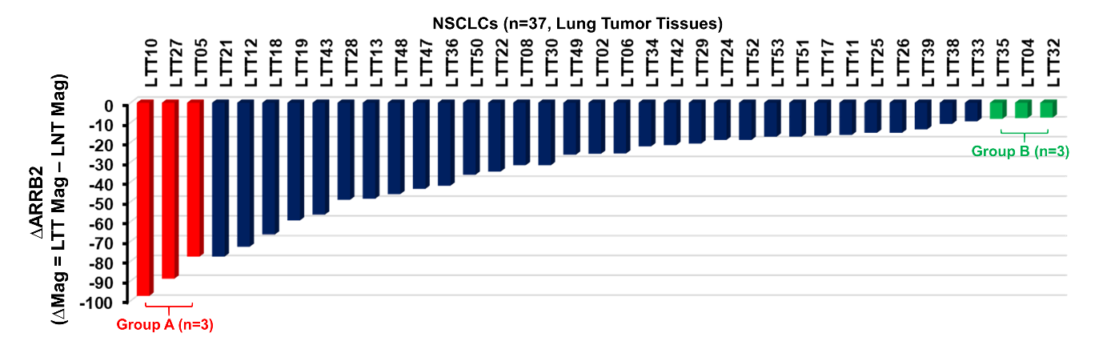
Supplementary Fig. S5. Differential magnitude of ARRB2 expression between lung tumor tissues (LTTs) and matched lung normal tissues (LNTs) of NSCLC patients (n=37). Magnitude difference of ARRB2 (∆ARRB2) was obtained from the pre-processed microarray data between LTTs (n=37) and matched LNTs (n=37, ∆Mag = LTT Mag – LNT Mag). 6 LTTs were selected from the top (3 LTTs with highly down-regulated ARRB2, Group A, red boxes) and bottom (3 LTTs with lowly down-regulated ARRB2, Group B, green boxes).

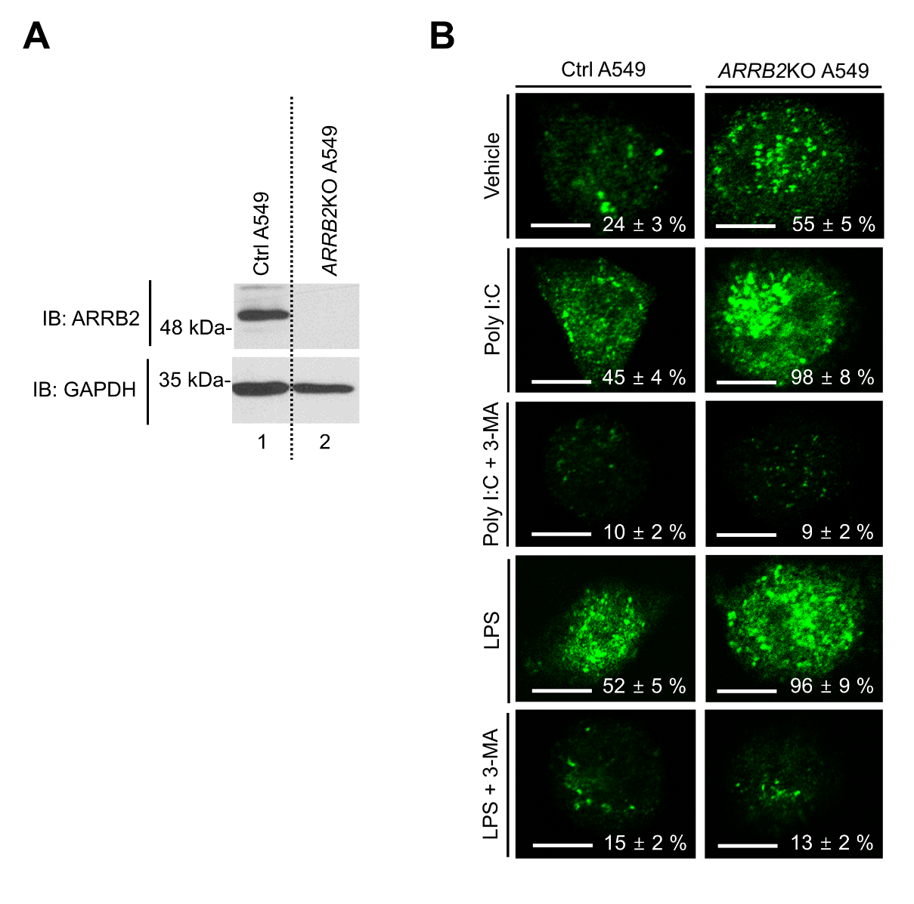
Supplementary Fig. S6. Generation of ARRB2-knockout (ARRB2KO) A549 cells and LC3 puncta assay. A ARRB2-knockout (ARRB2KO) A549 cells were generated by CRISPR/Cas9 gene-editing method, as described in Material and Methods. ARRB2 expression was verified by anti-ARRB2 antibody, along with anti-GAPDH as a loading control. B Ctrl A549 and ARRB2KO A549 cells were treated with vehicle (DMSO, 0.1% v/v concentration), Poly I:C (5 μg/ml), or LPS (15 μg/ml) in the presence or absence of 3-MA (5 mM) for 6 h, and immunolabeled with LC3 antibody, as described in Material and Methods. Images shown are representative fluorescence confocal microscopic photographs. Quantification of the percentage of cells with autophagosomes is shown (± SD, n = 50 cells). Scale bar: 10 μm.

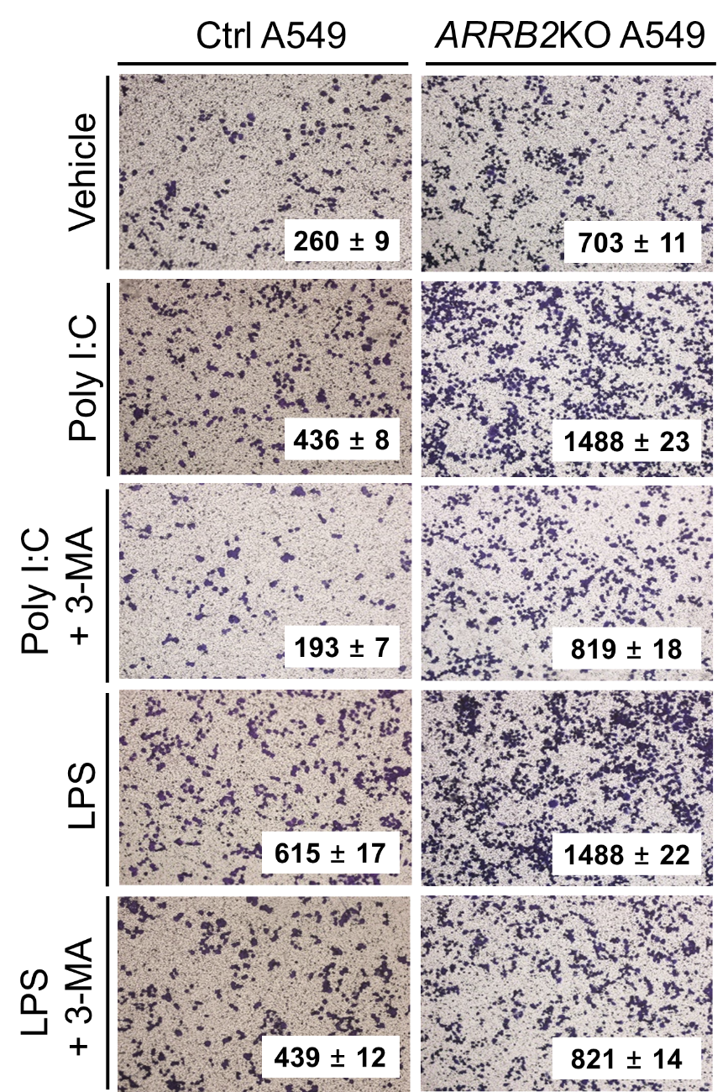
Supplementary Fig. S7. ARRB2KO A549 cells exhibit enhancements of cell invasion induced by TLR3 and TLR4. Ctrl A549 and ARRB2KO A549 cells treated with vehicle (DMSO, 0.1% v/v concentration), Poly I:C (15 μg/ml), or LPS (15 μg/ml) in the presence or absence of 3-MA (5 mM) for different times, as described in Material and Methods. The migrating cells were counted. The results are presented as the mean ± SD of three independent experiments.

Supplement Table information
Supplementary Table S1. Magnitude difference of ARRB2 (∆ARRB2) between lung tumor tissues (LTTs) and matched lung normal tissues (LNTs) of NSCLC patients (n=37)

