Supplementary Material

Supplementary Figure 1
“Let's make something with Goo Choki Paa” (Anpanman version)‘ sheet music
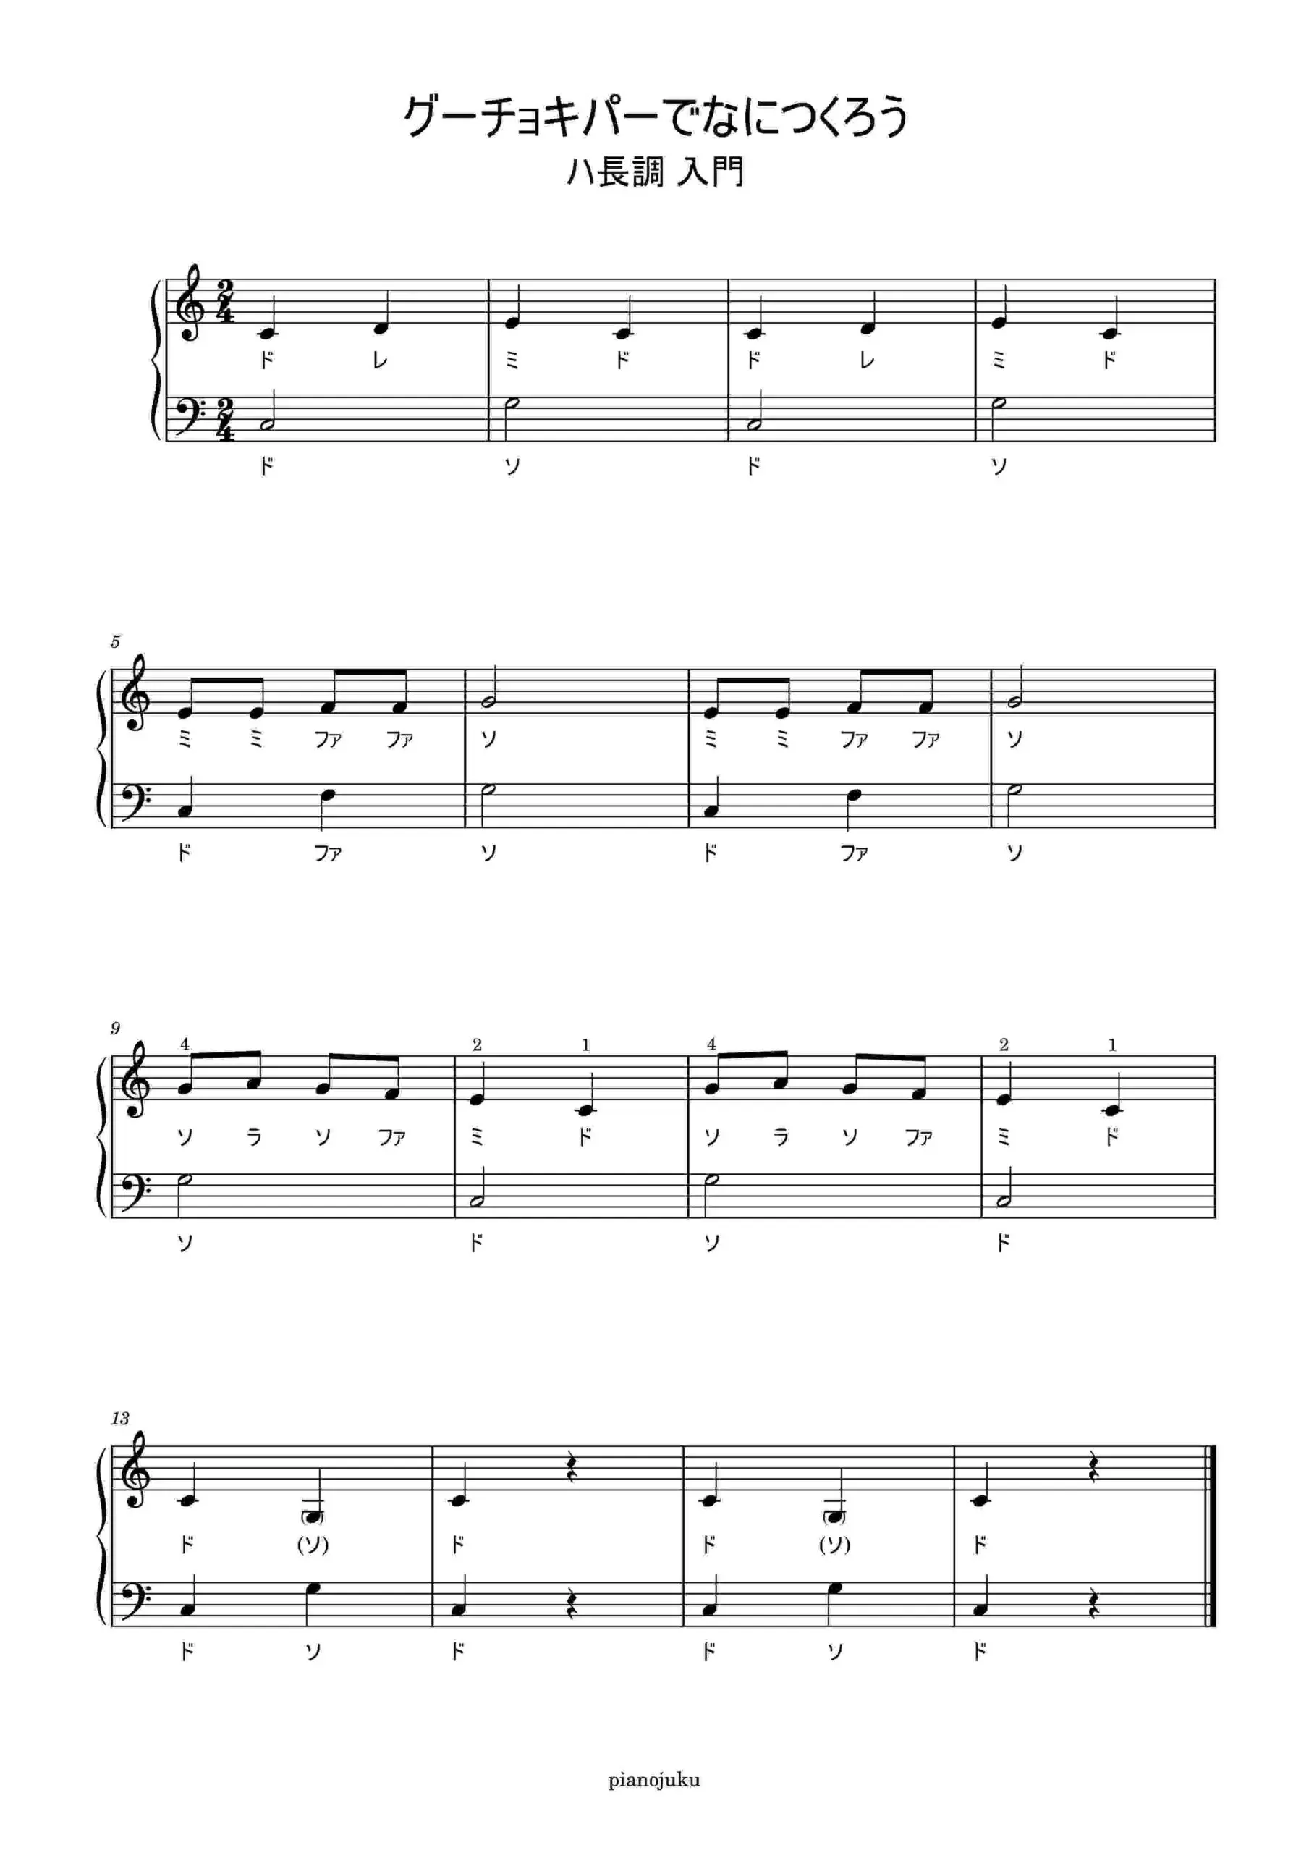
Note. Sing with goo (“stone” in Japanese), choki (“scissors”), and par (“paper”) while slowly showing stone, scissors, or paper using both hands, In tune with the melody; then use right hand as “stone” and left hand as “stone”, touch hands against cheeks, while singing Anpanman a cappella．
Supplementary Figure 2
“"Ton-ton-ton-ton beard grandpa” (Anpanman version)’s sheet music
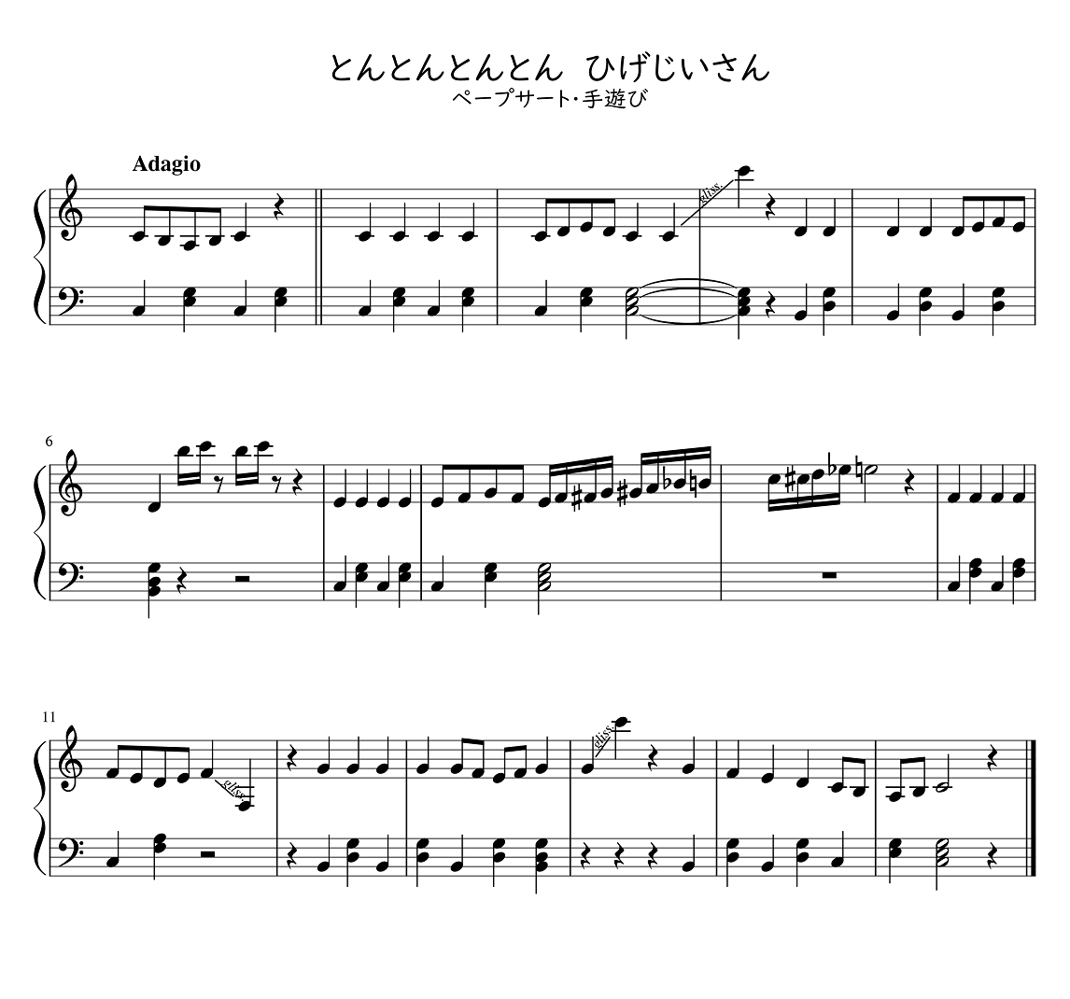
Note. The original is a French folk song. Swap the top and bottom with both hands shaped as “stone” (according to the melody) and sing with tap (ton in Japanese). Then touch the cheeks with both hands shaped as “stone,” while singing Anpanman a cappella.

