Supplementary Information

Distributions of total mercury and methylmercury in dragonflies from a large abandoned mercury mining region in China

Gaoen Wu^{a,b}, Shunlin Tang^{a**}, Jialiang Han^{b}, Chan Li^{b,c}, Lin Liu^{b}, Xiaohang Xu^{b}, Zhidong Xu^{b}, Zhuo Chen^{c},Yajie, Wang^{d}, Guangle Qiu^{b*}

ªInstitute of Resources and Environment, Henan Polytechnic University, Jiaozuo 454000, China
^{b}State Key Laboratory of Environmental Geochemistry, Institute of Geochemistry, Chinese Academy of Sciences, Guiyang 550081, China
^{c}School of Chemistry and Materials Science, Guizhou Normal University, Guiyang 550001, China
^{d}College of Food Science, Guizhou Medical University, Guiyang 550025, China

Correspondences
*Guangle Qiu, State Key Laboratory of Environmental Geochemistry, Institute of Geochemistry, Chinese Academy of Sciences, Guiyang 550081, China. E-mail: qiuguangle@vip.skleg.cn Phone: 0086-851-84396675 Fax: 0086-851-85891605.
**Shunlin Tang, Institute of Resources and Environment, Henan Polytechnic University, Jiaozuo 454000, China. E-mail: tangshunlin@hpu.edu.cn.

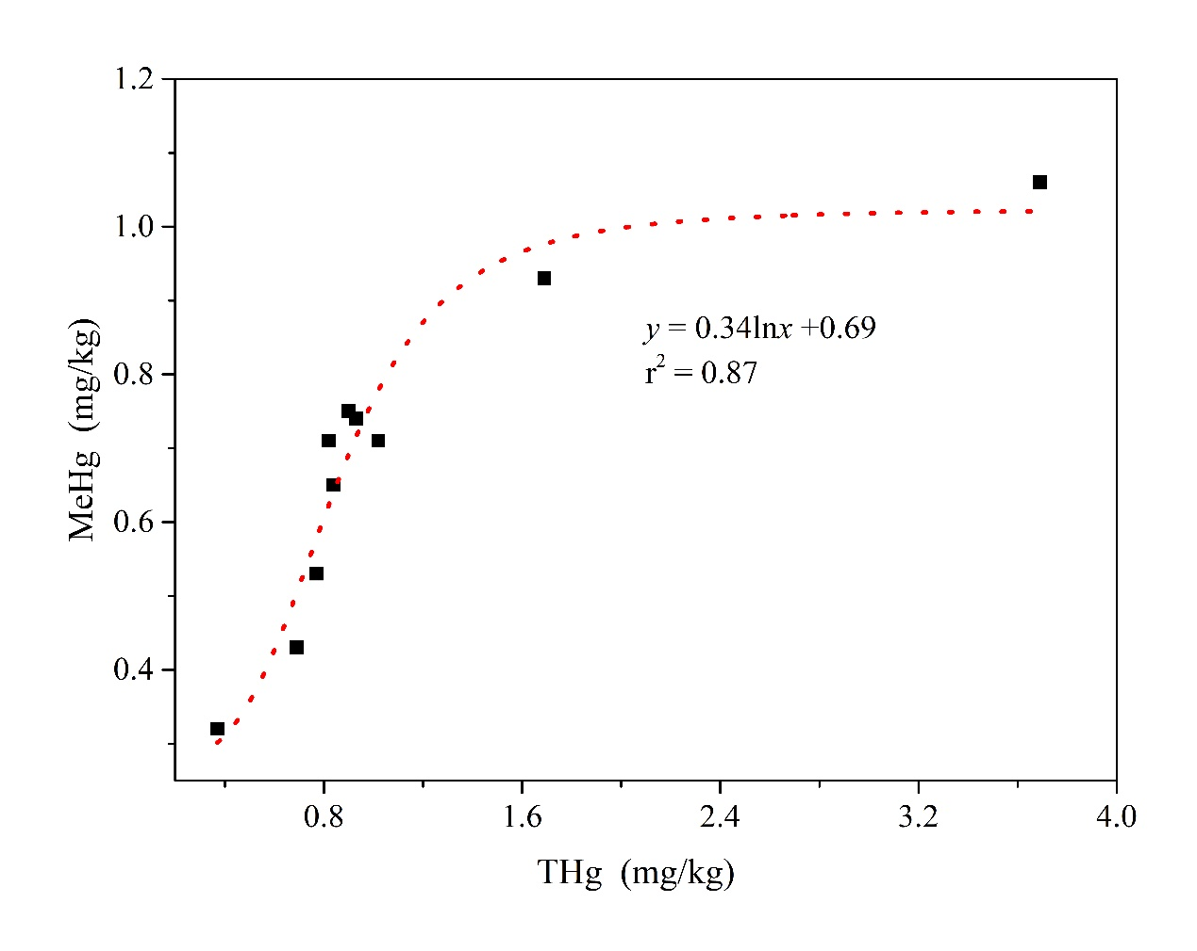
Figure S1 The relationship between THg and MeHg in dragonflies collected from 10 sites
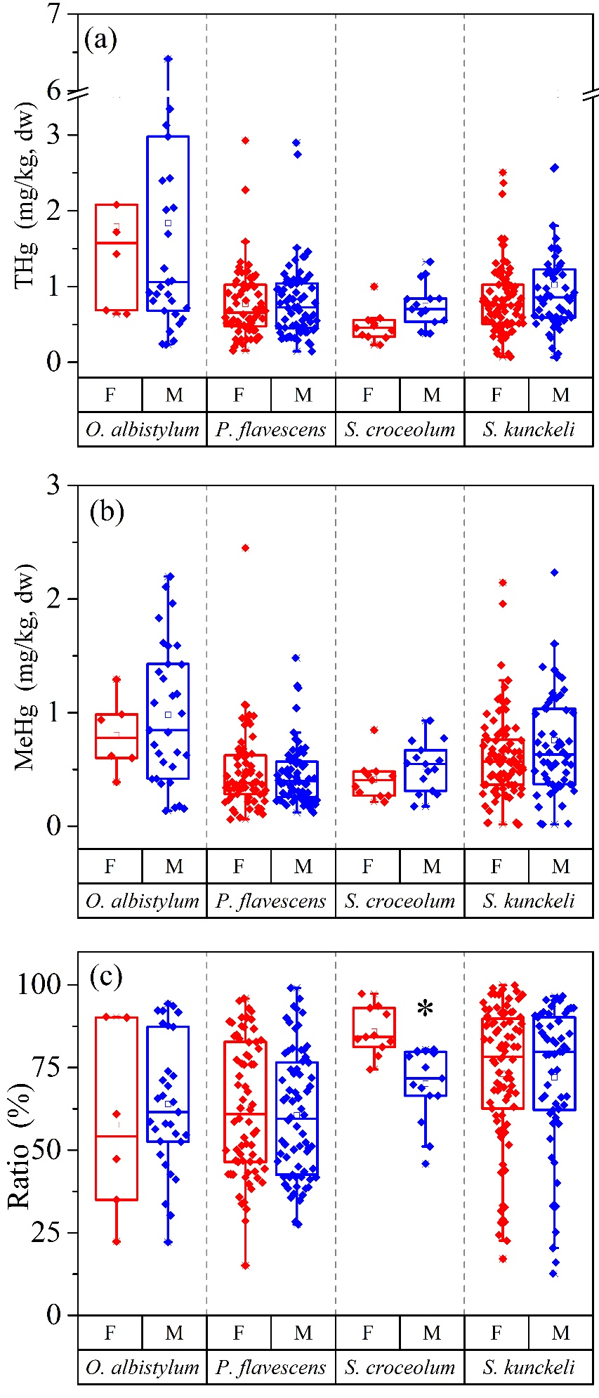
Figure S2 The distribution of THg, MeHg, and MeHg ratio of 4 common species on gender (*a significant difference at P < 0.05)

