Metaverse-based social skills training program for children with autism spectrum disorder to improve social interaction ability: A randomized controlled trial

Appendix and Appendix tables

Appendix A: Descriptions of the Metaverse based social skills training program
Appendix B: Data Sharing Statement
Table S1: Overview of the Metaverse based social skill training program curriculum
Table S2: Demographic and baseline variable for intervention and Control Group
Table S3: Comparison of outcome variables for the intervention group and Control Group
Table S4: Comparison of outcome variables for the intervention group (Lower grade vs Higher grade)
Figure S1: Changes in Primary outcome of the intervention and control group
Figure S2: Changes in Secondary outcome for children of the intervention and control group
Figure S3: Changes in Secondary outcome for parents of the intervention and control group
Supplement A: Descriptions of the Metaverse based social skills training program

For children with ASD to build friendships and engage in positive interactions, socialization with their peers is important. Children can participate in various group activities on a metaverse-based interactive game platform. The metaverse-based social skills training program implemented the PEERS within the metaverse platform for children with ASD using digital technology. The PEERS is a social skills training program developed for children with ASD who face difficulties in making or retaining friends. The PEERS consisted of 14 sessions. The 1st session gives the introduction and trading information; the 2nd session is about conversational skills; the 3rd session is on electronic communication; the 4th session is about choosing appropriate friends; the 5th session is regarding the appropriate use of humor; the 6th session is about peer entry strategies; the 7th session is regarding peer exit strategies; the 8th session is about get togethers, the 9th is on good sportsmanship; the 10th is about handling teasing; the 11th is on handling bullying and bad reputations; the 12th is regarding arguments and disagreements; the 13th is about handling rumors and gossip; and the 14th one includes a graduation party and ceremony^{1–5}. Registered nurses and clinical psychologist selected and drafted the 9th Good Sportsmanship considering interactive and cooperative activities between children in metaverse and sessions that promote their sociality in four weeks. And under the guidance of a clinical psychologist (with a PhD in education) and a clinical specialist in psychiatry, “Good Sportsmanship,” which is part of the PEERS program, was selected and conducted as a study. Socializing with peers is important for children and adolescents with ASD to build close friendships and engage in positive peer interactions. To reduce the burden of discussing a wide range of topics, it is better to proceed with activities that go well together. “Good Sportsmanship” was selected because experts considered it suitable for a metaverse based study because it is composed of activity-based socializing to become a good sportsman⁶. To maintain the consistency of the program, a professional clinical psychologist trained during the study period conducted it.
The program curriculum consisted of four sessions. The first session is the introduction and awareness of the need for rules and results. The second session is understanding the situation of behavior and participating in team activities. The third session includes responding appropriately to negative behavioral experiences and emotions. The fourth session is knowing and accepting individual differences. Each session consisted of theoretical classes, practice in metaverse, and giving homework and feedback (Appendix Table S1)
Appendix B: Data Sharing Statement

At the time the study was starting, the KONIBP IRB had not approved public data sharing as a component. Furthermore, because of the sensitive information collected about participants, their young age, and the possibility of identifying their identity, we find it hard to publicly reveal the data set. If you have any questions about the dataset, please contact your author. By emailing the corresponding author, qualified researchers can request access to the datasets.
Table S1. Overview of the Metaverse based Social Skill Training Program curriculum

Session | Didactic lesson | Learning Objectives | Description of the lesson | Homework
1 | Introduction and Good sportsmanship 1: Awareness of the need for rules and results | Learn and develop the right discipline behavior for inappropriate behavior. | 1. Subject and modulator introduce themselves to each other  2. Self-introduction by team  3. Rulemaking  4. Playing sports games in metaverse  5. Give session feedback and homework | Apply one of the rules set in the class to friends in daily life.
2 | Good sportsmanship 2: Understanding the situation of behavior and participating in team activities | Learn social understanding by noticing situations and conflicts that occur during team activities. | 1. Greeting therapists and participants  2. Checking the homework last session  3. Remind rules  4. Playing sports games in metaverse  5. Give session feedback and homework | Apply one of the rules set in the class to friends in daily life.
3 | Good sportsmanship 3: Responding appropriately to negative behavior experiences and negative emotions | Learn to accept the result of rule violations, failures, etc. experienced in team activities and understand appropriate emotional response. | 1. Greeting therapists and participants  2. Checking the homework last session  3. Educate and practice negative emotion acceptance and coping skills  4. Playing sports games in metaverse  5. Give session feedback and homework | 1. Practicing deep breathing with parents  2. Looking in the mirror, thinking about fun things, making a comfortable expression
4 | Good sportsmanship 4: Knowing and Accepting individual difference | To be able to recognize the characteristics of other team members and accept similarities and differences with friends while working as a team. | 1. Greeting therapists and participants  2. Checking the homework last session  3. Educate and practice “knowing and accepting” skills.  4. Playing sports games in metaverse  5. Give session feedback | None

Table S2. Demographic and baseline variable for intervention and Control Group

 | Group
Characteristic | Intervention  (N=9) | Control  (N=6) | P-value*
Sex |  |  | 1.000
- Male | 9(100.0%) | 6 (100.0%)
- Female | 0 (0.0%) | 0 (0.0%)
Age | 9.0 [8.0;10.0] | 8.5 [8.0; 10.0] | 1.000
K-WISC-IV
- Full scale IQ | 100.0 [95.0;101.0] | 116.5 [100.0;124.0] | 0.137
- VCI (Verbal Compression Index) | 104.0 [96.0;119.0] | 121.0 [112.0;124.0] | 0.087
Children measures
K-MAAS (Total) | 71.0 [61.0;80.0] | 85.5 [79.0;91.0] | 0.029
CDI (Total) | 14.0 [ 8.0;14.0] | 8.5 [ 5.0;11.0] | 0.123
- Negative Self-Esteem | 6.0 [3.0; 7.0] | 3.0 [2.0; 5.0] | 0.189
- Interpersonal Problems | 3.0 [2.0; 5.0] | 1.5 [0.0; 3.0] | 0.091
- Negative Mood/Physical Symptoms | 4.0 [2.0; 5.0] | 3.0 [2.0; 3.0] | 0.762
RCMAS (Total) | 15.0 [ 7.0;16.0] | 8.5 [ 7.0;16.0] | 0.512
- Overworry | 2.0 [2.0; 4.0] | 2.5 [2.0; 4.0] | 0.669
- Sensitiveness | 3.0 [1.0; 3.0] | 1.0 [1.0; 4.0] | 0.580
- A body/Sleep problem | 4.0 [2.0; 5.0] | 2.5 [2.0; 3.0] | 0.225
- Negative Emotions/Attention Problems | 3.0 [3.0; 6.0] | 3.0 [1.0; 5.0] | 0.439
Parents measures
(for children)
SRS-2 (Total) | 96.0 [74.0;112.0] | 74.5 [59.0;87.0] | 0.140
- Social awareness | 12.0 [9.0; 13.0] | 9.0 [7.0; 10.0] | 0.235
- Social cognition | 20.0 [18.0; 22.0] | 15.0 [14.0; 18.0] | 0.058
- Social communication | 33.0 [26.0; 39.0] | 24.0 [20.0; 30.0] | 0.216
- Social motivation | 13.0 [10.0; 19.0] | 13.5 [4.0; 18.0] | 0.637
- Autistic mannerism | 18.0 [16.0; 23.0] | 12.0 [9.0; 14.0] | 0.011
K-SCQ (Total) | 9.0 [4.0;12.0] | 6.0 [ 3.0;16.0] | 0.634
K-CBCL (Total) | 67.0 [63.0;78.0] | 69.5 [66.0;76.0] | 0.953
- Anxiety/Depression | 62.0 [62.0; 75.0] | 67.5 [62.0; 77.0] | 0.953
- Withdrawal | 65.0 [59.0; 72.0] | 67.0 [59.0; 72.0] | 1.000
- Somatization | 55.0 [50.0; 69.0] | 60.0 [55.0; 60.0] | 0.810
- Social problems | 79.0 [67.0; 79.0] | 67.5 [65.0; 70.0] | 0.173
- Thought problems | 68.0 [63.0; 73.0] | 68.0 [66.0; 70.0] | 0.858
- Inattention | 72.0 [65.0; 79.0] | 66.5 [64.0; 68.0] | 0.285
- Delinquent behavior | 54.0 [54.0; 59.0] | 60.5 [59.0; 69.0] | 0.167
- Aggressive behavior | 62.0 [50.0; 66.0] | 65.5 [61.0; 70.0] | 0.343
- Internalizing problems | 66.0 [63.0; 82.0] | 66.0 [61.0; 76.0] | 1.000
- Externalizing problems | 62.0 [51.0; 65.0] | 65.0 [62.0; 67.0] | 0.234
K-VABS-2
- Community | 84.0 [74.5;93.0] | 81.5 [75.0;103.0] | 0.859
- Daily living scale | 84.0 [77.0;87.0] | 86.5 [84.0;89.0] | 0.440
- Socialization | 72.0 [68.0;76.0] | 70.5 [65.0;75.0] | 0.344
Parents measures
(for parents)
SCL-R
- Depression | 49.0 [41.0;51.0] | 48.0 [45.0;54.0] | 0.953
- Anxiety | 52.0 [48.0;61.0] | 52.5 [45.0;56.0] | 0.859
- Panic | 45.0 [45.0;53.0] | 45.0 [45.0;45.0] | 0.494
- Agoraphobia | 44.0 [44.0;50.0] | 47.0 [44.0;50.0] | 0.896
- Obsessive | 49.0 [49.0;59.0] | 52.5 [44.0;57.0] | 1.000
- Obsessive compulsive  personality | 51.0 [49.0;57.0] | 51.0 [46.0;57.0] | 0.858
- PTSD | 47.0 [42.0;48.0] | 45.0 [43.0;48.0] | 1.000
- Anger attack | 54.0 [48.0;55.0] | 51.5 [44.0;54.0] | 0.552
- Somatic | 47.0 [44.0;52.0] | 49.0 [38.0;49.0] | 0.952
- Mania | 55.0 [49.0;58.0] | 41.0 [38.0;44.0] | 0.057
- Paranoia | 46.0 [43.0;48.0] | 51.0 [44.0;53.0] | 0.262
- Psychosis | 42.0 [42.0;46.0] | 48.0 [42.0;50.0] | 0.206
- Suicide | 41.0 [40.0;46.0] | 46.0 [41.0;50.0] | 0.231
- Addiction | 46.0 [44.0;63.0] | 46.0 [46.0;47.0] | 0.756
- Sleep disorder | 56.0 [46.0;61.0] | 46.0 [41.0;56.0] | 0.135
- Interpersonal  sensitivity | 50.0 [47.0;54.0] | 57.5 [56.0;65.0] | 0.156
- Regulation problem | 48.0 [48.0;52.0] | 52.5 [44.0;55.0] | 0.767
* Mann-Whitney U test

Table S3. Comparison of outcome variables for the intervention group and Control Group

 | Intervention  (n=9) |  |  |  | Control  (n=6) |  |  | Effect size (r)  (95% CI);  P-value**
Characteristic | Pre  (Median, IQR) |  | Post  (Median, IQR) | P-value* | Pre  (Median, IQR) | Post  (Median, IQR) | P-value* | Effect size (r)  (95% CI);  P-value**
Primary Outcome
SRS-2 (Total)ª | 96.0 [74.0;112.0] |  | 85.0 [84.0;103.0] | -8.0 [-11.0; -4.0]; P=0.098 | 74.5 [59.0;87.0] | 69.5 [61.0;95.0] | 3.5 [0.0; 8.0]; P=0.498 | 0.49  [0.06; 0.84];  P=0.066
- Social awareness | 12.0 [ 9.0;13.0] |  | 11.0 [11.0;13.0] | -1.0 [-2.0; 1.0]; P=0.672 | 9.0 [ 7.0;10.0] | 9.0 [ 7.0;11.0] | 0.0 [-1.0; 3.0]; P=0.672 | 0.20  [0.02;0.64]; P=0474
- Social cognition | 20.0 [18.0;22.0] |  | 19.0 [15.0;21.0] | -2.0 [-3.0; 1.0]; P=0.313 | 15.0 [14.0;18.0] | 16.0 [13.0;18.0] | 2.0 [1.0; 2.0]; P=0.396 | 0.36  [0.03; 0.78]; P=0.189
- Social communication | 33.0 [26.0;39.0] |  | 31.0 [25.0;35.0] | -2.0 [-3.0; 1.0]; P=0.311 | 24.0 [20.0;30.0] | 23.5 [20.0;35.0] | 1.0 [-2.0; 5.0]; P=0.496 | 0.37  [0.03; 0.75]; P=0.172
- Social motivation | 13.0 [10.0;19.0] |  | 11.0 [10.0;17.0] | -2.0 [-2.0; 0.0]; P=0.056 | 13.5 [ 4.0;18.0] | 13.0 [ 4.0;18.0] | 0.5 [-1.0; 2.0]; P=0.892 | 0.34  [0.02; 0.76]; P=0.211
- Autistic mannerism | 18.0 [16.0;23.0] |  | 16.0 [13.0;18.0] | -3.0 [-7.0; 0.0]; P=0.091 | 12.0 [ 9.0;14.0] | 12.0 [10.0;14.0] | 1.0 [-3.0; 2.0]; P=1.000 | 0.34  [0.02; 0.74]; P=0.213
Secondary Outcome
CDI (Total)ª | 14.0 [ 8.0;14.0] |  | 9.0 [ 5.0;14.0] | -5.0 [-5.0; 3.0]; P=0.725 | 8.5 [ 5.0;11.0] | 6.0 [ 4.0;10.0] | -1.0 [-2.0; 3.0]; P=1.000 | 0.12  [0.00; 0.66];  P=0.678
- Negative Self-Esteem | 6.0 [ 3.0; 7.0] |  | 7.0 [ 2.0; 8.0] | 1.0 [-3.0; 2.0]; P=0.905 | 3.0 [ 2.0; 5.0] | 2.5 [ 2.0; 5.0] | 0.0 [0.0; 0.0]; P=1.000 | 0.03  [0.00; 0.62];  P=0.953
- Interpersonal Problems | 3.0 [ 2.0; 5.0] |  | 2.0 [ 1.0; 2.0] | -1.0 [-2.0; 0.0]; P=0.098 | 1.5 [ 0.0; 3.0] | 2.0 [ 1.0; 4.0] | 0.5 [-1.0; 2.0]; P=0.410 | 0.45  [0.05; 0.75];  P=0.091
- Negative Mood/Physical Symptoms | 4.0 [ 2.0; 5.0] |  | 2.0 [ 1.0; 5.0] | -1.0 [-2.0; 1.0]; P=0.621 | 3.0 [ 2.0; 3.0] | 1.0 [ 1.0; 3.0] | -1.0 [-2.0; 0.0]; P=0.170 | 0.14  [0.00; 0.59];  P=0.633
K-MAAS ª | 71.0 [61.0;80.0] |  | 66.0 [36.0;77.0] | -5.0 [-9.0; -2.0]; P=0.285 | 85.5 [79.0;91.0] | 75.5 [53.0;80.0] | -14.5 [-22.0; -2.0]; P=0.094 | 0.23  [0.02; 0.69];  P=0.407
RCMAS (Total)ª | 15.0 [ 7.0;16.0] |  | 14.0 [11.0;17.0] | -1.0 [-3.0; 1.0]; P=0.481 | 8.5 [ 7.0;16.0] | 14.0 [ 7.0;19.0] | ]; P=0.410 | 0.26  [0.02; 0.72];  P=0.342
- Overworry | 2.0 [ 2.0; 4.0] |  | 2.0 [ 2.0; 4.0] | 0.0 [0.0; 1.0]; P=0.746 | 2.5 [ 2.0; 4.0] | 5.0 [ 2.0; 5.0] | 0.0 [-1.0; 3.0]; P=0.589 | 0.06  [0.00; 0.68];  P=0.856
- Sensitiveness | 3.0 [ 1.0; 3.0] |  | 3.0 [ 3.0; 4.0] | 0.0 [-1.0; 1.0]; P=0.605 | 1.0 [ 1.0; 4.0] | 2.5 [ 2.0; 5.0] | 0.5 [0.0; 2.0]; P=0.462 | 0.12  [0.02; 0.62];  P=0.675
- A body/Sleep problem | 4.0 [ 2.0; 5.0] |  | 3.0 [ 0.0; 4.0] | -1.0 [-2.0; 0.0]; P=0.138 | 2.5 [ 2.0; 3.0] | 2.5 [ 1.0; 3.0] | -0.5 [-1.0; 1.0]; P=1.000 | 0.33  [0.02; 0.72];  P=0.228
- Negative Emotions/Attention Problems | 3.0 [ 3.0; 6.0] |  | 4.0 [ 4.0; 5.0] | -1.0 [-2.0; 1.0]; P=0.671 | 3.0 [ 1.0; 5.0] | 3.5 [ 2.0; 6.0] | 0.0 [-2.0; 3.0]; P=0.752 | 0.15  [0.00; 0.62];  P=0.591
K-SCQ (Total)ª |  | 9.0 [4.0;12.0] | 7.0 [6.0;11.0] | 0.0 [-2.0; 2.0]; P=0.518 | 6.0 [ 3.0;16.0] | 5.5 [ 5.0;11.0] | -1.0 [-2.0; 3.0]; P=1.000 | 0.09  [0.00; 0.60];  P=0.765
K-CBCL (Total)ª |  | 67.0 [63.0;78.0] | 63.0 [61.0;70.0] | -4.0 [-12.0; -2.0]; P=0.049 | 69.5 [66.0;76.0] | 68.0 [61.0;71.0] | -3.5 [-5.0; 2.0]; P=0.246 | 0.20  [0.02; 0.66];  P=0.479
- Anxiety/Depression |  | 62.0 [62.0;75.0] | 57.0 [53.0;72.0] | -5.0 [-9.0; -3.0]; P=0.074 | 67.5 [62.0;77.0] | 69.5 [59.0;73.0] | -2.5 [-3.0; 2.0]; P=0.339 | 0.43  [0.06; 0.78];  P=0.105
- Withdrawal |  | 65.0 [59.0;72.0] | 65.0 [54.0;66.0] | 0.0 [-10.0; 0.0]; P=0.105 | 67.0 [59.0;72.0] | 64.5 [59.0;75.0] | -1.0 [-3.0; 0.0]; P=0.571 | 0.16  [0.00; 0.61];  P=0.584
- Somatization |  | 55.0 [50.0;69.0] | 55.0 [50.0;60.0] | -5.0 [-5.0; 0.0]; P=0.105 | 60.0 [55.0;60.0] | 57.5 [55.0;60.0] | -2.5 [-9.0; 0.0]; P=0.269 | 0.05  [0.00; 0.65];  P=0.903
- Social problems |  | 79.0 [67.0;79.0] | 70.0 [67.0;72.0] | -5.0 [-11.0; 0.0]; P=0.057 | 67.5 [65.0;70.0] | 66.0 [64.0;70.0] | -1.5 [-4.0; 0.0]; P=0.174 | 0.25  [0.00; 0.71];  P=0.371
- Thought problems |  | 68.0 [63.0;73.0] | 68.0 [59.0;69.0] | -4.0 [-5.0; 0.0]; P=0.058 | 68.0 [66.0;70.0] | 67.5 [63.0;69.0] | -2.0 [-4.0; 2.0]; P=0.344 | 0.20  [0.02; 0.65];  P=0.478
- Inattention |  | 72.0 [65.0;79.0] | 64.0 [61.0;79.0] | -4.0 [-10.0; -2.0]; P=0.191 | 66.5 [64.0;68.0] | 65.0 [59.0;68.0] | -2.5 [-11.0; 4.0]; P=0.416 | 0.05  [0.00; 0.58];  P=0.905
- Delinquent behavior |  | 54.0 [54.0;59.0] | 59.0 [50.0;62.0] | 0.0 [0.0; 3.0]; P=0.833 | 60.5 [59.0;69.0] | 63.5 [59.0;69.0] | 0.5 [-5.0; 7.0]; P=0.588 | 0.05  [0.00; 0.61];  P=0.905
- Aggressive behavior |  | 62.0 [50.0;66.0] | 62.0 [50.0;66.0] | 0.0 [-3.0; 0.0]; P=0.833 | 65.5 [61.0;70.0] | 62.0 [57.0;67.0] | 0.0 [-8.0; 1.0]; P=0.672 | 0.03  0.00; 0.59];  P=0.953
- Internalizing problems |  | 66.0 [63.0;82.0] | 62.0 [55.0;72.0] | -8.0 [10.0; -1.0]; P=0.050 | 66.0 [61.0;76.0] | 65.0 [61.0;74.0] | -1.0 [-4.0; 0.0]; P=0.279 | 0.26  [0.02; 0.75];  P=0.344
- Externalizing problems |  | 62.0 [51.0;65.0] | 62.0 [48.0;65.0] | -1.0 [-11.0; 0.0]; P=0.272 | 65.0 [62.0;67.0] | 63.0 [58.0;66.0] | 0.0 [-5.0; 2.0]; P=0.584 | 0.15  [0.00; 0.64];  P=0.593
K-VABS-2^{b}
- Communication |  | 84.0 [75.0;93.0] | 86.0 [75.0;97.0] | 8.0 [0.0; 13.0]; P=0.933 | 81.5 [75.0;103.0] | 89.0[72.0;104.0] | 3.0 [-3.0; 8.0]; P=0.590 | 0.08  [0.00; 0.62];  P=0.813
- Daily living skill |  | 84.0 [77.0;87.0] | 82.0 [80.0;94.0] | 2.0 [-7.0; 7.0]; P=0.859 | 86.5 [84.0;89.0] | 83.0 [81.0;84.0] | -3.5 [-5.0; -2.0]; P=0.399 | 0.17  [0.00; 0.67];  P=0.555
- Socialization |  | 72.0 [68.0;76.0] | 75.0 [72.0;81.0] | 4.0 [1.0; 5.0]; P=0.553 | 70.5 [65.0;75.0] | 74.0 [65.0;79.0] | 2.5 [0.0; 6.0]; P=0.178 | 0.02  [0.02; 0.58];  P=1.000
Parents measures
(for parents)
SCL-Rª
- Depression |  | 49.0 [41.0;51.0] | 43.0 [41.0;48.0] | -1.0 [-8.0; 0.0]; P=0.205 | 48.0 [45.0;54.0] | 51.0 [47.0;65.0] | 3.0 [-4.0; 12.0]; P=0.563 | 0.28  [0.02; 0.78];  P=0.315
- Anxiety |  | 52.0 [48.0;61.0] | 52.0 [42.0;54.0] | 0.0 [-6.0; 0.0]; P=0.295 | 52.5 [45.0;56.0] | 52.5 [49.0;56.0] | 1.0 [-2.0; 11.0]; P=0.410 | 0.31  [0.02; 0.73];  P=0.258
- Panic |  | 45.0 [45.0;53.0] | 45.0 [45.0;53.0] | 0.0 [0.0; 0.0]; P=0.371 | 45.0 [45.0;45.0] | 45.0 [45.0;53.0] | 0.0 [0.0; 0.0]; P=1.000 | 0.07  [0.00; 0.52];  P=0.866
- Agoraphobia |  | 44.0 [44.0;50.0] | 50.0 [44.0;50.0] | 0.0 [0.0; 6.0]; P=0.892 | 47.0 [44.0;50.0] | 44.0 [44.0;52.0] | 0.0 [0.0; 0.0]; P=1.000 | 0.02  [0.00; 0.57];  P=1.000
- Obsessive |  | 49.0 [49.0;59.0] | 44.0 [39.0;54.0] | 0.0 [-15.0; 5.0]; P=0.526 | 52.5 [44.0;57.0] | 49.5 [44.0;57.0] | 0.0 [-4.0; 0.0]; P=0.789 | 0.02  [0.00; 0.57];  P=1.000
- Obsessive compulsive  personality |  | 51.0 [49.0;57.0] | 49.0 [45.0;55.0 | -6.0 [-12.0; 6.0]; P=0.401 | 51.0 [46.0;57.0] | 51.0 [51.0;59.0] | 0.0 [-6.0; 13.0]; P=0.581 | 0.28  [0.02; 0.68];  P=0.311
- PTSD |  | 47.0 [42.0;48.0] | 48.0 [47.0;48.0] | 5.0 [0.0; 6.0]; P=0.398 | 45.0 [43.0;48.0] | 48.0 [48.0;70.0] | 5.0 [0.0; 23.0]; P=0.279 | 0.12  [0.00; 0.63];  P=0.678
- Anger attack |  | 54.0 [48.0;55.0] | 45.0 [41.0;57.0] | 0.0 [-7.0; 3.0]; P=0.670 | 51.5 [44.0;54.0] | 50.0 [44.0;63.0] | 4.5 [-9.0; 11.0]; P=0.586 | 0.18  [0.00; 0.68];  P=0.515
- Somatic |  | 47.0 [44.0;52.0] | 39.0 [36.0;41.0] | -7.0 [-8.0; 0.0]; P=0.042 | 49.0 [38.0;49.0] | 51.5 [51.0;52.0] | 2.5 [2.0; 5.0]; P=0.058 | 0.60  [0.23; 0.84];  P=0.024
- Mania |  | 55.0 [49.0;58.0] | 53.0 [49.0;58.0] | 0.0 [-5.0; 0.0]; P=1.000 | 41.0 [38.0;44.0] | 44.0 [43.0;44.0] | 2.5 [0.0; 6.0]; P=0.181 | 0.35  [0.03; 0.73];  P=0.192
- Paranoia |  | 46.0 [43.0;48.0]] | 43.0 [40.0;53.0] | 0.0 [-4.0; 7.0]; P=0.478 | 51.0 [44.0;53.0] | 52.5 [47.0;56.0] | 0.0 [0.0; 12.0]; P=0.423 | 0.23  [0.02; 0.68];  P=0.402
- Psychosis |  | 42.0 [42.0;46.0] | 42.0 [42.0;49.0] | 0.0 [0.0; 2.0]; P=0.685 | 48.0 [42.0;50.0] | 44.5 [42.0;58.0] | 0.0 [-3.0; 8.0]; P=0.584 | 0.03  [0.00; 0.59];  P=0.951
- Suicide |  | 41.0 [40.0;46.0] | 41.0 [40.0;50.0] | 0.0 [0.0; 4.0]; P=0.198 | 46.0 [41.0;50.0] | 50.5 [46.0;55.0] | 2.5 [-4.0; 9.0]; P=0.498 | 0.08  [0.00; 0.73];  P=0.807
- Addiction |  | 46.0 [44.0;63.0] | 46.0 [42.0;46.0] | 0.0 [-4.0; 0.0]; P=0.892 | 46.0 [46.0;47.0] | 46.0 [46.0;47.0] | 0.0 [0.0; 0.0]; P=1.000 | 0.07  0.00; 0.59];  P=0.848
- Sleep disorder |  | 56.0 [46.0;61.0] | 41.0 [40.0;51.0] | -6.0 [-15.0; 0.0]; P=0.036 | 46.0 [41.0;56.0] | 41.0 [41.0;51.0] | 0.0 [0.0; 0.0]; P=1.000 | 0.47  [0.04; 0.79];  P=0.082
- Interpersonal  sensitivity |  | 50.0 [47.0;54.0] | 47.0 [43.0;54.0] | -4.0 [-7.0; 3.0]; P=0.398 | 57.5 [56.0;65.0] | 63.5 [50.0;69.0] | 6.0 [4.0; 11.0]; P=0.206 | 0.49  [0.03; 0.84];  P=0.086
- Regulation problem |  | 48.0 [48.0;52.0] | 57.0 [41.0;61.0] | -4.0 [-8.0; 9.0]; P=0.888 | 52.5 [44.0;55.0] | 53.5 [44.0;57.0] | 2.0 [0.0; 4.0]; P=0.710 | 0.12  [0.00; 0.62];  P=0.678
ª Lower score indicate increased ability
^{b} Higher scores indicate increased ability
* Within group difference; Wilcoxon signed-rank test
** Effect size for Wilcoxon signed rank test(r≈.10 to .30: small, .30 to .50: moderate, .50 to .80: large); Kruskal-Wallis test

Table S4. Comparison of outcome variables for the intervention group (Lower grade vs Higher grade)
 | Higher grade  (n=5) |  |  |  |  | Lower grade  (n=5)
Characteristic | Pre  (Median, IQR) | Post  (Median, IQR) | Effect size (r)  (95% CI); P-value* | Pre  (Median, IQR) | Post  (Median, IQR) |  | Effect size (r)  (95% CI); P-value*
Primary Outcome
SRS-2 (Total)ª | 96.0 [74.0;112.0] | 85.0 [84.0;103.0] | 0.302 [0.18; 0.95]; P=0.625 | 100.5 [82.0;117.0] | 86.5 [73.0;95.5] |  | 0.913 [0.91; 0.94]; P=0.125
- Social awareness | 12.0 [9.0;13.0] | 11.0 [11.0;13.0] | 0.122 [0.00; 0.89]; P=0.855 | 12.0 [ 9.5;14.0] | 10.5 [ 9.0;12.0] |  | 0.644 [0.19; 0.94]; P=0.269
- Social cognition | 22.0 [18.0.;22.0] | 19.0 [18.0;19.0] | 0.303 [0.06; 0.95]; P=0.588 | 20.0 [16.5;23.5] | 18.0 [13.0;21.5] |  | 0.276 [0.18; 0.94]; P=0.713
- Social communication | 29.0 [26.0;39.0] | 27.0 [25.0;35.0] | 0.553 [0.06; 0.95]; P=0.272 | 36.0 [25.5;41.5] | 32.0 [26.5;36.5] |  | 0.183 [0.00; 0.94]; P=0.875
- Social motivation | 15.0 [12.0;19.0] | 15.0 [10.0;20.0] | 0.620 [0.13; 1.00]; P=0.186 | 11.5 [ 9.0;17.0] | 10.5 [ 8.5;14.0] |  | 0.644 [0.19; 0.94]; P=0.269
- Autistic mannerism | 16.0 [14.0;18.0] | 18.0 [15.0;18.0] | 0.061 [0.00; 0.89]; P=1.000 | 21.5 [18.5;24.0] | 14.0 [11.0;16.5] |  | 0.921 [0.92; 1.00]; P=0.098
Secondary Outcome
CDI (Total) ª | 14.0 [14.0;14.0] | 9.0 [9.0;14.0] | 0.611 [0.13; 0.95]; P=0.198 | 9.0 [ 5.5;18.5] | 8.0 [ 3.5;26.5] |  | 0.365 [0.18; 0.94]; P=0.625
- Negative Self-Esteem | 7.0 [4.0; 8.0] | 7.0 [7.0; 8.0] | 0.061 [0.06; 0.95]; P=1.000 | 4.5 [ 2.5; 6.0] | 3.0 [ 1.0;12.5] |  | 0.000 [0.00 ;0.94]; P=1.000
- Interpersonal Problems | 3.0 [3.0; 5.0] | 2.0 [1.0; 2.0] | NA; P=0.265 | 2.5 [ 1.5; 6.5] | 2.0 [ 1.0; 5.5] |  | 0.567 [0.00; 1.00]; P=0.345
- Negative Mood/Physical Symptoms | 4.0 [4.0; 5.0] | 1.0 [1.0; 3.0] | 0.727 [0.18; 0.93]; P=0.136 | 2.0 [ 1.5; 6.0] | 3.5 [ 1.5; 8.5] |  | 0.464 [0.09; 0.94]; P=0.423
K-MAAS (Total) ª | 62.0 [61.0;71.0] | 59.0 [36.0;82.0] | 0.302 [0.06; 0.93]; P=0.625 | 77.5 [58.0;81.0] | 70.5 [51.0;76.0] |  | 0.945 [0.93; 1.00]; P=0.089
RCMAS (Total) ª | 15.0 [12.0;16.0] | 14.0 [12.0;14.0] | 0.487 [0.00; 0.93]; P=0.361 | 11.5 [ 5.0;18.0] | 14.0 [ 6.5;17.0] |  | 0.092 [0.00; 0.94] P=1.000
- Overworry | 3.0 [2.0; 4.0] | 2.0 [2.0; 2.0] | NA; P=0.586 | 2.0 [ 1.5; 4.0] | 3.5 [ 2.5; 5.0] |  | NA; P=0.174
- Sensitiveness | 3.0 [2.0; 3.0] | 3.0 [3.0; 3.0] | NA; P=1.000 | 2.0 [ 1.0; 3.5] | 3.5 [ 1.5; 4.0] |  | 0.189 [0.00; 1.00]; P=0.850
- A body/Sleep problem | 4.0 [2.0; 5.0] | 4.0 [3.0; 4.0] | 0.247 [0.06; 0.95]; P=0.679 | 3.5 [ 2.0; 5.5] | 1.5 [ 0.0; 3.5] |  | NA; P=0.181
- Negative Emotions/Attention Problems | 6.0 [3.0; 6.0] | 4.0 [4.0; 5.0] | 0.676 [0.19; 0.95]; P=0.170 | 2.0 [ 0.5; 5.0] | 4.5 [ 2.0; 5.0] |  | NA; P=0.586
K-SCQ (Total) ª | 9.0 [4.0; 11.0] | 7.0 [6.0; 12.0] | 0.063 [0.06; 0.95]; P=1.000 | 12.0 [ 5.5;16.0] | 8.5 [ 5.0;10.5] |  | NA; P=0.423
K-CBCL (Total) ª | 67.0 [66.0; 78.0] | 70.0 [65.0; 76.0] | 0.487 [0.00; 0.93]; P=0.361 | 68.5 [61.0;83.0] | 60.5 [57.5;66.0] |  | 0.913 [0.91; 1.00]; P=0.125
- Anxiety/Depression | 68.5 [59.5;78.5] | 72.0 [62.5;75.5] | 0.307 [0.18; 1.00]; P=0.583 | 67.5 [62.0;80.5] | 57.0 [55.0;63.5] |  | 0.913 [0.91; 1.00]; P=0.125
- Withdrawal | 68.5 [62.0;73.5] | 65.0 [57.5;68.5] | NA; P=0.423 | 65.5 [59.5;75.0] | 60.0 [54.0;67.5] |  | NA; P=0.371
- Somatization | 62.0 [52.5;70.0] | 55.0 [50.0;65.5] | NA; P=0.371 | 60.5 [52.5;68.5] | 57.5 [52.5;63.0] |  | 0.567 [0.00; 1.00]; P=0.345
- Social problems | 79.0 [75.5;81.0] | 72.0 [69.5;73.0] | NA; P=0.201 | 73.0 [62.5;81.0] | 67.0 [62.5;70.0] |  | 0.644 [0.19; 0.94]; P=0.269
- Thought problems | 71.0 [65.5;74.5] | 69.5 [64.0;71.5] | 0.788 [0.18;0.95]; P=0.104 | 64.5 [63.0;67.0] | 61.0 [55.5;66.0] |  | NA; P=0.423
- Inattention | 77.0 [73.5;81.0] | 79.0 [72.0;82.5] | 0.061 [0.06; 1.00]; P=1.000 | 68.0 [62.5;75.5] | 60.0 [59.0;62.5] |  | 0.913 [0.91; 0.94]; P=0.125
- Delinquent behavior | 54.0 [52.0;56.5] | 59.0 [54.5;59.0] | NA; P=0.174 | 58.0 [52.0;67.0] | 57.5 [50.0;65.0] |  | NA; P=0.423
- Aggressive behavior | 59.0 [52.5;66.5] | 61.5 [55.5;64.5] | 0.245 [0.13; 0.93]; P=0.581 | 58.0 [50.0;72.0] | 56.5 [50.0;64.5] |  | NA; P=0.371
- Internalizing problems | 74.0 [60.5;84.5] | 67.5 [60.0;77.0] | 0.487 [0.00; 0.93]; P=0.361 | 65.5 [63.0;80.0] | 58.5 [54.5;67.0] |  | 0.913 [0.91; 0.94]; P=0.125
- Externalizing problems | 59.5 [52.5;64.5] | 61.5 [49.0;63.5] | NA; P=1.000 | 58.0 [49.5;74.5] | 56.0 [42.5;65.0] |  | NA; P=0.181
K-VABS-2 ^{b}
- Communication | 84.0 [75.0;86.0] | 86.0 [84.0; 88.0] | NA; P=1.000 | 84.5 [70.0;98.0] | 89.0 [56.5;111.0] |  | 0.184 [0.18; 1.00]; P=0.854
- Daily living skill | 87.0 [84.0; 98.0] | 84.0 [82.0; 94.0] | 0.060 [0.06; 0.93]; P=1.000 | 76.0 [75.0;81.5] | 79.0 [59.0;93.5] |  | 0.183 [0.18; 0.94] P=0.875
- Socialization | 74.0 [72.0; 76.0] | 75.0 [74.0; 81.0] | 0.302 [0.18; 0.93]; P=0.625 | 70.0 [66.5;78.5] | 74.0 [58.0;83.0] |  | 0.183 [0.18; 0.94]; P=0.875
Parents measures
(for parents)
SCL-R ª
- Depression | 51.0 [49.0; 58.0] | 48.0 [38.0; 51.0] | NA; P=0.181 | 43.0 [40.5;48.0] | 43.0 [42.0;44.0] |  | 0.183 [0.00; 0.94]; P=0.875
- Anxiety | 61.0 [45.0; 61.0] | 54.0 [39.0; 61.0] | NA; P=0.181 | 50.0 [48.0;52.0] | 51.0 [46.0;52.0] |  | NA; P=1.000
- Panic | 53.0 [45.0; 53.0] | 53.0 [45.0; 61.0] | NA; P=0.371 | 45.0 [45.0;45.0] | 45.0 [45.0;45.0] |  | NA
- Agoraphobia | 44.0 [44.0; 50.0] | 50.0 [44.0; 50.0] | NA; P=1.000 | 47.0 [44.0;54.0] | 47.5 [44.0;51.0] |  | 0.000 [0.00; 1.00]; P=1.000
- Obsessive | 53.0 [49.0; 59.0] | 44.0 [34.0; 61.0] | 0.245 [0.07; 0.89]; P=0.581 | 49.0 [46.5;57.0] | 46.5 [41.5;51.5] |  | 0.189 [0.00; 1.00]; P=0.850
- Obsessive compulsive  personality | 51.0 [51.0; 57.0] | 55.0 [45.0; 57.0] | 0.316 [0.00; 0.95]; P=0.572 | 47.0 [44.0;61.5] | 49.0 [43.0;52.0] |  | 0.276 [0.00; 0.94]; P=0.713
- PTSD | 47.0 [43.0; 53.0] | 47.0 [47.0; 48.0] | 0.061 [0.00; 0.93]; P=1.000 | 44.5 [42.0;47.5] | 48.0 [48.0;51.5] |  | 0.921 [0.92; 1.00]; P=0.098
- Anger attack | 54.0 [48.0; 55.0] | 45.0 [41.0; 73.0] | 0.121 [0.06; 0.93]; P=0.892 | 51.0 [44.5;56.5] | 44.5 [41.0;52.5] |  | NA; P=1.000
- Somatic | 45.0 [38.0; 59.0] | 41.0 [38.0; 58.0] | NA; P=0.578 | 47.0 [45.5;49.5] | 37.5 [36.0;40.0] |  | 0.928 [0.93; 1.00]; P=0.095
- Mania | 49.0 [46.0; 54.0] | 49.0 [46.0; 54.0] | NA; P=0.414 | 62.0 [58.0;68.0] | 55.5 [53.0;64.0] |  | NA; P=0.371
- Paranoia | 47.0 [44.0; 48.0] | 44.0 [40.0; 59.0] | 0.246 [0.07; 0.89]; P=0.578 | 44.5 [41.0;47.0] | 43.0 [41.0;48.0] |  | 0.092 [0.00; 0.94]; P=1.000
- Psychosis | 42.0 [42.0; 46.0] | 42.0 [42.0; 47.0] | NA; P=1.000 | 43.0 [41.0;46.0] | 45.0 [41.0;49.0] |  | NA; P=0.789
- Suicide | 46.0 [43.0; 50.0] | 50.0 [43.0; 55.0] | NA; P=0.174 | 40.0 [40.0;40.5] | 40.0 [40.0;40.0] |  | NA; P=1.000
- Addiction | 46.0 [46.0; 63.0] | 46.0 [46.0; 46.0] | NA; P=1.000 | 44.0 [42.0;55.0] | 42.0 [42.0;53.0] |  | NA; P=1.000
- Sleep disorder | 56.0 [56.0; 58.0] | 51.0 [41.0; 51.0] | NA; P=0.181 | 60.5 [46.0;78.0] | 40.0 [40.0;43.0] |  | NA; P=0.181
- Interpersonal  sensitivity | 50.0 [49.0; 58.0] | 52.0 [40.0; 54.0] | NA; P=0.713 | 49.0 [43.5;52.5] | 45.0 [43.0;51.0] |  | 0.183 [0.18; 0.94]; P=0.875
- Regulation problem | 52.0 [49.0; 58.0] | 44.0 [41.0; 58.0] | 0.856 [0.63; 0.95]; P=0.098 | 56.0 [42.0;48.0] | 59.0 [48.5;61.0] |  | 0.730 [0.19; 0.94]; P=0.250
ª Lower score indicate increased ability
^{b} Higher scores indicate increased ability
* Effect size for Wilcoxon signed rank test (r≈.10 to .30: small, .30 to .50: moderate, .50 to .80: large); Wilcoxon signed rank tests

Figure S1. Changes in Primary outcome of the intervention and control group
- SRS-2 Total score
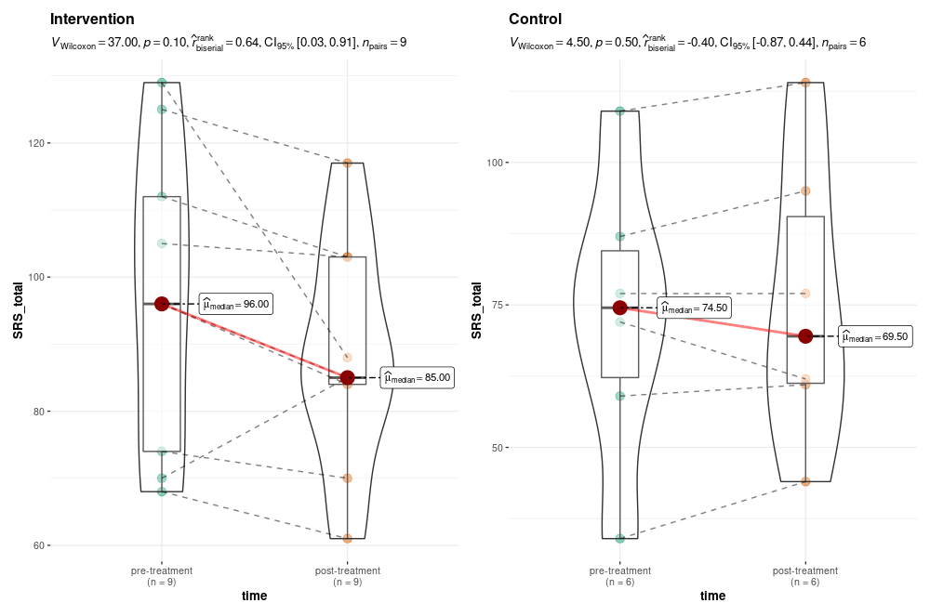
- Social Awareness of SRS-2
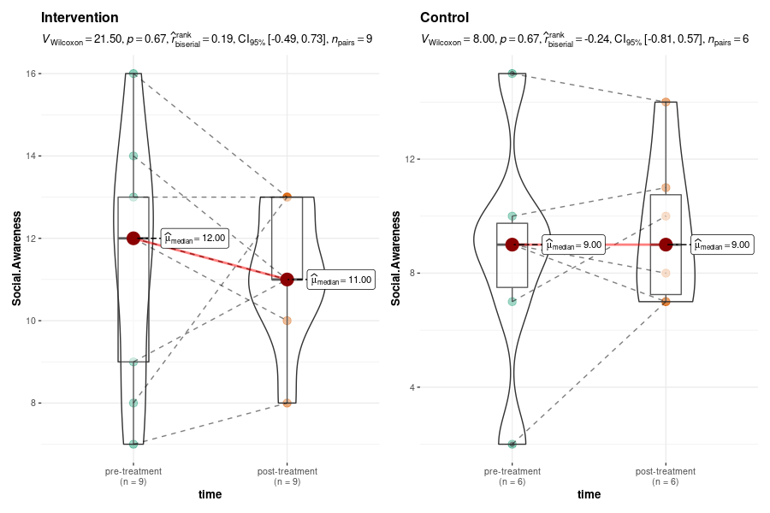
- Social Cognition of SRS-2
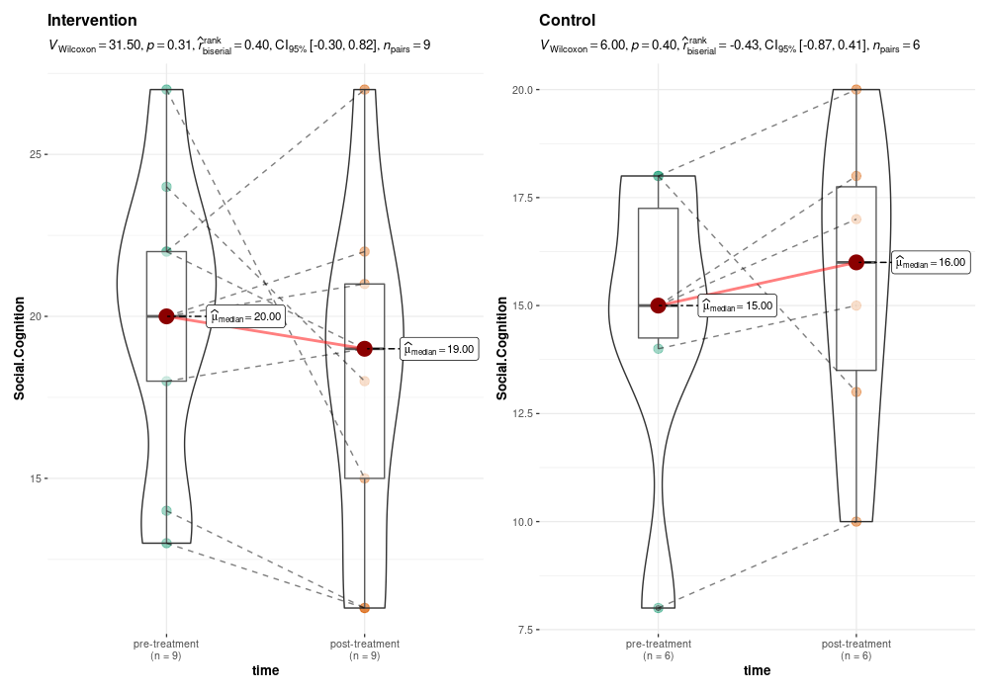
- Social Communication of SRS-2
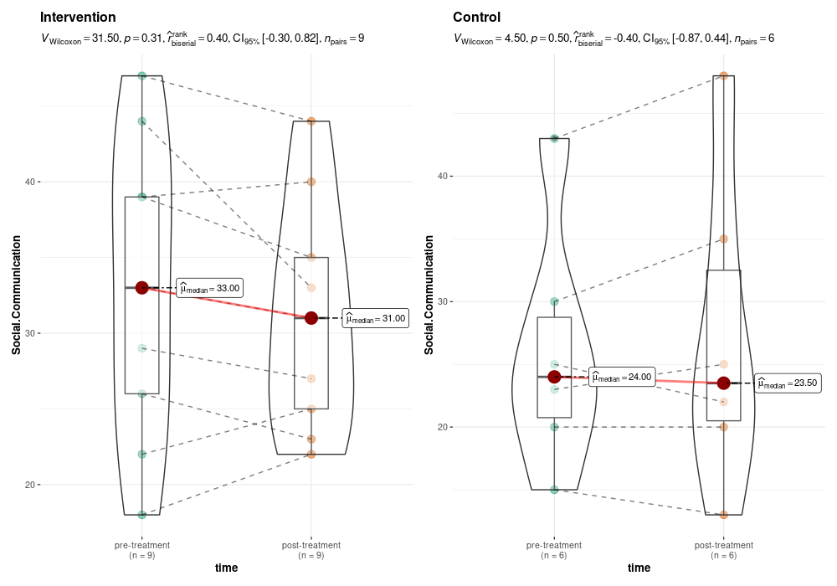
- Social Motivation of SRS-2
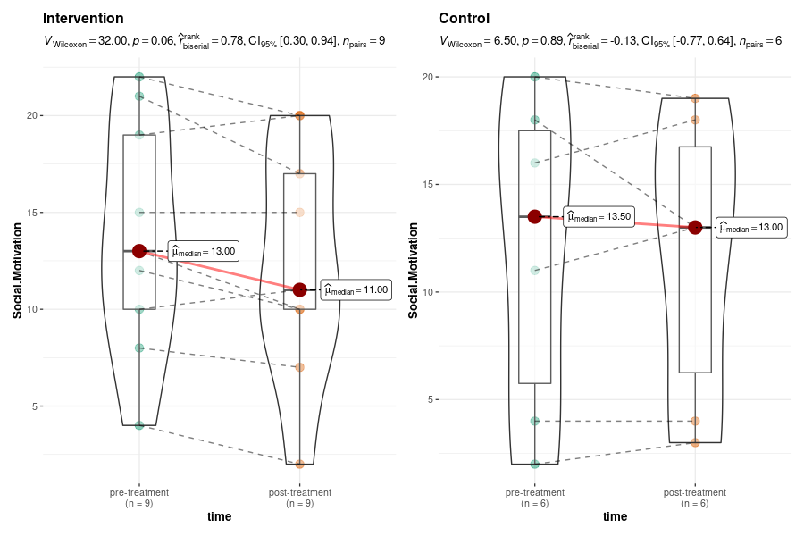
- Autistic Mannerism of SRS-2
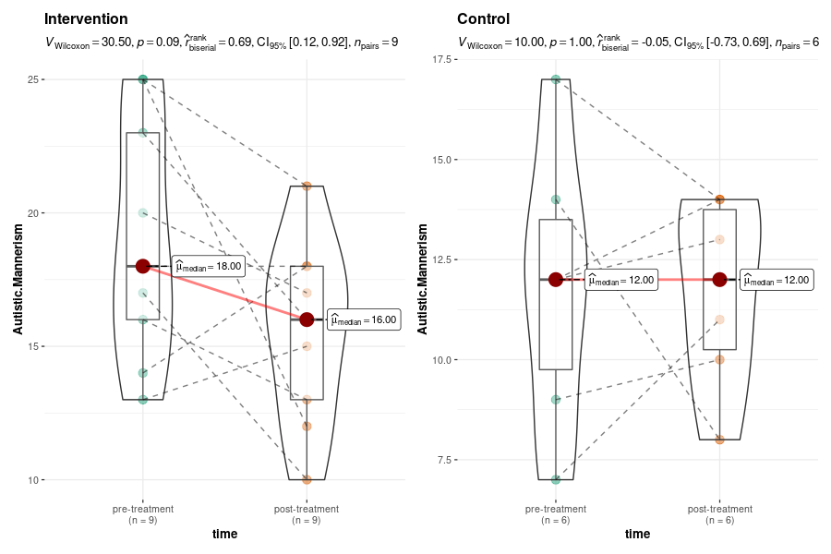

Figure S2. Changes in Secondary outcome for children of the intervention and control group
- CDI Total score
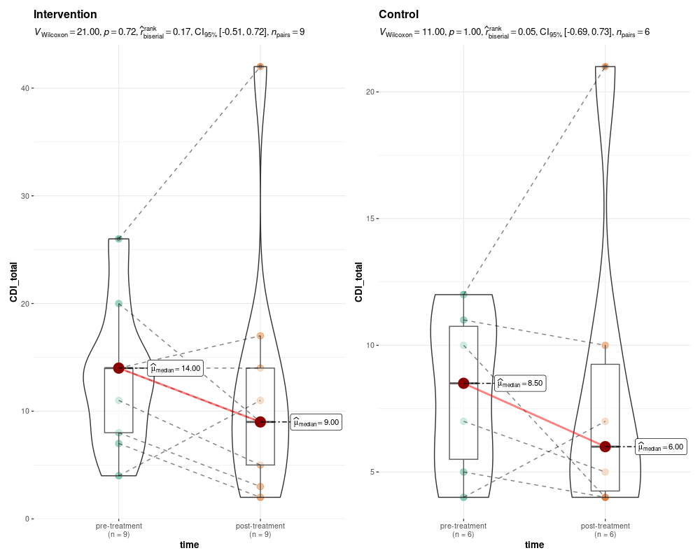
- Negative-self-Esteem
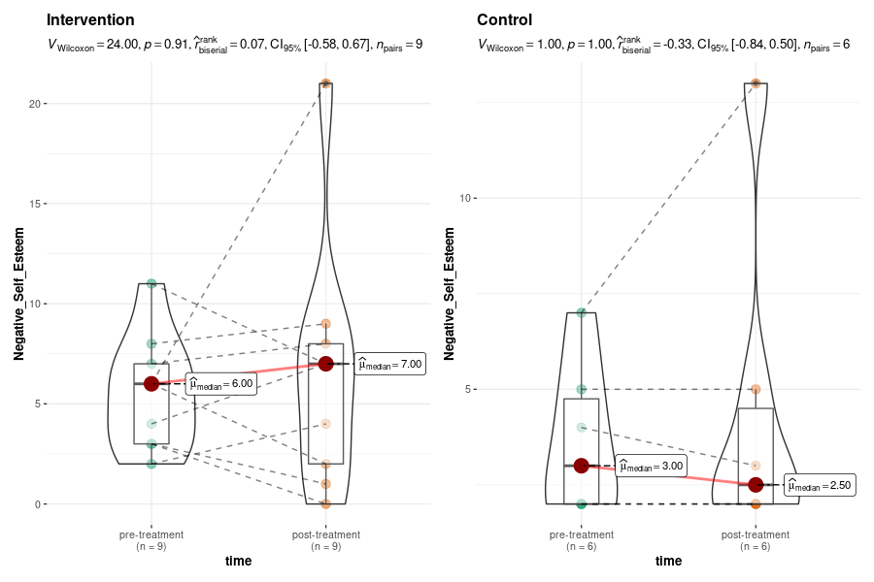
- Interpersonal Problems
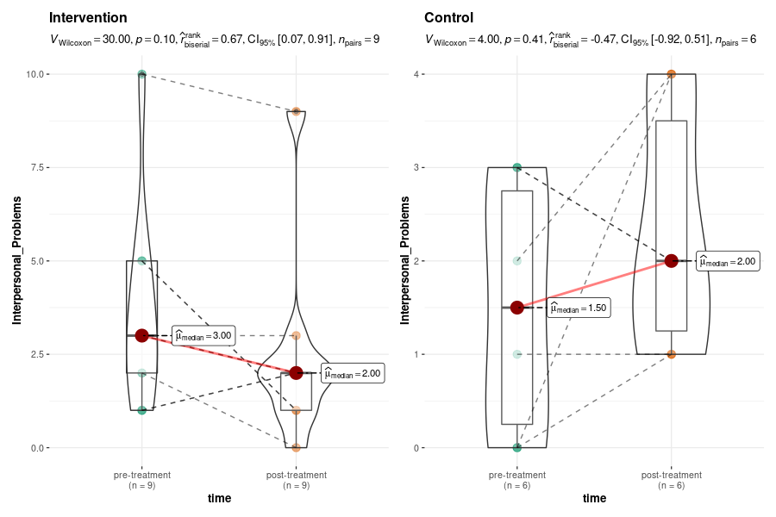
- Negative Mood and Physical Symptom
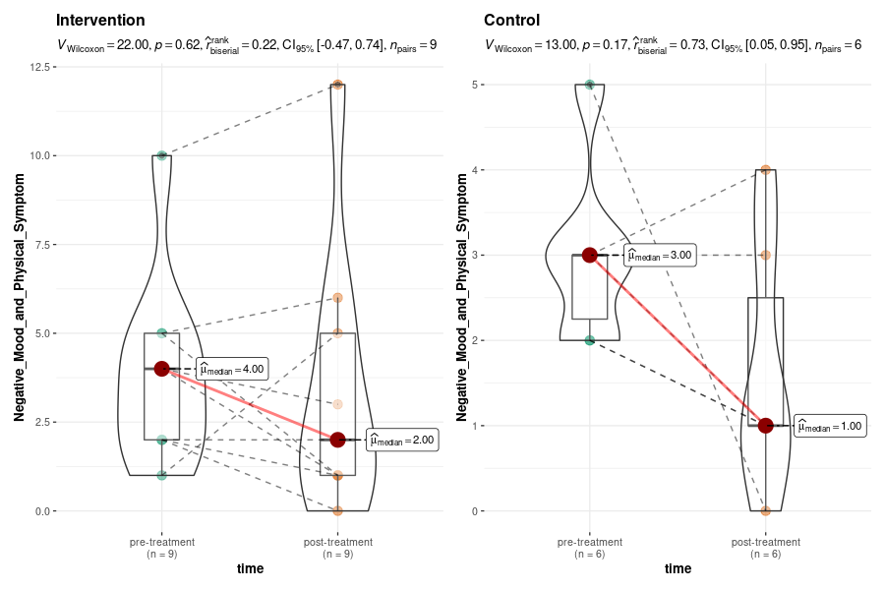
- K-MAAS total score
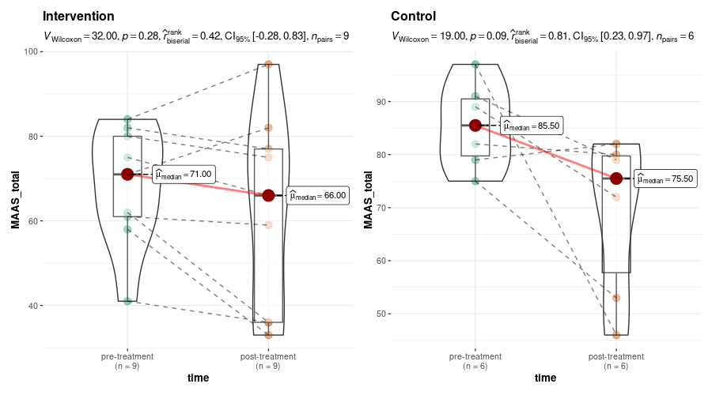
- RCMAS Total score
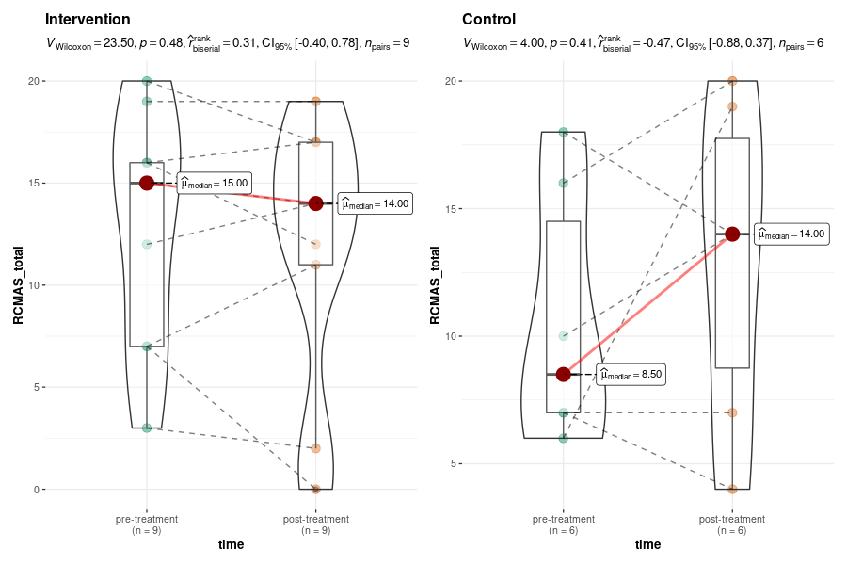
- Over worry of RCMAS
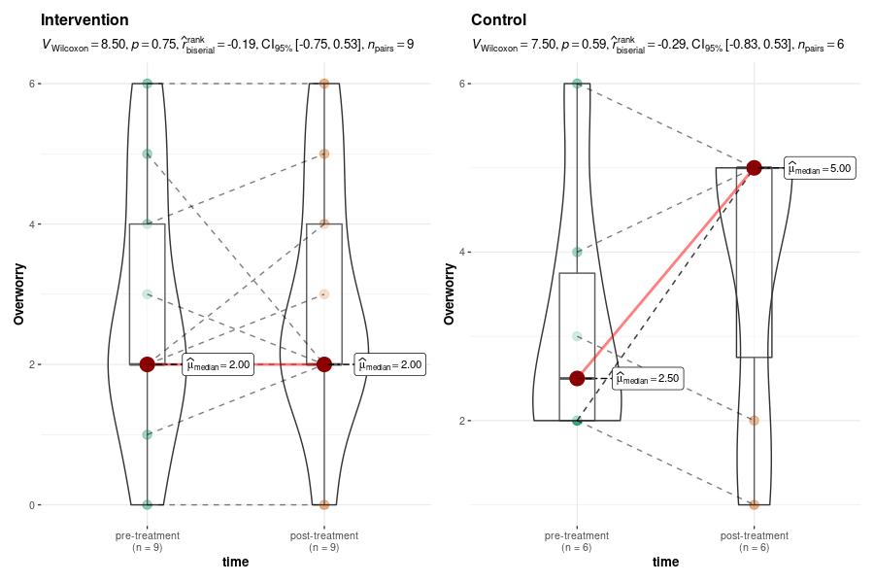
- Sensitiveness of RCMAS
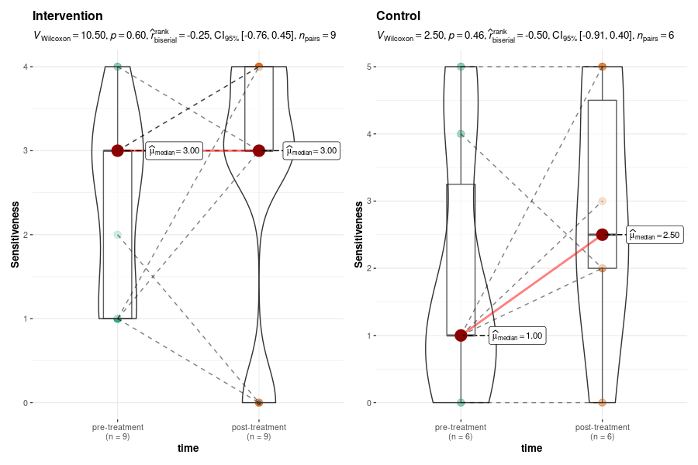
- A body and sleep problem of RCMAS
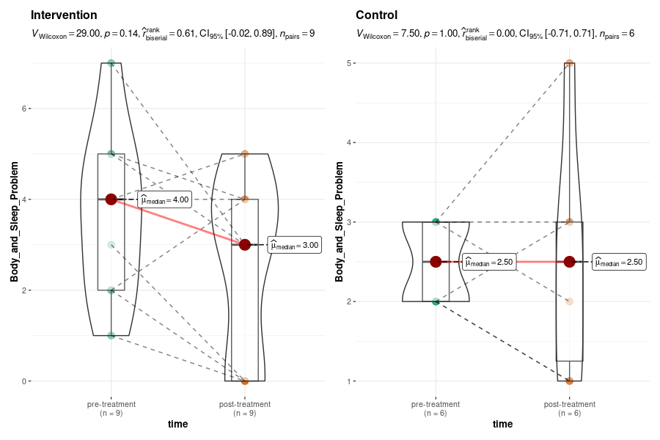
- Negative emotions and Attention Problems of RCMAS
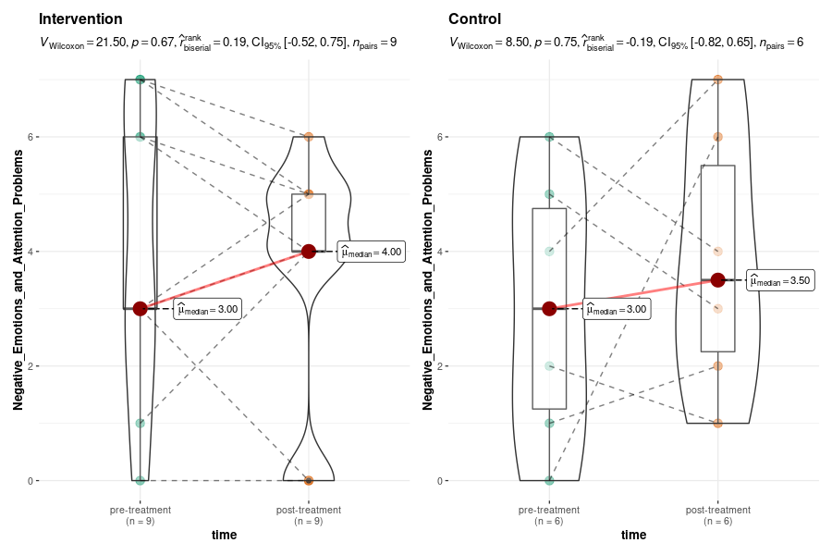
- K-SCQ Total score
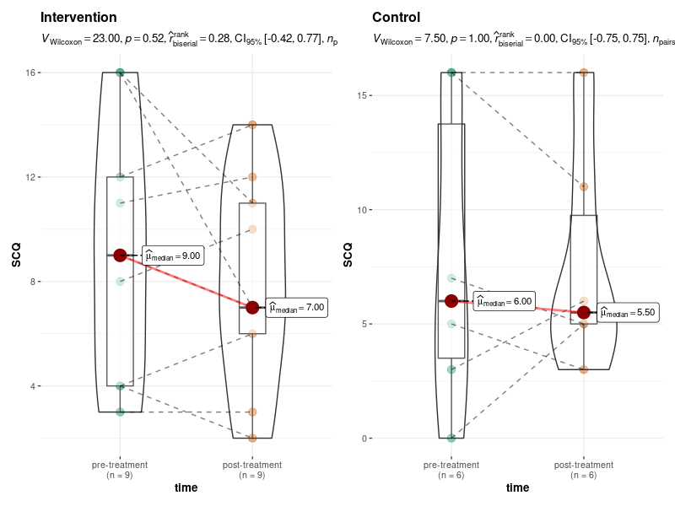
- K-CBCL Total score
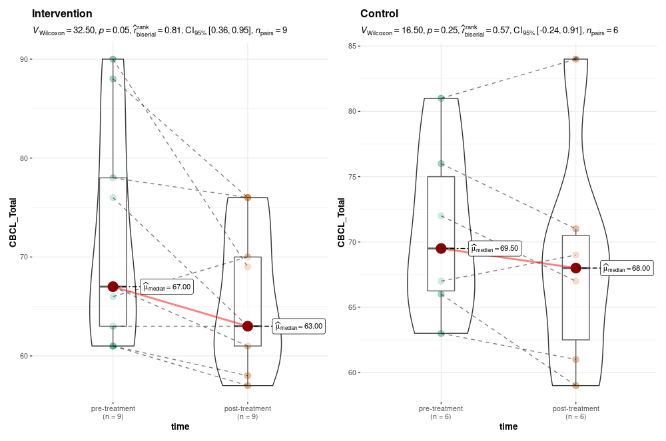
- Anxiety and Depression of K-CBCL
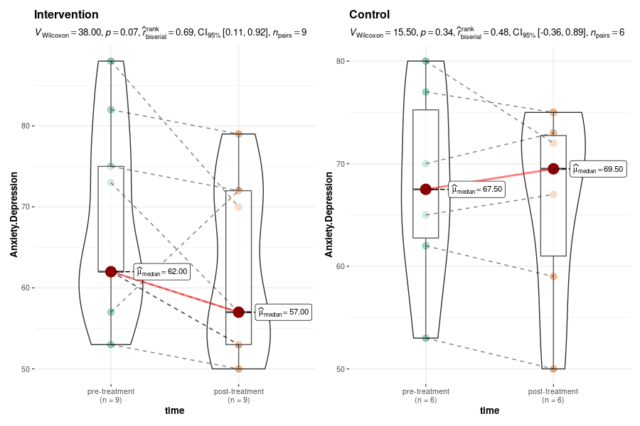
- Withdrawal of K-CBCL
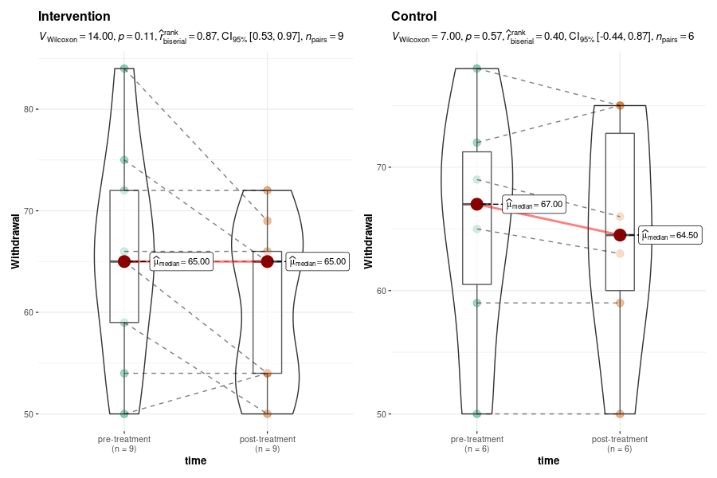
- Somatization of K-CBCL
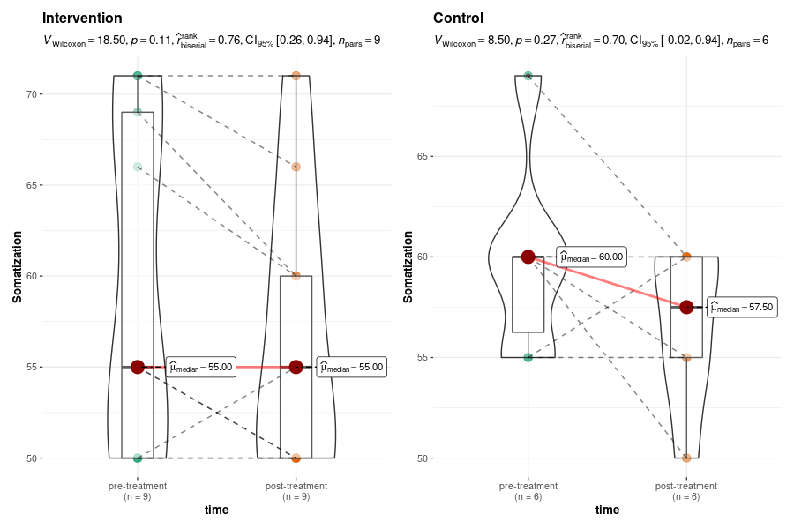
- Social Problems of K-CBCL
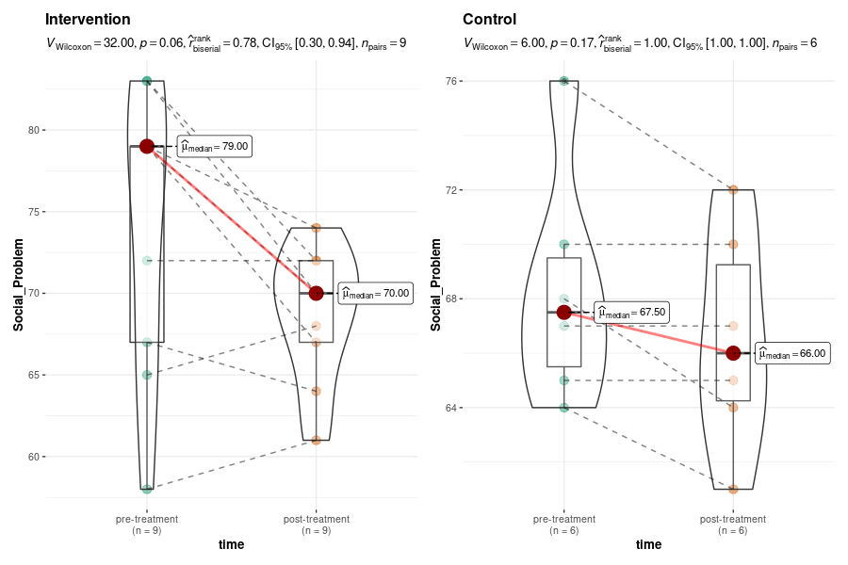
- Thought Problems of K-CBCL
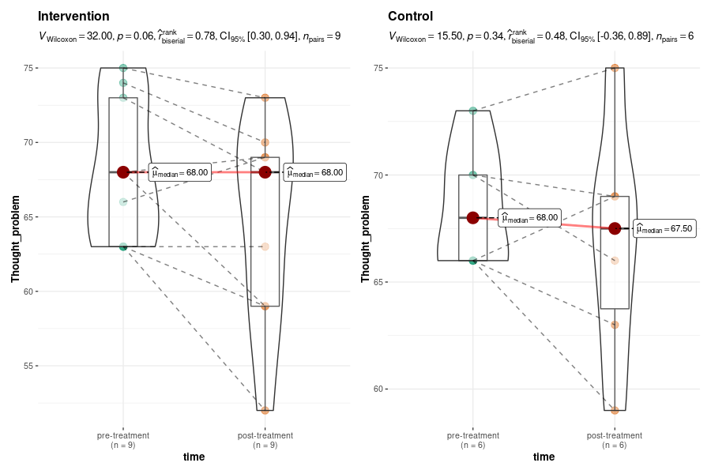
- Inattention of K-CBCL
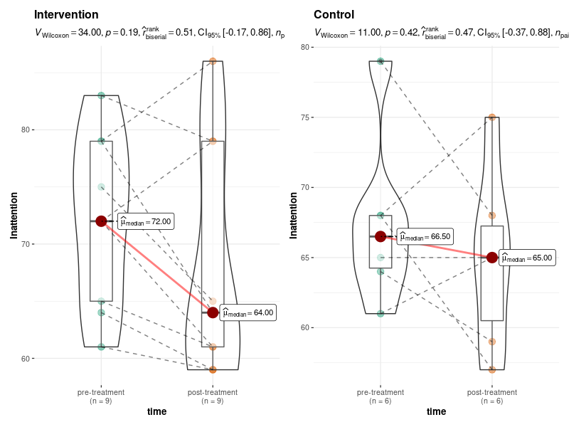
- Delinquent behavior of K-CBCL
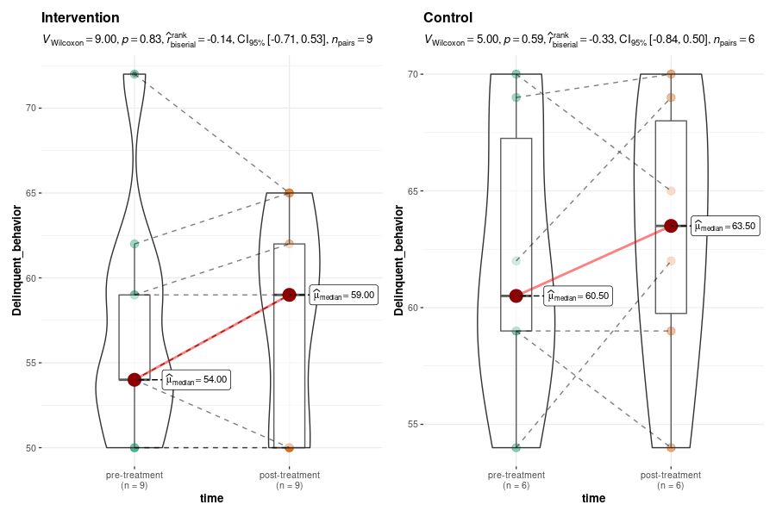
- Aggressive behavior of K-CBCL
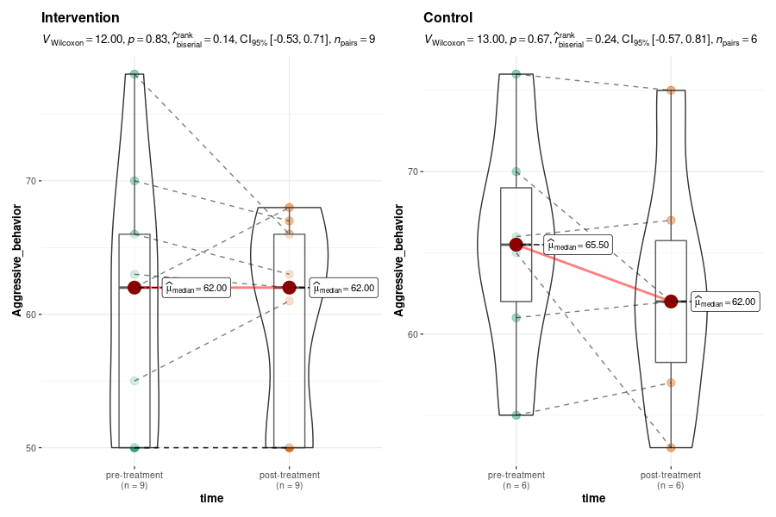
- Internalizing problems of K-CBCL
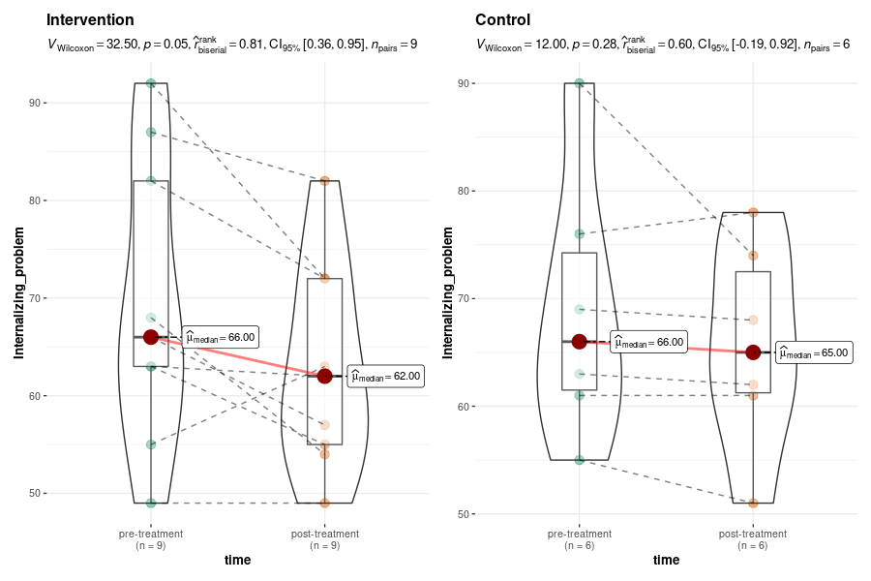
- Externalizing problems of K-CBCL
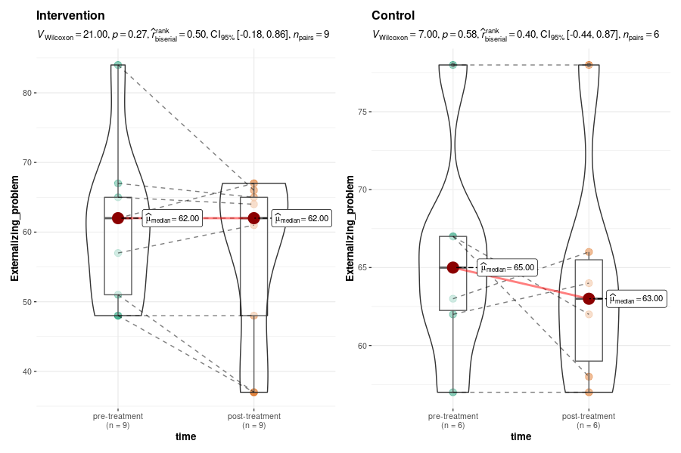
- Communication of K-VABS-2
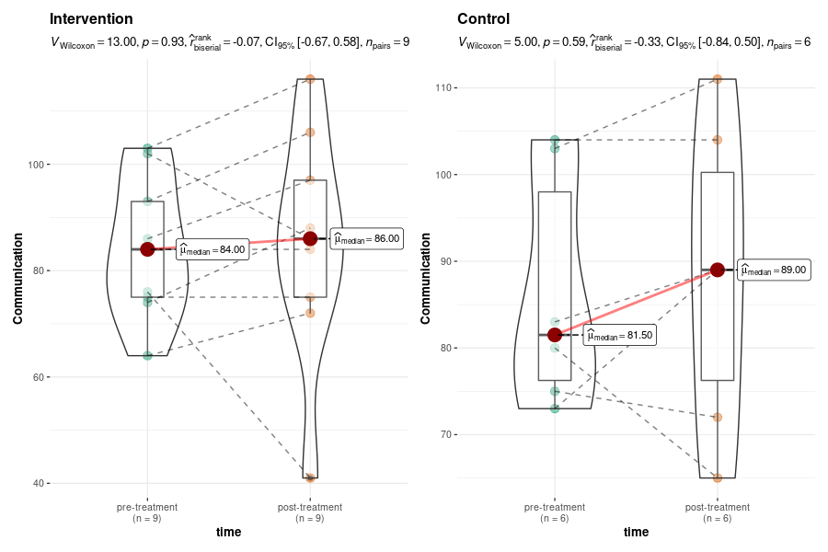
- Daily living skill of K-VABS-2
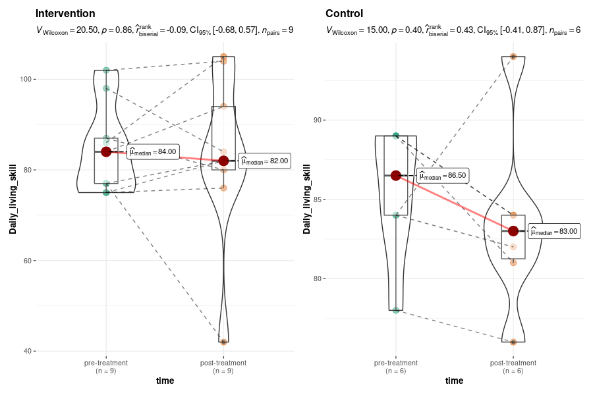
- Socialization of K-VABS-2
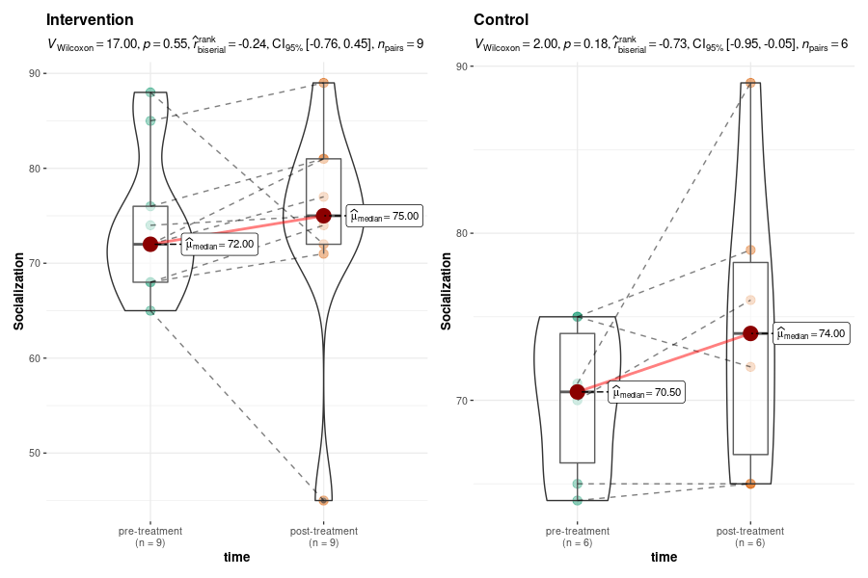

Figure S3. Changes in Secondary outcome for parents of the intervention and control group
- Depression
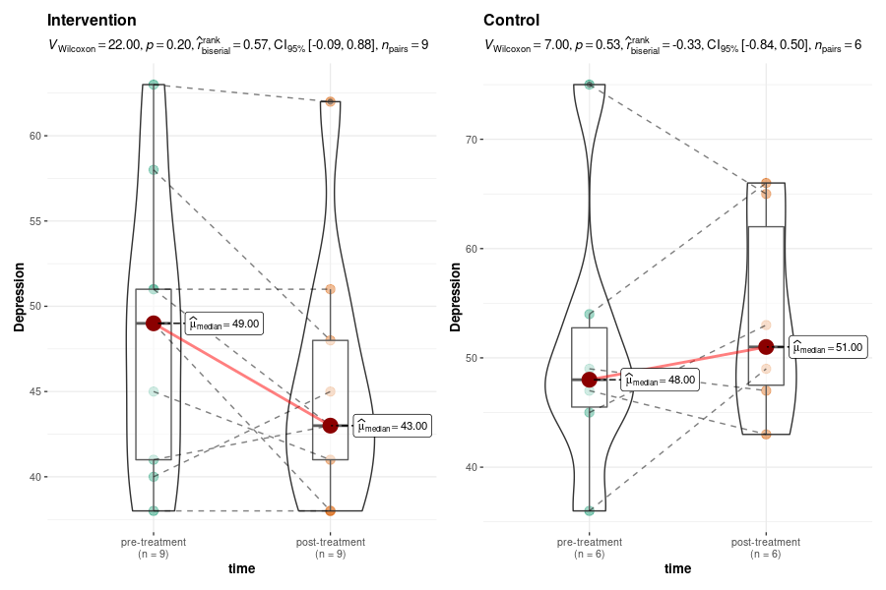
- Anxiety
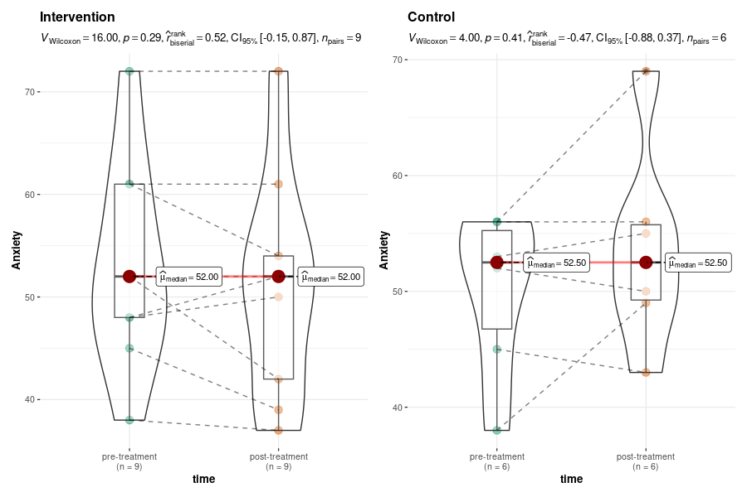
- Panic
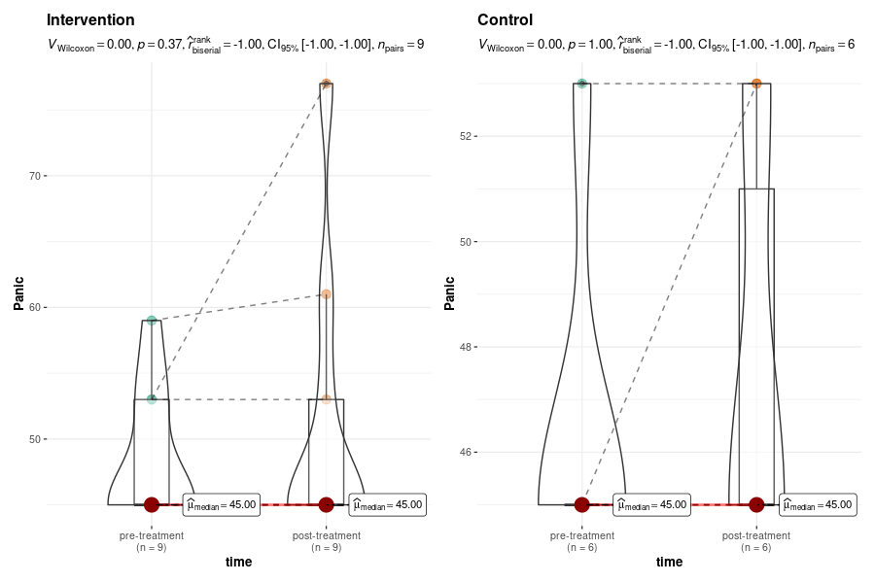
- Agoraphobia
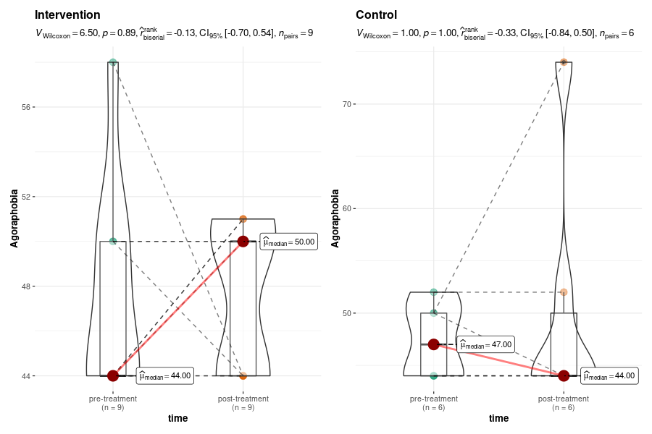
- Obsessive
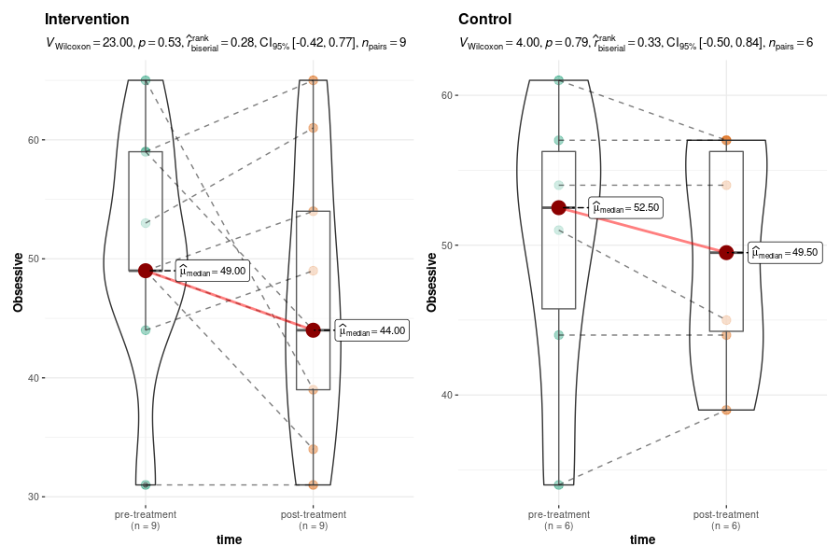
- Obsessive-Compulsive-Personality
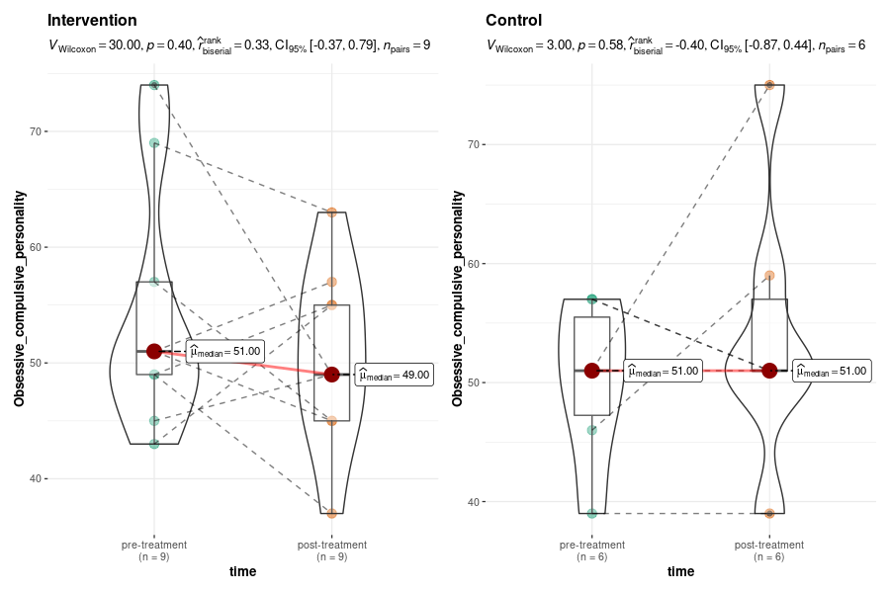
- PTSD
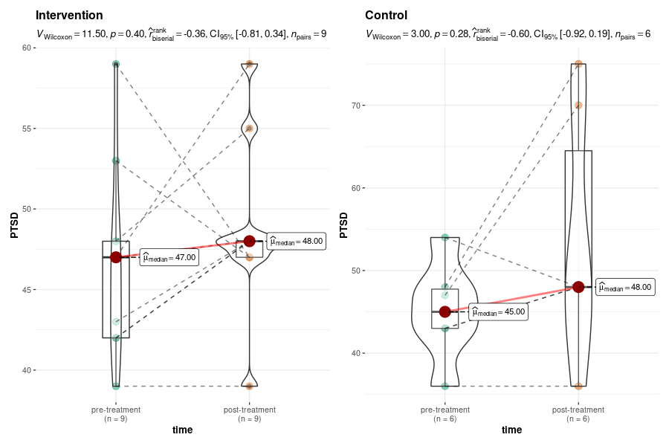
- Anger attack
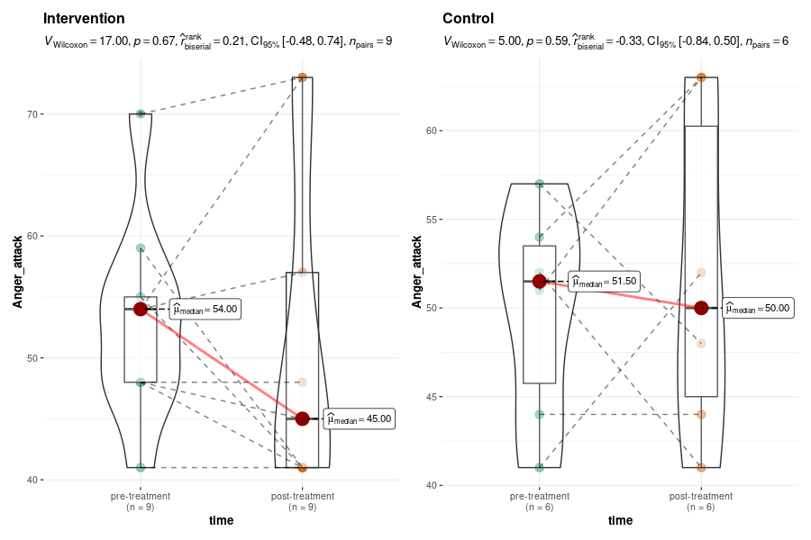
- Somatic
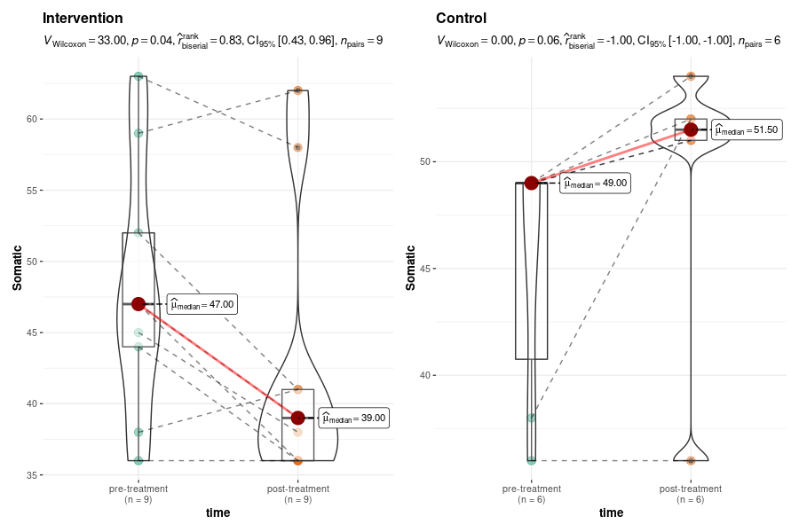
- Mania
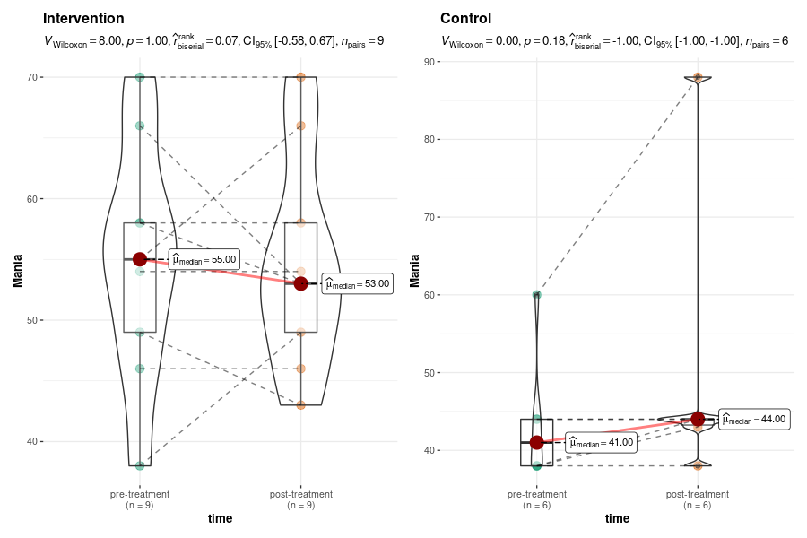
- Paranoia
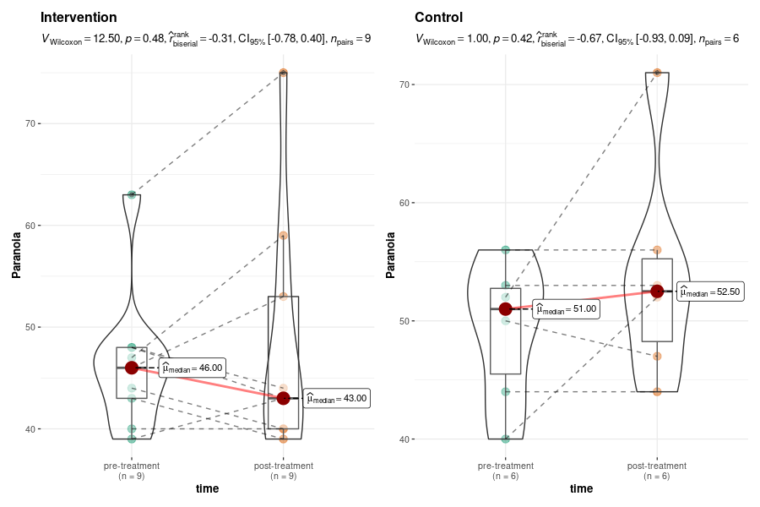
- Psychosis
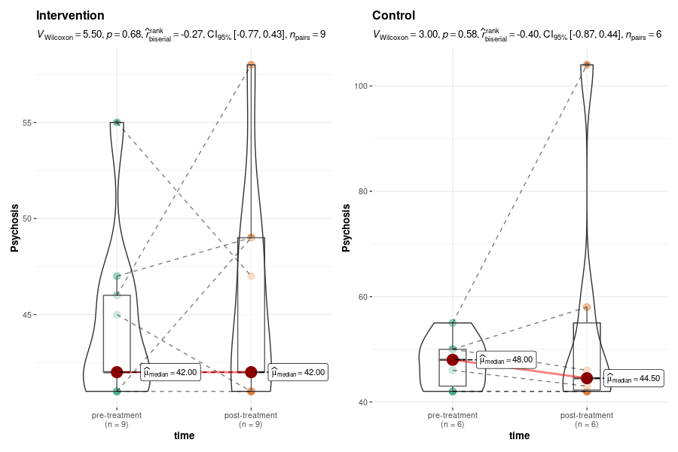
- Suicide
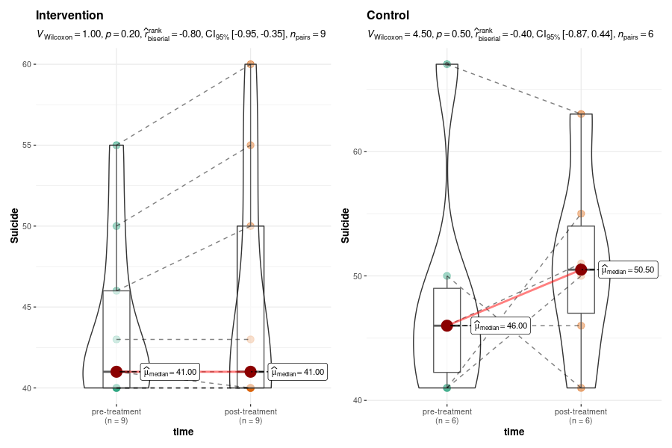
- Addiction
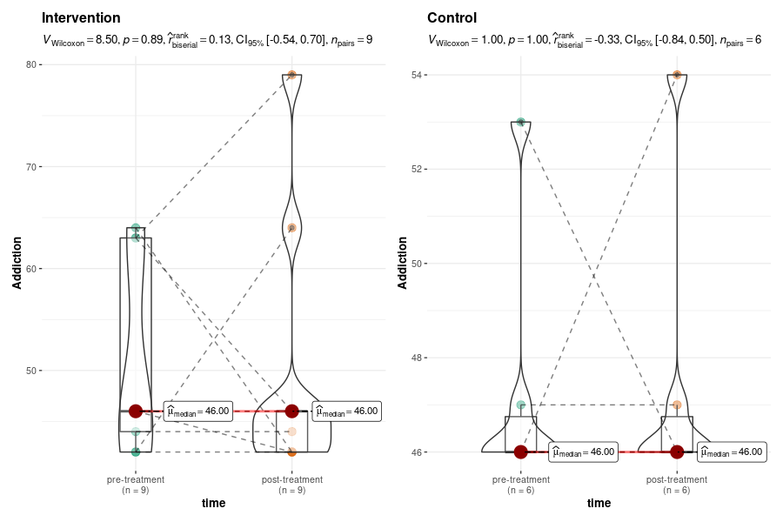
- Sleep-disorder
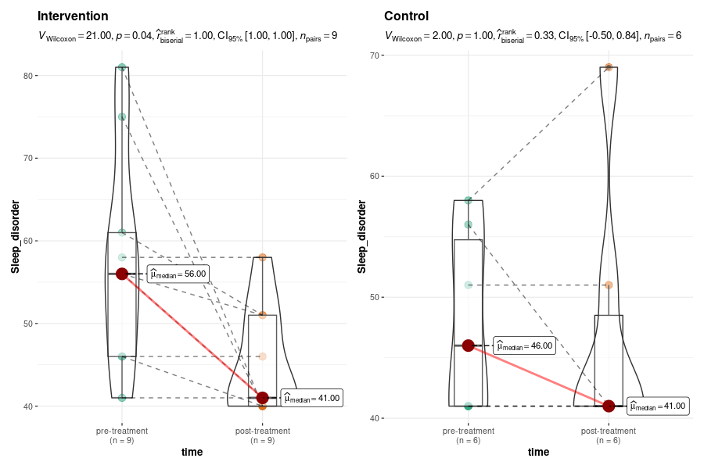
- Interpersonal-Sensitivity
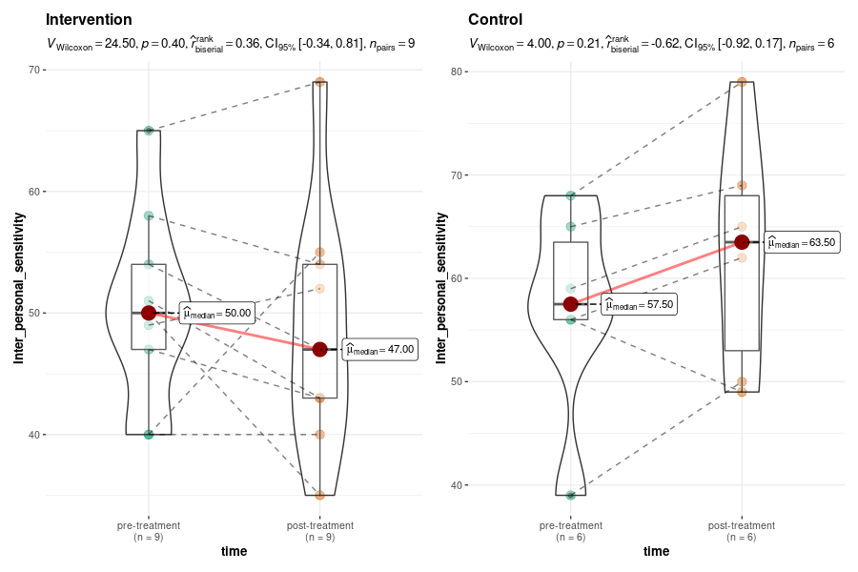
- Regulation-problem
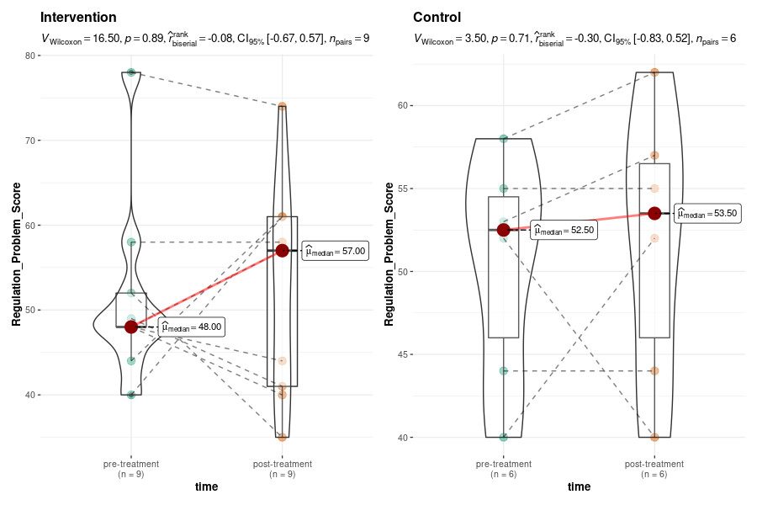

Reference

1. Laugeson EA, Gantman A, Kapp SK, Orenski K, Ellingsen R. A Randomized Controlled Trial to Improve Social Skills in Young Adults with Autism Spectrum Disorder: The UCLA PEERS® Program. J Autism Dev Disord. 2015;45(12):3978-3989. doi:10.1007/s10803-015-2504-8
2. Yoo HJ, Bahn G, Cho IH, et al. A randomized controlled trial of the korean version of the PEERS® parent-assisted social skills training program for teens with ASD. Autism Research. 2014;7(1):145-161. doi:10.1002/aur.1354
3. Laugeson EA, Frankel F, Gantman A, Dillon AR, Mogil C. Evidence-based social skills training for adolescents with autism spectrum disorders: The UCLA PEERS program. J Autism Dev Disord. 2012;42(6):1025-1036. doi:10.1007/s10803-011-1339-1
4. Yamada T, Miura Y, Oi M, et al. Examining the Treatment Efficacy of PEERS in Japan: Improving Social Skills Among Adolescents with Autism Spectrum Disorder. J Autism Dev Disord. 2020;50(3):976-997. doi:10.1007/s10803-019-04325-1
5. Mandelberg J, Laugeson EA, Cunningham TD, Ellingsen R, Bates S, Frankel F. Long-term treatment outcomes for parent-assisted social skills training for adolescents with autism spectrum disorders: The UCLA PEERS program. J Ment Health Res Intellect Disabil. 2014;7(1):45-73. doi:10.1080/19315864.2012.730600
6. Haddad J. Social skills for teenagers with developmental and autism spectrum disorders: The PEERS treatment manual. J Child Adolesc Ment Health. 2013;25(1):93-94. doi:10.2989/17280583.2013.802447

